CLOUD COMPUTING
SE-490
COMPLEX ENGINEERING ACTIVITY (CEA)
Design, Deployment, and Cloud-Native Enhancement of a Three-Tier Web Application


Syeda Azwa Asif | SE-23035
Azka Hassan | SE-23037

Course Instructor: Ms. Aminah

DEPARTMENT OF SOFTWARE ENGINEERING
NED UNIVERSITY OF ENGINEERING & TECHNOLOGY

1. Cloud provider and justification
Provider: Amazon Web Services (AWS), region us-east-1 (N. Virginia).
Azure and Google Cloud also provide every component the brief asks for (virtual network, load balancer, scalable instance groups, managed PostgreSQL, container registry), so service coverage alone did not decide the choice. We chose AWS for four reasons that applied to this project:
- An existing, familiar account. The course labs (CloudLab) were done on our AWS account, so the team already knew the console and IAM, and no time was lost on account setup.
- No billing risk. The account has AWS free-plan credits. The whole environment costs about $0.20 per hour and was deleted after the screenshots were taken, so the activity used a few dollars of credit.
- Keyless deployment from GitHub. AWS IAM supports OpenID Connect (OIDC): the GitHub Actions pipeline assumes one IAM role, limited to our repository, and receives short-lived credentials. No AWS access keys are stored in GitHub.
- Built-in infrastructure as code. CloudFormation is part of AWS: the stack is created by uploading one file in the console, with no tool to install and no state storage to manage (Terraform would need both).
Region us-east-1 is the region our account and labs already use, and it offers every service in this design. Each requirement of the brief is met by one AWS service:
Requirement in the brief | AWS service used
Network layer (VPC, subnets, gateway, routes, NAT) | VPC, subnets, Internet Gateway, route tables, NAT Gateway
Web tier and application tier as Docker containers | EC2 instances running Docker (Nginx and Flask containers)
Managed database, never public | Amazon RDS for PostgreSQL in private subnets
Container registry | Amazon ECR
Load balancer, target groups, auto scaling | Application Load Balancers, target groups, Auto Scaling groups
Secrets management | AWS Secrets Manager and IAM roles
CI/CD pipeline | GitHub Actions with OIDC, ECR and Systems Manager Run Command
Infrastructure as code, logging and monitoring | CloudFormation, CloudWatch Logs, dashboard and alarms
Application. A small "Three-Tier Notes" page: the browser loads a static page from the web tier (Nginx), which forwards calls under /api/ to the application tier (Flask API served by gunicorn), which saves and reads notes in the database tier (PostgreSQL). The page shows the ID of the web and app container that answered, which makes load balancing visible.

2. Overall architecture and design decisions
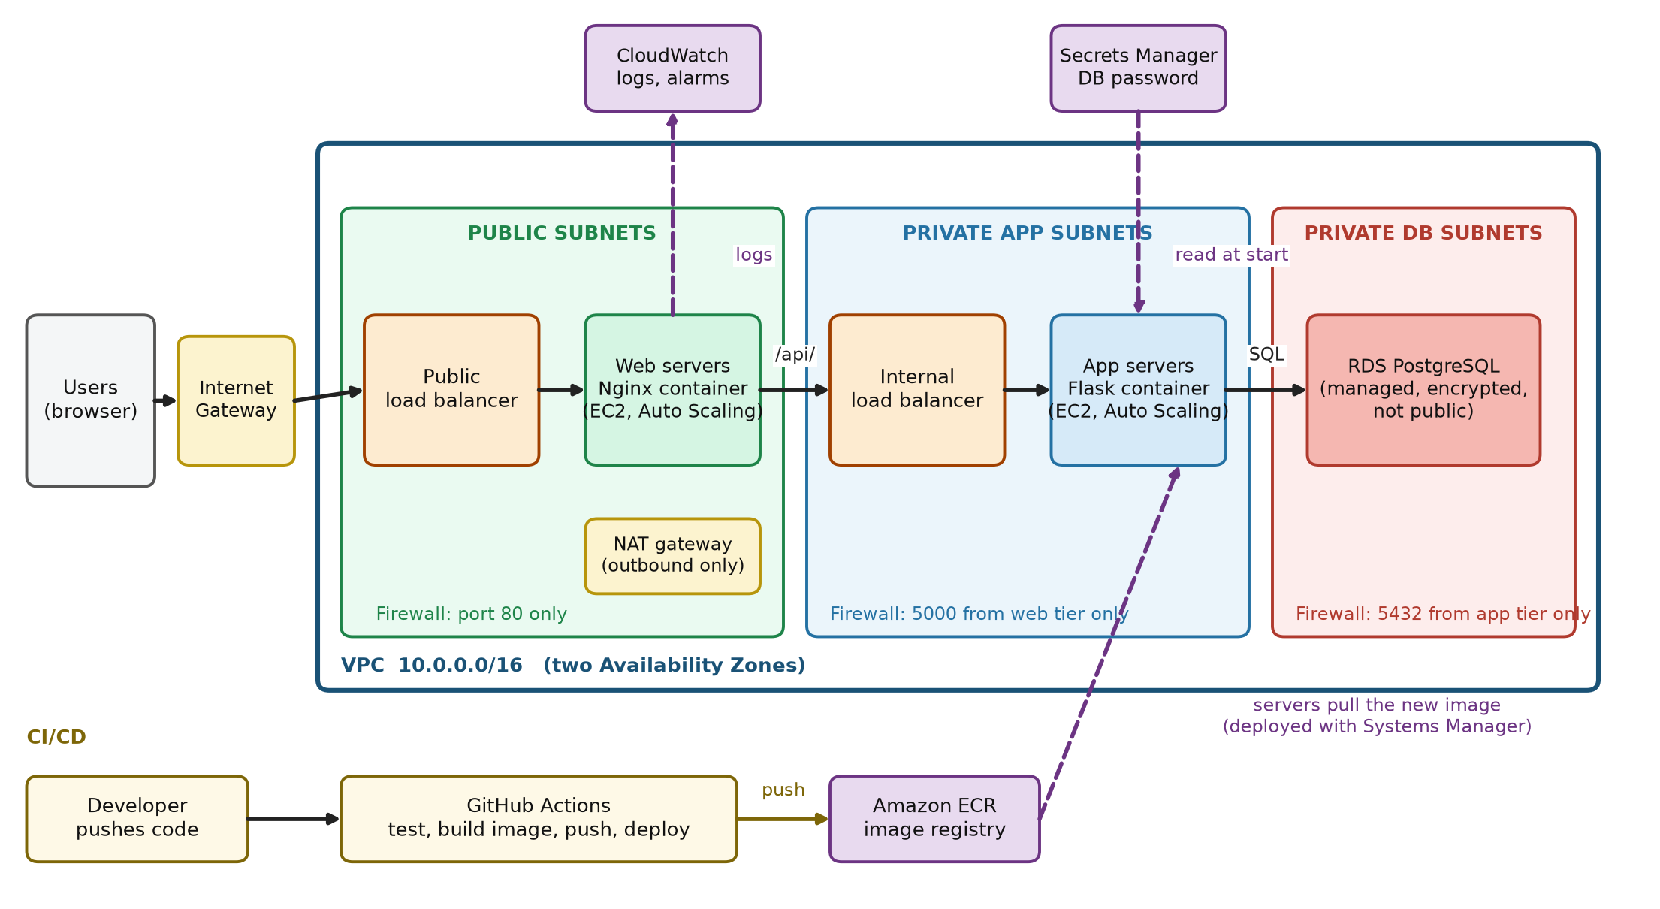
Figure 1: Architecture, network design, security boundaries and the CI/CD flow.
Request path. Browser, Internet Gateway, public load balancer, Nginx containers (public subnets), internal load balancer, Flask containers (private app subnets), PostgreSQL on RDS (private DB subnets). Every layer is a separate subnet pair across two Availability Zones, and each hop is allowed only by a security group rule from the previous layer.
Design decision | Reason
VPC 10.0.0.0/16 with six /24 subnets in two AZs: public 10.0.1.0 and 10.0.2.0, app 10.0.11.0 and 10.0.12.0, database 10.0.21.0 and 10.0.22.0 | One subnet pair per tier lets each tier have its own routes and firewall; two AZs avoid a single data-centre failure; /24 ranges leave room to add instances
Web tier in public subnets behind a public load balancer | The only components reachable from the internet are the load balancer and the web instances, which accept traffic from the load balancer only
App tier in private subnets behind an internal load balancer | The app tier has no internet address and accepts traffic only from the web tier. The internal load balancer gives Nginx one stable address, so Auto Scaling can add or remove app instances without changing Nginx
Database on managed RDS in private subnets with no internet route | RDS provides patching, backups and encryption, and the route table has only the local route, so the database cannot be reached from the internet
NAT Gateway (one, in a public subnet) | Private app instances need outbound access to pull images and read the secret; NAT allows outbound connections only. One NAT instead of two halves the cost (a known single-AZ gap)
Docker containers on EC2, not Kubernetes | The brief asks for Docker containers on the target instance. EC2 with Docker is simpler and cheaper to run for three small containers
Stateless containers; all data in PostgreSQL | Any web or app container can be started, stopped or replaced without losing data
Images tagged with the git commit and deployed through Systems Manager | Every release can be traced to one commit, and no SSH port is needed to deploy

3. Services used and their role in each tier
Tier | Service and configuration | Role
Network | VPC, 6 subnets, Internet Gateway, NAT Gateway, 3 route tables (public to gateway, app to NAT, database local only) | Separates the tiers and controls which can reach the internet
Web | Public Application Load Balancer (HTTP 80, health check /health every 15 s); Auto Scaling group of 2 to 3 EC2 t3.small instances running the Nginx container | Serves the page and forwards /api/ to the app tier
Application | Internal Application Load Balancer; Auto Scaling group of 2 to 3 EC2 t3.small instances running the Flask container on port 5000 | Runs the business logic and talks to the database
Database | RDS PostgreSQL db.t4g.micro, 20 GB gp3, encrypted, not publicly accessible, 1-day backups | Stores the notes
Registry | Amazon ECR repositories cea-web and cea-app, scan on push | Stores the images built by the pipeline
Secrets and identity | Secrets Manager (generated 24-character password); IAM instance role and GitHub deploy role | Keeps credentials out of code; gives each component only the access it needs
Operations | CloudFormation; CloudWatch Logs (3-day retention), dashboard, two alarms; Systems Manager | Creates the environment, collects logs, raises alarms, runs deployments

4. Containerization and CI/CD pipeline design
Repository: https://github.com/sazwa-asif/cea-three-tier (web/, app/, docker-compose.yml, infra/cea-stack.yaml, .github/workflows/deploy.yml)
- Web image (web/Dockerfile): based on nginx:1.27-alpine. Its configuration is a template where the upstream address and DNS resolver come from environment variables, so the same image works locally (app:5000) and on AWS (the internal load balancer name).
- App image (app/Dockerfile): based on python:3.12-slim, installs the pinned requirements, runs gunicorn with two workers on port 5000, and runs as a non-root user.
- Local orchestration (docker-compose.yml): starts web, app and PostgreSQL on two networks. The database is only on the backend network and publishes no port; the web container publishes port 8080.
Pipeline (GitHub Actions, deploy.yml), triggered by every push to main and manually:
- Test job: install the requirements and run pytest (4 tests). If a test fails, nothing is built or deployed.
- Authenticate: the build job assumes the AWS role through OIDC and logs in to ECR.
- Build: docker build for the web and app images.
- Push: each image is pushed to ECR with two tags, the commit hash and latest.
- Deploy: AWS Systems Manager Run Command runs the deploy script on every instance tagged for the app tier, then the web tier. The script logs in to ECR, pulls the image and restarts the container.
- Verify: the pipeline polls each command and fails the run if any instance reports a failure.
Instances started later by Auto Scaling run the same script at boot, so scaled-out instances also get the newest image.

5. Security considerations
Control required | How it is implemented
Security group per tier | Public ALB: port 80 from the internet. Web: port 80 only from the public ALB group. Internal ALB: port 80 only from the web group. App: port 5000 only from the internal ALB group. Database: port 5432 only from the app group. No SSH port is open.
Segmentation between public and private subnets | App and database instances have no public IP. The app route table reaches the internet only through the NAT Gateway (outbound). The database route table has only the local route.
Least privilege between tiers and services | Security group rules reference the previous tier's group, not IP ranges. The instance IAM role may only read the one database secret, write to the two log groups, pull from ECR and use Systems Manager. The pipeline role may only push to the two ECR repositories and run commands on instances tagged for this project. Instance metadata requires IMDSv2.
Secrets and credentials, including the pipeline | The database password is generated by Secrets Manager and is not in the code, the template or the repository. Instances read it at start-up through their IAM role. Locally, docker-compose reads a git-ignored .env file. The pipeline uses OIDC, so no AWS keys are stored; the only GitHub secret is the role identifier (AWS_ROLE_ARN), which is not a credential.
Data and image protection | RDS storage is encrypted; ECR scans images on push; containers run as a non-root user.

6. Testing results
Test | Result | Evidence
Unit tests (pytest) | 4 of 4 passed; run automatically by the pipeline before every build | Fig. 17
Local run (docker compose up --build) | Web, app and database containers started; notes were saved and were still there after a refresh at localhost:8080 | Figs. 2 to 4
Automated build and deploy | GitHub Actions run succeeded in 1 min 11 s (test 9 s, build, push and deploy 54 s); images with latest and commit-hash tags appeared in ECR | Figs. 15 to 17
Application on AWS | Opened through the public load balancer address; three notes were saved and kept; the web and app container IDs on the page changed between refreshes | Fig. 18
Health and scaling groups | Both Auto Scaling groups 2 of 2 healthy; web and app target groups 2 healthy and 0 unhealthy | Figs. 7, 12, 13
Database isolation | RDS shows Publicly accessible: No; its security group accepts port 5432 only from the app security group | Figs. 10, 14
Problems found and fixed. (1) The instances were created before the first pipeline run had pushed any image, so the load balancer marked them unhealthy and Auto Scaling replaced them repeatedly; once the images existed, new instances became healthy. (2) The pipeline's role was first rejected because GitHub now puts numeric IDs in the identity name it presents (repo:owner@id/repo@id); the role's trust rule and the template were changed to accept that format.

7. Additional cloud-native enhancements
The brief requires at least one. We implemented three:
- Infrastructure as code: the whole environment (52 resources) is one CloudFormation template, checked with cfn-lint, created in about 15 minutes and deleted in one step.
- Logging and monitoring: container logs are sent to CloudWatch Logs; a dashboard shows requests, healthy hosts, response time, CPU and database load; alarms fire on unhealthy web hosts and on server errors.
- Cost estimate with two optimizations: estimated monthly cost at on-demand prices for continuous running (to be confirmed in the AWS Pricing Calculator):
Item | Quantity | Approx. cost per month (USD)
EC2 t3.small (2 web, 2 app) | 4 | 60
Application Load Balancers | 2 | 34
NAT Gateway (fixed part) | 1 | 33
RDS db.t4g.micro and 20 GB gp3 | 1 | 15
Secrets Manager, ECR, CloudWatch | - | 4
Total |  | about 146 (about 0.20 per hour)
Optimization 1, scale in and right-size: run one instance per tier outside busy hours and use t3.micro for the app tier (about $35 per month saved). Optimization 2, remove fixed costs: replace the NAT Gateway with VPC endpoints for ECR, S3, Secrets Manager and CloudWatch Logs (about $15 to $20 per month saved), and stop the database and scale the groups to zero outside working hours in a test environment.

8. NFR justification
NFR | Design and implementation decisions that support it | Not fully addressed, and improvement
Scalability | Stateless containers; both tiers in Auto Scaling groups (2 to 3 instances) that scale independently behind load balancers | Maximum of 3 per tier, and the database scales only vertically. Raise the maximum; add read replicas and caching
Availability / reliability | Web and app instances spread over two AZs; load balancer health checks every 15 s mark an instance unhealthy after 3 failures and Auto Scaling replaces it | RDS is single-AZ and the NAT Gateway is in one AZ. Enable Multi-AZ RDS and add a NAT per AZ
Elasticity | Target-tracking policy keeps average CPU near 50%, adding and removing instances automatically | Not load-tested, and scaling takes several minutes. Run a load test and tune the target
Security | Per-tier security groups, private subnets, Secrets Manager, OIDC, least-privilege IAM, IMDSv2, encryption at rest (Section 5) | Traffic is HTTP only (no domain or certificate). Add an ACM certificate with HTTPS and TLS to the database
Maintainability / deployability | One push to main tests, builds, pushes and deploys; images are tagged by commit; one template recreates the environment | Deploy uses the latest tag with no automatic rollback. Add versioned rollouts
Performance / latency | Nginx serves the static page directly; load balancers spread requests; all tiers are in one region; two gunicorn workers per instance | No caching or CDN and no measured latency. Add CloudFront or Redis and measure response times
Cost efficiency | Small instance types, gp3 storage, 3-day log retention, environment deleted when not used; about $0.20 per hour | Two load balancers and the NAT Gateway dominate cost. Apply the optimizations in Section 7
Portability | Everything runs as Docker containers; docker-compose ran the same three tiers locally; the database is standard PostgreSQL | IAM roles and the CloudFormation template are AWS-specific and would need rewriting on another cloud

Appendix A: Deployment evidence
A.1 Containers and local run
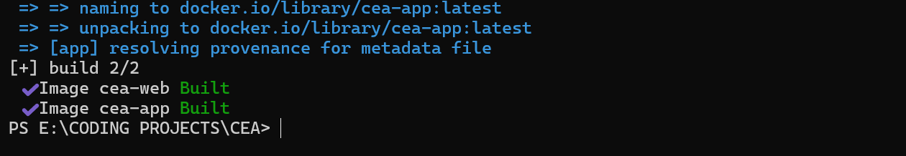
Figure 2: docker compose build: the web and app images were built.
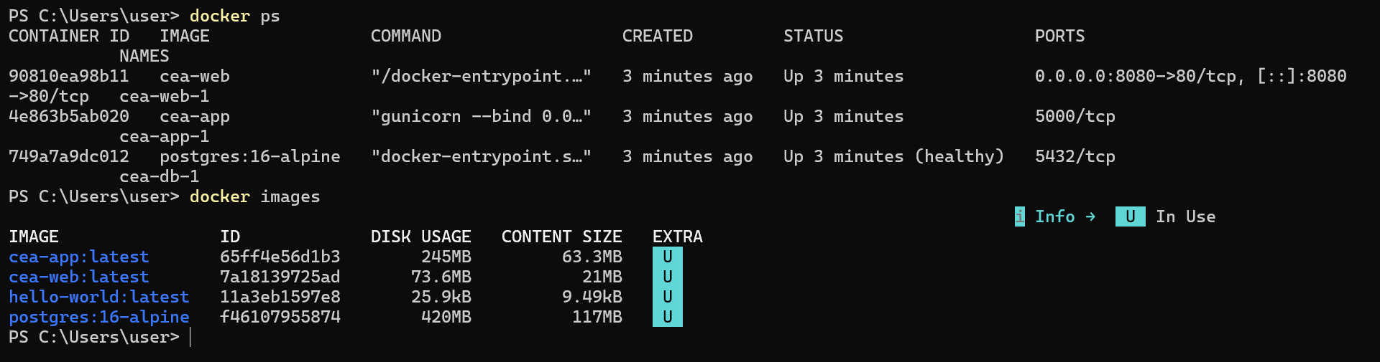
Figure 3: docker ps and docker images: web, app and database containers running locally; the database publishes no port.
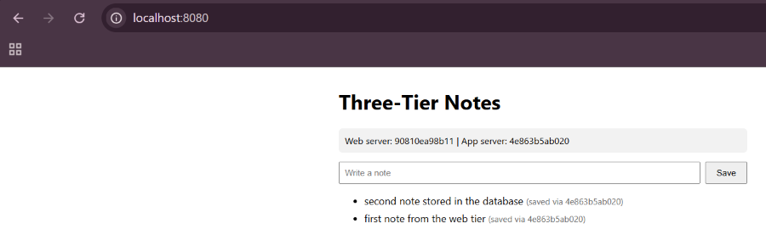
Figure 4: The application running locally through docker compose (localhost:8080).
A.2 Infrastructure, network and compute
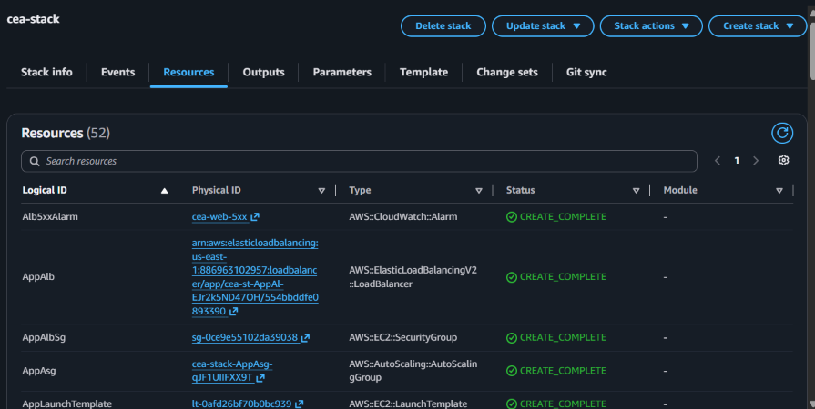
Figure 5: CloudFormation stack: 52 resources created (infrastructure as code).
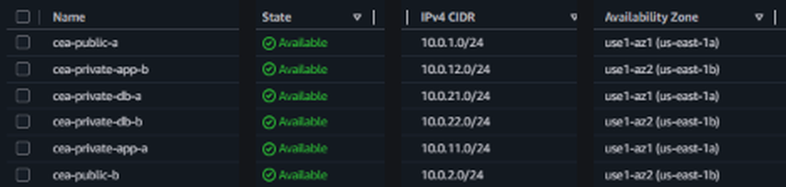
Figure 6: VPC cea-vpc: six subnets (public, private-app, private-db) in two Availability Zones, with CIDR ranges.
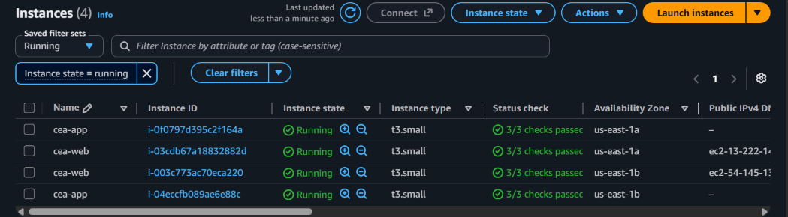
Figure 7: Running EC2 instances: two web servers and two app servers, all status checks passed.
A.3 Security groups (one per tier)
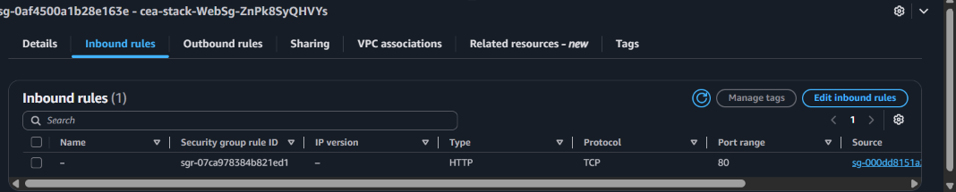
Figure 8: Web security group: HTTP port 80 allowed only from the public load balancer group.
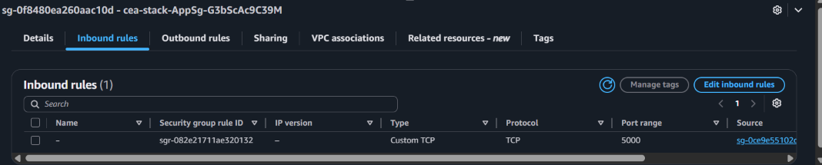
Figure 9: App security group: port 5000 allowed only from the internal load balancer group.
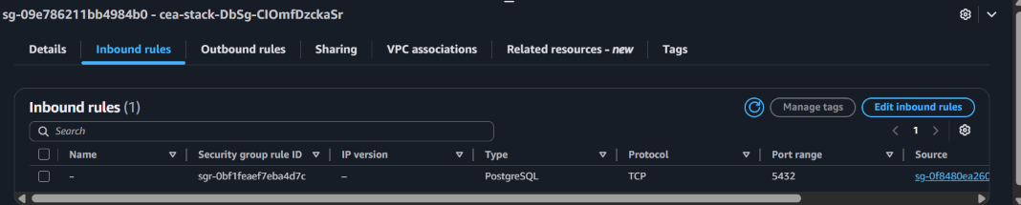
Figure 10: Database security group: PostgreSQL port 5432 allowed only from the app security group.
A.4 Load balancing and database
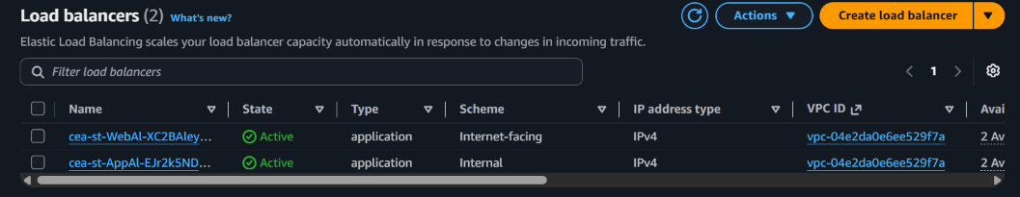
Figure 11: Load balancers: one internet-facing and one internal.
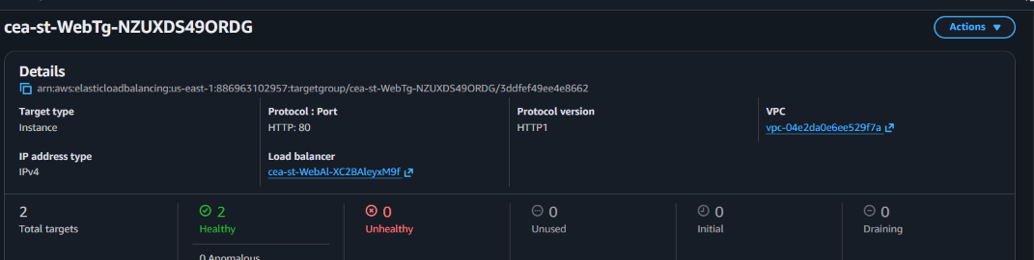
Figure 12: Web target group: 2 targets, both healthy.
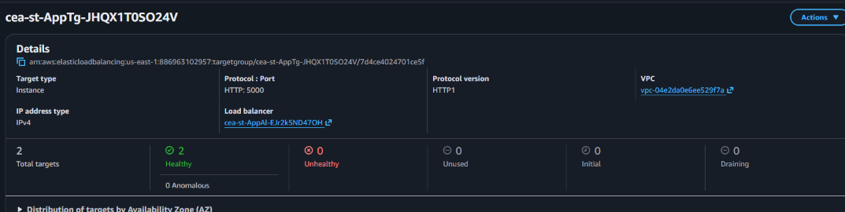
Figure 13: App target group: 2 targets, both healthy.
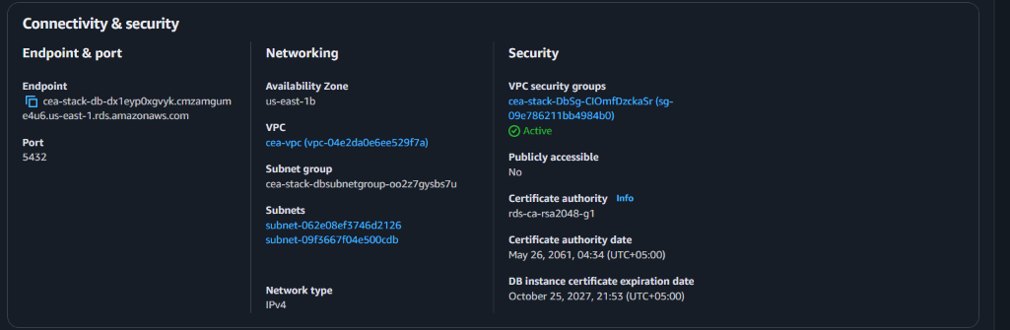
Figure 14: RDS PostgreSQL in private DB subnets: Publicly accessible: No.
A.5 Registry, pipeline and running application
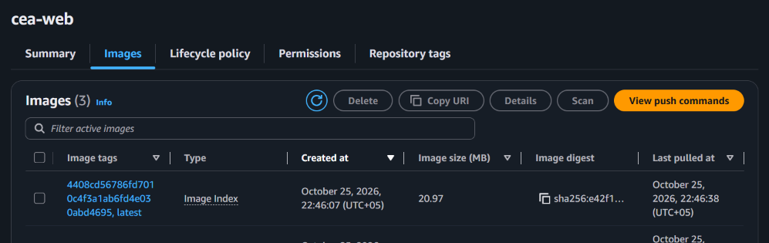
Figure 15: ECR repository cea-web with the latest and commit-hash tags.
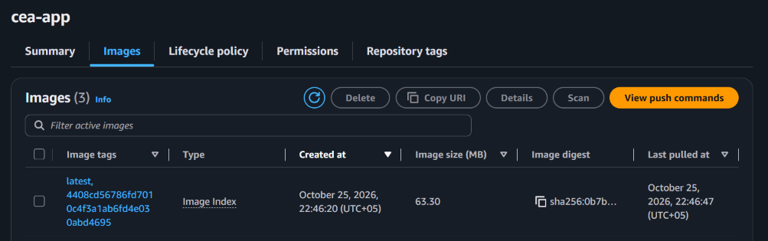
Figure 16: ECR repository cea-app with the latest and commit-hash tags.
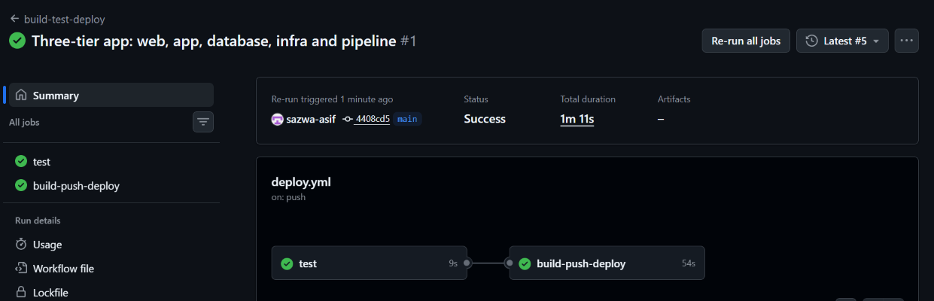
Figure 17: GitHub Actions run: test and build-push-deploy both succeeded.
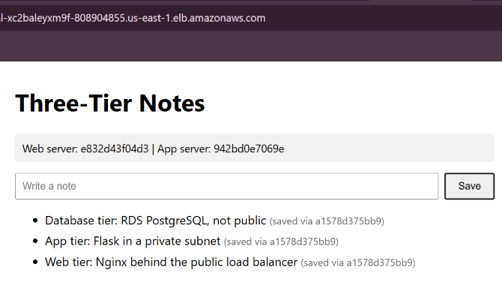
Figure 18: Running application on AWS, reached through the load balancer address.

