

**A** **PROJECT REPORT**

**ON**

“[[Online Food Ordaring System]]”

## Submitted in partial fulfillment for the Course of

**Database Management System Laboratory**

Submitted by:

|  |  |  |
| --- | --- | --- |
| **S/L** | **Name** | **ID** |
| **1** | **Sazzad Hossain Shovon** | **173-15-1706** |
| **2** | **Kalpana Akter** | **191-15-2597** |
| **3** | **Anika Arafat** | **191-15-2746** |

Submitted to

|  |
| --- |
| **Rubel Sheikh**  Lecturer  Department of Computer Science and Engineering Daffodil International University |

**TABLE OF CONTENTS**

**ABSTRACT**

1. INTRODUCTION
   1. PROJECT AIMS AND OBJECTIVES
   2. BACKGROUND OF PROJECT
   3. SCOPE OF THE PROJECT
2. SYSTEM ANALYSIS
   1. SOFTWARE REQUIREMENT SPECIFICATION
   2. EXISTING VS PROPOSED
   3. SOFTWARE TOOL USED
3. SYSTEM DESIGN
   1. TABLE DESIGN
   2. E-R DIAGRAM OF THE SYSTEM
4. SYSTEM IMPLEMENTATION
   1. MODULE DESCRIPTION
   2. SCREEN SHOTS
5. SYSTEM TESTING
   1. UNIT TESTING
   2. INTEGRATION TESTING
6. CONCLUSION & FUTURE SCOPE
7. REFERENCES

CHAPTER 1

INTRODUCTION

* 1. **PROJECT AIMS AND OBJECTIVES**

The database is currently functional as a stand-alone web application with a mySQL back-end and can begin to be used. However, the ideal situation would be for the database to be completely wrapped into the CoE/CAEN’s existing structure so that it could be a college supported production application and not have to be maintained by CAEN. Dino Anastasia has decided to do a DFE this summer to further develop the database using JSP and Oracle, as well as CoE’s Zope content management system. It is anticipated that the following tasks will need to be accomplished in order to achieve the goals stated above:

* Gather feedback from CAEN Service Center staff on feature set and usability requirements for the repair form using prototype as a model.
* Develop information architecture for needed forms, web pages, and database tables to support the form.
* Create the database tables in Oracle.
* Code web pages using JSP to interact with database tables.
* Conduct usability testing of the completed pages with CAEN Service Center staff and develop punch list of improvements and fixes needed.
* Update code to incorporate feedback noted in #5 above.
* Document and hand off code base for production implementation by CoE web team
  1. **BACKGROUND OF THE PROJECT**

The project is about SQL database. SQL is a programming language used by nearly all [relational databases](https://www.oracle.com/database/what-is-database/#relational) to query, manipulate, and define data, and to provide access control. SQL was first developed at IBM in the 1970s with Oracle as a major contributor, which led to implementation of the SQL ANSI standard, SQL has spurred many extensions from companies such as IBM, Oracle, and Microsoft. Although SQL is still widely used today, new programming languages are beginning to appear.

Databases have evolved dramatically since their inception in the early 1960s. Navigational databases such as the hierarchical database (which relied on a tree-like model and allowed only a one-to-many relationship), and the network database (a more flexible model that allowed multiple relationships), were the original systems used to store and manipulate data. Although simple, these early systems were inflexible. In the 1980s, [relational databases](https://www.oracle.com/database/what-is-database/#relational) became popular, followed by [object-oriented databases](https://www.oracle.com/database/what-is-database/#object-oriented) in the 1990s. More recently, [NoSQL databases](https://www.oracle.com/database/what-is-database/#nosql) came about as a response to the growth of the internet and the need for faster speed and processing of unstructured data. Today, [cloud databases](https://www.oracle.com/database/what-is-database/#cloud) and [self-driving databases](https://www.oracle.com/database/what-is-database/#autonomous) are breaking new ground when it comes to how data is collected, stored, managed, and utilized.

* 1. **SCOPE OF THE PROJECT**

Databases are very important in today's world. Our project is an online business project. The use of current online businesses has increased. Online shopping has also increased. In this case database is being used the most. The most widely used websites provide information using databases. Many small businesses have also expanded the job market by doing business online

CHAPTER 2

SYSTEM ANALYSIS

**2.1 SOFTWARE REQUIREMENT SPECIFICATION**

For run this project we need install XAMPP application. XAMPP is an abbreviation where X stands for Cross-Platform, A stands for Apache, M stands for [*MYSQL*](https://www.javatpoint.com/mysql-tutorial), and the Ps stand for PHP and Perl, respectively. It is an open-source package of web solutions that includes Apache distribution for many servers and command-line executables along with modules such as Apache server, [MariaDB](https://www.javatpoint.com/mariadb-tutorial), PHP, and Perl.

XAMPP helps a local host or server to test its website and clients via computers and laptops before releasing it to the main server. It is a platform that furnishes a suitable environment to test and verify the working of projects based on Apache, Perl, MySQL database, and PHP through the system of the host itself. Among these technologies, [Perl](https://www.javatpoint.com/perl-tutorial) is a programming language used for web development, [PHP](https://www.javatpoint.com/php-tutorial) is a backend scripting language, and MariaDB is the most vividly used database developed by MySQL.

**2.2 EXISTING VS PROPOSED**

|  |  |  |
| --- | --- | --- |
| **Topic** | **Existing System** | **Proposed System** |
| Algorithm | Not set external Algorithm | Algorithm will be for special query |
| Security | Username and password required only. | Only authenticated person will fitch data. |
| Data Analysis | Not set yet | Able to store user activity and provide suggestion. |

**2.3 SOFTWARE TOOL USED**

Given the tools list below,

* XAMPP/WAMPP Server
* Web Browser
* Operating System Windows/MAC

CHAPTER 3

SYSTEM DESIGN

**3.1 TABLE DESIGN**

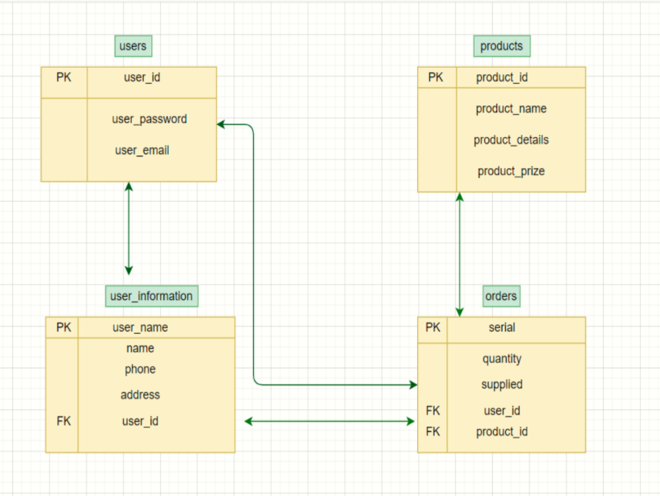

Fig 0.1

**3.2 E-R DIAGRAM OF THE SYSTEM**

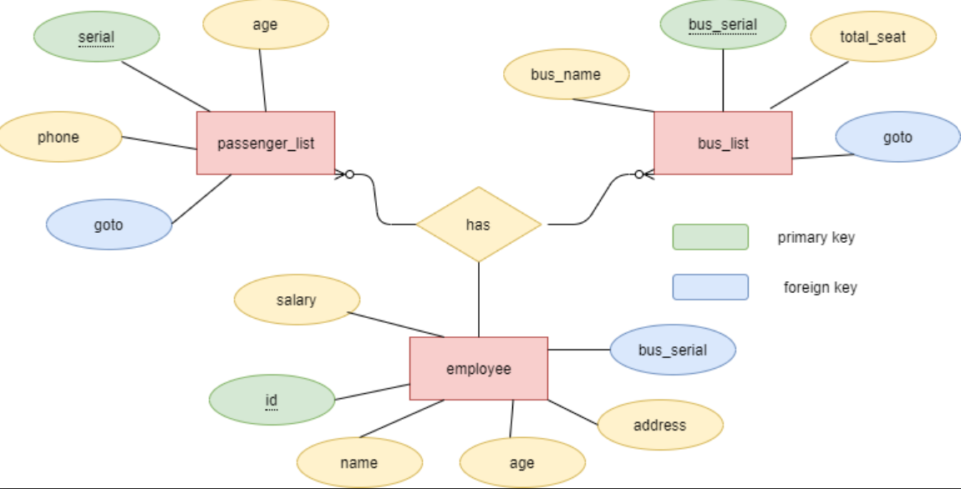

Fig 0.2

CHAPTER 4

SYSTEM IMPLEMENTATION

**4.1 MODULE DESCRIPTION**

phpMyAdmin support a wide range of MySQL operations which makes working with database easy and simple. Moreover, the interactive user interface of phpMyAdmin helps us manage the queries pretty easily. In order to create a [XAMPP MySQL](https://blog.templatetoaster.com/xampp-mysql/) database,

* We need to launch XAMPP first.
* Then we open web browser and type: localhost/phpmyadmin
* And click on the Database tab. Then we saw the option to Create a Database and input field to enter the database name. Wrote the database name and hit the ‘Create’ button. We saw a success message in a while.
* From the list of tables, we can view our database. We are free to use this database wherever we like with default settings. By default the HostName is ‘localhost’, MySQL user is ‘root’ and have no password.

Then we use SQL for insert data on the table-----

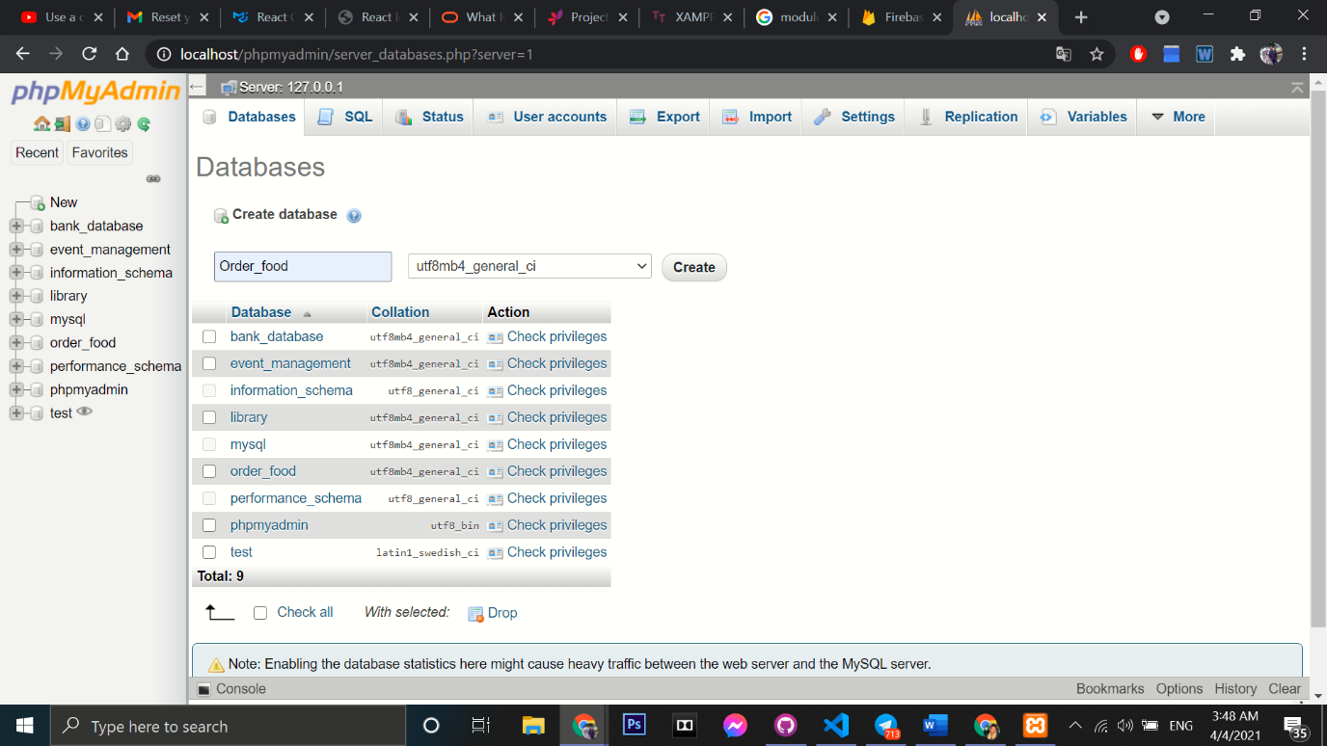

Fig 0.3

**4.2 SCREEN SHOTS**

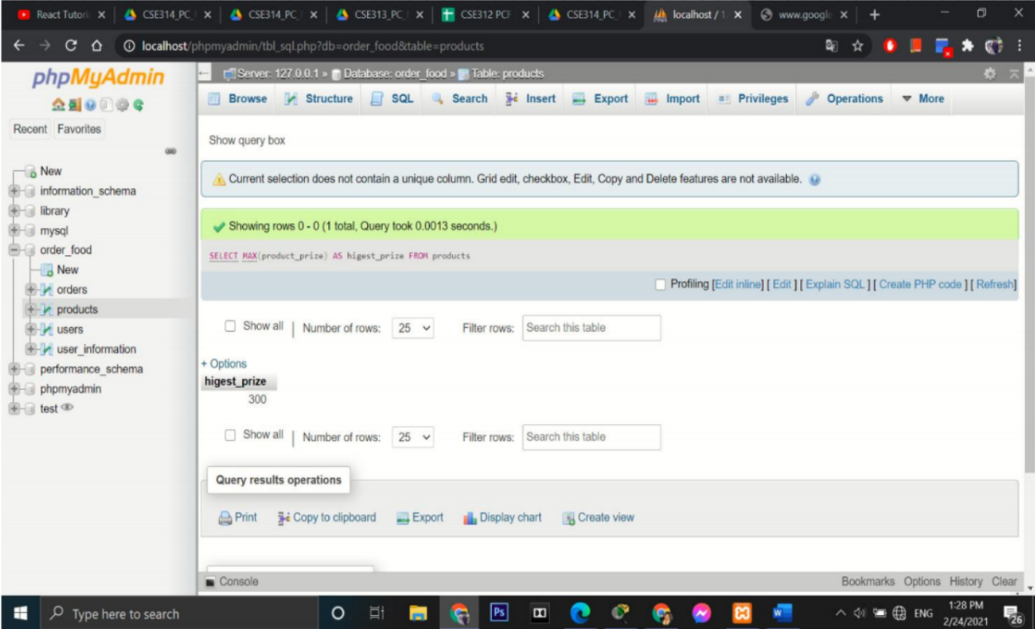

Fig 0.4

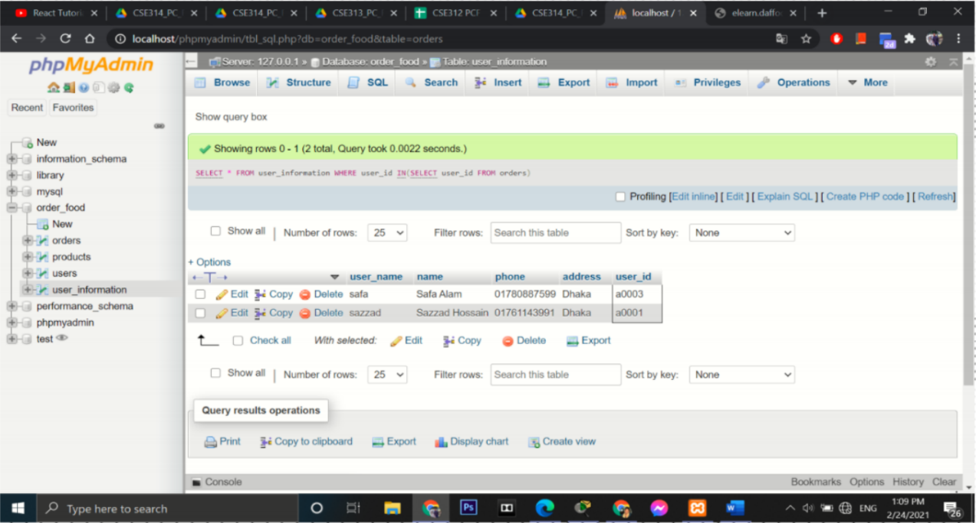

Fig 0.5

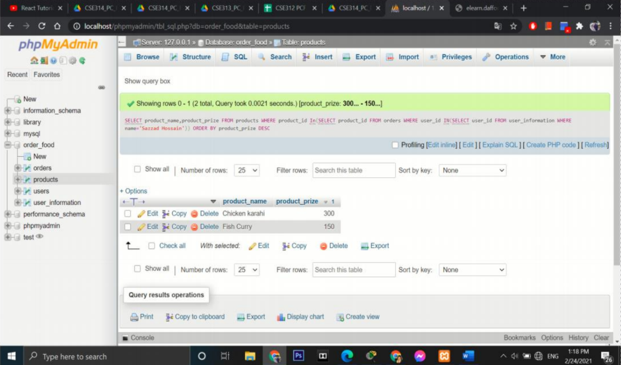

Fig 0.6

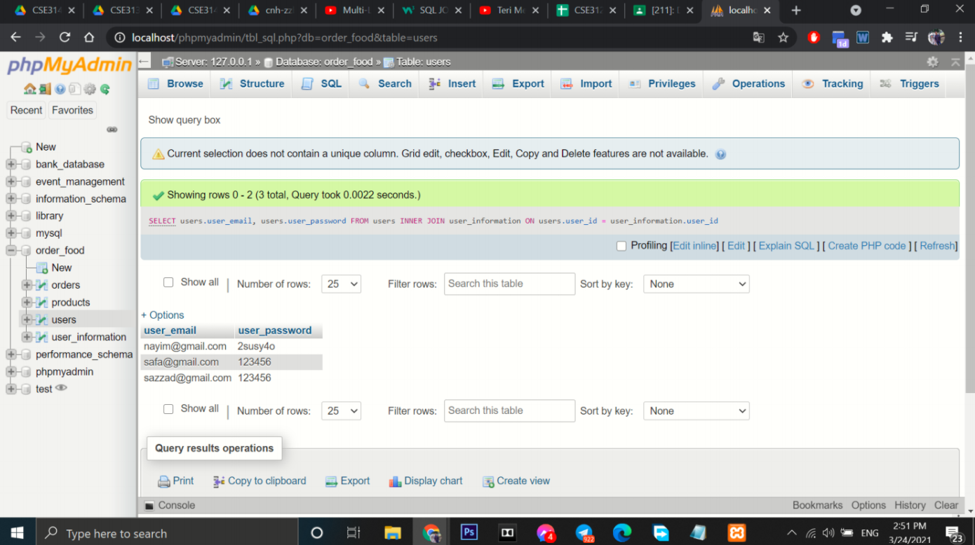

Fig 0.7

CHAPTER 5

SYSTEM TESTING

**5.1 UNIT TESTING**

**UNIT TESTING** is a type of software testing where individual units or components of a software are tested. The purpose is to validate that each unit of the software code performs as expected.

We run the system in XAMPP server and we find the result. We use my SQL Query for searching data, Delete data, Insert data, Update data, Nested query and we find the result is ok of our project. We test it 3 times when we run query in our XAMPP application.

**5.2 INTEGRATION TESTING**

The project was tested when we implementation the code and run it.

CHAPTER 6

CONCLUSION AND FUTURE SCOPE

The first autonomous database was announced in late 2017, and multiple independent industry analysts quickly recognized the technology and its potential impact on computing.

The February 2018 IDC Perspective praised autonomous database technology for making “enterprise software easier to deploy, use, and administer, using artificial intelligence and machine learning to provide capabilities requiring little or no human intervention to manage software.”

And KuppingerCole’s January 2018 report (PDF) said, “This approach has immense potential benefits, not just for reducing labor and costs for customers, but for dramatically improving databases’ resiliency against both human errors and malicious activities, internal or external. Each database is also designed to have security features enabled by default and relevant parameters automatically configured according to current security best practices.”

CHAPTER 7

REFERENCES

[YouTube](https://youtu.be/WmFHreVid-k)