Class Test 02
Part 01:
- Write a query that displays Hello ADBMS Section A using the concept of literal.
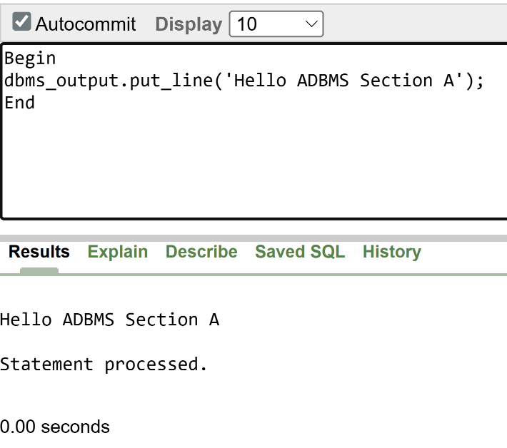
Answer:
Begin
dbms_output.put_line('Hello ADBMS Section A');
End;

- Write a query that can add two numbers using the concept of inner block and outer block.
Answer:
Declare
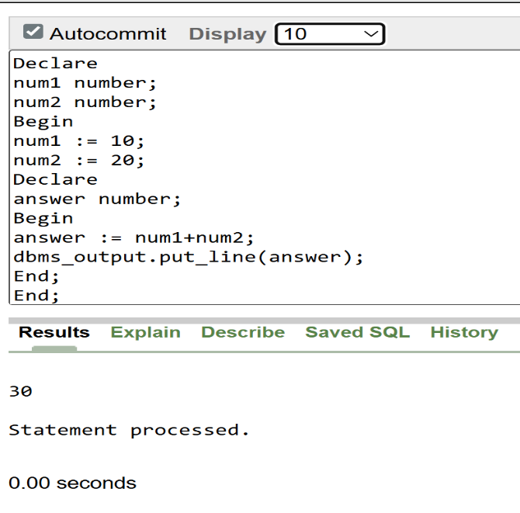
num1 number;
num2 number;
Begin
num1 := 10;
num2 := 20;
Declare
answer number;
Begin
answer := num1+num2;
dbms_output.put_line(answer);
End;
End;

- Write a query that can multiply three numbers using the concept of literal.
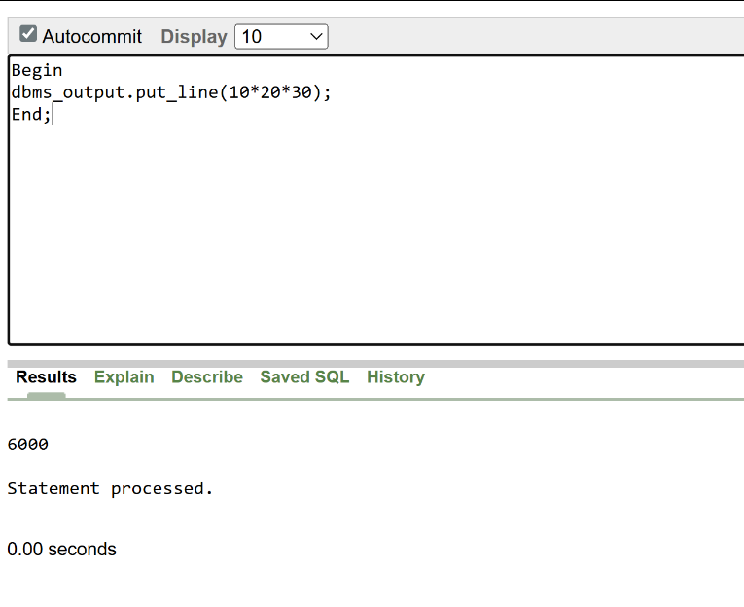
Answer:
Begin
dbms_output.put_line(10*20*30);
End;

- Write a query that stores Hello World in a variable and displays it in block letters.
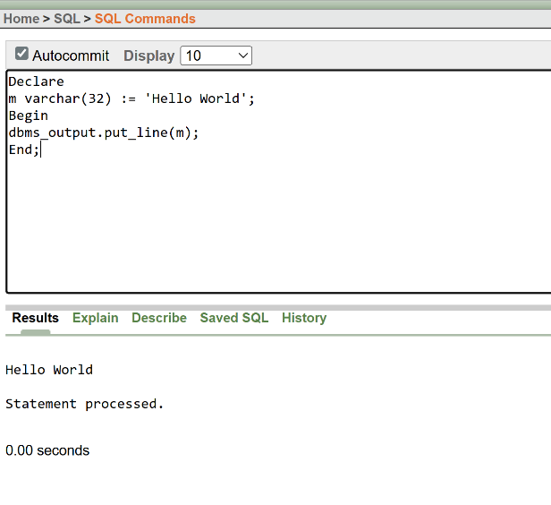
Answer:
Declare
m varchar(32) := 'Hello World';
Begin
dbms_output.put_line(m);
End;

- Write a query that can subtract a smaller number from a larger number and display the result using the concept of variable.
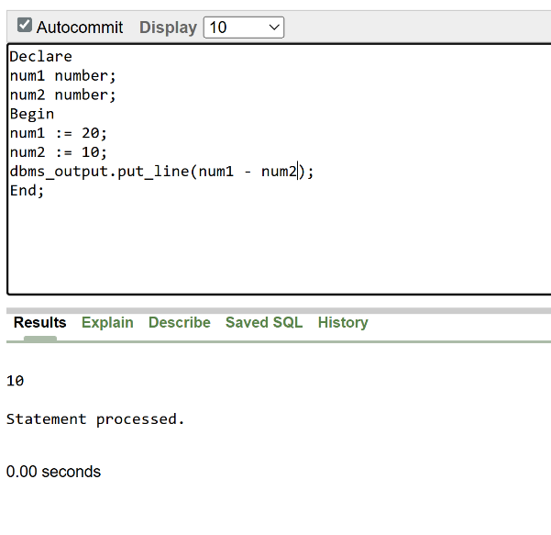
Answer:
Declare
num1 number;
num2 number;
Begin
num1 := 20;
num2 := 10;
dbms_output.put_line(num1 - num2);
End;

- There are four numbers given i.e. 12,14,16,18. Find out the average.
Answer:
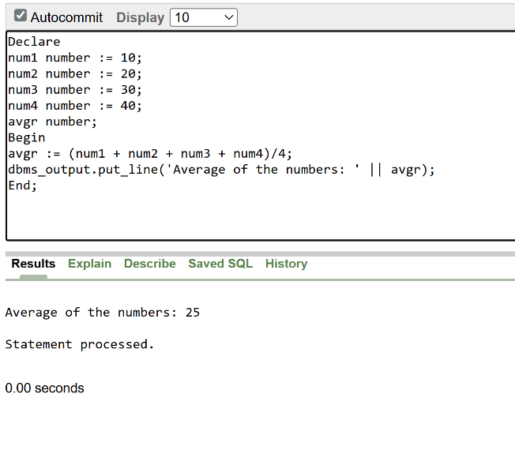
Declare
num1 number := 10;
num2 number := 20;
num3 number := 30;
num4 number := 40;
avgr number;
Begin
avgr := (num1 + num2 + num3 + num4)/4;
dbms_output.put_line('Average of the numbers: ' || avgr);
End;

- Write a query that displays the value of pi using the concept of constant.
Answer:
Declare
pi constant number := 3.1416;
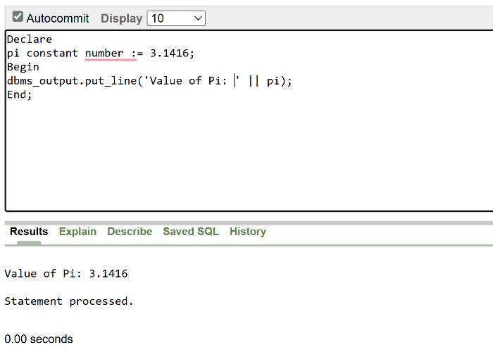
Begin
dbms_output.put_line('Value of Pi: ' || pi);
End;

Part 02:

- Write a query that can display the name of the department which has department number 10.
DECLARE  v_dname dept.dname%TYPE;  BEGIN  SELECT dname INTO v_dname  FROM dept  WHERE deptno = 10; DBMS_OUTPUT.PUT_LINE('Department Name: ' || v_dname);  END;  / | 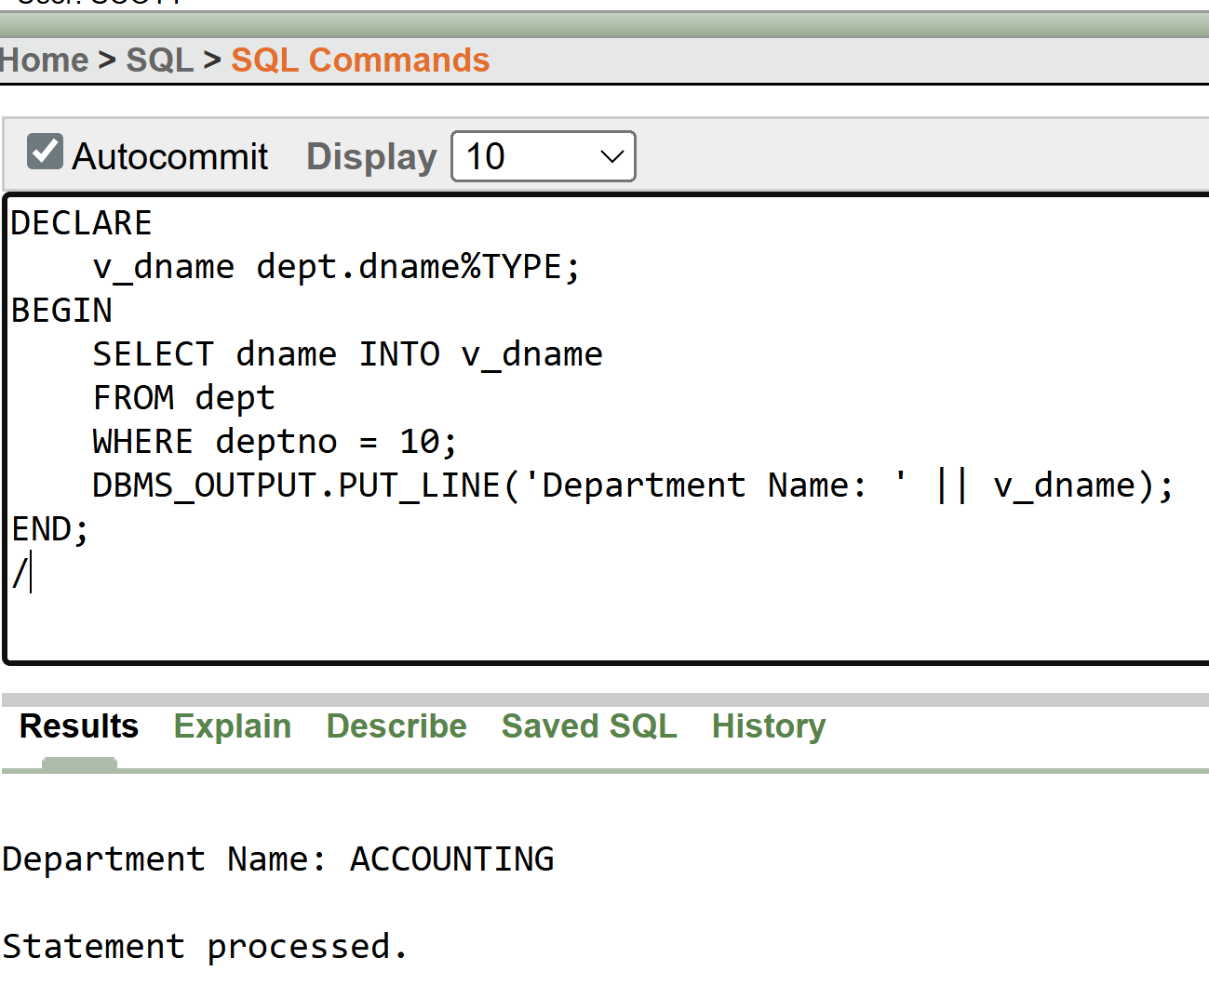

- Write a query that can display the name of the department in lower case which has department number 20.
DECLARE  v_dname dept.dname%TYPE;  BEGIN  SELECT LOWER(dname) INTO v_dname  FROM dept  WHERE deptno = 20;  DBMS_OUTPUT.PUT_LINE('Department Name (Lowercase): ' || v_dname);  END;  / | 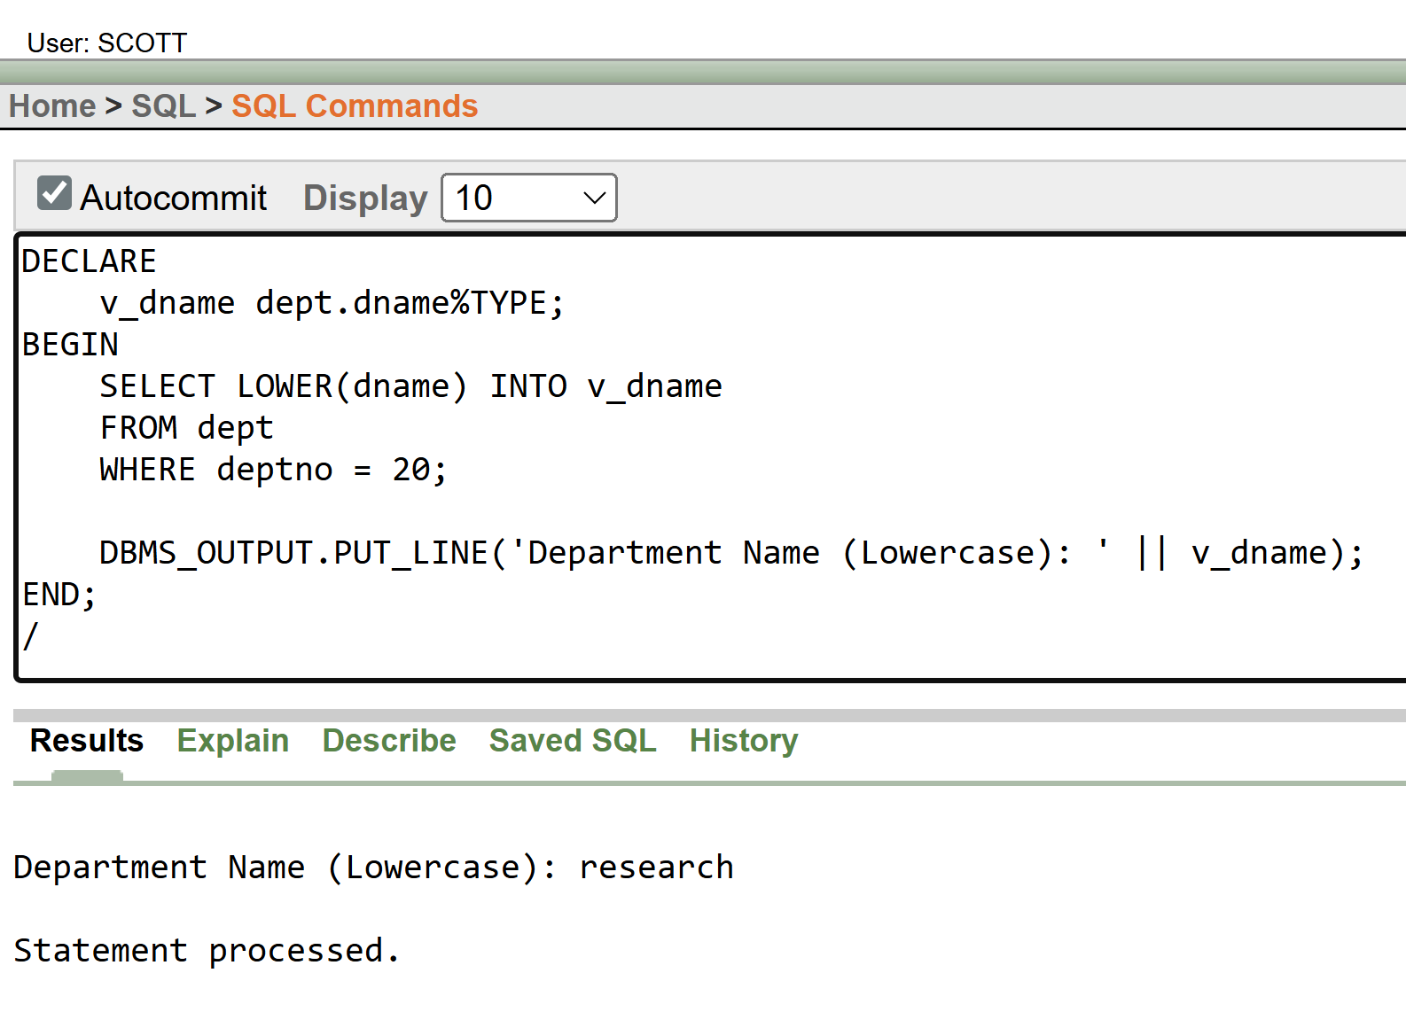

- Write a query that displays the incremented salary (sal+250) of employee Smith.
DECLARE  v_inc_salary emp.sal%TYPE;  BEGIN  SELECT sal + 250 INTO v_inc_salary  FROM emp  WHERE ename = 'SMITH';  DBMS_OUTPUT.PUT_LINE('Incremented Salary of SMITH: ' || v_inc_salary);  END;  / | 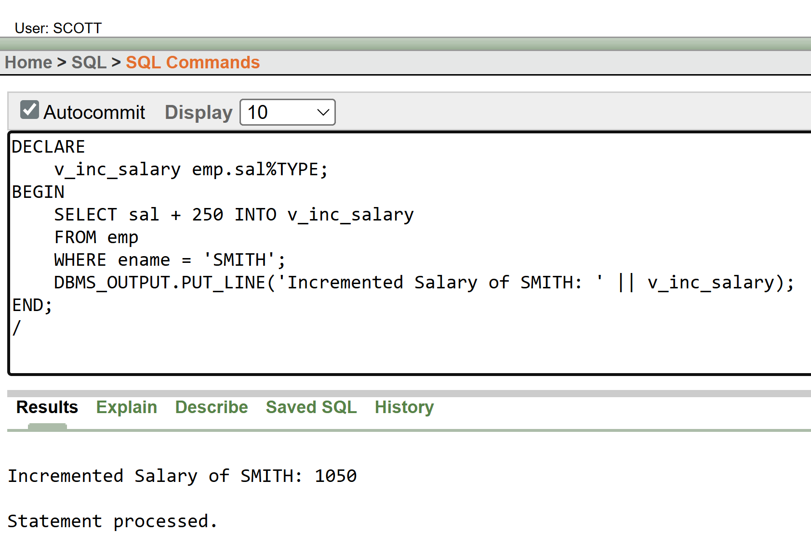

- Write a query that displays the hiredate of employee KING.
DECLARE  v_hiredate emp.hiredate%TYPE;  BEGIN  SELECT hiredate INTO v_hiredate  FROM emp  WHERE ename = 'KING'; DBMS_OUTPUT.PUT_LINE('Hiredate of KING: ' || TO_CHAR(v_hiredate, 'DD-MON-YYYY'));  END;  / | 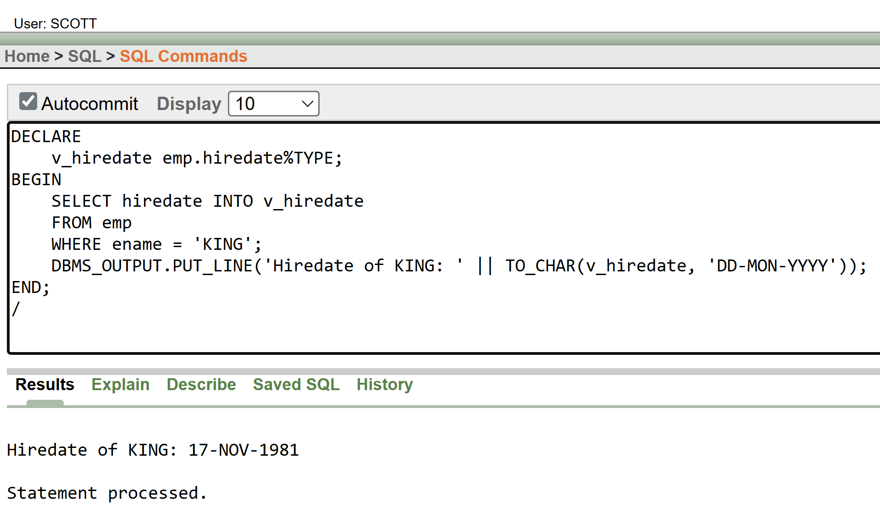
- Write a query that displays the sum of salary of all the employees.
DECLARE  v_total_salary NUMBER;  BEGIN  SELECT SUM(sal) INTO v_total_salary  FROM emp;  DBMS_OUTPUT.PUT_LINE('Total Salary of All Employees: ' || v_total_salary);  END;  / | 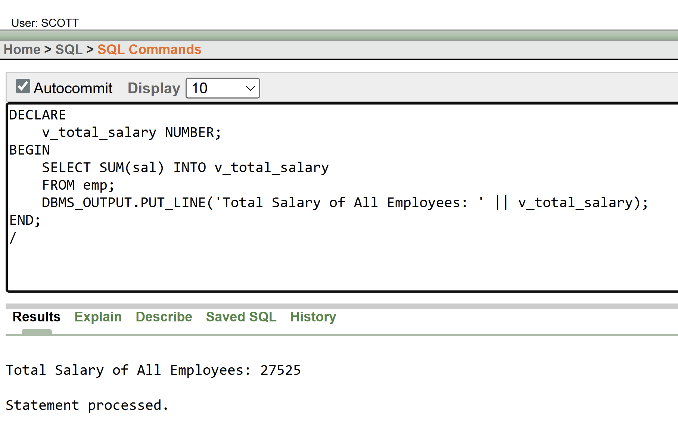
- Write a query that displays the salary and commission of employee Allen.
DECLARE  v_sal emp.sal%TYPE;  v_comm emp.comm%TYPE;  BEGIN  SELECT sal, comm INTO v_sal, v_comm  FROM emp  WHERE ename = 'ALLEN';  DBMS_OUTPUT.PUT_LINE('Salary of ALLEN: ' || v_sal);  DBMS_OUTPUT.PUT_LINE('Commission of ALLEN: ' || NVL(v_comm, 0));  END;  / | 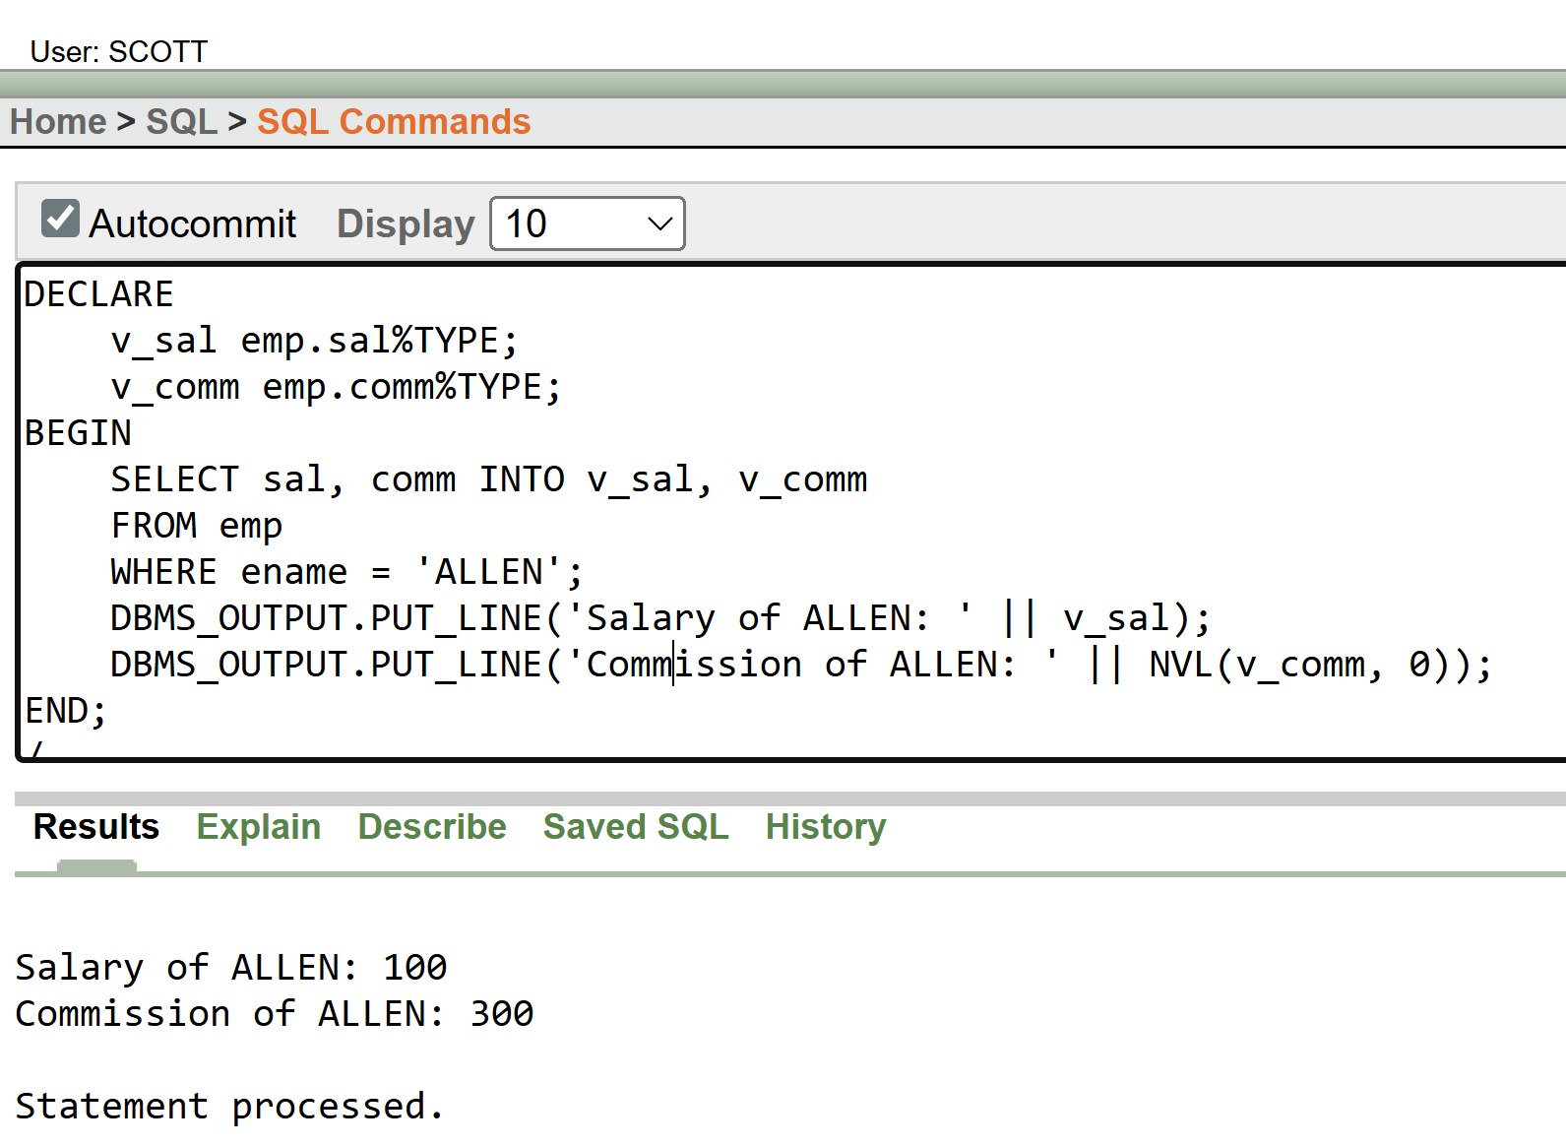

- Write a query that displays only those employees who have TT (double T) in their name.
BEGIN  DBMS_OUTPUT.PUT_LINE('Employees having "TT" in their name:');  FOR rec IN (SELECT ename  FROM emp  WHERE ename LIKE '%TT%')  LOOP DBMS_OUTPUT.PUT_LINE(rec.ename);  END LOOP;  END;  / | 