Class Test 03
PL/SQL
Part 01:
- Write a query that can multiply two numbers taking input from user.

Declare  a number(5):=:a;  b number(5):=:b;  Begin  dbms_output.put_line('Multiplication '|| a * b);  End  / | 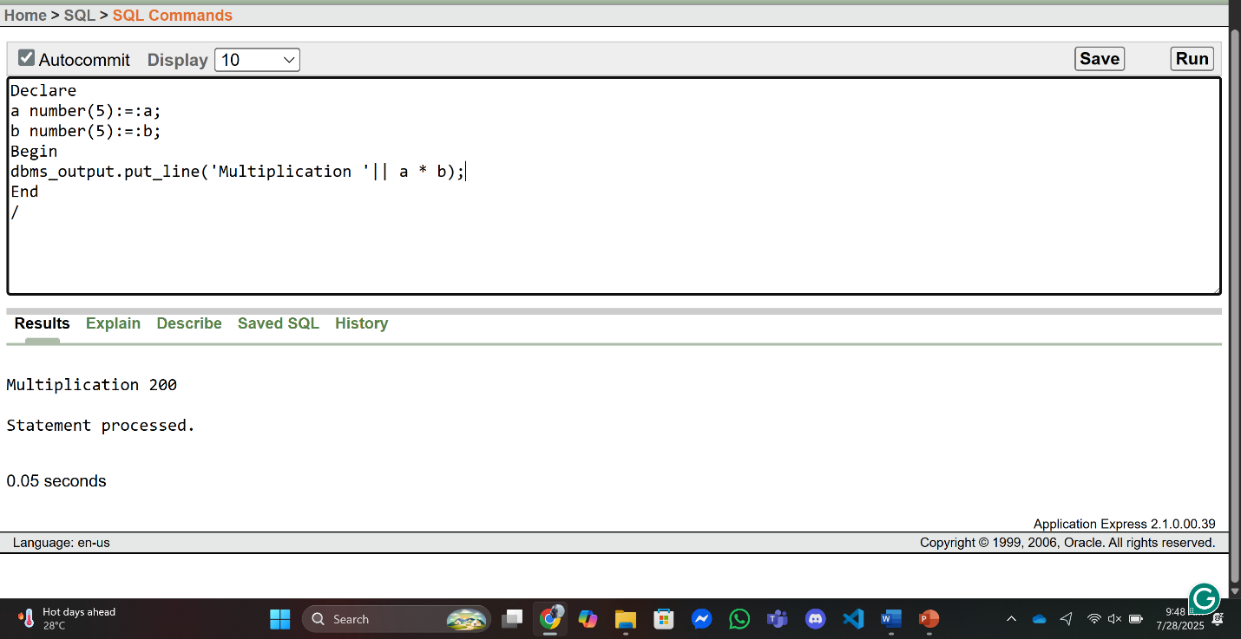

- Write a query that can add two numbers if the numbers are equal. Use CASE Statement.

DECLARE  num1 NUMBER(5) := 20;  num2 NUMBER(5) := 20;  BEGIN  CASE  When num1 = num2 Then  DBMS_OUTPUT.PUT_LINE('Sum of equal numbers: ' || (num1 + num2));  Else DBMS_OUTPUT.PUT_LINE('Numbers are not equal. No addition performed.');  end case;  END | 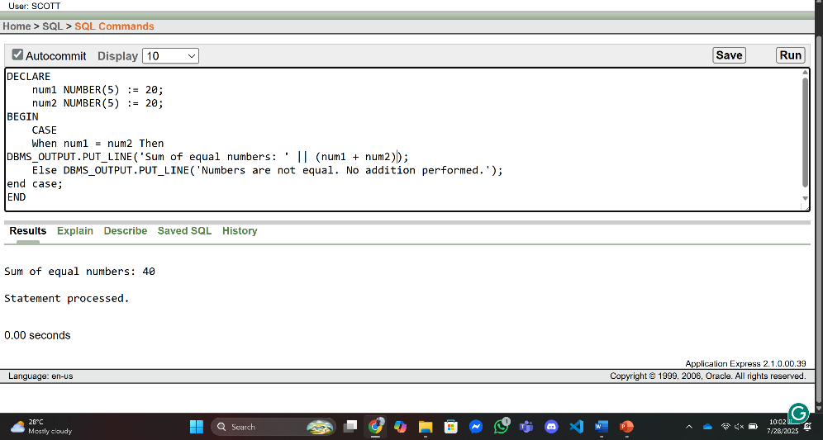
/
- Write a query that can check if two strings are equal or not. Use IF-THEN-ELSIF Statement.

DECLARE  str1 VARCHAR2(50) := 'Oracle';  str2 VARCHAR2(50) := 'oracle';  BEGIN  IF str1 = str2 THEN  DBMS_OUTPUT.PUT_LINE('Strings are equal.');  ELSIF str1 != str2 THEN  DBMS_OUTPUT.PUT_LINE('Strings are not equal.');  END IF;  END;  / | 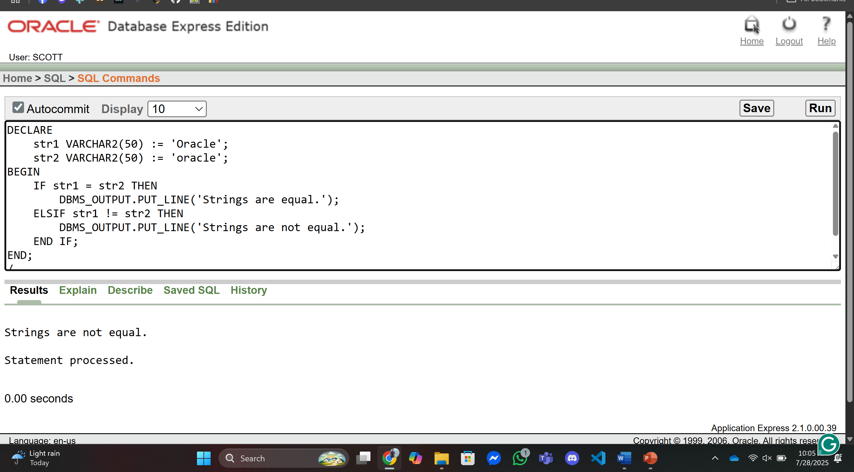

- Write a query that can multiply two numbers. If the result obtained is less than 100, Hi is displayed, if the result obtained is more than 100, Bye is displayed and if the result obtained is equal to 100, ADBMS is displayed. Use IF-THEN-ELSIF Statement

DECLARE  num1 NUMBER := 10;  num2 NUMBER := 10;  result NUMBER;  BEGIN  result := num1 * num2;  IF result < 100 THEN  DBMS_OUTPUT.PUT_LINE('Hi');  ELSIF result > 100 THEN  DBMS_OUTPUT.PUT_LINE('Bye');  ELSE -- result = 100  DBMS_OUTPUT.PUT_LINE('ADBMS');  END IF;  END;  / | 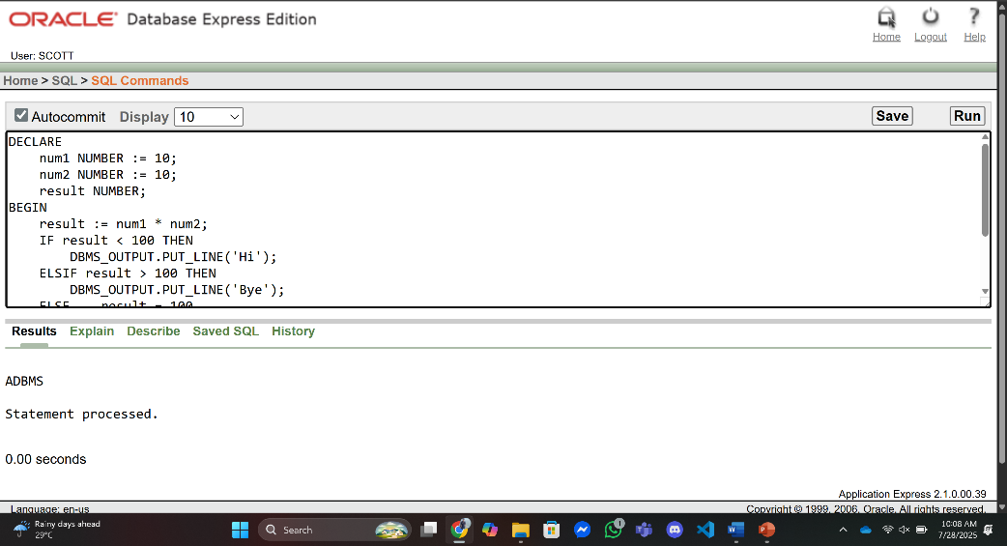

- Write a query that can check if two numbers are equal or not. Use CASE Statement.

DECLARE  num1 NUMBER := 25;  num2 NUMBER := 30;  BEGIN  CASE  WHEN num1 = num2 THEN  DBMS_OUTPUT.PUT_LINE('Numbers are equal.');  ELSE  DBMS_OUTPUT.PUT_LINE('Numbers are not equal.');  END CASE;  END;  / | 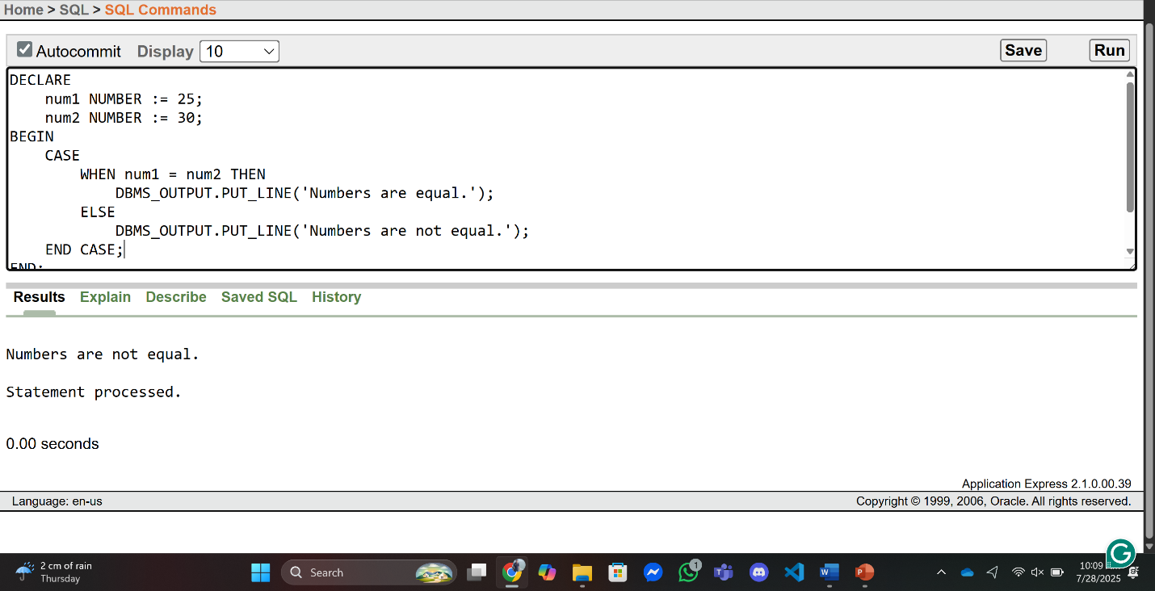

Part 02:
- Write a query that can display the salary of employee ALLEN. If ALLEN’s salary is greater than 2000 display ‘SALARY GREATER THAN 2000’ and If not then display ‘SALARY LESS THAN 2000’.

DECLARE  sal number;  BEGIN  select sal into sal  from emp  where ename = 'ALLEN';  if sal > 2000 then  DBMS_OUTPUT.PUT_LINE('SALARY GREATER THAN 2000');  else  DBMS_OUTPUT.PUT_LINE('SALARY LESS THAN 2000');  End IF;  END;  / | 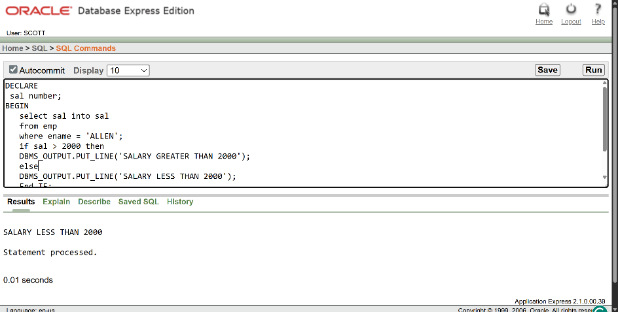

- Write a query that can ask user to input the EMPNO of employee WARD and display his salary.

DECLARE  emno number:=:EmployeNo;  sal number;  BEGIN  select sal into sal  from emp  where empno= emno;  DBMS_OUTPUT.PUT_LINE('SALARY IS : '|| sal);  END;  / | 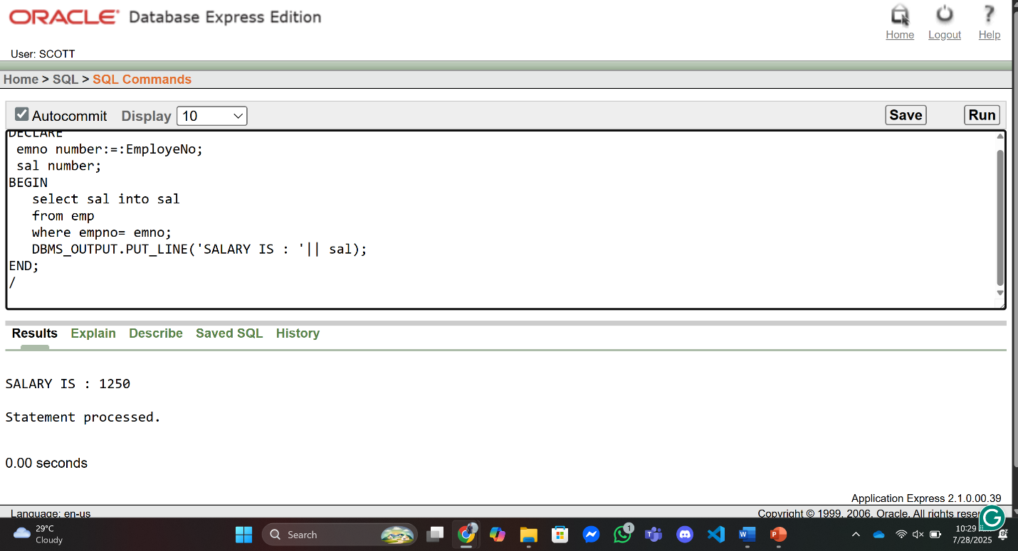

- Write a query that can ask user to input the EMPNO of employee BLAKE,CLARK and TURNER and display their respective salary.

DECLARE  emno1 number:=:EmployeBlake;  emno2 number:=:EmployeClark;  emno3 number:=:EmployeTurner;  sal number;  BEGIN  select sal into sal  from emp  where empno= emno1;  DBMS_OUTPUT.PUT_LINE('CLARK SALARY IS : '|| sal);  select sal into sal  from emp  where empno= emno2;  DBMS_OUTPUT.PUT_LINE('BLAKE SALARY IS : '|| sal);  select sal into sal  from emp  where empno= emno3;  DBMS_OUTPUT.PUT_LINE('TURNER SALARY IS : '|| sal);  END;  / | 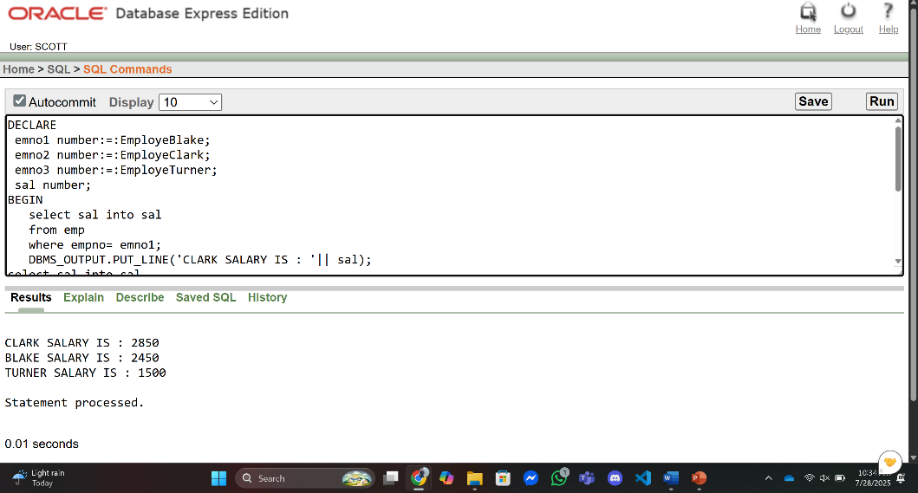

- Write a query that can ask user to input the EMPNO of employee BLAKE,CLARK and TURNER and display their respective salary, add the salaries and display the total.

DECLARE  emno1 number:=:EmployeBlake;  emno2 number:=:EmployeClark;  emno3 number:=:EmployeTurner;  result number:= 0;  sal number;  BEGIN  select sal into sal  from emp  where empno = emno1;  result := result+ sal;  DBMS_OUTPUT.PUT_LINE('CLARK SALARY IS : '|| sal);  select sal into sal  from emp  where empno= emno2;  result := result+ sal;  DBMS_OUTPUT.PUT_LINE('BLAKE SALARY IS : '|| sal);  select sal into sal  from emp  where empno= emno3;  result := result+ sal;  DBMS_OUTPUT.PUT_LINE('TURNER SALARY IS : '|| sal);  DBMS_OUTPUT.PUT_LINE('TOTAL SALARY IS : '|| result);  END;  / | 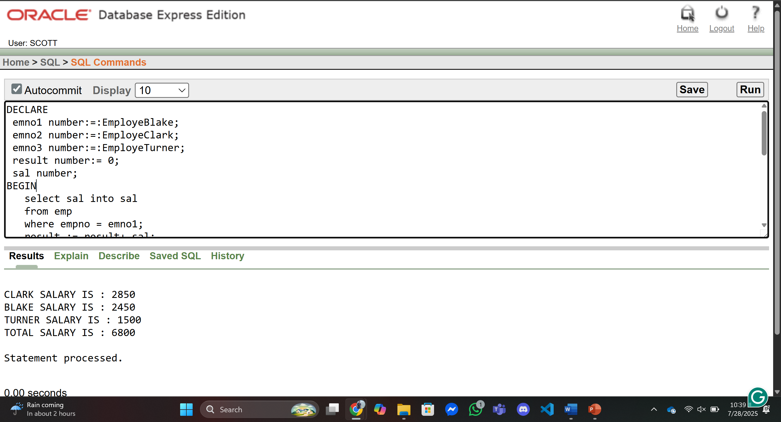

- Write a query that displays the commission of employee SMITH. If SMITH’s commission is NULL. Display ‘NOT APPLICABLE FOR COMMISSION’

DECLARE  commission number;  BEGIN  select comm into commission  from emp  where ename= 'SMITH';  if commission is NULL then  DBMS_OUTPUT.PUT_LINE('NOT APPLICABLE FOR COMMISSION');  else  DBMS_OUTPUT.PUT_LINE('Commission of Smith is '|| commission);  End If;  END;  / | 