Class Test 04
Name: Md. Sazzad Khan
ID: 22-49172-3
Section: A
PL/SQL
Part 01:
To solve the following use the scott schema
- Write a query that can display the salary of employee JONES three times using basic loop.

DECLARE  x number := 1;  sal varchar2(10);  BEGIN  select sal into sal  from emp  where ename = 'JONES';  LOOP  dbms_output.put_line(sal);  x := x + 1;  IF x > 3 THEN  exit;  END IF;  END LOOP;  END;  / | 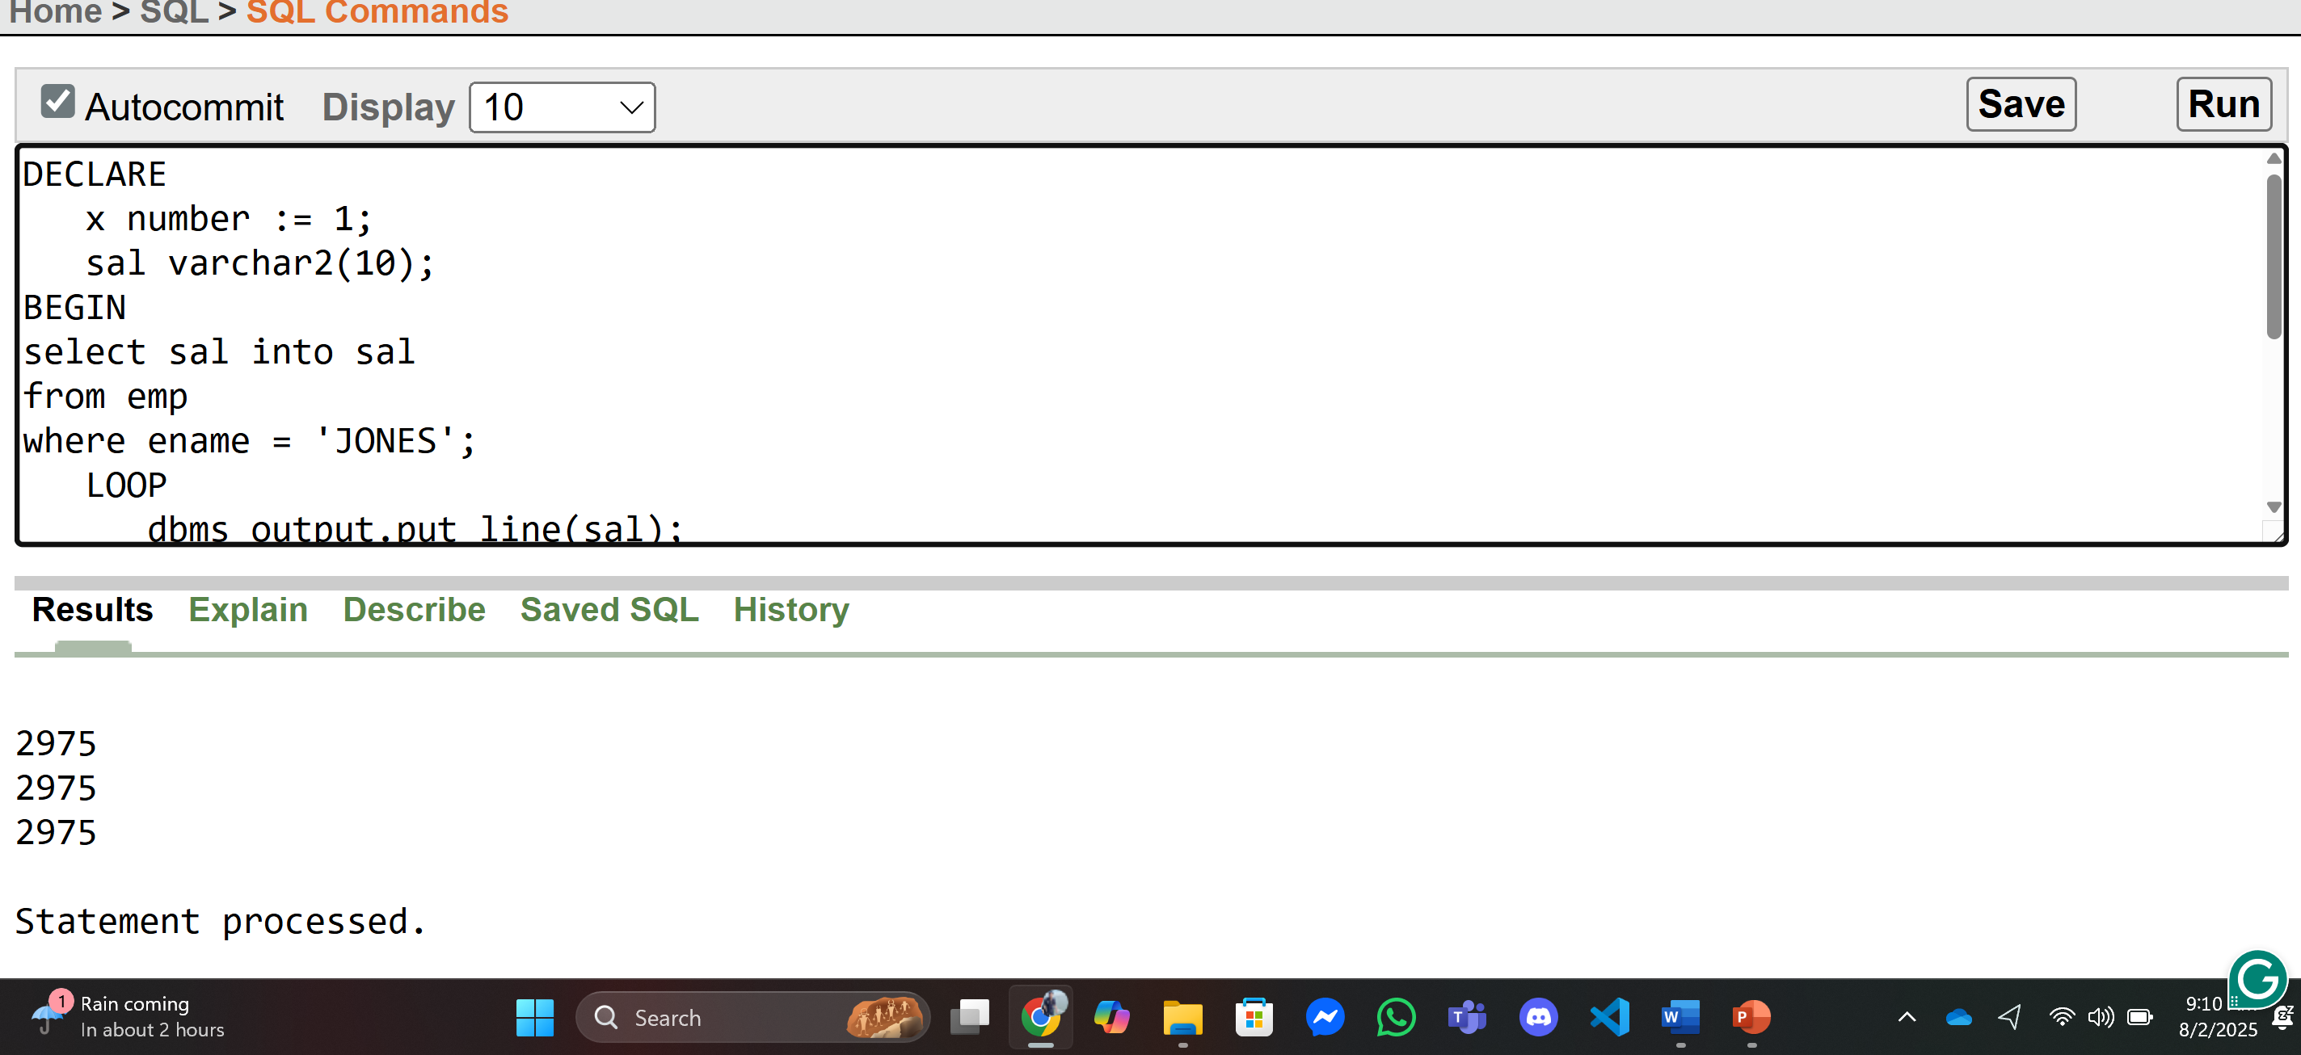

- Write a query that can display the salary of employee JONES three times using while loop.

DECLARE  x number := 1;  sal varchar2(10);  BEGIN  select sal into sal  from emp  where ename = 'JONES';  WHILE x < 4 LOOP  dbms_output.put_line(sal);  x := x + 1;  END LOOP;  END;  / | 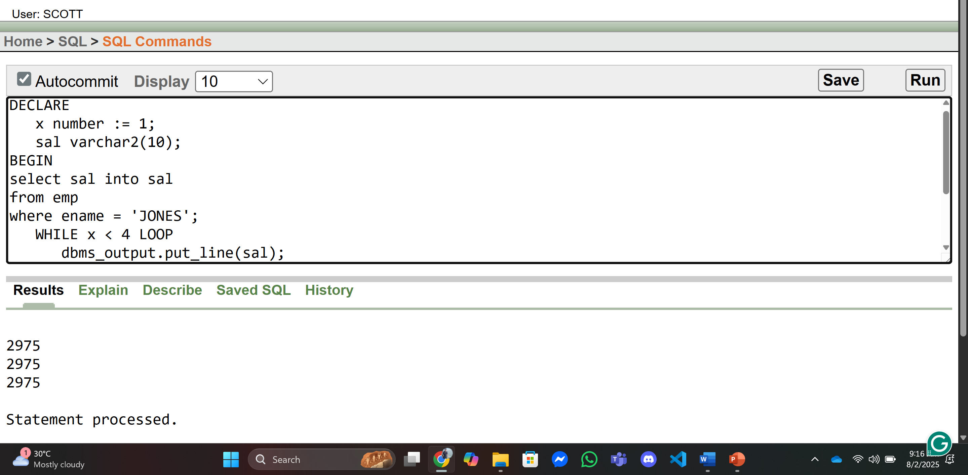

- Write a query that can display the salary of employee JONES three times using for loop.

DECLARE  x number(2);  sal varchar2(10);  BEGIN  select sal into sal  from emp  where ename = 'JONES';  FOR x in 1 .. 3 LOOP  dbms_output.put_line(sal);  END LOOP;  END;  / | 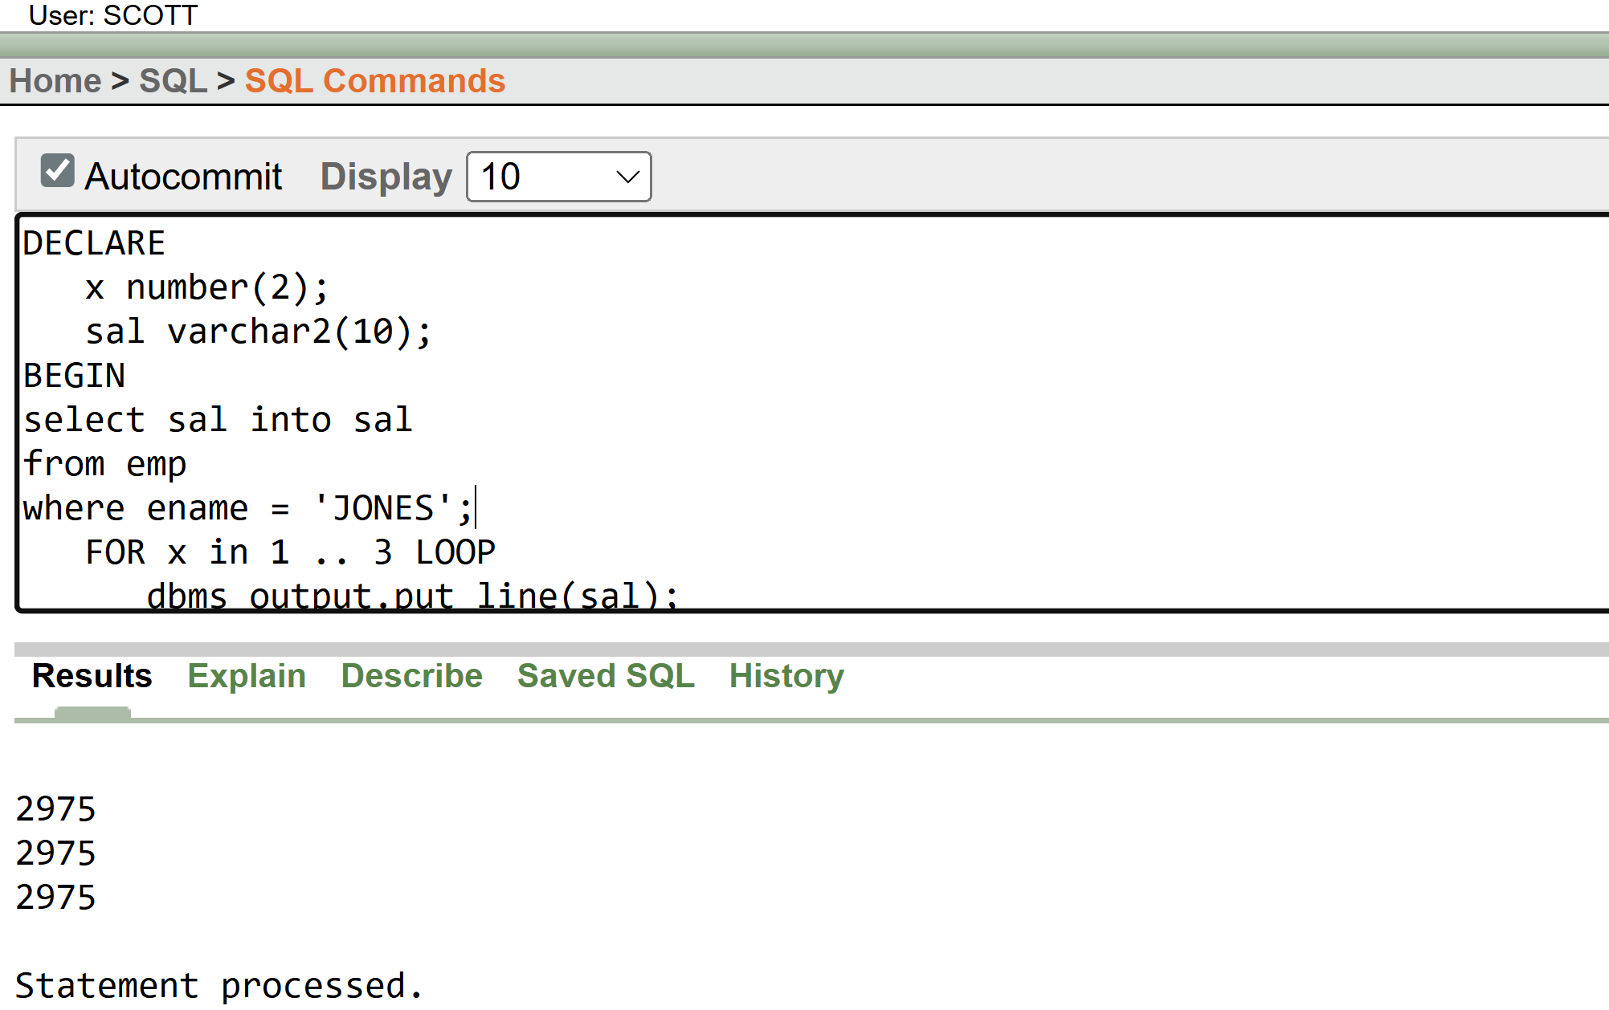

Part 02:
To solve the following use the scott schema
- Create a procedure to display the salary of employee Allen to 100.

Declare  salary number;  procedure update_salary AS  Begin  update emp  set sal = 100  where ename = 'ALLEN';  Commit;  End update_salary;  BEGIN  update_salary();  select sal into salary  from emp  where ename = 'ALLEN';  dbms_output.put_line('ALLEN New Salary '|| salary);  END;  / | 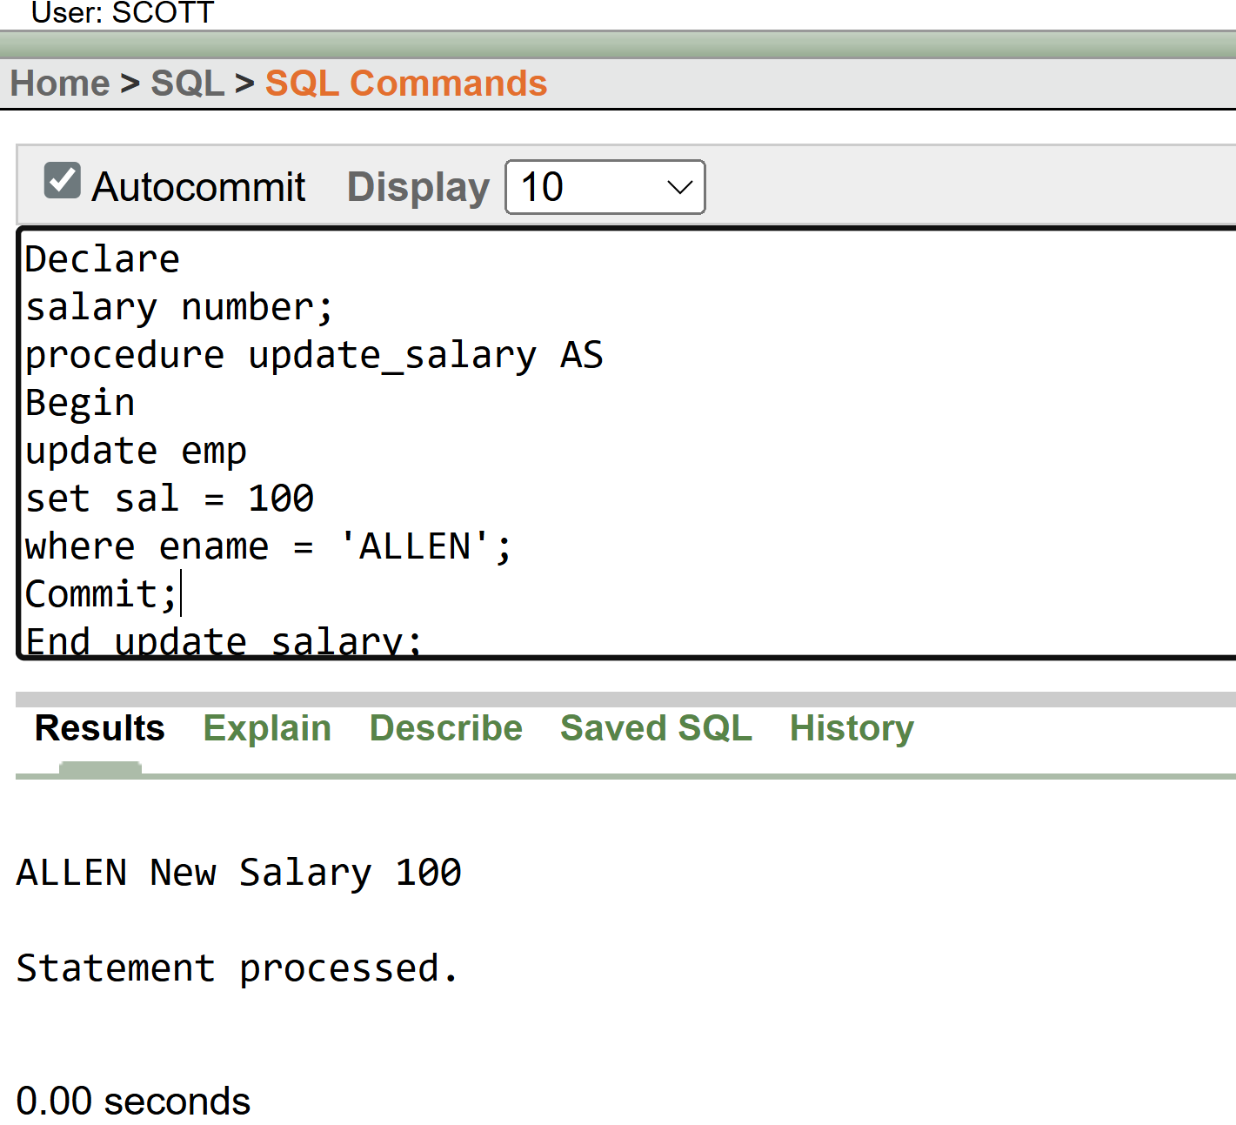

- Create a function that returns the total number of departments.

DECLARE  deptnum number;  Function total_department  Return NUMBER  AS  total number;  Begin  select count(*) into total  from dept;  return total;  End total_department;  BEGIN  deptnum := total_department();  dbms_output.put_line('All Departments '|| deptnum);  END;  / | 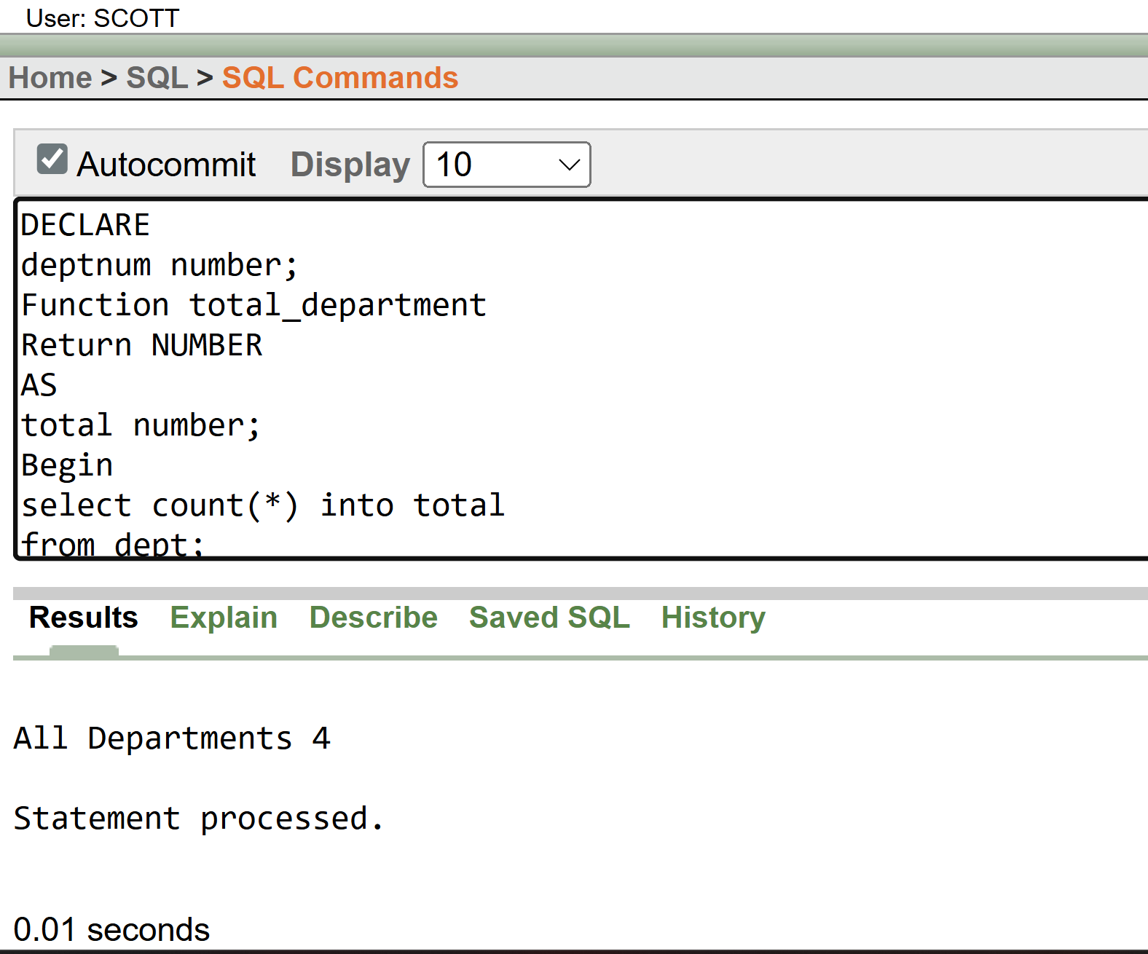

- Create a package that contains a procedure which can display the grade whose losal and hisal is passed as its parameter.
Package display_grade_pack As  Procedure display_grade(lowSal salgrade.losal%type,highSal salgrade.hisal%type);  End Salary_Grade;  Package Body display_grade_pack As  Procedure display_grade(lowSal salgrade.losal%type,highSal salgrade.hisal%type) Is  grade salgrade.grade%type;  Begin  Select grade into grade  from salgrade  where losal = lowSal and hisal = highSal;  dbms_output.put_line('Grade of Low Salary '|| lowSal || ' and '|| 'High Salary ' || highSal || ' is '|| grade);  End display_grade;  End display_grade_pack;  Declare  lowSal number:=:lowSal;  highSal number:=:highSal;  Begin  display_grade_pack.display_grade(lowSal,highSal);  End;  / | 