Class Test 05
Name: Md. Sazzad Khan
ID: 22-49172-3
Section: A
PL/SQL
- Create a cursor that can output all the data from salgrade table.
Answer:

Declare
grade salgrade.grade%type;
lowsal salgrade.losal%type;
highsal salgrade.hisal %type;
cursor c_salgrade is
select * from salgrade;
Begin
Open c_salgrade;
Loop
Fetch c_salgrade into grade,lowsal,highsal;
Exit When c_salgrade%NotFound;
dbms_output.put_line('Grade is: '|| grade||' and Low Salary is - '|| lowsal||' and High Salary is - '||highsal);
End Loop;
Close c_salgrade;
End
/
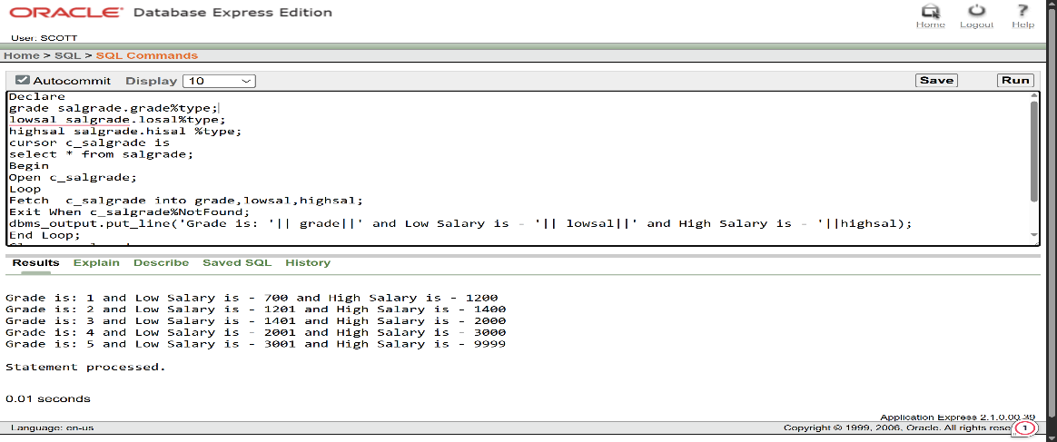

- Create a record that can output the id, name, job, and hiredate of the employee whose Id is 7654.
Answer:

Declare
type UserInfo is Record
(empno emp.empno%type,
ename emp.ename%type,
job emp.job%type,
hiredate emp.hiredate%type);
uinfo UserInfo;
Begin
Select empno, ename, job, hiredate into uinfo.empno,uinfo.ename,uinfo.job,uinfo.hiredate
from emp
where empno = 7654;
dbms_output.put_line(uinfo.empno||' '||uinfo.ename||' '||uinfo.job||' '||uinfo.hiredate);
End;
/

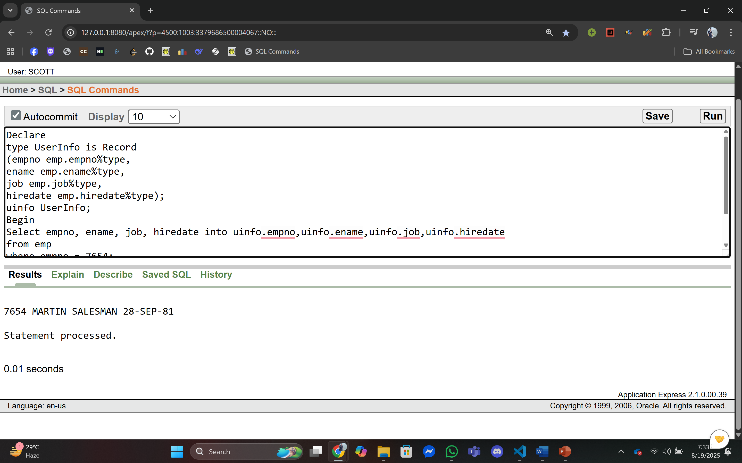

- Create a trigger in such a way that whenever a new row is inserted into the salgrade table an output ‘New Row Added’ is generated.
Answer:

Trigger Creation:
Create OR Replace Trigger Salary_grade_update
after Insert ON salgrade
Begin
dbms_output.put_line('New Row Added');
End;
/
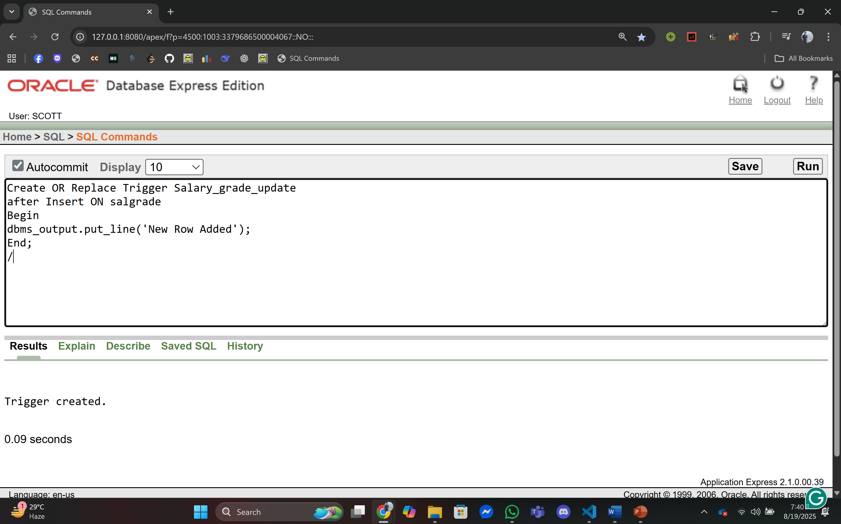

Output(New Row Added into Salgrade Table):

Insert into salgrade values(6,1500,2500);

