**

**UNIVERSITY-BANGLADESH**

**Assignment Cover Sheet**

|  |  |  |  |  |
| --- | --- | --- | --- | --- |
| Assignment Title: | SRE Project ( Donate Money For Needy People) | | | |
| Assignment No: | 01 | | Date of Submission: | 10/28/2022 |
| Course Title: | SOFTWARE REQUIREMENT ENGINEERING | | | |
| Course Code: | 01417 | | Section:D |  |
| Semester: | Fall | 2021-22 | Course Teacher: | DR. S. M. HASAN MAHMUD |

**Declaration and Statement of Authorship:**

1. I/we hold a copy of this Assignment/Case-Study, which can be produced if the original is lost/damaged.
2. This Assignment/Case-Study is my/our original work and no part of it has been copied from any other student’s work or from any other source except where due acknowledgement is made.
3. No part of this Assignment/Case-Study has been written for me/us by any other person except where such collaboration has been authorized by the concerned teacher and is clearly acknowledged in the assignment.
4. I/we have not previously submitted or currently submitting this work for any other course/unit.
5. This work may be reproduced, communicated, compared and archived for the purpose of detecting plagiarism.
6. I/we give permission for a copy of my/our marked work to be retained by the Faculty for review and comparison, including review by external examiners.
7. I/we understand that plagiarism is the presentation of the work, idea or creation of another person as though it is your own. It is a formofcheatingandisaveryseriousacademicoffencethatmayleadtoexpulsionfromtheUniversity. Plagiarized material can be drawn from, and presented in, written, graphic and visual form, including electronic data, and oral presentations. Plagiarism occurs when the origin of the arterial used is not appropriately cited.
8. I/we also understand that enabling plagiarism is the act of assisting or allowing another person to plagiarize or to copy my/our work.

*\* Student(s) must complete all details except the faculty use part.*

** Please submit all assignments to your course teacher or the office of the concerned teacher.

|  |  |
| --- | --- |
| Group Name/No.: | 07 |

|  |  |  |  |  |
| --- | --- | --- | --- | --- |
| **No** | **Name** | **ID** | **Program** | **Signature** |
| 1 | Shawon, Sazzadul Alam | 19-39385-1 | **BSc CSE** |  |
| 2 | Fredus, Jannatul | 19-39371-1 | **BSc CSE** |  |
| 3 | Dola, Nabanita Saha | 19-39364-1 | **BSc CSE** |  |

|  |  |  |
| --- | --- | --- |
| ***Faculty use only*** | | |
| FACULTYCOMMENTS | **Marks Obtained** |  |
|  |
|  |
|  | **Total Marks** |  |
|  |
|  |

INDEX

1. Problem Statement 2

2. Background 2

3. Requirements 2

3.1. Business Requirement 2

3.2. User Requirement 2

3.3. Functional Requirement 3

3.4. System Requirement 4

4. Requirement Development 4

4.1. Effort Estimation 4

4.2. Constructive Cost Model (COCOMO) 5

4.3. Timeline Charts 5

4.4. Earned Value Analysis (EVA) 6

4.5. Process Model 6

5. Product Vision and Project Scope 8

6. Diagram 8

6.1. Use-Case 8

6.2. Class Diagram 8

6.3. Sequence Diagram 9

6.4. Activity Diagram 9

7. Validation and verification 10

7.1. UI 10

7.2. Risk Estimation 12

7.3. Testing 12

1. **Problem Statement**

This system is all about donation distribution from a renowned person to a needy person(receiver). There are many kinds of needy people in our country. Donating to the world’s poorest families can help them eventually leave behind hunger, fear, and isolation. Our long-term goal is for them to put food on the table, pay for education, and follow a path out of a generational cycle of poverty. Renowned people can directly give their contribution to a needy person through this system. donating money is the easiest way in which the needy can be helped. They can be donated money or things to improve their lives. With this money, they can buy food for themselves. Many people donate money, food, clothes, toys and various other things. Even small donations can make the life of the needy much better and brighter. For donations, we create this system. In this particular system, people will have the ability to verify before doing any charity. There will be properly verified information of actual needy people where no third party is concerned as far as the donor and receiver. There will be security measures for correct validation.

1. **Background**

This project is regarding a verifiable medium of donation or charity works among donors and receivers. When people want to donate money to any cause, they usually tend to depend on various NGOs and communities. But nowadays this is a big issue for every donor there isn’t really any great way to track donations in most places. The money could go anywhere because it’s not convenient for everyone to find needy people by themselves and donate. In this particular system, people will have the ability to verify before doing any charity. There will be properly verified information of actual needy people where no third party is concerned as far as the donor and receiver. People who need help can ask for it here providing the context and monetary amount. Donors can donate to people who they see fit, they can give a specific amount of money and later on track their progress for further donation. There will be security measures for correct validation. For instance, if someone wants to find financial help regarding a medical issue, they will have to submit proper documents along. There are various features like this in the system that will help solve the problem of charity work.

1. **Requirements** 
   1. **Business Requirement**

The Doner donates money to needy people. Because our country has so many needy people, actually they need money to live well. This is a big issue in our county. The doner can solve the problem very quickly with their contribution. The business requirement is to lead to a positive change and decrease needy people.

* 1. **User Requirement**

The user interfaces use four types of users. They can easily use their requirement interface and they can understand.

**RECEIVER**

1. Need to register/log in.
2. Add/delete/update problem.
3. Add/delete/update problem’s photos.
4. Add/delete/update problem solution’s cost.
5. Add/delete/update problem’s details information.
6. View your own problems.
7. View the amount & update (cancel/received).

**DONER**

1. Need to register/log in.
2. View Needy people’s problems.
3. Can search needy person’s phone number, address, and present situation.
4. Add/delete/update donation.
5. Can send payment.
6. View the problem’s history (cancel/received)

**VIEWER**

1. View Needy people’s problems.
2. Can search needy person’s phone number, address, and present situation.
3. View the problem’s history (cancel/received)

**ADMIN**

1. Need to register/log in.
2. Do administration.
3. Change in the software.
   1. **Functional Requirement**

Function requirements define the fundamental actions that the system must perform. The functional requirements for the system are divided into three main categories as Receiver, Donor, and Viewer.

**RECEIVER:**

1. The system shall record the registration/login.
2. The system shall record the Receiver’s first name.
3. The system shall record the Receiver’s last name.
4. The system shall record add/delete/ problem.
5. The system shall record add/delete/problem photos.
6. The system shall record add/delete/ problem solution’s cost.
7. The system shall record add/delete/problem details information.
8. The system shall display its own problems
9. The system shall display the amount & update(cancel/received)

**DONOR:**

1. The system shall record the registration/login
2. The system display receiver’s problems
3. The system shall record the receiver’s phone number, address, or present situation.
4. The system shall record add/delete/update donations
5. The system shall record the sent donation
6. The system shall display the receiver's history(cancel/received).

**VIEWER:**

1. The system shall display the receiver’s problems
2. The system shall record the receiver’s phone number, address, and present situation.
3. The system shall record the problem’s history(cancel/received)

**ADMIN:**

1. Admin will accept/decline the request from the receiver.
2. Update the system configuration.
   1. **System Requirement**

The Project provides a platform where peoples receive donations. As a result, needy people can lead their life well.

1. When needy people can get donations, they can buy the things they need.
2. Many needy people can small businesses with donation money.
3. Many needy people can afford their medical expenses through donations.
4. There are many needy people who cannot eat for lack of money. But through donation money, they can eat. By doing this they will get rid of the problem of malnutrition.
5. **Requirement Development**

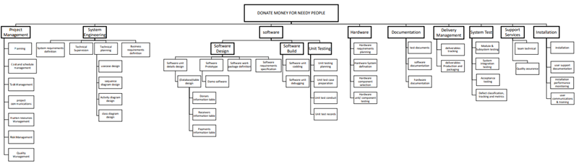

* 1. **Effort Estimation**

|  |  |  |  |  |
| --- | --- | --- | --- | --- |
| PM: Person months needed for a project in hours.  SLOC: Source line of code.  P: Project complexity (1.04-1.24)  Effort = PM = Coefficient <Effort Fector> *(SLOC/1000)^P  PM=2.4 x (7000/1000)1.05 =18.51 | Software Project type | Coefficient <Effort Fector> | P | T |
| Organic | 2.4 | 1.05 | 0.38 |
| Semi-detached | 3.0 | 1.12 | 0.35 |
| Embedded | 3.6 | 1.20 | 0.32 |

* 1. **Constructive Cost Model (COCOMO)**

DM: Duration time in months for the project (weekdays).

T: SLOC-dependent coefficient(0.32-0.38).

ST: Average staffing necessary.

Development time = DM = 2.5*(PM)^T

DM=2.5 x (18.51)0.38 = 7.57 [8 Month]

Required number of people = ST = PM/DM

ST = 18.51/7.57 = 2.44 [3 Person]

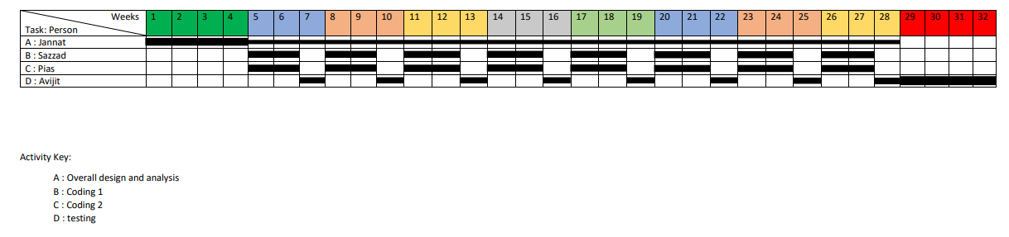

* 1. **Timeline Charts**

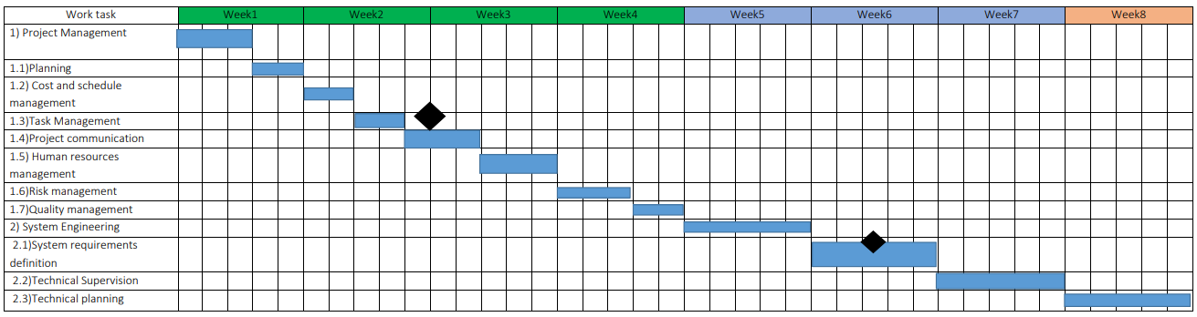  
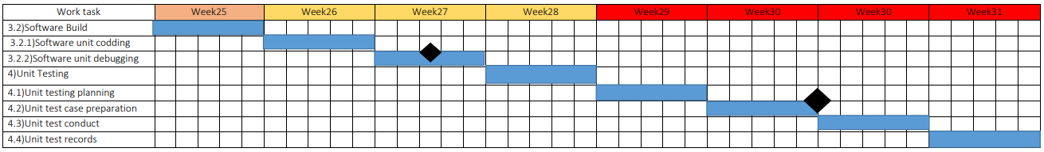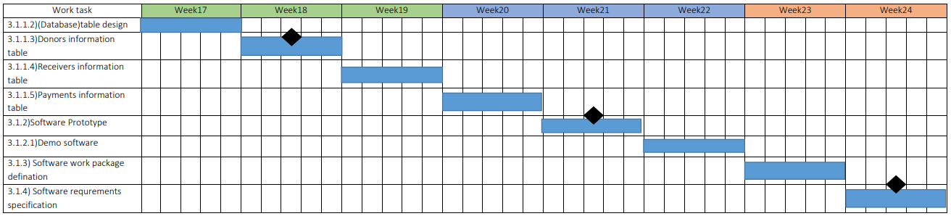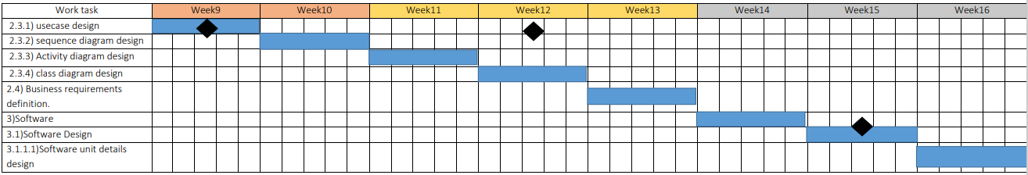

* 1. **Earned Value Analysis (EVA)**

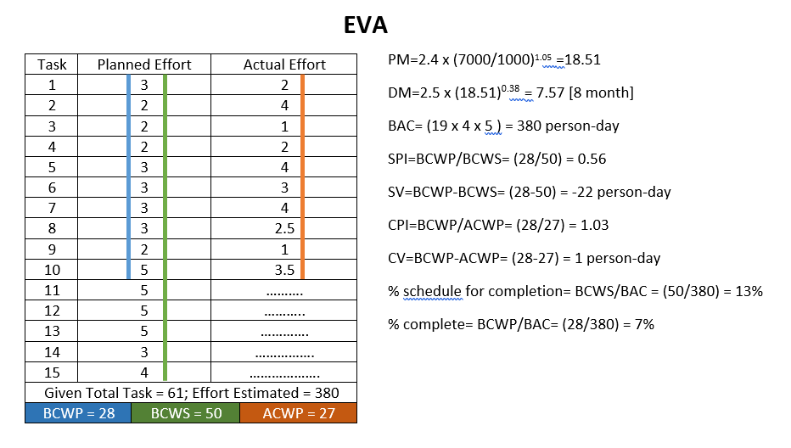

* 1. **Process Model**

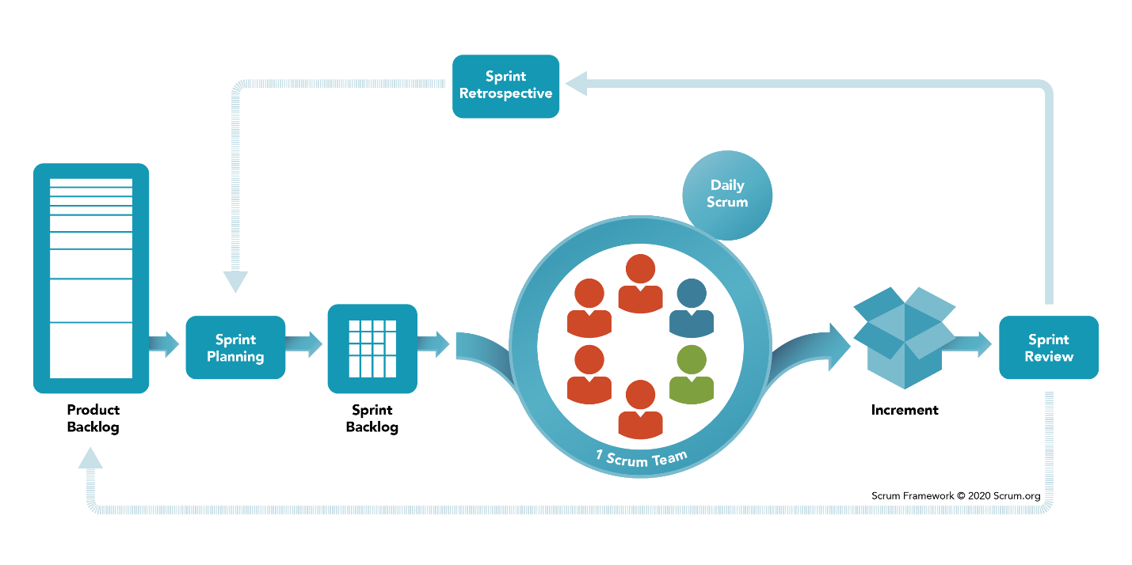In my analysis SCRUM is the best choice among all other methods to develop your proposed software. Because SCRUM is an Agile methodology consisting of lightweight management practices that have relatively little overhead. Its practices are simple to understand but very difficult to master in their entirety.

In the SCRUM time is the main priority. For that reason, SCRUM uses sprint. product owners give their requirements, that’s called the Product Pack log. Then developers make planning to divide their work into small parts, this planning is called Sprint planning. And every small part is called Sprint Backlog. Then developer teams start SCRUM. A SCRUM has a daily SCRUM. Every day they implemented something and show their team. After implementing a sprint backlog it’s gone for Sprint Review. If everything ok then goes ahead. Or any Review goes for Sprint retrospective. After doing every sprint backlog product is ready for publishing.

**Scrum Master**

1. Scrum Master is responsible for ensuring that the project is carried through according to the practices, values, and rules of Scrum and that it progresses as planned. They do this by helping everyone understand Scrum theory and practice, both within the Scrum Team and the organization.
2. Scrum Master interacts with the project team as well as with the customer and the management during the project. The Scrum Master is accountable for the Scrum Team’s effectiveness. They do this by enabling the Scrum Team to improve its practices, within the Scrum framework.

**Product Owner**

1. The Product Owner is officially responsible for the project, managing, controlling, and making visible the Product Backlog list.
2. He is selected by the Scrum Master, the customer, and the management.
3. He makes the final decisions on the tasks related to product Backlog.
4. He helps to establish empirical product planning for a complex environment.
5. He helps employees and stakeholders understand and enact an empirical approach for complex work

**Scrum Team**

1. The scrum Team is the project team that has the authority to decide on the necessary actions and to organize itself in order to achieve the goals of each Sprint and Coach the team members in self-management and cross-functionality
2. The scrum team is involved, for example, in effort estimation, creating the Sprint Backlog, reviewing the product Backlog list and suggesting impediments that need to be removed from the project.

**Customer**

The customer participates in the tasks related to product Backlog items for the system being developed or enhanced.

**Management**

1. Management is in charge of final decision-making, along with the agreements, standards, and conventions to be followed in the project.
2. Management also participates in the setting of goals and requirements.
3. **Product Vision and Project Scope**

**Vision:**

The product vision describes what the product is about and what it ultimately could become. Product vision is the purpose for developing the product but not a plan on how to achieve the goal of the product. Product vision is important for our project “DONATE MONEY FOR NEEDY PEOPLE". Because our project plan helps needy people. This product vision improves our strategic decision-making throughout the development process. It helps us align teams and stakeholders across the donate website.

**Scopes:**

The Project Scopes identify what portion of the ultimate product vision the current project or development iteration will address. The state of scopes draws the boundary between what’s in and what’s out for this project. Our donation website's main goal needy people can get a donation of what they actually need. And they can show the problems which they are actually facing. And any donor can send their contribution directly to needy people. Needy people will receive easily their donation through NOGOD or BKASH or ROCKET or UPEY.

1. **Diagram**
   1. **Use-Case**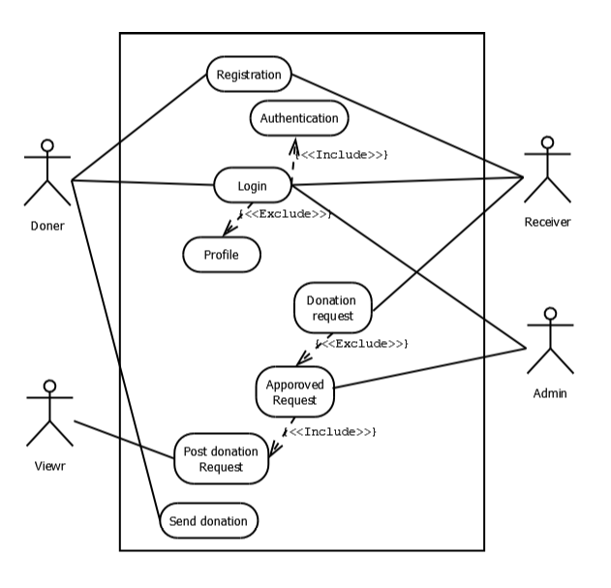

* 1. **Class Diagram**

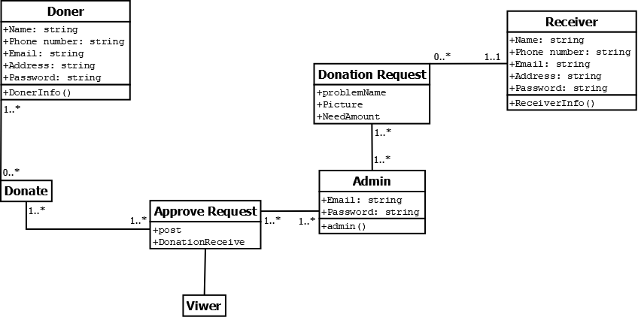

* 1. **Sequence Diagram**

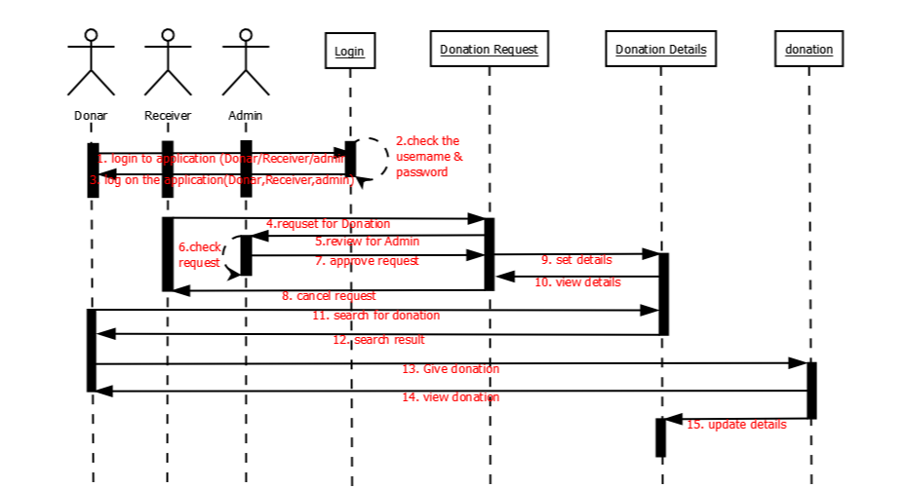

* 1. **Activity Diagram**

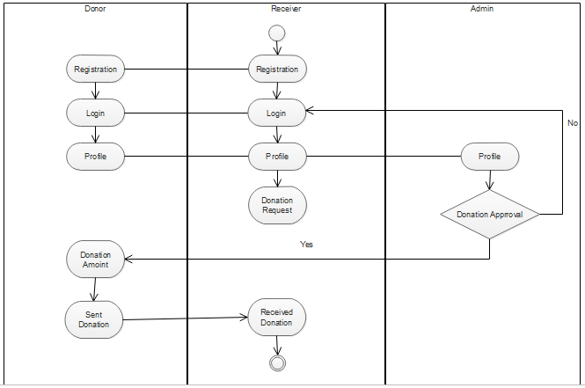

1. **Validation and verification**
   1. **UI**

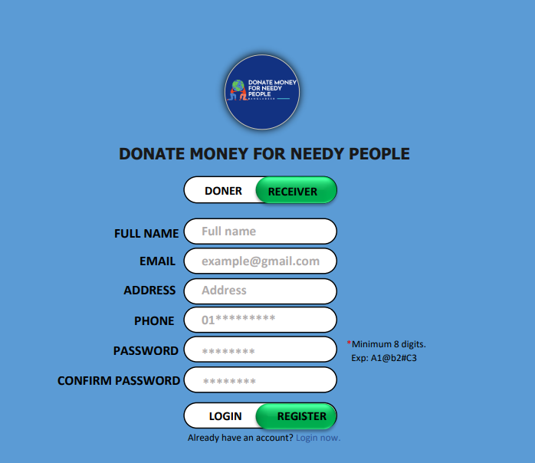

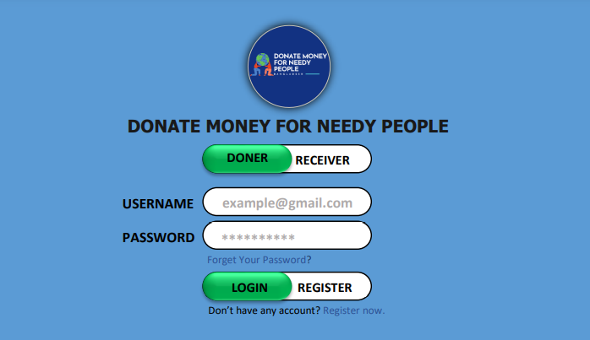

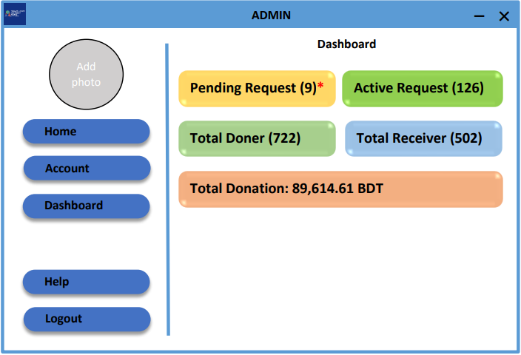

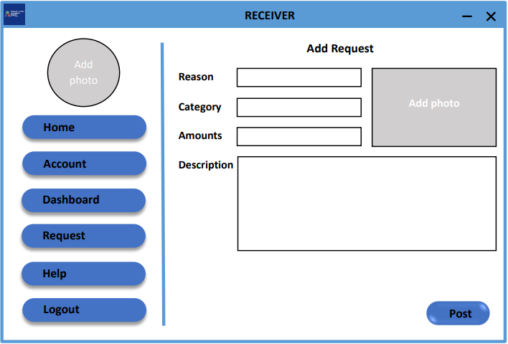

* 1. **Risk Estimation**

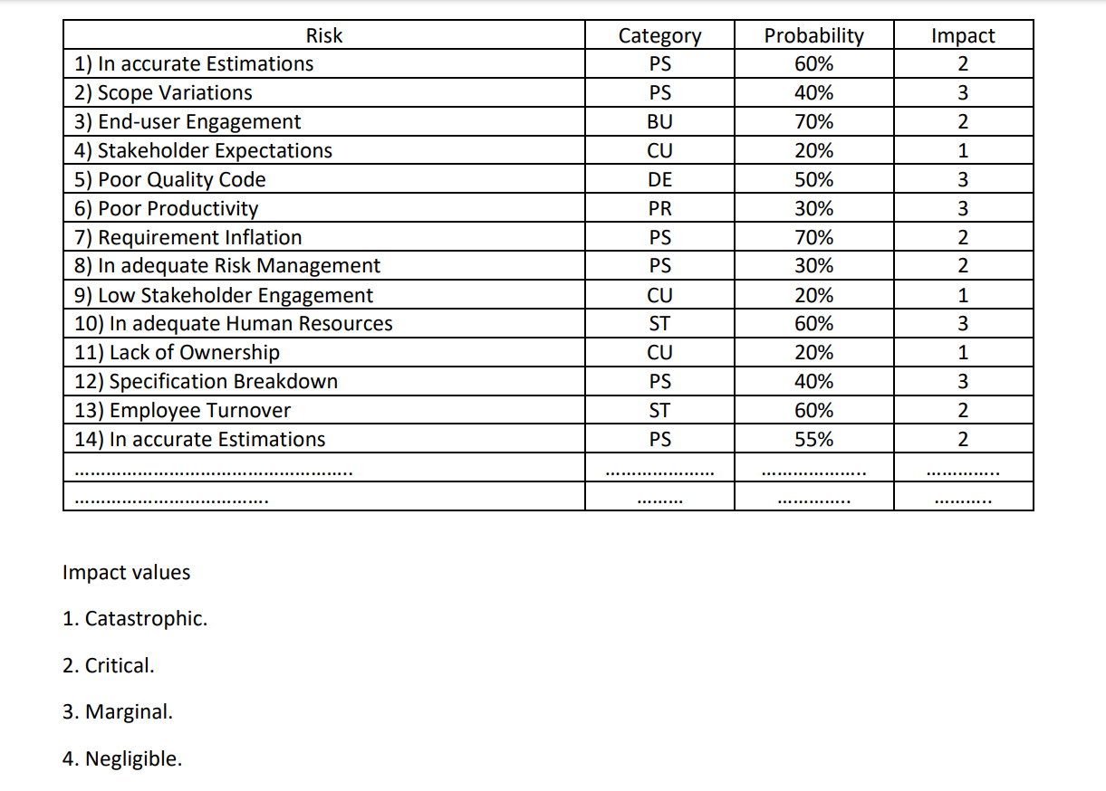

* 1. **Testing**

At first, we need to test the demo project. Then test logically things by white box testing. Buttons are working properly or not; login and register are working properly or not. Payment is working or not, then all summation and subtraction is working properly or not. Then do black box testing in the interface like textbox, check box, select any things, make payments, select payment options, right person gets payments or not. This software is user-friendly or not etc.

