📘 Azure Resiliency Assessment Tool – README

⚠️ Disclaimer
This tool and associated scripts are provided for informational and assessment purposes only and do not represent an official Microsoft product or supported solution.
All outputs are generated based on available Azure metadata and configuration at the time of execution. As such:
- Results may not fully reflect actual application behavior, dependencies, or runtime resiliency.
- Certain edge cases, service-specific behaviors, or architectural nuances may not be captured.
- Azure services, features, and behaviors are subject to change over time.
This tool does not replace architecture validation, resiliency testing, or design reviews.
Customers are responsible for:
- Validating all findings
- Performing appropriate testing (including failover and recovery scenarios)
- Ensuring alignment with their specific requirements, policies, and risk posture
No warranties, guarantees, or support obligations are provided with this tool.

📌 Overview
The RAISEiliency tool scans Azure resources across subscriptions and consolidates resiliency-related configurations into structured outputs for easier analysis.
The objective is to provide clear visibility of zone redundancy, resiliency posture, and potential gaps across your Azure environment.

🎯 What the Tool Extracts
The script collects and reports on:
- Availability Set placement
- Availability Zone (AZ) mapping across subscriptions
- AZ redundancy configuration
- AZ pinning (zonal resources)
- Same-zone / zonal high availability for supported PaaS services
- Capacity distribution across zones
- Storage resiliency configuration (LRS, ZRS, GRS, etc.)
- Backup resiliency configuration
- Public IP exposure and association
- Resource relationships (e.g., VM → NIC → Public IP)

⚙️ Requirements

🔹 Azure Permissions
- Minimum required role: Reader on all target subscriptions

🔹 PowerShell Setup

✅ Option 1 – Azure Cloud Shell (Recommended)
It is recommended to run the script in Azure Cloud Shell because:
- All required modules (Az, Resource Graph) are already installed
- No local setup is required
- Authentication is handled automatically
👉 This avoids most prerequisite and environment issues.

🖥️ Option 2 – Local Machine
Install Azure PowerShell modules:
Install-Module -Name Az -Repository PSGallery -Force
Ensure:
- Az.ResourceGraph module is available
- You are authenticated:
Connect-AzAccount

🚀 How to Use

🔹 Define Customer Tags (Optional but Recommended)
These tag names should correspond to the Azure resource tags used in your environment (e.g., Environment, Application, Business Unit). The script will extract the values of these tags for each resource and include them in the output, enabling filtering, grouping, and slice-and-dice analysis in Power BI dashboards to better understand resiliency posture per workload.
$custTags=('Environment','Business Unit','Application','AssetClassification')

🔹 Example Usage

✅ Example 1 – Target Specific Subscriptions
.\RelAZ_Assess_v2_18.ps1 `
-localexport $true `
-Customertags $custTags `
-targetSubscriptions @(
'xxxxxx-xxxx-xxx-xxxx-xxxxxxxxxxx',
'yyyy-yyyy-yyyy-yyy-yyyyyyyyyyyy'
)

✅ Example 2 – Using Management Group Scope
.\RelAZ_Assess_v2_18.ps1 `
-localexport $true `
-managementGroupId @('MG1','ContosoSamir') `
-Customertags $custTags

⚙️ Script Parameters
Parameter | Description
-localexport | Enables export of results to local CSV files , it creates a folder and a zip file
-Customertags | Array of tag names used to identify workloads
-targetSubscriptions | (optional) List of subscription IDs to include in the scan
-managementGroupId | (Optional) Scope the scan to a specific management group

📊 Output Files
When -localexport $true is enabled, the script generates the following files:
- MasterReport.csv
Main output file containing the consolidated view of all scanned resources, including:
- Zone configuration (zonal / non-zonal / zone-redundant)
- Resiliency-related properties
- Tags (if provided)
- Key relationships between resources
👉 This is the primary dataset used for analysis and Power BI dashboards.

- asr_backup.csv
Inventory of resources with backup or disaster recovery configurations, including:
- Backup status
- Last backup information (where available)
- ASR replication details

- pipReport.csv
Public IP inventory, including:
- Associated resources
- Zone configuration
- Exposure insights

- zonemapping.csv
Mapping of Availability Zones to physical zones across subscriptions.
👉 Useful to understand how logical zone numbers (1,2,3) align across subscriptions.

- lbReport.csv
Load Balancer configuration details, including:
- Frontend configurations
- Associated Public IPs
- Zone setup

- CustomerAzRetirements.csv
Lists Azure services/resources in the environment that are:
- Retired
- Or approaching retirement
👉 Helps identify modernization or migration needs.

- Azureretirements.json
Reference file used to map retirement information and enrich the retirement report.

📌 Notes
- All files are CSV-based and ready for direct consumption in:
- Excel
- Power BI
- MasterReport.csv is the central dataset and should be used as the primary source for analysis.
- Other files provide supporting datasets to enrich visibility on:
- Backup & DR posture
- Network exposure
- Zone alignment
- Platform lifecycle (retirements)
When -localexport $true is enabled, the script generates:
- CSV files per resource provider
- Each file includes:
- Resource details
- Expanded properties
- Tags
- Zone and resiliency-related configurations
These outputs are:
- Raw but structured
- Designed for further processing (e.g., Excel, Power BI)

📊 Visualization with Power BI
The exported data can be visualized using the provided Power BI template:
ReliabilityAssessment_Template_Vx.x.pbit

⚙️ Prerequisites
- Power BI Desktop installed (required to open .pbit template files)
- Access to the folder containing the exported CSV files
- (Optional) Power BI Service (PowerBI Web) account for publishing and sharing

🚀 How to Use
- Open the template file (double click), this will open Power BI Desktop
- When prompted, provide the export folder path (the folder generated by the script): for example C:\Resiliency Scripts\20260324
- Click Load
Power BI will automatically:
- Import all CSV files
- Build the data model
- Populate all visuals and dashboards

☁️ Publishing (Optional)
Once the report is loaded and validated you can save it locally or:
- You can publish it to Power BI Service (PowerBI Web)
- This enables:
- Sharing dashboards with stakeholders
- Centralized access
- Scheduled refresh (if configured)

📈 Dashboard Overview
The template provides multiple tabs to analyze resiliency posture from different perspectives:

🔹 ResourceSummary
- High-level overview of all resources
- Shows:
- Resource count by type
- Distribution by resiliency configuration (Zonal, Zone-Redundant, Non-Zonal, etc.)
👉 Used for quick understanding of the overall resiliency posture
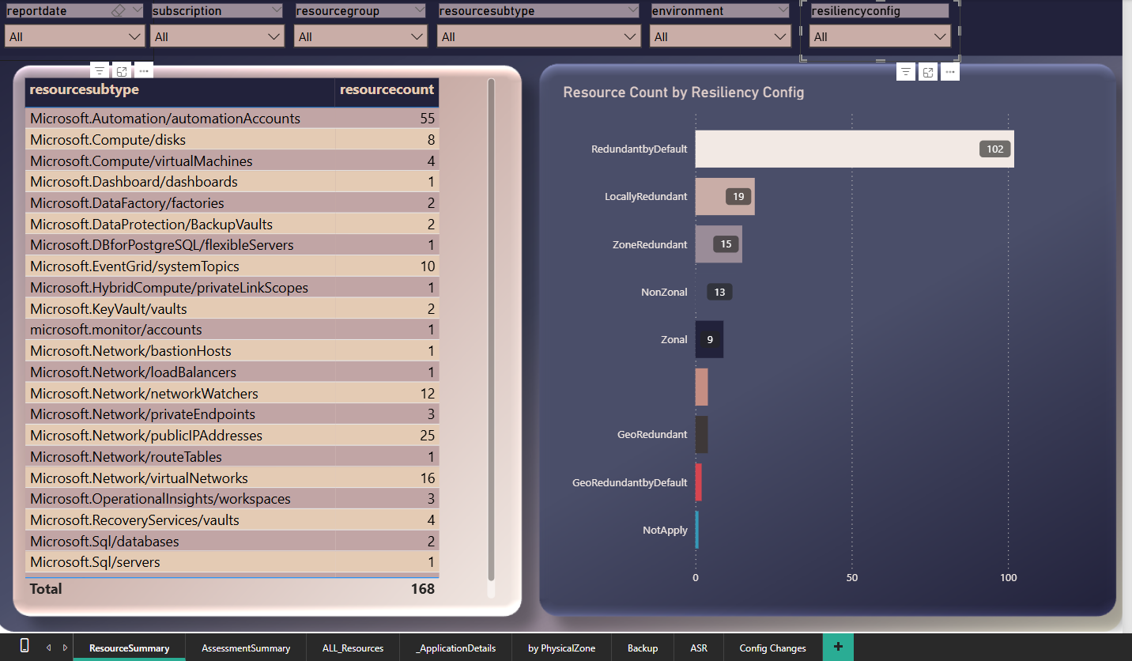

🔹 AssessmentSummary
- Aggregated view per:
- Subscription
- Resource Group
- Provides:
- Percentage of resilient resources
- Classification (e.g., >90%, 75–90%, <50%)
👉 Used to identify weak areas and prioritize remediation
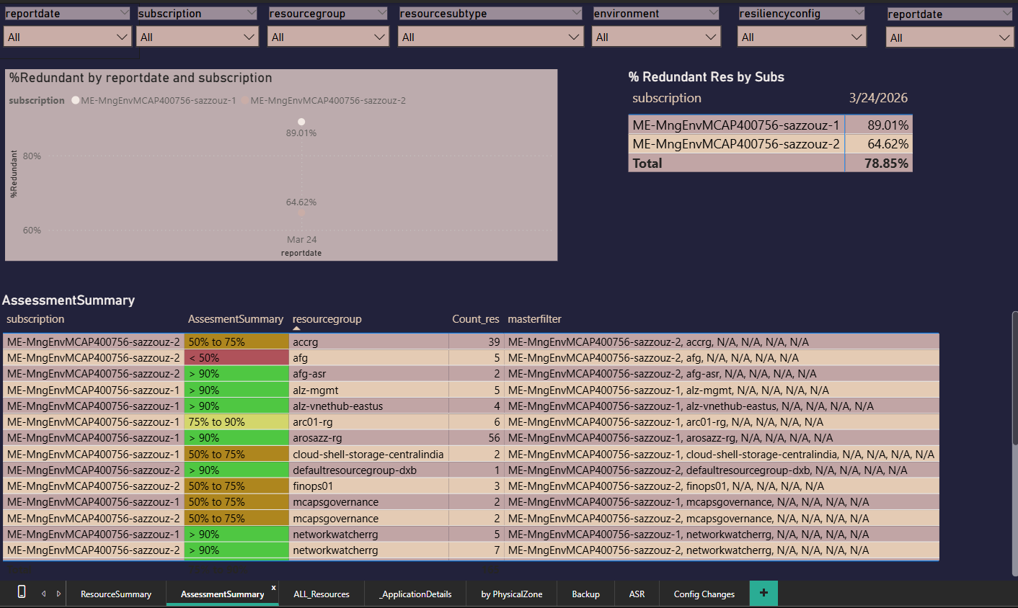

🔹 ALL_Resources
- Full detailed inventory of all scanned resources
- Includes:
- Resource name, type, region
- Zone configuration
- Backup and resiliency details
👉 Used for deep-dive analysis and troubleshooting
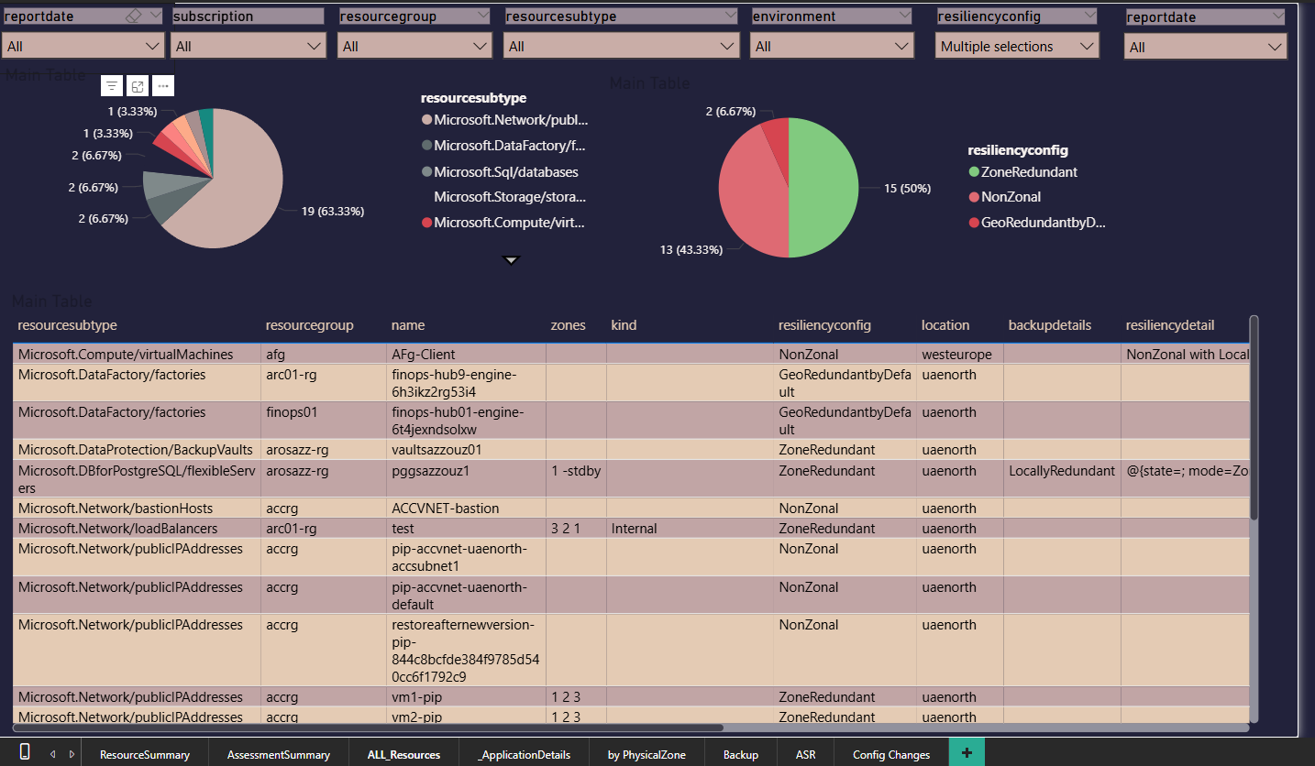

🔹 ApplicationDetails
- View filtered using customer-defined tags (Application, Environment, etc.)
- Enables:
- Workload-level analysis
- Application-specific insights
👉 Used to align findings with business workloads

🔹 by PhysicalZone
- Displays distribution of resources across physical zones
- Helps identify:
- Imbalance in zone usage
- Concentration risks
👉 Used to validate actual zone distribution and resilience
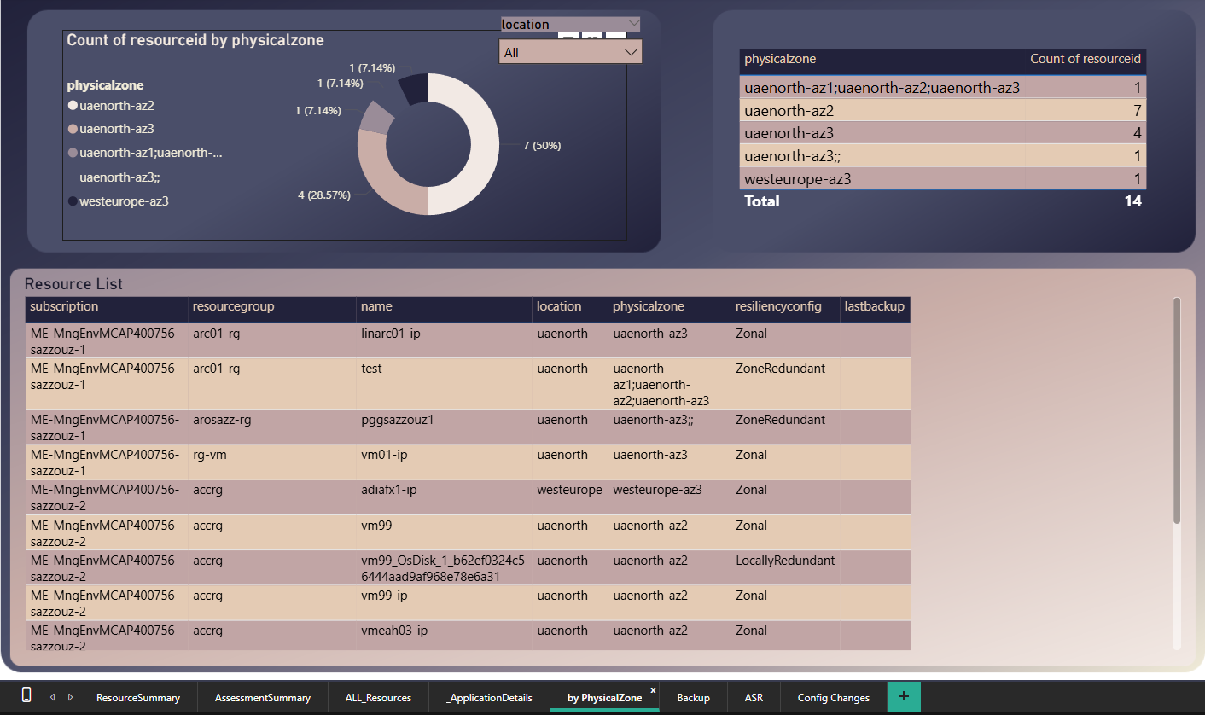

🔹 Backup
- Shows backup posture:
- Protected resources
- Backup status (Healthy / Failed)
- Last backup time
👉 Used to assess data protection readiness
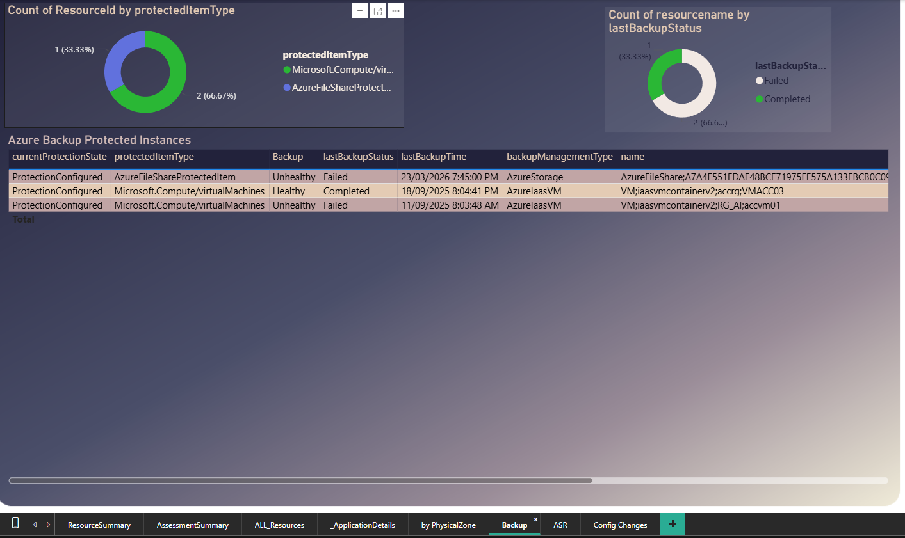

🔹 ASR
- Displays disaster recovery (ASR) configuration:
- Replication health
- Failover status
- Source and target regions
👉 Used to evaluate disaster recovery readiness
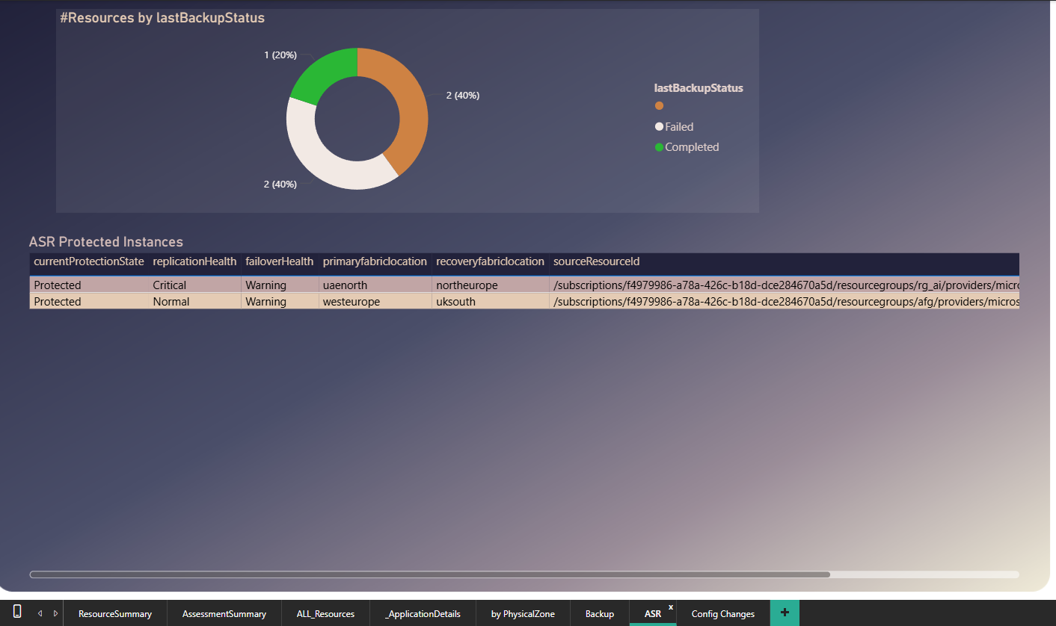

🔹 Config Changes
- Provides insights into configuration-related changes (if applicable)
👉 Used for operational monitoring and tracking

📌 Notes
- The dashboard is primarily driven by:
- MasterReport.csv (main dataset)
- Supporting datasets (Backup, ASR, Networking, etc.)
- Filters available across reports:
- Subscription
- Resource Group
- Resource Type
- Environment
- Resiliency Configuration
👉 These enable slice-and-dice analysis across multiple dimensions

🧠 Key Value
Using Power BI with this tool allows you to:
- Transform raw data into actionable insights
- Identify resiliency gaps at scale
- Align infrastructure posture with business workloads
- Support data-driven decision making and prioritization

📊 How to Interpret Results

🔹 Virtual Machines
- Non-zonal VM
- ❗ Not protected against zone failure
- Zonal VM
- ✅ Good baseline
- ⚠️ Must verify:
  - Multiple instances exist
  - Instances are distributed across different zones
👉 This distribution cannot be automatically validated because:
- The script cannot infer application roles or workload grouping

🔹 General Classification
Status | Meaning
Zone-Redundant | Highest resiliency (platform-managed)
Zonal | Requires proper distribution across zones
Non-Zonal | Potential single point of failure

🧠 Tagging Guidance
Providing meaningful tags is critical.
Recommended tags:
- Environment (Prod / Dev / UAT)
- Application name
- Business unit
- Project / workload identifier
If no tags are provided:
- Analysis will be limited to resource-level only
- Workload-level insights will be harder to derive

⚠️ Limitations & Important Considerations
This tool provides infrastructure-level insights only and must not be considered as a full validation of resiliency.

🔹 What the Tool Does NOT Do
- It does not validate application architecture
- It does not confirm high availability at workload level
- It does not simulate failover scenarios
- It does not understand application dependencies or roles

🔹 Example – Virtual Machines
- A VM marked as zonal is often interpreted as “resilient”
- However, this is not sufficient
👉 The tool cannot determine:
- If multiple VMs belong to the same application tier
- If those VMs are correctly distributed across zones
- If the application can actually fail over between instances
➡️ Example risk:
- 3 VMs of the same role all deployed in Zone 1 → still a single point of failure, even if they are “zonal”

🔹 Human Review is Mandatory
The output of this tool must be reviewed by someone who understands the application architecture, including:
- Application owners
- Cloud architects
- Platform engineers
This review is required to:
- Validate workload distribution
- Confirm actual high availability design
- Identify real resiliency gaps

📝 Recommended Next Steps
- Identify non-zonal resources
- Validate zonal distribution across workloads
- Engage application owners for architecture validation
- Prioritize critical workloads for remediation
- Import CSV outputs into:
- Power BI

📌 Summary
The RAISEiliency tool enables:
- Large-scale visibility of zone resiliency posture
- Identification of configuration gaps
- Structured data export for analysis and reporting
It should be used as:
👉 A foundation for resiliency assessment, followed by:
- Architecture validation
- Workload-level design review
- Failover and resiliency testing

