


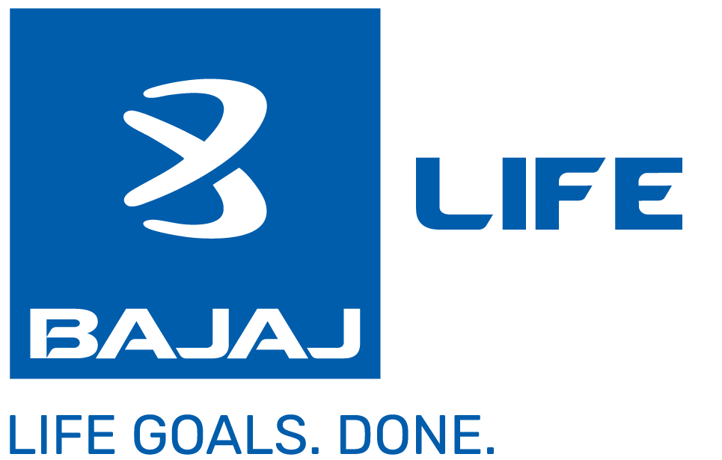



Product Proposal for achieving your Life Goals

Bajaj Life ACE
A Non linked, Parīicipaīing, Individual Life Insurance Savings Plan
UIN: 116N186V03

Hi Mr. Vilas Hema Thakare,

Congratulations on taking the first step towards fulfilling your Life Goals with Bajaj Life Insurance. You have opted for Bajaj Life ACE, a truly modular product where you are the one in charge of your financial plan along with life cover




Key Features
Decide your Income Wide range of policy term Choice of premium amount and Income from 10 to 85 years or up payment term from 5 to
start year to age 100 years 10 year or 12 years
Life Cover to secure your planned Life Goals
Comprehensive coverage through multiple riders
Tax Benefits

Here's your illustration of Bajaj Life ACE

51
Age 46
57







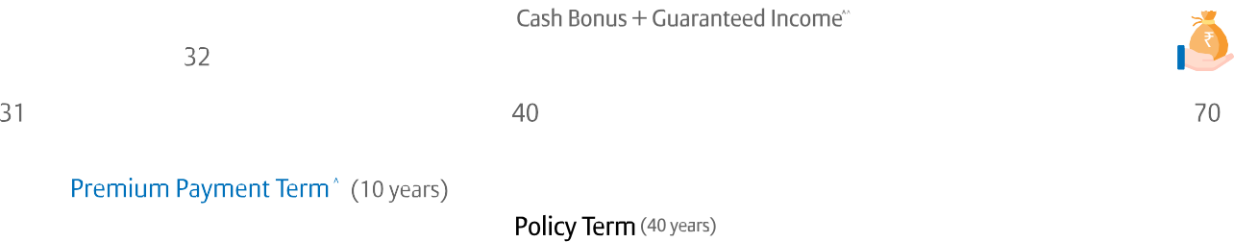



(12 years)
84
(39 years)
You Pay You Get








Premium
Including discounts (if any) and excluding GST
First year
₹ 1,50,920 Yearly
Guaranteed Income (A)
(From Age 51 to 84)
1st Income
₹39,142
Last Income
₹39,142
Cash Bonus (B)
(From Age 51 to 84)
Second year
onwards
₹ 1,54,000 Yearly
Income Benefit (A+B)
(From Age 51 to 84)
@8% ₹58,713
@4% ₹9,786
@8% ₹97,855
@4% ₹48,928
@8% ₹58,713
@4% ₹9,786
@8% ₹97,855
@4% ₹48,928
Maturity Benefit (At age 84) @8% ₹35,11,659 @4% ₹19,81,283
Total Premium
₹ 18,44,920
Total Benefits
@8%₹ 68,38,729
@4%₹ 36,44,835
Life Cover(At Inception)
16,94,000
Additional Coverages ( signifies Opted | signifies Not-opted )
Accidental death Benefit
From age 46 to 65
Sum Assured: 15,00,000 | Premium: Rs. 1,020 Yearly
Accidental Permanent Total/Partial
Disability Benefit
Family Income Benefit

2

Above Additonal Coverages Premiums are excluding GST
^Premiums are payable at the beginning of year; ^^Benefits to be received at the end of year. Product features mentioned above are dependent on benefit chosen.The assumed rate of returns indicated at 4% and 8% are illustrative and not guaranteed and do not indicate the upper or lower limits of returns under the policy.The guaranteed benefits are dependent on the Policy terms, Premium payment terms availed along with other variable factors.The above benefits/returns shown in the document are for illustrative purpose only & must be read in conjunction with the Benefit Illustration. For more details on risk factors, terms and conditions please read sales brochure & policy document (available on www.bajajlifeinsurance.com) carefully before concluding a sale.Tax benefits as per prevailing Income tax laws shall apply. Please check with your tax consultant for eligibility. Product features mentioned above are dependent on benefit chosen




Why Bajaj Life

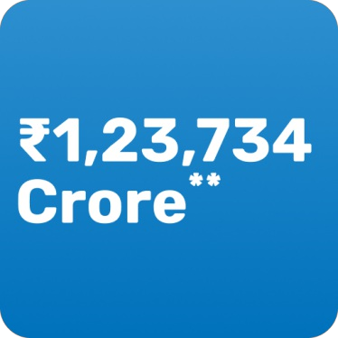
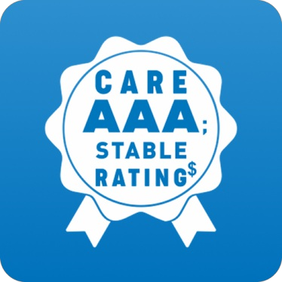
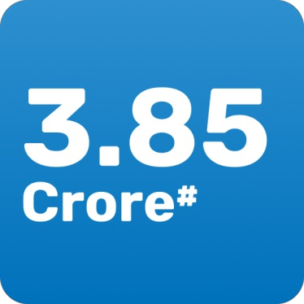


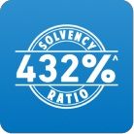
Total Asset Under Managment (AUM)
AAA; Stable Rating by CARE
Number of Lives Covered
Claim settlement Ratio
Get 1 Day Claim Approval
Solvency Ratio
~Individual Death Claim Settlement Ratio for FY 2024-2025. | ^Solvency ratio 359% as at 31 March 2025 against IRDAI mandated 150% | %99.29% of non-investigative individual claims approved in one working day for FY 2024-25. 1 day is counted from date of intimation of claim before 3 PM on a working day (excluding Non-NAV days for ULIP) at Bajaj Life offices. 96% of non - investigative claims notified were processed within one day in FY'25| $For details refer to press release published by CARE. *All figures as on 31 March 2025 | *Individual & Group
For more details please refer to Company Factsheet
https://www.bajajlifeinsurance.com/content/dam/balic-web/pdf/financialinformation/Factsheet/none/Q1/Factsheet-FY-2024- 2025.pdf

Bajaj L ife Insurance L imited ( Formerly known as Bajaj Allianz L ife Insurance Company L imited), CIN: U66010PN 2001PLC015959 | IRDAI Reg. No. 116
BEWARE OF SPURIOUS PHONE CALLS AND FICTITIOUS / FRAUDULENT OFFERS -
IRDAI or its officials do not involve in activities like selling insurance policies, announcing bonus or investment of
premiums. Public receiving such phone calls are requested to lodge a police complaint.
3
Mail us: customercare@bajajlife.com | Call on: 020 6712 1212 ( Customer Care Number)
Registered Office Address: Bajaj Insurance House, Airport Rd, Yerawada, Pune, Maharashtra - 411006, Maharashtra
The Logo of Bajaj L ife Insurance L imited is provided on the basis of license given by Bajaj Finserv Ltd. to use its " Bajaj" Logo.

Quotation No : 60082865275

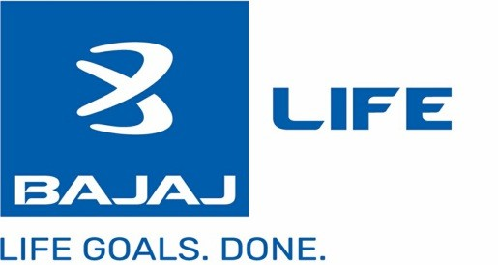

Bajaj Life ACE
A Non linked, Participating, Individual Life Insurance Savings Plan

Name of the Prospect/ Policyholder:
Age:
Name of the Life Assured: Age:
Premium Payment Term: Policy Term:
Deferment Period:
Amount of Instalment Premium: Mode of Payment of Premium:
Vilas Hema Thakare
46
Gender:
Male
Vilas Hema Thakare
46
12
Gender:
Male
Name of the Product: Bajaj Life ACE
Tag Line: A Non linked, Participating, Individual Life Insurance Savings Plan
Unique Identification Number: 116N186V03
GST Rate: —
Maturity Age 85
5
1,51,940
Annual
How to read and understand this benefit illustrationị
This benefit illustration is intented to show year-wise premiums payable and benefits under the policy, at two assumed rates of interest i.e., 8% p.a. and 4% p.a.
Some benefits are guaranteed and some benefits are variable with returns based on the future performance of your insurer carrying on life insurance business. If your policy offers guaranteed benefits then these will be clearly marked "guaranteed" in the illustration table on this page. If your policy offers variable benefits then the illustrations on this page will show two different rates of assumed future investment returns, of 8% p.a. and 4% p.a. These assumed rates of return are not guaranteed and they are not the upper or lower limits of what you might get back, as the value of your policy is dependent on a number of factors including future investment performance.

Policy Details
 | Early Income | Wealth | Income Benefit Frequency | Annually
Premium Allocation | 95% | 5% | Goal Protection Benefit | No
Benefit Sum Assured* | 9,78,557 | 91,280 | Accumulate Income Benefits | No
Income Period | 34 | NA | Bonus Type | Cash Bonus, Simple Revisionary Bonus and Terminal Bonus
Sum Assured on Death (at inception of policy) | 16,94,000
*Benefit Sum Assured will be used for calculating Guaranteed Income and declaring Bonuses, and will not be payable on Maturity or Death.

Rider | Accidental Death Benefit (UIN: 116B034V02)
Sum Assured (Rs.) | 15,00,000
Rider Policy Term (Years) | 19
Installment Premium without GST (Rs.) | 1,020

Premium Summary
 | Base Plan | Riders | Total Installment Premium
Instalment Premium without GST (including 2.00% discount in 1st year) | 1,50,920 | 1,020 | 1,51,940
Installment Premium without GST(2nd year) | 1,54,000 | 1,020 | 1,55,020
Instalment Premium with First Year GST | 1,50,920 | 1,020 | 1,51,940

O.X.X.A.X

Quotation No : 60082865275

Premium Summary
Installment Premium with GST 2nd year Onwards | 1,54,000 | 1,020 | 1,55,020
(Amount i n Rupees)
Benefit Summary
 |  | Guaranteed Benefits |  |  | Non Guaranteed Benefit @ 4% p.a. |  |  |  | Non Guaranteed Benefit @ 8% p.a. |  |  |  | Total Benefits including Guarantee and Non-Guaranteed Benefits
Policy Year | Annualized Premium  (Excl of GST) | Survival Benefit | Death Benefit | Maturity Benefit | Accrued Simple Reversionary Bonus | Cash Bonus | Guaranteed Surrender Value (GSV) | Special Surrender Value (SSV) | Accrued Simple Reversionary Bonus | Cash Bonus | Guaranteed Surrender Value (GSV) | Special Surrender Value (SSV) | Surrender Value @4% | Surrender Value @8% | Survival and Maturity Benefit incl TB (if any) @4% | Survival and Maturity Benefit incl TB (if any) @8% | Death Benefit incl TB (if any) @4% | Death Benefit incl TB (if any) @8%
1 | 2 | 3 | 4 | 5 | 6 | 7 | 8 | 9 | 10 | 11 | 12 | 13 | 14 | 15 | 16 | 17 | 18 | 19
1 | 1,50,920 | 0 | 16,94,000 | 0 | 822 | 0 | 0 | 44,000 | 2,054 | 0 | 0 | 44,134 | 44,000 | 44,134 | 0 | 0 | 16,94,000 | 16,94,000
2 | 1,54,000 | 0 | 16,94,000 | 0 | 1,643 | 0 | 92,489 | 94,311 | 4,108 | 0 | 92,624 | 94,595 | 97,054 | 97,189 | 0 | 0 | 16,94,822 | 16,96,054
3 | 1,54,000 | 0 | 16,94,000 | 0 | 2,465 | 0 | 1,61,845 | 1,51,622 | 6,161 | 0 | 1,62,063 | 1,52,074 | 1,61,845 | 1,62,063 | 0 | 0 | 16,95,643 | 16,98,108
4 | 1,54,000 | 0 | 16,94,000 | 0 | 3,286 | 0 | 3,08,209 | 2,16,690 | 8,215 | 0 | 3,08,523 | 2,17,330 | 3,08,209 | 3,08,523 | 0 | 0 | 16,96,465 | 17,00,161
5 | 1,54,000 | 0 | 16,94,000 | 0 | 4,108 | 0 | 3,85,283 | 2,90,345 | 10,269 | 0 | 3,85,707 | 2,91,196 | 3,85,283 | 3,85,707 | 0 | 0 | 16,97,286 | 17,02,215
6 | 1,54,000 | 39,142 | 16,94,000 | 0 | 4,929 | 9,786 | 4,13,439 | 3,58,877 | 12,323 | 58,713 | 3,65,061 | 4,95,724 | 4,13,439 | 4,96,302 | 48,928 | 97,855 | 16,98,108 | 17,04,269
7 | 1,54,000 | 39,142 | 16,94,000 | 0 | 5,751 | 9,786 | 4,41,607 | 4,12,692 | 14,377 | 58,713 | 3,44,444 | 5,97,971 | 4,41,607 | 5,97,971 | 48,928 | 97,855 | 16,98,929 | 17,06,323
8 | 1,54,000 | 39,142 | 16,94,000 | 0 | 6,572 | 9,786 | 4,82,107 | 4,68,236 | 16,430 | 58,713 | 3,36,179 | 7,14,783 | 4,88,873 | 7,14,783 | 48,928 | 97,855 | 16,99,751 | 17,08,377
9 | 1,54,000 | 39,142 | 16,94,000 | 0 | 7,394 | 9,786 | 5,25,701 | 5,25,647 | 18,484 | 58,713 | 3,31,028 | 8,47,445 | 5,48,819 | 8,47,445 | 48,928 | 97,855 | 17,00,572 | 17,10,430
10 | 1,54,000 | 39,142 | 16,94,000 | 0 | 8,215 | 9,786 | 5,72,390 | 5,85,062 | 20,538 | 58,713 | 3,28,994 | 9,98,660 | 6,10,715 | 9,98,660 | 48,928 | 97,855 | 17,01,394 | 17,12,484
11 | 1,54,000 | 39,142 | 16,94,000 | 0 | 9,037 | 9,786 | 6,39,115 | 6,46,620 | 22,592 | 58,713 | 3,47,021 | 11,69,993 | 6,75,536 | 11,69,993 | 48,928 | 97,855 | 17,82,680 | 17,95,003
12 | 1,54,000 | 39,142 | 16,94,000 | 0 | 9,858 | 9,786 | 6,93,538 | 8,27,123 | 24,646 | 58,713 | 3,52,773 | 13,90,607 | 8,58,449 | 13,90,607 | 48,928 | 97,855 | 19,40,400 | 19,50,672
13 | 0 | 39,142 | 16,94,000 | 0 | 10,680 | 9,786 | 6,63,280 | 8,43,189 | 26,699 | 58,713 | 2,73,871 | 14,74,190 | 8,74,163 | 14,74,190 | 48,928 | 97,855 | 19,40,400 | 19,55,493
14 | 0 | 39,142 | 16,94,000 | 0 | 11,501 | 9,786 | 6,33,043 | 8,60,094 | 28,753 | 58,713 | 1,95,022 | 14,94,895 | 8,90,649 | 14,94,895 | 48,928 | 97,855 | 19,40,400 | 19,64,369
15 | 0 | 39,142 | 16,94,000 | 0 | 12,323 | 9,786 | 6,21,308 | 8,77,896 | 30,807 | 58,713 | 1,34,709 | 15,18,142 | 9,08,887 | 15,18,142 | 48,928 | 97,855 | 19,40,400 | 19,74,101
16 | 0 | 39,142 | 16,94,000 | 0 | 13,144 | 9,786 | 5,91,118 | 8,96,669 | 32,861 | 58,713 | 61,476 | 15,42,041 | 9,27,097 | 15,42,041 | 48,928 | 97,855 | 19,40,403 | 19,84,398
17 | 0 | 39,142 | 16,94,000 | 0 | 13,966 | 9,786 | 5,60,957 | 9,16,508 | 34,914 | 58,713 | 63,115 | 15,69,602 | 9,46,292 | 15,69,602 | 48,928 | 97,855 | 19,41,224 | 19,95,638
18 | 0 | 39,142 | 16,94,000 | 0 | 14,787 | 9,786 | 5,30,826 | 9,37,507 | 36,968 | 58,713 | 64,831 | 15,96,756 | 9,66,557 | 15,96,756 | 48,928 | 97,855 | 19,42,046 | 20,07,779
19 | 0 | 39,142 | 16,94,000 | 0 | 15,609 | 9,786 | 5,19,209 | 9,59,781 | 39,022 | 58,713 | 67,558 | 16,27,718 | 9,88,927 | 16,27,718 | 48,928 | 97,855 | 19,42,867 | 20,20,919
20 | 0 | 39,142 | 16,94,000 | 0 | 16,430 | 9,786 | 4,89,152 | 9,83,454 | 41,076 | 58,713 | 69,458 | 16,61,441 | 10,11,669 | 16,61,441 | 48,928 | 97,855 | 19,43,689 | 20,34,976
21 | 0 | 39,142 | 16,94,000 | 0 | 17,252 | 9,786 | 4,59,138 | 10,08,651 | 43,130 | 58,713 | 71,467 | 16,97,025 | 10,35,823 | 16,97,025 | 48,928 | 97,855 | 19,44,510 | 20,50,406
22 | 0 | 39,142 | 16,94,000 | 0 | 18,073 | 9,786 | 4,29,173 | 10,35,519 | 45,183 | 58,713 | 73,598 | 17,36,777 | 10,61,527 | 17,36,777 | 48,928 | 97,855 | 19,45,332 | 20,66,938
23 | 0 | 39,142 | 16,94,000 | 0 | 18,895 | 9,786 | 4,17,743 | 10,64,199 | 47,237 | 58,713 | 76,791 | 17,79,446 | 10,89,837 | 17,79,446 | 48,928 | 97,855 | 19,46,153 | 20,84,857
24 | 0 | 39,142 | 16,94,000 | 0 | 19,716 | 9,786 | 3,87,895 | 10,94,852 | 49,291 | 58,713 | 79,214 | 18,25,576 | 11,19,056 | 18,25,576 | 48,928 | 97,855 | 19,46,975 | 21,04,269
25 | 0 | 39,142 | 16,94,000 | 0 | 20,538 | 9,786 | 3,58,116 | 11,27,648 | 51,345 | 58,713 | 81,810 | 18,75,720 | 11,50,271 | 18,75,720 | 48,928 | 97,855 | 19,47,796 | 21,25,281
26 | 0 | 39,142 | 16,94,000 | 0 | 21,359 | 9,786 | 3,28,415 | 11,62,777 | 53,399 | 58,713 | 84,600 | 19,30,453 | 11,83,658 | 19,30,453 | 48,928 | 97,855 | 19,48,618 | 21,48,004
27 | 0 | 39,142 | 16,94,000 | 0 | 22,181 | 9,786 | 3,17,281 | 12,00,450 | 55,452 | 58,713 | 88,534 | 19,87,728 | 12,20,341 | 19,87,728 | 48,928 | 97,855 | 19,49,439 | 21,72,551
28 | 0 | 39,142 | 16,94,000 | 0 | 23,002 | 9,786 | 2,87,766 | 12,40,911 | 57,506 | 58,713 | 91,790 | 20,53,362 | 12,58,702 | 20,53,362 | 48,928 | 97,855 | 19,50,261 | 21,99,038
29 | 0 | 39,142 | 16,94,000 | 0 | 23,824 | 9,786 | 2,58,362 | 12,84,437 | 59,560 | 58,713 | 95,325 | 21,25,476 | 12,99,929 | 21,25,476 | 48,928 | 97,855 | 19,51,082 | 22,27,587
30 | 0 | 39,142 | 16,94,000 | 0 | 24,646 | 9,786 | 2,29,086 | 13,31,363 | 61,614 | 58,713 | 99,176 | 22,02,404 | 13,44,336 | 22,02,404 | 48,928 | 97,855 | 19,51,904 | 22,58,877
31 | 0 | 39,142 | 16,94,000 | 0 | 25,467 | 9,786 | 2,18,434 | 13,82,082 | 63,668 | 58,713 | 1,04,314 | 22,87,161 | 13,93,220 | 22,87,161 | 48,928 | 97,855 | 19,52,726 | 22,92,531
32 | 0 | 39,142 | 16,94,000 | 0 | 26,289 | 9,786 | 1,89,467 | 14,37,061 | 65,721 | 58,713 | 1,08,942 | 23,80,900 | 14,45,175 | 23,80,900 | 48,928 | 97,855 | 19,53,547 | 23,80,900
33 | 0 | 39,142 | 16,94,000 | 0 | 27,110 | 9,786 | 1,60,693 | 14,96,863 | 67,775 | 58,713 | 1,14,049 | 24,81,680 | 15,01,658 | 24,81,680 | 48,928 | 97,855 | 19,54,369 | 24,81,680
34 | 0 | 39,142 | 16,94,000 | 0 | 27,932 | 9,786 | 1,32,142 | 15,62,178 | 69,829 | 58,713 | 1,19,714 | 25,93,062 | 15,63,322 | 25,93,062 | 48,928 | 97,855 | 19,55,190 | 25,93,062
35 | 0 | 39,142 | 16,94,000 | 0 | 28,753 | 9,786 | 1,22,332 | 16,33,841 | 71,883 | 58,713 | 1,26,957 | 27,40,440 | 16,33,841 | 27,40,440 | 48,928 | 97,855 | 19,56,012 | 27,40,440
36 | 0 | 39,142 | 16,94,000 | 0 | 29,575 | 9,786 | 1,01,298 | 17,12,875 | 73,937 | 58,713 | 1,34,048 | 28,96,092 | 17,12,875 | 28,96,092 | 48,928 | 97,855 | 19,56,833 | 28,96,092
37 | 0 | 39,142 | 16,94,000 | 0 | 30,396 | 9,786 | 1,05,057 | 18,00,550 | 75,990 | 58,713 | 1,42,059 | 30,68,756 | 18,00,550 | 30,68,756 | 48,928 | 97,855 | 19,59,797 | 30,68,756
38 | 0 | 39,142 | 16,94,000 | 0 | 31,218 | 9,786 | 1,11,106 | 18,98,443 | 78,044 | 58,713 | 1,53,026 | 32,53,437 | 18,98,443 | 32,53,437 | 48,928 | 97,855 | 19,69,521 | 32,53,437
39 | 0 | 39,142 | 16,94,000 | 19,49,243 | 32,039 | 9,786 | 0 | 0 | 80,098 | 58,713 | 0 | 0 | 0 | 0 | 20,30,211 | 36,09,514 | 19,81,283 | 35,11,659
There are muluple product opuons in the product. I understand that returns vary under each opuon. I have made choice of invesung in more than one product option considering my need and understanding the benefit under each option.
Notes: Annualized Premium excludes underwriung extra premium, frequency loadings on premiums, the premiums paid towards the riders, if any, and Goods & Service Tax. Refer Sales literature for explanation of terms used in this illustration.
- The above benefit illustrauon demonstrates premium paid at the beginning of the year and all the benefits (other than cash bonus and guaranteed Income) are paid out at the end of year. Cash Bonus and Guaranteed Income will be paid as per the uming of payout opted by the customer.
- The Survival Benefits are payable during the policy year when they are due as per the frequency. Upon payment at Maturity (Last Payout), the policy terminates, and no further benefits become payable. The Maturity benefit will be the sum of Sum Assured on Maturity plus Accumulated Income benefits, if not paid earlier, plus Terminal Bonus (if declared).
- The surrender value payable will be higher of Guaranteed Surrender Value or Special Surrender Value (including any Terminal Bonus payable, if declared) and is illustrated under 'Total Surrender Benefit' columns.
- Surrender value illustrated above is end of the policy year value. The Special Surrender Value (SSV) displayed above are not guaranteed and only indicauve. The Company shall comply with prevailing guidelines w.r.t SSV issued by IRDAI from ume to ume. Upon payment of surrender benefit, the policy terminates, and no further benefit becomes payable.
- The death benefits shown above are at the end of the year. Upon payment of death benefit the policy terminates and no further benefit is payable. Not Applicable for Policies with Goal Protection Benefit.
- Income Tax benefits would be available as per the prevailing income tax laws.
- For more details on risk factors, terms and conditions please read sales brochure carefully before concluding a sale.

O.X.X.A.X

Quotation No : 60082865275
- RB - Reversionary Bonus, TB - Terminal Bonus
- On payment at Maturity (Last Payout), the policy terminates and no further benefits become payable.
I, , have explained the premiums, charges and benefits under the policy fully to the prospect/policyholder.
Place:
Date:
Signature of Agent/ Intermediary/ Official
I, Vilas Hema Thakare , having received the informauon with respect
to the above, have understood the above statement before enterin g into the contract.
Date:
Signature of Prospect / Policyholder
Bajaj Life Insurance Limited (Formerly known as Bajaj Allianz Life Insurance Company Limited) Bajaj Insurance House, Airport Rd, Yerawada, Pune, Maharastra - 411006. Reg No.: 116.
Customer Care Number: 020 6712 1212. Email: customercare@bajajlife.com www.bajajlifeinsurance.com

O.X.X.A.X

CUSTOMER INFORMATION SHEET / KNOW YOUR POLICY.

This document provides key information about your policy. You are also advised to go through your policy document.
We request you to kindly review the CIS and acknowledge the same through a link shared to you on your registered mobile number/Email ID/WhatsApp.

Sr.  No. | Title | Description in Simple Words  (Please refer to applicable Policy Clause Number in next column) | Policy Clause Number
1 | Name of the Insurance Product and Unique Identification Number (UIN) | Bajaj Life ACE  (UIN - 116N186V03) | Policy Schedule
2 | Quotation number | 60082865275 | Policy Schedule
3 | Type of Insurance Policy | Non-Linked other than pure risk and pension | Policy Schedule
4 | Basic Policy Details | Installment Premium for Year 1 (Rs)*: 1,51,940 Instalment Premium Year 2 onwards (Rs): 1,55,020 Mode of Premium Payment: Annual  Sum Assured on Death (Rs): 16,94,000 Sum Assured on Maturity (Rs): 19,49,243 Premium Payment Term (Years): 12 Policy Term (Years): 39  *Instalment Premium includes Rider Premium, if opted but excludes applicable GST & cess and Extra Premium (if any) | Policy Schedule
 |  | Benefits payable on maturity-  On maturity of the Policy, sum assured on maturity, accumulated income benefits (if any) and bonuses, if declared will be paid. | Part C Section 4
 |  | Benefits payable on death-  On death of Life assured during the policy term, sum assured on death, 105% of accumulated income benefits (if any) and bonuses, if declared will be paid. | Part C Section 4

5 | Policy Coverage/ben efits payable | Survival Benefits excluding that payable on maturity -  - Option 1- Deferred Income: Guaranteed Income plus cash bonuses, if declared will be paid after the end of the Premium Payment Term and Deferment period and is payable till the end of policy term.  - Option 2- Early Income: Guaranteed Income plus cash bonuses, if declared will be paid after the end of Deferment period and is payable for the end of policy term.  - Option 3- Increasing Income: Guaranteed Income plus cash bonuses, if declared will be paid after the end of the Premium Payment Term and Deferment period and is payable till the end of policy term. These incomes will be declared as a percentage of the Benefit Sum Assured. Benefit Sum Assured is guaranteed to increase at 5% p.a. (on compounding basis) every year. The increased Benefit Sum Assured will be used for calculation of respective years Guaranteed Incomes and Cash bonuses.  - Option 4- Wealth: No Survival benefit is paid. | Part C Section 4
 |  | Surrender Benefits  The policyholder will have the option to surrender the policy. The surrender value payable will be the higher of the guaranteed surrender value (GSV) or the special surrender value (SSV).  The policy will acquire a GSV provided two (2) full years' regular premiums have been paid. SSV shall become payable after completion of first (1st) policy year provided at least one (1) full  years' regular premium has been received.  A product option alone in a policy cannot be surrendered. | Part D Section 8
 |  | Options to policyholders for availing benefits, if any, covered under the policy -  You can avail the policy survival benefits in yearly, half-yearly, quarterly and monthly instalments (in advance or arrears) or accumulate within the policy. The accumulated amount can be withdrawn anytime during the policy term  Option to take Death/ Maturity Benefit in Installments | Part D  Section 10
 |  | Other benefits/options payable, specific to the policy, if any:  No other benefit payable other than survival, maturity, surrender and death benefit | -
 |  | Lock-in period for Linked Insurance products:  Not Applicable | -
6 | Options available (in case of Linked Insurance Products) | Not Applicable | Not Applicabl e

Rider Name | UIN | Sum Assured (Rs.)
Bajaj Accidental Death Benefit | 116B034V02 | ₹15,00,000

7 | Option available(in case of Annuity product) | Not Applicable | Not Applicabl e
8 | Riders Opted if Any | For details on the rider, please refer the customer information sheet of the respective rider. | Policy Schedule
9 | Exclusions (events where insurance coverage is not payable), if any | Suicide Exclusions: In case of death of Life Assured due to suicide within twelve (12) months from the Date of Commencement of Risk or the date of latest revival of the Policy, whichever is later, then, the Claimant shall be entitled to receive the higher of 80% of the total premiums received till the date of death of the Life Assured or the Surrender Value, if any, available as on the date of death, provided the Policy is in-force and the Policy will be terminated. There are no other exclusions in the Policy. | Part F  Section 12
10 | Waiting /lien Period, if any | Not Applicable | Not Applicabl e
11 | Grace Period | Thirty (30) days for premium payment frequencies other than monthly and fifteen (15) days for monthly frequency. | Part B  Section 1
12 | Free Look Period | 30 Days | Part D  Section 5
13 | Lapse, paid-up and Revival of the Policy | - Non- payment of premium -  If at least one (1) full years premium is not paid, the policy will, immediately & automatically, lapse at the expiry of the grace period, and no benefit other than the Accumulated income benefit, if any, will be payable under the policy. The Accumulated income benefit, if any, in the policy will be paid out at the end of grace period.  If at least one (1) full years premium has been paid and subsequent premiums are not paid, then, the policy will be, immediately & automatically, converted to a reduced paid-up policy at the expiry of the grace period.  - Revival of the policy - Within five (5) years from the due date of the first unpaid premium, before the Maturity Date. | Part D  Section 6  and Part B  Section 1
14 | Policy Loan If Applicable | You will have the option to take Policy loan, subject to a maximum limit of 80% of the [Surrender Value less TB on surrender (if any) less any AIB] + 50% of TB on surrender (if any). Loan interest rate applicable for the loan will be as decided by the company from time-to-time. | Part D  Section 11

15 | Claims / Claims Procedure | - Turn Around Time (TAT) for claims settlement and brief procedure:  Link for Brief Procedure : https://www.bajajlifeinsurance.com/life- insurance-claim-assistance.html  Link for Turn Around Time (TAT) for claims settlement: https://www.bajajlifeinsurance.com/content/dam/balic- web/pdf/customer-services/services-tat.pdf  - Helpline/Call Centre Numbers:  020 6712 1212 (Customer Care Number) Mail Us : customercare@bajajlife.com  - Contact details of the insurer:  Bajaj Life Insurance Limited (Formerly known as Bajaj Allianz Life Insurance Company Limited)  Bajaj Insurance House, Airport Rd, Yerawada, Pune, Maharashtra 411006  - Link for downloading claim form and list of documents required including bank account details:  https://www.bajajlifeinsurance.com/life-insurance-claim-assistance.html  WhatsApp- 8806727272 | Part F  Section 22
16 | Policy Servicing | Turn Around Time (TAT):  https://www.bajajlifeinsurance.com/content/dam/balic- web/pdf/customer-services/services-tat.pdf  Helpline/Call Centre number: 020 6712 1212  Contact details of the insurer: In case you have any query, you may communicate with the Company:  - By post at: Customer Care Desk, Bajaj Life Insurance Limited, Bajaj Insurance House, 5th floor, Airport Road, Yerawada, Pune – 411006  - By Email: customercare@bajajlife.com  Link for downloading applicable forms and list of documents required including bank account details:  https://online.bajajlife.com/online/portal/logon/serviceRequest.do? user_name=WEBSITE&p_flag=0 | Part G  Section 25

17 | Grievances  /Complaints | Contact details of Grievance Redressal Officer of the insurer: Grievance Redressal Officer of the insurer - In case you do not receive a response within 14 days or if you are not satisfied with the resolution, you may approach Grievance Redressal Officer at gro@bajajlife.com  Link for registering the grievance with the insurer’s portal:Insurance company grievance portal - https://webpartner2.bajajlife.com/GrvOnlineApi/indexOnlineGrv.jsp#_ga=2.7 272630.541013491.1717475077-  1601763320.1694668355&_gac=1.52751388.1715749803.EAIaIQobChMIy  _eqivKOhgMVdWsPAh0NFQrEEAAYASAAEgJObPD_BwE  Contact details of Ombudsman: Find your nearest Ombudsman office at http://www.cioins.co.in/ombudsman | Part G  Section 25 and  26

I have read the above and confirm having noted the details Place:
Declaration by the policyholder
Date:

(Signature of the Policy Holder)

Web-link for the product where sample policy document can be downloaded:
https://www.bajajlifeinsurance.com/savings-plans/bajaj-life-ace.html

Disclaimer:
In case of conflict in the content mentioned hereinabove, the terms and conditions mentioned in the policy document shall prevail.

CUSTOMER INFORMATION SHEET / KNOW YOUR POLICY.

This document provides key information about your policy. You are also advised to go through your policy document.
We request you to kindly review the CIS and acknowledge the same through a link shared to you on your registered mobile number/Email ID/WhatsApp.

Sr.  No. | Title | Description in Simple Words  (Please refer to applicable Policy Clause Number in next column) | Policy Clause Number
1 | Name of the Insurance Product and Unique Identification Number (UIN) | Bajaj Accidental Death Benefit Rider (116B034V02) | Policy Schedule
2 | Quotation number | 60082865275 | Policy Schedule
3 | Type of Insurance Policy | Pure Risk | Policy Schedule
4 | Basic Policy Details | Installment Premium (Rs) - 1,020 Mode of Premium Payment - Annual  Sum Assured on Death (Rs) - 15,00,000  Sum Assured on Maturity (Rs) - Not Applicable Premium Payment Term (Years) - 12  Policy Term (Years) - 19 | Policy Schedule
5 | Policy Coverage/ben efits payable | Benefits payable on maturity -  No maturity benefit is payable under this Rider | Part C -  Section 4
 |  | Benefits payable on death -  The Rider Sum Assured will be payable on death of Rider Life Assured due to Accident. | Part C - Section 4
 |  | Survival Benefits excluding that payable on maturity - Not Applicable | -
 |  | Surrender benefits - On surrender of the rider anytime before the maturity date, you will be eligible for rider surrender value, if rider premium payment term is less than rider term and if at least two full year’s premium have been paid. | Part D - Section 6
 |  | Options to policyholders for availing benefits, if any, covered under the policy - Not Applicable | -
 |  | Other benefits/options payable, specific to the policy, if any - Not Applicable | -
 |  | Lock-in period for Linked Insurance products - Not Applicable | -

6 | Options available (in case of Linked Insurance Products) | Not Applicable | Not Applicabl e
7 | Option available(in case of Annuity product) | Not Applicable | Not Applicabl e
8 | Riders Opted if Any | Not Applicable | Not Applicabl e
9 | Exclusions (events where insurance coverage is not payable), if any | The Rider does not cover any other risk, other than those mentioned below  -  - Death occurs as a result of the insured person committing any breach of law with criminal intent  - Death as a consequence of the insured person being under the influence of alcohol or drugs other than in accordance with the directions of a registered medical practitioner  - Death as a result of self-inflicted injuries  - Death occurs as a result of the insured person taking part in any naval, military or air force operation during peace time  - Death occurs as a result of the insured person participating in or training for any dangerous or hazardous sport or competition or riding or driving in any form of race or competition  - Death occurs as a result of suicide  - Death occurs as a result of aviation, gliding or any form of aerial flight other than as a fare paying passenger of a recognised airline on regular routes and on a scheduled timetable  - Death occurs as a result of war, invasion, civil war, rebellion, riots. | Part D - Section 9
10 | Waiting / lien Period, if any | Not Applicable | Not Applicabl e
11 | Grace Period | Thirty (30) days for premium payment frequencies other than monthly and fifteen (15) days for monthly frequency. | As per base policy
12 | Free Look Period | 30 days | Part D -  Section 5
13 | Lapse, paid-up and Revival of the Policy | Non- payment of premium - As per base policy subject to termination conditions. | Part F - Section 12
 |  | Revival of the policy – A lapsed Rider can be revived subject to the revival conditions applicable to the base Policy. | Part D  Section 7

14 | Policy Loan If Applicable | Not Applicable | Not Applicabl e
15 | Claims / Claims Procedure | Turn Around Time (TAT) for claims settlement and brief procedure:  Link for Brief Procedure : https://www.bajajlifeinsurance.com/life- insurance-claim-assistance.html  Link for Turn Around Time (TAT) for claims settlement: https://www.bajajlifeinsurance.com/content/dam/balic- web/pdf/customer-services/services-tat.pdf  Helpline/Call Centre Numbers:  020 6712 1212 (Customer Care Number) Mail Us : customercare@bajajlife.com  Contact details of the insurer:  Bajaj Life Insurance Limited (Formerly known as Bajaj Allianz Life Insurance Company Limited)  Bajaj Insurance House, Airport Rd, Yerawada, Pune, Maharashtra 411006  Link for downloading claim form and list of documents required including bank account details:  https://www.bajajlifeinsurance.com/life-insurance-claim-assistance.html WhatsApp- 8806727272 | Part F -  Section 15
16 | Policy Servicing | Turn Around Time (TAT):  https://www.bajajlifeinsurance.com/content/dam/balic- web/pdf/customer-services/services-tat.pdf  Helpline/Call Centre number: 020 6712 1212  Contact details of the insurer: In case you have any query, you may communicate with the Company:  - By post at: Customer Care Desk, Bajaj Life Insurance Limited, Bajaj Insurance House, 5th floor, Airport Road, Yerawada, Pune – 411006  - By Email: customercare@bajajlife.com  Link for downloading applicable form and list of documents required including bank account details:  https://online.bajajlife.com/online/portal/logon/serviceRequest.do? user_name=WEBSITE&p_flag=0 | Part G -  As per base policy

17 | Grievances  /Complaints | Contact details of Grievance Redressal Officer of the insurer: Grievance Redressal Officer of the insurer - In case you do not receive a response within 14 days or if you are not satisfied with the resolution, you may approach Grievance Redressal Officer at gro@bajajlife.com  Link for registering the grievance with the insurer’s portal:Insurance company grievance portal-  https://webpartner2.bajajlife.com/GrvOnlineApi/indexOnlineGrv.jsp#_ga=2.7 272630.541013491.1717475077-  1601763320.1694668355&_gac=1.52751388.1715749803.EAIaIQobChMIy  _eqivKOhgMVdWsPAh0NFQrEEAAYASAAEgJObPD_BwE  Contact details of Ombudsman: Find your nearest Ombudsman office at http://www.cioins.co.in/ombudsman | Part G -  As per base policy

I have read the above and confirm having noted the details Place:
Declaration by the policyholder
Date:

(Signature of the Policy Holder)

Web-link for the product where sample policy document can be downloaded: https://www.bajajlifeinsurance.com/content/dam/balic/pdf/riders/trad-ADB-policy-document.pdf Disclaimer:
In case of conflict in the content mentioned hereinabove, the terms and conditions mentioned in the policy document shall prevail.

