What is Database
The database is a collection of inter-related data which is used to retrieve, insert and delete the data efficiently. It is also used to organize the data in the form of a table, schema, views, and reports, etc.
For example: The college Database organizes the data about the admin, staff, students and faculty etc.
Using the database, you can easily retrieve, insert, and delete the information.

Database Management System
- Database management system is a software which is used to manage the database. For example: MySQL, Oracle, etc are a very popular commercial database which is used in different applications.
- DBMS provides an interface to perform various operations like database creation, storing data in it, updating data, creating a table in the database and a lot more.
- It provides protection and security to the database. In the case of multiple users, it also maintains data consistency.
DBMS allows users the following tasks:
- Data Definition: It is used for creation, modification, and removal of definition that defines the organization of data in the database.
- Data Updation: It is used for the insertion, modification, and deletion of the actual data in the database.
- Data Retrieval: It is used to retrieve the data from the database which can be used by applications for various purposes.
- User Administration: It is used for registering and monitoring users, maintain data integrity, enforcing data security, dealing with concurrency control, monitoring performance and recovering information corrupted by unexpected failure.

Characteristics of DBMS
- It uses a digital repository established on a server to store and manage the information.
- It can provide a clear and logical view of the process that manipulates data.
- DBMS contains automatic backup and recovery procedures.
- It contains ACID properties which maintain data in a healthy state in case of failure.
- It can reduce the complex relationship between data.
- It is used to support manipulation and processing of data.
- It is used to provide security of data.
- It can view the database from different viewpoints according to the requirements of the user.

Advantages of DBMS
- Controls database redundancy: It can control data redundancy because it stores all the data in one single database file and that recorded data is placed in the database.
- Data sharing: In DBMS, the authorized users of an organization can share the data among multiple users.
- Easily Maintenance: It can be easily maintainable due to the centralized nature of the database system.
- Reduce time: It reduces development time and maintenance need.
- Backup: It provides backup and recovery subsystems which create automatic backup of data from hardware and software failures and restores the data if required.
- multiple user interface: It provides different types of user interfaces like graphical user interfaces, application program interfaces

Disadvantages of DBMS
- Cost of Hardware and Software: It requires a high speed of data processor and large memory size to run DBMS software.
- Size: It occupies a large space of disks and large memory to run them efficiently.
- Complexity: Database system creates additional complexity and requirements.
- Higher impact of failure: Failure is highly impacted the database because in most of the organization, all the data stored in a single database and if the database is damaged due to electric failure or database corruption then the data may be lost forever.

DBMS vs. File System
There are following differences between DBMS and File system:
DBMS | File System
DBMS is a collection of data. In DBMS, the user is not required to write the procedures. | File system is a collection of data. In this system, the user has to write the procedures for managing the database.
DBMS gives an abstract view of data that hides the details. | File system provides the detail of the data representation and storage of data.
DBMS provides a crash recovery mechanism, i.e., DBMS protects the user from the system failure. | File system doesn't have a crash mechanism, i.e., if the system crashes while entering some data, then the content of the file will lost.
DBMS provides a good protection mechanism. | It is very difficult to protect a file under the file system.
DBMS contains a wide variety of sophisticated techniques to store and retrieve the data. | File system can't efficiently store and retrieve the data.
DBMS takes care of Concurrent access of data using some form of locking. | In the File system, concurrent access has many problems like redirecting the file while other deleting some information or updating some information.

DBMS Architecture- The DBMS design depends upon its architecture. The basic client/server architecture is used to deal with a large number of PCs, web servers, database servers and other components that are connected with networks.
- The client/server architecture consists of many PCs and a workstation which are connected via the network.
- DBMS architecture depends upon how users are connected to the database to get their request done.
Types of DBMS Architecture
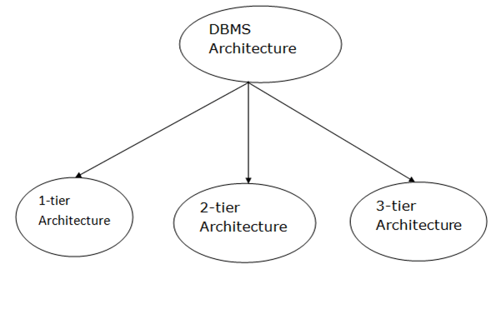
Database architecture can be seen as a single tier or multi-tier. But logically, database architecture is of two types like: 2-tier architecture and 3-tier architecture.

1-Tier Architecture
- In this architecture, the database is directly available to the user. It means the user can directly sit on the DBMS and uses it.
- Any changes done here will directly be done on the database itself. It doesn't provide a handy tool for end users.
- The 1-Tier architecture is used for development of the local application, where programmers can directly communicate with the database for the quick response.

2-Tier Architecture
- The 2-Tier architecture is same as basic client-server. In the two-tier architecture, applications on the client end can directly communicate with the database at the server side. For this interaction, API's like: ODBC, JDBC are used.
- The user interfaces and application programs are run on the client-side.
- The server side is responsible to provide the functionalities like: query processing and transaction management.
- To communicate with the DBMS, client-side application establishes a connection with the server side.
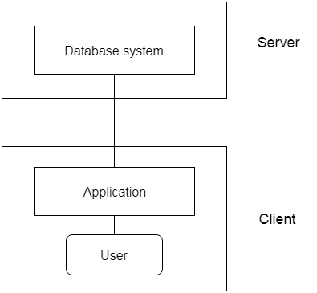
Fig: 2-tier Architecture

3-Tier Architecture
- The 3-Tier architecture contains another layer between the client and server. In this architecture, client can't directly communicate with the server.
- The application on the client-end interacts with an application server which further communicates with the database system.
- End user has no idea about the existence of the database beyond the application server. The database also has no idea about any other user beyond the application.
- The 3-Tier architecture is used in case of large web application.
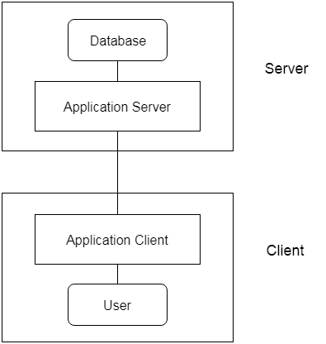
Fig: 3-tier Architecture

