ER Diagrams | ER Diagram Symbols

ER diagram-
- ER diagram or Entity Relationship diagram is a conceptual model that gives the graphical representation of the logical structure of the database.
- It shows all the constraints and relationships that exist among the different components.

Components of ER diagram-

An ER diagram is mainly composed of following three components-
- Entity Sets
- Attributes
- Relationship Set

Example-

Consider the following Student table-

Roll_no | Name | Age
1 | Akshay | 20
2 | Rahul | 19
3 | Pooja | 20
4 | Aarti | 19

This complete table is referred to as “Student Entity Set” and each row represents an “entity”.

Representation as ER Diagram-

The above table may be represented as ER diagram as-

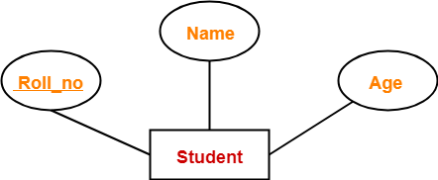

Here,
- Roll_no is a primary key that can identify each entity uniquely.
- Thus, by using student’s roll number, a student can be identified uniquely.

ER Diagram Symbols-

An ER diagram is composed of several components and each component in ER diagram is represented using a specific symbol.
ER diagram symbols are discussed below-

1. For Entity Sets-

An entity set is a set of same type of entities.
An entity refers to any object having-
- Either a physical existence such as a particular person, office, house or car.
- Or a conceptual existence such as a school or a company.

An entity set may be of the following two types-

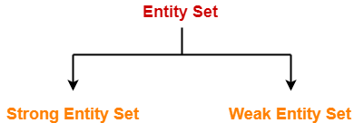

- Strong entity set
- Weak entity set

1. Strong Entity Set-

- A strong entity set possess its own primary key.
- It is represented using a single rectangle.

2. Weak Entity Set-

- A weak entity set do not possess its own primary key.
- It is represented using a double rectangle.

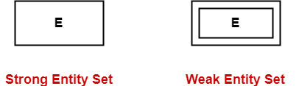

Read more- Entity Sets in DBMS

2. For Relationship Sets-

- Relationship defines an association among several entities.
- A relationship set is a set of same type of relationships.

A relationship set may be of the following two types-

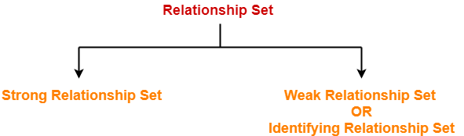

- Strong relationship set
- Weak relationship set

1. Strong Relationship Set-

- A strong relationship exists between two strong entity sets.
- It is represented using a diamond symbol.

2. Weak Relationship Set-

- A weak or identifying relationship exists between the strong and weak entity set.
- It is represented using a double diamond symbol.

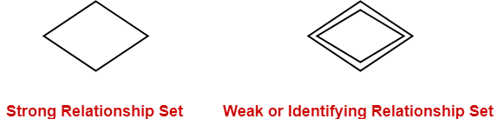

Read more- Relationship Sets in DBMS

3. For Attributes-

- Attributes are the properties which describes the entities of an entity set.
- There are several types of attributes.

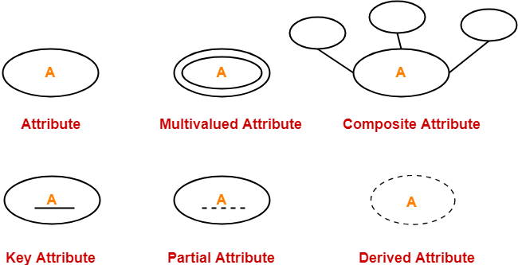

Read more- Attributes in ER Diagram

4. For Participation Constraints-

Participation constraint defines the least number of relationship instances in which an entity has to necessarily participate.
There are two types of participation constraints-

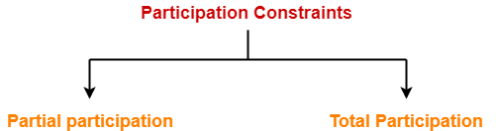
- Partial participation
- Total participation

1. Partial Participation-

Partial participation is represented using a single line between the entity set and relationship set.

2. Total Participation-

Total participation is represented using a double line between the entity set and relationship set.

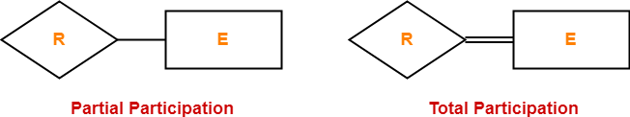

Read more- Participation Constraints in DBMS

5. For Specialization and Generalization-

- Generalization is a process of forming a generalized super class by extracting the common characteristics from two or more classes.
- Specialization is a reverse process of generalization where a super class is divided into sub classes by assigning the specific characteristics of sub classes to them.

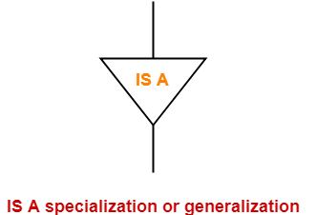

6. For Cardinality Constraints / Ratios-

Cardinality constraint defines the maximum number of relationship instances in which an entity can participate.
There are 4 types of cardinality ratios-

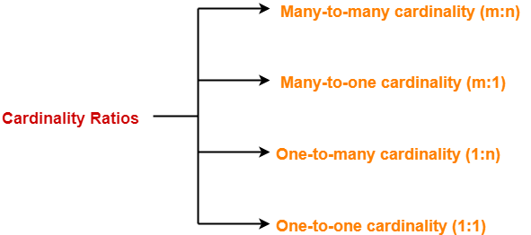

- Many-to-many cardinality (m:n)
- Many-to-one cardinality (m:1)
- One-to-many cardinality (1:n)
- One-to-one cardinality (1:1)

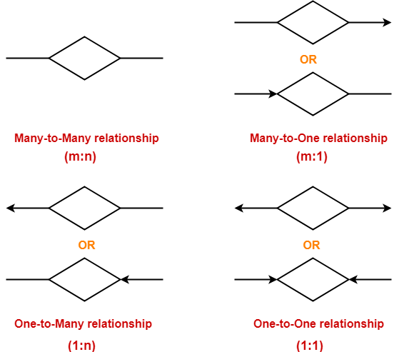

Entity Set in DBMS-
An entity set is a set of same type of entities.

An entity refers to any object having-
- Either a physical existence such as a particular person, office, house or car.
- Or a conceptual existence such as a school, a university, a company or a job.

In ER diagram,
- Attributes are associated with an entity set.
- Attributes describe the properties of entities in the entity set.
- Based on the values of certain attributes, an entity can be identified uniquely.

Types of Entity Sets-

An entity set may be of the following two types-

- Strong entity set
- Weak entity set

1. Strong Entity Set-
- A strong entity set is an entity set that contains sufficient attributes to uniquely identify all its entities.
- In other words, a primary key exists for a strong entity set.
- Primary key of a strong entity set is represented by underlining it.

Symbols Used-

- A single rectangle is used for representing a strong entity set.
- A diamond symbol is used for representing the relationship that exists between two strong entity sets.
- A single line is used for representing the connection of the strong entity set with the relationship set.
- A double line is used for representing the total participation of an entity set with the relationship set.
- Total participation may or may not exist in the relationship.

Example-

Consider the following ER diagram-
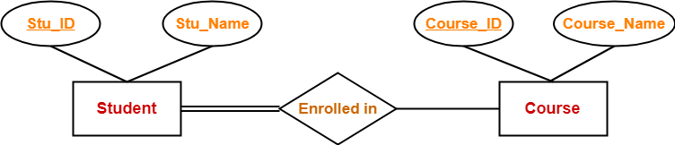
In this ER diagram,

- Two strong entity sets “Student” and “Course” are related to each other.
- Student ID and Student name are the attributes of entity set “Student”.
- Student ID is the primary key using which any student can be identified uniquely.
- Course ID and Course name are the attributes of entity set “Course”.
- Course ID is the primary key using which any course can be identified uniquely.
- Double line between Student and relationship set signifies total participation.
- It suggests that each student must be enrolled in at least one course.
- Single line between Course and relationship set signifies partial participation.
- It suggests that there might exist some courses for which no enrollments are made.

2. Weak Entity Set-

- A weak entity set is an entity set that does not contain sufficient attributes to uniquely identify its entities.
- In other words, a primary key does not exist for a weak entity set.
- However, it contains a partial key called as a discriminator.
- Discriminator can identify a group of entities from the entity set.
- Discriminator is represented by underlining with a dashed line.

NOTE-

- The combination of discriminator and primary key of the strong entity set makes it possible to uniquely identify all entities of the weak entity set.
- Thus, this combination serves as a primary key for the weak entity set.
- Clearly, this primary key is not formed by the weak entity set completely.

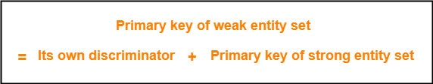

Symbols Used-
- A double rectangle is used for representing a weak entity set.
- A double diamond symbol is used for representing the relationship that exists between the strong and weak entity sets and this relationship is known as identifying relationship.
- A double line is used for representing the connection of the weak entity set with the relationship set.
- Total participation always exists in the identifying relationship.

Example-

Consider the following ER diagram-

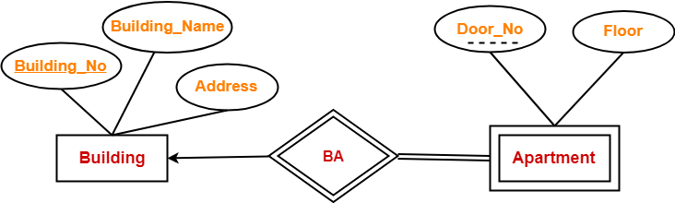

In this ER diagram,

- One strong entity set “Building” and one weak entity set “Apartment” are related to each other.
- Strong entity set “Building” has building number as its primary key.
- Door number is the discriminator of the weak entity set “Apartment”.
- This is because door number alone can not identify an apartment uniquely as there may be several other buildings having the same door number.
- Double line between Apartment and relationship set signifies total participation.
- It suggests that each apartment must be present in at least one building.
- Single line between Building and relationship set signifies partial participation.
- It suggests that there might exist some buildings which has no apartment.

To uniquely identify any apartment,
- First, building number is required to identify the particular building.
- Secondly, door number of the apartment is required to uniquely identify the apartment.

Thus,
Primary key of Apartment
= Primary key of Building + Its own discriminator
= Building number + Door number

Differences between Strong entity set and Weak entity set-

Strong entity set | Weak entity set
A single rectangle is used for the representation of a strong entity set. | A double rectangle is used for the representation of a weak entity set.
It contains sufficient attributes to form its primary key. | It does not contain sufficient attributes to form its primary key.
A diamond symbol is used for the representation of the relationship that exists between the two strong entity sets. | A double diamond symbol is used for the representation of the identifying relationship that exists between the strong and weak entity set.
A single line is used for the representation of the connection between the strong entity set and the relationship. | A double line is used for the representation of the connection between the weak entity set and the relationship set.
Total participation may or may not exist in the relationship. | Total participation always exists in the identifying relationship.

Important Note-

In ER diagram, weak entity set is always present in total participation with the identifying relationship set.
So, we always have the picture like shown here-

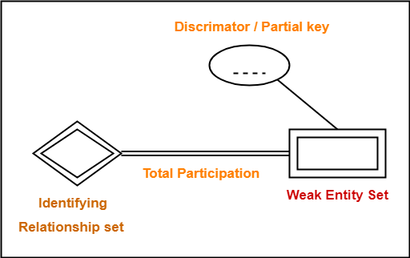

Relationship Sets | DBMS
Database Management System

Relationship in DBMS-

A relationship is defined as an association among several entities.

Example-

‘Enrolled in’ is a relationship that exists between entities Student and Course.

Relationship Set-

A relationship set is a set of relationships of same type.

Example-

Set representation of above ER diagram is-

Degree of a Relationship Set-

The number of entity sets that participate in a relationship set is termed as the degree of that relationship set. Thus,

Degree of a relationship set = Number of entity sets participating in a relationship set

Types of Relationship Sets-

On the basis of degree of a relationship set, a relationship set can be classified into the following types-

- Unary relationship set
- Binary relationship set
- Ternary relationship set
- N-ary relationship set

1. Unary Relationship Set-

Unary relationship set is a relationship set where only one entity set participates in a relationship set.

Example-
One person is married to only one person

2. Binary Relationship Set-

Binary relationship set is a relationship set where two entity sets participate in a relationship set.

Example-
Student is enrolled in a Course

3. Ternary Relationship Set-

Ternary relationship set is a relationship set where three entity sets participate in a relationship set.

Example-

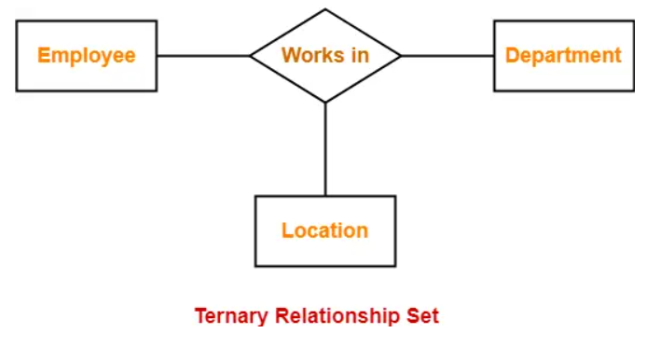

4. N-ary Relationship Set-

N-ary relationship set is a relationship set where ‘n’ entity sets participate in a relationship set.

Cardinality in ER Diagram | DBMS
Database Management System

Cardinality Constraint-
Cardinality constraint defines the maximum number of relationship instances in which an entity can participate.

Types of Cardinality Ratios-
There are 4 types of cardinality ratios-

- Many-to-Many cardinality (m:n)
- Many-to-One cardinality (m:1)
- One-to-Many cardinality (1:n)
- One-to-One cardinality (1:1 )

1. Many-to-Many Cardinality-

By this cardinality constraint,
- An entity in set A can be associated with any number (zero or more) of entities in set B.
- An entity in set B can be associated with any number (zero or more) of entities in set A.

Symbol Used-
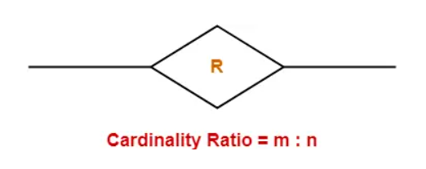

Example-
Consider the following ER diagram-
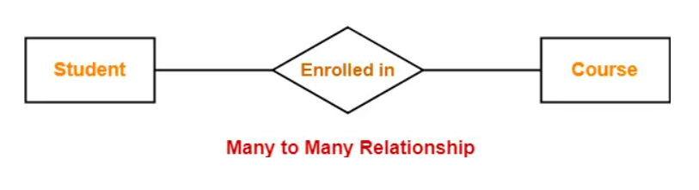
Here,
- One student can enroll in any number (zero or more) of courses.
- One course can be enrolled by any number (zero or more) of students.

2. Many-to-One Cardinality-

By this cardinality constraint,
- An entity in set A can be associated with at most one entity in set B.
- An entity in set B can be associated with any number (zero or more) of entities in set A.

Symbol Used-

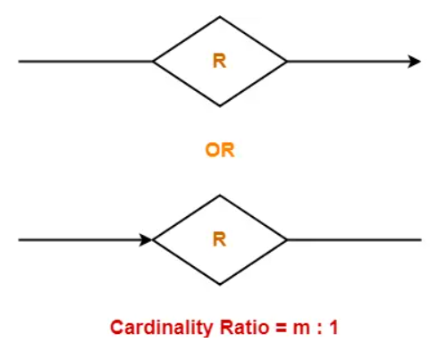

Example-

Consider the following ER diagram-

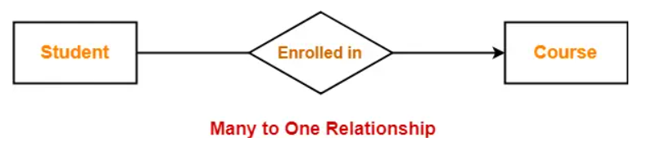

Here,
- One student can enroll in at most one course.
- One course can be enrolled by any number (zero or more) of students.

3. One-to-Many Cardinality-

By this cardinality constraint,
- An entity in set A can be associated with any number (zero or more) of entities in set B.
- An entity in set B can be associated with at most one entity in set A.

Symbol Used-

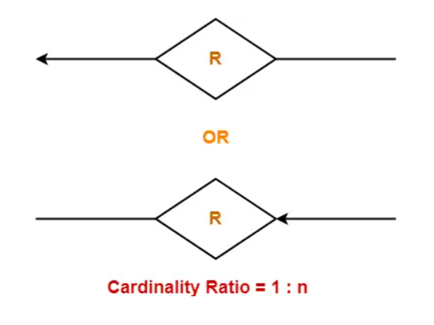
Example-
Consider the following ER diagram-

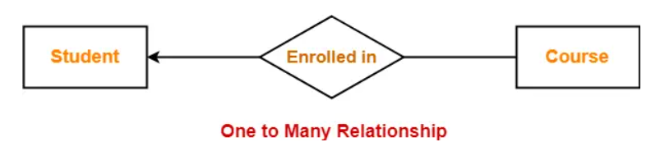
Here,
- One student can enroll in any number (zero or more) of courses.
- One course can be enrolled by at most one student.

4. One-to-One Cardinality-

By this cardinality constraint,
- An entity in set A can be associated with at most one entity in set B.
- An entity in set B can be associated with at most one entity in set A.

Symbol Used-

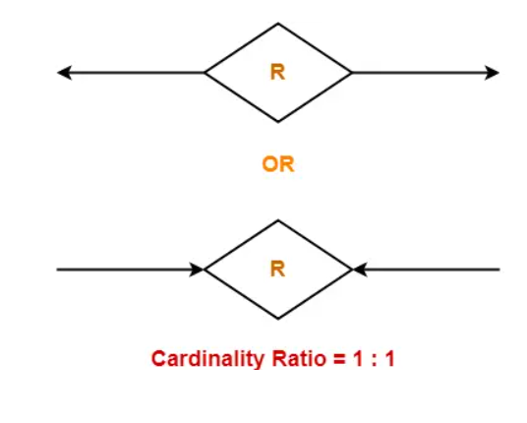

Example-

Consider the following ER diagram-

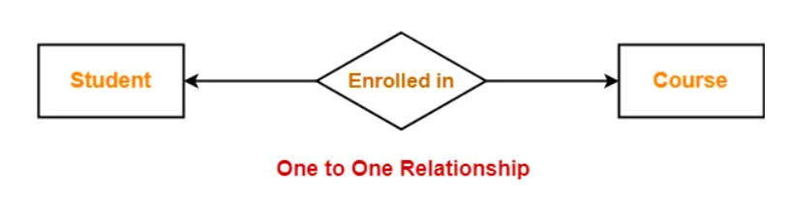

Here,
- One student can enroll in at most one course.
- One course can be enrolled by at most one student.

Participation Constraints | DBMS
Database Management System

Participation Constraints-

Participation constraints define the least number of relationship instances in which an entity must compulsorily participate.

Types of Participation Constraints-

There are two types of participation constraints-

- Total participation
- Partial participation

1. Total Participation-
- It specifies that each entity in the entity set must compulsorily participate in at least one relationship instance in that relationship set.
- That is why, it is also called as mandatory participation.
- Total participation is represented using a double line between the entity set and relationship set.
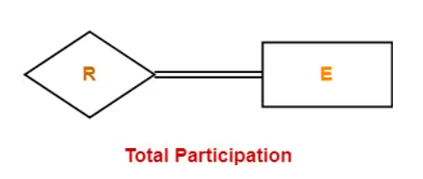

Example-

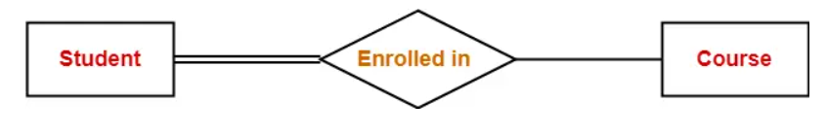
Here,
- Double line between the entity set “Student” and relationship set “Enrolled in” signifies total participation.
- It specifies that each student must be enrolled in at least one course.

2. Partial Participation-

- It specifies that each entity in the entity set may or may not participate in the relationship instance in that relationship set.
- That is why, it is also called as optional participation.
- Partial participation is represented using a single line between the entity set and relationship set.
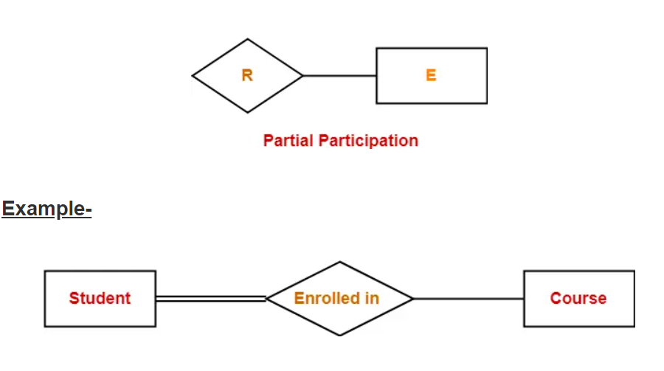
Here,
- Single line between the entity set “Course” and relationship set “Enrolled in” signifies partial participation.
- It specifies that there might exist some courses for which no enrollments are made.

Relationship between Cardinality and Participation Constraints-

Minimum cardinality tells whether the participation is partial or total.
- If minimum cardinality = 0, then it signifies partial participation.
- If minimum cardinality = 1, then it signifies total participation.
Maximum cardinality tells the maximum number of entities that participates in a relationship set.

Types of Attributes | DBMS
Database Management System

Attributes in ER Diagram-
- Attributes are the descriptive properties which are owned by each entity of an Entity Set.
- There exist a specific domain or set of values for each attribute from where the attribute can take its values.

Types of Attributes-

In ER diagram, attributes associated with an entity set may be of the following types-
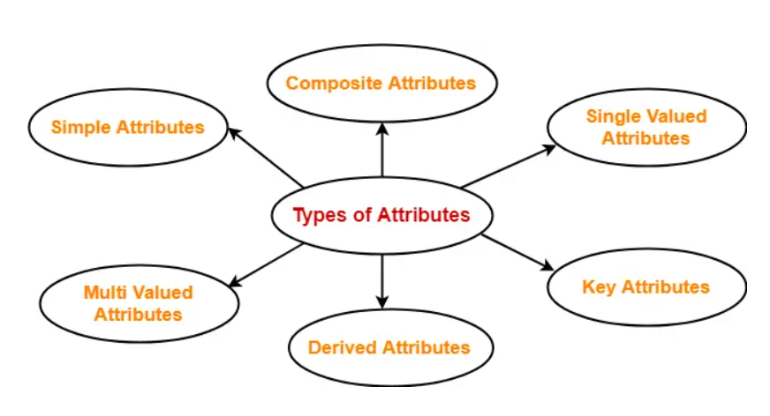
- Simple attributes
- Composite attributes
- Single valued attributes
- Multi valued attributes
- Derived attributes
- Key attributes

1. Simple Attributes-

Simple attributes are those attributes, which cannot be divided further.

Example-

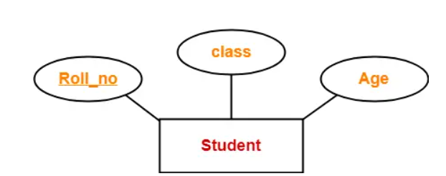
Here, all the attributes are simple attributes as they can not be divided further.

2. Composite Attributes-

Composite attributes are those attributes which are composed of many other simple attributes.

Example-
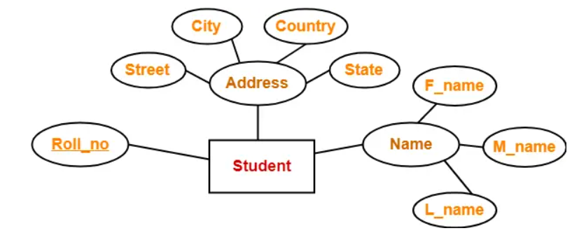
Here, the attributes “Name” and “Address” are composite attributes as they are composed of many other simple attributes.

3. Single Valued Attributes-

Single valued attributes are those attributes which can take only one value for a given entity from an entity set.

Example-

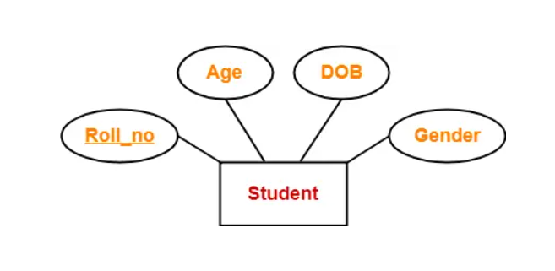

Here, all the attributes are single valued attributes as they can take only one specific value for each entity.

4. Multi Valued Attributes-

Multi valued attributes are those attributes which can take more than one value for a given entity from an entity set.

Example-

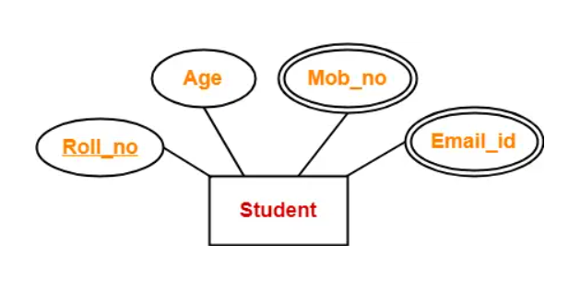

Here, the attributes “Mob_no” and “Email_id” are multi valued attributes as they can take more than one values for a given entity.

5. Derived Attributes-
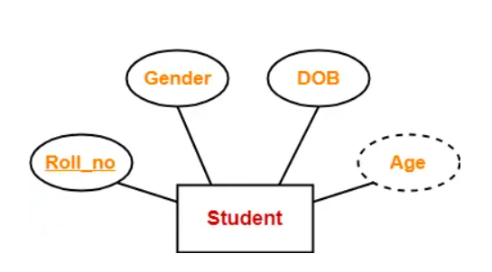
Here, the attribute “Age” is a derived attribute as it can be derived from the attribute “DOB”.

6. Key Attributes-

Key attributes are those attributes which can identify an entity uniquely in an entity set.

Example-
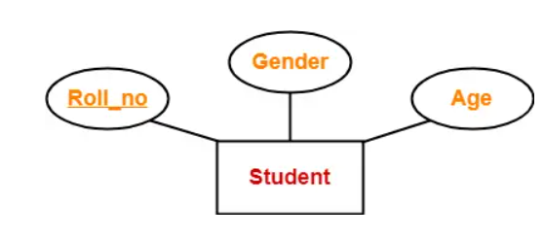

Here, the attribute “Roll_no” is a key attribute as it can identify any student uniquely.

ER Diagrams to Tables

Converting ER Diagrams to Tables-
After designing an ER Diagram,
- ER diagram is converted into the tables in relational model.
- This is because relational models can be easily implemented by RDBMS like MySQL , Oracle etc.

Following rules are used for converting an ER diagram into the tables-

Rule-01: For Strong Entity Set With Only Simple Attributes-

A strong entity set with only simple attributes will require only one table in relational model.
- Attributes of the table will be the attributes of the entity set.
- The primary key of the table will be the key attribute of the entity set.

Example-

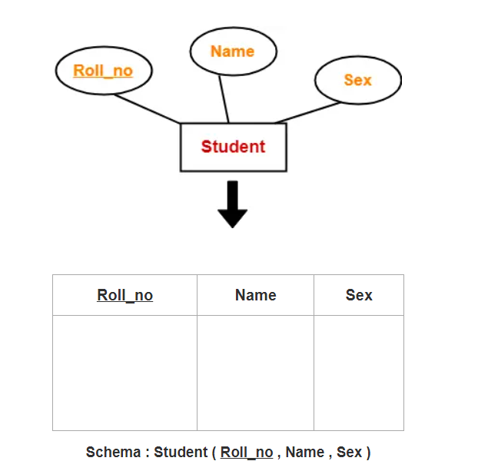

Rule-02: For Strong Entity Set With Composite Attributes-

- A strong entity set with any number of composite attributes will require only one table in relational model.
- While conversion, simple attributes of the composite attributes are taken into account and not the composite attribute itself.

Example-
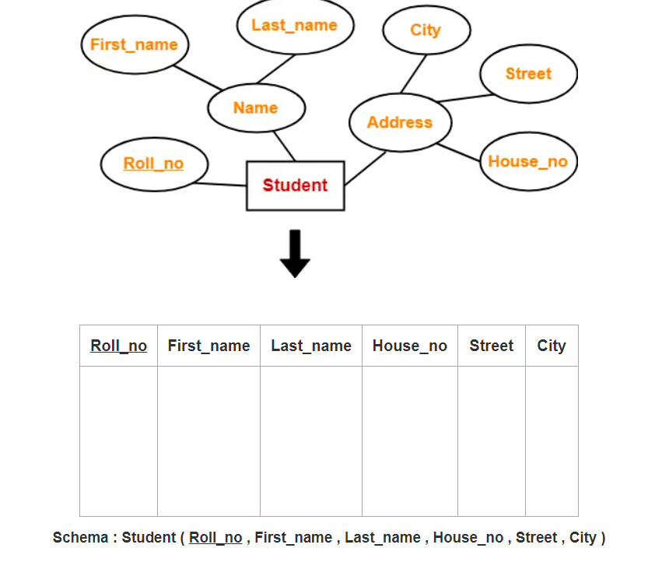

Rule-03: For Strong Entity Set With Multi Valued Attributes-

A strong entity set with any number of multi valued attributes will require two tables in relational model.
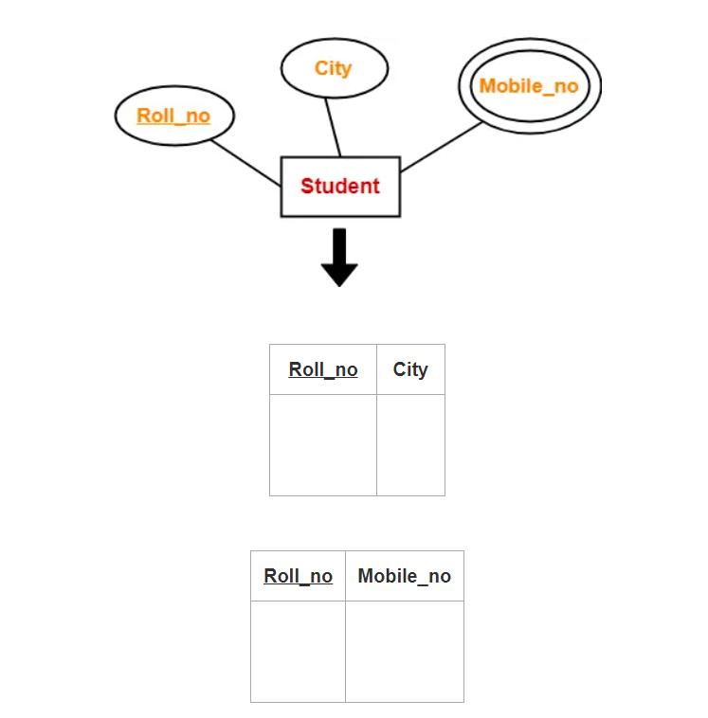

Rule-04: Translating Relationship Set into a Table-

A relationship set will require one table in the relational model.
Attributes of the table are-
- Primary key attributes of the participating entity sets
- Its own descriptive attributes if any.
Set of non-descriptive attributes will be the primary key.

Example-
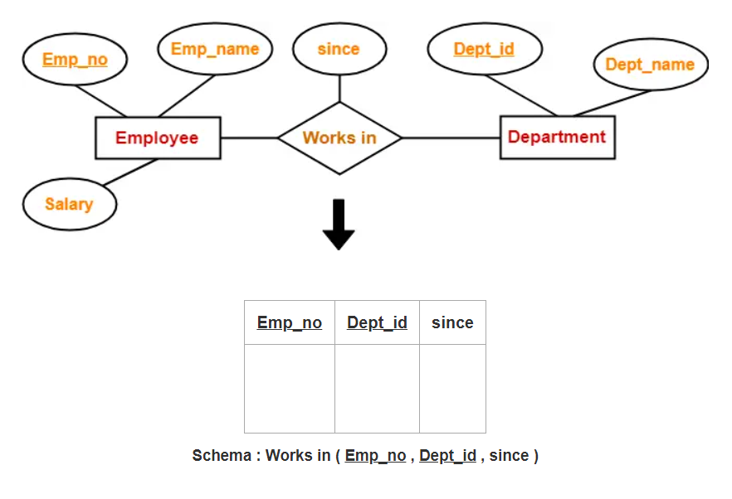

NOTE-
If we consider the overall ER diagram, three tables will be required in relational model-
- One table for the entity set “Employee”
- One table for the entity set “Department”
- One table for the relationship set “Works in”

Rule-05: For Binary Relationships With Cardinality Ratios-

The following four cases are possible-

Case-01: Binary relationship with cardinality ratio m:n
Case-02: Binary relationship with cardinality ratio 1:n
Case-03: Binary relationship with cardinality ratio m:1
Case-04: Binary relationship with cardinality ratio 1:1

Also read- Cardinality Ratios in DBMS

Case-01: For Binary Relationship With Cardinality Ratio m:n

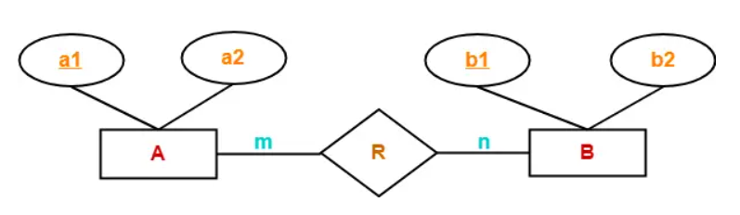

Here, three tables will be required-
- A ( a1 , a2 )
- R ( a1 , b1 )
- B ( b1 , b2 )

Case-02: For Binary Relationship With Cardinality Ratio 1:n
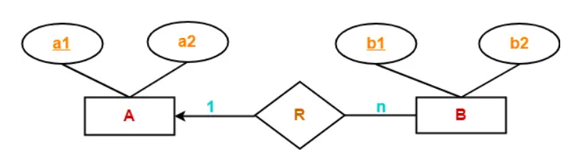

Here, two tables will be required-
- A ( a1 , a2 )
- BR ( a1 , b1 , b2 )

NOTE- Here, combined table will be drawn for the entity set B and relationship set R.

Case-03: For Binary Relationship With Cardinality Ratio m:1

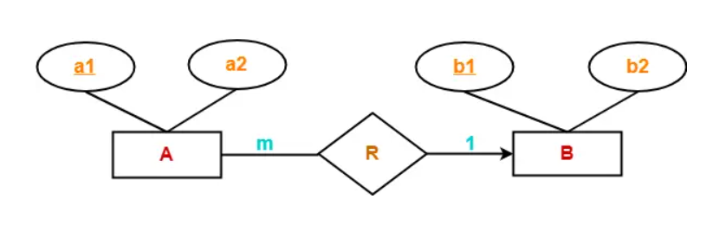

Here, two tables will be required-
- AR ( a1 , a2 , b1 )
- B ( b1 , b2 )

Case-04: For Binary Relationship With Cardinality Ratio 1:1

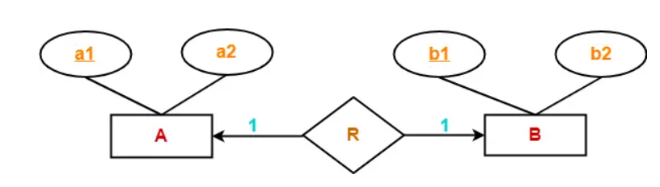

Here, two tables will be required. Either combine ‘R’ with ‘A’ or ‘B’

Way-01:
- AR ( a1 , a2 , b1 )
- B ( b1 , b2 )

Way-02:
- A ( a1 , a2 )
- BR ( a1 , b1 , b2 )

Thumb Rules to Remember

While determining the minimum number of tables required for binary relationships with given cardinality ratios, following thumb rules must be kept in mind-
- For binary relationship with cardinality ration m : n , separate and individual tables will be drawn for each entity set and relationship.
- For binary relationship with cardinality ratio either m : 1 or 1 : n , always remember “many side will consume the relationship” i.e. a combined table will be drawn for many side entity set and relationship set.
- For binary relationship with cardinality ratio 1 : 1 , two tables will be required. You can combine the relationship set with any one of the entity sets.

Rule-06: For Binary Relationship With Both Cardinality Constraints and Participation Constraints-

- Cardinality constraints will be implemented as discussed in Rule-05.
- Because of the total participation constraint, foreign key acquires NOT NULL constraint i.e. now foreign key can not be null.

Case-01: For Binary Relationship With Cardinality Constraint and Total Participation Constraint From One Side-

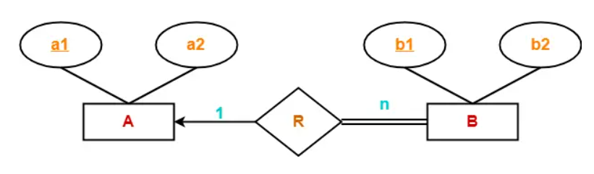
Because cardinality ratio = 1 : n , so we will combine the entity set B and relationship set R.

Then, two tables will be required-
- A ( a1 , a2 )
- BR ( a1 , b1 , b2 )
Because of total participation, foreign key a1 has acquired NOT NULL constraint, so it can’t be null now.

Case-02: For Binary Relationship With Cardinality Constraint and Total Participation Constraint From Both Sides-

If there is a key constraint from both the sides of an entity set with total participation, then that binary relationship is represented using only single table.
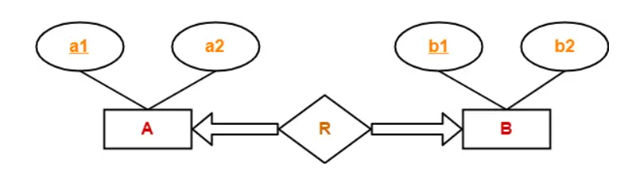
Here, Only one table is required.
- ARB ( a1 , a2 , b1 , b2 )

Rule-07: For Binary Relationship With Weak Entity Set-

Weak entity set always appears in association with identifying relationship with total participation constraint.

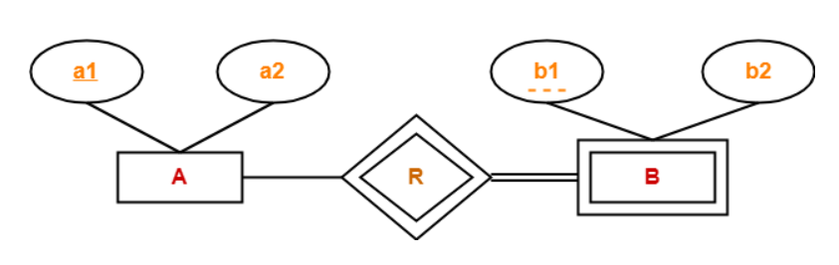
Here, two tables will be required-
- A ( a1 , a2 )
- BR ( a1 , b1 , b2 )

ER Diagrams to Tables-
After designing an ER Diagram,
- ER diagram is converted into the tables in relational model.
- This is because relational models can be easily implemented by RDBMS like MySQL , Oracle etc.
- The rules used for converting an ER diagram into the tables are already discussed.

PRACTICE PROBLEMS BASED ON CONVERTING ER DIAGRAM TO TABLES-

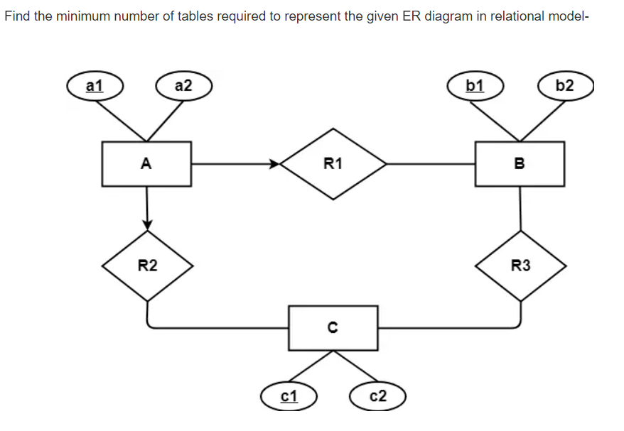

Problem-03:

Find the minimum number of tables required to represent the given ER diagram in relational model-
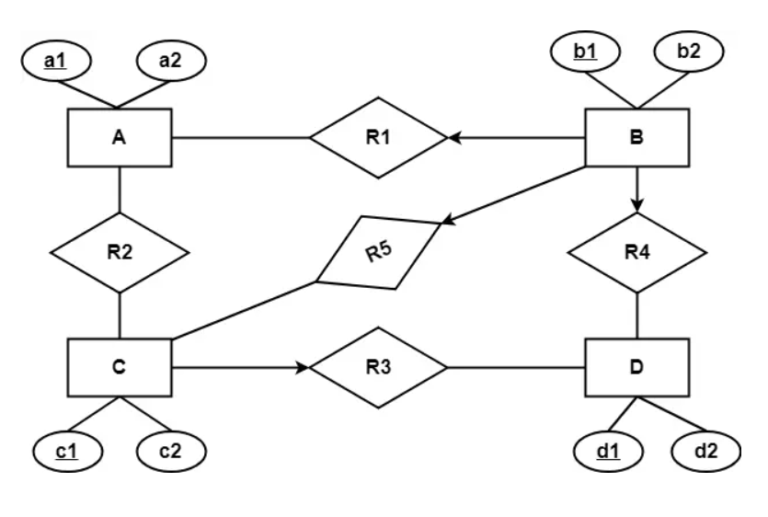

Solution-

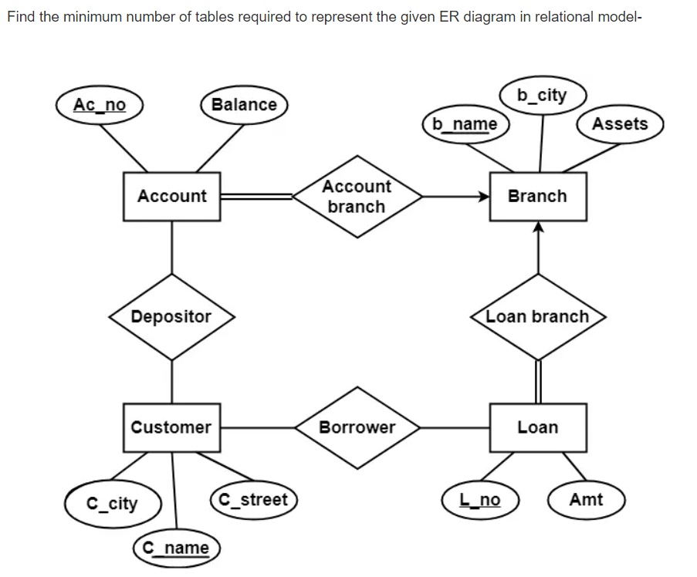

Solution-

