MySQL View
A view is a database object that has no values. Its contents are based on the base table. It contains rows and columns similar to the real table. In MySQL, the View is a virtual table created by a query by joining one or more tables. It is operated similarly to the base table but does not contain any data of its own. The View and table have one main difference that the views are definitions built on top of other tables (or views). If any changes occur in the underlying table, the same changes reflected in the View also.
MySQL allows us to create a view in mainly two ways:
- MySQL Command line client
- MySQL Workbench

MySQL Command Line Client
We can create a new view by using the CREATE VIEW and SELECT statement. SELECT statements are used to take data from the source table to make a VIEW.

Syntax
Following is the syntax to create a view in MySQL:
- CREATE [OR REPLACE] VIEW view_name AS
- SELECT columns
- FROM tables
- [WHERE conditions];

Parameters:
The view syntax contains the following parameters:
OR REPLACE: It is optional. It is used when a VIEW already exists. If you do not specify this clause and the VIEW already exists, the CREATE VIEW statement will return an error.
view_name: It specifies the name of the VIEW that you want to create in MySQL.
WHERE conditions: It is also optional. It specifies the conditions that must be met for the records to be included in the VIEW.

Example
Let us understand it with the help of an example. Suppose our database has a table course, and we are going to create a view based on this table. Thus, the below example will create a VIEW name "trainer" that creates a virtual table made by taking data from the table courses.

- CREATE VIEW trainer AS
- SELECT course_name, trainer
- FROM courses;
Once the execution of the CREATE VIEW statement becomes successful, MySQL will create a view and stores it in the database.
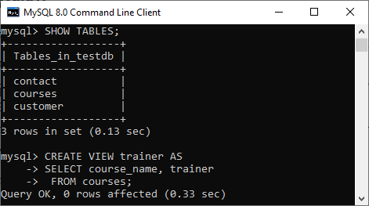
To see the created VIEW
We can see the created view by using the following syntax:
- SELECT * FROM view_name;
Let's see how it looks the created VIEW:
- SELECT * FROM trainer;
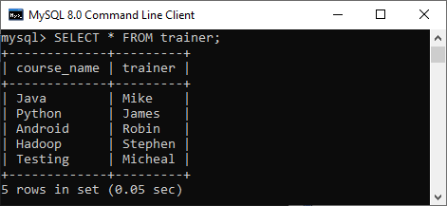

NOTE: It is essential to know that a view does not store the data physically. When we execute the SELECT statement for the view, MySQL uses the query specified in the view's definition and produces the output. Due to this feature, it is sometimes referred to as a virtual table.

MySQL Update VIEW
In MYSQL, the ALTER VIEW statement is used to modify or update the already created VIEW without dropping it.
Syntax:
Following is the syntax used to update the existing view in MySQL:
- ALTER VIEW view_name AS
- SELECT columns
- FROM table
- WHERE conditions;
Example:
The following example will alter the already created VIEW name "trainer" by adding a new column.
- ALTER VIEW trainer AS
- SELECT id, course_name, trainer
- FROM courses;
Once the execution of the ALTER VIEW statement becomes successful, MySQL will update a view and stores it in the database. We can see the altered view using the SELECT statement, as shown in the output:
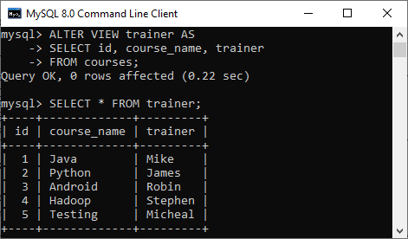

MySQL Drop VIEW
We can drop the existing VIEW by using the DROP VIEW statement.
Syntax:
The following is the syntax used to delete the view:
- DROP VIEW [IF EXISTS] view_name;
Parameters:
view_name: It specifies the name of the VIEW that we want to drop.
IF EXISTS: It is optional. If we do not specify this clause and the VIEW doesn't exist, the DROP VIEW statement will return an error.
Example:
Suppose we want to delete the view "trainer" that we have created above. Execute the below statement:
- DROP VIEW trainer;
After successful execution, it is required to verify the view is available or not as below:
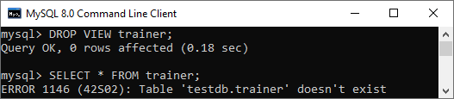

MySQL Create View with JOIN Clause
Here, we will see the complex example of view creation that involves multiple tables and uses a join clause.
Suppose we have two sample table as shown below:
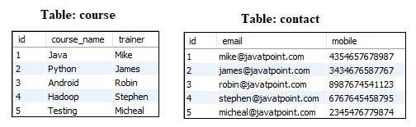
Now execute the below statement that will create a view Trainer along with the join statement:
- CREATE VIEW Trainer
- AS SELECT c.course_name, c.trainer, t.email
- FROM courses c, contact t
- WHERE c.id = t.id;
We can verify the view using the SELECT statement shown in the below image:
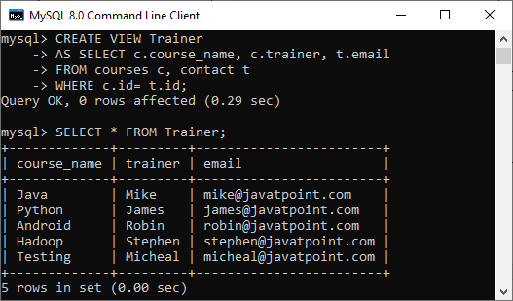

SQL Server Create View
A view is a virtual table created according to the result set of an SQL statement.
A view contains rows and columns, just like a real table. The columns in the view are the columns from one or more real tables in the database. SQL functions, WHERE, and JOIN statements can also be added to the view.
There are two ways to create a view in SQL Server:
- By using SQL Server management studio UI.
- By using SQL Server query statement.

By using SQL Server query statement.

Syntax:
- CREATE VIEW view_name AS
- SELECT column1, column2, ...
- FROM table_name
- WHERE condition;

SQL Create VIEW Example
Let's create a view named "Student_name" which contains all data from table "Student" where id is >3.
- CREATE VIEW [Student_view] AS
- SELECT id, name, age
- FROM [student]
- WHERE id > 3;
Output:
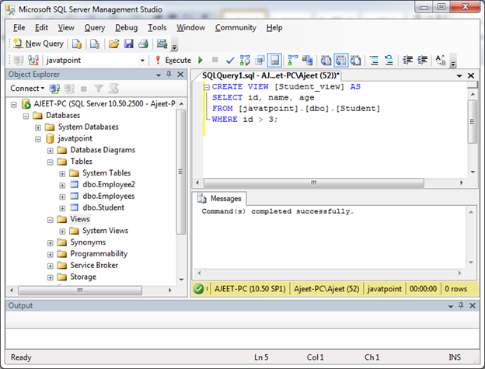
View is created successfully.
You can verify that created view:
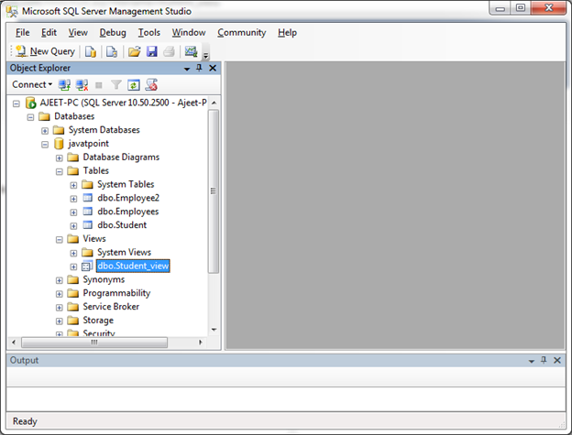
Now query the view:
- SELECT * FROM [Student_view];
Output:
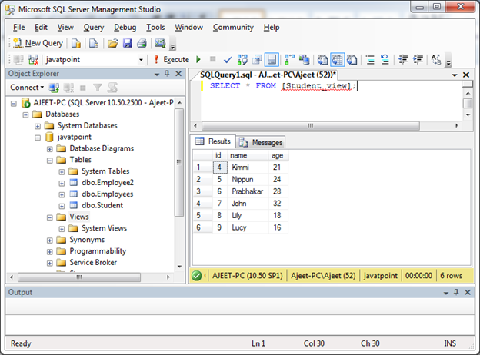

Update a View
You can update a view by using ALTER VIEW statement.
Syntax:
- CREATE OR REPLACE VIEW view_name AS
- SELECT column1, column2, ...
- FROM table_name
- WHERE condition;
Now add a column "fee" to the created view "Student_view" from the table "Student". Use the following statement:
- ALTER VIEW [Student_view] AS
- SELECT id, name, age, fee
- FROM Student
- WHERE id > 3;
Output:
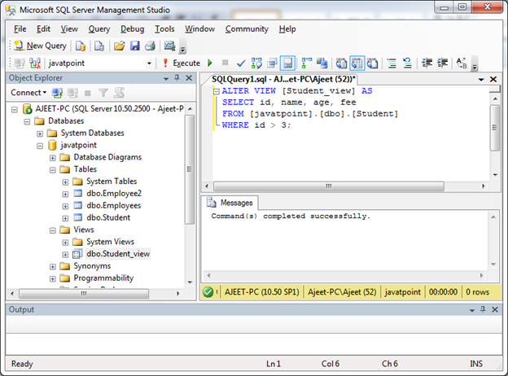
You can see that view is updated successfully. Verify it by using SELECT statement:
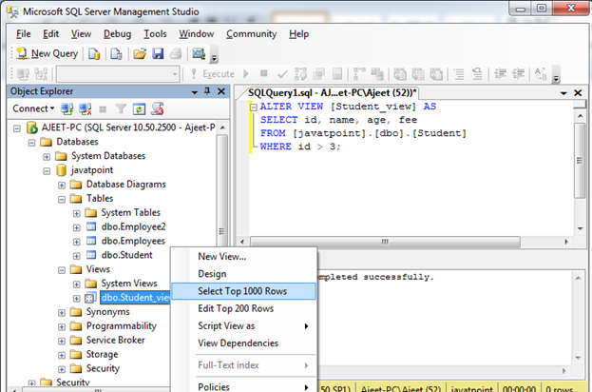
Output:
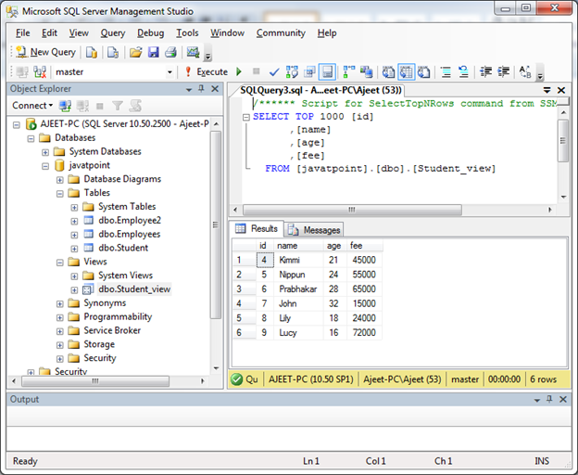

SQL Server DROP a View
DROP VIEW command is used to delete a view.
Syntax:
- DROP VIEW view_name;
Example:
Let's delete the view "Student_view".
- DROP VIEW [Student_view];
Output:
