Database Management System UNIT 1

Introduction to DBMS

Data - raw facts/details of the model

- DATABASE- A shared collection of logically related data designed to meet the organization needs .

- The Database Management System (DBMS) - software that enables users to define, create and maintain the database and provides controlled access to the database

Drawbacks of File processing system:

•Data redundancy and inconsistency
Multiple file formats, duplication of information in different files

- Difficulty in accessing data
Need to write a new program to carry out each new task

- Data isolation – since data scattered in various files & files in various format, it is difficult to write new application program to retrieve appropriate data.

- Integrity problems
Data value stored in database must satisfy certain types of consistency constraints
 Integrity constraints (e.g. account balance > 0) become “buried” in program code .

Hard to add new constraints or change existing ones

- Atomicity of updates
Failures may leave database in an inconsistent state with partial updates carried out.

Example: Transfer of funds from one account to another should either complete or not happen at all.

•Concurrent access by multiple users
Concurrent accessed needed for performance
 Uncontrolled concurrent accesses can lead to inconsistencies
–Example: Two people reading a balance and updating it at the same time

•Security problems
Hard to provide user access to some, but not all, data

Advantages Of DBMS System
  - Centralized management and control over data
Database administrator is the person having central control over the system.
  - Reduction of redundancies
Centralized control of data by DBA avoids unnecessary duplication of data.
  - Shared Data
DBMS allows the sharing of data under its control by any number of application programmers and users.
  - Integrity
Centralized control also ensures that adequate checks are incorporated in the database to provide data integrity.

    - Security
DBA can defined the access path for accessing the data stored in database & he can define authorization checks to sensitive data is attempted
    - Conflict Resolution
DBA resolves the conflicting requirements of various users and applications
    - Data Independence
DBA can modify the structure of data record. This modification do not affect other applications.

Database Applications
- DBMS contains information about a particular enterprise
- DBMS provides an environment that is both convenient and efficient
to use.
- Database Applications:

  - Banking: all transaction
  - Airlines: reservations, schedules
  - Universities: registration, grades
  - Sales: customers, products, purchases
  - Manufacturing: production, inventory, orders, supply chain
  - Human resources: employee records, salaries, tax deductions
- Databases touch all aspects of our lives

Data Abstraction

Purpose-Hides the certain details of how data stored & maintained, provide only abstract view.

There are 3 levels of abstraction

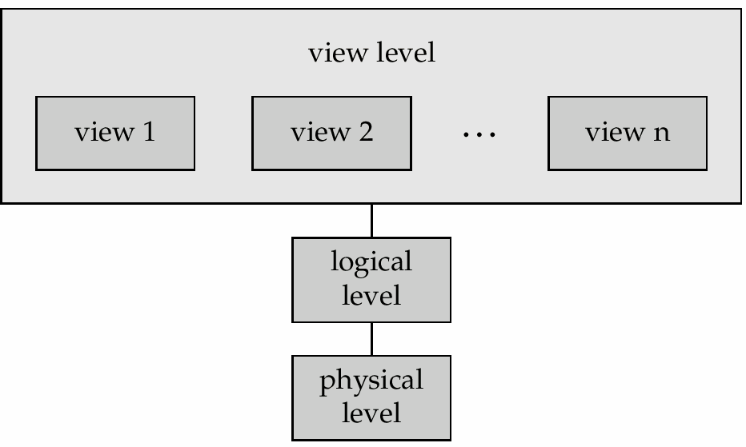view level logical level physical level

view level:- describe only part of entire database
- v1: select ssn from student
- v2: select ssn, c-id from takes
logical level:- it describes what data actually stored & relationship between them.
eg., tables
- Student(ssn, name)
- TAKES (ssn, c-id, grade)

physical level:
- how are these tables stored, how many bytes / attribute etc

Data Independence
The ability to modify a schema definition in one level without affecting a schema definition in the next higher level is called data independence.
Two levels of independence:
Logical data independence Physical data independence

Physical data independence—
The ability to modify physical level schema without affecting the logical or view level schema.
Logical data independence---
The ability to change the logical level scheme without affecting the view level schemes or application programs

Instances and Schemas
Similar to types and variables in programming languages
- Schema – The logical structure of the database
The overall design of a database ( i.e., the description of the database ) is called the database schema
  - e.g., the database consists of information about a set of customers and accounts and the relationship between them

- Instance – the actual content of the database at a particular point in time
The collection of information stored in the database at a particular moment is called an instance of database.
Analogous to the value of a variable

Schema diagram for UNIVERSITY database

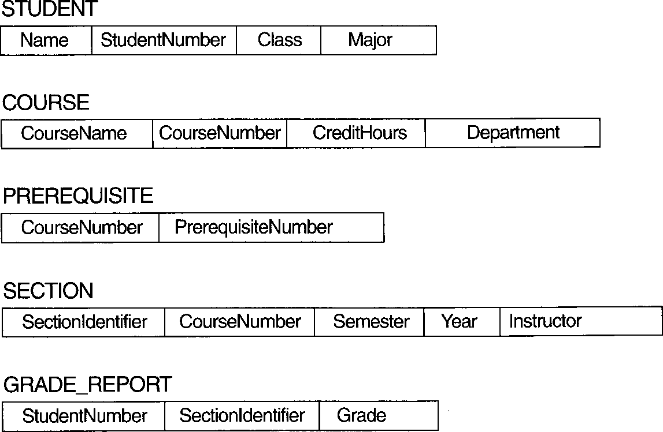

schema construct

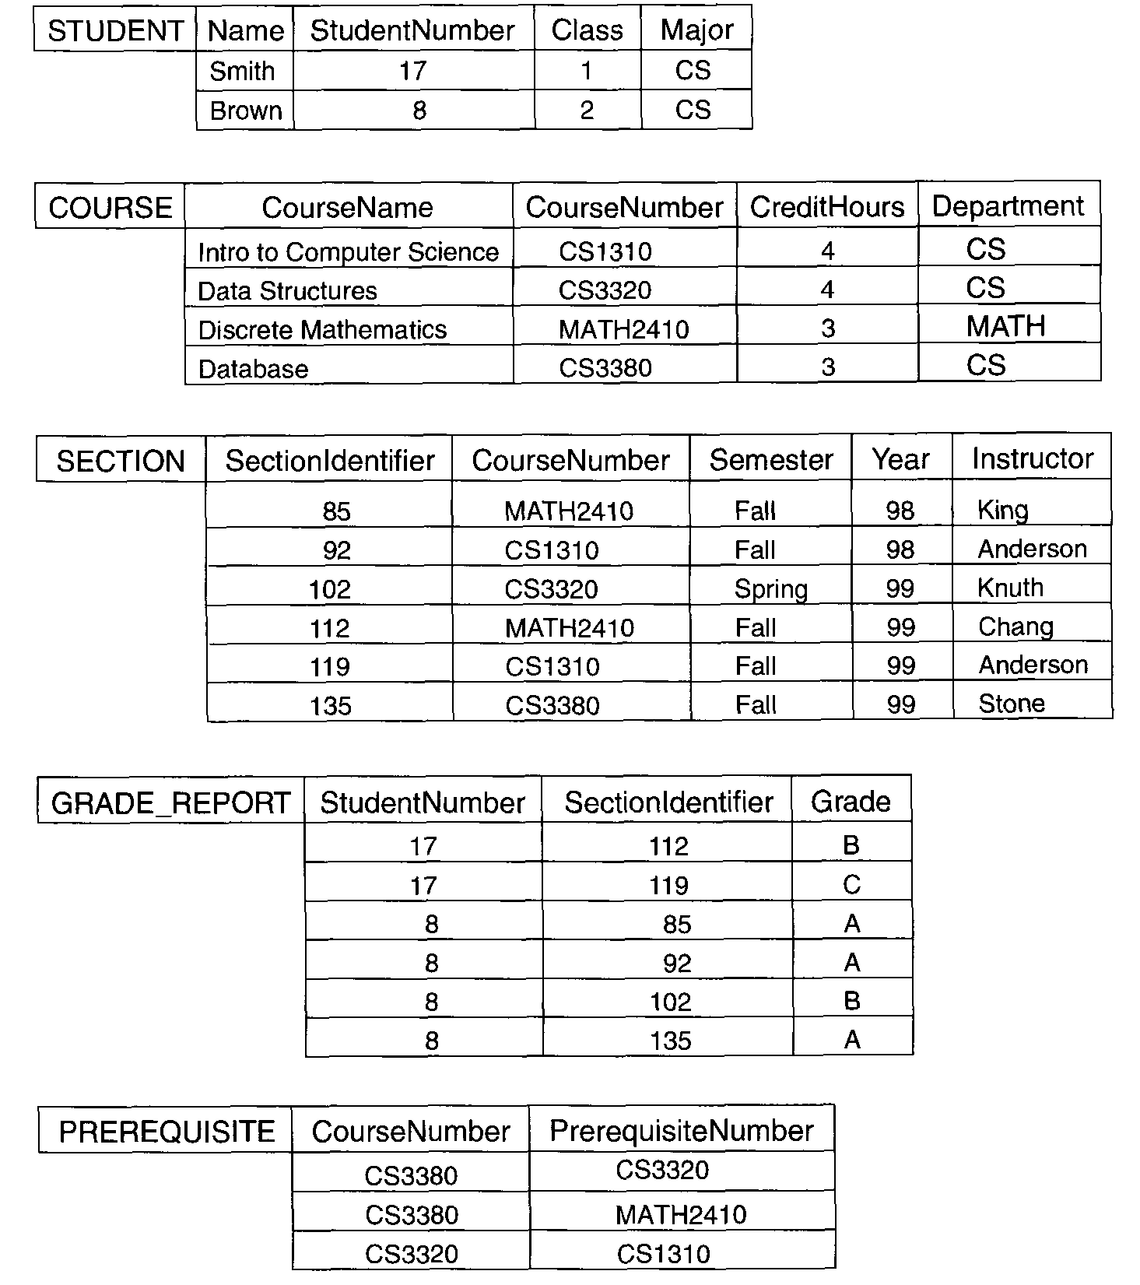Figure 1.2 UNIVERSITY Database

Data Models

It is a collection of conceptual tools for describing data, data relationship, data semantics & consistency constraints.

Different types of data models:

  - Entity-Relationship model

  - Relational model

  - Hierarchical model

  - Network model

  - object-oriented model

- Entity-Relationship model:-
It consist of
Entities (objects) : ex. customer ,bank account.
Relationships between entities: ex. John having account no. S15751

The set of all entities of same type & the set of all relationship of the same type are termed as an entity set & relationship set respectively .
E-R diagram consist of following components: Rectangles: which represent entity set.
Ellipses: which represent attributes
Diamonds: which represent relationship among entity sets
Lines :which link attributes to entity sets and entity sets to relationships.

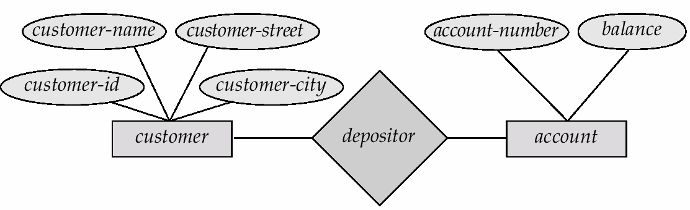
E-R diagram for banking system

Advantages:-
It is easy to develop relational model using E-R model It specify mapping cardinalities
It specifies key like primary key
We can specify generalization & specialization

Disadvantages:-
It is used for design not for implementation

Relational Model-
It represent data and relationships among those data by a collection of tables.
Each table has multiple columns and each column has a unique name.
Each table contains records of a particular type. Each record defines a fixed number of fields or attributes.
A relation having following rules----
Relation is a two-dimensional table.
- A tuple is a row in the table.
- Attribute is a column in the table.
- Each column in the table has a unique name within the table. 5.Each column has a domain , the set of possible values that can
appear in that column.
6.The order of the rows and columns is not important. & duplicate row are not allowed

- Example of tabular data in the relational model

Attributes

Customer- id | customer- name | customer- street | customer- city | account- number

tuple
192-83-7465 | Johnson | Alma | Palo Alto | A-101
019-28-3746 | Smith | North | Rye | A-215
192-83-7465 | Johnson | Alma | Palo Alto | A-201
321-12-3123 | Jones | Main | Harrison | A-217
019-28-3746 | Smith | North | Rye | A-201

domain

A Sample Relational Database

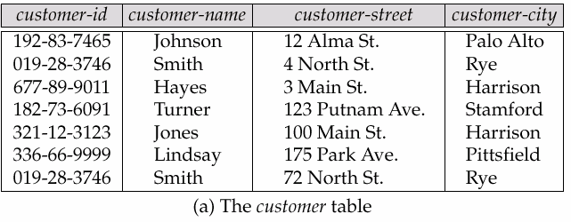
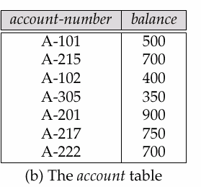
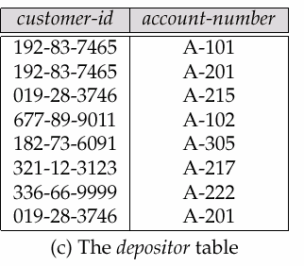

Advantages:

- Structural independence: when it is possible to make change to the database structure without affecting the DBMS ‘s capability to access data, we can say that structural independence In relational database changes in database do not affect the data access

- Conceptual simplicity: Relational database model is simpler at conceptual level. since the relational model frees the designer from the physical data storage details, the designer can concentrate on logical view of data base

- Design implementation, maintenance & usage ease: relational model achieves both data independence & structural independence making the database design , maintenance, administration ?& usage much easier than other models

Disadvantages:

•Significant hardware & software overheads

•Not as good for transaction process modeling as hierarchical & network models May have slower processing times than hierarchical & network model

Hierarchical Model-
It is a kind of data management system that links the records in tree data structure such that each record type has only one owner
.

course

subject

teacher
title
id
name
id
title
id

A sample Hierarchical Model

Advantages:

•High speed of access to large datasets
•Ease of updates
•Simplicity: design is simple
•Data security: It is the first model which provide data security
•Efficiency:- It is very efficient when database contain large number of 1:n relationships & when user require large number of transaction, using data whose relationships are fixed

Disadvantages:-

Implementation complexity:- although the hierarchical model is conceptually simple & easy to design it is quite complex to implement; Database management problems: If you make any changes in the database structure of hierarchical database ,then you need to make the necessary changes in all application programs that access the database Lack of structural independence:-Hierarchical database system use physical storage path to navigate to different data segments. so if physical structure is changed the application will also have to be modified. thus in a hierarchical database the benefits of independence is limited by structural dependence

Network Model-

Data in the Network Model are represented by collections of records and relationships among data are represented by links.
.The records in the database are organized as collections of arbitrary graphs.
sidehill
kim
west
smith
249
101
North
John
900

2000
2000
3000

A Sample Network Model

Advantages:

Conceptual simplicity: just like the hierarchical model, the network model is also conceptually simple & easy o design.

Capability to handle more relationship types: The network model can handle the one to many (1:n) & many to many (m:n) relationships.
Data independence:- the changes in data characteristics do not require changes to application programs.

Disadvantages:
•Detailed structural knowledge is required .

•Lack of structural independence.

The Object Oriented Model-

  - The Object Oriented model is based on a collection of objects.

  - An Object contains values stored in the instance variables within the object.

  - An Object contains bodies of code that operate on the object These objects are called methods.
  - Objects that contains same type of values and same methods grouped into classes.

  - A class may be viewed as a type definition for objects.

  - The only way in which one object can access the data of another object is invoking method of that object

Advantages:

•Application require less code

•Application use more natural data model

•Code is easier to maintain

•Data access is easy

•Object oriented features improve productivity

Database Languages
A data base system provides
Data- Definition Language - specify the database schema
Data- Manipulation Language - express database queries and updates
Data – Definition Language ( DDL ) –
Specification notation for defining the database schema E.g.
create table Book ( Name char(10), price integer)
The result of compilation of DDL statements is a set of tables , which is stored in a special file called data dictionary.

Data dictionary contains metadata (i.e., data about data) Name of relations (table).
Name of attributes of each relation Domains of attributes.
Integrity constraints for each relation.

Domain constraints:
A domain of possible values must be associated with every attribute (for ex. Integer type, character etc).
Declaring attributes to be of particular domain acts as constraints on the values that it can take.
Referential Integrity:
There are the cases where we wish to ensure that a value that appears in One relation for a given set of attributes also appears for a certain
set of attributes in another relation. Assertion:
An assertion is any condition that database must always satisfy. Domain constraints &referential integrity constraints are special forms of assertions.

Authorization:
We may want to differentiate among the users as far as the types of access they are permitted on various data values in database.
These differentiation expressed in terms of authorization.
Read authorization :which allows reading but not modification of data. Insert authorization: which allows insertion of new data but not modification of existing data.
Update authorization: allow update but not deletion of data Delete authorization: which allows deletion of data.

DBMS
Data Dictionary

Data Item |  |  | Value
Name | Type | Length | Min Max | Description
Course | Alphanumeric | 30 |  | Course ID and Name
Section | Integer | 1 | 1 9 | Section Number
Semester | Alphanumeric | 10 |  | Semester and year
Name | Alphanumeric | 30 |  | Student name
ID | Integer | 9 |  | Social Security #
Major | Alphanumeric | 4 |  | Student major
GPA | Decimal | 3 |  | Student grade point

Field Name

Metadata

Data Storage and Definition Language :

The storage structure and access methods used by database systems are specified by a set of definitions in a special type of DDL called data storage and definition language.

These statements define the implementation details of the database schemas , which are usually hidden from the users.

Data Manipulation Language- ( DML ) –

It is a language that enables users to access or manipulate the data as organized by the appropriate data model.

DML also known as query language
Two classes of DML
Procedural – user specifies what data is required and how to get those data
Nonprocedural – user specifies what data is required without specifying how to get those data

By using DML we can:

Retrieve information stored in the database. Insert new information into the database.
Delete information from the database. Modify information stored in the database

SQL
- SQL is the used query language
- SQL: widely used non-procedural language
  - E.g. find the name of the student with student-id C07001475
select student. student-name
from student
where student. student-id =C07001475

- Application programs generally access databases through one of
  - Language extensions to allow embedded SQL
  - Application program interface (e.g. ODBC/JDBC) which allow SQL queries to be sent to a database

Overall system architecture

[Users] DBMS
    - query processor
    - storage manager
[Files]

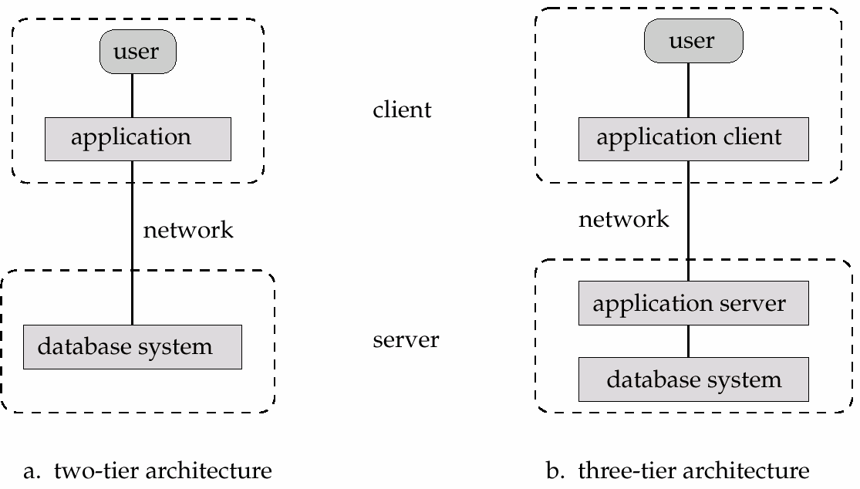Application Architectures

- Two-tier architecture: E.g. client programs using ODBC/JDBC to communicate with a database
- Three-tier architecture: E.g. web-based applications, and applications built using “middleware”

Database Users

Naive users / Data entry operators
- Use the GUI provided by an application program
•Feed-in the data and invoke an operation
-e.g., person at the train reservation counter,
-person at library issue / return counter
•No deep knowledge of the IS required

Application programmers
•These are the computer professionals who write application program. He can choose from many tools to develop user interfaces
RAD tools are the tools that enables an application programmer to construct forms & reports.

Sophisticated user / data analyst:
These user interact with the system without writing programs. Instead they form their requests in database query language.
They submit such query to query processor.

DBA (Database Administrator)
One of the main reason for using DBMS is to have central control of both data & the programs that access those data.
The person who has such central control over the system is called a DBA
The functions of DBA:
Schema definition :Designing the logical scheme
Storage structure and access method definition: DBA create appropriate storage structure & access methods by writing set of definitions which is translated by data storage & data definition compiler.

Schema and physical organization modification:
DBA carries out changes to the schema & physical organization to reflect the changing needs of the organization.
Grant / Revoke data access permissions to other users etc. - Integrity constraint specification-
Routine Maintenance-
Periodically backing up the database ,either onto tapes or onto remote server to prevent loss of data.
Ensure that enough disk space is available for normal operations. Monitoring jobs running on database.

Overall Structure of the DBMS –
Components of DBMS are broadly classified as follows : Query Processor Components
Storage Manager Components Data Structures

Query Processor – DML Compiler –
Translates the DML statements into low level instructions that query evaluation Engine understand.
It might also do optimization for query.

Embedded DML precompiler—
Converts the DML statements in an application program to normal procedure calls in the host language.

DDL interpreter :

Interprets DDL statements and records them in a set of tables containing metadata or data dictionary.

Query Evaluation Engine
It executes low level instruction generated by DML compiler
Storage Manager:
Storage manager is a program module that provide the interface between the low level data stored in database& application program & query submitted to system.
Storage manager is responsible for storing ,retrieving and updating data in database.

Components of storage manager:
Authorization and Integrity Manager
Tests for the satisfaction of integrity constraints and checks the authority of to perform various action.
Transaction Manager:
Ensures the database remains in a consistent ( correct) state despite system failures.
File manager :
Responsible for the allocation of space on disk storage system.
Buffer Manager-:
Responsible for fetching data from disk storage into main memory

storage manager implements several data structure as part of the physical system implementation

Data Structures : Data Files
Which Stores Database itself.

Data Dictionary
Metadata about the structure of the database in particular schema of the database.

Indices
Used to provide fast access to the data items.

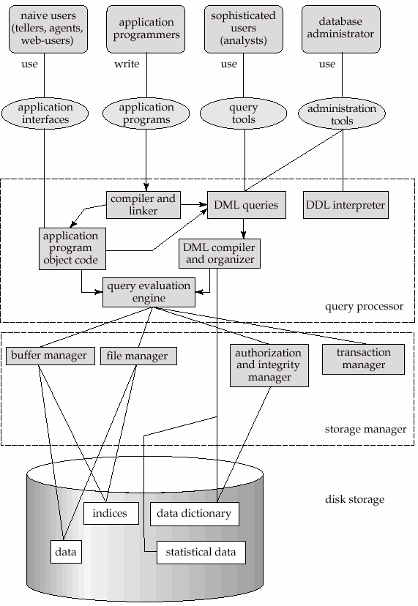

Overall System Structure

Transaction Management
  - A transaction is a collection of operations that performs a single logical function in a database application.
  - Transaction-management component ensures that the database remains in a consistent (correct) state despite system failures (e.g., power failures and operating system crashes) and transaction failures.
  - Concurrency-control manager controls the interaction among the concurrent transactions, to ensure the consistency of the database.

Transaction Management cont..
The dependant tasks can be controlled with transaction management facility of the DBMS.

Ex- Transferring the cash from one account to second account consists of withdrawing the amount from one account and deposit in other. If the application fails after the withdrawal ,the DBMS system will rollback the withdrawal automatically.

casual users
Interact with the system through a database query language.
whose function is to break down DML statements into instructions that the storage manager understands.

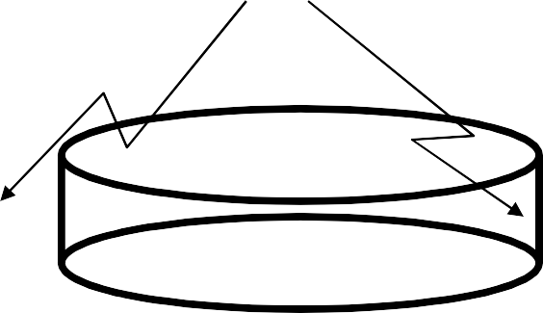select * from student

DBMS

data

and meta-data = catalog

naive users
They are unsophisticated users who interact with the system by invoking one of the permanent application programs that have been previously written.

Pictorially:

DBMS

data

app. (eg.,

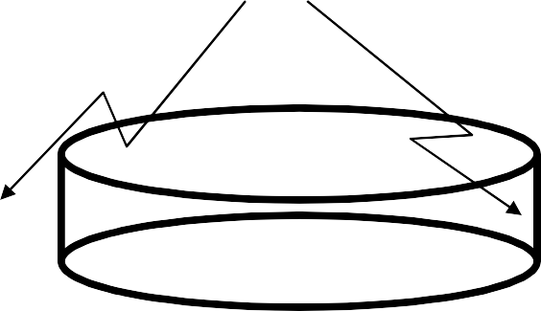report generator)

and meta-data = catalog

Application programmers
    - those who write the applications (like the ‘report generator’)

Some examples:
- DBA doing a DDL (data definition language) operation, eg.,
create table student ...

Some examples:
- DBA doing a DDL (data definition language) operation, eg.,
create table student ...

Some examples:
- casual user, asking for an update, eg.:
update student
set name to ‘smith’ where ssn = ‘345’

Some examples:
- app. programmer, creating a report, eg
main(){
....
exec sql “select * from student”
...
}

