**Name – Siddharth Bulia (130050012)  
 Charmi Dedhia (130070007)**

**Assignment 2**

Q1.

1. Lion 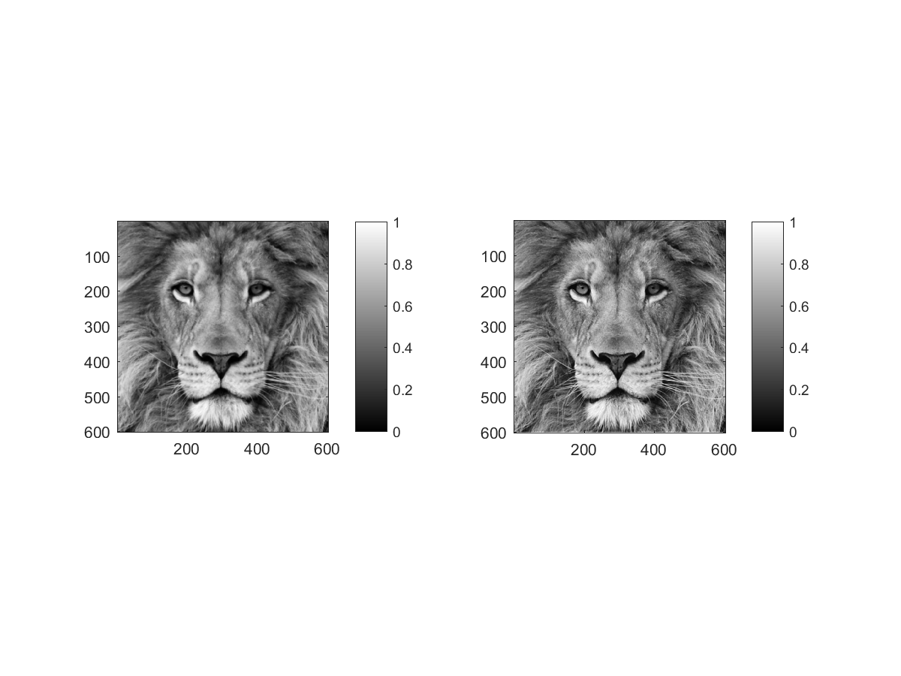

Sigma – 1 , Scaling Factor – 2

b) Super Moon

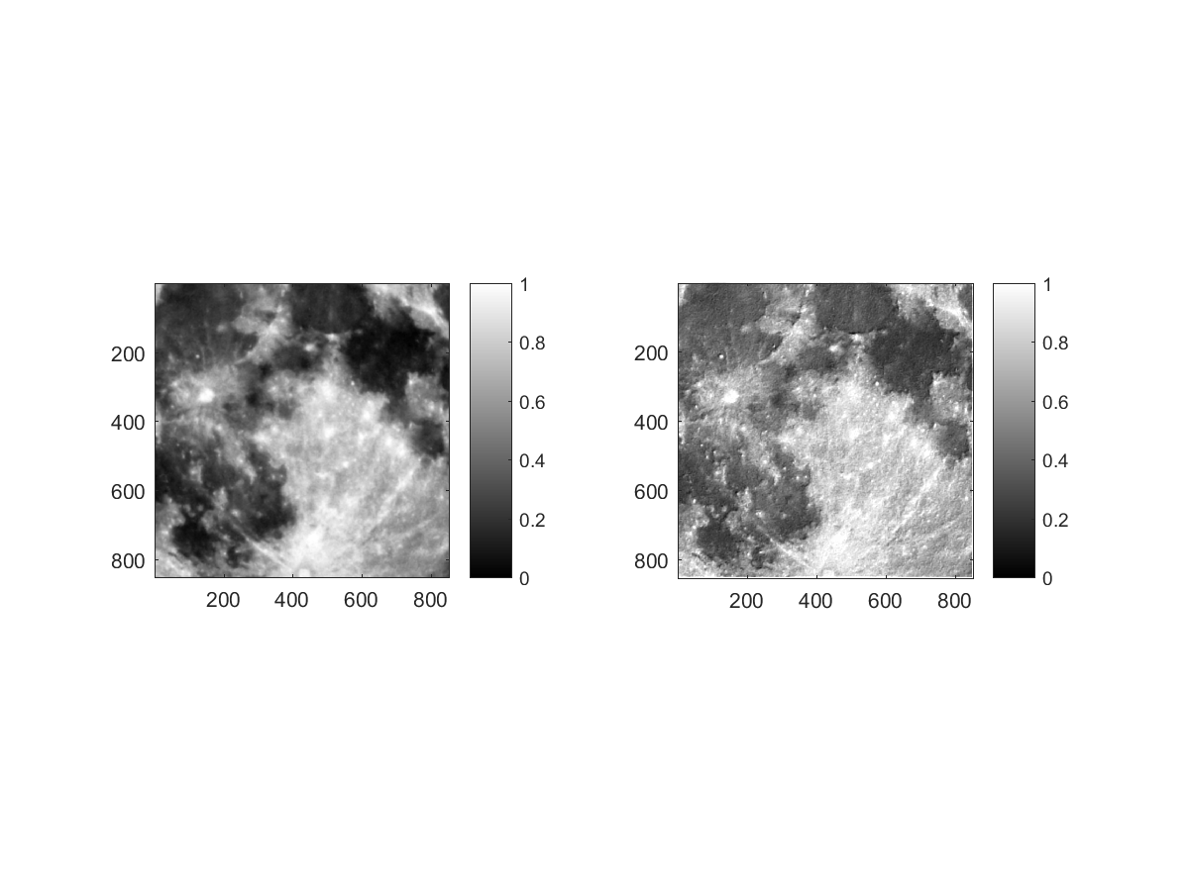

Sigma – 1 , Scaling Factor -10