**Name – Siddharth Bulia (130050012)  
 Charmi Dedhia (130070007)**

**Assignment 2**

Q2.

Noise

Original

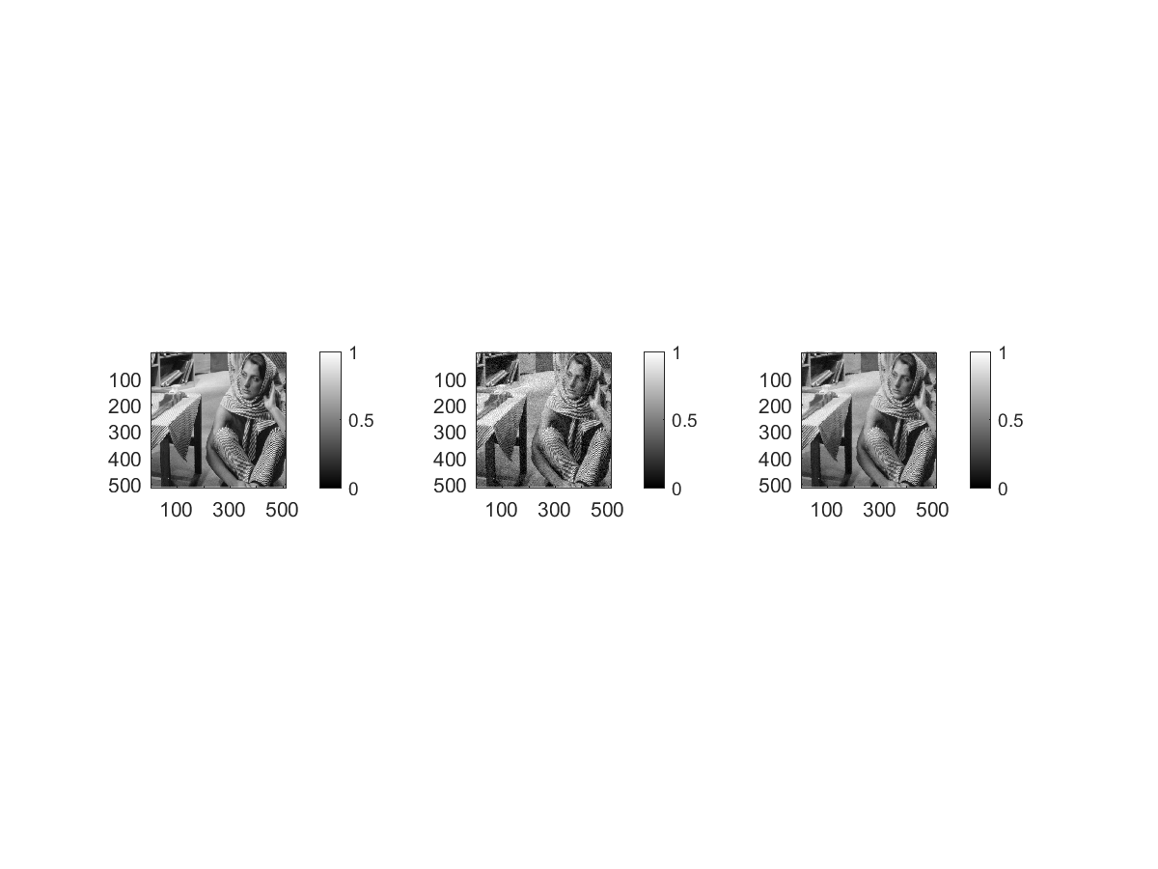

Bilateralina

SigmaSpace – 1.4

SigmaIntensity – 0.102

|  |  |  |
| --- | --- | --- |
| SigmaSpace | SigmaIntensity | RMSD |
| 1*sigmaSpace | 1*sigmaIntensity | 0.0328 |
| 0.9*sigmaSpace | 1*sigmaIntensity | 0.0329 |
| 1.1*sigmaSpace | 1*sigmaIntensity | 0.0329 |
| 1*sigmaSpace | 0.9*sigmaIntensity | 0.0330 |
| 1*sigmaSpace | 1.1*sigmaIntensity | 0.0331 |

Spatial Gaussian –

