**Name – Siddharth Bulia (130050012)  
 Charmi Dedhia (130070007)**

**Assignment 2**

Q3.

Original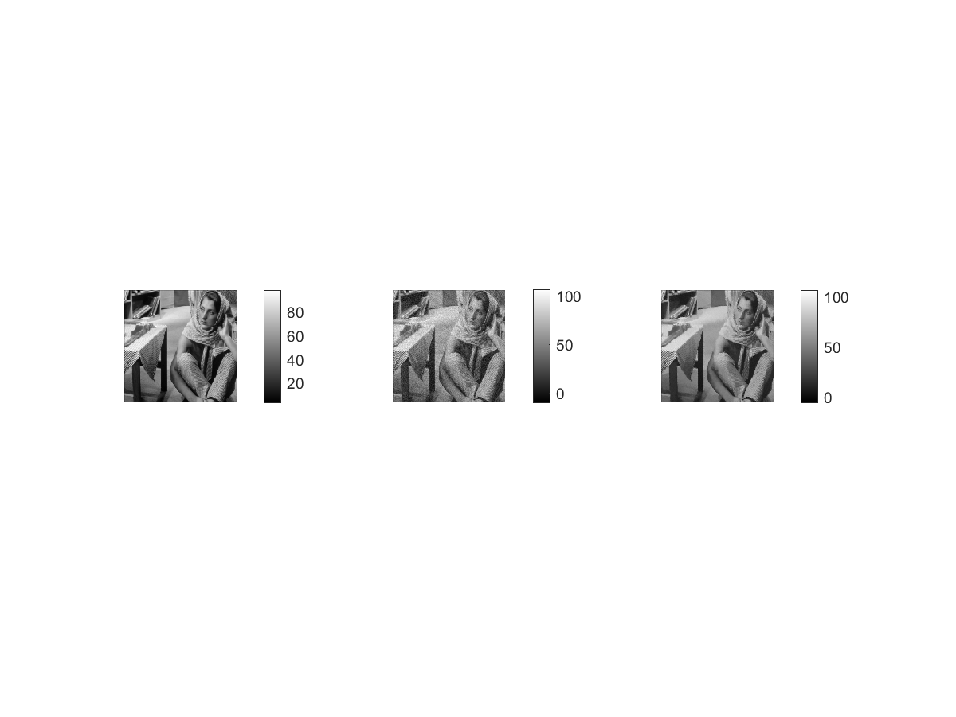nal

All these images can be found in images folder as well.

Originalnal



Patch Basednal

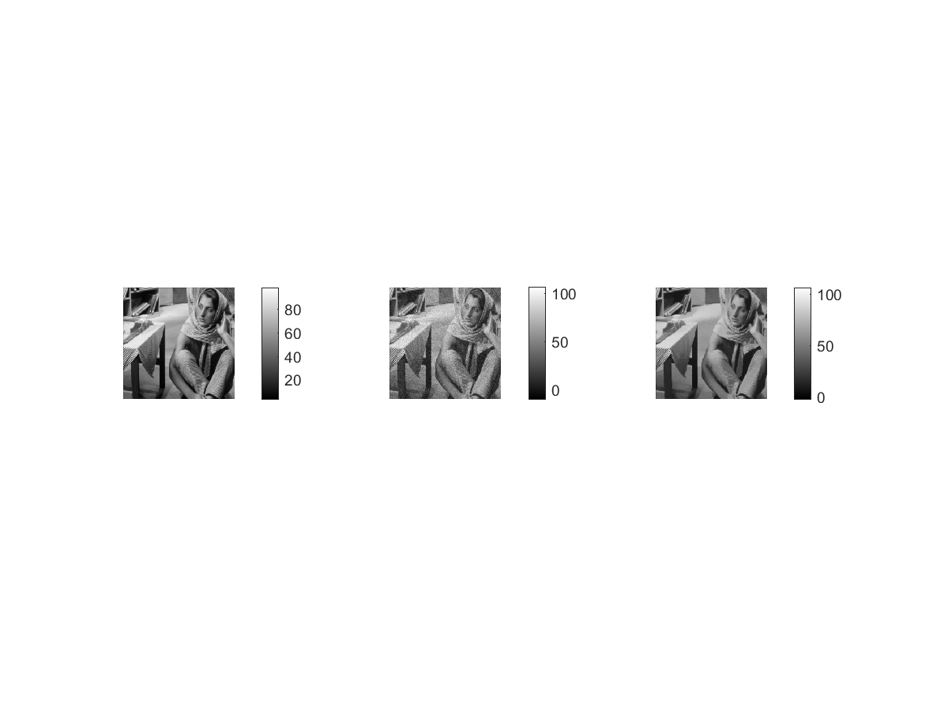

**Optimal Sigma – 4**

|  |  |
| --- | --- |
| SigmaIntensity | RMSD |
| 1*sigma | 2.6643 |
| 0.9*sigma | 2.7121 |
| 1.1*sigma | 2.7136 |

Iostropic Mask

