- Security configuration in an app:
- config class
config class SecurityConfiguration is created:

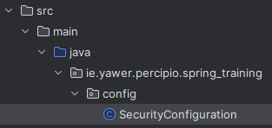

- SecurityFilterChain class
In configuration class a Bean SecurityFilterChain is used to set access process.
- SecurityFilterChain class takes a passed in HttpSecurity class as parameter, whose authorizeHttpRequests method is used to set which resources (pages and files) can be accesses without authorization and which requires it:

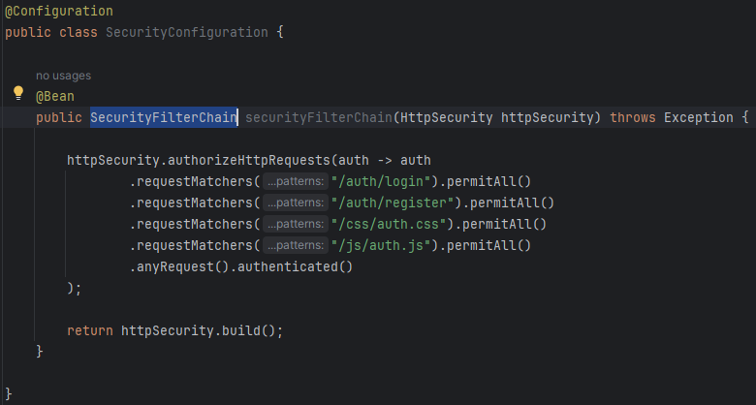

- further within SecurityFilterChain class, with HttpSecurity object passed into is, the latter’s method formLogin(Customizer<FormLoginConfigurer<HttpSecurity>> fLC) is used to set logging in process:
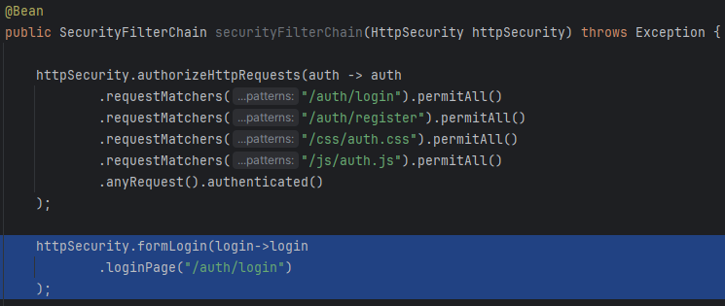

- further redirection after successful login should be set:

????????????????????????????????????????????
- PasswordEncoder class
in the same class SecurityConfiguration a password encoder is configured that will be used by Spring Security for password comparison while logging in and for encoding passwords when registering users

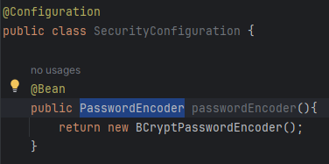
?????????????????????????????????????????????????????????????????

- Usage of PasswordEncoder class:
- encoding password when registering users:
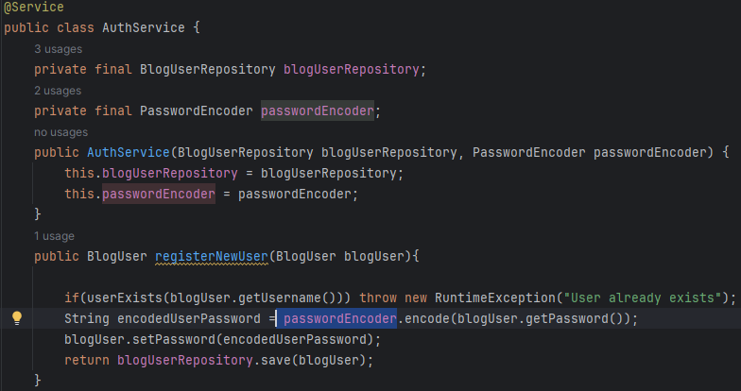

- Usage of UserDetailsService interface
the class is used to manage users of the application
The interface is implemented through a created class:
In this class, User Details loadUserByUsername(String username); method is implemented to get user’s details for checking inserted credentials against registered user’s details.
It accomplished by:
- querying user database for a user by username (1)
- checking if a user exists: (2)
  - if not, an exception is thrown (3)
  - if does, a user’s details are retrieved and returned (4)
