A COMPARATIVE ANALYSIS OF TRADITIONAL ARIMA AND MODERN PROPHET ARCHITECTURES FOR VOLATILE CRUDE OIL PRICE FORECASTING
Table of Contents

Introduction 3
Literature Review 3
Exploratory Data Analysis (EDA) 4
Methodology Part 1: ARIMA Modelling 5
Methodology Part 2: Prophet Modelling 5
Results and Performance Comparison 6
Discussion and Inferences 6
Future Improvements and Conclusion 7
References 8

Introduction
Crude oil is still a foundation of the world industrial economy, as it is one of the main sources of transportation, production and the international trade. Due to this centrality, there have been direct and extensive effects on the world inflation rates, interest rates in the nations, and the general economic stability because of oil price fluctuations. As a result, proper price forecasting is a necessity to the policy makers and the players in the market. The dataset on which this report is based is a set of 500 observations on a daily basis, in which an oil price may vary between 16.48 dollar to 158.78 dollar. The key goal is to identify the historical trends of the data, to introduce a classic statistical answer, and to suggest an alternative modern methodology to understand whether algorithmic versatility can be more effective than classical methods.

Literature Review
The scholarly analysis of contemporary forecasting tools highlights the shift between hard model-driven systems to soft systems, which are decomposable into parts. According to Aziz, Barawi, and Shahiri (2022), the Prophet model is a powerful machine learning based model that is specially engineered to generate credible weekly and monthly price projections of crude oil by taking into consideration the dependency of various aspects, including economic cycles and international relations. Such capability in dealing with complicated trends is a key reason why it has been adopted in modern research. Moreover, the mathematical foundations of this approach give an opportunity to have a granular perspective on market dynamics. Rehman, Albalawi, and Ahmad (2024) stated that the Prophet model involves a modular regression process, which includes the Fourier-based periodic seasonal variations and a piece-wise linear model to address the changes in the overall trend. Although these researchers frequently detect that there is still a possibility of the traditional models having an advantage in the short term accuracy, literature data indicates that the modern alternative is better at being interpretable based on its ability to break the time series down into explainable factors such as seasonality and trend.

Exploratory Data Analysis (EDA)
The first exploration of the data shows the presence of a very turbulent trend. As seen in the first plot, the oil price started the period at approximately 30 dollars in the end of 2024 and then underwent a consistent decrease to around 16 dollars in the beginning of 2025 before going on a sizable bullish run that will see the price reach up to the 150 dollar range towards the end of 2025. The analysis of summary statistics supports a high level of dispersion as the standard deviation is 42.91, showing that the price is not distributed around the stable average.
To be statistically rigid, it needed to test the stationarity in order to find the validity of subsequent models. The original data when subjected to the Augmented Dickey-Fuller (ADF) test had p-value of 0.882, which implied that the null hypothesis of non-stationarity could not be rejected. To correct this, first-order differencing was used. This transformation was successful in stabilizing the data and therefore, the ADF statistic value was -4.54 with a p-value of 0.0001. As the data was made immobile, the stage was established to pass to traditional time series modelling.
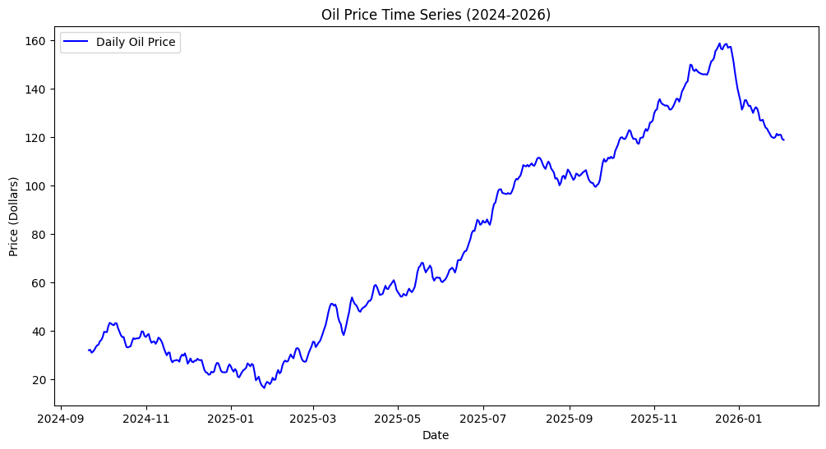
Figure 1: Oil Price Time Series
(Source: Implemented in Google Collab)

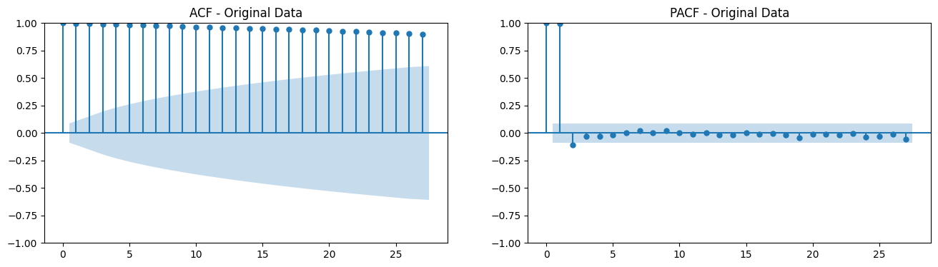
Figure 2: ACF and PACF Test
(Source: Implemented in Google Collab)

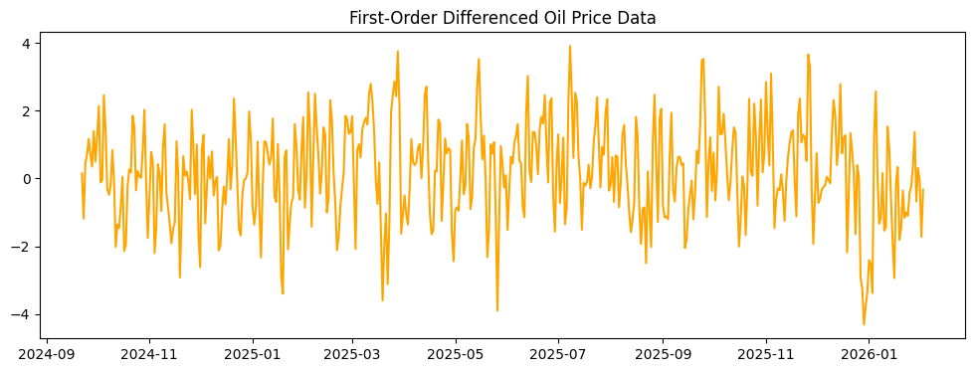
Figure 3: Stationarity Check
(Source: Implemented in Google Collab)

Methodology Part 1: ARIMA Modelling
ARIMA framework was used in the first stage of the modelling level. According to this traditional approach, there is an assumption that the past values and past errors have enough information to forecast future movements (Alharbi, 2025). To combat the subjectivity of the manual parameter selection, automated grid search loop was adopted to search the best values. The model with the minimum Akaike Information Criterion (AIC) was selected by going through 243 possible combinations.
The optimal model was the ARIMA that had an AIC score of 1429.35. To prove the fit, residual analysis was conducted. Autocorrelation Function (ACF) plot of the residues indicated that most of the error spikes were within the limits of confidence implying that the model had indeed captivated the signal in the data. Moreover, the residuals distribution was approximately equal and around zero, which showed no significant bias in errors of the model.
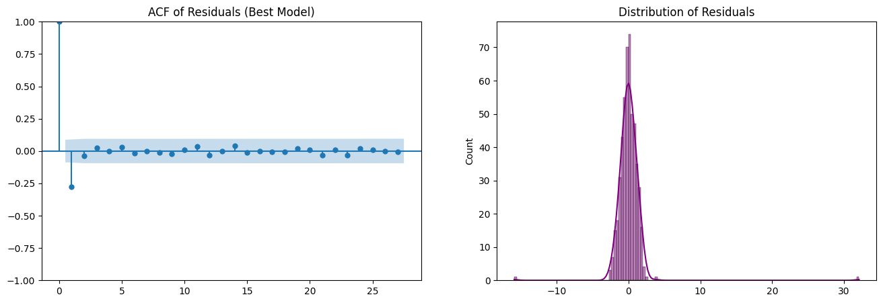
Figure 4: ACF of Residuals
(Source: Implemented in Google Collab)

Methodology Part 2: Prophet Modelling
To replace the classical model, the Prophet model has been selected as it is said to be more effective in dealing with seasonality and trend changes when compared to the linear models (Elneel et al., 2024). This new method assumes that time series forecasting is curve fitting, as opposed to a linear dependency problem. In order to be able to compare the Prophet model fairly, the model was heavily hyperparameter tuned, with a grid search.
The identification of the best parameters was a changepoint/priorscale of 0.1 and seasonality/priorscale of 10.0. These environments enabled the model to be very sensitive to changes in trends but sensitive to seasonal cycles. When the model was fitted, a component decomposition was created. This showed that there was an upward trend and a clear week-to-week seasonality in which the prices were high on Tuesdays and Wednesdays and fell to the weekend. This current view gave an account of the behavior in the market which could not be captured in an explicit manner by the ARIMA model.

Results and Performance Comparison
In order to evaluate which model gave a more correct solution, the two were compared on a held-out test set using the Root Mean Squared Error (RMSE) measure. ARIMA model generated a lower RMSE of 14.78, which, compared to Prophet model produced a greater RMSE of 18.38. The traditional ARIMA model proved to be the best at predicting the data in this particular instance, despite the modern model being able to capture the complex seasonality.
There is a difference in the philosophy as seen in the visual projection of the future of both models. The ARIMA forecast expects a linear-trend continuing steadily up to a value of 250 in the year 2028, the confidence interval is symmetric and continuously increasing. By comparison, the Prophet model makes a more conservative projection, more waviness in nature, trying to consider the weekly cycles it found during the training stage.

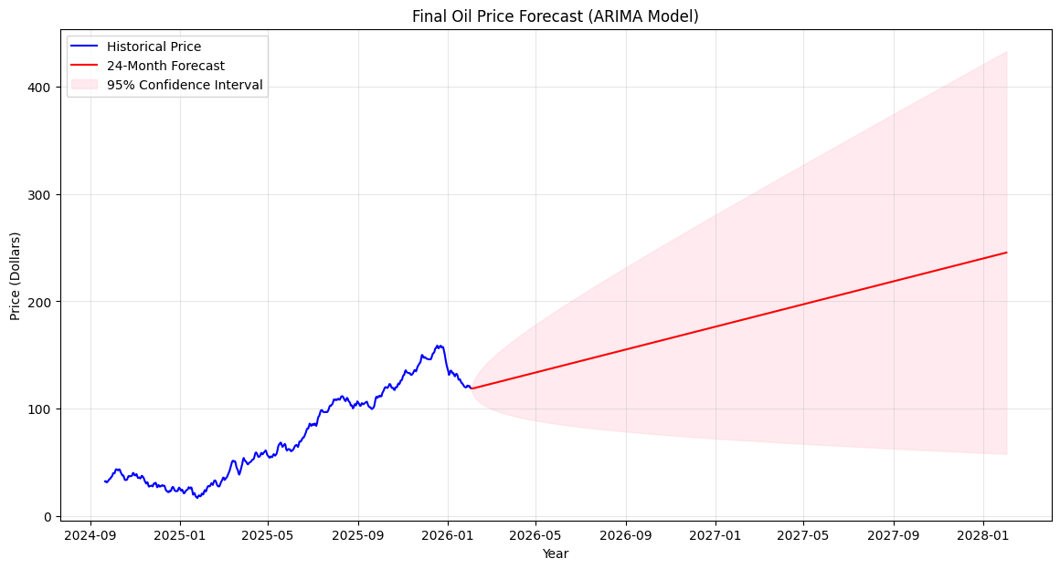
Figure 5: ARIMA Model Forecast
(Source: Implemented in Google Collab)

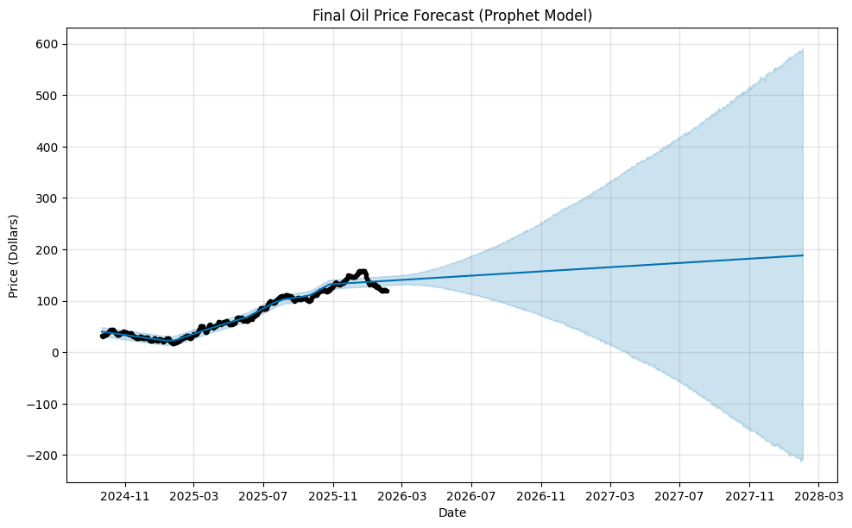
Figure 6: PROPHET Model Forecast
(Source: Implemented in Google Collab)

Discussion and Inferences
The finding that ARIMA outperformed Prophet implies that the local linear relationship and moving averages errors outperformed the global dependency on trend-plus-seasonality strategies in this particular 500-day window. Although it is generally said that Prophet is flexible, researchers such as Rehman et al. (2024) have observed that in some cases, it can even give overly linear predictions that cannot keep up with sudden and high-frequency changes in the energy market.
An important aspect of the analysis is the comparison of the forecasts with the actual data that is gathered after the modelling process. Looking at the plot of Performance Test, it is possible to see that at the end of the historical data, at the beginning of 2026, the actual oil price was sharply corrected downwards (blue line) decreasing to almost 160 and returning to the 120 level. Both models never anticipated the scale of this sharp crash perfectly. The ARIMA model (red dashed line) was on its upward trend and virtually missed the short turnaround on the market. This shows the inherent shortcoming of both models that they are historically dependent. Although the traditional model was mathematically closer in the period of test, it did not have a mechanism of predicting an abrupt structural breach in the oil market.

Future Improvements and Conclusion
In order to make these models more reliable, exogenous variables should be included in the future versions. External shocks which cannot be observed by univariate models may have been the reasons behind price movements in the 2024-2026 period. The interrelation of data like the US dollar index, the world inventory, or the geopolitical sentiment scores based on text of the news may resolve the transition between the past and the future.
To conclude, this case study proves that even the most advanced machine learning models such as Prophet can provide extensive information about the aspects of data and seasonality but cannot be regarded as an ultimate substitution of old-fashioned statistical processes. The more accurate and parsimonious model was the ARIMA model of this data. But the fact that both models cannot predict the sudden price correction at the beginning of 2026 is a reminder that mathematical models can be viewed as a guide and not something to be absolutely confident in the unstable world of energy commodities.

References

Alharbi, M.H., 2025. Prediction of the stock market using LSTM, ARIMA, and hybrid of LSTM-ARIMA models. Journal of Knowledge Management Application and Practice, 7(1), pp.15-22.
Aziz, M.I.A., Barawi, M.H. and Shahiri, H., 2022. Is Facebook PROPHET Superior than Hybrid ARIMA Model to Forecast Crude Oil Price?. Sains Malaysiana.
Elneel, L., Zitouni, M.S., Mukhtar, H. and Al-Ahmad, H., 2024. Examining sea levels forecasting using autoregressive and prophet models. Scientific Reports, 14(1), p.14337.
Hasnain, A., Sheng, Y., Hashmi, M.Z., Bhatti, U.A., Hussain, A., Hameed, M., Marjan, S., Bazai, S.U., Hossain, M.A., Sahabuddin, M. and Wagan, R.A., 2022. Time series analysis and forecasting of air pollutants based on prophet forecasting model in Jiangsu province, China. Frontiers in Environmental Science, 10, p.945628.
Rehman, D., Albalawi, O. and Ahmad, F., 2024. Forecasting Saudi Arabia’s Refined Petroleum Products: An In-depth Analysis of Time Series vs Machine Learning Models.
Sharma, K., Bhalla, R. and Ganesan, G., 2022, August. Time Series Forecasting Using FB-Prophet. In ACM (pp. 59-65).

