# Question 1:

Display the Countries and corresponding states dynamically.

1. By default, display only select country.

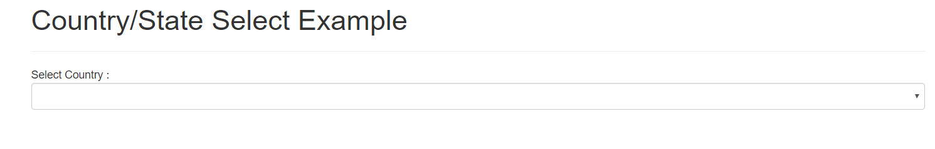

1. Display all the countries as dropdown list as mentioned below

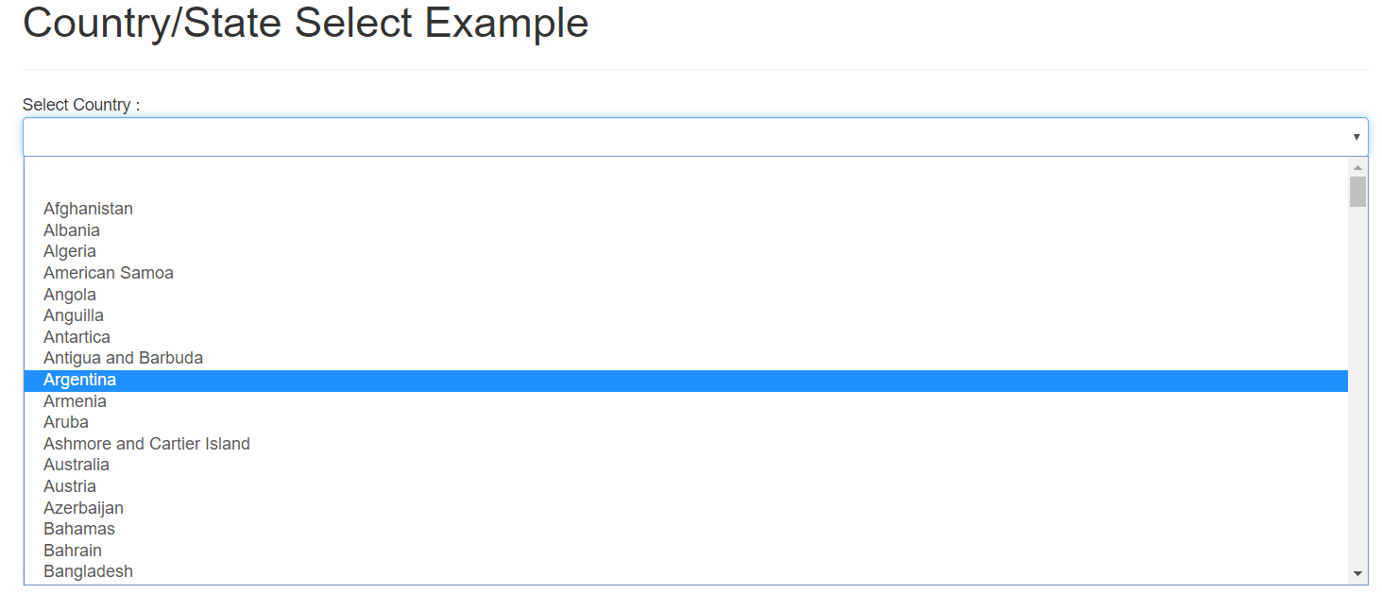

1. Display select state only after selecting the country

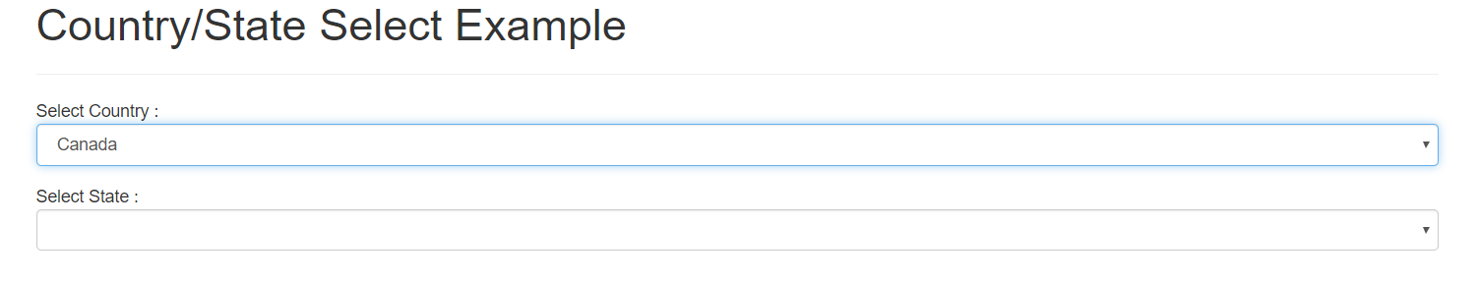

1. Display the states corresponding to the country

**Ex: As mentioned below, I have selected ‘Canada’ as a country and here I’m displaying states corresponding to the Canada.**

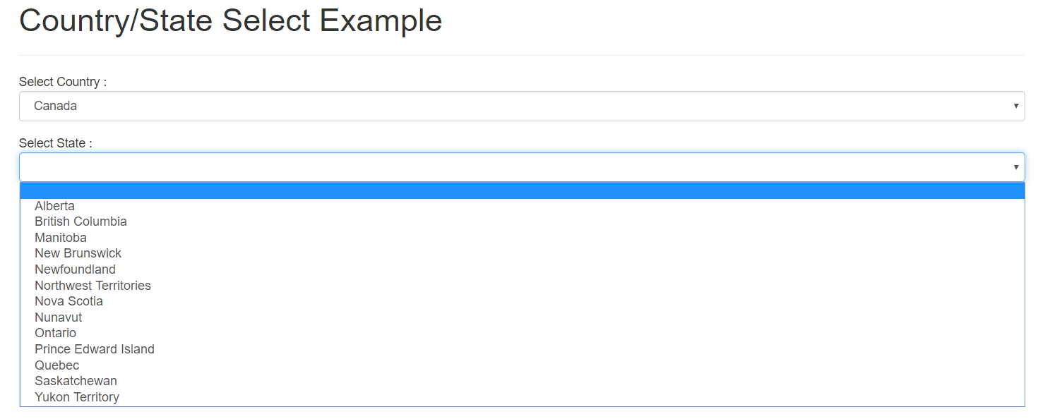

# Question 2:

Display the list of sale items as mentioned below using the HTML’s provided.

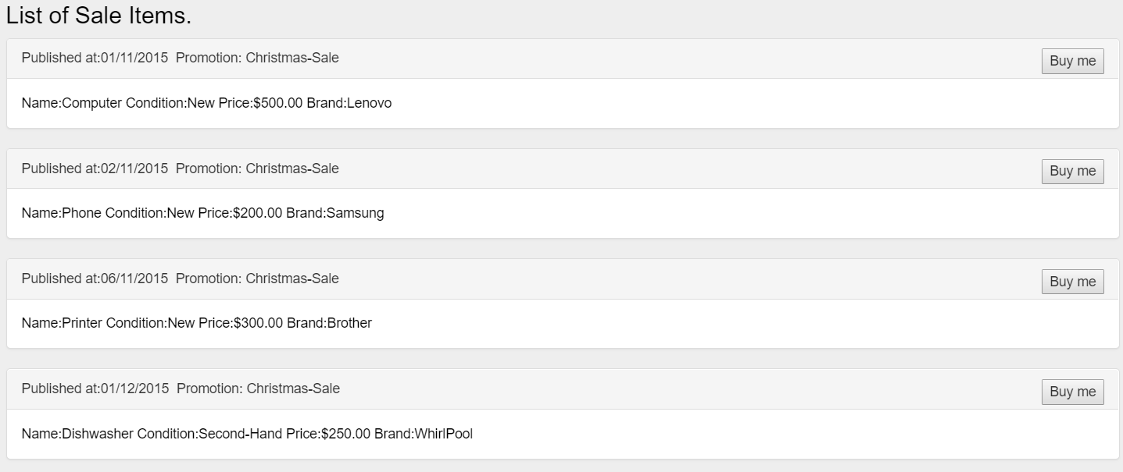

When you click Buy Me, it should display as below output.

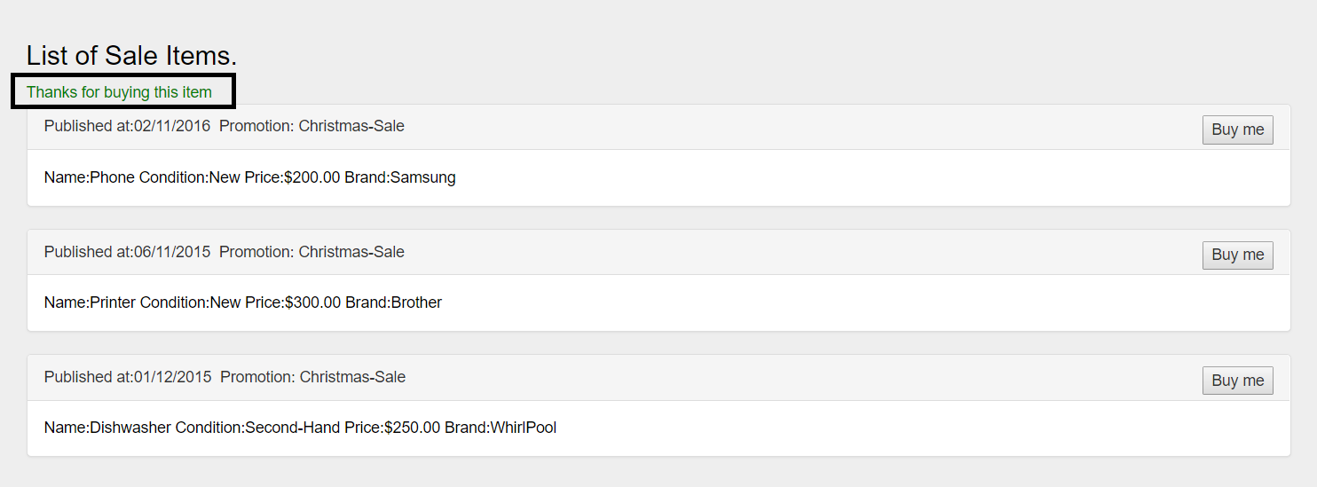

# Question 3:

Define the routing for each header click as highlighted below (home. About Me/Skills… Etc.) and display the html’s provided for each click.



# Question 4:

Create a **custom pipe** to display numbers based on both input boxes.

PS: DO NOT USE **SLICE** HERE. Create a custom pipe to achieve the below logic.

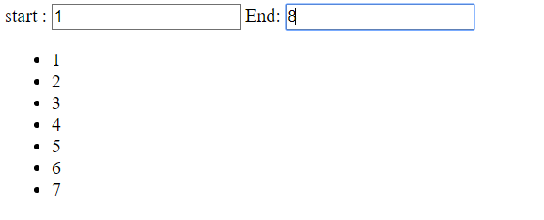

# Question 5:

Create a temporary database in Firebase and get the end point from Firebase to issue a http post call

Also, don’t enable the signup button if the user input is empty for all the below 3 input boxes.

