**Step 1:** Mapping of Regular Entities

*For each regular (strong) entity type E in the ER schema, create a relation R that includes all the simple attributes of E.*

Since this includes Specialization, the superclasses and subclasses are mapped next although this is step 8 in the algorithms. This makes it easier to map weaker entities that depend on these subclasses for keys.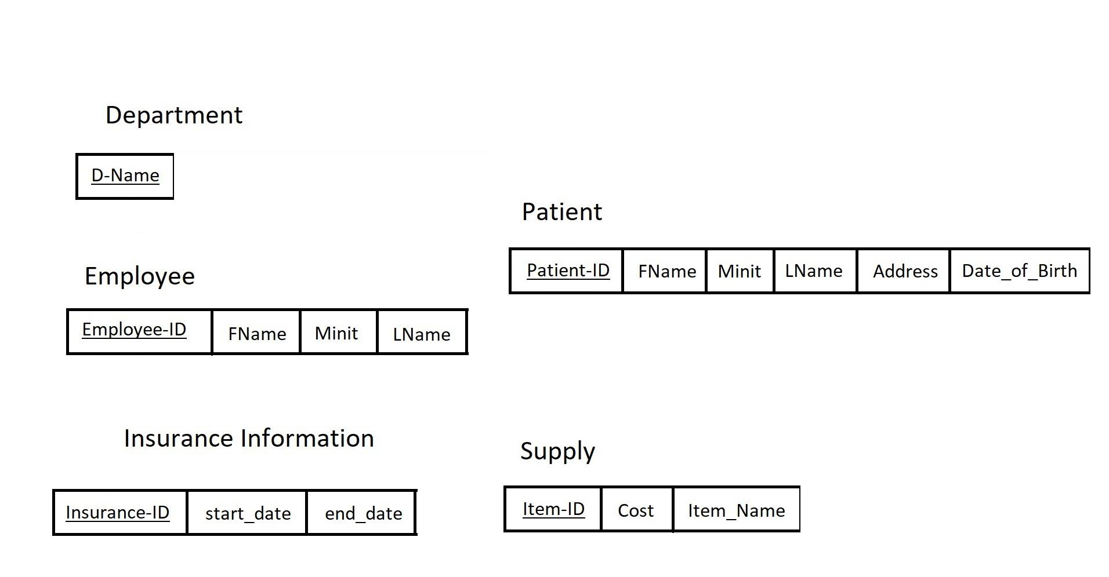 The keys are underlined, and no primary keys have yet been defined because there are no relations yet.

Step 8: Mapping specializations

*Convert each specialization with m subclasses {S1, S2, … , Sm} and (generalized) superclass C, where the attributes of C are {k, a1, … , an} and k is the (primary) key, into relation schemas.*

Step 2: Mapping of Weak Entity Types  
For each weak entity type, create a relation R and include all simple attributes of the entity type W (or simple components of composite attributes of W) as attributes of R  
Create the primary key of R as the combination of the primary key(s) of the owner(s) and the partial key of the weak entity type W  
Include primary key attribute(s) of owner(s) as foreign key attributes of R.

Here the primary keys are now employee_id in Employee, Patient_ID in Patient, and the foreign key primary key combinations created for the weak entities in Treatment, Visit, and Diagnosis, which all inherit from Patient, while Initial Assessment inherits its primary key from Nurse, in Employee.

Just like in Step 1 we also applied step 8 to give presence to the subclasses in the weak entities. The difference is shown via the two pictures.

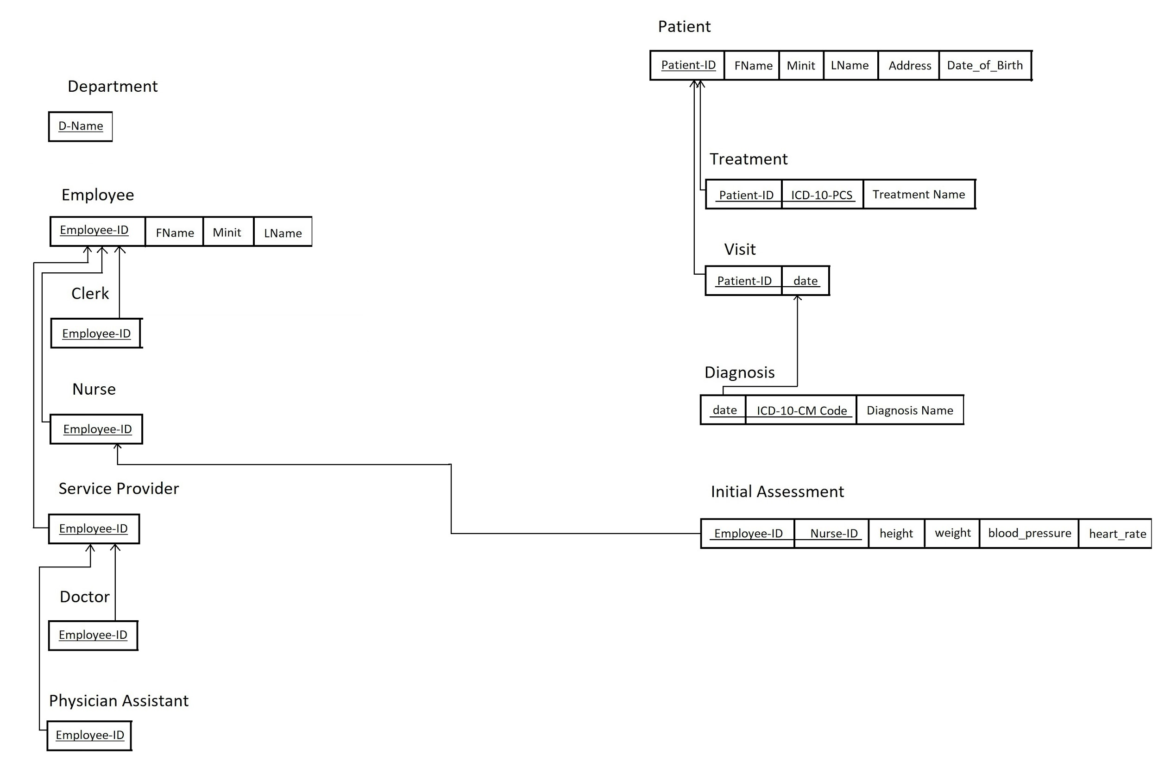

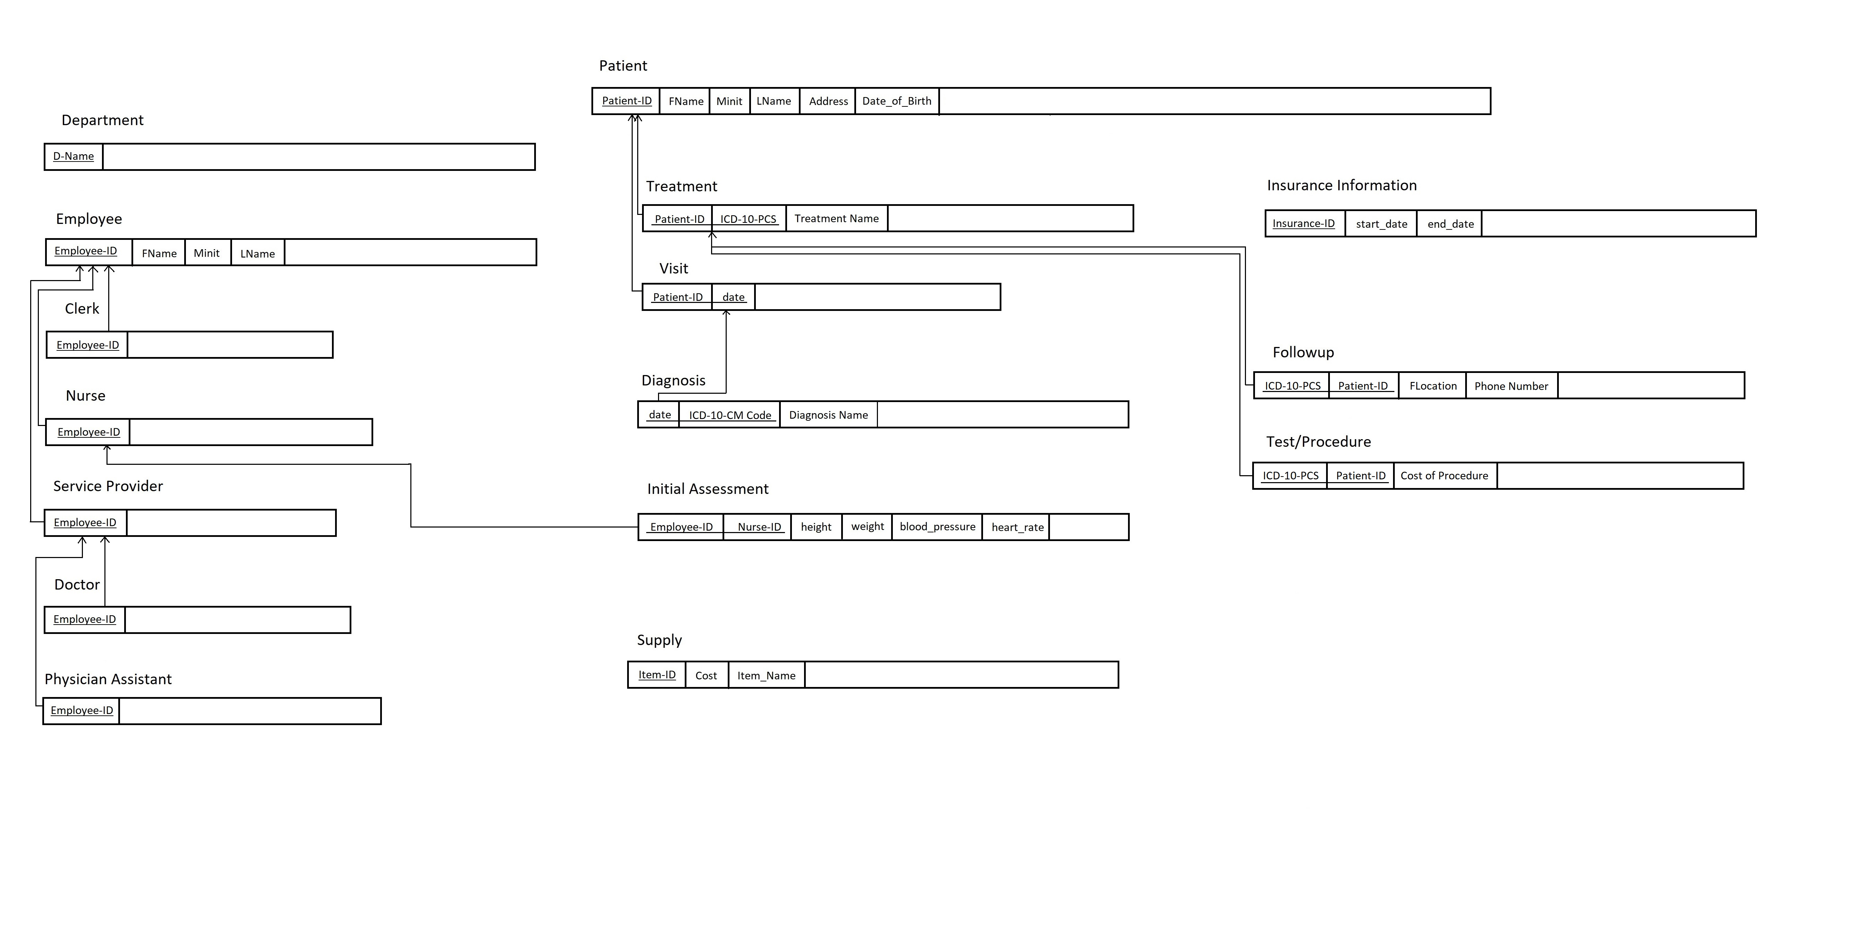

**Step 3:** Mapping of Binary 1:1 Relationship Types

1. Foreign Key Approach: *Choose one of the relations—S, say—and include as  
   a foreign key in S the primary key of T. It is better to choose an entity type  
   with total participation in R in the role of S*

The keys are still of course underlined. There are no new primary keys present, but a new foreign key has been created as the combination of Patient-ID and date in Initial Assessment, which it gets from Visit.

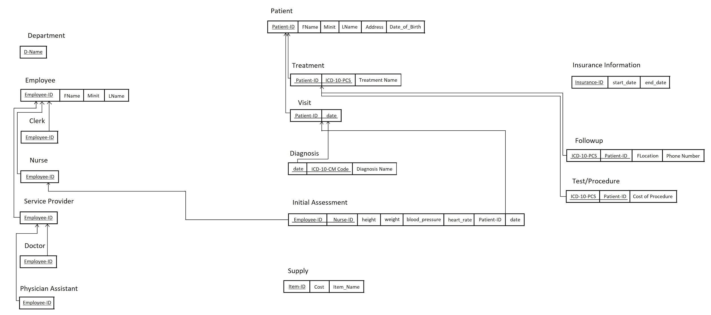

**Step 4:** Mapping of Binary 1:N Relationship Types.

*For each regular binary 1:N relationship type R, identify the relation S that  
 represents the participating entity type at the N-side of the relationship type.  
 Include as foreign key in S the primary key of the relation T that represents the  
 other entity type participating in R*

Step 4 here is not really applicable because all of the 1:N relationships were mapped in Step 2, where we mapped the weak entities, therefore the diagram looks identical to the previous step.

**Step 5:** Mapping of Binary M:N Relationship Types

*For each binary M:N relationship type R, create a new relation S to represent R.  
 Include as foreign key attributes in S the primary keys of the relations that   
 represent the participating entity types; their combination will form the primary   
 key of S*

The new primary key in this step is Item-ID in the Supply entity. This was necessary to map the relation Supply has with Nurse and Test/Procedure by creating the Accounts-For and Supplies relations that you can see below.

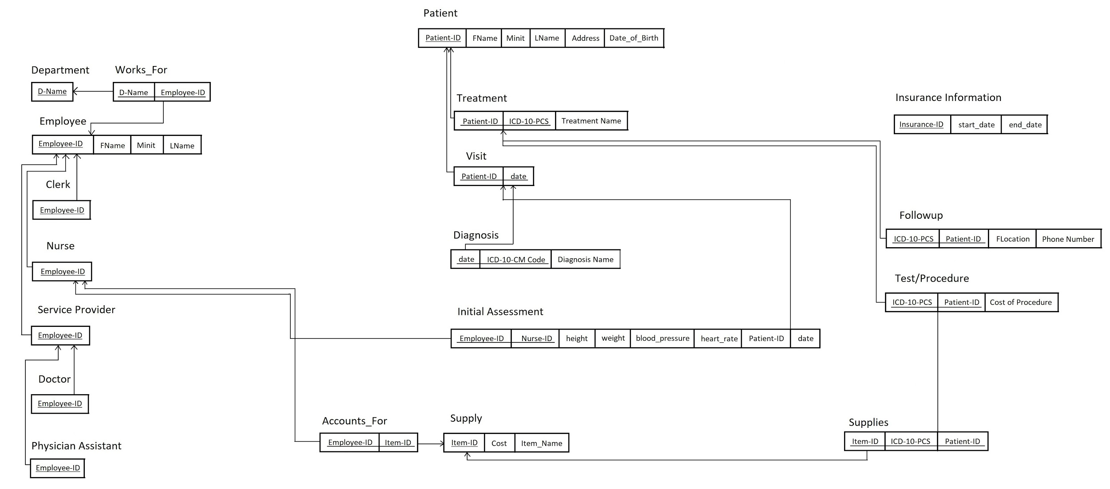

**Step 6:** Mapping of Multivalued Attributes  
*For each multivalued attribute A  
Create a new relation R  
Include an attribute corresponding to A plus the primary key attribute K as a foreign key in R of the relation that represents the entity type or relationship type that has A as a multivalued attribute.  
Primary key of R is the combination of A and K  
if the multivalued attribute is composite, include its simple components.*

Here we created two new entities, Emergency Contact and Parent/Guardian Information, to give existence to the multivalued attributes necessary to be mapped in this step. They both get their key information from Patient.

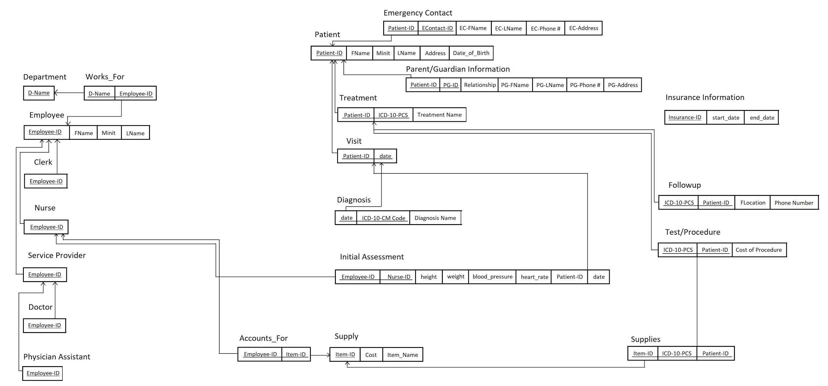

**Step 7:** Mapping of N-ary Relationship Types  
*For each n-ary relationship type R create a new relation S to represent R  
Include primary keys of participating entity types as foreign keys  
Primary key becomes the combination of all the foreign keys that reference the relations representing the participating entity types. However, if the cardinality constraints on any of the participating entity types E participating in R is 1, then the primary key of S should not include the foreign key attribute that references the Relation E’ corresponding to E  
Include any simple attributes as attributes*

Lastly we map any N-Ary relationships, and there are 4. Intakes, Uses, and Provider/Diag/Visit are all 3-ary relationships that bring together multiple entities. They all get their keys from the entities they are related to, as shown below.

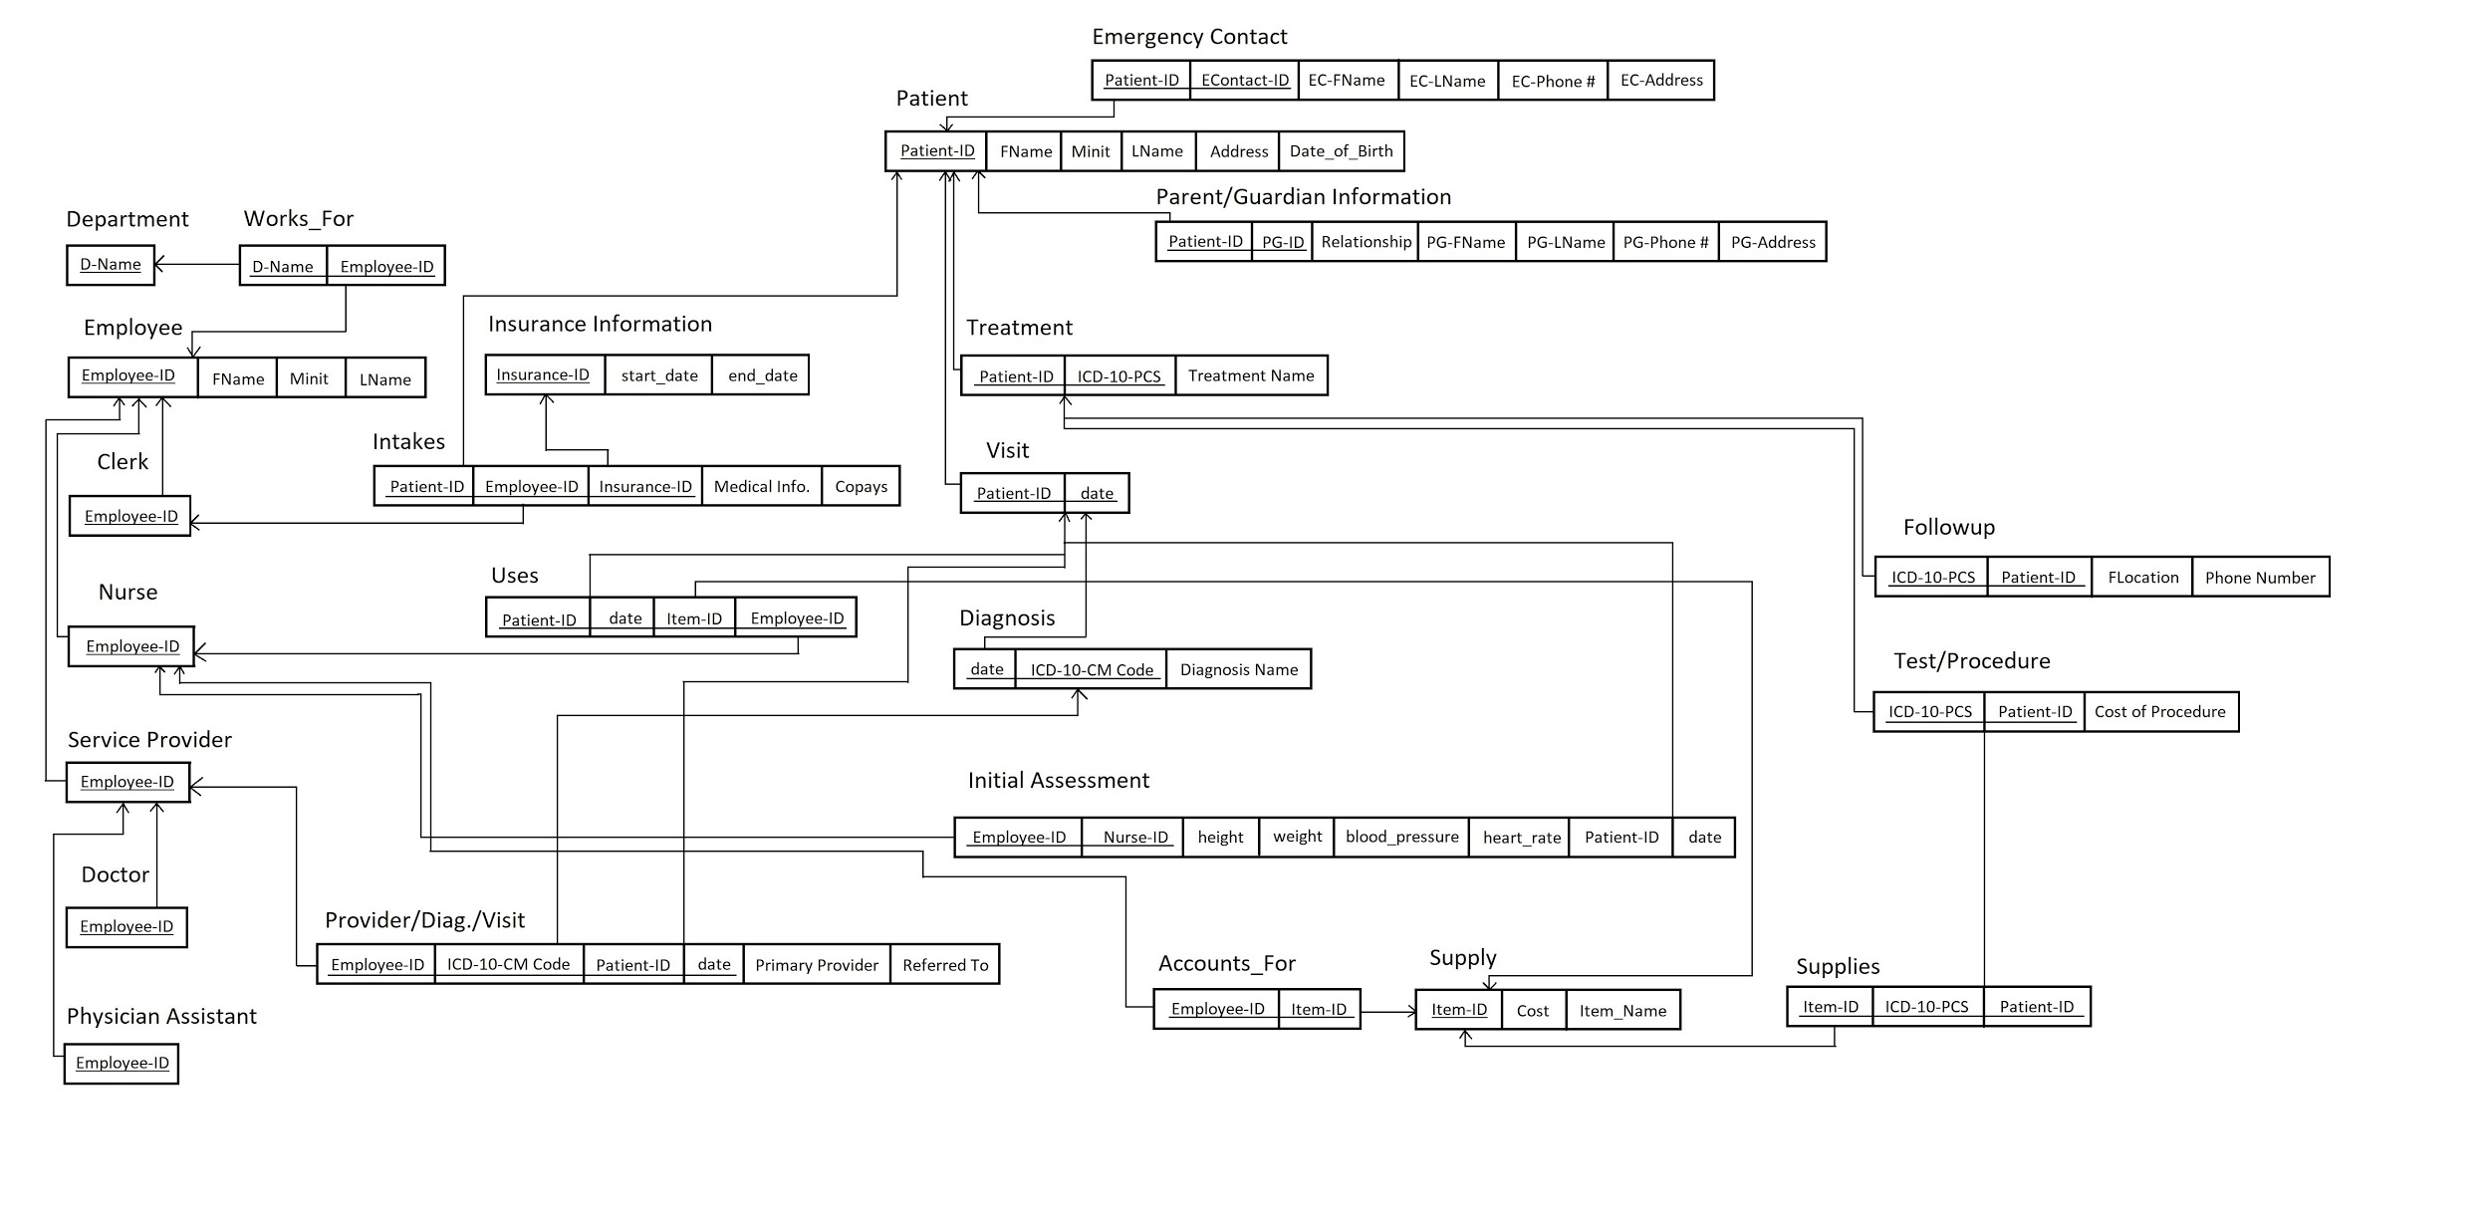

Constraints:

1. A patient can have zero to many treatments assigned to them. A treatment is assigned to a particular patient.
2. A patient has one to many visits. A visit has a date, and a patient can only visit once per day.
3. A patient has zero to many forms of insurance. For each form of insurance, this information is collected by exactly one clerk.
4. At a visit, an initial assessment must be performed performed by exactly one nurse.
5. A nurse may perform zero to many initial assessments at New Haven.
6. Zero to many supplies may be used at a visit. Every supply that is used at the visit must be accounted for by at least one nurse. A nurse may keep track of any number of supplies. A supply may be tracked by multiple nurses.
7. A treatment is either a test/procedure performed at New Haven or an assigned followup at a different location.
8. A test/procedure at New Haven may use zero to many different types of supplies. The cost of these supplies is calculated for each test/procedure.
9. At a patient’s visit, there is exactly one primary service provider. This primary service provider provides one to many diagnoses for the visit.
10. Service providers, nurses, and clerks are all employees. One to many employees work in a department.
11. A department contains one to many employees.
12. A patient has one to many emergency contacts.
13. A patient under the age of 18 must have parent/guardian information.