SOUND

FOH
Bass 2x d&b audiotechnik 1881-SUB
High 2x d&b audiotechnik 902-LS
Amplifier incl. controller
2 x d&b audiotechnik P1200L
Monitoring
4x Shiva FR2310Kontakt 2way 12’ active Monitors

Amplifier incl. controller
Lab.Gruppen C Series 20:8X
Stagebox
22 Line XLR
4 Returns XLR
Desk
Crest HPW36 4x stereo
36 mono XLR
10 aux
4 monitorways
4 monitorreturns
2 PA-returns
8 subgroups

Peripherie
Alesis Midiverb2 Effect
Lexicon MPX500 Effect
Behringer XR2000 Expander/ Gate
Behringer 2x MPX2200 Compressor
Audient 2x ASP231 Stereoequalizer monitoring
LA Audio EQ231G Stereoequalizer FOH
DI Boxes
2x Proco passive
1x Monarch passive
1x Zeck DBA20 active
2x Behringer UltraDI active
Microphones
2x Shure SM58 Vocal
2x Shure Beta58 Vocal
1x EV N/D757 Vocal
1x EV N/D357 Vocal/ Allround
2x EV N/D257 Vocal/ Allround
1x EV N/D408 Snare/ Instrumental
1x EV PL10 wind
1x AKG D12 Bass Drum/ Bass
1x AKG D112 Bass Drum/ Bass
2x AKG C1000S Vocal/ Overhead Phantomfeeding
1x Bayer Dynamic M700TGS Vocal
2x Bayer Dynamic M300 Vocal/ Allround
3x Sennheiser evolution 604 Drum/ Instrumental
Microphoneholders
7x Overhead
4x K+M Teleskopracks large
2x Teleskopracks small

LIGHT

Controlling
Desk LSC Atom 24 channels
Scannercontrolling Genius Hi-Tech Control
Dimmer LCS E-Pack 12 channels

Lamps
Backlight 6x ETC Sourcefour 575W
8x Pin Spots
Frontlight 2x PC Selecom Acclaim 650W
2x Fresnel Spotlight F05 650W
Floorlight 4x PAR56 Spot 300W

Effects and varia
1x Stroboskop Best Light
1x Mirrorball with motor, lighted by 4 spots
4x Sanner Genius Micro Scan
1x Fogmachine JEM Techno Fog, timer function included
Lee Filters

STAGE
width front 668 cm
width back 616 cm
lenght 300 cm
height stage 60 cm
height stage-ceiling 270 cm

HALL
height 330 cm
lenght 833 cm
width 668 cm
capacity 180
bar/technik lenght 125 cm width 668 cm
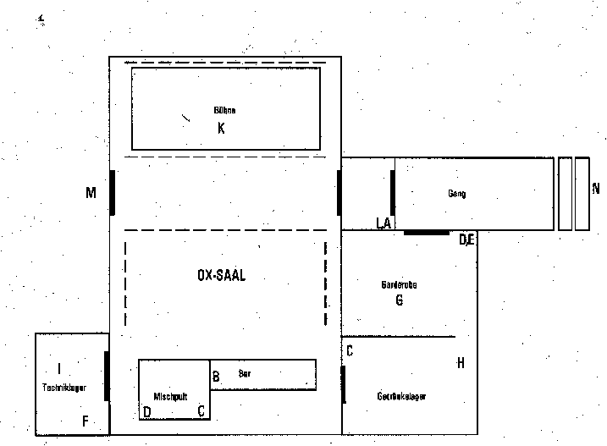

Contact

Responsible persons for technics:
Concerning material and equipement:
Manser Tudor – Tel. 0041 76 521 32 18

For further questions:
contact the responsible promoter.

