How Deep Learning and Big Data can help move the energy sector to the smart grid.

Ambrose Desmond
Word count 4112
Module Title: Advanced Data Analytics Big Data Storage and Processing
Assessment Title: Integrated CA1 Sem 2 MSc in Data Analytics

Abstract—The energy sector in Europe is at an a inflection point . Energy shocks due to the 2022 war in Ukraine, the continuously growing energy demand, and the legal requirement to cut pollution from fossil-based fuels has refocused and accelerated the EUs push towards renewable energy as part of its green new deal. The speed of the transition has results in the EU lowering it carbon emissions by 2.5% since the war started with renewables mostly replacing coal and gas. The down side of this accelerated push to renewables is the destabilizing effect they have on energy grids of EU Countries. There had already been a move to smart energy grids where big data analytics play a curtail role. The ability to collect reliable data and to use it for better decision-making is a key feature of the smart grid. Wind and solar energy are one of the most important renewable energy sources in this push for green, but its intermittent nature leads to energy production volatility thus putting pressure on power grids. Smart energy management is essential for grid stability going forward, I look at the benefits and challenges of implementing big data analytics as a solution to this problem on smart energy grids. I look at the big data infrastructure and discuss efforts being made to harden big data from a security point of view against cyber attacks , another risk heightened since the war.. (Abstract)
Keywords—Energy Internet, Renewable, Deep Learning, RNN , Hadoop , PySpark, Cassandra (key words)

Objective
I will be researching what is said of the need for big data in the new era of the energy internet, looking at the different big data (BD) structures available and determining what is the best road forward for this sector.
As part of the research I will review research papers on the topic of big data and energy internet and will also source a BD dataset to use on the researched technologies with an emphasis on Cassandra and pySpark to access the differences and the effectiveness of these tools.

Introduction

There is no denying the world is producing an ever increasing amount of data on a daily basis. There is huge growth in emerging technologies such as, sensors, smartphones, 5G communication, and virtual reality leads to innovative applications such as, connected industries, smart city, smart energy, connected automobiles, smart agriculture, connected building complexes, connected health care, smart retail outlets, and smart supply chain, which adversely contribute to the accumulation of massive amounts of data.

The data deluge from smart meters, PMUs, billing, weather sensors, and other intelligent electronic devices (IEDs) has opened up many new opportunities such as predictive analytics, demand side management, real-time grid awareness, outage detection, asset management, and theft detection to name just a few.

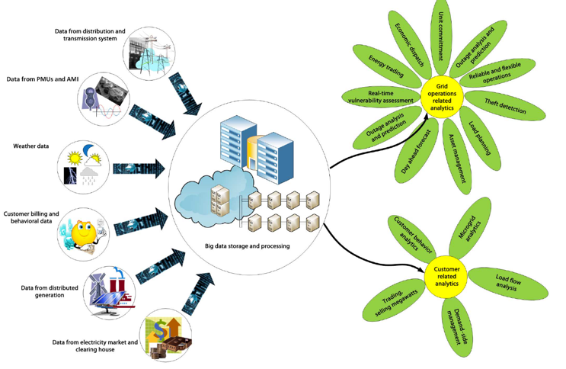

The difficulty to manage these large and diverse datasets through using traditional relational type database management tools is widely acknowledged, this type of data, namely ‘Big data’ requires advanced management approaches. Big data is a computer science technology that can be applied to data from different and uncorrelated sources, which make it hard to use traditional data analysis tools to process this data. It is characterised by its four main components: Variety, Velocity, Volume and Veracity, namely ‘the 4Vs’ (Mostafa et al., 2022, p. 2) . In the book Big Data Systems (Shamsi and Khojaye, 2021) they describe big data with 5 vs as outlined below.
Volume : The volume of data would challenge the processing requirements of traditional ACID / SQL databases. Normally BD volume would vary from Terabyte and xeabytes and beyond.
Velocity: i.e. the data is being generated at a very fast pace.
Variety: The data comes from wide array of sources , for example , Web logs, IoT devices , URLs , tweets etc. all have different formats . This data typically comes in three flavours. Structured , Semi structured and Unstructured.
Veracity: This refers to the trustworthiness of the data, i.e. its accuracy or authenticity.
Value: data should be of high value , stale data has limited value.
The 5 v represent a paradigm shift from the traditional types of data which can be described as ACID ( Atomic, Consistency, Isolated, Durability) . This schema typically relies on SQL type databases. They have great consistency and are ideal for transactions where all or nothing is transacted and only valid data is saved. These type of transactions are isolated in that , they do not effect each other and the record of the transaction is durable, i.e. the data is written and will not be lost. But this type of schema is too rigid and slow to cope with Big Data.
Maintaining ACID properties in the context of big data is challenging due to the massif size and distributed nature of the data , therefore BD systems typically employ a BASE schema. BASE (Basically Available Soft state Eventual consistent). This schema came about to meet the needs of big data. The main focus of such a system is to ensure availability, whereas eventual consistency will follow. The types of databases used are called NoSQL and are generally optimized to meet the scalability needs of big data. Typically these models are suitable for OLAP ( Online Analytical Processing) . NoSQL can accommodate a range of Big Data requirements with four flavours . A thorough understanding of the data is needed to choose the right database flavour for the job. The 4 types to choose from are.
1. Key-Value Database
2. Document-orientated database
3. Column-orientated Database
4. Graph Database.

A key-value database is one of the simplest NoSOL databases. Data is represented as a collection of <key, value> pairs. It works by storing buckets of <key, value> pairs in a logical way in which all relevant data relating to an item are stored within that item. A key can have a dynamic set of attributes attached to it. It has an ability to store an enormous number of records with extremely low-latency and provides all the maintenance and failover services.

Key Value DB
Advantages
There are numerous advantages of a key-value database:
- It gives a simple mechanism to store and represent data and has scalability as it doesn’t require data from multiple tables
- It can handle huge amounts of network traffic per second with a massive number of records and state changes.
- A key-value database has built in redundancy. That is, there are no single points of failures and the database can handle the failure of storage nodes without bringing down the whole application.

Disadvantages
- It does not have the richness of a query language
similar to SQL and does not support range queries.
- The values in the key-value database are opaque to the database which means that we cannot index and query by the fields of values.
- Transaction guarantees are generally available in the
context of a single key put in a <key, value> store.
- A relational database uses integrity constraints to
prevent invalid data, however, a key-value database typically does not support these constraints.
- In comparison with other NoSQL databases, it
provides a simple and limited set of operations

Document-Orientated Database
A document-oriented database extends the concept of a key-value database by employing flexible data structures, which do not require predefined schemas. These databases store records as "documents" and support nested and complex structure documents to define subcategories of information.
There are a few major differences between document databases and key-value databases.
First, a document database organizes documents into related sets called collections. This is similar to the concept of tables.
Secondly, the data values in a key-value database are opaque to the store, whereas the data values in a document-oriented database are transparent to the store.

Advantages
1. The price of scaling out with a document database is much less, compared to a SQL database.
2. Since the data is transparent to the store, these databases can index the fields of documents which allows the user to query not only by the primary key but also by a document's contents.

Disadvantages
- This database is not suitable for business transaction
application.
2. It does not offer joins across collections.
3. It does not offer any referential integrity support.

Column-orientated Database
This database will store its content by column as apposed to row and serialised all the values of a column together.
Advantages
- Similar data types gets stored in columns. This
makes compression more effective as different data types used different compression algorithms.
- This in turn increases the read write performance of
the database , making query times faster.
- It also makes aggregative functions Min, Max,
Count much quicker as well.

Disadvantages.
1. Very slow when it comes to ACID transactions
2. Write operation like Insert and Update are slower
compared to row orientated , so is not good for
systems with greatly varying queries.

Graph Database
This NoSQL Database is basically a graph with nodes , properties and edges and is designed for very quick access to complex data. In this model, elements of data have direct reference to their adjacent element. It typically models real world relationships.

Advantages
- Can store many types of graphs creating rich and
highly connected data.
2. Can manage complex queries on big data sets.

Disadvantages
- Not the best at updating sets of data compared to other schemas.
- Usually requires all the data to fit on one machine so can only scale vertically making it poor for very big data which would require horizontal scaling.

For this reason BASE would be the preferred schema for Energy internet data streams storage requirements

Litriture review.
Introduction. The research topic under consideration is how Deep Learning and Big Data can help move the energy sector to the smart grid. I will be reviewing available research papers from the DL and energy sector.

A study conducted by the National Cable & Telecommunications Association (NCTA) predicts that by 2023, approximately 50.1 Billion Internet of Things (IoT) devices will be connected to the Internet.(Amanullah et al., 2020, p. 1)
Back in 2011 a research report by the International Data Corporation pointed out that 1.8ZB data was created and replicated worldwide that year and predicted a 50 fold increase by 2020. This figure is now predicted to increase to over 180ZB by 2025 (“Total data volume worldwide 2010-2025,” n.d.) that’s a 100 fold increase in just over 10 years.
Predicting the volume of data to be generated in the future is difficult due to new sources of data being invented all the time.
Rifkin goes on to define energy internet as a new energy utilisation system that integrates renewable energy sources, distributed power stations, hydrogen energy, storage technologies and electric vehicles with the Internet technologies. The author has defined four characteristics for energy Internet , Powered by renewable energy sources, supports access to large-scale generation and storage systems, supports energy sharing, and supports the electrification of transportation systems.
Unlike fuel-based energy power stations, renewable energy requires more advanced management of power, balancing, and production capacity, which can only be achieved by using smart grids. Managing a modern smart grid requires efficient real-time data processing and analysis of the massive amount of data captured by all the computers, meters, monitors, sensors, cameras to both improve the efficiency and to avoid delays and system shutdowns.(Mostafa et al., 2022, p. 1)
The challenges facing the energy grid were reviewed in 2016 by Zhou , he said at the time “with the increasing penetration of emerging information technologies . The innovations brought by big data are changing the landscape of traditional energy industry. Currently, the energy sector is facing various challenges, such as challenges in operational efficiency and cost control , system stability and reliability, renewable energy management, energy efficiency and environmental issues , as well as consumer engagement and service improvement. To better deal with these challenges, energy big data analytics provide new opportunities by achieving smart energy management.” (Zhou et al., 2016, p. 216)
“Security and privacy. The energy system is vulnerable to be attacked, and a lot of privacy information is involved in energy big data. Therefore, security and privacy is one of the most serious challenges in big data driven smart energy management . The security mechanism of the IT infrastructure of smart energy systems need to be further improved.
Also, protecting the privacy of sensitive customer data is a key issue in energy big data analytics. In smart energy management, consumers should have the right to own their data, and their personal data such as household electricity usage should be protected and only used as the consumer allows. Industry self-regulation, technical means,” (Zhou et al., 2016, p. 222) Doesn’t go deep enough on security , starting point (Zhou et al., 2016) in the idea around ownership of data was addressed in part by GDPR legislation introduced in the EU in 2016 , the author may not have been aware of this fact but since then the EUs GDPR legislation has had a significant effect on data usage in other jurisdictions.
“it is estimated that weather data will one day become the next generation infrastructure platform of energy saving services and applications, like maps and location data that form the basic platform for a lot of services. Currently, industry has realized the significance of weather data. WeatherBug, founded in 1992, is a company that provides live weather data, information and services. In 2010, it has launched its smart grid products and solutions, by selling its weather services to the smart grid industry” (Zhou et al., 2016, p. 216)
“The research problem under consideration is to provide the maximum stable smart grid system through identifying the stability of a complex smart grid system consisting of many renewable energy input sources and many outputs , challenges exist especially with the integration of renewable energy sources and smart grids.” (Mostafa et al., 2022, p. 1-2)
“Luo and Oyedele (2022) have developed an integrated model based on self-adaptive deep learning model and particle swarm optimization to predict residential electricity load with moving horizons. The proposed model has shown its accuracy and robustness with a coefficient of determination up to 98.9%.” (Mostafa et al., 2022, p. 2) The Accuracy here is quite high, I would question over fitting on a small data size.
“In Mashayekhy et al. (2014), MapReduce, a programming model for processing and generating big datasets, and its open-source implementation Hadoop were used. Two fast and energy aware scheduling algorithms have been used for real- time situations and performed simulation to analyse the performance of the proposed algorithms. The results showed the adequate capability of the algorithms to obtain near optimal solutions which leads to significant energy savings. (Mostafa et al., 2022, p. 3)
“The data from smart meters can enable several applications such as forecasting, pricing, load profiling, connecting renewable energy to grids and irregularities capturing. A recent work by Zhang et al. (2021) has proposed a model based on convolutional neural network and Sequence-to-Sequence to perform multi-task learning for short-time multi-energy load forecasting. The results have shown that the model can effectively extract the overall feature and the time series feature.” (Mostafa et al., 2022, p. 3)
“In Shyam et al. (2015), ‘Apache spark’ was used as a cluster computing platform for smart grids. It combines batch and real-time data processing techniques with utilizing machine learning algorithms.” (Mostafa et al., 2022, p. 3)
Ansari deduces in his paper “Based on our implementation, we evaluated the performance of Elasticsearch, MongDB, Hbase and Cassandra in terms of different criteria. Our results show that among these database technologies, Cassandra has the best overall performance and satisfies all requirements for smart grid bid data analysis. In the future, we plan to perform cyber security analysis using smart grid big data based on Cassandra” (Ansari et al., 2019, p. 12) Conclusion Cassandra wins

technology assessment
For this research I sourced a large energy dataset from the entsoe transparency platform (enteso “Data view,” n.d.), it collects energy production data from all over the Europe. Both these data frames were combined and loaded into a Hadoop distributed

The second data set I sourced for MET Eireann , the Irish governments official Meteorological Service.
(“Historical Data - Met Éireann - The Irish Meteorological Service,” n.d.)
The research involved setting up an Oracle VM Virtual box (VirtualBox 7.0.6) , running linux with the Ubuntu graphical user interface installed. To get files in and out of the Ubuntu OS I installed the extension pack for the OS which allowed an external thumb drive to be mounted on each boot, I was also able to log into google drive for file sharing.
Hadoop version 3.2.4 was installed, and after the environment and paths were set up the HDFS was activated with the start-yarn.sh and start-dfs.sh commands. Hadoop was configures as a single node distribution which was sufficient for the analysis.
Apache Spark 3.2.3 prebuilt for Hadoop3.2 was also installed and after editing the paths , could be launched with the command ‘pyspark’ .
Cassandra version 3.11.14 was installed from the Apache website . Cassandra was set up with a single-node on the installation.
The java version used was openjdk-8-jdk
I loaded the dataset onto the HDFS system with the Hadoop -put commands. The data in this structure gets stored horizontally , meaning, the available storage space can be increased to accommodate very big datasets that would not be able to fit on a local rack system. This is where pandas data analysis bottoms out and the data processing is better handled by pyspark which is made to work with this distributed file system.
Pyspark when run launched jupyter notebook from where I could load the Spark UI(version3.1.3 PySParkShell) and perform EDA on the pyspark data set.
While this is not as API rich an enviroument as pandas , it is capable of many of the same operations.
Cassdandra on the other hand does not support as well this type of analysis. As a demonstration I loaded the large dataset onto Cassandra which seemed quicker.

Conclusions
While Cassandra and Hadoop are both distributed data storage systems , they serve different purposes and have some key differences in their architecture, and use cases.
Hadoop is open sourced and enables the processing and storing of large datasets across clusters of commodity hardware on its file system , Hadoop Distributed File System (HDFS). Its big advantage is in batch processing, but of the main problems with hadoop is the master-worker architecture, with has one master node (NameNode) and multiple worker nodes (DataNodes). The master node is a critical point in this system , in that it stores the namespace image and the edit logs, this can create a single point of failure for the system.
Some solutions have been Implemented to mitigate this issue , like Checkpoint nodes and Backup nodes but they add more to the processing overhead.
Another issue with the Hadoop architecture is that the secondary name node will lag the primary Name node , if there is a failure , there is a high probability of data loss.
Cassandra offers a better choice for Energy internet due to its highly available and distributed NoSQL database management system designed for handling large amounts of data across many commodity servers, it offers high write and read throughput and low latency.
An advantage of Cassandra is its data model is schema-free and designed to store semi-structured , structured, , and unstructured data. Cassandra also uses a masterless, peer-to-peer architecture, which ensures there is no single point of failure, while at the same time this architecture gives high availability, and scalability.
Unlike Hadoop , Cassandra supports real-time data processing, which offers low-latency data access and high write and read throughput.

Cassandra was built from the ground up to bridge the gap between SQL and NoSql , and offers tuneable consistency levels, allowing you to choose between strong ACID like consistency and BASE eventual consistency based on the data requirement suiting the large and varied data types required to enable the energy internet.

Declaration of competing interest The authors declare that they have no known competing financial interests or personal relationships that could have appeared to influence the work reported in this paper.

The Hadoop Distributed File System (HDFS) Architecture is explained is fault-tolerant by design. Data is stored in individual data blocks in three separate copies across multiple nodes and server racks. If a node or even an entire rack fails, the impact on the broader system is negligible.DataNodes process and store data blocks, while NameNodes manage the many DataNodes, maintain data block metadata, and control client access.
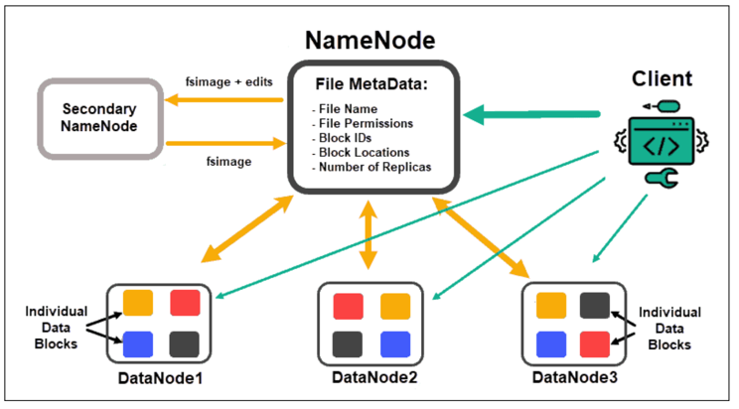
YARN (Yet Another Resource Negotiator) is the default cluster management resource for Hadoop 2 and Hadoop 3. In previous Hadoop versions, MapReduce used to conduct both data processing and resource allocation. Over time the necessity to split processing and resource management led to the development of YARN. Its resource allocation role places it between the storage layer, represented by HDFS, and the MapReduce processing engine. YARN also provides a generic interface that allows you to implement new processing engines for various data types.
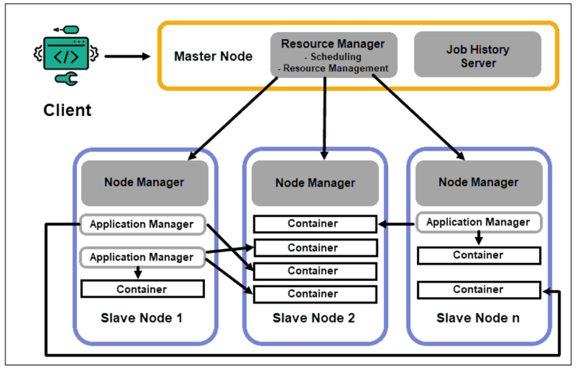
(Kaplarevic, 2020)

Cassandra is designed such that it has no master or slave nodes. It instead has a ring-type architecture, where its nodes are logically distributed in a ring.
Data is automatically distributed across all the nodes. Similar to HDFS, data is replicated across the nodes for redundancy. Data is kept in memory and lazily written to the disk. Hash values of the keys are used to distribute the data among nodes in the cluster.
A hash value is a number that maps any given key to a numeric value. For example, the string ‘ABC’ may be mapped to 101, and decimal number 25.34 may be mapped to 257. A hash value is generated using an algorithm so that the same value of the key always gives the same hash value. In a ring architecture, each node is assigned a token value.

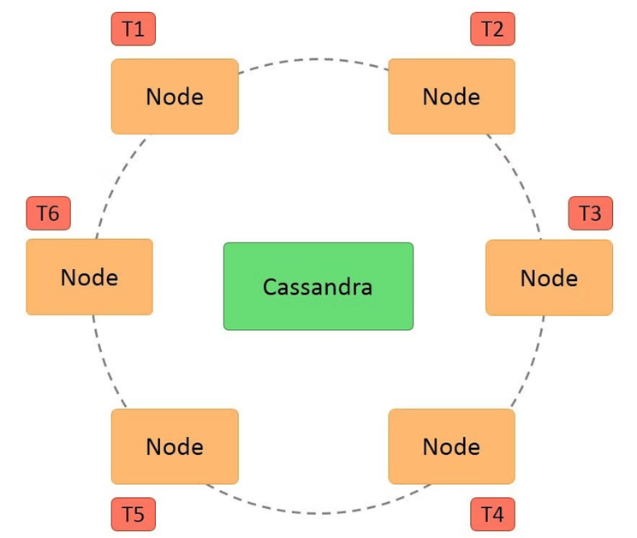

Index
Issues experienced:
I experienced a lot of issues with the Virtual Machine (VirtualBox) and setting up Hadoop. I had to set up Hadoop several times from scratch and experienced many errors along the way. One error in particular

“ERROR: org.apache.hadoop.hbase.PleaseHoldException: Master is initializing” followed by HMaster quitting.

When trying to install a disk image on my VM, the same problem came up.

I got my hands on another laptop, this time a well specked Windows 11 Machine but to my amazement the same error happened even with the disk image. Finally, thanks to help from Dr Muhammad I got the system going back on by stepping back the software rev. But I still had an issue with loading csv file in Hadoop, where it would fail for HMaster quitting again.

Determined to get this key service going, I turned to Amazons AWS services where I spent a considerable time setting up E2 instances for a 4 node Hadoop set up. The instances were for Name Node , Secondary NameNode , DateNode_1 and DataNode_2 .
The steps included…
Setting up security keys and ssh connect to each instance.
Copy keys between instances to set up password-less communication between the servers.
Editing ~/.ssh/config file
Editing the /etc/hosts file
Install java on all instances.
Installing hadoop on all instances
Modifying the ~/.bashrc file on all instances for the paths
Create data directory on all nodes.
And many more steps, but ultimately ran into permission problems between instances which I was not able to resolve as I was running out of time.

Ultimately the solution lay with setting up Elastic on AWS but this was not going to cover the scope of the course work I needed to demonstrate.

Online services are continually evolving, adding new features and services The code solutions implemented in this project were shown to work on previous iterations of the AWS services

Further study. Set up Hadoop on Microsoft Azure would be a sound alternative to AWS , further investigation will ne needed in this area.

References

IEEE conference templates

Amanullah, M.A., Habeeb, R.A.A., Nasaruddin, F.H., Gani, A., Ahmed, E., Nainar, A.S.M., Akim, N.M., Imran, M., 2020. Deep learning and big data technologies for IoT security. Comput. Commun. 151, 495–517.
Asad, Z., Asad, M., n.d. (PDF) A Two-Way Street: Green Big Data Processing for a Greener Smart Grid [WWW Document]. URL https://www.researchgate.net/publication/293193650_A_Two-Way_Street_Green_Big_Data_Processing_for_a_Greener_Smart_Grid (accessed 4.10.23).
Kaplarevic, V., 2020. Apache Hadoop Architecture Explained (In-Depth Overview) [WWW Document]. Knowl. Base PhoenixNAP. URL https://phoenixnap.com/kb/apache-hadoop-architecture-explained (accessed 4.16.23).
Mostafa, N., Ramadan, H.S.M., Elfarouk, O., 2022. Renewable energy management in smart grids by using big data analytics and machine learning. Mach. Learn. Appl. 9, 100363. https://doi.org/10.1016/j.mlwa.2022.100363
Rifkin: The third industrial revolution: how lateral... - Google Scholar [WWW Document], n.d. URL https://scholar.google.com/scholar_lookup?title=The%20third%20industrial%20revolution%3A%20how%20lateral%20power%20is%20transforming%20energy%2C%20the%20economy%2C%20and%20the%20world&author=J.%20Rifkin&publication_year=2011 (accessed 4.10.23).
Shamsi, J.A., Khojaye, M.A., 2021. Big data systems: a 360-degree approach, First edition. ed, Chapman & Hall/CRC big data series. CRC Press/Taylor & Franics Group, Boca Raton.
Total data volume worldwide 2010-2025 [WWW Document], n.d. . Statista. URL https://www.statista.com/statistics/871513/worldwide-data-created/ (accessed 4.10.23).
Zhou, K., Fu, C., Yang, S., 2016. Big data driven smart energy management: From big data to big insights. Renew. Sustain. Energy Rev. 56, 215–225. https://doi.org/10.1016/j.rser.2015.11.050

[1] G. Amanullah, M.A., Habeeb, R.A.A., Nasaruddin, F.H., Gani, A., Ahmed, E., Nainar, A.S.M., Akim, N.M., Imran, M., 2020. Deep learning and big data technologies for IoT security. Comput. Commun. 151, 495–517.
[2] Asad, Z., Asad, M., n.d. (PDF) A Two-Way Street: Green Big Data Processing for a Greener Smart Grid [WWW Document]. URL https://www.researchgate.net/publication/293193650_A_Two-Way_Street_Green_Big_Data_Processing_for_a_Greener_Smart_Grid (accessed 4.10.23).
[3] Kaplarevic, V., 2020. Apache Hadoop Architecture Explained (In-Depth Overview) [WWW Document]. Knowl. Base PhoenixNAP. URL https://phoenixnap.com/kb/apache-hadoop-architecture-explained (accessed 4.16.23).
[4] Mostafa, N., Ramadan, H.S.M., Elfarouk, O., 2022. Renewable energy management in smart grids by using big data analytics and machine learning. Mach. Learn. Appl. 9, 100363. https://doi.org/10.1016/j.mlwa.2022.100363
[5] Rifkin: The third industrial revolution: how lateral... - Google Scholar [WWW Document], n.d. URL https://scholar.google.com/scholar_lookup?title=The%20third%20industrial%20revolution%3A%20how%20lateral%20power%20is%20transforming%20energy%2C%20the%20economy%2C%20and%20the%20world&author=J.%20Rifkin&publication_year=2011 (accessed 4.10.23).
[6] Shamsi, J.A., Khojaye, M.A., 2021. Big data systems: a 360-degree approach, First edition. ed, Chapman & Hall/CRC big data series. CRC Press/Taylor & Franics Group, Boca Raton.
[7] Total data volume worldwide 2010-2025 [WWW Document], n.d. . Statista. URL https://www.statista.com/statistics/871513/worldwide-data-created/ (accessed 4.10.23).
[8] Zhou, K., Fu, C., Yang, S., 2016. Big data driven smart energy management: From big data to big insights. Renew. Sustain. Energy Rev. 56, 215–225. https://doi.org/10.1016/j.rser.2015.11.050. (references)
Data view [WWW Document], n.d. URL https://transparency.entsoe.eu/load-domain/r2/totalLoadR2/show (accessed 4.16.23).
Historical Data - Met Éireann - The Irish Meteorological Service [WWW Document], n.d. URL https://www.met.ie/climate/available-data/historical-data (accessed 4.21.23).
Kaplarevic, V., 2020. Apache Hadoop Architecture Explained (In-Depth Overview) [WWW Document]. Knowledge Base by phoenixNAP. URL https://phoenixnap.com/kb/apache-hadoop-architecture-explained (accessed 4.16.23).

