Abstract:
Organic farming is an agricultural method that aims to produce food using natural substances and processes. This means that organic farming tends to have a limited environmental impact as it encourages, among others: the responsible use of energy and natural resources; the maintenance of biodiversity; preservation of regional ecological balances; enhancement of soil fertility; maintenance of water quality; a high standard of animal welfare which requires farmers to meet the specific behavioural needs of animals.

Data Exploration
The first step, after getting our data, is to explore it, as exploring data is a big part of the two-step data preparation activity. We want to do some preliminary investigation in order to gain a better understanding of the specific characteristics of our data.
.head() and .info() gives me the knowledge of variables in the dataset that shows most of the features in our dataset are categorical, I wanted to get a better understanding of the different values of each variables. For this purpose .info() .dtype()tells me about my each variable type.
.describe(): Summary statistics provide the numerical values to describe our data. Mean and median are measures of the location of specific values. Mode is the value that occurs most frequently in our data set. And range and standard deviation are measures of spread in your data. Looking at these measures will give us an idea of the nature of our data. They can tell us if there's something wrong with our data.
.concat() As we have two dataset that have same features and columns so we can use concatenate function to bring both datasets together in one dataset.

Pre-Processing Data
There are two main goals in the data pre-processing step. The first is to clean the data to address data quality issues. The second is sort of transform the data to make it suitable for analysis. A very important part of data preparation is to address quality issues in our data.
ACQUIRE
PREPARE
ANALYSE
REPORT
ACT

Acquire
Acquire includes anything that makes us retrieve data including finding, accessing, acquiring, and moving data. It includes identification of an authenticated access to all related data, transportation of the data from different sources, and ways to subset and match the data to regions or times of interests.

Prepare
Prepare data into two steps based on the nature of the activity. First step in data preparation involves literally looking at the data to understand its nature, what it means, it's quality, and format. It often takes a preliminary analysis of data or samples of data to understand this. This is why this step is called Prepare.
Analyse
Once we know more about the data through exploratory analysis next step is analyzing It includes cleaning data, subsetting or filtering data, and creating data that programs can read and understand via modeling raw data into a more defined data model or packaging it using a specific data format. If there are multiple datasets involved, this step also includes integration of data from different data sources or streams. The prepared data then will be passed onto the analysis step which involves selection of analytical techniques to use, building a model of the data, and analyzing results
Data Cleaning
The second part of preparing data is to manipulate the clean data into a format needed for analysis. This step is known by many names, data manipulation, data pre-processing, data wrangling and probably best defining as data munging.
Some operations for this data munging, wrangling, pre-processing includes scaling, transformation, feature selection, dimensionality reduction and data manipulation.
We can remove the data records with missing values, we can merge duplicate records, in our data set we have most null values present in Observation Flag column. So, we remove Observation Flag column as it won’t affect our results. Outliers can also be removed if they are not important to the task.
We looked for duplicated values as we do not have any duplicated values in our data, but we did remove UK from our dataset as UK is not the part of EU.
when it comes to data processing, garbage in is garbage out. If we do not spend the time and effort to create good data for the analysis, we will not get good results no matter how sophisticated our data analysis techniques are.

Data Grouping (Subsetting Data)
Data analysis frequently call for grouping records by one or more columns. One of the most crucial Pandas functions is group by. Records are grouped and summed up using the split-apply-combine methodology.
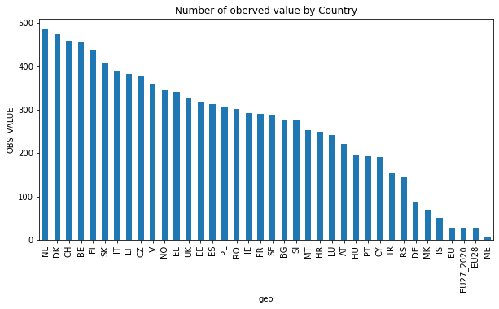
Before making different country set, we used bar plot to look for Observed Values For all countries so first we set our geo data and gets values count for it and plot it. Looking carefully, we can see Sweden, France and Ireland has similarities and looks very closer to each other.
That’s why we created Subset the data frame for Ireland, Sweden and France and try to get insights of Ireland.

Data Visualization

Data visualization is one of the primary skills of any data scientist, hence value cannot be understated. When it comes to defining visualization these two definitions particularly interesting.

“The use of computer-supported, interactive, visual representations of abstract data to amplify cognition.”[Card et al., 1999].

“The representation and presentation of data to facilitate understanding.”[Kirk,2016].
Good data visualization is
- Trustworthy
- Accessible
- Elegant

1.Trustworthy
Trustworthy mean data is presented honestly. For example, if we re displaying something in such a way that it implies a relationship or trend or a correlation, there should be evidence for such relationship in the data. Otherwise, we’re just misleading our audience.
So for this purpose we plot graphs for Ireland, Sweden and France so we can have a look better to find relationship between them.
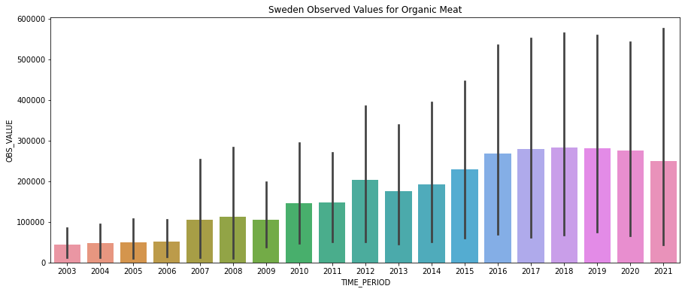

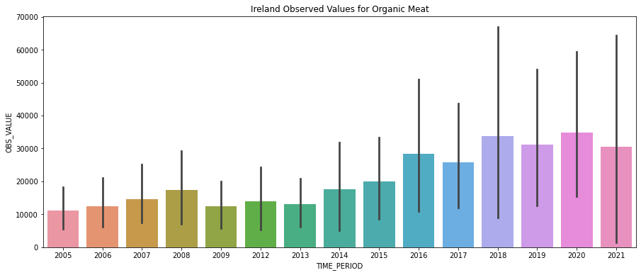
Selecting bar sub plot graph is the right choice when it comes to trying to see the relationship between two variables. Its easy to understand and especially good with multiple data points.
2.Accessible
Accessible means focusing on our audience and their ability to use our visualization. Presentation could be useless or great depending on our audience. So, two things that need to keep in mind before the presentation are to know your audience, know the culture, appropriate color scheme according to individual culture and how they perceive the information. Understand what they understand and know how they might interpret the result. Also be sure to know what the purpose is of your visualization. Are we only exploring the data? Or we presenting it? This will help us craft it in the appropriate way.
3.Elegant
Thinking about elegance takes us towards styling or grace. So, we can think about something clear and beautiful. These all reasonably apply to good data visualizations. So, lack of elegance shouldn’t get in the way of data interpretation.
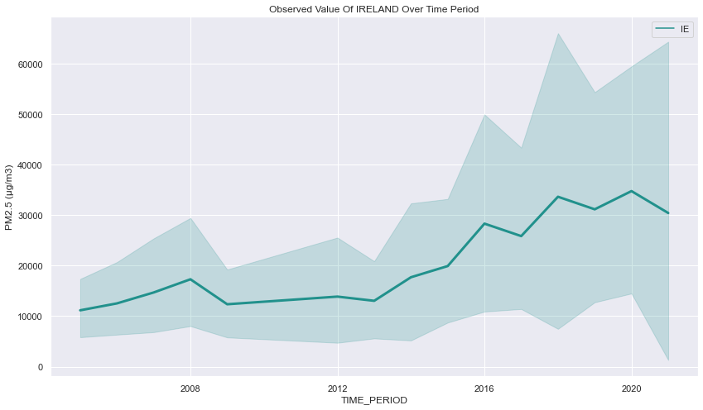
Another Elegant choice in matplotlib is Tick that allows us to visual access to huge amount of data in easily digestible visuals. Ticks are the values used to show specific points on the coordinate axis. In our case it is a number. It visualizes the Ireland Observed values of animals on time period beautifully.
- Focus on the relevant
Focus on what is relevant and remove anything that isn’t adding to the figure so trying to make design invisible so that the viewer can take as much from the visualizations as possible without being distracted. Purpose of using Choropleth maps so that we can use color to show how data changes from place to place. These maps allow us to visualize information tied to geography, and to compare and analyse data from across locations.
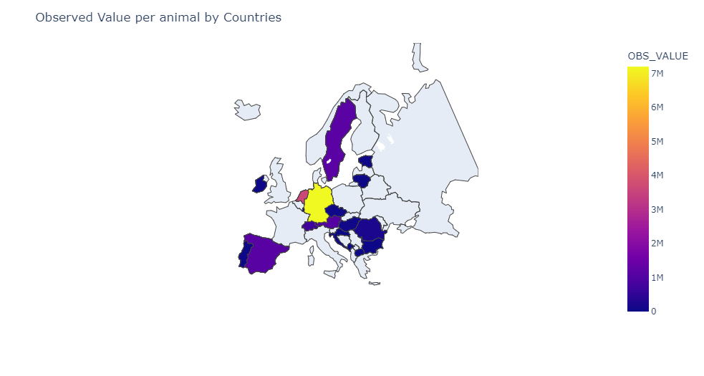
- Be stylish if possible
There’s a distinct style to presentations and graphs, choosing color scheme according to audience culture as different colors presents different emotions for individual culture. Choropleth maps like these can be a powerful tool for understanding trends and planning for the future.
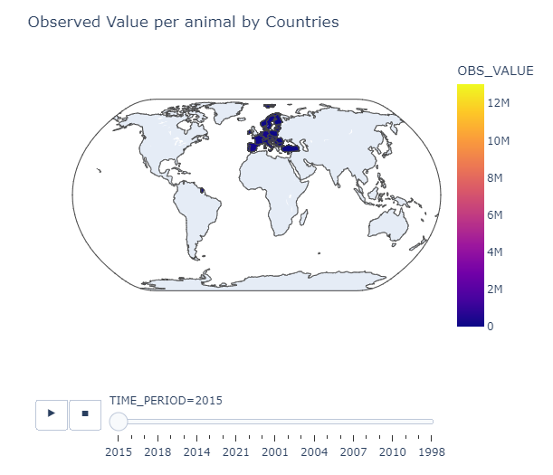
- Think about decorations
Decorations may seem contrary to honesty and in some cases, they kind of are. Decorations may bring the visualization extra attention, and this just goes back to knowing your intended audience.
Data Visualization is an essential part of exploratory data analysis. It is more effective than plain numbers at providing an overview or summary of data(Soner Yildirim, Feb 23,2021)
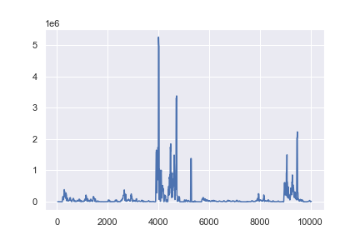
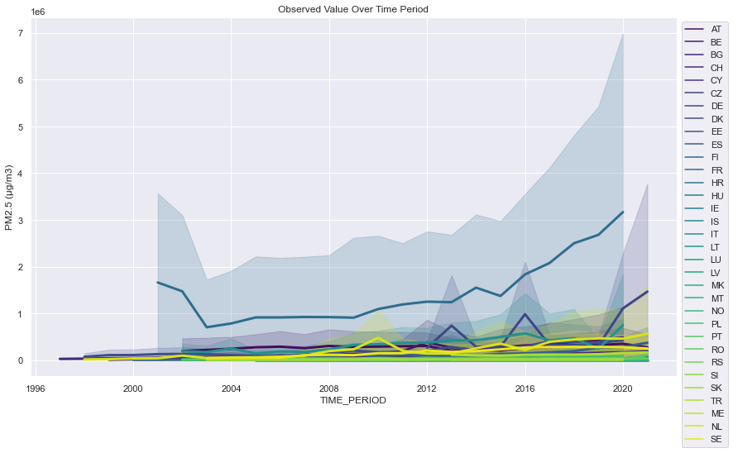
Plotly Express: Plotly Express is the easy-to-use, high-level interface to Plotly, which operates on a variety of types of data and produces easy to style figures. Plotly Express provides functions to visualize a variety of types of data. For our geographical data we used px.bar () functions which provides us very elegant visualization for our Observed Values of Countries over number of years.
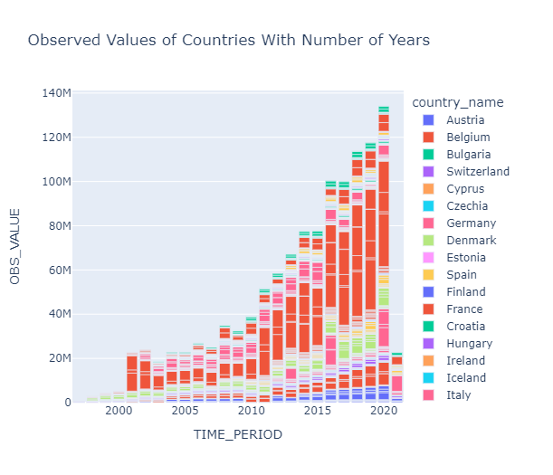
Seaborn: Seaborn is a statistical plotting library and its built-on top of matplot lib. It has beautiful default styles, and it also is delighted to work very well with pandas’ data frame objects. With sns pair plot we would be able to see all features visualization.
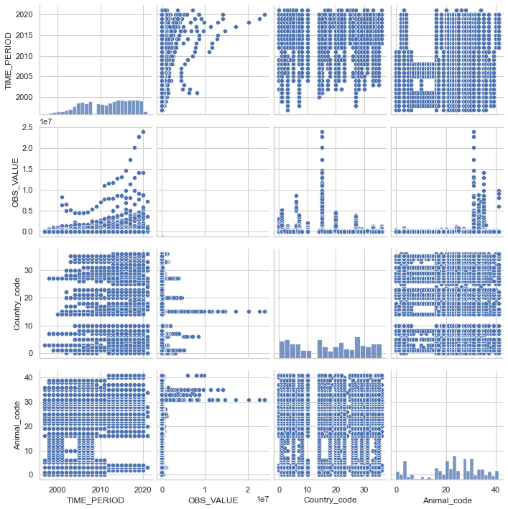
JOINTS PLOT
Joint plots from seaborne: Joint plots from seaborne allows us to basically match up to this plot for by various data meaning you can essentially combine two different distribution plots. And by very it is just two variables. And when we have a kind of parameter that we're going to play around with which allows us to choose how we want to compare these two distributions.
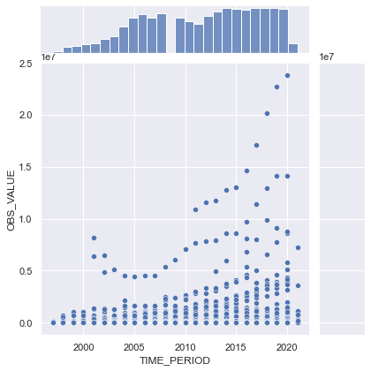
Correlation
we'll be looking for things like correlations, general trends, outliers. And without this step, we will not be able to use the data effectively. Correlation graphs can be used to explore the dependencies between different variables in the data.
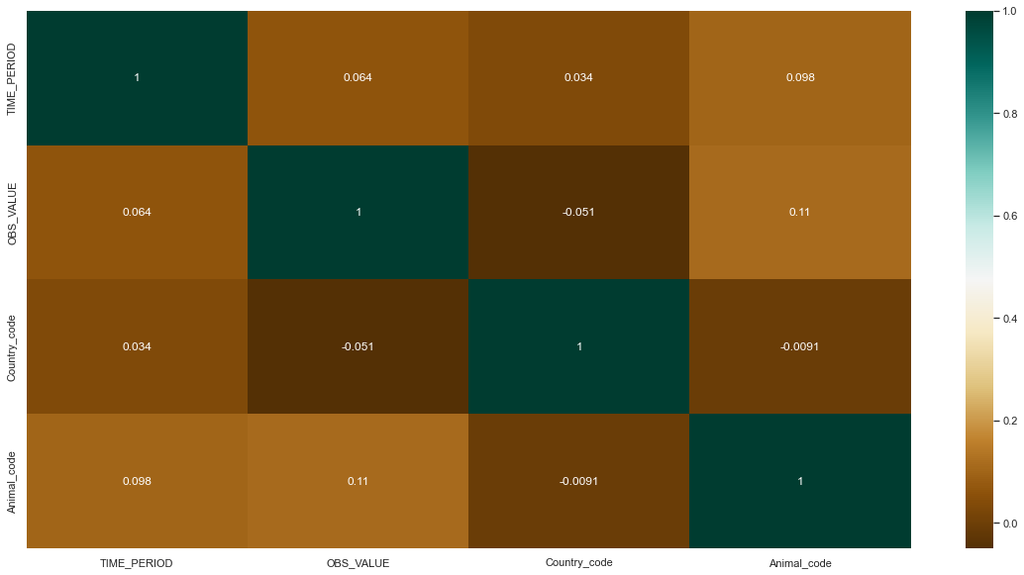
Statistics
Hypothesis Testing
Normality Test
This term is often heard where it is saying assumptions in linear regression and in some other test including machine learning is for target variable should be normally distributed for this purpose, we are going to use Normality Test.
Correlation Test
Correlation test is done between continuous to continuous or categorical to categorical features we do hypothesis testing
Another test as Parametric, Nonparametric test and last one is Stationary test. It is easy to understand what the Parametric and Nonparametric test is but we need to know what stationary test is and what is it importance in data science. It is usually used in time series analysis that tell our time series is stationary or not stationary.
For hypothesis testing we take the data built the null hypothesis and alternative hypothesis and we run test we accept or reject the null hypothesis.
Process of Hypothesis Test
- Purpose
- Assumptions
- Interpret
- How to interpret that

Test # 1
Normality Test Using Shapiro-Wilk Test:
This test will tell us if our data is normally distributed or not based on our sample. For this purpose, we took only observed value to check the normality. Before that we plot histogram so we can find out if our distribution for this feature is normally distributed and looking at histogram, we can say it is not normally distributed its more towards rightly skewed. We can verify this by doing Shapiro test. We assume if probability is more then 5% it is normally distributed if not normally distributed
Ho: Observed Values are Normally Distributed
H1: Observed Values are not Normally Distributed
Our p value is 0.00000 very low so its evident our data is not normally distributed. So we reject our null hypothesis.
Using Randn function
Using this function as it will generate the random number we will run the Shapiro-Wilk test and that gives us Data is normally distributed results with p-value greater than 0.05, resulting to accepting Null Hypothesis.
K^2 Normality Test
Test whether data is normally distributed and for that we assume our null hypothesis is identical distributed that mean all the element in our data have equal probability to occur. We run the test and in which our
H0: Observed Values are Normally Distributed
H1: Observed Values are not Normally Distributed
Our p value is 0.000 so we reject our null hypothesis and its shows our that its not normally distributed.
Correlation Test: Pearson and Spearman’s Rank Correlation
For this purpose we took first 30record from our observed values and names as first sample and for second sample I took first 30 samples from group by animal data frame and in third we took first 30 samples of observed values for Ireland data frame. Now we see how these first two sample vary with each other from plot we can see it doesn’t show any clear pattern so we can deduce that variables are not dependent on each other.
Hypothesis Testing for Spearman and Pearson
We run the spearman test in which our H0: Samples are Independent, H1: samples are dependent. Looking at the p value we accept our null hypothesis.
For Pearson we accept our alternative hypothesis.
Parametric test: One Sample T-test
For this purpose, we take two samples and calculate the means of these two samples and now we are testing mean score of first sample is equal to 0 regardless of what real mean score of first sample is. For this purpose, we run the test and see what’s my p value is very low so that’s mean we reject our Null hypothesis. This was one t test.
Now we try to put assumed mean value closer to our first sample mean value and we choose 3000 that’s bringing p value closer to 0.05 but its still small so we still reject our null hypothesis bases on 3000, 6000, 7000, but when we choose 9000, we get our required result that leads us to accepting our null hypothesis.
Independent Sample T-Test: Two sample test
Our assumption in this case that both samples mean are equal and when we run this test, we get very low p value that’s shows that first Sample mean is not equal to Second Sample mean.
Parametric test- ANOVA-Test
Whether the means of the two or more independent samples are significantly different.
H0: ‘Same distribution of score’
H1: ‘Different Distribution of Scores’
We test three samples, and our p value is very low and it shows we accept two samples are significantly different.

Chi Square Test:1
Chi square test is used to figure out correlation between two categorical variables and assumption for chi square that we should have independent observations and size in each box of contingency table should be greater than 25.
For this purpose, we did panda cross tab function on geo and animals columns. We got contingency table that shows as how many A0019 animals per country are there and so on. The assumption of chi square that each observation in column should be greater than 25 and we can see they are all less than 25 so that’s mean we are violating the assumption. That’s why we did another chi square test later as well.
We test our assumption as H0: Categories are independent vs H1: Categories are dependent. So that’s looking at the p value we reject our null hypothesis and assuming ‘categories are independent’.

Chi Square Test:2
Statistics For Data Analysis
Label | index | math. symbol | Python command | the value
A4100 | 0 | O1 | Observed[0] | 551
A2000 | 1 | O2 | Observed[ 1] | 543
A4200 | 2 | O3 | Observed [ 2] | 509
A5000 | 3 | O4 | Observed[ 3]
A2300F | 4 | O5 | Observed[ 4]
A3120:Breeding sows, live weight 50 kg or over | 5 | O6 | Observed[ 5]
A3132:Fattening pigs, live weight 50 kg or over | 6 | O7 | Observed[ 6]
A3130:Other pigs | 7 | O8 | Observed[ 7]
A5110O | 8 | O9 | Observed[ 8]
A5140 | 9 | O10 | Observed[ 9]
A4110:Ewes and ewe-lambs, breeding females | 10 | O11 | Observed[ 10]
A4120:Other sheep | 11 | O12 | Observed[ 11]
A4210:Goats, breeding females | 12 | O13 | Observed[ 12]
A4220:Other goats" | 13 | O14 | Observed[ 13]
A3100:Live swine, domestic species | 14 | O15 | Observed[ 14]
A2900:Other bovine animals | 15 | O16 | Observed[ 15]
A2000B:Bovine animals for slaughter | 16 | O17 | Observed[ 16]
A6110 | 17 | O18 | Observed[ 17]
A3000 | 18 | O19 | Observed[ 18]
A1100 | 19 | O20 | Observed[ 19]
A6710R:Bees (hives) | 20 | O21 | Observed[ 20]
A5000X5110O_5140:Live poultry excluding laying hens and broilers" | 21 | O22 | Observed[ 21]
A5200 | 22 | O23 | Observed[ 22]
A1000 | 23 | O24 | Observed[ 23]
A6710 | 24 | O25 | Observed[ 24]
A0019 | 25 | O26 | Observed[ 25]
A2000E | 26 | O27 | Observed[ 26]
A6900 | 27 | O28 | Observed[ 27]
A2000D | 28 | O29 | Observed[ 28]
A2300H | 29 | O30 | Observed[ 29]
A2020 | 30 | O31 | Observed[ 30]
A6111 | 31 | O32 | Observed[ 31]
A2010 | 32 | O33 | Observed[ 32]
A2030 | 33 | O34 | Observed[ 33]
A2030C | 34 | O35 | Observed[34 ]
A2020C | 35 | O36 | Observed[ 35]
A2030B | 36 | O37 | Observed[ 36]
A2020B | 37 | O38 | Observed[ 37]
A2010C | 38 | O39 | Observed[ 38]
A2010B | 39 | O40 | Observed[ 39]
A5110OH Laying hens (producing eggs for consumption) | 40 | O41 | Observed[ 40]
A4110K:Ewes and ewe-lambs put to the ram | 41 | O42 | Observed[ 41]
 |  |  |  | 9287

O=(O1,O2,O3,….O42)
O=(576,562,526,…9) all I’m doing is describing the table of observed frequencies (i.e., observed), but I’m referring to it using mathematical notation, rather than by referring to an Python variable.

The null hypothesis and the alternative hypothesis:

All Animals are chosen with equal probability. What we’re going to want to do now is translate this into some statistical hypotheses and construct a statistical test of those
hypotheses.
H0: All Animals are chosen with equal probability.
H1: All Animals are not chosen with equal probability.
If the null hypothesis is true, then Pj to refer to the true probability that the j-th suit is chosen. If the null hypothesis is true, then each of the four suits has a 2.4%chance of being selected: in other words, our null hypothesis claims that P1=0.024, P2=0.024, Pj=0.024 However, in the same way that we can group our observed frequencies into a vector O that summarises the entire data set, we can use P to refer to the probabilities that correspond to our null hypothesis. So if I let the vector P=(P1,P2,P3,…Pj) Where j varies from1,2…41, refer to the collection of probabilities that describe our null hypothesis, then we have
H0 : P=(0.024,0.024,…0.024j)
H1: P!=(0.024,0.024,…..0.024j)
We calculated chi square along with plotting it. So as our χ2 statistic is bigger than 56.94 or so, then we can reject the null hypothesis. Since we calculated that before (i.e χ2=4592.53) we know that we can reject the null hypothesis.
Non-Parametric test: Mann-Whitney U Test whether the distributions of two or more independent samples are equal or not
Nonparametric have assumption of normally data distribution. So, we run substantial
evidence for null hypothesis.
H0: Same Distribution
H1: Different Distribution
Our P-value is very low, so we reject our null hypothesis that shows our distribution is different.
Test Type | H0 | H1 | Accept H0 | Accept H1
Shapiro-Wilk Test | Values are  Normally  Distributed | Values are not normally  Distribution | Reject H0 | Accept H1
Shapiro-Test on randn() | Values are  Normally  Distributed | Values are not Normally  Distribution | Accept H0 | Reject H1
K Square  Normality Test | Values are  Normally  Distributed | Values are not Normally  Distribution | Reject H0 | Accept H1
Pearson  Correlation | Samples are  Independent | Samples are  Dependent | Reject H0 | Accept H1
Spearman Rank Correlation | Samples are  Independent | Samples are  Dependent | Accept H0 | Reject H1
One Sample T-Test | Sample Means are equal to First Sample mean | Sample Means are not equal to First Sample mean | Reject H0 | Accept H1
Two sample T-Test | First Sample mean equals to second sample | First Sample mean not equals to second sample | Reject H0 | Accept H1
Three Sample T- Test | Same  Distribution of score | Different  Distributions of scores | Reject H0 | Accept H1
Chi Test1  Importing chi contingency | Categories are Independent | Categories are Dependent | Reject H0 | Accept H1
Chi Test 2 | H0 : P=(0.024,0.024,…0.024j) | H1: P!=(0.024,0.024,…..0.024j) | Reject H0 | Accept H1
Non Parametric Mann-Whitney U | Same Distribution | Different Distribution | Reject  H0 | Accept  H1

Machine Learning
Machine Learning is a subdomain pf computer science that focuses on algorithms which might help a computer learn from data without explicit programming being there telling the computer exactly what to do that’s what called explicit programming.
ARTIFICIAL INTELLIGENCE
AI is an area of computer science where the goal is to enable computers and machines to perform human like tasks and simulate human behaviour. Now machine learning is a subset of AI that tries to solve one specific problem and make predictions using certain data.
Types Of Machine Learning
Supervised Machine Learning
First type of machine learning is supervised machine learning that uses inputs(meaning the input has a corresponding output label) to train models and learn outputs of different new inputs that we might feed our example.
Unsupervised Machine Learning
In Unsupervised Machine Learning we use unlabelled data to learn about patterns in data.
KNN Classifier
The KNN went through the following processes for each data sample when it was trained on training data: Use a method like Euclidean to calculate the distance between the data sample and each other sample. Arrange these distance values in descending order. Pick the top K distances from the sorted list. Based on the most prevalent class in the K values, assign the class to the sample.

Splitting Data
In case of Our data set we can see each row for each data point and column for each feature here, we can see we have observed values of animals all over the country with respect to years. The aim of supervised machine learning is to build a model its able to predict the target variables.

The KNN Model
K-Nearest Neighbors (KNN) is considered as one of the simplest and extremely easy to implement in its most basic form and yet performs quite complex classification tasks in supervised machine learning algorithm and is used in machine learning regression and classification. KNN doesn’t assume anything about the underlying data this is extremely useful feature since most of the real-world data doesn’t really follow any theoretical assumptions for example linear scalability or uniform distribution lets start using the KNN algorithm using scikit-learn now, after we load clean analyse and normalize our data now its time for us to feed the data to KNN Model. For this purpose, we will use sklearn function that is already built-in function and it has a class which is known as K NeighborsClassifier.

An kNN Algorithm
The kNN algorithm can be summarized in the following simple steps: First of all we need to determine k and it really depend on individual dataset for our model we use k =10. Next, we will calculate the distance between our input data and the output data points. This distance will decide the k nearest neighbors based on the minimum distance from K. Next, we will bring all those neighbors together. We test the accuracy and got 51% of accuracy.

Grid Search CV For KNN
The exhaustive search identified the best parameters for our K-Neighbors Classifier to be leaf_size=15, n_neighbors=5, and weights='distance'. This combination of parameters
produced an accuracy score of 0.67.
Naive Bayes and Support Vector Machine
Naive Bayes is a supervised machine learning algorithm used for classification problems. It is built on Bayes Theorem. It is called Naive because of its Naive assumption of Conditional Independence among predictors. It assumes that all the features in a class are unrelated to each other. SVM is a supervised machine learning algorithm by which we can perform Regression and Classification. In SVM, data points are plotted in n-dimensional space where n is the number of features. Then the classification is done by selecting a suitable hyper-plane that differentiates two classes.
We take all numeric feature columns as X values and for output we used ‘unit’ feature. We split the dataset into training and test set.
After that we used feature scaling so that we can bring all variables to a single scale. After StandardScaler we initialise and object sc by calling method GaussianNB. After this I predicted the y values. Checked how often our classifier is correct and it shows it corrects 0.47%.
Use of Cross Validation
Cross-Validation is a resampling technique that helps to make our model sure about its efficiency and accuracy on the unseen data. It is a method for evaluating Machine Learning models by training several other Machine learning models on subsets of the available input data set and evaluating them on the subset of the data set. We used cross validation for GaussianNB and we got 48% score.
Looking at f1 score we can see we got 76% true positive that’s mean 76 percent is correctly predicted and 46% False Negative mean are wrongly negatively predicted.
precision recall f1-score support

Head 0.62 0.76 0.68 1003
Number 0.62 0.46 0.53 855

accuracy 0.62 1858
macro avg 0.62 0.61 0.61 1858
weighted avg 0.62 0.62 0.61 1858

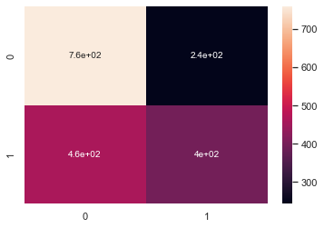

Grid Search Cv
One of the great things about GridSearchCV is that it is a meta-estimator. It takes an estimator like SVC and creates a new estimator, that behaves the same, in this case, like a classifier. We have almost 71% prediction results.
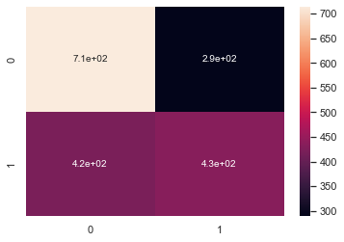

Decision Tree Classification model
Decision Tree in Machine Learning has got a wide field in the modern world. There are a lot of algorithms in ML which is utilized in our day-to-day life. One of the important algorithms is the Decision Tree used for classification and a solution for regression problems. As it is a predictive model, Decision Tree Analysis is done via an algorithmic approach where a data set is split into subsets as per conditions. The name itself says it is a tree-like model in the form of if-then-else statements. The deeper is the tree and more are the nodes, the better is the model. Decision tree classifier gives us 63% of accuracy.

Linear Regression
The term regression is used when you try to find the relationship between variables. In Machine Learning, and in statistical modeling, that relationship is used to predict the outcome of future events. Linear regression uses the relationship between the data-points to draw a straight line through all them.
Lasso and Ridge Regression
Lasso and Ridge regression are two of the most popular variations of linear regression which try to make it a bit more robust. Nowadays it is actually very uncommon to see regular linear regression out in the wild and not one of its variations like Lasso and Ridge. The purpose of Lasso and Ridge is to stabilize the vanilla linear regression and make it more robust against outliers, overfitting and more

S/No | Models | Accuracy
1 | KNN Model | 0.51
2 | Grid Search CV for KNN | 0.67
3 | Naive Bayes And Support Vector Machine | 0.47
4 | Cross Validation | 0.49
5 | GridSearchCV(SVC) | 0.71
6 | DecisionTreeClassifier | 0.64
7 | Linear Regression Model | Train:0.017, Test:0.019
8 | Ridge Regression | Train:0.02, Test:0.02
9 | Lasso Regression | Train: 0.02, Test: 0.02

Sentiment Analysis of Tweets
Sentiment analysis is an approach to analyse data and retrieve sentiment that it embodies. With exploration and pre-processing of data, transforming data into a proper input format and classify the user’s perspective via tweets into positive(non-racist) and negative (racist) by building supervised learning models using Python and NLTK library.
1.Authenticate to Twitter
First import some dependencies so those dependencies will be tweepy, NumPy, nltk, seaborn panda and matplotlib. Next step we have to do to grab some credentials from twitter developer account. There are four credentials that we need we run all those four keys to authenticate to twitter.
2.Get Tweets
For this purpose we set the query that we are looking for and set empty tweets cell and make the limit to 1000 and for getting the tweets we used sntwitter to TwitterSearchScarper for this before we install snscrape and create the data frame with required column.

3.Preprocess
We want to see which kind of organic meat is mentioned in each one of the tweets. For this we set up a reference array then loop through each one of these tweets and if a particular type of meat is mentioned we are going to create new column within this dataset. So we created two column with name as meat and chicken.
After this we defined a function called cleanup tweets that will clean all stoppers punctuation special characters etc and we need to remove and also we need to remove retweet. For this define cleanup tweets and I removed all the mentions using regular expression so as we already had imported this library and removed all hashtags, URL, retweets and apply this tweet by calling this function. Applying this to all tweets so this has cleaned all the mentions, retweets, special character etc.
I used textblob API to get the subjectivity and polarity of these tweets for this I define two functions as “def getTextSubjectivity(txt): return TextBlob(txt).sentiment.subjectivity” and did same for polarity. After this we define a function to get text analysis set our values if less than 0 its negative sentiment if its greater than 0 positive and if its equal to 0 its neutral. Apply this to polarity and after this it will created a score column.
4.Calculate Sentiment
After this we define X as tweets Column and Y as score. Collect all columns into sentimental ordering. Instantiate an object cv by calling countVectorzer() method. Instantiate an object model by calling MultinomialNB() method.train the model by calling methodfit(). After calling predict method we instantiate cla method and predict precision. Our precision is 98%.
5.Visualise
By visualizing we saw we have more positive tweets
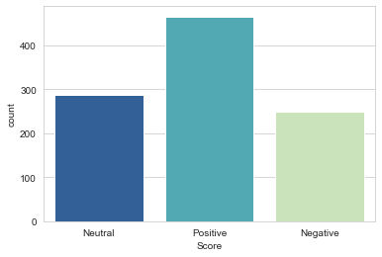

References

Card,S and Mackinaly,J. and Sheiderman,B., Readings information Visualization: Using Vision to Think, Morgan Kaufmann Publisher, 1999.
Kirk,A.Data Visualization: A handbook for Data Driven Design.SAGE publications,2016.
Sjoukie A. Osinga, Dilli Paudel, Spiros A. Mouzakitis, loannis N. Athansiadis(2022): “Big data in agriculture: Between opportunity and solution”, https://doi.org/10.1016/j.agsy.2021.103298,(https://www.sciencedirect.com/science/article/pii/S030852X21002511)
ZACH July 19 2021. How to Use the Poisson Distribution in Python. [Online] Available at: https://www.statology.org/poisson-distribution-python/. [Accessed 10 Nov 2022].
Soner Yildirim Feb 23 2021: “Data Visualization with Pandas”, https://towardsdatascience.com/data-visualization-with-pandas-1571bbc541c8. [Accessed 22 Dec 2022].

