Abstract

I. Introduction

* Overview of CRISP DM
* Why CRISP DM is important in data science projects

II. Business Understanding

* Defining the project objectives and goals
* Identifying stakeholders and their needs
* Defining the project scope

III. Data Understanding

* Collecting and preparing data for analysis
* Exploring and visualizing data
* Verifying data quality

IV. Data Preparation

* Cleaning and transforming data
* Selecting relevant data for analysis
* Creating derived variables

V. Modeling

* Selecting and training a model
* Evaluating model performance
* Fine-tuning the model

VI. Evaluation

* Assessing model performance against business objectives
* Identifying potential improvements
* Communicating results to stakeholders

VII. Deployment

* Planning for model deployment
* Implementing the model in a production environment
* Monitoring model performance and maintaining it over time

VIII. Conclusion

* Summary of key points from the project
* Implications and next steps
* Reflection on the use of CRISP DM in the project.

# **Abstract:**

This project is based on the Food and **Agriculture Organization of the United Nations (FAO)**. Data from FAO was selected to represent Producer Prices and **Producer Price Index for Agriculture**.

Agri-Producer Prices refer to the prices farmers receive at the point of sale for their primary crops, live animals, and livestock. Data for the 27 EU member countries is provided by the FAO dataset beginning in 1991 and continuing through 2020.

An agricultural producer price index measures changes in the average selling prices received by farmers over time (prices at the farm gate or at the first point of sale).

This study examines and identifies changes in the agricultural producer price index over time in terms of the average selling prices received by farmers. Data for EU countries have been downloaded, and on the basis of this data, a separate dataset is generated for the Republic of Ireland. This will be compared with other countries in the European Union at a later stage.

* (FAO - Agriculture Organization of the United Nations - https://www.fao.org)

# Introduction

Based on the information obtained from FAO, it seems that the business problem being addressed in this project is to examine changes in agricultural producer prices and producer price indices over time in the European Union, with a focus on the Republic of Ireland. The goal is to identify trends and patterns in these prices and indices, and potentially to use this information to inform policy or decision-making related to agriculture in the EU.

One potential approach to solving this problem using the CRISP-DM framework would be to:

There are several reasons why CRISP-DM has been chosen over other PM Data science frameworks:

* + CRISP-DM is a widely used and well-established framework that has been around for over two decades. It has been tested and refined through years of practical use and is widely recognized as a reliable and effective approach to data mining.
  + CRISP-DM is a flexible framework that can be adapted to fit the needs of a wide range of projects. It is not tied to any specific industry or technology and can be applied to a variety of business contexts.
  + CRISP-DM is a comprehensive framework that covers all the key steps in the data mining process, from business understanding and data preparation to modeling, evaluation, and deployment. This makes it well-suited for projects that require a structured and systematic approach.
  + CRISP-DM is easy to understand and use, with clear guidance and best practices for each step in the process. This makes it accessible to practitioners who are new to data mining, as well as those who are more experienced.
  + Overall, the CRISP-DM framework is a solid choice for data mining projects due to its widespread adoption, flexibility, comprehensiveness, and ease of use.
* **Overview of CRISP DM process**

The steps in the CRISP-DM process are as follows:

* + **Business Understanding:** Define the project goals and objectives, as well as the stakeholders who will be affected by the project.
  + **Data Understanding:** Collect and summarize data and assess the quality of the data.
  + **Data Preparation:** Clean and transform the data to make it ready for analysis.
  + **Modeling:** Select and apply the appropriate data mining techniques to build the model.
  + **Evaluation:** Evaluate the results of the model and determine whether it meets the project goals and objectives.
  + **Deployment:** Plan for the deployment of the model and prepare for the ongoing maintenance of the model.

Here is a flowchart that illustrates the CRISP-DM process in the CA-2:

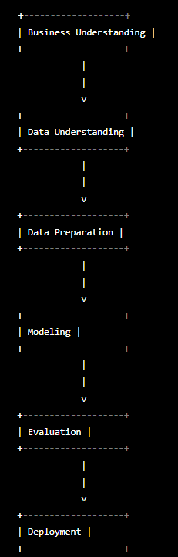

**Fig 1**:

II. Business Understanding

In this project, the business problem being addressed is the examination of changes in agricultural producer prices and producer price indices over time in the European Union, with a focus on the Republic of Ireland. The goal of the project is to identify trends and patterns in these prices and indices, and potentially use this information to inform policy or decision-making related to agriculture in the EU.

III. Data Understanding

* Collecting and preparing data for analysis
* Exploring and visualizing data
* Verifying data quality

IV. Data Preparation

* Cleaning and transforming data
* Selecting relevant data for analysis
* Creating derived variables