Group ID - MSc in Data Analytics

Author: Sezai Koc
e-mail: sba22303@student.cct.ie
Student ID: 22303

Selected Data Source: Agriculture Livestock and Meat
Main Goal of the Dataset provided by Eurostat: Livestock and production Data.

Main Source Files Page :
https://ec.europa.eu/eurostat/web/agriculture/data/main-tables

Meet Supply Balance 2021
https://www.cso.ie/en/releasesandpublications/ep/p-msb/meatsupplybalance2021/data/

Git Repository : https://github.com/sba22303/ca2.git

CAP : Income Support source info:
https://agridata.ec.europa.eu/extensions/DashboardIndicators/FarmIncome.html

Abstract

Established in 1962, the Common Agricultural Policy (CAP) was introduced to provide affordable, safe and high-quality food to people, in addition to ensuring a fair standard of living for farmers. Over its lifetime, the CAP has gone through many reforms. The first came in 1968 from Sicco Mansholt, the first European Commissioner responsible for Agriculture. The Mansholt Plan aimed to improve the standard of living for farmers by advancing a wide-scale modernisation of the agricultural sector and enabling European farmers to become more self-sufficient.
In anticipation of future EU enlargement, the programme added a second ‘pillar’ within the CAP dedicated to rural development and was intended to provide new sources of income to rural areas. The establishment of rural development into the CAP added to a first ‘pillar’ introduced by the MacSharry Reforms, which dedicated direct income supports to farmers. ‘Agenda 2000’ also aimed to strengthen social cohesion and increase the competitiveness of the agricultural sector.
EU Member States agreed to reform the CAP once again for the period 2014 – 2022. Ireland’s membership of the EU has been of particular importance to the agricultural sector. It was one of the key reasons behind Ireland joining the then European Economic Community (EEC) in 1973. At the time 24% of Irish employment was in agriculture, according to the CSO.
In the latest Eurobarometer report on the CAP, 72% of Irish people think that agriculture and rural areas are very important for our future. Further, 86% of people believe that securing a stable supply of safe, healthy, and sustainable food should remain the primary objective of the CAP.

The key elements of the current CAP Programme 2014 – 2020 include:
- A Basic Payment applied at farm level on the basis of the new internal convergence model with variable greening which will involve some re-distribution of the Basic Payment on a phased basis;
- 2% of the Basic Payment will be allocated to young farmers to provide a 25% top-up, and an allocation of 3% for the National Reserve. Farmers with low payments will be moved up to a minimum of 60% of the national average;
- An agri-environment scheme (GLAS) with a payment of up to €5,000 per annum for 50,000 farmers;
- A new Suckler payment (Beef Data and Genomics Programme) worth €52m per annum;
- A Capital Investment Programme (TAMS) for all sectors to cover infrastructure and equipment, and supporting on-farm efficiency and expansion, particularly in the context of the abolition of dairy quotas;
- €195m funding for Disadvantaged Areas, to be known as Areas of Natural Constraint (ANC);
- A coupled payment for protein crops;
- A Sheep Grassland Payment of €13m incorporated into the Basic Payment to top-up sheep farmers’ payments.

Introduction

The agriculture production value is a good indicator that can help us to have an overview of the whole agriculture production performance for Ireland and many other specific country. In EU, all members country is part of the Common agriculture policy that gives some countribution to agricultors of members country. The main support is under income support done directly to beneficary those are most of the time local farmers.

It is interesting to have an idea how this CAP support is performing between Ireland and others EU countries and also if we can conduct that analyse further, measuring agriculture sector performance in Irelan, EU against USA.

Exploratory Data Analysis

Extraction
First of all we are extract dataset from the online database provided by the Food and Agriculture Organization of United Nations named the FAOSTAT. Before downloading we apply some filter in order to simplify the volume and the size of the data that we will get.

For this reason the following filters will be applied and will reflect the following information :
-> Country : Ireland, France, Spain, USA
-> Product Item : All
-> Years : 2018,2019,2022. (We take the last 3 years as they are the most recent values.)

We obtain the a dataset in which we have the following column and values:
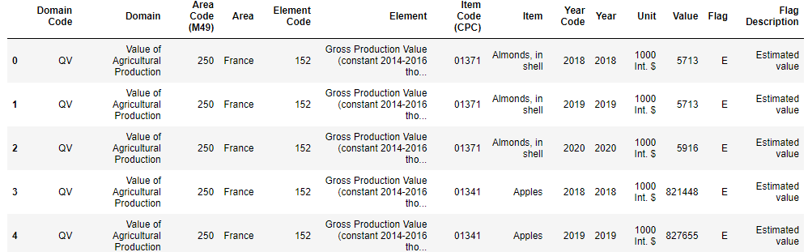

First analyses of what is available in our dataset. We have 14 columns in which following values and meaning from left to right:
Domain Code : QV for Quantitative Value is the same value for all lines.
Domain : Value of Agriculture Production, specify that we have data for this specific domain. This value is the same for all lines.
Area and Area Code : Used to identify the country one is the lable the other is the numeric code itself.
Element Code : Code used by the FAOSTAT for the given agriculture product group.
Element : Specifiy the Current production value currency if it is in standard Dollar or Standard Local Currency.
Item Code(CPC) : Is the unqiue code used by the FAOSTAT to identify the agriculture product measured and quantified.
Item : description of the agriculture product itself measured.
Year Code and Year : We have here the same value for the Year for which the measure and quantification has been made.
Unit : Specify the if the multliplier of 1000 is in Standard Dollar or SLC.
Value : Is the production value measured for the specific item.
Flag, and Flag Description : E for estimated value, and his description.

Reshaping
Looking the shape of our dataset we have 14 Columns and 4207 rows. First things to do is the standardization of the column name in order to avoid any confusion, we rename then all columns with capital letters at the beginning and use and under score as word separator. No need to reorder column for now.

Value check
We check the unique value in our dataset. We can see that Domain_code, Domain, Flag_description and Flag have a single value. These columns are irrelevant for us we remove them first using the drop() method. We remove also Element, and Element_code column because they dont help us in our analyse.

For simplification purpuse we consider that the standard currency is the US dollar and 1 Euros = US dollar for now. The multiplier is 1000 and is the same for each rows, we will remove the Unit column that wont bring to much in our analyses.

Year_code, column has the same value of the Year we then remove that column.

We have reduced our dataset to the following :
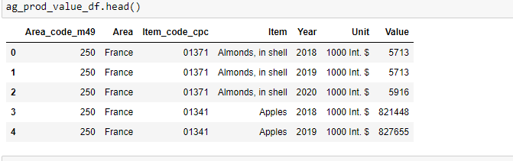

ag_prod_value_df is trhe
ag_prod_value_df is the dataset that contains all the agriculture production value for all items including fruit and legumes. We can see that checking unique values in the Item column.

In general, Meat and Mealt is the most expensive, and most important product of a consumer. For simplification purpose we will focus on meat/milk production value only for our analysis. For these reasons we create a new dataframe in which we only these items.

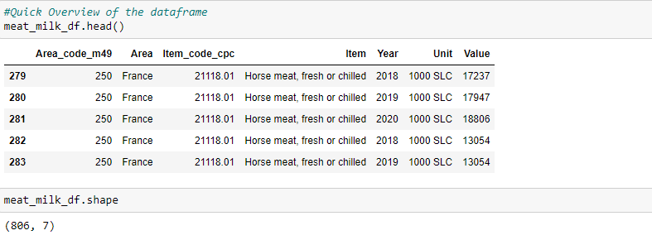
Our new dataframe contains 806 rows and 7 columns for now. After verifying unique values in Item column we can see that we have only Meat and Milk related items. We classify the data tha we have in our dataset creating 3 different columns. Meat/Milk column that will tell us we are with Milk or Meat category, Animal column that will contains the exact descritpion of which type of aninal we have in the item, and animal group in order to group animals by category. The Animal_group column will categories as follow :
Cattle for Cattle only, Poultry for Chickens, Ducks, Gees, Rabbits, Turkey, Others : Horse,Game,Pig.

We obtain the following dataset :

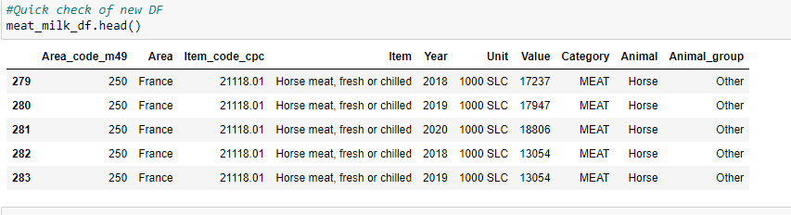

We check if we have any null values in our rows that can bother our analysis. We can see that we dont have any null values.

Last check before plotting our data, is to check value the vlaue count.
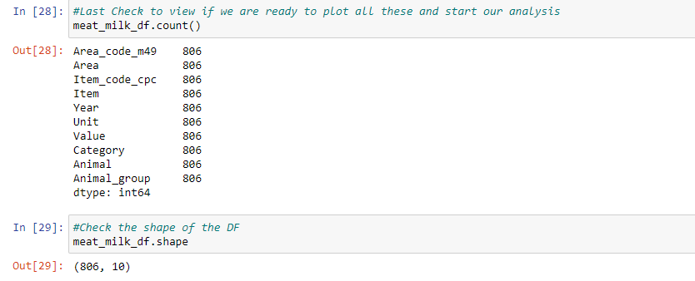
Our dataframe is now ready to be plotted and for analysis.

Visualization of our dataframe with Altair for Ireland Only

We are now plotting our dataframe using Altair library for Ireland only. The second plot enable user to select the year from 2018 up to 2020, in order to visulise data for Ireland. Ou first conclusion about the data that we are viewing is that, cattle production values is the higfhest followed by pig and sheep for Ireland.

Statistics on our Dataset

CAP Performance
We need to involved a new dataframe in order to measure the performance of the CAP, because some information that we need are not present in the existing dataframe that we have built above.
This data is from agridata website dashboard the link is provided. It's easier for us to built from scratch the dataset as the bulk dataset doesnt contain relevant column and will complicate our task.
We need here to use the Year(2018,2019,2020), Entity(EU,France,Spain,Ireland), Beneficiary number, and Amount per beneficiary. Adding to this dataframe Total_amount that will calculate the total amount paid for the Entity we obtain the following dataframe :

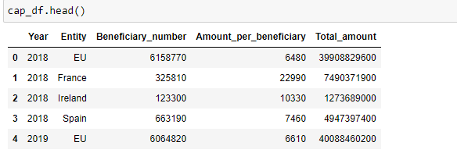
As cap_df, dataframe is now ready we can start to do our statistics.

Descriptive Statistics

For Ireland, using our ir_mm_df, dataframe we calculate our Meat/Milk production value for the last 3 years and obtain the following result :
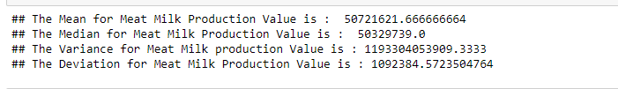
We plot all these dataset in a boxplot to have an overview of the performance of Ireland for the last 3 years.

Our Conclusion : Without applying the mulyiplier of 1000,00, we have a mean at 50721621 and a standard deviation of 1092384 for the Meat/Milk production value for Ireland only in the last 3 years.

Inferantial Statistics

Hypothesis test t-test One Way : In our t-test we will consider that cap performance will be the same for coming next 3 years and we believe that the mean will be at least equal to the mean of the last 3 years.
In this case we have our H0 scenarion u = ir_mm_mean that has the value of 50721621 and the H1 will be the scenrion where u is different of ir_mm_mean.
We use the scipy library of python and call the method stats.ttest_1samp passing the last 3 years production value against the mean.
We obtain the following result for of p-value that gives us the highest probabilty that is equal to 1.0 and a result of t-value equal to 0, confirming that our data matches null value hypothesis and there are no irregularities found.

Confidence Interval : In order to calculate our confidence interval we first calculate our degree of freedom, we obtain a value of n-1 = 3-1 = 2 using python. We calculate the standard error and set the confidence level at 0.95. We call then the python method t.interval passing it as parameters all these variable calculated and setted. After the method has been called we obtain a confidence interval with a value max = 53435255 and min = 48007987.

Other countries performance against Ireland
We create a new column in the cap_df dataframe that will contain the cap coefficient value between France, Spain, Ireland. This is a critical information as this one can help us to measure the performance of the cap. I define the value of the cap coefficient based on per year and per country with the following formula :
(number of beneficiary * amount per beneficiary) / (total amount paid by EU)

Im creating a new dataframe in which i will contain data for France, Spain, Ireland for the last 3 years only for Meat and Milk. After grouping rows and renaming column, im merging these dataframe with cap_df, dataframe.

I'm checking the normality distribution of our data, doing a normality plot that display a graph from the cap_df dataframe using the Production_value column as measured data.
According to the result we obtain, we can conclude that our data is normally distributed as they are very close to each other for each country. They make almost a line around a specific level.

Shapiro Test Wilk is used to confirm, the result that we have obtained by the graph plotted previously, the result is as follow :

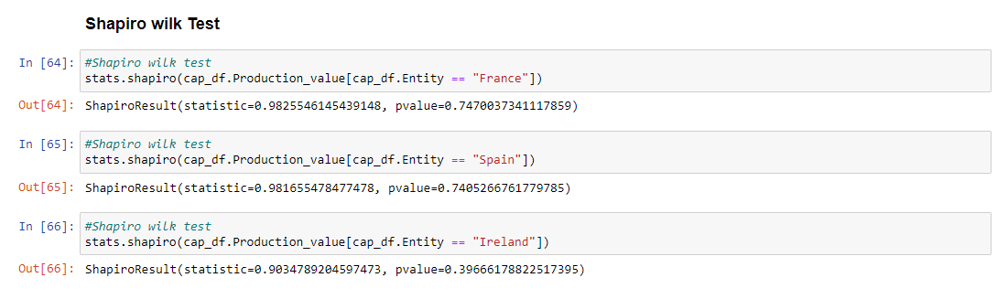
Our conclusion, pvalues are greater than 0.05 for each country, this confirm to us the normal distribution of our data.
The standard deviation calculation is made in order to compare this value, the highest value is for Spain and the lowest for France. Let's check the variance homogeneity in the Levene test. We obtain a value greater than 0.05 so the Levene test is non significant.

One way ANOVA test is done, we obtain the a value lower than 0,05 means for us that there are significant difference among Entity.
Two way Anova results gives us p value lower than 0,05 for Enity and Cap_coefficient.

ML ON CAP PERFORMANCE

Classification

Readjustment of the model

GridsearchCV - Confusion Matrix

Use of multiple models (at least two) to compare and contrast results and insights gained.
- Describe the rationale and justification for the choice of machine learning models for the above-mentioned scenario. Machine Learning models can be used for Prediction, Classification, Clustering, sentiment analysis, recommendation systems and Time series analysis. You should plan on trying multiple approaches (at least two) with proper selection of hyperparameters using GridSearchCV method. You can choose appropriate features from the datasets and a target feature to answer the question asked in the scenario in the case of supervised learning.
[0 - 30]
- Collect and develop a dataset based on the agriculture topic related to Ireland as well as other parts of the world. Perform a sentimental analysis for an appropriate agricultural topic (e.g., product price, feed quality etc…) for producers and consumers point of view in Ireland.
[0 - 25]
- You should train and test for Supervised Learning and other appropriate metrics for unsupervised/ semi-supervised machine learning models that you have chosen. Use cross validation to provide authenticity of the modelling outcomes. You can apply dimensionality reduction methods to prepare the dataset based on your machine learning modelling requirements.
[0 - 30]
- A Table or graphics should be provided to illustrate the similarities and contrast of the Machine Learning modelling outcomes based on the scoring metric used for the analysis of the above-mentioned scenario. Discuss and elaborate your understanding clearly.
[0 - 15]

Total Mark = 30+25+30+15=100:(100*0.5=50%)

Definition

.

Lorry Types and Weight

