Table of Contents
1.0 Introduction, Motivation and Problem Domain
2.0 Data Description and Preparation
2.1 Data Characterisation
2.2 Pre‑processing and Feature Selection
2.3 Train/Test Splits and Cross-Validation
2.4 Results Across the Three Splits
3.0 Hyperparameter Tuning
3.1 Purpose of Hyperparameter Tuning
3.2 GridSearchCV Results
4.0 Model Comparison and Interpretation
4.1 Best Performing Model
4.2 Overfitting, Underfitting and Generalisation
4.3 Binary Dropout Experiment
5.0 Conclusion
References

Predicting Student Dropout and Academic Success Using Machine Learning
1. Introduction, Motivation and Problem Domain
Student dropout is a significant challenge for colleges and universities. Leaving a program before completion can affect students financially, academically, and professionally, while institutions may experience lower completion rates. Machine learning can help identify at-risk students by analysing historical data and recognizing patterns associated with academic outcomes.
This assignment uses the UCI Predict Students’ Dropout and Academic Success dataset, containing information on 4,424 students across different undergraduate programs. The target variable has three categories: Dropout, Enrolled, and Graduate (Realinho et al., 2021).
For this task, I used a classification model, and I selected three models: Random Forest, Support Vector Machine (SVM), and Logistic Regression. Comparing these models helps determine which performs best in predicting student outcomes.
The motivation for this work is practical: a prediction model could support an early-warning system. Staff could use predictions to identify students who may need academic, financial, or personal support. However, predictions should not replace human judgement.
The overall aim is to support student retention by better identifying students who may require additional support.
2. Data Description and Preparation
2.1 Data Characterisation
The original dataset contains 4,424 rows and 37 columns, comprising 36 input variables and one target variable. The features include demographic information, admission details, previous qualifications, financial information, and academic performance.
The dataset contains missing values in several columns. I replaced values such as "Unknown", "N/A", blank entries, and "?" with missing values (NaN), then removed incomplete records. Following cleaning, 4,399 rows remain, meaning 25 records were removed.

The target distribution is:
Outcome | Number of Students
Graduate | 2,196
Dropout | 1,416
Enrolled | 787

The distribution shows class imbalance, with Graduate representing the largest group and Enrolled the smallest.
Target labels were standardised, and LabelEncoder converted them into numerical categories: 0 (Dropout), 1 (Enrolled), and 2 (Graduate).
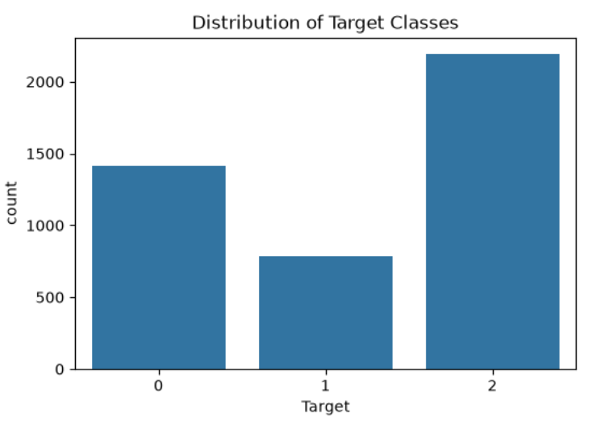
2.2 Pre-processing and Feature Selection
I renamed "Nacionality" to "Nationality", converted selected variables into numeric formats, and removed six features: Course, Daytime/evening attendance, Mother’s occupation, Father’s occupation, Mother’s qualification, and Father’s qualification.
The remaining variables form the independent features (X), while Target represents the dependent variable (y).
StandardScaler was applied to SVM and Logistic Regression because these models are sensitive to differences in feature scales. Random Forest did not require scaling. SMOTE was also used during model tuning to address class imbalance by generating synthetic minority-class observations (Chawla et al., 2002).
2.3 Train/Test Splits and Cross-Validation
I split the dataset into training and test sets and evaluated three proportions: 5%, 15%, and 25%. Stratification maintained similar class distributions across the training and test sets.
I used ten-fold cross-validation to evaluate model performance. This involves dividing training data into ten subsets, training on nine and validating on the remaining subset, repeating the process until every subset has been used for validation.
Accuracy measures the proportion of correctly classified observations. However, precision, recall, and F1-score are also important because the target classes are imbalanced.
2.4 Results Across the Three Splits
Test Split | Random Forest CV | SVM CV | Logistic Regression CV
5% | 77.17% | 75.98% | 76.50%
15% | 77.51% | 76.28% | 76.79%
25% | 76.87% | 76.63% | 76.96%

Random Forest achieved the highest cross-validation accuracy for the 5% and 15% splits, reaching 77.51%. The differences between the three models were relatively small.
The Enrolled category was the most difficult to predict. For example, Random Forest achieved only 0.36 recall and 0.40 F1-score for this class in the 15% split. In comparison, Dropout achieved 0.75 recall, and Graduate achieved 0.89 recall.
3. Hyperparameter Tuning
3.1 Purpose of Hyperparameter Tuning
Hyperparameter tuning involves adjusting model settings to improve predictive performance. GridSearchCV tests different parameter combinations using cross-validation to identify the best-performing configuration (scikit-learn, 2026a; scikit-learn, 2026b).

3.2 GridSearchCV Results
I selected the 15% test split for tuning. Random Forest parameters included the number of trees, maximum depth, and minimum samples required for splitting. SVM parameters included C, gamma, and the RBF kernel. Logistic Regression parameters included C, solver, and maximum iterations.
Model | Best Parameters | Best CV Accuracy | Test Accuracy
Random Forest | max_depth=20, min_samples_split=2, n_estimators=300 | 77.80% | 75.15%
SVM | C=10, gamma=scale, kernel=rbf | 82.22% | 69.39%
Logistic Regression | C=10, solver=lbfgs, max_iter=2000 | 76.47% | 72.58%

SVM achieved the highest cross-validation accuracy (82.22%), but its test accuracy dropped to 69.39%. Random Forest achieved the highest test accuracy (75.15%), indicating more consistent performance on unseen data.
4. Model Comparison and Interpretation
4.1 Best Performing Model
Random Forest demonstrated the strongest overall performance, achieving the highest tuned test accuracy of 75.15%. Its ability to capture complex relationships between variables makes it well suited to this classification task.
Although SVM achieved the highest cross-validation accuracy, its lower test performance suggests weaker test accuracy. Logistic Regression produced a test accuracy of 72.58%.
The PCA experiment also showed that dimensionality reduction did not improve performance. Without PCA, Random Forest, SVM, and Logistic Regression achieved 75.30%, 71.82%, and 72.58%, respectively. With PCA retaining 95% of variance, their accuracies decreased to 69.39%, 70.91%, and 69.70%.
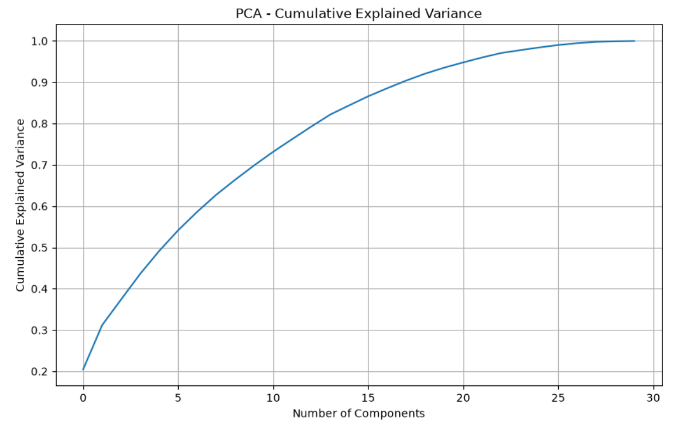
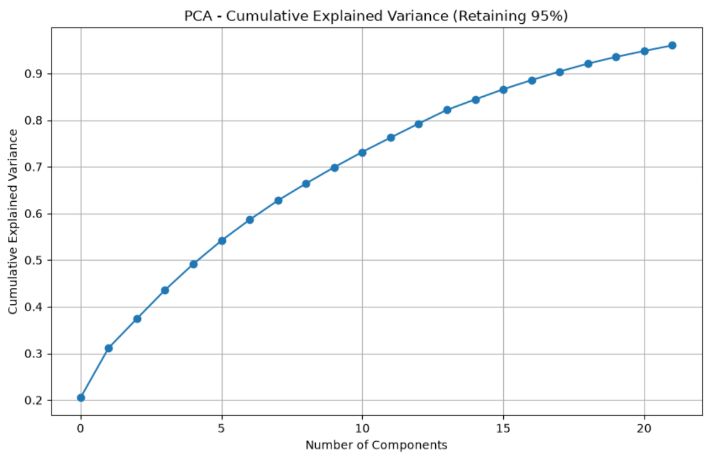
4.2 Overfitting, Underfitting and Generalisation
Overfitting occurs when a model learns training data patterns that do not generalise well to unseen observations. The SVM's difference between cross-validation accuracy (82.22%) and test accuracy (69.39%) indicates possible overfitting.
Underfitting occurs when a model is too simple to capture important patterns. Logistic Regression may struggle with complex relationships, although its performance remained reasonably close to the other models.
Generalisation refers to a model's ability to make accurate predictions on unseen data. Random Forest demonstrated relatively balanced performance, making it the preferred model in this experiment.
4.3 Binary Dropout Experiment
A separate binary classification experiment grouped Dropout as churn (1), while Enrolled and Graduate were classified as non-churn (0).
Using a 25% test split, SVM achieved 86.73% accuracy, while Logistic Regression achieved 86.00%. However, Logistic Regression identified more actual dropout cases, achieving 0.77 recall compared with SVM's 0.75.
These results demonstrate machine learning's potential to identify students at risk of leaving their programs.

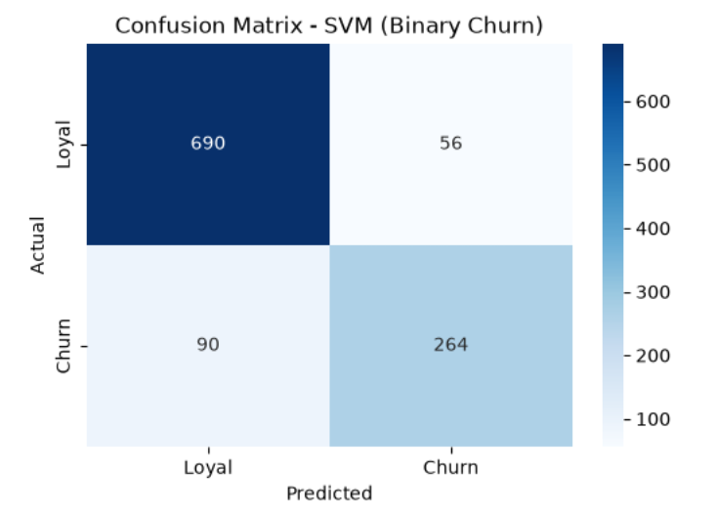
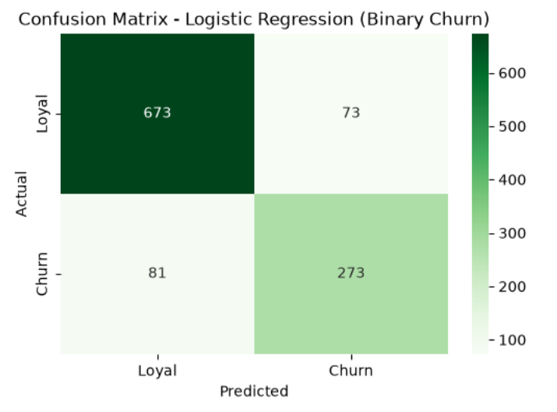

5. Conclusion
This assignment applied Random Forest, SVM, and Logistic Regression to predict student dropout and academic success using the UCI dataset. After cleaning, 4,399 records remained from the original 4,424 observations.
Random Forest demonstrated the strongest overall performance, achieving 75.15% test accuracy after hyperparameter tuning. Although SVM achieved the highest cross-validation accuracy, it had lower test accuracy due to possible overfitting, and PCA did not improve the model's performance.
The binary classification experiment also produced promising results, with SVM achieving 86.73% accuracy and Logistic Regression achieving 86.00%.
Overall, the findings demonstrate that machine learning can support student retention by identifying potential dropout risks. However, predictions should complement, rather than replace, academic staff judgement.

References
Chawla, N.V., Bowyer, K.W., Hall, L.O. and Kegelmeyer, W.P. (2002) ‘SMOTE: Synthetic Minority Over-sampling Technique’, Journal of Artificial Intelligence Research, 16, pp. 321–357. Available at: https://jair.org/index.php/jair/article/view/10302
Realinho, V., Vieira Martins, M., Machado, J. and Baptista, L. (2021) Predict Students’ Dropout and Academic Success [Dataset]. UCI Machine Learning Repository. Available at: https://doi.org/10.24432/C5MC89 .
scikit-learn (2026a) ‘GridSearchCV’. Available at: https://scikit-learn.org/stable/modules/generated/sklearn.model_selection.GridSearchCV.html .
scikit-learn (2026b) ‘Tuning the hyper-parameters of an estimator’. Available at: https://scikit-learn.org/stable/modules/grid_search.html .
scikit-learn (2026c) ‘Cross-validation: evaluating estimator performance’. Available at: https://scikit-learn.org/stable/modules/cross_validation.html .

