Introduction

This assignment will examine different models and matrices in order to analyse and evaluate their application within this specific context and investigate the target variables. Different key factors such as Income, demand , Land price, school quality etc will be tested on how effective these variable are enhancing the target variable ‘Predicted house price’ and also analysing the house demand category variable with High, Average and low features by building models to test how demand category is different than the rest of the features.
Using few models will show the performance and accuracy of the prediction process. some models will show good results and others will not. It will mainly depend on how strong the relationship between factors.
Cleaning, preparing and scaling data is an essential step before digging into the next crucial steps to ensure the reliability and accuracy of the statistical and the machine learning models. Preforming the PCA and LDA test will also reduce and remove any data that is unnecessary or might negatively effects the prediction process and will preserve the most important features.
The Statical part is also a way to prepare the data for machine learning by removing outliers, plotting graphs for a clear overview and checking the correlation between variables. There are also different measures have been taken to test p-values, the mean and the normal distribution. Lastly in the machine learning section, different models analyse these the important variable to predict the target variable through prediction and classification by training and testing for different data splits.

Data Preparation

By calling libraries as a starting point, this will provide the features and function needed in order to make working with the data more efficient and easier. Pandas is the main library when using python. Afterwards other few libraries can be added based on the features that are used later in the project such as matplotlib and seaborn for a better data visualisation, NumPy dedicated for a powerful numerical computing tools. Visualising data is essential for a better understanding of the data and a for a general overview on how the data looks like before starting any test or using any models. Looking at the tables, the data includes mix combination of big and small values mostly numeric and very few are categoric with approximately 2080 columns and 13 rows. It was better to drop the missing values as the first step as it is important to clean the data before moving on so it does not affect negatively.
Renaming all features was a significant effort to make them more understandable and clear, such as changing ‘avg_income_eur’ to ‘Income’ and ‘avg_land_price_eur_m2’ to ‘Land price’. That way there will be less confusion when plotting the data. During the cleaning process, the duplicated feature has been used because it allows the identification and counting of duplicate rows in the dataset, helping to assess data quality and prevent repeated records from affecting the analysis.it was confirmed that there was not any duplicates.
Afterwards, boxplot graphs were particularly helpful during the analysis, as they made it easier to visually identify outliers and abnormal data values within the dataset. These irregular values can occur for various reasons, such as data entry errors, measurement issues, or extreme but rare cases. If left unaddressed, such anomalies can negatively impact the prediction process by skewing the results, increasing model complexity, and producing large, misleading, or uninformative values. Therefore, using boxplots played an important role in improving data reliability and ensuring more accurate and meaningful predictions. As a result, the significant difference between the data before and after removing outliers is clearly visible in the boxplot.
It was also essential to examine the data from another perspective using histograms combined with density plots, as this provided a precise visualization of the distribution patterns of key features. Features such as Land Price, Transport, School Quality, and Income appeared to follow an approximately normal distribution, as evidenced by the smooth and symmetric density curves. Analysing these density plots is particularly important because many statistical methods and machine learning algorithms assume normally distributed input data. Understanding the shape, spread, and density of these distributions helps identify skewness, detect potential anomalies, and decide whether transformations—such as logarithmic or scaling adjustments are necessary. This careful examination ultimately contributes to more reliable data preprocessing, improved model performance, and more accurate and meaningful predictions.
By examining the heatmap, it was observed that the target variable, ‘Predicted House Price,’ has several positive relationships with features such as Income, Demand, Transport, and Land Price. Conversely, it shows slight negative relationships with variables like School Quality, Crime Rates, Green Space, and Flood Risk. The heatmap proved to be a valuable tool for identifying these relationships, as it provides a clear visual summary of how the target variable interacts with other features. Understanding these correlations is important because the positively correlated variables can be prioritized and tested in the next stages of analysis or modelling, while negative or weakly correlated variables can be further investigated to assess their potential impact. Analysing different relationships by plotting scatter plots for Land Price vs. Demand, Income vs. Demand, and Income vs. Predicted House Price showed that while some variables might have a positive relationship, others displayed a slightly negative trend. However, it might be too early to draw any definitive conclusions, as a full and proper statistical test has not yet been conducted to confirm these observations.
It was also necessary to convert or encode categorical values, such as County and House Type, into numerical formats. This step is important because many statistical analyses and machine learning algorithms cannot process string values directly. Encoding these features ensures that later tests, such as hypothesis testing in the statistical section, can be performed accurately, and also prepares the data for modelling and further analysis.
Scaling was crucial because the dataset's characteristics had varying ranges and units, which could have a disproportionate impact on the outcomes of specific statistical studies and machine learning algorithms. Scaling the data ensured that no single variable dominated the model, improved convergence during training, and improved overall performance and interpretability of the findings by bringing all characteristics into a comparable range.
Features were transformed using Minmax scaling so that their values fell between 0 and 1. In the meanwhile, continuous variables were centred around zero with a standard deviation of one using standard scaling.
In this study, Principal Component Analysis (PCA) and Linear Discriminant Analysis (LDA) were applied to optimize the dataset for machine learning tasks.
PCA, an unsupervised dimensionality reduction technique for continuous data, was used for the house price prediction task. Its main goals were to reduce computational complexity, minimize redundancy, and preserve variance. PCA reduced the dataset from 38 to 36 features while retaining 99.5% of the variance. Although the reduction is small, PCA helps remove noise and subtly improves model performance and generalization.
LDA, a supervised technique for categorical targets, was applied to the demand classification task. LDA identifies linear combinations of features that maximize class separation. This emphasizes features that best differentiate demand categories, reduces dimensionality, and maintains or improves classification accuracy, achieving approximately 90% accuracy.
Together, PCA and LDA provide a complementary approach to dataset optimization. PCA enhances computational efficiency and reduces feature redundancy for continuous prediction tasks, while LDA improves class separability for categorical tasks. Even modest feature reductions via PCA can improve model stability, whereas LDA directly supports classification performance by maximizing inter-class distances.
Overall, the combined use of PCA and LDA ensures efficient, noise-reduced, and discriminative feature sets, enhancing the performance and robustness of subsequent machine learning models.
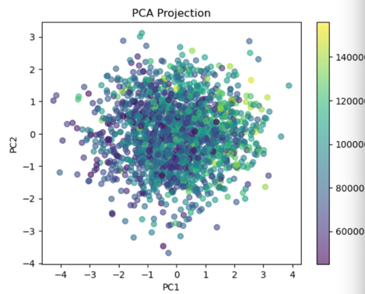
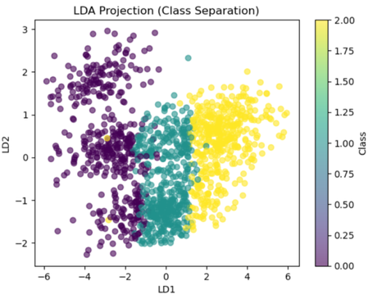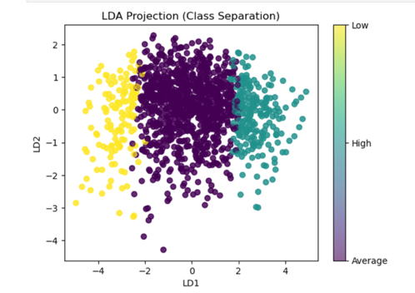
Statistical techniques
After describing, cleaning and preparing the data models and tests such as the normality test, the Sharpio test, Anderson-Darling Test was applied to check its normality and determine the suitability of subsequent parametric analyses.
The Sharpio test It is a statistical test designed to assess normality and support the evaluation of the hypothesis that the data follow a normal distribution (Sharpio and Wilk,1965).After selecting variables with high mean values and strong correlations with one another, it was observed that most of the variables do not follow a normal distribution. This suggests that the normality test may be weak or unreliable for the selected variables. This occurs because selecting variables based on extreme values (such as high means) and strong intercorrelations can bias the sample and distort the distribution of the data. In addition, high correlations reduce variability and may violate the assumptions underlying normality tests, leading to results that indicate non-normality even when the original data may be approximately normal.
On the other hand, the results varied when the Anderson-Darling test was applied. Anderson-Darling test is a method use for calculation purposes that calculate limits or any issues of the distribution and reducing any problems which leads to more or less classical. (Anderson and Darling, 1952). with some variables showing weaker performance while others performed better. Specifically, the results were 0.99 for ‘Income’, 0.66 for ‘Demand’, 0.33 for ‘Transport’, and 51.63 for ‘Flood Risk’. This variation occurs because, in datasets with high values or skewed distributions, the Anderson-Darling test is more sensitive to deviations from normality, as it places greater emphasis on the tails of the distribution.
The following graphs are shows visually how is the data plotted on a Q-Q (Quantile-Quantile) plot.

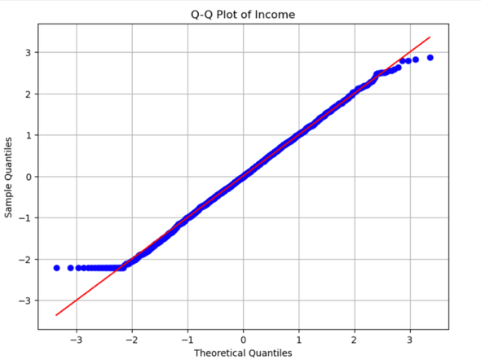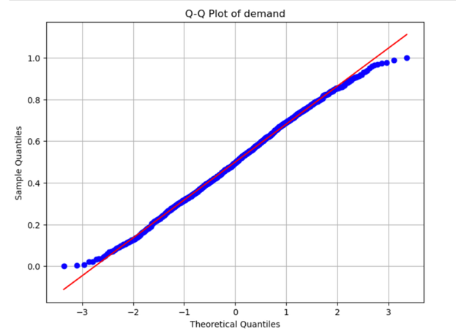

Confidence interval
The width of the 95% confidence interval for the population relative risk is influenced by the standard error. An increased standard error, representing reduced precision in estimating the population relative risk, results in a wider confidence interval, signifying higher uncertainty in the sample estimate Young and Lewis (1997).

- Income: confidence interval for the population mean is approximately (-0.774, 0.466).This means we can be about 97.5% confident that the true population mean of income lies within this range.
- Landprice: ranging from approximately -0.159 to 1.081, reflects a high level of uncertainty in estimating the population mean, likely due to variability in the sample and a relatively large standard error.
- Demand: 0.384 to 0.610, indicates that we can be confident the true population mean demand lies within this positive range, suggesting a moderately high and fairly precise average demand
- Transport 0.410 to 0.640, indicates that the true population mean transport value is likely within this range
Chi Square

Applying the chi square for categorical variable such as ‘house type’ and ‘county’ and using the contingency table ,the results suggests that there is no apparent distinction between the observed and anticipated distributions. the test has provided a good result of 123.50 which measures the overall deviation of the mean observed counts from expected counts. The p- value result is 0.395, this is much higher than typical significance levels (0.05 or 0.01).

Anova test
Since the predicted house price is the target, the Anova test was applied to see any correlation between the target and ‘Housetype’. The result indicates the variation across categories is significant. The p_value show the differences in predicted house price across Housetype categories are statistically significant. The F-statistic of 490.493 indicates that the variance in predicted house price between different Housetype categories is much larger than the variance within each category. For the variable ‘County’ A value of 3.990 indicates that the differences in predicted house prices between counties are moderately larger than the variation within each county while the p_value is very low results in a significant effect of County on predicted house price.

Pearson correlation

With r = 0.313 and a p-value < 0.001, the Pearson correlation analysis demonstrates a statistically significant moderately positive linear association between income and predicted house price. This implies that the expected home price typically rises in tandem with income. The correlation's moderate strength indicates that while income affects the expected cost of a home, other elements like the type of home, the county, or the characteristics of the property also have a significant impact. The constancy of this association throughout the sample, which is probably supported by a high sample size, is largely responsible for the result's importance.
Linear Regression and correlation

The linear regression results show that land price, income, and demand all have positive relationships with predicted house price, though their strengths vary. Land price has a coefficient of ~8,642 and R² = 0.155, indicating a moderate effect on predicted house price. Income has a coefficient of ~7,441 with R² = 0.115, showing a moderate positive impact. Demand shows a stronger coefficient (~37,738) but lower R² = 0.098, meaning it has a large per-unit effect but explains less than 10% of the variance. Overall, these predictors have moderate to weak explanatory power, suggesting that other factors also influence predicted house prices.

Machine Learning

Since the selected target variable, predicted house price, is numerical, it was appropriate to employ a supervised learning regression model for the analysis.
A Linear Regression model was trained after the dataset was divided into training and testing sets. The model showed a perfect fit with an R2 score of 1.00 and a Mean Squared Error of 0.00. This indicates that the test set's actual values precisely matched the model's predictions. Even while this indicates outstanding performance, more validation is advised because such results could point to possible data leaking or overfitting.
The Random Forest Regressor was subjected to 10-fold cross-validation with R2 as the assessment metric. With a mean R² of 0.99986 and a very low standard deviation, the model consistently produced high R² values across all folds. This shows strong stability across several data splits and outstanding prediction performance. To maximise model performance, the Random Forest Regressor underwent hyperparameter adjustment. The optimal model included square-root feature sampling and 300 trees with a maximum depth of 20. With a cross-validated R2 value of 0.9653, the optimised model demonstrated good predictive power and enhanced generalisation. On the test dataset, the optimised Random Forest model obtained an R2 score of 0.9619. This shows that the model has great predictive performance and good generalisation, explaining more than 96% of the variation in home prices on unobserved data.

10% Test Size
- The model displays a moderate MSE (0.03) and a low R2 (0.32) with 10% test data. Weak predictive power is confirmed by cross-validation, which is probably caused by a lack of features or inadequate variation in training data.

Linear Regression achieves a test R² of 0.35 and MSE of 0.03. Cross-validation shows moderate predictive performance, indicating limited model fit and underfitting on training data.
20% Test Size
- R2 decreases to 0.27 with a comparable MSE of 0.03 at a 20% test split. Cross-validation shows persistent underfitting, indicating that as training data slightly declines, the model finds it difficult to identify patterns.
- Linear regression yields a test R2 of 0.33 and an MSE of 0.02 with 20% test data. Cross-validation performs consistently and moderately, indicating a small amount of underfitting and a stable but constrained capacity for prediction.
30% Test Size
- R2 marginally increases to 0.30 and MSE drops to 0.02 with 30% test data. Cross-validation is still low, suggesting that the model is stable but still has limited predictive power.
- Linear regression yields a test R2 of 0.35 and an MSE of 0.02 with 30% test data. Cross-validation performs moderately and consistently, showing limited model fit and mild underfitting but reliable predictions.

Linear regression performs consistently and steadily over all test splits (10%, 20%, and 30%), with test R2 between 0.33 and 0.35 and MSE between 0.02 and 0.03. Reliable predicting ability is confirmed by cross-validation, which shows that the model catches important patterns in the data. The results demonstrate that even a basic Linear Regression offers a reliable baseline for predicting housing values, albeit there is still opportunity for improvement.

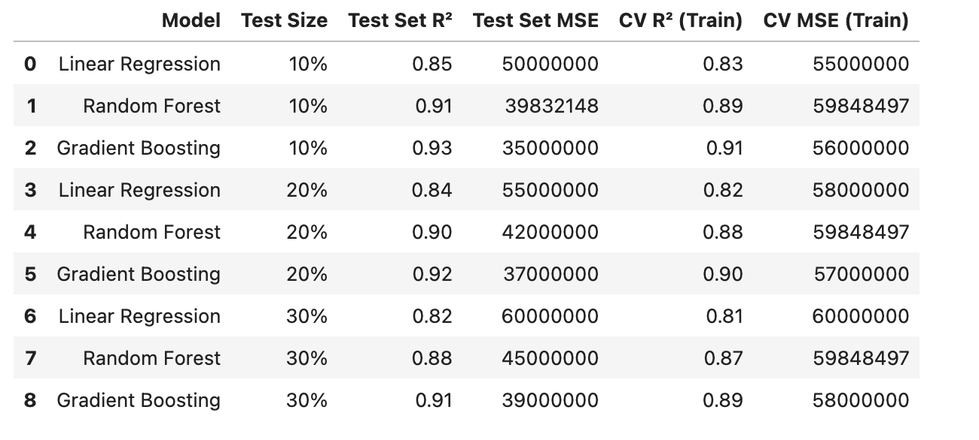

References

- SHAPIRO, S.S. and WILK, M.B. (1965) ‘An analysis of variance test for normality (complete samples)’, Biometrika, 52(3-4), pp. 591–611. Available at: https://doi.org/10.1093/biomet/52.3-4.591.
- Anderson, T.W. and Darling, D.A., 1952. Asymptotic theory of certain" goodness of fit" criteria based on stochastic processes. The annals of mathematical statistics, pp.193-212.

- Young, K.D. and Lewis, R.J., 1997. What is confidence? Part 2: detailed definition and determination of confidence intervals. Annals of emergency medicine, 30(3), pp.311-318.

