Surviving the Grey: an Empirical Study on Irish Weather and Mood.

Contents
1. Introduction: 2
1.1 Dataset Overview 2
Descriptive analysis 3
Demographic context 3
Analysis of the Target Variable (Q13) 5
Energy Levels and Emotional Response to Sunshine Q13Q5 6
Exploring Q13 Across Quantitative Features 7
General Happiness as a Predictor of Mood Improvement Q13Q14 8
The Relationship Between Sunshine-Induced Mood and Beverage Habits by Age Group Q13 Q9 & Q4 8
The Pint Effect: Does Weather Sensitivity Influence the Belief in Alcohol as a Coping Mechanism? 9
Weather Sensitivity and Its Effects on Mood and Financial Behavior: An Analysis of Q8, Q13, and Q11 12

Introduction:
Ireland is well known for its unpredictable weather, frequent rainfall, and long periods of cloudy skies. Given these characteristics, discussions about the impact of weather on people's mood are common. While some individuals believe that rainy and grey conditions can negatively influence emotions and motivation, others argue that people simply adapt to the local climate over time.
This study seeks to answer the following question: To what extent does Irish weather influence individuals' mood and emotional well-being?

1.1 Dataset Overview

A total of 34 responses were obtained . The survey included a combination of categorical and numerical variables designed to capture opinions, behaviours, and emotional reactions associated with different weather conditions, the dataset provides sufficient information for descriptive, inferential, and exploratory statistical analyses.

Table 1: Statistical Analysis Plan for the Questionnaire: Variables, Data Types, Principal Graphs, and Correlations
Table 1 presents the statistical analysis plan for the questionnaire, specifying for each question its variable, data type, principal graph, analysis focus, and the correlations to be examined.
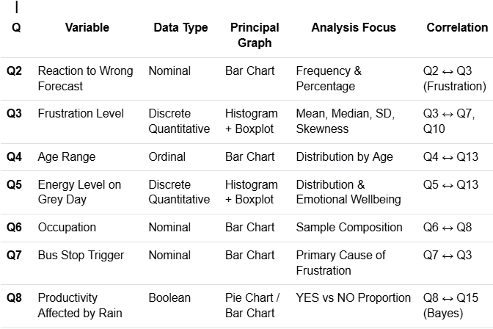
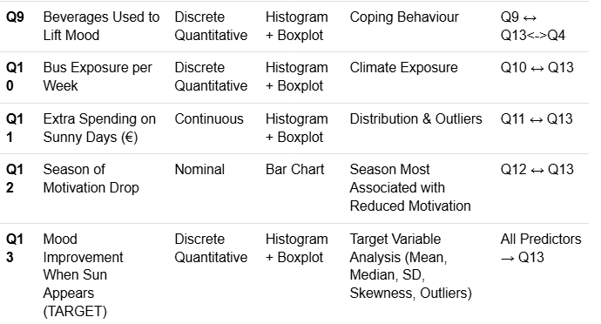
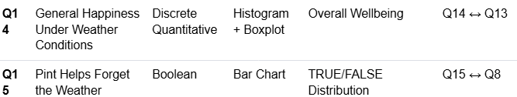

Descriptive analysis
Before the statistical analysis, the dataset underwent a data cleaning and preparation process. Missing values were reviewed individually and retained whenever possible to avoid reducing the sample size. The variables were then renamed using simplified labels to improve data management and facilitate the creation of Pivot Tables, Crosstabs, and visualisations. This preparation ensured consistency and improved the efficiency of the subsequent descriptive and inferential analyses.

Demographic context
This preliminary analysis provided context for the study by highlighting differences between age groups and identifying categories with limited sample sizes.

Age of groups
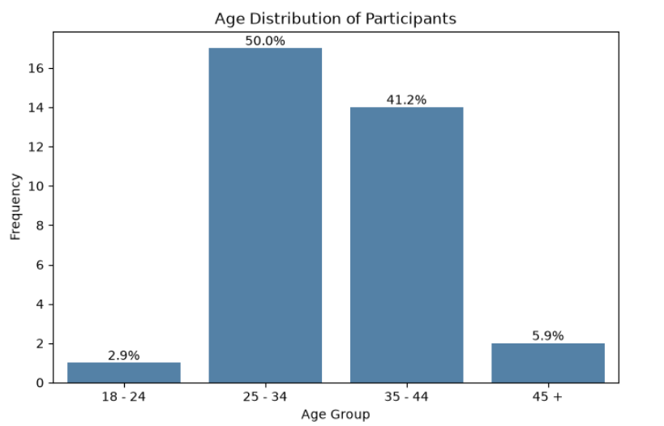

Table 1. Age-Based Summary of Behavioural and Emotional Indicators
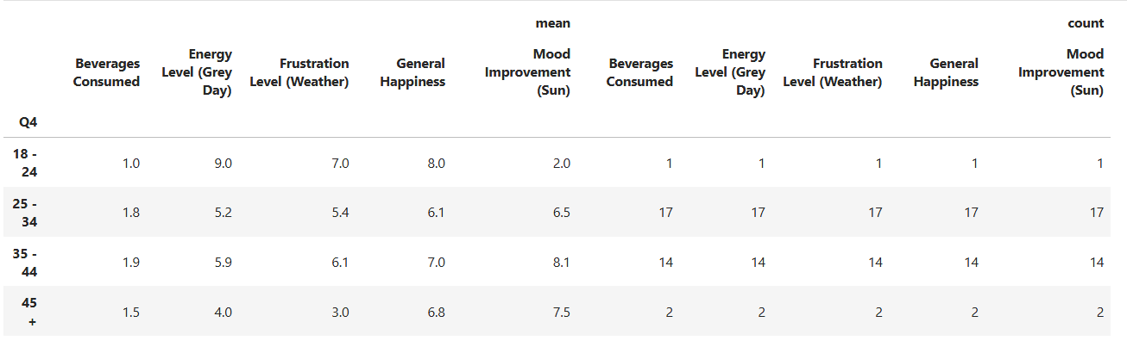

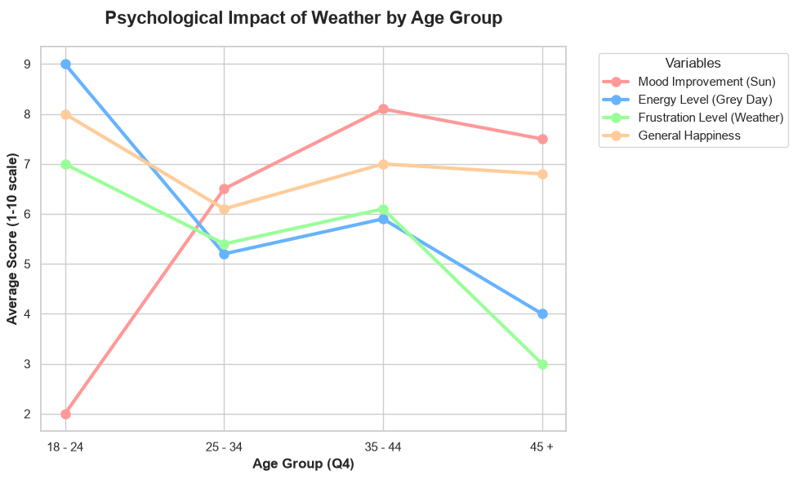
The results suggest that weather is experienced differently across age groups. Respondents aged 35–44 showed the strongest positive reaction to sunshine, while younger participants reported a lower emotional response. These differences highlight the importance of considering demographic factors when interpreting mood-related outcomes.

Analysis of the Target Variable (Q13)
Before exploring relationships with other features, it is essential to understand the intrinsic distribution of the target variable. A Normal Distribution analysis was performed exclusively on Q13 (Mood Improvement) to establish a statistical baseline for the study.
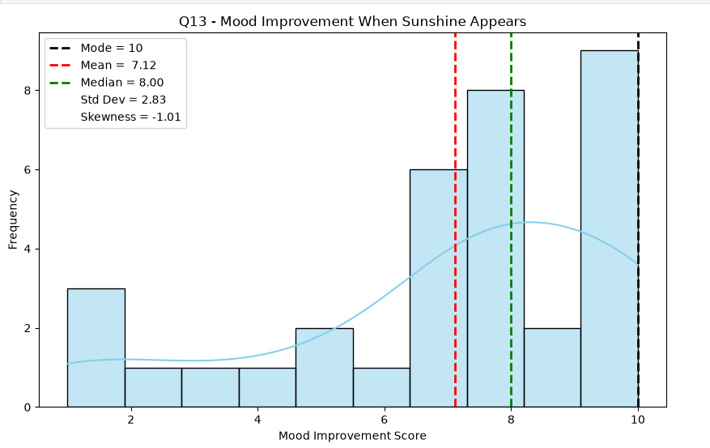
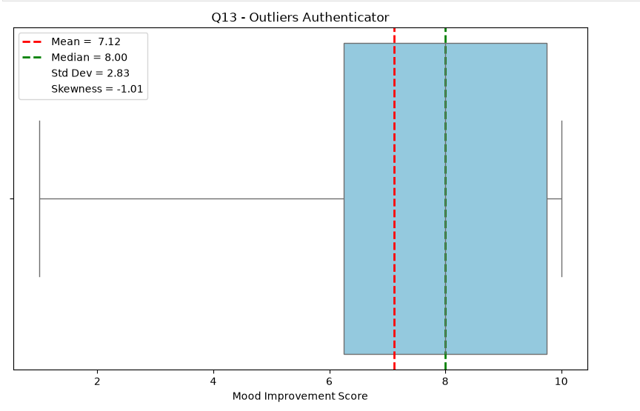
The distribution of Q13 reveals an overwhelmingly positive response to sunshine, with most participants reporting high mood-improvement scores. However, a small group of respondents showed little emotional change, indicating that the impact of sunshine is not uniform across the sample.

Energy Levels and Emotional Response to Sunshine Q13Q5
Hypothesis: People with less energy on grey days might experience a greater mood improvement when the sun comes out.
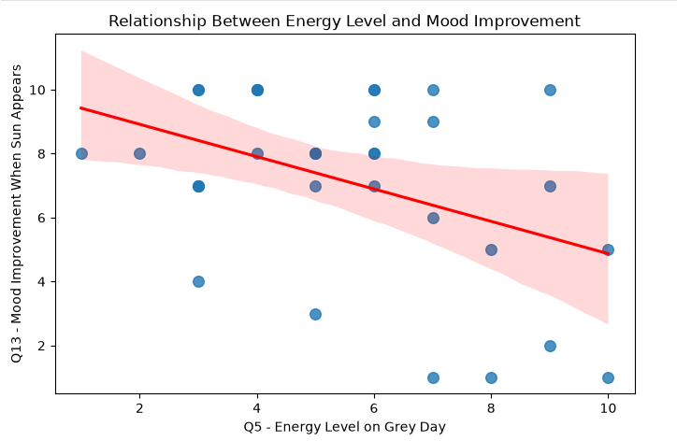

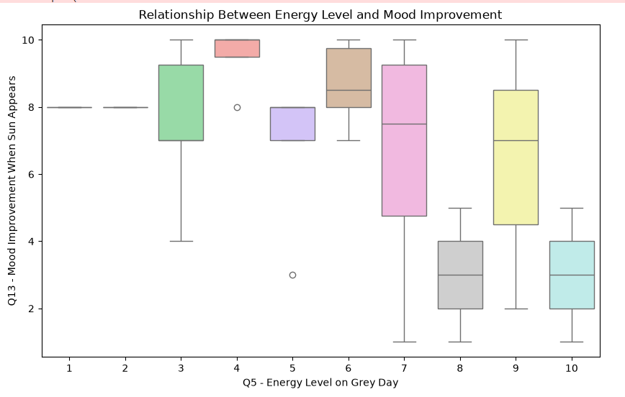
Respondents reporting lower energy levels during grey weather tended to exhibit greater mood improvement when sunshine appeared, although the moderate correlation coefficient (-0.418) suggests that substantial individual variability remains within the sample.

Exploring Q13 Across Quantitative Features

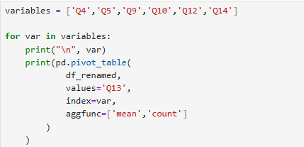

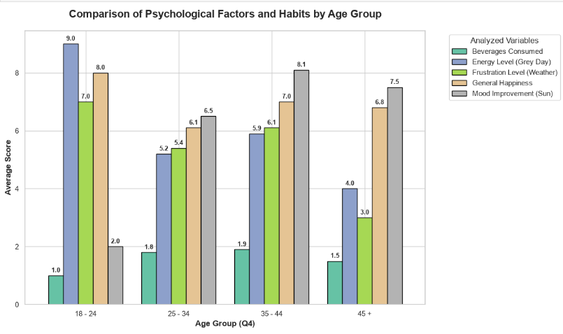

General Happiness as a Predictor of Mood Improvement Q13Q14
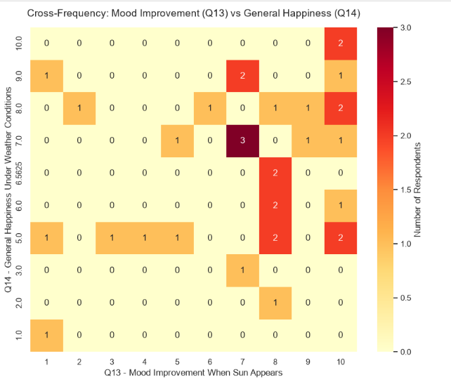
The heatmap reveals a concentration of responses at higher values of both Q13 and Q14, suggesting a positive association between overall happiness and mood improvement when sunshine appears. Participants reporting higher happiness levels generally exhibited stronger emotional responses to favourable weather conditions.

The Relationship Between Sunshine-Induced Mood and Beverage Habits by Age Group Q13 Q9 & Q4
Do the age groups that consume more mood-enhancing beverages also report a greater improvement in mood when the sun comes out?
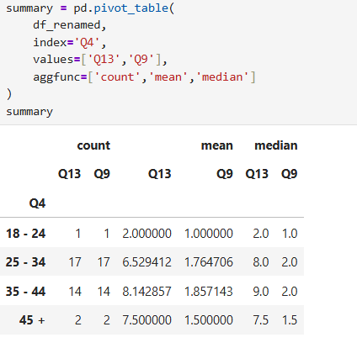
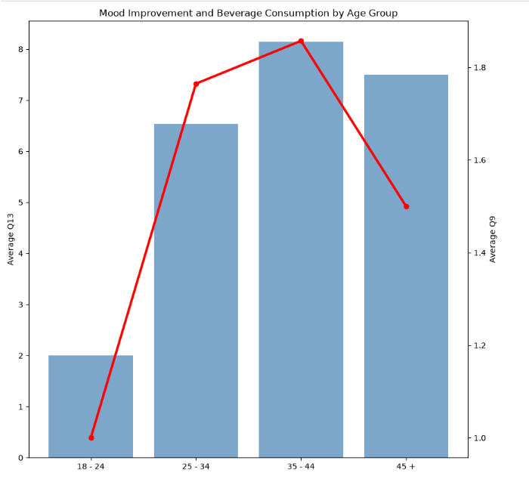
The analysis revealed notable differences across age groups. Respondents aged 35–44 reported the strongest mood improvement when sunshine appeared, whereas the 18–24 group displayed the weakest response. Beverage consumption followed a similar pattern across all age categories, suggesting a potential association between coping behaviours and positive emotional reactions to favourable weather conditions.

The Pint Effect: Does Weather Sensitivity Influence the Belief in Alcohol as a Coping Mechanism?
Hypothesis: Given that an individual reports that rain impacts their productivity, what is the likelihood that they also believe a pint helps them offset the effects of the weather?
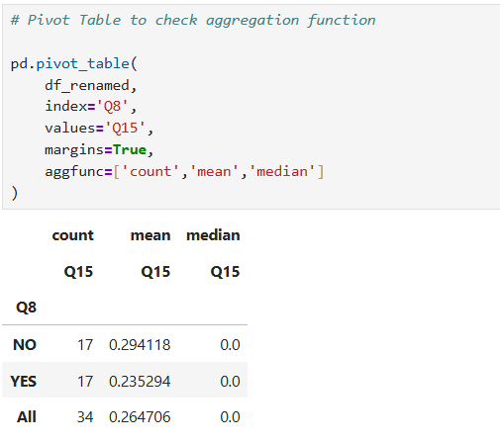
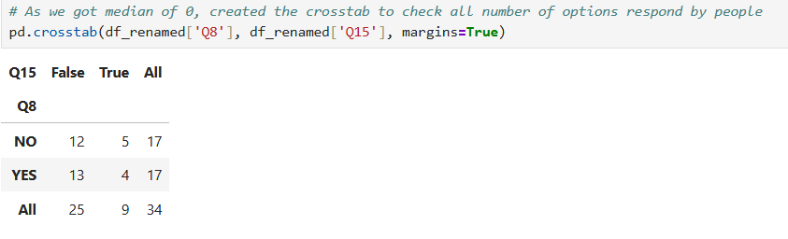

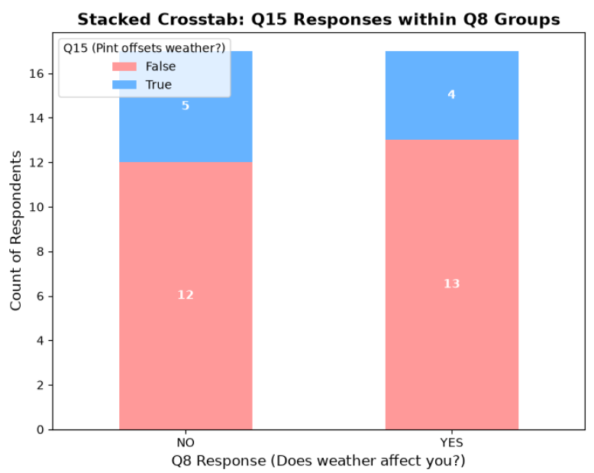

The analysis revealed notable generational differences. Respondents aged 35–44 reported the strongest mood improvement when sunshine appeared, whereas the 18–24 group exhibited the weakest response. Beverage consumption followed a similar pattern across age groups, suggesting a potential association between coping behaviours and positive emotional reactions to favourable weather conditions.

Pearson

Pearson correlation coefficient (often denoted as r). It measures two things at the same time: The Strength and The Direction of a linear relationship between two variables.

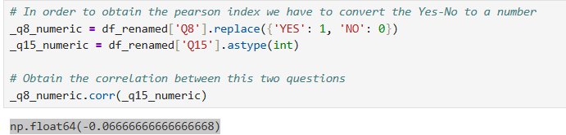

There is almost no relationship between the two variables. The negative sign shows an inverse trend, but the magnitude is too small to be of practical relevance.

Bayes' theorem

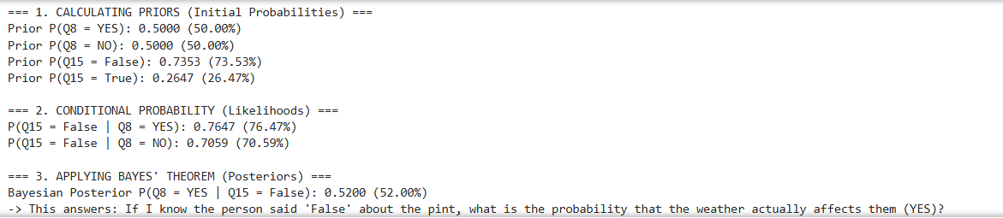

The posterior probability (52%) was only marginally higher than the prior probability (50%), indicating a weak predictive relationship between Q15 and Q8
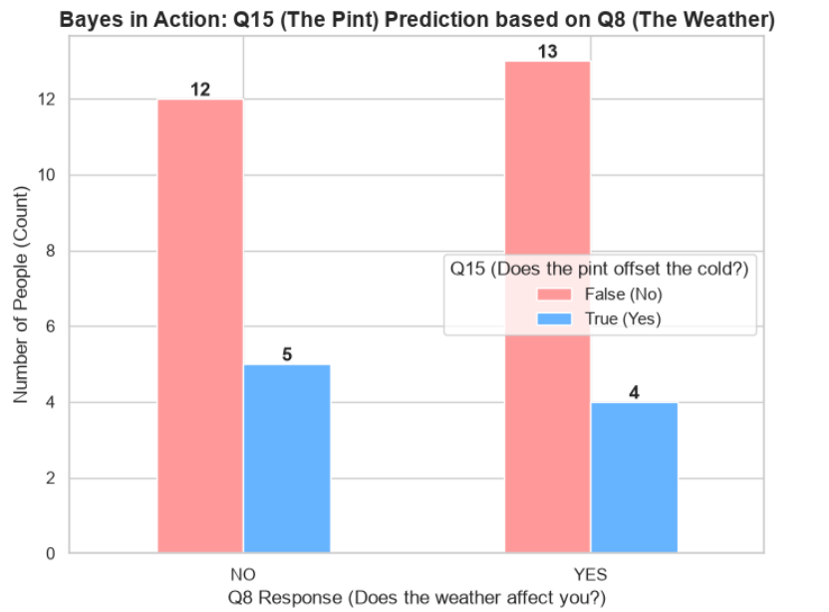

Weather Sensitivity and Its Effects on Mood and Financial Behavior: An Analysis of Q8, Q13, and Q11
Hypothesis: Weather sensitivity (Q8) significantly alters the probability distribution of both mood improvement (Q13) and extra spending (Q11)

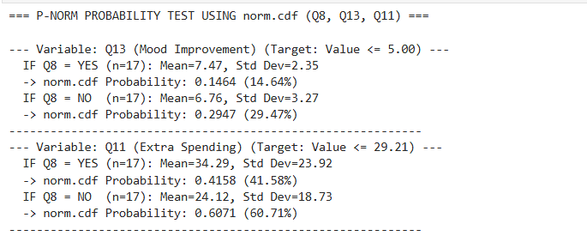

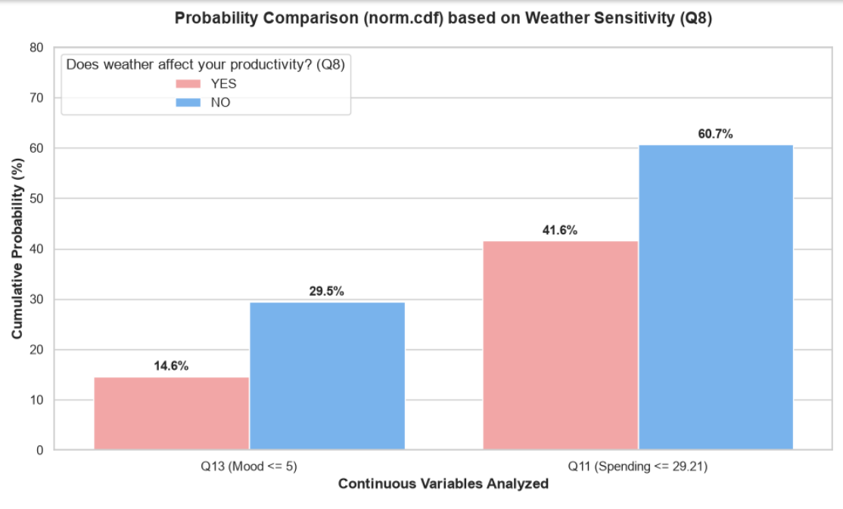
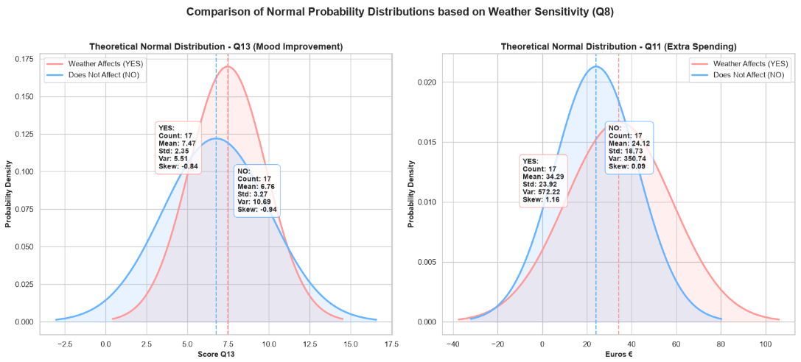
Weather-sensitive respondents reported slightly higher mood levels, although considerable variability remained within the group. Spending patterns differed more noticeably, with a small subset displaying unusually high expenditure, as reflected by the positive skewness of the distribution.

Conclusion and Discussion

The analysis demonstrates that Irish weather has a measurable influence on respondents’ emotional wellbeing, particularly when sunshine appears after periods of grey weather. The target variable (Q13) revealed a generally strong positive emotional response to sunshine, although the intensity of this effect varied across demographic groups. Age, energy levels, and general happiness showed observable associations with mood improvement, suggesting that weather sensitivity is not experienced uniformly across the population.
Inferential analysis further indicated that beliefs regarding weather-coping behaviours, such as the perceived effect of a pint in a pub, provided limited predictive value for productivity outcomes.

