Sam Bachman

1.2

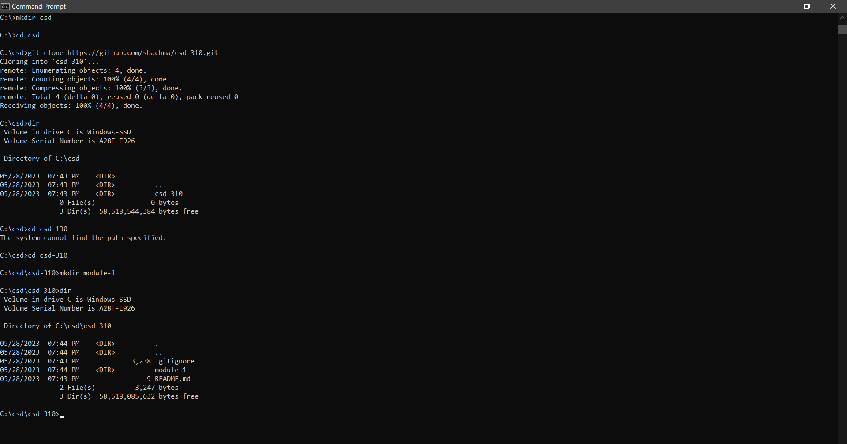

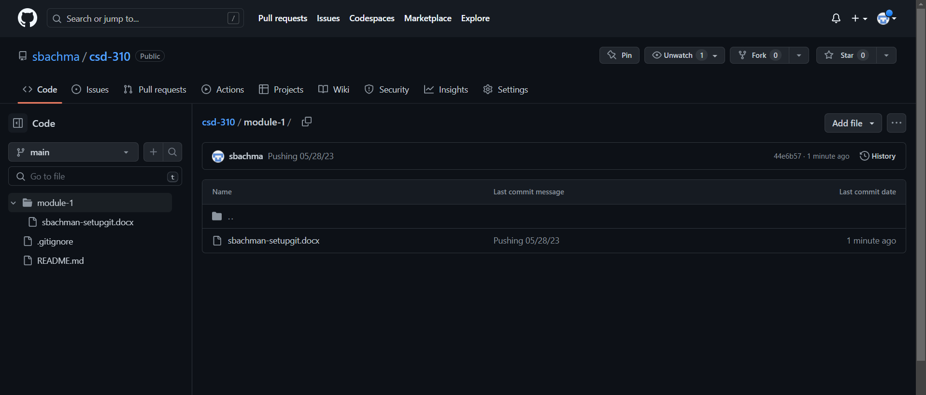

https://github.com/sbachma/csd-310/tree/main/module-1