**RTOS REVIEW REPORT**

**“TRAFFIC RULES VIOLATIONS TRACKING SYSTEM”**

Team No:-07

|  |  |  |
| --- | --- | --- |
| **NAME** | **USN** | **ROLL NO** |
| Suraj Baddi | 01FE19BEC268 | 525 |
| Sandeep S P | 01FE19BEC269 | 526 |
| Daneshwari S Hurali | 01FE19BEC270 | 527 |
| G B Madhuritha | 01FE19BEC271 | 528 |

**Problem statement:**

Currently, traffic police and cameras are only deployed at traffic signals. This limits them to report violations only if they happen within the vicinity leaving room for many blind spots. Another constraint is the capacity of this personnel to quickly capture as many violations photographs as possible towards proof before the vehicle rushes away. Vehicles automatically identify and report traffic violations on the road around them as they move around, thus acting as crowd sourced law enforcement.

**Solution Ask**- Leverage front-mounted mobile phone/dedicated cameras on car windshield to identify, photograph, and report traffic violations anywhere on the road, thus reducing dependency on static cameras and human personnel.

**Introduction:**

Traffic rule violation leads to various road accidents. Statistics show that traffic violations are the most important cause of the accidents. Street mischance is most undesirable thing to happen to a street client, however they happen frequently. The most deplorable thing is that we don't gain from our errors on street. Most of the street clients are very much aware of the general tenets and security measures while utilizing streets however it is just the laxity on part of street clients, which cause mishaps and accidents. These days’ movement police confronting numerous challenges to identify the vehicles that violets activity rules. More than one officer is required for activity checking. Still large portions of the culprits are effortlessly gotten away from the police.

**Multiple Solutions:**

In accordance with the Problem Statement below listed are some solutions:

* + Leverage dedicated cameras on car windshield to identify photographs and report traffic violations anywhere on the road.
  + Citizen’s involvement in enforcement road safety regulations by reporting about the traffic rules violations through their phones.

|  |  |
| --- | --- |
| **Objectives** | **Multiple Solutions** |
| Detection of violation | * Camera * Sensors * Manually (through bare eyes) |
| Notification of detected violation | * LED’s * Buzzer |
| Information gathering | * Camera(photo’s) * Manually (UART/ Keypad) |
| Displaying the sent Information | * LCD * UART |

**Best suited solution:**

Leveraging dedicated cameras on car windshield to identify photographs and report traffic violations anywhere on the road thus reducing dependency on static cameras and human personnel.

As traffic rule violations largely go unchecked because of manpower and resources constraints while vehicles hitting the roads continue to increase exponentially.

So, the use of cameras on car windshield helps to:

* + Deter Crime
  + Monitor Scenarios and Activities
  + Gather Evidence
  + Maintain Records
  + Arrive at the right decisions

|  |  |
| --- | --- |
| **Objectives** | **Chosen Solution** |
| Detection of violation | Manually |
| Notification of detected violation | LED’s |
| Information gathering | UART |
| Displaying the sent Information | LCD  UART |

**Functions involved in the selected solution:**

* Firstly, we use the camera to detect the violations.
* As soon as the violations occur in front the camera the photographs are taken.
* Now we manually send the text message along with the photographs as proof to the police.
* The police receive the proof and carries out the action.

**Use of the ARM components:**

* We use a camera to detect the violations.
* As soon as the violation is detected the Buzzer makes sound.
* Now we send the text message through UART.
* As the message is sent to/received by police we get the indication on LCD along with the blink of LED's.

**Constraints:**

* Sensors.
* Camera.

**Peripherals Used:**

* LED’s
* LCD
* UART

**Optimization Techniques:**

* Loop unrolling
* Code minimization
* If-else
* While and for
* Data types
* Local and Global declaration
* Loop fusion
* Functions or modular approach
* Using header files
* Conditional execution
* Pass by value
* Pass by reference

**Block Diagram:**

UART [Violation reported]

Processor

LPC2148

Camera [captures the violation]

LCD

[Message sent to police and owner]

**Algorithm:**

Step 1: Start

Step 2: Take the input from the user using UART.

Step 3: Turn on the Buzzer to notify that the violation is detected.

Step 4: Display “Violation detected” on LCD.

Step 5: Take the input using UART.

Step 6: Select the type of violation made.

Step 7: Display the type of violation on LCD.

Step 8: After all the functions, Display “Report Sent” on UART.

Step 9: Display “Report received by Police” on LCD.

**Flowchart:**

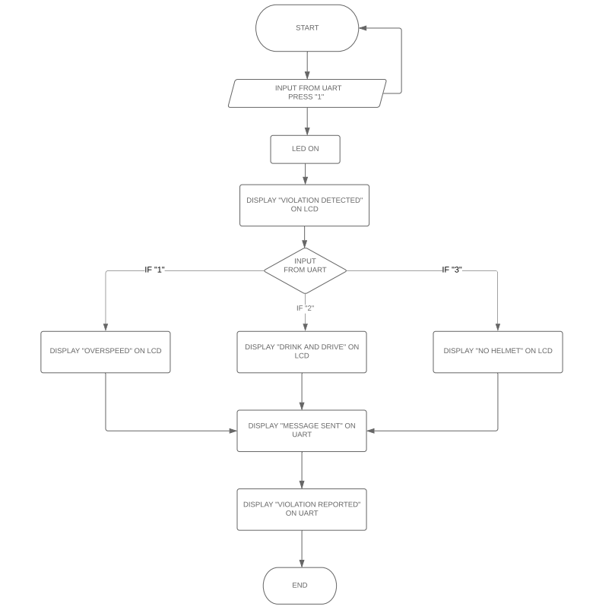

**LPC2148 Code:**

#include <lpc214x.h>

#include <stdint.h>

#include <stdlib.h>

#include <stdio.h>

void serial()

{

PINSEL0 = 5;

U0LCR = 0x83;

U0DLM = 0x00;

U0DLL = 0x61;

U0LCR = 0x03;

}

unsigned char receive()

{

while(!(U0LSR & 0x01));

return (U0RBR);

}

void display(char *msg)

{

uint8_t i=0;

for(i=0;msg[i]!=0;i++)

{

U0THR = msg[i];

while(!(U0LSR & 0x20));

}

}

int main(void)

{

while(1){

unsigned int i;

unsigned char mg;

serial();

display("PRESS 1 TO REPORT A VOILATION\n");

mg = receive();

//m = mg;

if(mg == '1'){

//first line

serial();

display("OUTPUT :: VOILATION FOUND\n");

serial();

display("ENTER 1-OVER SPEED 2-DRINK AND DRIVE 3-NO HELMET AND SEND PHOTO PROOF\n");

mg = receive();

if(mg == '1'){

//second line

display("OUTPUT :: OVER SPEED\n");

}

else if(mg == '2')

{

display("OUTPUT :: DRINK AND DRIVE\n");

}

else if(mg == '3')

{

display("OUTPUT :: NO HELMET\n");

}

else{}

serial();

display("REPORT SENT\n");

display("OUTPUT :: PHOTOS RECEIVED\n");

display("BY POLICE\n");

display("OUTPUT :: OWNER FOUND\n");

display("OUTPUT :: MESSAGE SENT\n");

}

}

}

**Proteus Code:**

#include <lpc214x.h>

#include <stdint.h>

#include <stdlib.h>

#include <stdio.h>

void delay_ms(uint16_t j) /* Function for delay in milliseconds */

{

uint16_t x,i;

for(i=0;i<j;i++)

{

for(x=0; x<6000; x++); /* loop to generate 1 millisecond delay with Cclk = 60MHz */

}

}

void LCD_CMD(char command)

{

IO0PIN = ( (IO0PIN & 0xFFFF00FF) | (command<<8) );

IO0SET = 0x00080000; /* EN = 1 */

IO0CLR = 0x00060000; /* RS = 0, RW = 0 */

delay_ms(2);

IO0CLR = 0x00080000; /* EN = 0, RS and RW unchanged(i.e. RS = RW = 0) */

delay_ms(5);

}

void LCD_INIT(void)

{

IO0DIR = 0x000FFF00; /* P0.8 to P0.15 LCD Data. P0.4,5,6 as RS RW and EN */

delay_ms(20);

LCD_CMD(0x38); /* Initialize lcd */

LCD_CMD(0x0C); /* Display on cursor off */

LCD_CMD(0x06); /* Auto increment cursor */

LCD_CMD(0x01); /* Display clear */

LCD_CMD(0x80); /* First line first position */

}

void LCD_STRING (char* msg)

{

uint8_t i=0;

while(msg[i]!=0)

{

IO0PIN = ( (IO0PIN & 0xFFFF00FF) | (msg[i]<<8) );

IO0SET = 0x000A0000; /* RS = 1, , EN = 1 */

IO0CLR = 0x00040000; /* RW = 0 */

delay_ms(2);

IO0CLR = 0x00080000; /* EN = 0, RS and RW unchanged(i.e. RS = 1, RW = 0) */

delay_ms(5);

i++;

}

}

//void LCD_CHAR (char msg)

//{

// IO0PIN = ( (IO0PIN & 0xFFFF00FF) | (msg<<8) );

// IO0SET = 0x00000050; /* RS = 1, , EN = 1 */

// IO0CLR = 0x00000020; /* RW = 0 */

// delay_ms(2);

// IO0CLR = 0x00000040; /* EN = 0, RS and RW unchanged(i.e. RS = 1, RW = 0) */

// delay_ms(5);

//}

void serial()

{

PINSEL0 = 5;

U0LCR = 0x83;

U0DLM = 0x00;

U0DLL = 0x61;

U0LCR = 0x03;

}

unsigned char receive()

{

serial();

while(!(U0LSR & 0x01));

return (U0RBR);

}

void display(char *msg)

{

uint8_t i=0;

for(i=0;msg[i]!=0;i++)

{

U0THR = msg[i];

while(!(U0LSR & 0x20));

}

}

int main(void)

{

while(1){

unsigned int i;

unsigned char mg;

serial();

display("PRESS 1 TO REPORT A VOILATION //// \n");

mg = receive();

//m = mg;

if(mg == '1'){

LCD_INIT();

LCD_STRING("voilation found");//first line

//serial();

display("ENTER 1-OVER SPEED 2-DRINK AND DRIVE 3-NO HELMET AND SEND PHOTO PROOF //// \n");

mg = receive();

LCD_INIT();

if(mg == '1'){

LCD_STRING("OVER SPEED");//second line

}

else if(mg == '2')

{LCD_STRING("DRINK AND DRIVE");

}

else if(mg == '3')

{LCD_STRING("NO HELMET");

}

else{}

serial();

display("REPORT SENT //// \n");

LCD_INIT();

LCD_STRING("PHOTOS RECEIVED");

LCD_CMD(0xC0);

LCD_STRING("BY POLICE");

mg = receive();

LCD_INIT();

LCD_STRING("OWNER FOUND");

mg = receive();

LCD_CMD(0xC0);

LCD_STRING("MESSAGE SENT");

}}

}

**Execution Profiling:**

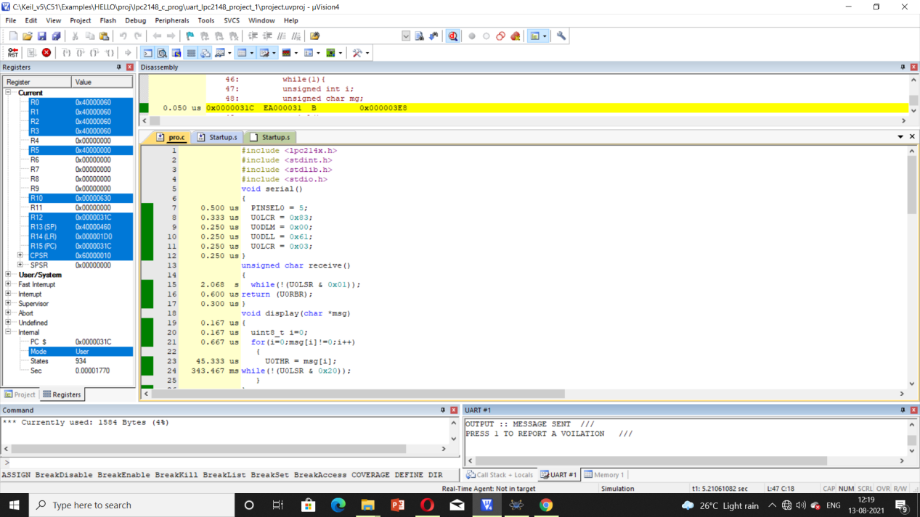

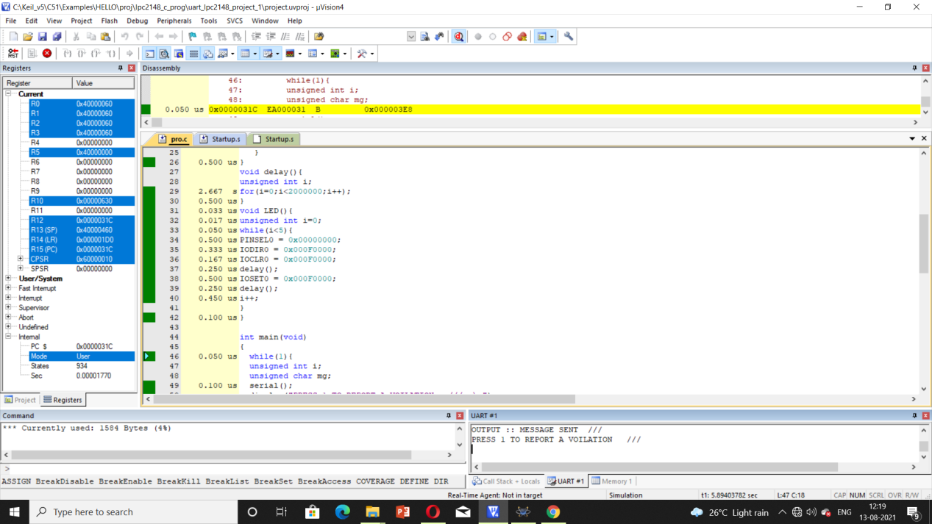

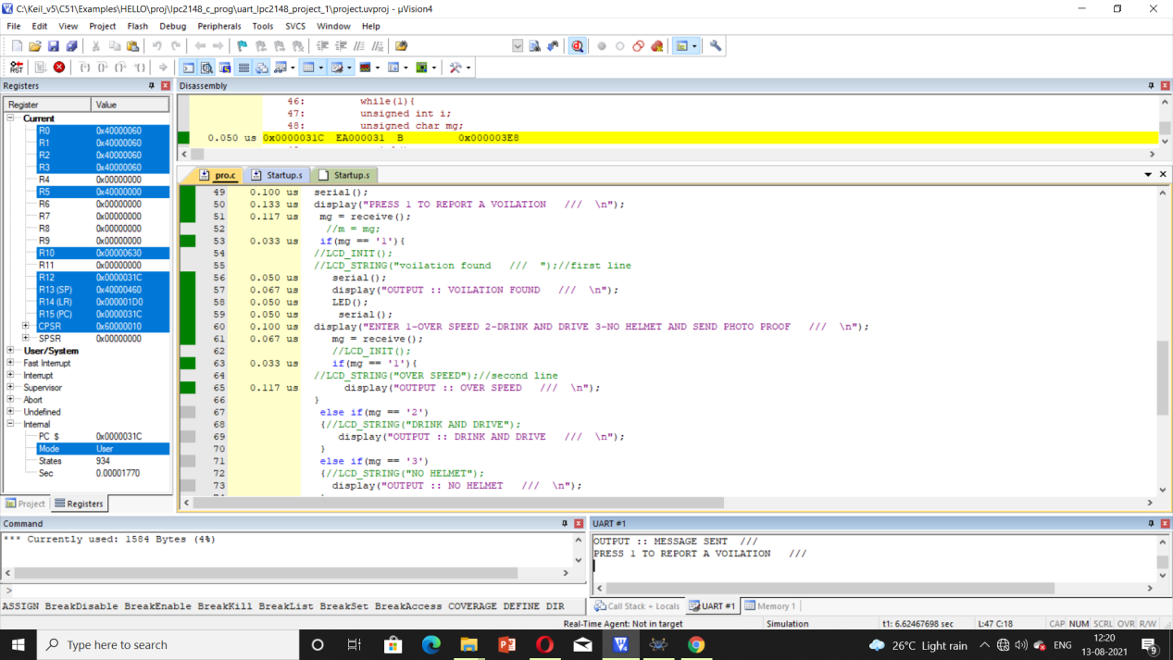

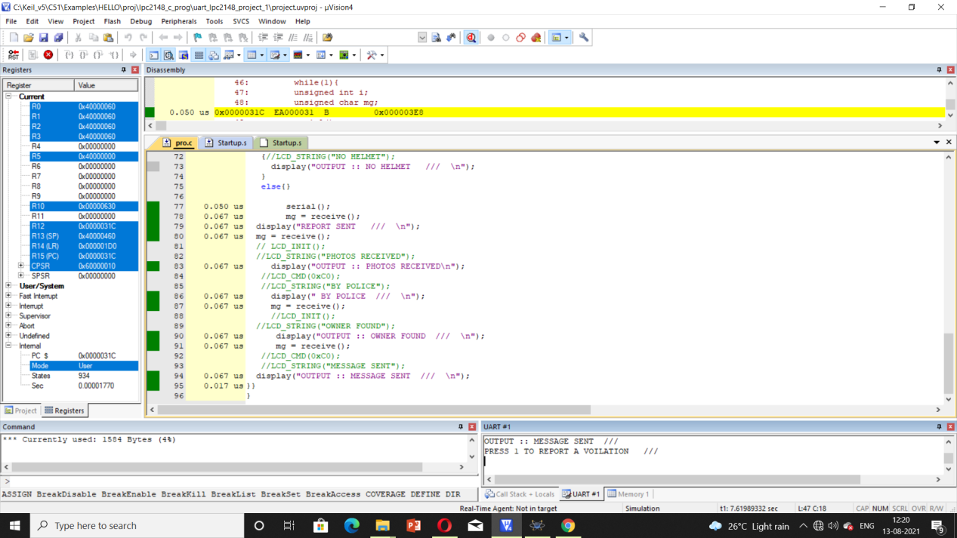

**Simulation Results:**

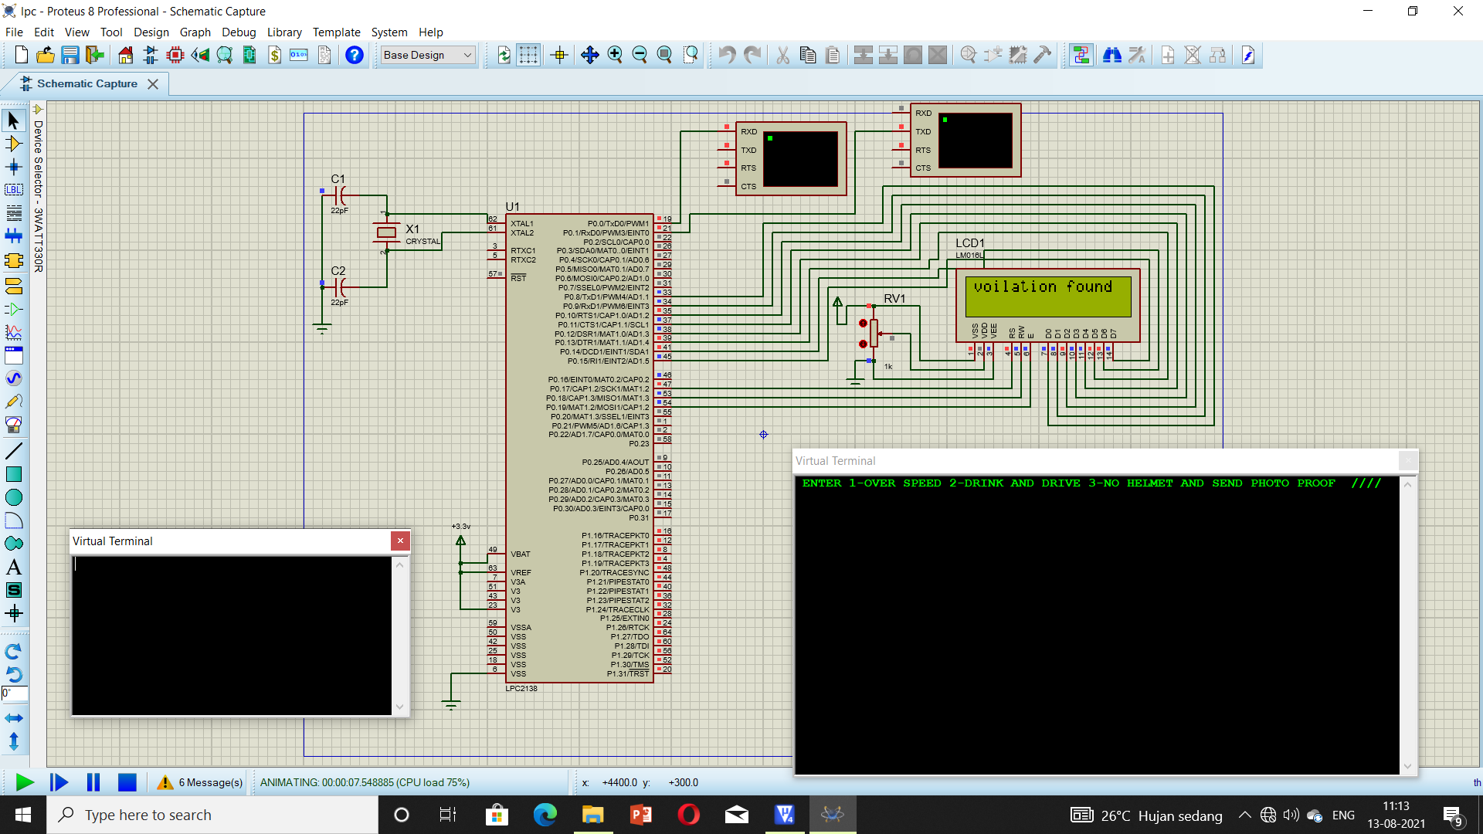

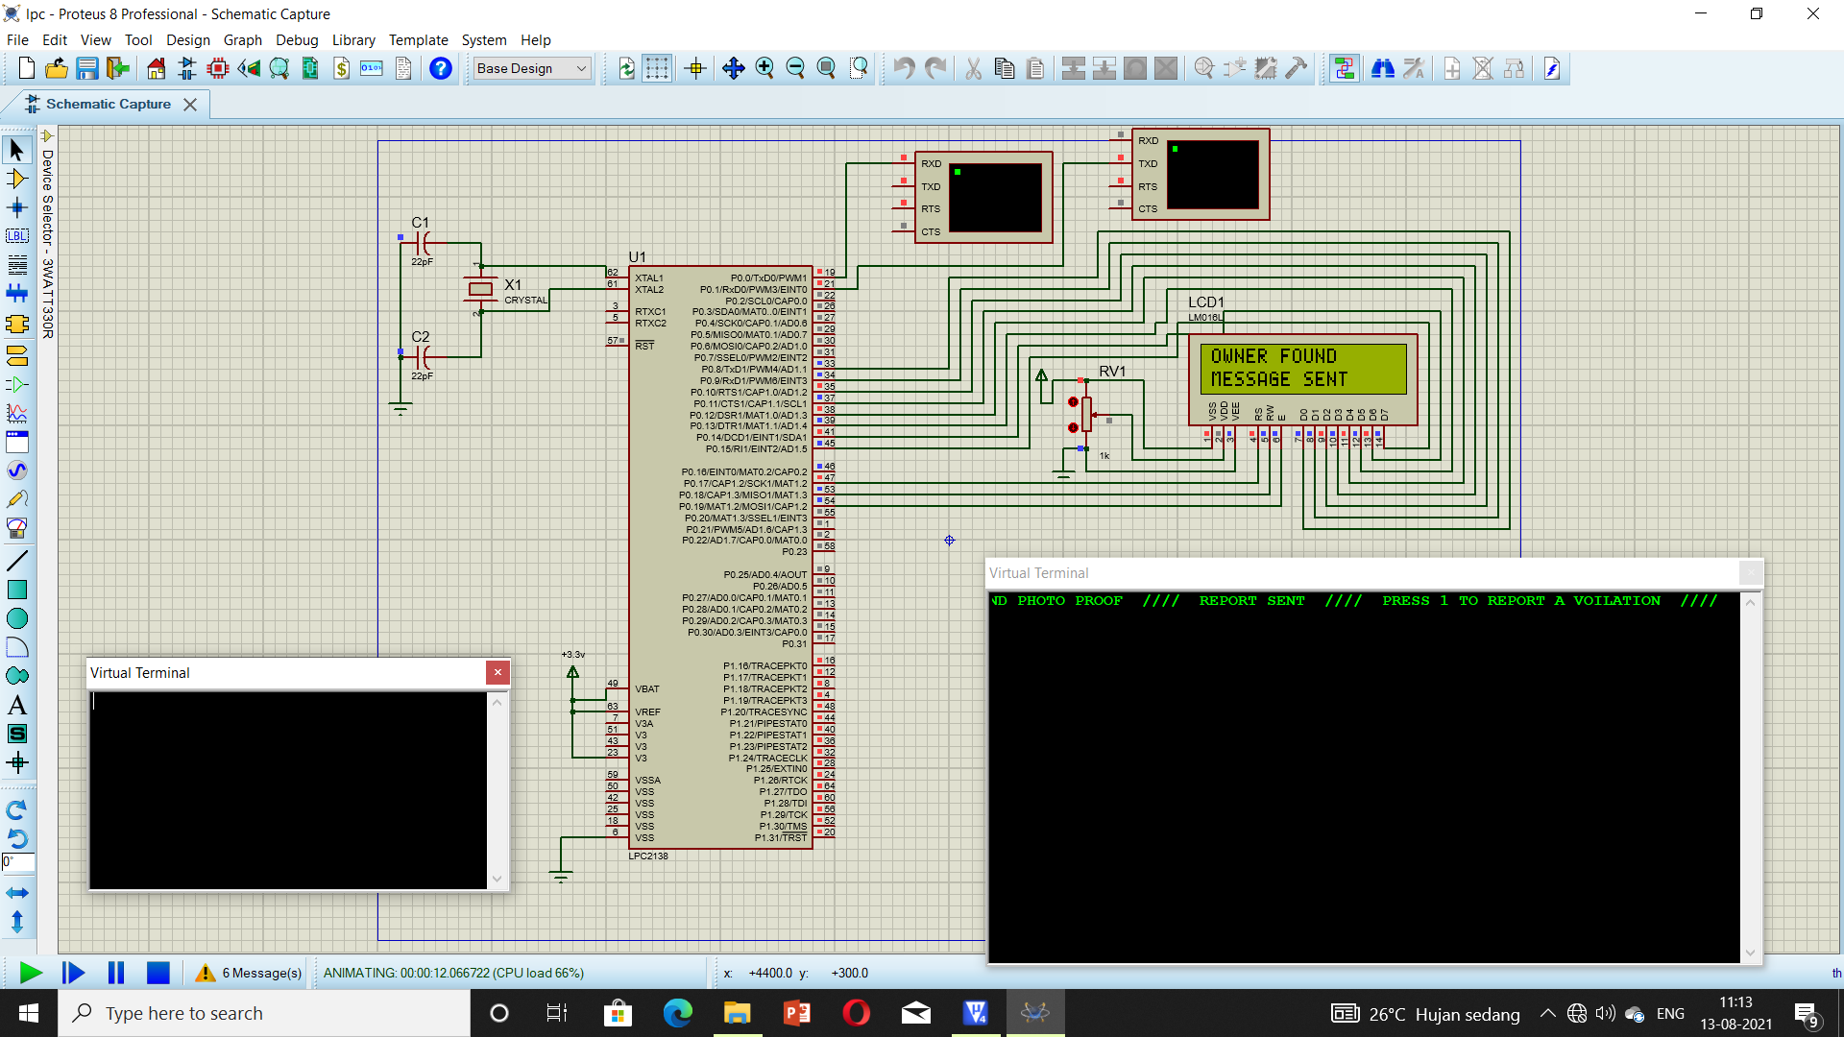

**Hardware Results:**

**References:**

* [**www.nevonprojects.com**](http://www.nevonprojects.com)
* [**www.8051projects.com**](http://www.8051projects.com)
* [**www.youtube.com**](http://www.youtube.com)
* [**www.github.com**](http://www.github.com)

**Books:**

* Steve Furber
* William Hohl