**Grooming detector handbook**

**Part I. Quick start without labelling new training samples ........................................ 2**

**Part II. Labelling and applying your own training samples ....................................... 6**

Overview

This grooming detecting package is designed for long-term (hours to days) grooming detection in multiple fruit flies (~20) placed individually in tubes. Details about experimental setups and video analyzing algorithms can be found in main paper.

With the GUI, positions and grooming events of flies are extracted from input videos and saved as time series into customized path in .txt format.

The procedures for grooming detection and parameter setting are described in this handbook. For a quick start, you can use training sets come with the package, as described in **Part I**. In this way,you do not need to manually label training samples from your own video. For a better performance, we **strongly recommend** you to label training samples from your own experimental videos and apply these samples in grooming detecting. Details of creating your own training samples are described in **Part II.**

Errors: When program stopped by errors, check if the folder is under Matlab path. If it is not the path issue, try close all windows and reload the GUI.

**Part I. Quick start without labelling new training samples**

**Preparation:**

You will need a mono color input video of flies for grooming detection, and a video (~5 minutes long in 10 hz) taken under same conditions as the input video, but with no flies in, for setting parameters C0 and C1. For a quick check of the detector, you can use example videos named ‘FlyVideo1min.avi’ for grooming detection and ‘NoFlyVideo1.avi’ for parameter setting. Both example videos are taken at a frame rate of 10 hz.

**Procedures:**

**1.** Open the ‘GroomingDetector’ panel by running ‘GroomingDetector.m’ in Matlab.

**2.** If any of the following cases is satisfied, follow **Step 3-5** below to customize parameters for the detector. Otherwise, jump to **Step 6** to video analyzing steps. (Detector may still work without customizing parameters, but the output may be less accurate).

a. It is the first time to run the package after downloading to the computer.

b. It is the first time to run the package after making changes to experimental settings, such like replacing the camera/ light, changing number/ orientation of tubes, adjusting the frame rate of raw video/ the rate to analyze the video.

c. It is the first time to run the package after resetting parameters.

**3.** Click on the ‘**Setting Parameters**’ button to open the parameter setting panel. Some of the recent settings of parameters are shown in the panel:

Frame rate: Frame rate of input videos in units of Hz. To extract grooming, usually a minimum frequency of 5 hz is required. Default: 10 hz.

Analyzing rate: Rate to analyze input videos, i.e. to analyze every frame, set Frame rate = Analyzing rate. Note: Frame rate must be multiples of Analyzing rate. Default: 5 Hz.

Number of tubes: Number of rows and columns of tubes. Default: 10 rows * 2 columns

Transpose video: The program assumes that tubes in videos are oriented horizontally. Thus, placing tubes horizontally in videos is strongly recommended. On the other hand, if tubes are vertical, tick the checkbox to transpose tubes to horizontal direction.

If any of above parameter values displayed in the panel need to be changed, type in new values and click ‘**Save**’ button.

**4.** Other two parameters C0 and C1 are thresholds to distinguish real changes in videos from fluctuations of random noise, as described in the paper. It is strongly recommended to update C0 and C1 when quality of the input video has just been changed, such like change of camera, lens or illumination. To set C0 and C1, you need to take a short test video (~1 minute or 600 frames) with no flies in it. The quality of the test video should be as close to actual experimental videos as possible

C0: Since changes of grayscale caused by fly movement are usually bigger than those caused by noise, real movement of objects can be distinguished from changes caused by noise by ignoring changes of grayscale smaller than a threshold C0. Default: 10 grayscales.

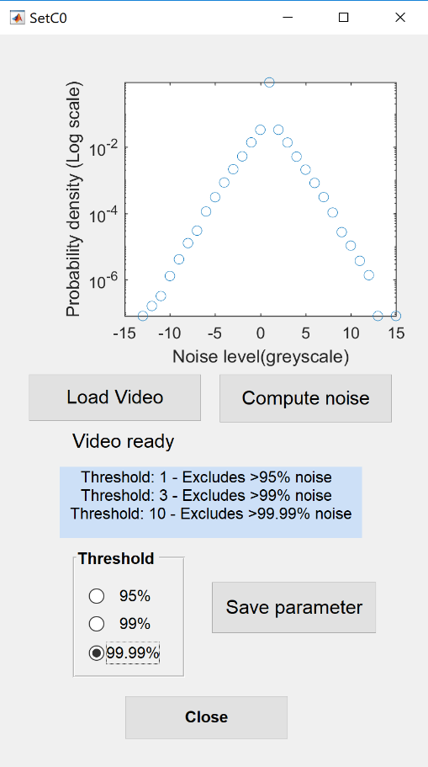

a. Open ‘SetC0’ panel by clicking ‘**Set C0**’ button in parameter setting panel.

b. Click ‘**Load Video**’ button and select a video with no flies in it (you can use the example video ‘NoFlyVideo1.avi’ when testing the program).

c. Click ‘**Compute noise**’ and wait until a probability distribution of noise shows up on top. At the same time, thresholds for excluding different fractions of noise are printed below the button. Usually, if the threshold ‘>99.99%’ at the last line is not too big (<20), select ’99.99%’ radio box, click ‘**Save parameter**’ and close the C0 panel.

C1: After C0 is applied, the remaining false detected pixels caused by noise are still possibly to form connected objects. Since sizes of these connected objects are usually much smaller than size of a fly. We set threshold C1 to remove false detected objects from flies by size of them. Default: 25 pixels.

a. Open ‘SetC1’ panel by clicking ‘**Set C1**’ button in parameter setting panel.

b. Click ‘**Load Video**’ button to select the same test video used in setting C0 and then generate a background from the video by clicking ‘**Create background**’ button.

c. After the background is displayed on right, click ‘**Background subtraction**’. The program compares each frame with the background and finds the maximum size of objects

generated by noise in each frame. The histogram of these maximum sizes is plotted on right. Based on this histogram, a threshold C1 can be set to erase objects smaller than it.

d. Click ‘**Save parameter**’ button and the program will select a proper C1 automatically. Then close the panel. You can also type in a C1 value manually before saving the parameter.

Parameters in **Step 3** and **Step 4** can be set to default values with ‘**Reset**’ button.

**5.** There are some other parameters can be customized, while in most cases, you can keep them as default. To change these parameters, click ‘**Advanced setting**’. In this panel, you can see values of some advanced parameters and make changes to them.

BackgroundRate: It defines the time interval to update the background, in unites of minutes. Default: 60 minutes.

k: Number of nearest neighbors in *k*NN method, Default: k=10.

NumberofContrast: Number of contrast frames for updating background. Default: 8 frames.

VideoBatchSize: Number of frames being loaded at once during analyzing. It does not affect the accuracy of output, but does influence the analyzing time. Default: 500 frames

Type in new parameters and click ‘**save and close**’ if any changes are needs. Click ‘**Reset**’ to set above parameters in **Step 5** back to default values.

**6.** Select and load videos for analysis by clicking ‘**Open video files**’. You can select multiple videos at once so that the program can analyze one after another in row. It is important that videos being selected together must have the same settings, such like positions of tubes and frame rates, since the segmentation of tubes and setting of parameters only be done once before starting analyzing the first video. After finishing loading, names of selected files are displayed below the button. Skip parameter setting if not needed (refer to **Step 2**). Then select path to save output data with ‘**Save output to**’ button. After analysis finished, folders with same names as raw videos will be generated in the selected path and output will be saved to correlated folders.

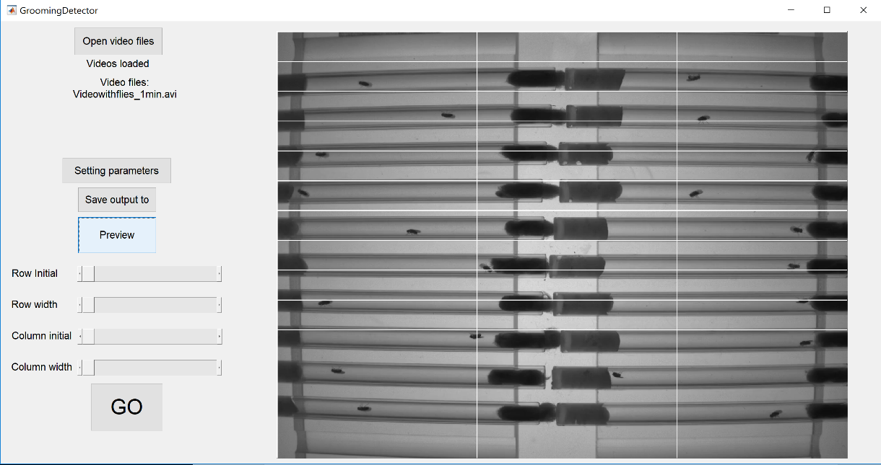**7.** Click ‘**Preview**’ button to print a sample frame from input videos for segmentation of tubes. At the beginning, you will see horizontal and vertical white lines for segmentation on top of the picture, as shown in the picture below. Numbers and initial positions of these lines are decided by the input numbers of rows and columns (Nrow+1 horizontal lines and Ncolumn+1 vertical lines). Then you can adjust positions of the lines so that individual tubes can be separated into different regions.

a. Adjust the upper boundary of tubes by slide the slider ‘**Row initial**’, until the first horizontal line moves right above the first row of tubes on top.

b. Adjust the width of tubes with the slider ‘**Row width**’, until the line on bottom just below the boundary of the last row of tubes. Make sure each row of tubes is separated by two lines from adjacent rows.

c. Similarly to **7a** and **7b**, separate columns of tubes with sliders ‘**Column initial’** and ‘**Column width**’.

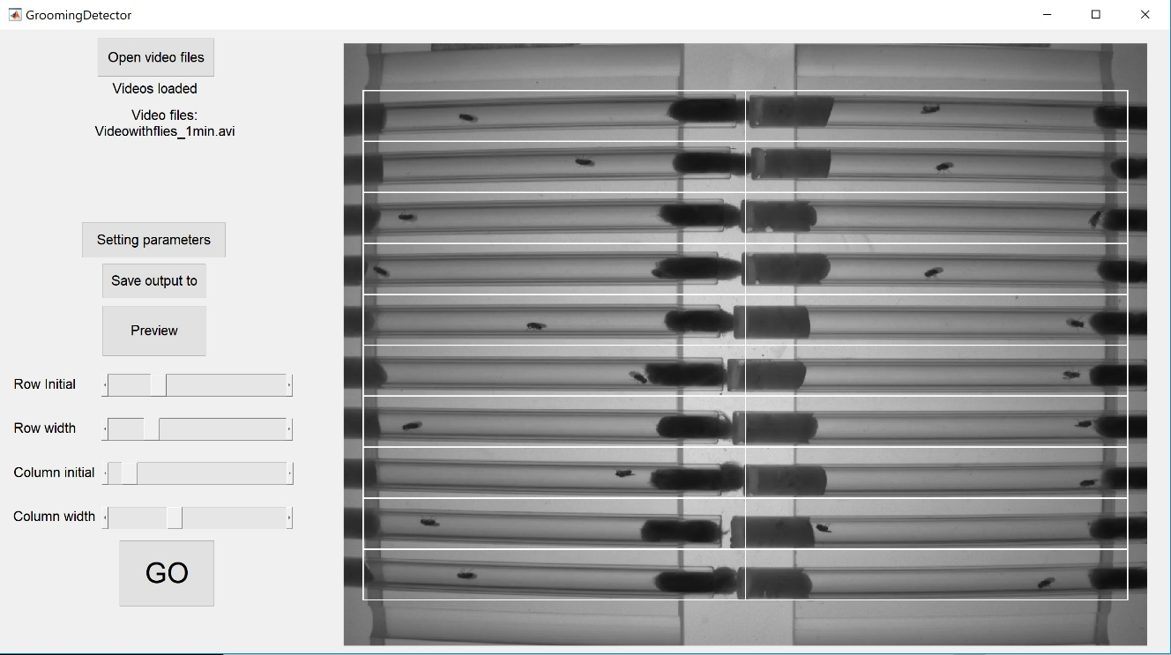Finally, individual tubes are separated into different regions, as shown in the figure below.

**8.** ‘GO’!

**Part II. Labelling and applying your own training samples**

For quick start, training samples are available (‘GroomTrainfeature.mat’ and ‘GroomTrainlabel.mat’) in the package. In this case, the performance of detector may affect by actual experimental conditions. To enhance accuracy in grooming detection, it is strongly recommended to label behaviors from your own experimental video and apply these labeled frames as training samples for grooming detection.

**Preparation:**

A video with no flies, as described in **Part I,** is still needed for parameter setting. In addition, you also need a typical experimental video, of which the length can be half hour to hours long, for generating training samples. Rename the video for training as ‘*TrainingVideo.avi’*’.

To prepare your own training samples, you need to manually label fly behaviors in *TrainingVideo.avi* as ‘Grooming’, ‘Locomotion’, and ‘Rest’. By watching the video, pick out typical samples of each of these three behaviors and record starting and ending time of each sample. Samples can be labeled from different flies in the video. Usually a total of 5000 or more frames of each behavior is enough for constructing a detector.

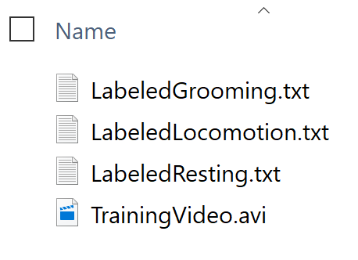

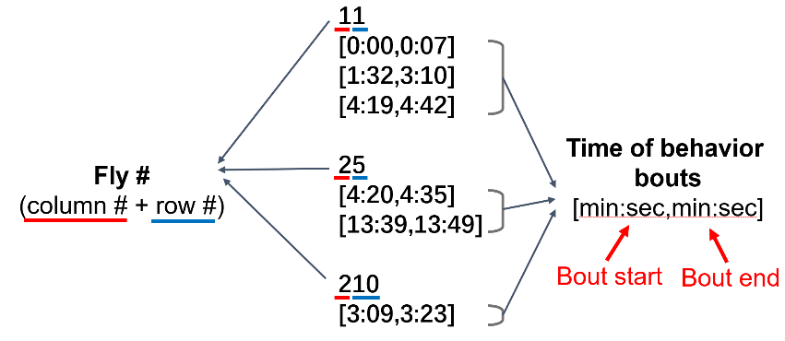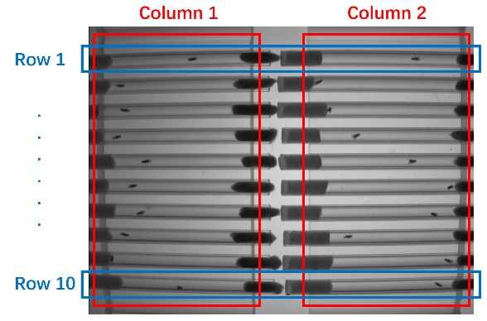Save starting and ending times of different behaviors into separate files with names of ‘*LabeledGrooming.txt*’, ‘*LabeledLocomotion.txt*’, and ‘*LabeledResting.txt*’. Create a new folder and put these three .txt files and *TrainingVideo.avi* into it. Examples of above files are available in a folder named ‘TrainingFiles’ in the package. The names of files and format of starting and ending time of behaviors from different flies need to be consistent with these examples, as shown in the figures below. To create your own, just replace the existing files.

**Procedures:**

**1.** Set up program by following **Steps 1-7** in **Part I**. In **Step 6**, load the labeled video *TrainingVideo.avi* through **Open video files** button. While setting training samples, you can skip the procedure of selecting path to save output data with ‘**Save output to**’ button.

**2.** By clicking ‘**Train**’, the program first extracts features of each frame from *TrainingVideo.avi.* Then based on starting and ending time of behaviors, Behavior labels and corresponding features are reformatted and saved as ‘*GroomingTrainlabel.mat’* and ‘*GroomingTrainfeature.mat*’ under the same path as the video.

**3.** To apply the new training samples in grooming detection. Replace original ‘*GroomingTrainlabel.mat’* and ‘*GroomingTrainfeature.mat*’ in the main folder of the package with the newly generated files. Before replacement, don’t forget a copy of original files as backup in case the new ones do not work well.

**4.** Start grooming detection as described in **Part I** with new training samples.