Goal

The main goal of this project is to develop a methodology and a framework for a complete assessment of the AFG-Miner to determine for which types of graphs it works well and to identify domain areas where it can be used successfully.

Design

Graphs with defined parameters are generated to be inputted into AFG-Miner. The runtime was recorded to examine how changing certain parameters affected the runtime of AFG-Miner.

Graph Generation

Graph Generation was a central part of this project. There was no suitable graph generation algorithms available that could be found and therefore one was made. The generator made produces a defined number of execution flow graphs (EFG). These graphs consist of nodes, attributes, and directed edges. Weights are assigned to nodes, attributes, and edges. Attributes are assigned to nodes. Each EFG contains a source node and sink node that are added at the end of generation to ensure each EFG is single entry, single exit. The graphs generated initially had no artificial pattern insertion. Therefore, the random nature of the graphs meant that no patterns were present in the dataset to be found by AFG-Miner. After this, patterns were artificially inserted into the graph to be found. For every node called for in the parameters, a bernoulli test was done. If false, then the node was inserted. If true, then instead of inserting the node, a pattern selected from a patternBank is inserted into the graph. This patternBank is created by storing a user-inputted number of patterns into a file. Each pattern is another EFG minus the artificial patterns and typically a lot smaller than full size EFGs (Size is determined by user-input).

This generator takes in a number of parameters to assist in the generation. There are two sets of parameters: Configuration, and Generation. Configuration parameters are used to create a configuration file required by AFG-Miner. Generation parameters are used for the actual creation of the dataset. These parameters are as follows:

For Configuration File
- Max attributes per pattern
- Max forward edges
- max backward edges
- gap value
- minSupport
- max nodes per pattern

For Graph Generation
- Number of Execution Flow Graphs
- Number of Nodes in the total dataset
- Size of the superset of all attributes in the dataset
- Probability for Attribute Placement Bernoulli trials
- Probability for Edge Placement Bernoulli trials
- Distribution of Number of Nodes per EFG (Uniform, Exponential, Gaussian, Poisson)
- Distribution of Edge Weights (Uniform, Exponential, Gaussian, Poisson)
- Distribution of Node Weights (Uniform, Exponential, Gaussian, Poisson)
- Distribution of Attribute Weights (Uniform, Exponential, Gaussian, Poisson)
- Distribution of Pattern Nodes/Pattern
- Number of Patterns
- Number of Nodes in Total pattern dataset
- Probability for Pattern insertion Bernoulli trials

For each distribution, a number of parameters were also required. For each Uniform distribution, a maximum and minimum were required. For each Exponential distribution, a rate value was required. For each Gaussian distribution, a height, centre, and width were required.

Initial Results

AFG-Miner has a significant space-time trade-off. Originally, AFG-Miner took extensive use of memoization in order to reduce time required to find patterns. This greatly reduced runtime however this also results in a great amount of memory being used for large graphs. This means that any large, partially dense graphs use up too much memory to be able to run.

Densities greater than .22 did not run with a minSupport of .11 with 10 EFGs, 1000 nodes and 10 Attributes:

Changes

A number of changes had to be made to AFG-Miner in order to limit the amount of memory the miner consumed. The main change was made through decreasing the amount of information that is stored when a pattern is found. In the original design, every time a pattern is found in the dataset, a new graph, called a pattern graph, is created. This graph contains a lot of information including a vertex set. This vertex set contains a mapping of weights to vertices, which themselves include a lot of information. This vertex set allows for quick access to any vertex in the pattern but becomes a large memory sink. All information that is stored in the vertex set, however, can be obtained via the set of edges that is also stored when the vertex ids are integers. Therefore memory can be saved by deleting the vertex set contained in pattern graph and obtain the necessary information from the edge set. This saves a significant amount of memory but has a significant time penalty as this involves traversing the edge set numerous times.

On top of this, AFG-Miner stored lots of information having to do with instruction and attribute information that is only relevant when running with an actual dataset. Since this evaluation is using automatically generated general graphs, this information is useless to our efforts and therefore can be eliminated.

Results

It was discovered that a main determination of runtime/memory usage is the density of the graphs made and the minSupport level. Any density over 25% is not likely to run. The following shows runs with 0, 0.05, 0.1, and 0.15 attribute density levels. These were run with .11 minSupport, 1000 nodes, 10 EFGs, and 10 Attributes.

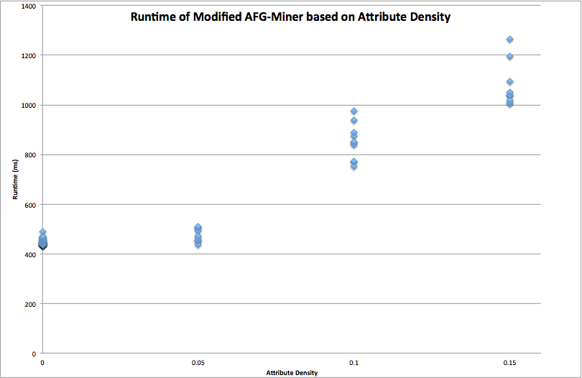

This shows that as density increases, runtime increases exponentially. 0 is slightly higher since these tests were not truly 0% dense since it is a pre-condition of AFG-Miner that each node has at least 1 attribute.

Adding up to 0.25 to the previous graph shows how quickly runtime increases as the density of a graph increases.

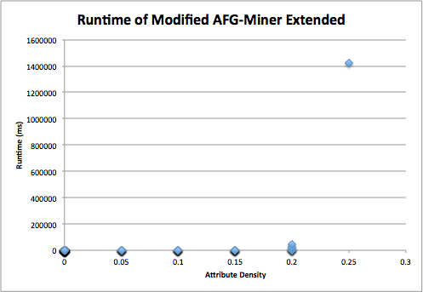

At the end of the summer, we discovered that limiting out-degree to 2 greatly enhances the performance of the original AFG-Miner. By limiting the out-degree, graphs of large sizes (10000 Nodes) and low minSupport (as low as 0) are able to run quickly and effectively.

Further Work

Further investigation into the effect of the distributions is required as well as the range of out-degree (time only allowed for limit to 2 vs no limit). These parameters were mostly ignored for tests done so far due to the issues that arose due to memory consumption. Also more work can be done looking into types of patterns and controlling their content more effectively.

Git Repository

All work is kept in a git repository found at https://github.com/sbaergen/Evaluation-of-Data-Mining-Algorithm

To obtain these files, go into a terminal, navigate to where you want the project, and use:
git clone https://github.com/sbaergen/Evaluation-of-Data-Mining-Algorithm

There are 2 main folders: GraphGenerator and carolina_msc_project. GraphGenerator contains the modified code and tests run on this code and carolina_msc_project contains the original AFG-Miner plus Main.java.

