- Normal
- Vertical more
- Horizontal more
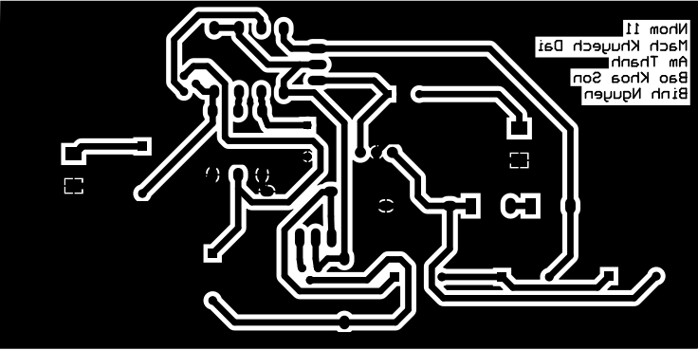
- Both more

