1. Title of the Project:

Online Bus Ticket Booking System

1. Introduction:

This Online Bus Ticket Booking System project will provide an Online Bus Ticket Booking platform and thereby leverage the tedious manual ticket booking activity for a customer. We can provide a feature that will allow the customer to get a seat blocked and ticket booked without much hassle. Initially, customers used to book tickets manually by queuing in lines at bus stations or go to travel agents who in turn used to book tickets for them. This was actually a tedious process and was leading to wastage of time. It also had issues like having incorrect names or other information used to book tickets. We can eliminate the drawbacks by developing an application which will allow customers to register themselves and block seats book tickets or postpone or propone travel dates with feasibility. This actually is a welcome step for customers as they can access the application from anywhere and will also avoid wastage of time that was caused due to the drawbacks in the previous way of booking tickets manually.

1. Objectives:

• Bus ticket service provider -

1. Build an application which provides availability of buses between source and destination. Only authorized users/applications should be able to make call to APIs of service provider.
2. Bus Search

* Bus search should take input – source, destination, date of journey.
* Bus search should return – Buses available along with start time of bus, no of seats available in that bus and stops between source and destination.

1. Block seats

* Blocking of seats should take input – No of passengers, Bus (based of
* start time), pickup point (one of the stops in the route)
* Blocking of seats should return confirmation along with blocking id.

1. Book tickets

* Booking tickets should take input – Blocking id.
* Booking ticket should return confirmation message along with Booking id

4. Hardware & Software Requirements:

Hardware:

Hardware includes the physical features, which are every part that you can either see or touch, for example: monitor, case, keyboard, mouse and printer.

Software:

The part which activates the physical components called software. It includes the features that responsible for directing the work to the hardware. Software can be divided into the programs and data.

Hardware Specification (Minimum):

Disc Space :40 GBMemory :512 MB RAMFile System : 32 Bit/64 Bit

Software Specification:

Operating System (Server Side) :Windows 7/8/9.

Operating System (Client Side) :Windows 7/8/9.

Client End Language : React

Server Side Language : Node, Express

Database : MongoDB

Web Server :AWS EC2 Linux

Web Browser : Mozilla Firefox/ Chrome

1. Limitations & Advantages:

Constraints:

User interface is only in Bus i.e. no other Bookings option is available. User can login only with his assigned username and password i.e. no guest facility is available. Limited to HTTP/HTTPS.

Cost

The cost required in the proposed system is comparatively less to the existing system.

Effort

Compared to the existing system the proposed system will provide a better working environment in which there will be ease of work and the effort required will be comparatively less than the existing system.

Time

Also the time required generating a report or for doing any other work will be comparatively very less than in the existing system. Record finding and updating will take less time than the existing system.

Labor

In the existing system the number of staff required for completing the work is more while the new system will require quite less number of staff.

Testing Booking Cities:

From Mumbai to Bengaluru tickets can be selected.

Razorpay test payment Cards:

<https://razorpay.com/docs/payments/payments/test-card-details/>

1. Mongo DB Schema designs:

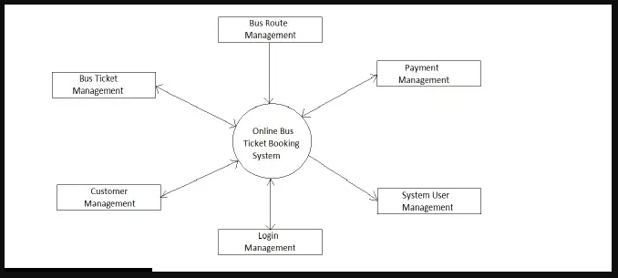

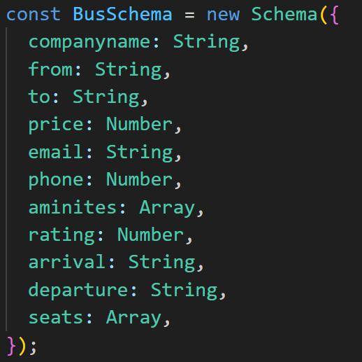

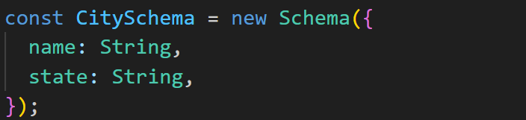

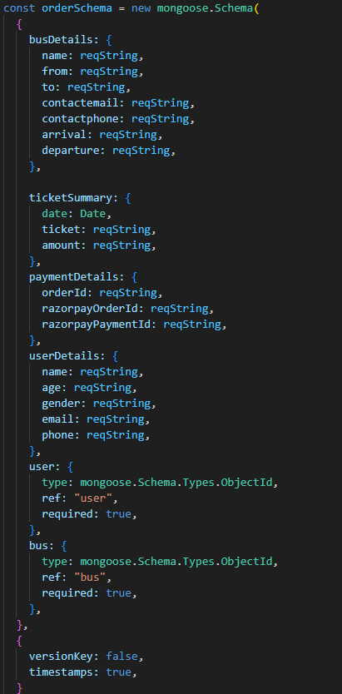

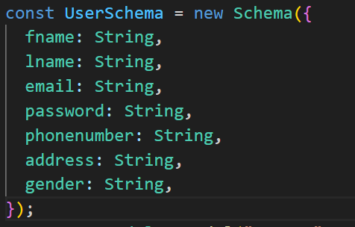

1. Source code:

<https://github.com/sbagri2708/busbooking.git>

1. Conclusion:

It can be observed that computer applications are very important in every field of human endeavor. Here all the information about customer that made reservation can be gotten just by clicking a button with this new system, some of the difficulties encountered with the manual system are overcome. It will also reduce the workload of the staff, reduce the time used for making reservation at the bus terminal and also increase efficiency.