Registry-Driven ETL and Real-Time BI Platform Architecture Design
Technical Design Documentation for the Realtime BI Platform

Field | Value
Document type | Technical architecture design
System | Realtime BI Platform
Implementation baseline | new_architecture_v2 repository snapshot and uploaded architecture notes
Status | Draft v1.0
Audience | Data engineers, platform engineers, BI engineers, architects, and technical reviewers

This document formalizes the current registry-driven ETL and streaming BI design in clean technical English. It separates implemented capabilities from target extensions so the architecture is defensible and practical.

1. Executive Summary
This design describes a modular ETL and real-time BI platform that standardizes how data is ingested from operational sources, APIs, and event producers, then transformed into analytics-ready Delta Lake tables. The platform follows a layered architecture: Source Systems -> Ingestion/Raw Zone -> Processing/Transformation Layer -> Curated/Gold Layer -> Consumption and Analytics Layer.
The central design decision is to make pipelines registry-driven rather than hard-coded. Batch jobs are defined in a catalog and converted automatically into Airflow DAGs. Streaming jobs are defined in a stream registry and executed by a supervisor that starts and monitors reusable Spark Structured Streaming engines. New sources should require configuration first and custom code only when the transformation logic is genuinely unique.
The current implementation uses Docker Compose, Apache Spark, Delta Lake on MinIO, Apache Kafka, Apache Airflow, FastAPI services, PostgreSQL, and a dashboard application. The design is extensible toward production deployments on cloud object storage, Databricks/Synapse-style compute, managed Kafka, and enterprise orchestration tools.

2. Architecture Goals
Goal | Design response
Reduce custom ETL code | Use generic ingestion and transformation engines driven by JSON manifests and catalogs.
Support both batch and streaming workloads | Separate batch orchestration through Airflow from always-on streaming supervision through a Spark stream supervisor.
Standardize lakehouse layering | Persist raw records in Bronze, clean/validated records in Silver, business-ready records in Gold, and invalid streaming rows in Quarantine.
Enable fast onboarding of new sources | Add new batch jobs in pipeline_catalog.json, new JDBC sources in source manifests, and new streams in stream_registry.json.
Improve observability | Use Airflow task state, job-run registry records, heartbeat files, runtime logs, and dashboard APIs.
Preserve operational flexibility | Keep source-specific behavior in configuration and optional plugins rather than spreading logic across many scripts.

3. Scope and Non-Scope

3.1 In Scope
- API-to-Bronze batch ingestion.
- JDBC source-manifest-to-Bronze batch ingestion for SQL Server/PostgreSQL/MySQL-style sources.
- Bronze-to-Silver and Silver-to-Gold batch transformations.
- Kafka-to-Bronze streaming ingestion.
- Bronze-to-Silver streaming transformation with validation and quarantine handling.
- Local lakehouse storage on MinIO using Delta Lake.
- Airflow-based batch orchestration.
- Stream supervisor-based always-on execution for streaming units.
- Dashboard/API visibility into configuration, job state, run history, logs, and stream health.

3.2 Non-Scope in the Current Implementation
- A full semantic layer or OLAP cube implementation.
- Production-grade identity, access management, secret management, TLS, and network isolation.
- Full warehouse dimensional modeling and dbt-managed star schemas.
- Enterprise deployment automation such as Kubernetes, Terraform, or CI/CD pipelines.
- End-to-end data lineage catalog integration.
These items are valid next-phase extensions, but they are not fully implemented in the current code baseline.

4. Design Principles
1. Configuration-first execution: pipeline behavior is defined in registries, catalogs, and manifests before code is modified.
2. Reusable engines: ingestion, transformation, validation, deduplication, and writing are implemented as generic engines.
3. Layered lakehouse design: raw, cleaned, curated, and quarantined data are physically separated.
4. Separation of control plane and data plane: Airflow and the stream supervisor control execution, while Spark performs data processing.
5. Observable-by-default execution: jobs emit run events, heartbeat files, logs, row counts, status, and failure details.
6. Idempotent and replayable processing: Delta Lake merge keys, checkpoint directories, deduplication rules, and partitioning support controlled reruns.
7. Plugin only when needed: domain-specific code is introduced only when generic mapping, SQL expressions, and quality rules are insufficient.

5. Logical Architecture
The platform is organized as five logical layers.
Layer | Responsibility | Current components
Source systems | Produce raw operational, API, file, or event data | External APIs, SQL Server/PostgreSQL manifests, demo web app, backend services
Ingestion / Raw Zone | Capture source data with minimal transformation | API-to-Bronze runner, JDBC manifest runner, Kafka-to-Bronze engine, Collector API
ETL processing layer | Validate, map, derive, deduplicate, transform, and enrich | Generic Bronze-to-Silver and Silver-to-Gold runners; streaming Bronze-to-Silver engine
Storage and serving layer | Persist Delta tables and serve analytics consumers | MinIO/S3A, Bronze/Silver/Gold/Quarantine Delta paths, PostgreSQL warehouse target
Consumption and operations layer | Dashboards, BI tools, logs, monitoring, job history | Dashboard UI/API, Airflow UI/API, Spark UI, Jupyter, pgAdmin

The one-line summary of the architecture is: a configuration-driven, orchestrated, modular ETL platform that reads data from source systems, stores raw data in a standardized raw zone, transforms it using Spark-based reusable engines, and publishes analytics-ready datasets with built-in monitoring and governance hooks.

6. Physical Deployment Architecture
The local implementation is split into three Docker Compose profiles.
Compose file | Main purpose | Main services
compose.phase1.yaml | Core lakehouse and compute foundation | MinIO, PostgreSQL warehouse, pgAdmin, Spark master, Spark workers, Jupyter
compose.phase2.yaml | Orchestration and streaming runtime | Airflow PostgreSQL, Airflow API server, scheduler, DAG processor, triggerer, Kafka, Collector API, Kafka topic initializer, Spark stream supervisor
compose.simulator.yaml | Demo application and dashboard | Demo web application, dashboard API, Nginx dashboard frontend

The current runtime assumes a shared Docker network named rltm_shared_net and a repository mount at /workspace/rltm_bi_pltfrm inside most runtime containers.

7. Batch Architecture
Batch processing is registry-driven. Airflow DAGs are not manually written for each pipeline. Instead, the DAG factory reads configs/batch/pipeline_catalog.json, validates enabled pipelines, and creates Airflow tasks based on job definitions and dependencies.
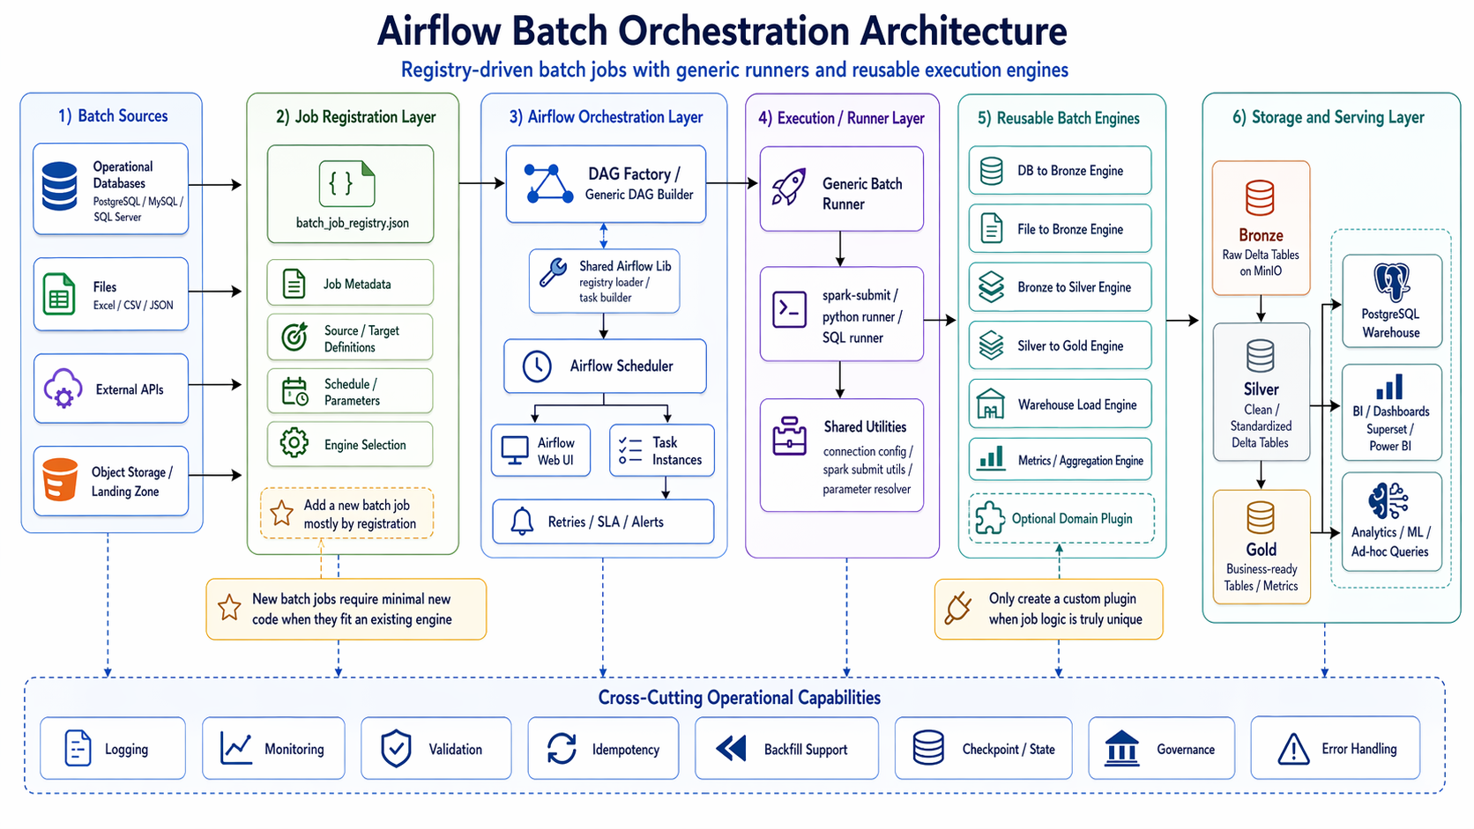
Figure 1. Airflow batch orchestration architecture.

7.1 Batch Flow
1. A pipeline is registered in pipeline_catalog.json.
2. airflow/dags/batch_catalog_dags.py loads enabled pipeline specifications.
3. airflow/builder/batch_catalog_builder.py converts jobs into Airflow BashOperator tasks.
4. Each task builds a spark-submit command using shared/spark/spark_submit_utils.py.
5. The selected generic runner executes the job.
6. The runner reads/writes Delta tables through Spark and records status in the job-run registry.
7. The dashboard combines configuration, Airflow state, registry events, logs, and target path metadata.

7.2 Supported Batch Job Types
Job type | Runner | Purpose
generic_api_to_bronze | batch/runners/generic_api_to_bronze.py | Calls an HTTP API, validates JSON payloads, maps fields, and writes Bronze Delta rows.
generic_bronze_to_silver | batch/runners/generic_bronze_to_silver.py | Reads Bronze Delta data, applies filters, mappings, derived fields, quality rules, deduplication, and writes Silver Delta.
generic_silver_to_gold | batch/runners/generic_silver_to_gold.py | Reads Silver Delta data, applies business-ready transformations, and writes Gold Delta.
generic_jdbc_manifest_to_bronze | batch/runners/generic_jdbc_manifest_to_bronze.py | Reads one or more JDBC source tables according to a manifest and writes Bronze Delta tables.
spark_batch | Config-defined entrypoint | Allows a custom Spark job when a generic runner is not sufficient.

7.3 Batch Configuration Model
Area | Example fields | Responsibility
Pipeline metadata | name, enabled, description, domain, source_type | Describes the pipeline and whether it should be generated.
DAG settings | schedule, catchup, max_active_runs, start_date, tags, default_args | Controls Airflow scheduling and runtime behavior.
Jobs | name, job_type, dependencies, spec, retries, execution_timeout_minutes | Defines executable units and their dependencies.

Pipeline | Source type | Jobs | Output direction
weather_forecast_pipeline | API | ingest -> silver -> gold | API response to Bronze/Silver/Gold Delta paths
gold_price_pipeline | API | ingest -> silver -> gold | API response to Bronze/Silver/Gold Delta paths
ecommerce_sqlserver_bronze_pipeline | JDBC | SQL Server manifest to Bronze | Source tables to Bronze Delta paths

7.4 API-to-Bronze Pattern
1. Load the selected job from the batch catalog.
2. Build a runtime context from the job specification.
3. Resolve authentication from environment variables when required.
4. Execute the HTTP request with retry/backoff policy.
5. Validate required JSON paths and validation rules.
6. Map the payload into a typed row according to the declared schema.
7. Generate an event_id when missing.
8. Add ingestion partition columns where configured.
9. Write the output to a Bronze Delta path.
10. Append success or failure metadata to the job-run registry.

7.5 JDBC Manifest-to-Bronze Pattern
JDBC ingestion is designed around source manifests. A manifest declares the source system, connection reference, default ingestion behavior, target path template, table list, primary keys, columns, read mode, watermark columns, partitioning, and metadata options.
1. Add or update the physical connection in configs/connections/jdbc_connections.json.
2. Create a source manifest under configs/sources/jdbc/.
3. Register a generic_jdbc_manifest_to_bronze job in pipeline_catalog.json.
4. Choose one_task_per_manifest or one_task_per_table execution strategy.
5. Let Airflow generate the necessary tasks automatically.
The current code includes an SQL Server connection entry and SQL Server/PostgreSQL-style manifest examples. PostgreSQL and MySQL should be added to the connection registry before they are used operationally.

7.6 Batch Transformation Capabilities
Capability | Description
Selection/mapping | Rename or select source columns using select_map.
Filtering | Apply configured filters such as equals, not equals, comparisons, and non-null checks.
Derived fields | Add SQL-expression-based fields through derived_fields.
Quality rules | Enforce not-null and comparison-based data-quality rules.
Deduplication | Use key columns and optional ordering expressions to select one row per entity/event.
Delta merge | Merge into an existing Delta target using configured merge keys.
Partitioning | Partition output by ingestion or business date columns.
Run registry | Emit started, succeeded, and failed run records with timing and row counts.

8. Streaming Architecture
Streaming is separated from Airflow batch execution. It uses a stream registry and a long-running supervisor process. The supervisor reads configs/streaming/stream_registry.json, starts one or more stream units, monitors their process state and heartbeat files, and restarts failed units based on policy.
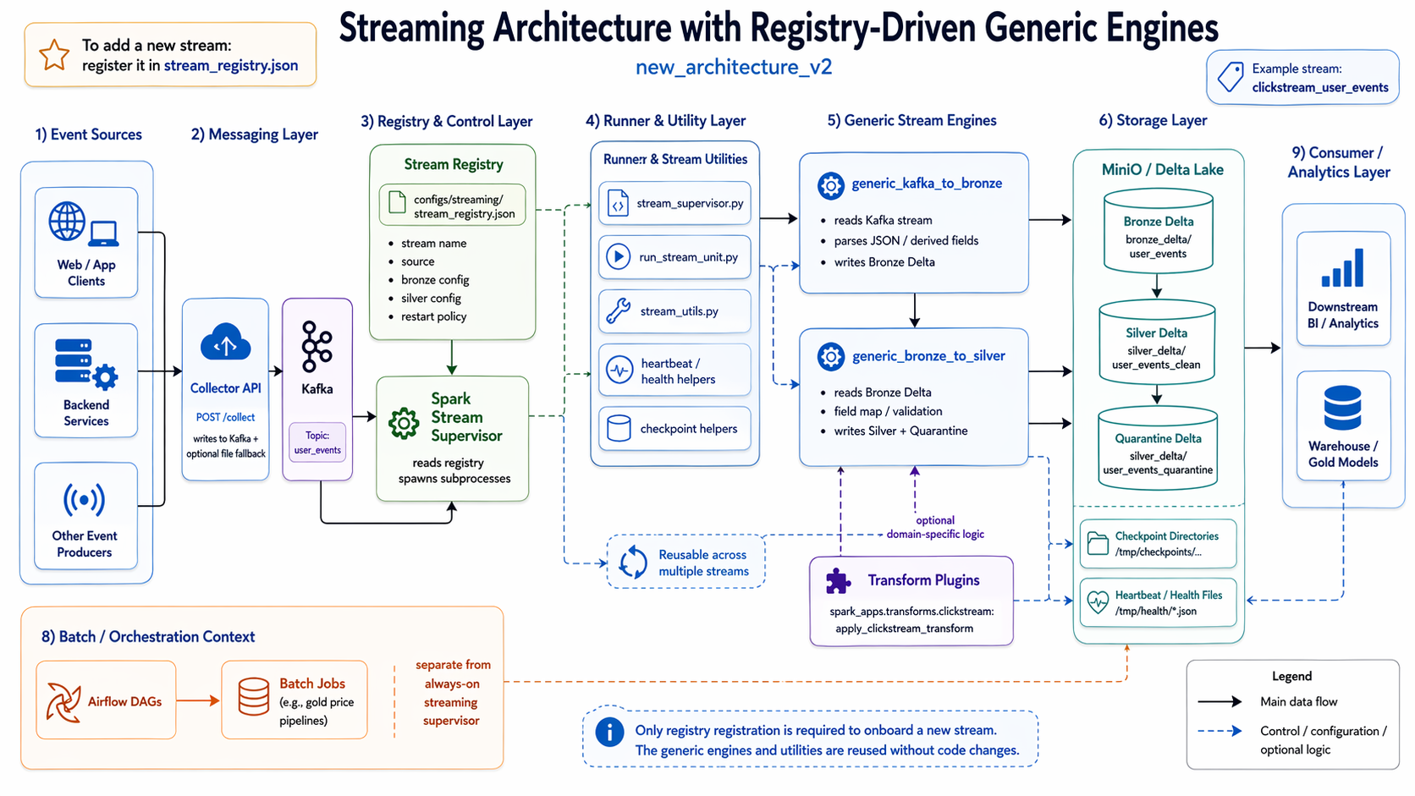
Figure 2. Registry-driven streaming architecture.

8.1 Streaming Flow
1. Web/app clients or backend services send structured events to the Collector API.
2. The Collector API validates the event minimally, enriches it with collector metadata, and writes to Kafka.
3. If enabled, the Collector also appends events to a JSONL fallback file.
4. The stream supervisor reads stream_registry.json and starts Bronze and Silver stream units.
5. generic_kafka_to_bronze reads Kafka messages and writes Bronze Delta rows.
6. generic_bronze_to_silver reads Bronze Delta streams, maps fields, computes fields, validates rows, and writes valid rows to Silver and invalid rows to Quarantine.
7. Heartbeat files and logs are written for runtime monitoring.
8. The dashboard API reads stream state, heartbeats, logs, and configuration for display.

8.2 Streaming Units
Unit | Engine | Input | Output
Bronze stream | generic_kafka_to_bronze | Kafka topic user_events | s3a://lakehouse/bronze_delta/user_events
Silver stream | generic_bronze_to_silver | Bronze Delta path | s3a://lakehouse/silver_delta/user_events_clean and quarantine path

8.3 Collector API Contract
Endpoint | Purpose
GET /health | Reports service health, Kafka target, producer readiness, and fallback setting.
POST /collect | Receives a JSON event, validates event_type, enriches the event, writes to Kafka, and optionally writes to file fallback.
GET /events | Returns recent events from the JSONL fallback file for debugging.

The event payload should contain at least event_type. Recommended event fields include event_id, event_ts, source, user_id, anonymous_id, session_id, page_url, and a nested properties object.

8.4 Streaming Quality and Quarantine
The Silver streaming engine separates valid and invalid rows. Required fields and identity fields are configured in the stream registry. Rows that fail validation are written to a quarantine Delta path rather than being silently dropped. This is important because event streams often contain incomplete, duplicated, late, or malformed records.

8.5 Stream Restart and Health Model
The stream supervisor maintains runtime state for each stream unit. It tracks process ID, status, return code, restart count, last start time, last stop time, heartbeat content, and error details. The restart policy is configured per stream, currently with fields such as max_retries and backoff_seconds.

9. Storage Architecture
The platform uses object storage as the lakehouse substrate and Delta Lake as the table format.
Zone | Purpose | Example paths
Bronze | Raw or minimally processed source records | s3a://lakehouse/bronze/..., s3a://lakehouse/bronze_delta/user_events
Silver | Cleaned, validated, standardized records | s3a://lakehouse/silver/..., s3a://lakehouse/silver_delta/user_events_clean
Gold | Business-ready curated datasets and metrics | s3a://lakehouse/gold/...
Quarantine | Invalid streaming rows requiring investigation | s3a://lakehouse/silver_delta/user_events_quarantine
Checkpoints | Spark Structured Streaming state | /tmp/checkpoints/... mounted to the host
Health/log files | Operational observability | /tmp/health/..., /tmp/health/logs/...

The current local object store is MinIO. In production, this layer can be replaced by S3, ADLS, GCS, or an enterprise object-store equivalent.

10. Observability and Runtime Dashboard
The dashboard is not just a static page. The dashboard API assembles a runtime view from multiple sources.
Source | Information used
Configuration files | Registered batch pipelines, jobs, streams, paths, and metadata.
Job-run registry | Batch run start/success/failure events, durations, row counts, and target paths.
Stream status file | Supervisor state, stream unit status, heartbeat content, restart counts.
Airflow API and logs | Recent DAG runs, task instances, execution states, and task logs.
Runtime mounts | Availability and freshness of mounted runtime directories.

Endpoint | Purpose
GET /health | Dashboard API health.
GET /api/config | Normalized platform configuration.
GET /api/runtime/mounts | Runtime mount diagnostics.
GET /api/runtime/streams/status | Stream supervisor and unit status.
GET /api/runtime/jobs | Unified batch and streaming job view.
GET /api/runtime/runs/{{job_id}} | Historical runs for a job.
GET /api/runtime/logs/{{job_id}} | Runtime logs for batch or streaming jobs.

11. Governance, Security, and Data Quality

11.1 Current Governance Hooks
- Explicit source manifests and pipeline catalogs.
- Defined target paths and partitioning rules.
- Required fields and quality rules.
- Quarantine handling for invalid streaming records.
- Job-run registry with timing, row counts, status, and error details.
- Optional source-specific metadata and row hashes in JDBC ingestion.

11.2 Production Hardening Required
Area | Current state | Required production action
Secrets | Development credentials and environment variables | Move to a secret manager; remove default credentials.
Transport security | Local HTTP and internal Docker network | Add TLS and network policies.
Authentication | Development defaults for Airflow/dashboard | Use enterprise identity provider or service accounts.
Authorization | Minimal role separation | Implement least-privilege access to storage, jobs, and APIs.
Data privacy | No full PII classification workflow | Add schema-level classification, masking, and retention rules.
Auditability | Job-run registry and logs exist | Add immutable audit storage and lineage integration.

12. Extension Points
Extension point | How to extend
New API source | Add a generic_api_to_bronze job and downstream transformation jobs to pipeline_catalog.json.
New JDBC source | Add connection registry entry, create a manifest, and register a manifest-driven Bronze job.
New streaming source | Add a stream definition to stream_registry.json; reuse generic Bronze/Silver engines.
Custom transformation | Use SQL expressions first; then add a transform plugin only when generic rules are insufficient.
New serving target | Add a warehouse load engine or downstream consumer from Gold tables.
New monitoring tool | Consume job-run JSONL, heartbeat files, Airflow API data, or dashboard API output.

13. Implementation Status and Gaps
The design is sound, but several gaps should be addressed before presenting it as a production-ready architecture.
Gap | Why it matters | Recommended action
PostgreSQL and MySQL JDBC registry entries are not fully configured | The design claims multi-database ETL, but the current connection registry only defines SQL Server. | Add PostgreSQL and MySQL connection templates, drivers, packages, and sample manifests.
Warehouse load engine is shown conceptually but not fully implemented | The serving layer needs controlled loading into PostgreSQL or BI models. | Implement a generic Delta-to-PostgreSQL or Gold-to-warehouse loader.
Gold layer is still simple | Current Gold jobs are curated outputs, not a complete dimensional model. | Add fact/dimension design, dbt models, data marts, and metric definitions.
Security is development-grade | Default credentials and local network assumptions are not acceptable in production. | Add secret management, TLS, authentication, and role-based access.
Error handling needs policy formalization | Some runners handle failures and registry events, but retry, dead-letter, and replay policies are not fully standardized. | Define platform-wide retry, quarantine, backfill, replay, and alerting policies.
Documentation should separate target architecture from implemented scope | Reviewers may confuse intended design with completed implementation. | Keep an explicit implementation-status matrix in the README and architecture docs.

14. Recommended Next Engineering Milestones
1. Complete multi-database JDBC support for SQL Server, PostgreSQL, and MySQL.
2. Implement a generic Delta-to-warehouse load engine.
3. Add a formal .env.example and configuration validation command.
4. Add unit tests for catalog validation, manifest loading, Spark command generation, and transformation rules.
5. Add integration tests for API -> Bronze -> Silver -> Gold and Kafka -> Bronze -> Silver.
6. Add a dimensional Gold model for e-commerce analytics, such as fact_user_events, dim_user, dim_session, dim_product, and fact_product_interaction.
7. Add CI/CD checks for formatting, tests, Docker build, and documentation generation.
8. Add production security hardening before any real client deployment.

15. File and Folder Map
Path | Role
configs/batch/pipeline_catalog.json | Main batch pipeline and DAG/job registry.
configs/streaming/stream_registry.json | Main stream registry for always-on streaming pipelines.
configs/connections/jdbc_connections.json | JDBC connection templates and Spark package definitions.
configs/sources/jdbc/*.json | Table-level JDBC ingestion manifests.
airflow/dags/batch_catalog_dags.py | Dynamic Airflow DAG factory entrypoint.
airflow/builder/batch_catalog_builder.py | Converts catalog jobs into Airflow tasks and dependencies.
batch/runners/ | Generic batch runner scripts.
batch/utils/ | Reusable batch ingestion, API, JDBC, and manifest utilities.
streaming/engines/ | Generic Spark Structured Streaming engines.
streaming/runners/stream_supervisor.py | Starts, monitors, and restarts stream units.
apps/collector/ | FastAPI event collector that writes to Kafka and optional JSONL fallback.
apps/web/ | Demo web application for generating user events.
apps/dashboard/ | Dashboard frontend and runtime API.
shared/ | Shared Spark submit and job-run registry utilities.
compose/ | Docker Compose files for core, orchestration/streaming, and simulator/dashboard layers.

16. Final Architecture Summary
This design is a strong foundation for a reusable BI and lakehouse platform. The most important strength is the registry-driven separation between configuration, orchestration, execution engines, and storage. This allows the platform to onboard new sources quickly while keeping runtime behavior observable and repeatable.
The main risk is overclaiming maturity. The architecture should be documented as a working modular platform prototype with a clear production path, not yet as a fully hardened enterprise product. Once JDBC support, warehouse loading, semantic modeling, testing, and security hardening are completed, the platform can be positioned as a practical reusable architecture for small-to-medium BI deployments and real-time behavioral analytics.

