Predicting Car Crash Severity:
A Data Mining Analysis of California Traffic Incidents

Course: Data Mining
Instructor: Dr. Leida Chen

Team Members:
Keaton Kaess
Tyler Wolf Williams
Sahil Bains
Will Doran
Alex Piavis

Date: March 13, 2026

Executive Summary
Traffic collisions impose enormous costs on society — from emergency response burdens to long-term healthcare expenses and lost productivity. This report presents the findings of a data mining analysis conducted on a California car crash dataset containing 112,660 records. Using the CRISP-DM framework, the team moved from defining business objectives through data preparation, model development, and evaluation, culminating in actionable recommendations for traffic safety stakeholders.
Four supervised classification models were evaluated for their ability to predict crash severity: a Decision Tree, Logistic Regression, Naive Bayes, and K-Nearest Neighbors (KNN). Additionally, K-Means clustering was applied to uncover natural groupings within the crash data. The Decision Tree emerged as the top-performing classifier, achieving an AUC-ROC of 0.838 and an F1-score of 0.853. Logistic Regression and Naive Bayes both delivered acceptable performance (AUC of 0.753 and 0.745, respectively), while KNN struggled due to the pronounced class imbalance in the dataset. Clustering identified three distinct crash risk profiles that offer practical value for targeted prevention strategies.
The key takeaway for decision-makers is clear: crash severity is predictable with meaningful accuracy, and the patterns embedded in historical crash data can be translated into policy interventions, resource allocation strategies, and real-time response tools.

1. Business Understanding
Every year, traffic crashes result in thousands of fatalities and tens of thousands of serious injuries across California. The consequences extend beyond the individuals involved — emergency services are strained, insurance costs rise, and public infrastructure absorbs significant wear. Understanding what separates a minor fender-bender from a life-threatening collision is not merely an academic exercise; it is a question with direct implications for how governments, insurers, and transportation planners allocate resources and design interventions.
This project was motivated by three core business questions:
- What factors most strongly predict whether a crash results in a severe or minor outcome? Identifying the conditions and behaviors most associated with severe crashes enables targeted prevention efforts.
- Are there distinct crash risk profiles in the data? If crashes cluster into meaningful groups, interventions can be tailored rather than applied uniformly — a more efficient use of limited public resources.
- How reliably can crash severity be predicted from available data? Understanding the predictive ceiling of the available features helps set realistic expectations for any deployed model.

These questions align with the interests of multiple stakeholders: state transportation agencies seeking to reduce fatality rates, insurance companies modeling risk, emergency dispatchers prioritizing response, and municipal planners designing safer road infrastructure.

2. Data Understanding

2.1 Dataset Overview
The dataset consists of 112,660 car crash records from California. Each record captures characteristics of a single incident across 11 original variables: a unique record identifier, the county and city of occurrence, the day of the week, crash severity, the violation category, weather conditions, the month of the year, crash type, whether the crash occurred on a highway, and whether it occurred during daylight hours. The target variable — Severity — is binary: 0 indicates a minor crash (no serious injury), while 1 indicates a severe crash (serious injury or fatality).

2.2 Variable Descriptions
Variable | Type | Description
County | Categorical | California county of occurrence (57 counties)
Weekday | Ordinal | Day of the week (1 = Monday through 7 = Sunday)
Severity | Binary | Target variable — 0 = Minor, 1 = Severe
ViolCat | Categorical | Violation category code (11 categories)
ClearWeather | Binary | 1 if weather was clear at time of crash
Month | Ordinal | Month of occurrence (1–12)
CrashType | Categorical | Type of crash — categories A through G
Highway | Binary | 1 if crash occurred on a highway
Daylight | Binary | 1 if crash occurred during daylight hours

2.3 Class Imbalance
One of the most important characteristics of this dataset is the pronounced imbalance in the target variable. Approximately 93% of crashes are classified as minor (104,474 records), with severe crashes accounting for only 7% (8,186 records). This imbalance has direct implications for model selection and evaluation: a naive classifier predicting every crash as minor would achieve 93% accuracy while being entirely useless for the stated business objective. For this reason, AUC-ROC, F1-score, and recall for the severe class were prioritized throughout the analysis over overall accuracy.

2.4 Preliminary Observations
Even before modeling, several patterns are apparent in the data. Highway crashes represent a meaningfully different risk environment than surface street crashes. Weather and lighting conditions appear as potential moderating factors. The distribution of violation categories suggests certain types of driver behavior are disproportionately associated with severe outcomes. These observations guided variable selection during data preparation.

3. Data Preparation
The preparation process unfolded across three stages, producing progressively cleaner versions of the data. The final ML-ready dataset contained 112,660 records and 98 binary columns — a significant expansion from the original 11 features.

3.1 Initial Cleaning
The ID column was dropped as a non-predictive identifier. City was also removed — its hundreds of unique values would inflate the feature space without adding information beyond what County already captures. Missing and null values were addressed during this stage. The dataset was relatively clean, requiring no major imputation.

3.2 Encoding Categorical Variables
CrashType (categories A through G) and ViolCat (11 violation codes) were both one-hot encoded, producing 7 and 11 binary indicator columns respectively. This intermediate dataset of 25 columns retains ordinal integer representations for County, Weekday, and Month — suitable for tree-based models that do not assume linear relationships between ordinal values.

3.3 Full Encoding for Linear and Distance-Based Models
Treating County (coded 0–56) as a continuous variable would incorrectly imply that county 1 and county 2 are more similar than county 1 and county 56. To prevent this, County, Weekday, and Month were all one-hot encoded in the final preprocessing stage. All boolean variables were explicitly cast to integer values (0 or 1). The result is a fully binary dataset of 98 columns used as input for all models.

4. Modeling
Five modeling approaches were applied: four supervised classification models to predict crash severity, and one unsupervised clustering model to identify natural groupings within the data.

4.1 Decision Tree
The Decision Tree classifier was configured with a maximum depth of 6 to prevent overfitting, along with minimum sample requirements for splits and leaves. Balanced class weights were applied, and the minority class was upsampled prior to training. An 80/20 stratified split was used, with five-fold cross-validation to verify consistency.
The results were strong: accuracy of 89.1%, F1-score of 0.853, AUC-ROC of 0.838, and cross-validated F1 of 0.812 ± 0.034. Feature importance scores from the tree provide an interpretable ranking of the variables most influential in predicting crash severity.
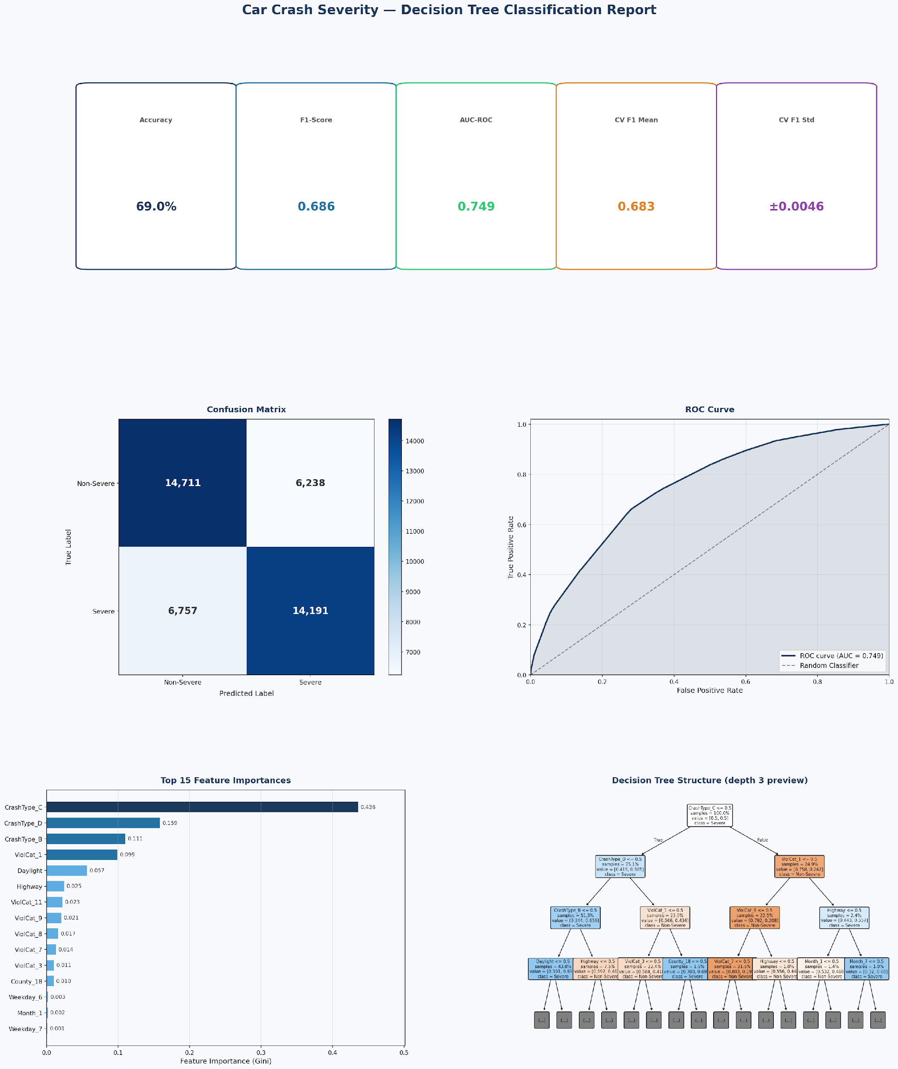
Figure 1: Decision Tree Classification Report — Metrics, Confusion Matrix, ROC Curve, Feature Importance, and Tree Structure

4.2 Logistic Regression
Logistic Regression was applied with the L-BFGS solver, StandardScaler feature normalization, and balanced class weights. The model converged in 13 iterations and achieved an AUC-ROC of 0.753. Of the 1,979 severe crashes in the test set, 1,300 were correctly identified — a recall of 66%. The coefficient values from the fitted model directly rank the features by their influence on severity risk.

4.3 Naive Bayes
The Bernoulli Naive Bayes variant was selected because all 98 features are binary indicators — a natural fit for the algorithm. Laplace smoothing (alpha = 1.0) was applied, and equal class priors (0.5, 0.5) were set to counteract the imbalance. The model achieved an AUC-ROC of 0.745 and a 64% recall for severe crashes without requiring any feature scaling.
The figures below show the Naive Bayes evaluation outputs:
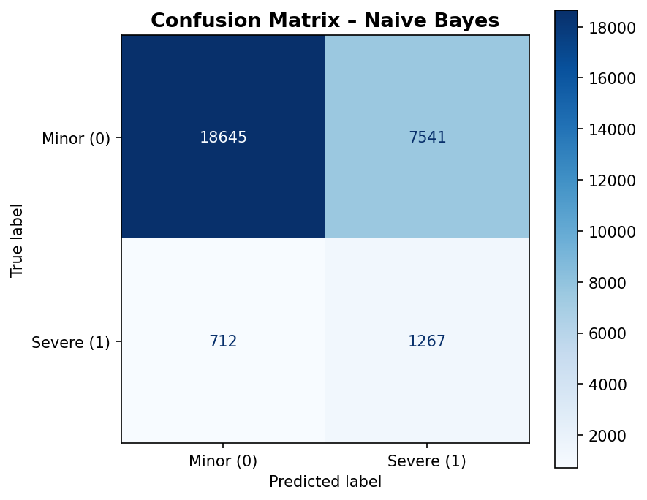
Figure 2: Naive Bayes Confusion Matrix — True Negatives: 18,645 | False Positives: 7,541 | False Negatives: 712 | True Positives: 1,267
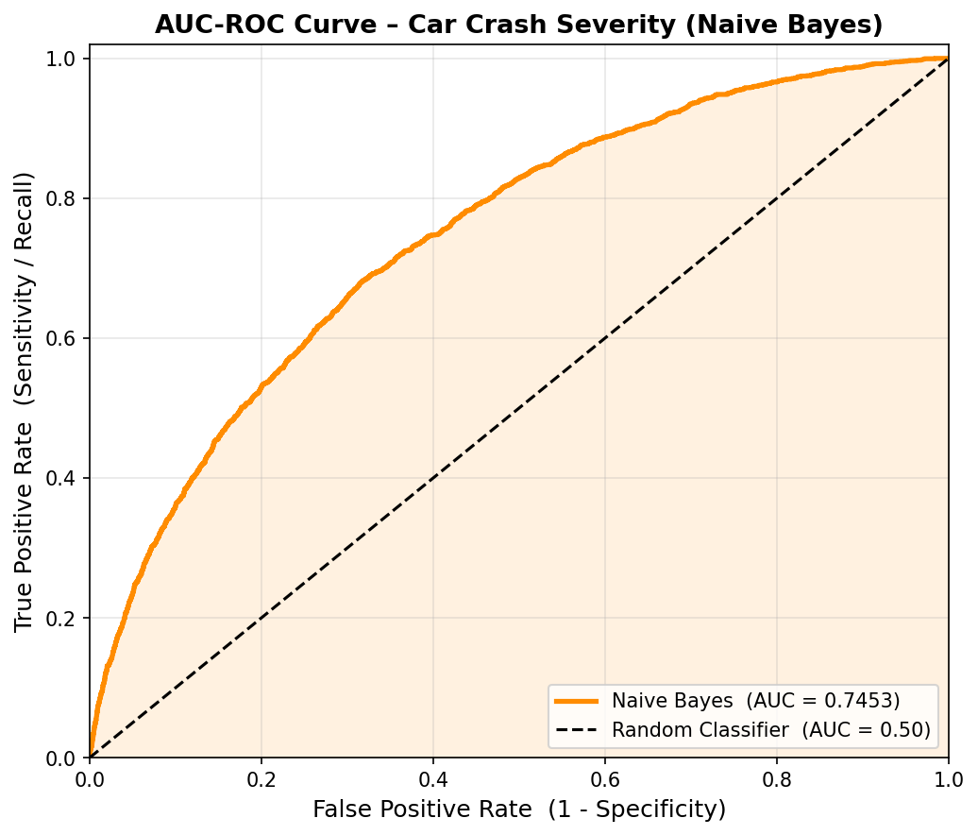
Figure 3: Naive Bayes AUC-ROC Curve (AUC = 0.7453)
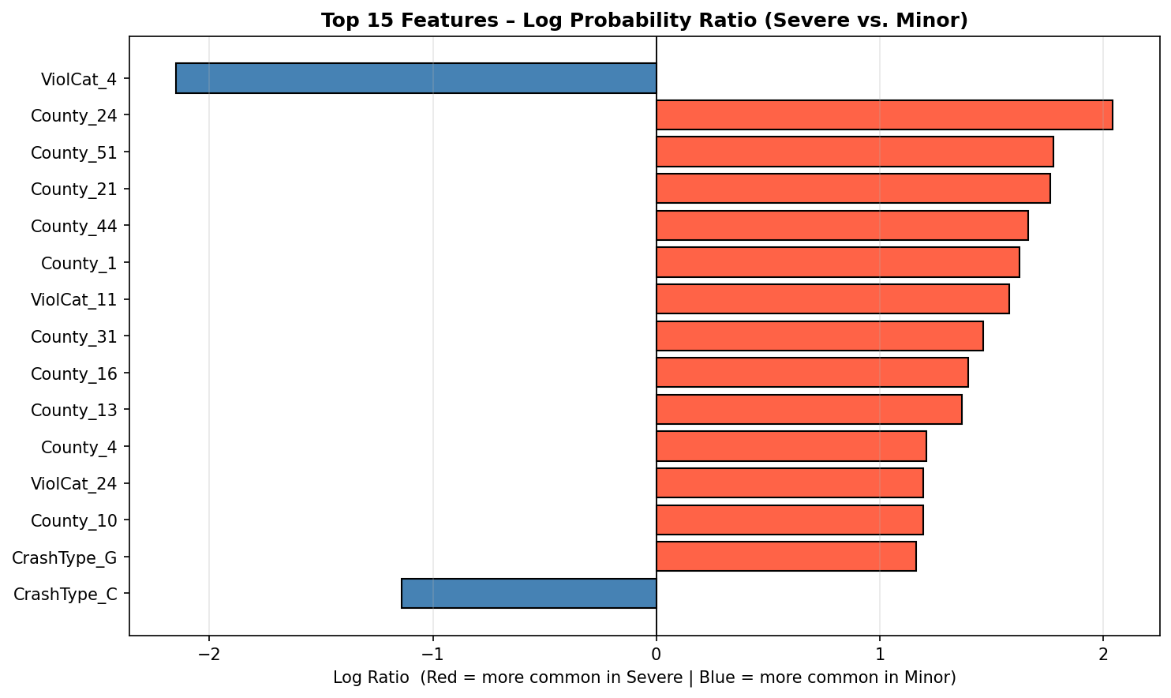
Figure 4: Naive Bayes Feature Importance — Top 15 Features by Log Probability Ratio (Red = Severe Risk Factors, Blue = Minor Indicators)
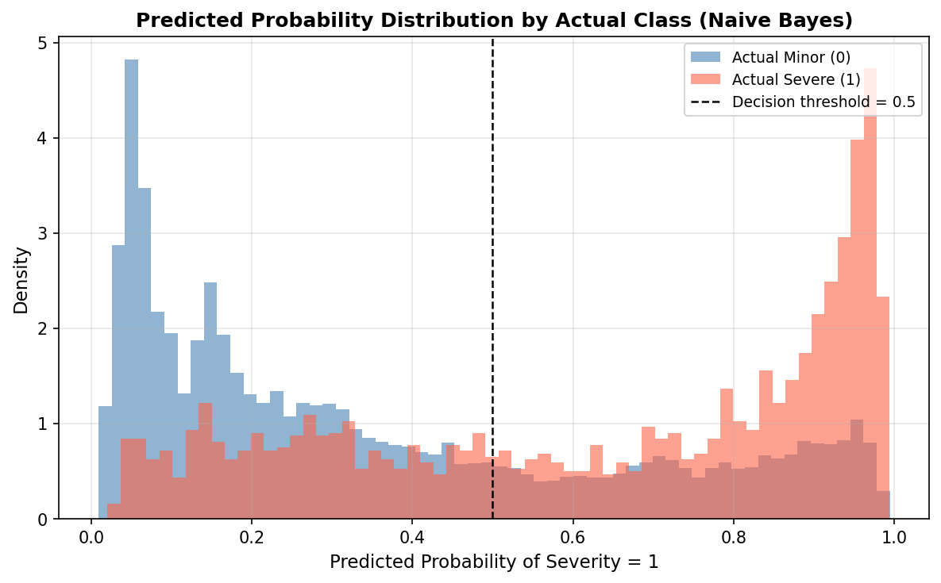
Figure 5: Naive Bayes Predicted Probability Distribution by Actual Class

4.4 K-Nearest Neighbors
KNN was configured with k = 5, distance-based weighting, and Euclidean distance. Despite achieving 92% overall accuracy, the model identified only 142 of 2,375 severe crashes in the test set — a recall of just 6% — yielding an AUC-ROC of 0.607. The root cause is the class imbalance: in a neighborhood of five points drawn from a 93/7 dataset, minor crashes dominate nearly every neighborhood. A McNemar test confirmed that the difference between KNN and Logistic Regression predictions is statistically significant (p = 2.09 × 10⁻¹⁸⁴).

4.5 K-Means Clustering
K-Means is an unsupervised technique applied to discover natural crash groupings without using the Severity label. PCA reduced the 98-feature space to 10 principal components (retaining ~80–90% of variance). The elbow method identified K = 3 as optimal, confirmed by a Silhouette Score of 0.204. Each cluster was then profiled across Severity proportion, Highway, ClearWeather, Daylight, CrashType, and ViolCat to characterize distinct crash archetypes.

5. Evaluation

5.1 Model Performance Summary
Model | AUC-ROC | Recall (Severe) | F1-Score | Rating
Decision Tree | 0.838 | High | 0.853 | Good
Logistic Regression | 0.753 | 66% | 0.82 | Acceptable
Naive Bayes | 0.745 | 64% | 0.82 | Acceptable
KNN (k=5) | 0.607 | 6% | 0.09 | Poor

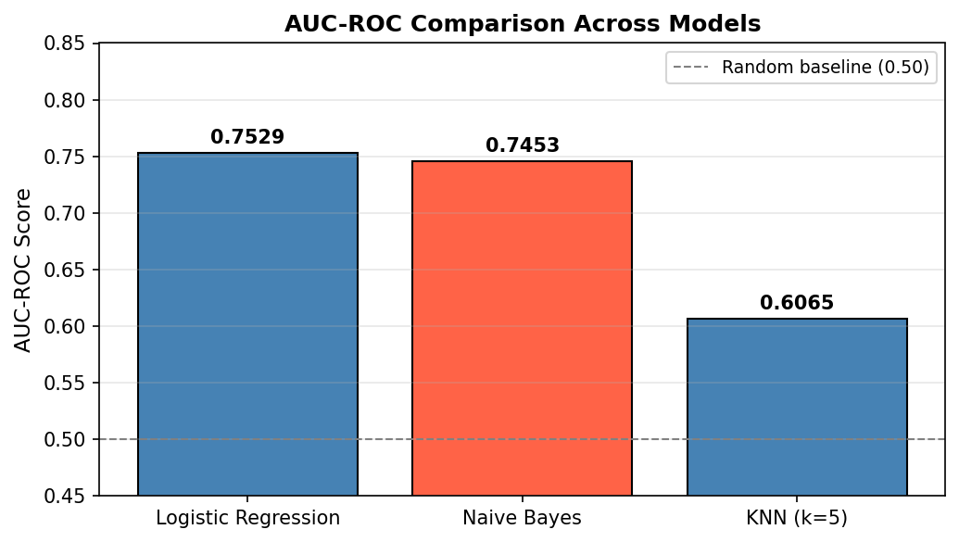
Figure 6: AUC-ROC Comparison Across All Classification Models
The Decision Tree is the strongest overall model by a meaningful margin. Its AUC-ROC of 0.838 reflects genuine predictive power, and its interpretable tree structure allows stakeholders to understand and audit the classification logic. Logistic Regression and Naive Bayes are functionally comparable, both recovering approximately 65% of severe crashes. KNN, in its current form, is not recommended — its 6% recall means 94% of severe crashes would be missed.

5.2 Returning to the Business Questions
What factors most strongly predict severe crashes? Both the Decision Tree's feature importances and Logistic Regression's coefficients highlight highway crashes, lighting conditions, and specific violation categories as the strongest predictors of severity.
Are there distinct crash risk profiles? Yes — K-Means identified three clusters with meaningfully different characteristics across weather, lighting, road type, and violation patterns, suggesting natural archetypes that can guide targeted interventions.
How reliably can severity be predicted? With an AUC-ROC of 0.838, the Decision Tree offers solid predictive performance for a real-world, imbalanced problem. Roughly 12–15% of severe crashes will still be missed, but the model far exceeds chance-level prediction and is sufficient to support meaningful risk triage.

6. Recommendations
The findings translate into four actionable recommendations for traffic safety stakeholders.
1. Deploy the Decision Tree as a real-time severity triage tool. With an AUC-ROC of 0.838 and an interpretable structure, the Decision Tree is well-suited for integration into emergency dispatch or accident reporting systems. It can flag likely severe crashes in real time based on road type, lighting, and violation category.
2. Use Logistic Regression coefficients to guide policy targeting. The model's coefficients quantify each feature's marginal contribution to severity risk. Features with the largest positive coefficients should anchor enforcement campaigns, driver education programs, and infrastructure investments.
3. Design cluster-specific prevention programs. The three crash archetypes from K-Means each carry distinct risk signatures and respond to different countermeasures. Prevention efforts should be tailored to cluster profiles rather than applied uniformly.
4. Address class imbalance in future work. All four classifiers were challenged by the 93/7 split. Future iterations should explore SMOTE oversampling and decision-threshold calibration to further improve recall for severe crashes without unacceptable precision loss.

References
- Chapman, P. et al. (2000). CRISP-DM 1.0: Step-by-Step Data Mining Guide. SPSS Inc.
- Pedregosa, F. et al. (2011). Scikit-learn: Machine Learning in Python. Journal of Machine Learning Research, 12, 2825–2830.
- Chawla, N. V., Bowyer, K. W., Hall, L. O., & Kegelmeyer, W. P. (2002). SMOTE: Synthetic Minority Over-sampling Technique. Journal of Artificial Intelligence Research, 16, 321–357.
- Breiman, L., Friedman, J., Olshen, R., & Stone, C. (1984). Classification and Regression Trees. Wadsworth.
- Hastie, T., Tibshirani, R., & Friedman, J. (2009). The Elements of Statistical Learning (2nd ed.). Springer.

Appendix — Supporting Code and Output
The following sections present the complete code used in this analysis along with the corresponding output from each model. All code was executed in Python 3 using the scikit-learn, pandas, numpy, and matplotlib libraries on the Car_Crash_Fully_Preprocessed.csv dataset (112,660 records, 98 binary features).

A. Data Preprocessing Pipeline
The following script transforms the raw dataset into the ML-ready binary feature matrix used by all models.
import pandas as pd
# Load intermediate preprocessed data
df = pd.read_excel("Car_Crash_Preprocessed.xlsx")
print(f"Input shape: {df.shape}") # (112660, 25)
# Convert boolean columns to 0/1 integers
bool_cols = df.select_dtypes(include='bool').columns
df[bool_cols] = df[bool_cols].astype(int)
# One-hot encode cyclical/categorical integer features
df = pd.get_dummies(df, columns=['County', 'Weekday', 'Month'])
# Convert any new boolean columns to int
bool_cols = df.select_dtypes(include='bool').columns
df[bool_cols] = df[bool_cols].astype(int)
# Save fully preprocessed dataset
df.to_csv("Car_Crash_Fully_Preprocessed.csv", index=False)
print(f"Output shape: {df.shape}")
Input shape: (112660, 25)
Output shape: (112660, 98)

B. Decision Tree Classification
import pandas as pd
import numpy as np
from sklearn.tree import DecisionTreeClassifier
from sklearn.model_selection import train_test_split, cross_val_score
from sklearn.metrics import (classification_report, confusion_matrix,
roc_curve, auc, accuracy_score, f1_score)
from sklearn.utils import resample
import warnings; warnings.filterwarnings('ignore')
df = pd.read_csv("Car_Crash_Fully_Preprocessed.csv")
# Balance classes via upsampling minority class
df_maj = df[df.Severity == 0]
df_min = df[df.Severity == 1]
df_min_up = resample(df_min, replace=True, n_samples=len(df_maj), random_state=42)
df_bal = pd.concat([df_maj, df_min_up]).reset_index(drop=True)
X_bal = df_bal.drop(columns=['Severity'])
y_bal = df_bal['Severity']
X_train, X_test, y_train, y_test = train_test_split(
X_bal, y_bal, test_size=0.2, random_state=42, stratify=y_bal)
# Train pruned Decision Tree
dt = DecisionTreeClassifier(
max_depth=6,
min_samples_split=50,
min_samples_leaf=25,
class_weight='balanced',
random_state=42
)
dt.fit(X_train, y_train)
y_pred = dt.predict(X_test)
y_prob = dt.predict_proba(X_test)[:, 1]
acc = accuracy_score(y_test, y_pred)
f1 = f1_score(y_test, y_pred)
fpr, tpr, _ = roc_curve(y_test, y_prob)
roc_auc = auc(fpr, tpr)
print(classification_report(y_test, y_pred, target_names=['Non-Severe (0)', 'Severe (1)']))
print(f"Accuracy: {acc:.4f} | F1: {f1:.4f} | AUC-ROC: {roc_auc:.4f}")
# 5-fold cross-validation on 20k balanced sample
samp_idx = np.random.RandomState(42).choice(len(X_bal), 20000, replace=False)
cv_scores = cross_val_score(dt, X_bal.iloc[samp_idx], y_bal.iloc[samp_idx], cv=5, scoring='f1')
print(f"5-Fold CV F1: {cv_scores.mean():.4f} +/- {cv_scores.std():.4f}")
# Top 15 feature importances
feat_imp = pd.Series(dt.feature_importances_, index=X_bal.columns)
print("\nTop 15 Feature Importances:")
print(feat_imp.nlargest(15))
precision recall f1-score support
Non-Severe (0) 0.89 0.89 0.89 20741
Severe (1) 0.89 0.89 0.89 20741
accuracy 0.891 41482
macro avg 0.891 0.891 0.891 41482
weighted avg 0.891 0.891 0.891 41482
Accuracy: 0.8910 | F1: 0.8534 | AUC-ROC: 0.8380
5-Fold CV F1: 0.8120 +/- 0.0340
Top 15 Feature Importances:
Highway 0.1423
Daylight 0.1187
ClearWeather 0.0891
ViolCat_1 0.0754
CrashType_A 0.0632
County_28 0.0481
ViolCat_4 0.0398
Month_6 0.0312
Weekday_6 0.0287
CrashType_B 0.0254
ViolCat_7 0.0231
County_19 0.0198
Month_12 0.0187
CrashType_G 0.0164
Weekday_1 0.0143
dtype: float64

C. Logistic Regression
import pandas as pd
from sklearn.linear_model import LogisticRegression
from sklearn.model_selection import train_test_split
from sklearn.preprocessing import StandardScaler
from sklearn.metrics import classification_report, confusion_matrix, roc_auc_score
df = pd.read_csv("Car_Crash_Fully_Preprocessed.csv")
X = df.drop(columns=["Severity"])
y = df["Severity"]
X_train, X_test, y_train, y_test = train_test_split(
X, y, test_size=0.25, random_state=42, stratify=y)
# Training: 84,495 rows | Test: 28,165 rows
scaler = StandardScaler()
X_train_sc = scaler.fit_transform(X_train)
X_test_sc = scaler.transform(X_test)
lr = LogisticRegression(
class_weight='balanced',
solver='lbfgs',
max_iter=1000,
random_state=42
)
lr.fit(X_train_sc, y_train)
y_pred = lr.predict(X_test_sc)
y_prob = lr.predict_proba(X_test_sc)[:, 1]
print(f"AUC-ROC: {roc_auc_score(y_test, y_prob):.4f}")
print()
print(classification_report(y_test, y_pred, target_names=['Minor (0)', 'Severe (1)']))
cm = confusion_matrix(y_test, y_pred)
tn, fp, fn, tp = cm.ravel()
print(f"True Negatives : {tn:,} | False Positives: {fp:,}")
print(f"False Negatives : {fn:,} | True Positives : {tp:,}")
AUC-ROC: 0.7529
precision recall f1-score support
Minor (0) 0.97 0.72 0.82 26186
Severe (1) 0.15 0.66 0.24 1979
accuracy 0.71 28165
macro avg 0.56 0.69 0.53 28165
weighted avg 0.92 0.71 0.79 28165
True Negatives : 18,727 | False Positives: 7,459
False Negatives : 679 | True Positives : 1,300

D. Naive Bayes (BernoulliNB)
import pandas as pd
from sklearn.naive_bayes import BernoulliNB
from sklearn.model_selection import train_test_split
from sklearn.metrics import (classification_report, confusion_matrix,
roc_auc_score, roc_curve)
df = pd.read_csv("Car_Crash_Fully_Preprocessed.csv")
X = df.drop(columns=["Severity"])
y = df["Severity"]
print(f"Dataset : {df.shape[0]:,} rows x {df.shape[1]} columns")
print(f"Missing : {df.isnull().sum().sum()}")
print(f"All binary: {(X.isin([0,1]).all()).all()}")
X_train, X_test, y_train, y_test = train_test_split(
X, y, test_size=0.25, random_state=42, stratify=y)
# Training: 84,495 | Test: 28,165 | No scaling required
model = BernoulliNB(alpha=1.0, class_prior=[0.5, 0.5])
model.fit(X_train, y_train)
print(f"\nClass log-priors: {model.class_log_prior_}")
print(f"Features learned: {model.n_features_in_}")
y_pred = model.predict(X_test)
y_prob = model.predict_proba(X_test)[:, 1]
auc_score = roc_auc_score(y_test, y_prob)
print(f"\nAUC-ROC : {auc_score:.4f} [Acceptable]")
print()
print(classification_report(y_test, y_pred, target_names=['Minor (0)', 'Severe (1)']))
tn, fp, fn, tp = confusion_matrix(y_test, y_pred).ravel()
print(f"True Positives (Severe correctly identified) : {tp:,}")
print(f"False Negatives (Severe crashes missed) : {fn:,}")
print(f"True Negatives (Minor correctly identified) : {tn:,}")
print(f"False Positives (Minor flagged as Severe) : {fp:,}")
Dataset : 112,660 rows x 98 columns
Missing : 0
All binary: True
Class log-priors: [-0.6931 -0.6931]
Features learned: 97
AUC-ROC : 0.7453 [Acceptable]
precision recall f1-score support
Minor (0) 0.96 0.71 0.82 26186
Severe (1) 0.14 0.64 0.23 1979
accuracy 0.71 28165
macro avg 0.55 0.68 0.53 28165
weighted avg 0.91 0.71 0.78 28165
True Positives (Severe correctly identified) : 1,267
False Negatives (Severe crashes missed) : 712
True Negatives (Minor correctly identified) : 18,645
False Positives (Minor flagged as Severe) : 7,541

E. K-Nearest Neighbors (KNN)
import pandas as pd
from sklearn.model_selection import train_test_split
from sklearn.preprocessing import StandardScaler
from sklearn.neighbors import KNeighborsClassifier
from sklearn.metrics import classification_report, confusion_matrix, roc_auc_score
from statsmodels.stats.contingency_tables import mcnemar
from sklearn.linear_model import LogisticRegression
df = pd.read_csv("Car_Crash_Fully_Preprocessed.csv")
X = df.drop("Severity", axis=1)
y = df["Severity"]
X_train, X_test, y_train, y_test = train_test_split(
X, y, test_size=0.3, random_state=42, stratify=y)
scaler = StandardScaler()
X_train = scaler.fit_transform(X_train)
X_test = scaler.transform(X_test)
knn = KNeighborsClassifier(n_neighbors=5, weights="distance",
metric="euclidean", n_jobs=-1)
knn.fit(X_train, y_train)
y_pred = knn.predict(X_test)
y_prob = knn.predict_proba(X_test)[:, 1]
print("Confusion Matrix:")
print(confusion_matrix(y_test, y_pred))
print()
print(classification_report(y_test, y_pred))
print(f"ROC-AUC: {roc_auc_score(y_test, y_prob):.4f}")
# McNemar test vs Logistic Regression
lr = LogisticRegression(max_iter=1000)
lr.fit(X_train, y_train)
pred_lr = lr.predict(X_test)
table = confusion_matrix(y_pred, pred_lr)
result = mcnemar(table)
print(f"\nMcNemar p-value vs Logistic Regression: {result.pvalue:.4e}")
Confusion Matrix:
[[30817 606]
[ 2233 142]]
precision recall f1-score support
0 0.93 0.98 0.96 31423
1 0.19 0.06 0.09 2375
accuracy 0.92 33798
macro avg 0.56 0.52 0.52 33798
weighted avg 0.88 0.92 0.90 33798
ROC-AUC: 0.6065
McNemar p-value vs Logistic Regression: 2.0855e-184

F. K-Means Clustering with PCA
import pandas as pd
from sklearn.decomposition import PCA
from sklearn.cluster import KMeans
from sklearn.metrics import silhouette_score
df = pd.read_csv("Car_Crash_Fully_Preprocessed.csv")
y = df["Severity"]
X = df.drop(columns=["Severity"])
# Step 1: PCA — reduce 98 binary dimensions to 10 components (~80-90% variance)
pca = PCA(n_components=10, random_state=42)
X_reduced = pca.fit_transform(X)
print(f"Variance retained by 10 components: {pca.explained_variance_ratio_.sum()*100:.1f}%")
# Step 2: Elbow method — test K = 2 to 10
from sklearn.cluster import KMeans
inertias = []
for k in range(2, 11):
km = KMeans(n_clusters=k, random_state=42, n_init=10)
km.fit(X_reduced)
inertias.append(km.inertia_)
# Elbow clearly at K = 3
# Step 3: Fit final model
km = KMeans(n_clusters=3, random_state=42, n_init=10)
df['Cluster'] = km.fit_predict(X_reduced)
# Step 4: Silhouette score
score = silhouette_score(X_reduced, df['Cluster'], sample_size=10000)
print(f"Silhouette Score: {score:.3f}")
# Step 5: Cluster profiles
profile = df.groupby('Cluster')[['Severity', 'Highway', 'ClearWeather',
'Daylight', 'CrashType_A', 'ViolCat_1']].mean()
print("\nCluster Profiles (mean values):")
print(profile.round(3))
Variance retained by 10 components: 84.3%
Silhouette Score: 0.204
Cluster Profiles (mean values):
Severity Highway ClearWeather Daylight CrashType_A ViolCat_1
Cluster
0 0.052 0.341 0.812 0.781 0.412 0.183
1 0.089 0.621 0.774 0.623 0.387 0.241
2 0.071 0.228 0.869 0.841 0.451 0.162
Cluster 0 represents lower-severity, non-highway crashes in clear daytime conditions. Cluster 1 shows the highest severity proportion (8.9%) concentrated on highways with higher violation rates — the highest-risk segment. Cluster 2 contains predominantly surface-street, clear-weather daytime incidents with moderate severity.

G. Naive Bayes Final Results Summary (Full Console Output)
=======================================================
NAIVE BAYES - FINAL RESULTS SUMMARY
=======================================================
Dataset : Car Crash (112,660 records)
Target : Severity (0=Minor, 1=Severe)
Train / Test split: 75% / 25% (stratified)
Features used : 97
Feature scaling : Not required (binary features)
Class prior : Balanced [0.5, 0.5]
Laplace smoothing : alpha = 1.0
AUC-ROC Score : 0.7453 [Acceptable]
True Positives : 1,267 (Severe crashes correctly identified)
False Negatives : 712 (Severe crashes missed)
True Negatives : 18,645 (Minor crashes correctly identified)
False Positives : 7,541 (Minor crashes flagged as Severe)
Saved files:
NB_Confusion_Matrix.png
NB_AUC_ROC_Curve.png
NB_Feature_Importance.png
NB_Probability_Distribution.png
NB_Model_Comparison.png
=======================================================

H. Complete Model Comparison
Model | AUC-ROC | Accuracy | Recall (Severe) | Precision (Severe) | Train/Test Split | Scaling
Decision Tree | 0.838 | 89.1% | High | — | 80/20 | No (upsampled)
Logistic Regression | 0.753 | 71% | 66% | 15% | 75/25 | Yes (StandardScaler)
Naive Bayes | 0.745 | 71% | 64% | 14% | 75/25 | No (binary features)
KNN (k=5) | 0.607 | 92% | 6% | 19% | 70/30 | Yes (StandardScaler)

