**Deep Learning (046211)**

**Homework 2 appendix**

# Question 3

## Section 1

The critical points are

Figure a:

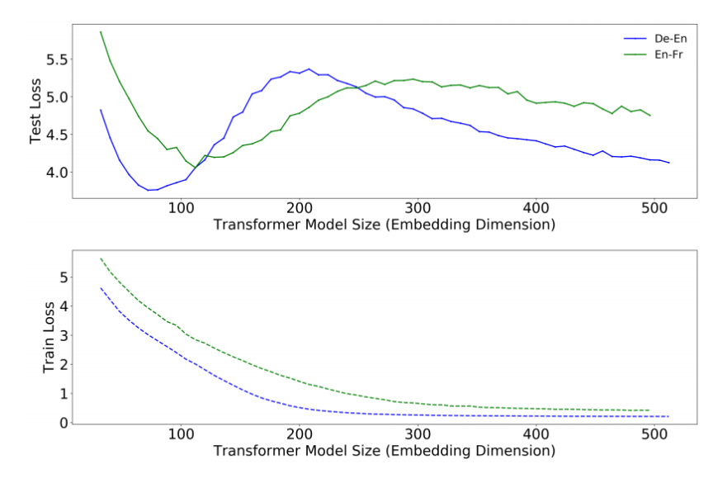

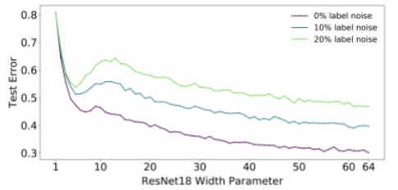Figure b:

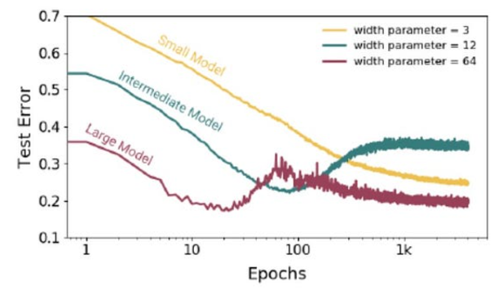Figure c: