  - Draft 2

AWS for Database Administrators
  - From On-Premises to Cloud
Sandeep S. Bajwa
Bajwa Consulting
bajwaconsulting.com
First edition

Publication information
Copyright © 2026 Sandeep S. Bajwa. All rights reserved.
AWS for Database Administrators: From On-Premises to Cloud
First edition
Author: Sandeep S. Bajwa
Bajwa Consulting
bajwaconsulting.com
This is an independently authored publication. It is not affiliated with, sponsored by, or endorsed by Amazon Web Services. Product and company names belong to their respective owners and are used to identify the technologies discussed.
The explanations and examples in this book are intended for learning and professional development. AWS services, interfaces, availability, pricing, and database features change over time. Consult current vendor documentation before applying an example to your environment.
Use a separate lab environment for the exercises. Review commands, permissions, network settings, and resource names before execution. Some operations modify or delete resources. Protect your data with suitable backups and recovery procedures before making changes.
Creating cloud resources can incur charges. Monitor lab spending and remove resources when exercises are complete, including resources that remain after an instance or database is deleted. Never publish passwords, access keys, customer data, or other confidential information in scripts or example files.

Preface
I wrote this book for database administrators who know how to keep databases running and want to apply that experience to Amazon Web Services. The goal is to connect familiar responsibilities—backup and recovery, performance tuning, security, availability, and capacity planning—with the choices and tools used in AWS.
My perspective comes from more than 20 years of working with enterprise database environments, particularly Oracle. Over that time, I have seen how much dependable database operations rely on preparation: understanding a workload, testing recovery, investigating performance with evidence, and documenting procedures that another administrator can follow.
Those habits remain valuable in the cloud. What changes is the operating model. A database on Amazon EC2 gives you substantial control over the operating system and database software. A managed service such as Amazon RDS changes the division of responsibility between your team and AWS. Each choice affects maintenance, access, recovery, cost, and the tools available for troubleshooting.
For an experienced DBA, learning AWS therefore involves more than memorizing service names. It means asking familiar questions in a different environment. Who manages the operating system? How is a backup restored? What happens when a database fails? Which settings can I change? How do I investigate a slow query when host access is limited? How much does a design cost to operate?
This book follows those questions through practical explanations, architecture examples, and exercises. Five parts cover foundations, relational databases on AWS, migration, cloud operations, and modern practices. It examines database service selection, Amazon RDS and Aurora, migration planning and execution, recovery, performance, security, cost, and automation.
Oracle examples provide a familiar starting point, while PostgreSQL and MySQL broaden the discussion. AWS CLI commands and Terraform examples help readers turn concepts into repeatable actions. The exercises are intended to build judgment as well as familiarity with the tools.
You do not need to abandon your existing expertise to become effective in AWS. You need to understand where that expertise applies, where the platform changes your responsibilities, and which assumptions deserve a fresh test. I hope this book helps you make that transition with confidence and a practical plan for continued learning.
Sandeep S. Bajwa
Bajwa Consulting

Acknowledgments
My understanding of database administration has grown through years of working with colleagues, learning from other professionals, and solving problems together. I am grateful to the database administrators, developers, infrastructure engineers, and mentors whose questions and experience have helped me become a better practitioner.
I also appreciate the people who maintain technical documentation, contribute to open-source projects, and share useful explanations with the wider technology community. Their work makes it possible for professionals to keep learning as platforms and tools evolve.
To my family, thank you for your encouragement, patience, and support throughout my career and the work of preparing this book.
Finally, thank you to the readers. Your willingness to develop new skills gives this book its purpose. I hope its explanations and exercises help you bring your experience to cloud database work and build confidence through practice.

About the author
Sandeep S. Bajwa is an Oracle Certified Professional and database administrator and engineer with more than 20 years of experience in enterprise database environments. His background includes Oracle Database administration, performance tuning, backup and recovery, high availability, disaster recovery, database security, and Oracle Enterprise Manager administration.
His experience includes Oracle Recovery Manager, Data Guard, and Oracle GoldenGate. His technical interests extend to AWS, PostgreSQL, MySQL, database migration, Terraform, Ansible, and data engineering.
Through Bajwa Consulting, he focuses on Oracle database technologies, cloud, and data engineering. This book connects established database administration practices with the skills required to operate databases in AWS.

Who should read this book
This book is for database administrators and engineers moving from on-premises environments into AWS. It is particularly useful for Oracle DBAs who want a practical starting point for cloud database operations, and for PostgreSQL or MySQL administrators learning the AWS operating model.
Infrastructure engineers, migration specialists, and technical leads may also find it useful when planning database deployments or working with a cloud operations team. Readers preparing for interviews can use the examples to practice explaining design decisions and operational tradeoffs.

Prerequisites
You should understand basic relational database concepts, SQL, database users and privileges, backup and recovery, and the purpose of high availability and disaster recovery. Basic Linux command-line skills and an understanding of IP addresses, ports, and network connectivity will help with the exercises.
Prior AWS experience is helpful but not required. The book introduces the foundations needed for database work. It assumes you are willing to use a lab account, inspect documentation, and test procedures rather than treating an example as a production runbook.

What you will learn
You will learn to evaluate databases on EC2 and managed database services; plan migrations; design backup, recovery, and availability arrangements; investigate performance; apply access controls; and use automation to make deployments repeatable. The aim is to help you explain why a design fits a workload and demonstrate how you would operate it.
The book provides a practical foundation across 16 chapters, supported by a terminology map, migration checklist, and further resources. Production designs still require workload testing, an understanding of business requirements, and review of current service capabilities and licensing terms.

How to use this book
If you are new to AWS, read the foundational material first and then work through the deployment and operations chapters in sequence. Keep a record of what you create, which settings you change, and how you verify each result.
If you already administer AWS databases, use the migration, performance, recovery, security, and automation material to address specific gaps. Read the prerequisites for each exercise before starting; later examples may depend on resources or concepts introduced earlier.
For interview preparation, practice explaining the choices behind each example. Describe the workload, failure scenario, recovery objective, security requirement, and cost implication. An explanation grounded in an exercise is more useful than a memorized service definition.

Working through the exercises
Use a dedicated lab account or isolated environment with synthetic data. Before starting, identify the resources an exercise creates and how to remove them. Set a spending budget, review permissions, and choose the AWS Region deliberately.
After each exercise, verify the outcome. For a backup exercise, perform a restore and check the restored data. For a migration, reconcile the source and target. For an availability exercise, observe application connectivity and recovery behavior. Record what happened and compare it with your expectations.
Adapt names, addresses, paths, and resource sizes to your environment. Preserve the purpose of each setting and understand the effect of changing it. Remove lab resources when you finish and check for retained storage, snapshots, and other chargeable resources.

Technical conventions
Code examples use monospaced text. SQL statements are shown separately from shell commands. Commands identify their intended context, such as a Linux shell, AWS CLI, SQL client, or Terraform working directory.
Values in angle brackets, such as <DB_INSTANCE_IDENTIFIER>, are placeholders. Replace them with your own values and remove the brackets unless the example explicitly instructs otherwise. Example credentials are illustrative; use an appropriate secret-management method in real deployments.
Example output may be shortened for readability. Your output can differ because of software versions, Region, account settings, or resource configuration. Notes explain relevant context; cautions identify steps that can affect data, access, availability, or cost.
Recovery point objective (RPO) describes acceptable data loss measured in time. Recovery time objective (RTO) describes the target time to restore service. These terms recur throughout the availability and recovery discussions.
Table of contents
Publication information 2
Preface 3
Acknowledgments 4
About the author 5
Who should read this book 6
How to use this book 7
Technical conventions 8
Introduction 10
Chapter 1: The DBA Role in the Cloud 14
Chapter 2: AWS Core Concepts and Networking 20
Chapter 3: Choosing a Database Service 27
Chapter 4: Amazon RDS 33
Chapter 5: Amazon Aurora 40
Chapter 6: High Availability and Disaster Recovery 47
Chapter 7: Assessment and Planning 55
Chapter 8: Schema Conversion and DMS 62
Chapter 9: Native Tools and Hybrid Approaches 70
Chapter 10: Cutover Rollback and Validation 77
Chapter 11: Security 83
Chapter 12: Monitoring and Performance Tuning 89
Chapter 13: Backup Recovery Patching and Upgrades 95
Chapter 14: Cost Optimization 101
Chapter 15: Infrastructure as Code and Automation 107
Chapter 16: Beyond Relational and Your Career Path 114
Closing Section 120
Appendix A 121
Appendix B 123
Appendix C 127
Glossary 129
Index 134

Introduction

From the Data Center to the Cloud
For decades, database administrators have been responsible for one of the most critical components of enterprise information technology: the database. Whether supporting financial transactions, healthcare applications, manufacturing systems, or large-scale enterprise resource planning platforms, DBAs have ensured that data remains available, secure, consistent, and recoverable.
Traditionally, database administration meant managing infrastructure within corporate data centers. DBAs worked closely with system administrators, storage engineers, network teams, and application developers to install, configure, monitor, optimize, and protect database environments.
The responsibilities were substantial. A production DBA needed to understand operating systems, memory allocation, disk I/O, database architecture, backup and recovery, high availability, disaster recovery, security, and performance optimization.
Then cloud computing fundamentally changed the way organizations provision and operate technology.
Amazon Web Services (AWS) introduced a model in which computing resources, storage, networking, and managed database platforms could be provisioned on demand. Instead of purchasing physical servers and waiting weeks for infrastructure deployment, organizations could create database environments in minutes.
This transformation did not eliminate the need for database administrators. It changed how they work.

Why Database Administrators Must Understand AWS
Organizations adopt cloud platforms to improve agility, scalability, operational resilience, and infrastructure management. Many businesses continue to operate Oracle, SQL Server, PostgreSQL, MySQL, and other database technologies in their own data centers while gradually migrating selected workloads to AWS.
As a result, database professionals often work in hybrid environments where some databases remain on premises while others operate on Amazon EC2, Amazon RDS, Amazon Aurora, or other cloud services.
A traditional Oracle DBA might be familiar with Recovery Manager (RMAN), Automatic Storage Management (ASM), Oracle Real Application Clusters (RAC), Data Guard, Automatic Workload Repository (AWR), and SQL performance tuning. Those skills remain valuable.
However, AWS introduces additional concepts that DBAs must understand, including:
- AWS Regions and Availability Zones
- Virtual Private Clouds (VPCs), subnets, and security groups
- Identity and Access Management (IAM)
- Amazon Elastic Compute Cloud (EC2)
- Amazon Elastic Block Store (EBS)
- Amazon Relational Database Service (RDS)
- Amazon Aurora
- Amazon DynamoDB and Amazon Redshift
- AWS Database Migration Service (DMS)
- Amazon CloudWatch
- Infrastructure as Code using Terraform
Understanding these services allows database administrators to participate in cloud architecture decisions, migration projects, cost optimization, and operational management.

What Changes in the Cloud and What Does Not
Moving a database to AWS does not automatically eliminate traditional database problems. Poorly written SQL statements can still consume excessive CPU resources. Missing indexes can still cause performance degradation. Long-running transactions can still create locking and blocking issues. Incorrect database configurations can still affect application availability.
Data corruption, accidental deletion, application errors, and security vulnerabilities also remain significant concerns.
What changes is the division of operational responsibilities. In a traditional data center, the organization typically manages the entire technology stack, including physical servers, storage, operating systems, database software, and applications. In AWS, responsibility depends on the selected service.
When running Oracle Database on Amazon EC2, the DBA and infrastructure team retain significant control over the operating system, database installation, patching, backup strategy, and database configuration. When using Amazon RDS for PostgreSQL, AWS manages more of the underlying infrastructure and routine database operations, allowing administrators to concentrate on logical database design, query optimization, security configuration, capacity planning, and application performance.
Understanding this shared responsibility model is essential for operating databases effectively in AWS.

Choosing the Right Database Platform
Not every database workload belongs on the same AWS service. An Oracle database requiring operating system access or features unavailable in a managed service may need a self-managed deployment on EC2.
A PostgreSQL application might benefit from Amazon RDS or Aurora, depending on its availability, scalability, compatibility, and cost requirements. A high-volume application requiring predictable key-value access might be suited to DynamoDB. An organization performing large-scale analytical queries across substantial historical datasets might consider Amazon Redshift.
Selecting the appropriate database platform requires understanding both application requirements and database architecture. This book explains these choices from the perspective of a practicing DBA.

Database Migration Is More Than Moving Data
Migrating a database from an on-premises environment to AWS involves considerably more than copying tables from one server to another. A successful migration requires careful evaluation of database dependencies, application connectivity, compatibility, security, performance, downtime tolerance, and recovery requirements.
Consider an organization running an Oracle production database in its own data center. Before migrating the workload to AWS, the team must answer several questions:
- Should the database continue running Oracle on EC2, or should the organization consider converting it to PostgreSQL?
- How much downtime can the business tolerate?
- Can AWS Database Migration Service support the migration requirements?
- Should native Oracle utilities, backup and recovery procedures, or replication technologies be used?
- How will the team validate the migrated data?
- What happens if the migration fails?
- How will backup, monitoring, security, and disaster recovery operate after migration?
These questions demonstrate why experienced database administrators remain essential to cloud transformation projects. Throughout this book, migration is treated as an engineering process involving planning, execution, validation, and operational readiness.

Infrastructure as Code and Automation
Cloud environments encourage automation. Tasks that previously required manual infrastructure provisioning can be performed using repeatable templates and scripts.
Terraform allows engineers to define AWS resources such as VPCs, subnets, security groups, EC2 instances, and storage volumes using configuration files. For DBAs, Infrastructure as Code provides opportunities to standardize environments, reduce configuration inconsistencies, and accelerate database deployment.
Automation also introduces responsibilities involving access control, change management, state management, and cost governance. This book introduces practical automation concepts and demonstrates how database professionals can use Terraform and AWS tools to build reproducible environments.

Who Should Read This Book
This book is intended for Oracle, SQL Server, PostgreSQL, and MySQL database administrators moving into AWS; experienced DBAs seeking to modernize their skills; database engineers supporting hybrid environments; and IT professionals involved in database migration projects.
Cloud engineers who need a stronger understanding of database operations and technical professionals preparing for AWS-related database roles and interviews will also benefit.
Readers should have a basic understanding of relational databases, SQL, and general computing concepts. Prior AWS experience is helpful but not required.

How This Book Is Organized
The book begins with AWS fundamentals and explains the networking, security, compute, and storage concepts necessary for database administration. It then examines relational database services, high availability, disaster recovery, and database architecture decisions.
The migration chapters explore assessment, planning, AWS Database Migration Service, schema conversion, native migration utilities, and hybrid approaches. Later chapters focus on monitoring, performance optimization, security, backup and recovery, automation, and cost management.
Practical examples and an end-to-end laboratory exercise help connect the concepts to real database administration activities. Readers who are new to AWS should work through the chapters sequentially. Experienced DBAs may prefer to begin with the topics most relevant to their current projects.

A New Chapter in the DBA Profession
The evolution from traditional data centers to cloud infrastructure represents an important transition in database administration. The technologies are changing, but the underlying responsibility remains the same: protecting business data and ensuring that database systems are reliable, secure, efficient, and recoverable.
A successful cloud DBA combines traditional database engineering knowledge with an understanding of cloud infrastructure, automation, managed services, security, and cost management. The objective of this book is to help database professionals make that transition confidently.
By the final chapter, readers should understand how to evaluate, migrate, deploy, monitor, troubleshoot, and manage database workloads in the cloud. The journey from the data center to AWS builds on years of database experience and applies it to a new generation of infrastructure.
Welcome to AWS for Database Administrators.

Chapter 1: The DBA Role in the Cloud
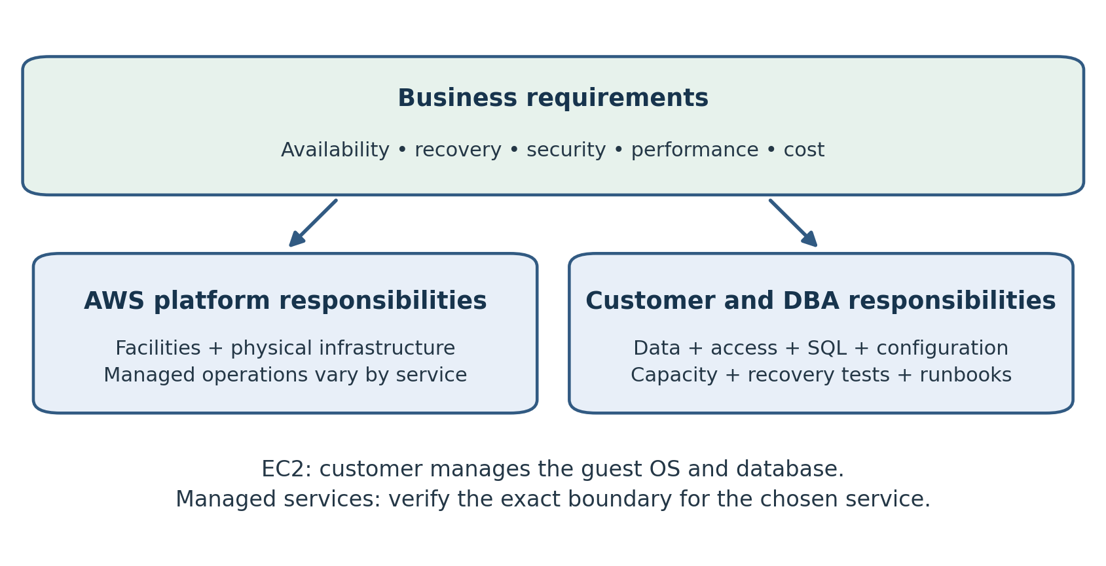
Figure 1.1. Business requirements drive shared responsibility. The service boundary changes, while the customer retains ownership of data, access and recovery outcomes.
A database service can automate maintenance without taking ownership of the business outcome. Someone must still decide whether the database is recoverable, whether an application can survive a failure, and whether the environment protects sensitive information. Those decisions form the core of the cloud DBA role.
This chapter explains how to divide responsibilities when a database moves to AWS. It also shows how to turn familiar DBA practices into an operating model with clear ownership, measurable requirements, and tested procedures. By the end, you should be able to review a proposed cloud database deployment and identify the work that remains with your team.

From the Field: From Months to Days
When I started as a DBA, a new database didn't begin with a database. It began with a long queue.
First came the data model and the business plan. What would the application store? How many users would it have this year, and in three years? From those answers we built a capacity plan: how many CPUs, how much memory, how much disk, and how fast that disk had to be. We had to get it right, because whatever we ordered was what we would live with for years.
Then came procurement. Quotes went to vendors, purchase requests went up for approval, and the team waited for hardware. When it arrived, the operating system had to be installed and configured before I could install the database software.
And that was just one environment. We needed development, testing and production, each with its own hardware or its own slice of shared hardware. Disaster recovery meant a second set of equipment at a second site, with its own procurement, its own network links and its own Data Guard configuration. From the first conversation to a production-ready database, the process took weeks at best and often months.
The worst part was the cost of being wrong. If the capacity plan underestimated growth, the fix was another purchase order and another wait. If it overestimated, expensive hardware sat idle for years.
Today the same project looks very different. The data model and business requirements still come first, and they should. That thinking hasn't gone away. But once the design is agreed, the rest happens in days.
 | On premises | AWS
Hardware | Quote, approval, purchase, delivery, racking | Choose an instance class
Capacity mistake | New purchase order and another wait | Modify the instance or storage
Dev, test, production | Separate builds, often separate hardware | Same code, different parameters
Disaster recovery | Second site, second purchase, separate setup | Configuration: Multi-AZ, backups, cross-Region copies
Time to production | Weeks to months | Days
A Terraform module or CloudFormation template defines database resources, including network placement, encryption, backups, and monitoring. Development, test, and production can use the same reviewed code with different parameters. Test data still needs appropriate masking. High availability and cross-Region disaster recovery require a complete design and tested procedures.
Capacity planning still matters, but a wrong guess is no longer a multi-year commitment. If production needs more memory, I change the instance class in a maintenance window. If storage grows faster than expected, autoscaling or a modification handles it. I can start with a sensible estimate, measure real usage, and adjust.
The cloud reduced the waiting. More of the DBA's time can go into understanding the workload, designing for recovery, and checking that the database meets business requirements.
Modern practice: define environments with reviewed infrastructure code, then choose capacity from workload evidence. High availability and cross-Region recovery still require explicit configuration, testing, and a cost plan. Chapter 15 covers repeatable provisioning; Chapters 6 and 14 cover recovery and cost.

Begin with the Business Requirement
The first question is not which instance to buy. It is what the database must deliver. A customer payment system, a development database, and a historical reporting warehouse have different consequences when they become unavailable. Their designs should reflect those differences.
Before selecting a service, record the workload's business owner, operating hours, peak periods, dependencies, data sensitivity, and expected growth. Ask how much data the organization can afford to lose and how long it can operate without the application. These answers become the recovery point objective, or RPO, and recovery time objective, or RTO.
An RPO of fifteen minutes means the recovery design must limit the acceptable loss of recent data to that interval. An RTO of one hour means the recovery process must restore the agreed business service within one hour. These are requirements to test, rather than promises obtained by selecting a checkbox.
For a payment application, restoring the database alone may not restore service. Identity systems, application servers, network connectivity, secrets, and external integrations may also need to recover. The DBA should participate in the application recovery plan so that the database procedure fits the larger sequence.
Write acceptance criteria in terms users understand. For example: the application must reconnect after a database failover, complete a test payment without duplicate processing, and reconcile transactions against an agreed control total. This gives the team a measurable definition of readiness.

Shared Responsibility in Practice
AWS describes its security model as shared responsibility. AWS protects the underlying cloud infrastructure; customer responsibilities vary with the service selected. On EC2, the customer manages the guest operating system and installed software. Managed services move more maintenance to AWS, while customers continue to control their data, access, and application configuration. [1]
For a DBA, the practical task is to translate that boundary into named owners. Avoid assigning a responsibility to the cloud in general. Record which team configures it, who approves changes, how failures are detected, and who responds.
An EC2-based database commonly requires your organization to coordinate operating system maintenance, engine installation, patches, monitoring, backups, and recovery. On RDS, AWS handles more routine platform work. Your team still chooses suitable settings and establishes the operating procedures around the service. The exact boundary must be checked for the selected engine and deployment. [2]
Consider a backup failure. Even if the platform performs the backup operation, your organization needs a person who verifies that recovery requirements are being met. That person must understand the retention policy, investigate alerts, and demonstrate restoration. A technical mechanism and an accountable owner are separate requirements.

A Practical Responsibility Matrix
Use the following matrix as a starting point for ordinary self-managed EC2 and standard RDS deployments. It is an operating guide, not an exhaustive contract; engine-specific features and service variants can change the boundary.
Activity | Database on EC2 | Standard Amazon RDS
Physical infrastructure | AWS | AWS
Guest operating system maintenance | Customer team | AWS platform operation
Database software maintenance | Customer team | Service-managed process with customer planning
SQL and index tuning | Customer team | Customer team
Database user privileges | Customer team | Customer team within service limits
Backup requirements and recovery tests | Customer team | Customer team
Availability architecture selection | Customer team | Customer team selects supported options
Application reconnect behavior | Customer team | Customer team
Budget and resource ownership | Customer team | Customer team
Treat a customer team as a named operational group, rather than a single person expected to perform every task. A platform engineer may maintain network controls, a security team may define identity policies, and the DBA may manage database privileges. All three must understand how their changes affect application access.

Skills That Transfer from the Data Center
SQL tuning remains a central skill. A slow statement still needs evidence: its execution plan, actual workload, row estimates, wait behavior, indexing, and recent changes. Moving the same inefficient query to a larger cloud instance may reduce the immediate symptom while increasing operating cost.
Backup and recovery experience also transfers. DBAs already understand that a completed backup is only one part of recoverability. A useful test checks whether the correct data can be restored, whether required access is available, and whether the application can use the recovered database.
Capacity planning becomes more continuous. In a data center, additional hardware might require a purchasing cycle. In AWS, a resource change may be easier to request, but it still needs a workload justification. More CPU does not resolve every bottleneck; storage latency, locking, poor plans, and connection pressure may remain.
An Oracle DBA should bring the discipline learned through RMAN, Data Guard, execution plans, and production incident management. The commands and diagnostic interfaces may change across services and engines. The habit of forming a hypothesis, collecting evidence, and validating a result remains useful.

New Boundaries to Learn
Cloud administration adds an important distinction between managing a service and logging into a database. Permission to modify an RDS resource through AWS does not automatically mean that a person has permission to select application tables. Conversely, a database administrator account does not necessarily have permission to modify the AWS resource.
Design these access paths separately. Use appropriate AWS identities for infrastructure operations and database roles for SQL access. Plan how humans and automation obtain credentials, how access is removed, and how emergency access is recorded. Avoid treating a powerful shared account as the normal operating model.
Connectivity requires similar attention. When an application cannot connect, the cause may be outside the engine. The DBA should help trace the path from the client through name resolution, network routes, security controls, and database authentication. Changing database passwords will not solve a missing network path.
Build a simple dependency inventory. Record the endpoint, application owner, approved client networks, credential source, and monitoring owner. This inventory helps diagnose failures and reduces the chance that a migration overlooks an overnight job or an external reporting tool.

Availability and Recoverability Need Separate Plans
High availability reduces disruption from certain infrastructure failures. Recovery procedures address situations such as accidental deletion, damaging application changes, or a larger outage. One design cannot be assumed to cover every failure.
RDS offers Multi-AZ deployment options for availability and failover. Backups and snapshots support recovery, and the appropriate disaster recovery strategy depends on the workload. A deployment that survives a local infrastructure failure does not by itself prove recovery from every scenario. [3]
Imagine an application mistakenly updates every customer's status. A standby may receive the same valid database changes. Switching to it does not necessarily undo the mistake. The recovery plan must identify how to obtain the earlier correct state and how to handle legitimate transactions that occurred afterward.
For each scenario, document a trigger, a decision owner, the recovery procedure, validation steps, and the return to normal service. Test with representative data. Measure elapsed time instead of relying only on estimates, and record any steps that depend on another team.
RDS provides automated backups and manual snapshots; their retention and usage need to fit your requirements. [4] The DBA's operating procedure should verify what is protected, where it can be recovered, and what happens when the source environment or required credentials are unavailable.

Change Management Still Matters
Fast provisioning makes experimentation easier, but production changes still require care. A parameter change, instance modification, access update, or application deployment can affect availability and performance. Review the effect before applying it.
For each change, record the reason, expected outcome, implementation steps, validation, and recovery approach. Check whether a service change is immediate, deferred, or requires a restart for the chosen setting. Schedule disruptive work around the application's needs.
Infrastructure as Code helps teams review resource definitions and reproduce approved configurations. It also requires disciplined review. A configuration file can request an unintended deletion or remove a security rule just as effectively as a console action.
Separate infrastructure rollback from data recovery. Returning a configuration file to an earlier version does not reverse transactions already committed to a database. Before approving a change, identify whether the recovery action involves configuration, application code, data restoration, or a combination.

Cost Becomes an Operational Signal
A cloud DBA should understand what causes the database bill to grow. Instance sizing is only one factor. Storage, retained copies, data movement, and supporting resources can also matter. Evaluate the actual service configuration and current pricing when estimating costs.
Establish a baseline for each environment and assign an owner. Use consistent resource tags, review idle development resources, and investigate unexplained growth. A budget alert should have a recipient and an action, not merely exist in an account.
Performance work can improve both response time and resource use. For example, correcting a repeated full scan may reduce pressure enough to avoid an unnecessary size increase. Validate the effect over representative workload periods; a quiet test does not prove that a smaller configuration will handle month-end processing.
For laboratories, write down cleanup steps before creating resources. Track dependent storage and backups as well as the main database or server. Confirm the remaining inventory after cleanup so that a learning exercise does not become an unattended recurring expense.

Example Moving an Order Database to AWS
Consider a hypothetical organization moving an on-premises Oracle order database to a self-managed Oracle deployment on EC2. The application has a one-hour RTO and fifteen-minute RPO. The team chooses EC2 because its assessed requirements need the control of a self-managed environment. This is an example, not a general recommendation for Oracle workloads.
Before migration, the DBA captures workload baselines, inventories jobs and integrations, and validates the backup procedure. The infrastructure team designs connectivity and compute resources. The security team reviews identities and access. Together, they assign owners for patching, monitoring, recovery, and cost.
The team then rehearses migration with representative data. It measures transfer and recovery time, checks application connections, and reconciles critical tables. It also defines the last safe point for abandoning cutover and returning to the original environment.
After migration, slow order processing appears during the first busy period. The DBA compares the new workload with the baseline instead of immediately increasing the instance size. The investigation considers execution plans, database waits, storage behavior, and network latency. A corrective change is tested and its effect measured.
Finally, the team performs a recovery exercise. A restored database is useful only when the application can connect, required jobs can run, and business checks pass. If the exercise exceeds one hour, the design has not met the RTO even though backup jobs completed successfully.

Establish the First Operating Runbook
Start with a small runbook that a second engineer can follow. Include the database purpose, service and engine, owners, endpoints, access process, monitoring, maintenance schedule, recovery requirements, backup policy, and escalation contacts.
Add procedures for the incidents most likely to occur: failed connections, storage pressure, blocking, slow queries, backup alerts, and failover. Each procedure should begin with evidence to collect and include criteria for escalation. Avoid unexplained commands copied from a different engine or deployment.
Review the runbook after rehearsals and incidents. If responders needed undocumented knowledge, add it. If a step could cause data loss or disrupt service, explain its preconditions and identify the decision owner. An operational document should make action easier without encouraging blind execution.

Review Questions
1. Which responsibilities remain with your organization when using a managed database service?
2. Why must database privileges and AWS infrastructure permissions be reviewed separately?
3. How can an availability design still fail to recover from an accidental mass update?
4. What evidence would you collect before increasing a slow database's instance size?
5. Why might a successful database restore still fail the application's RTO?
Suggested answers: Your organization still owns business requirements, appropriate configuration, access, application behavior, tuning, and recovery validation. Infrastructure permissions and SQL permissions control different operations. Replication can carry an unwanted but valid update to another copy. Performance investigation should examine workload, plans, waits, capacity, and recent changes. Application recovery also depends on connectivity, credentials, integrations, and business validation.

Practical Exercise
Choose one database you support, or use a laboratory database. Write a one-page operating profile with its business purpose, dependencies, RPO, RTO, backup approach, and current owners. Then create two responsibility columns: self-managed on EC2 and standard RDS. Identify which tasks move to the service and which require an accountable person in your organization.
Finish by selecting one recovery scenario and writing the evidence needed to prove success. This operating profile will provide context for Chapter 2, which introduces AWS networking and core infrastructure concepts.

References
[1] AWS Shared Responsibility Model. https://aws.amazon.com/compliance/shared-responsibility-model/
[2] What is Amazon RDS and Security in Amazon RDS. https://docs.aws.amazon.com/AmazonRDS/latest/UserGuide/ and https://docs.aws.amazon.com/AmazonRDS/latest/UserGuide/UsingWithRDS.html
[3] Resilience in Amazon RDS. https://docs.aws.amazon.com/AmazonRDS/latest/UserGuide/disaster-recovery-resiliency.html
[4] Introduction to backups. https://docs.aws.amazon.com/AmazonRDS/latest/UserGuide/USER_WorkingWithAutomatedBackups.html

Chapter 2: AWS Core Concepts and Networking
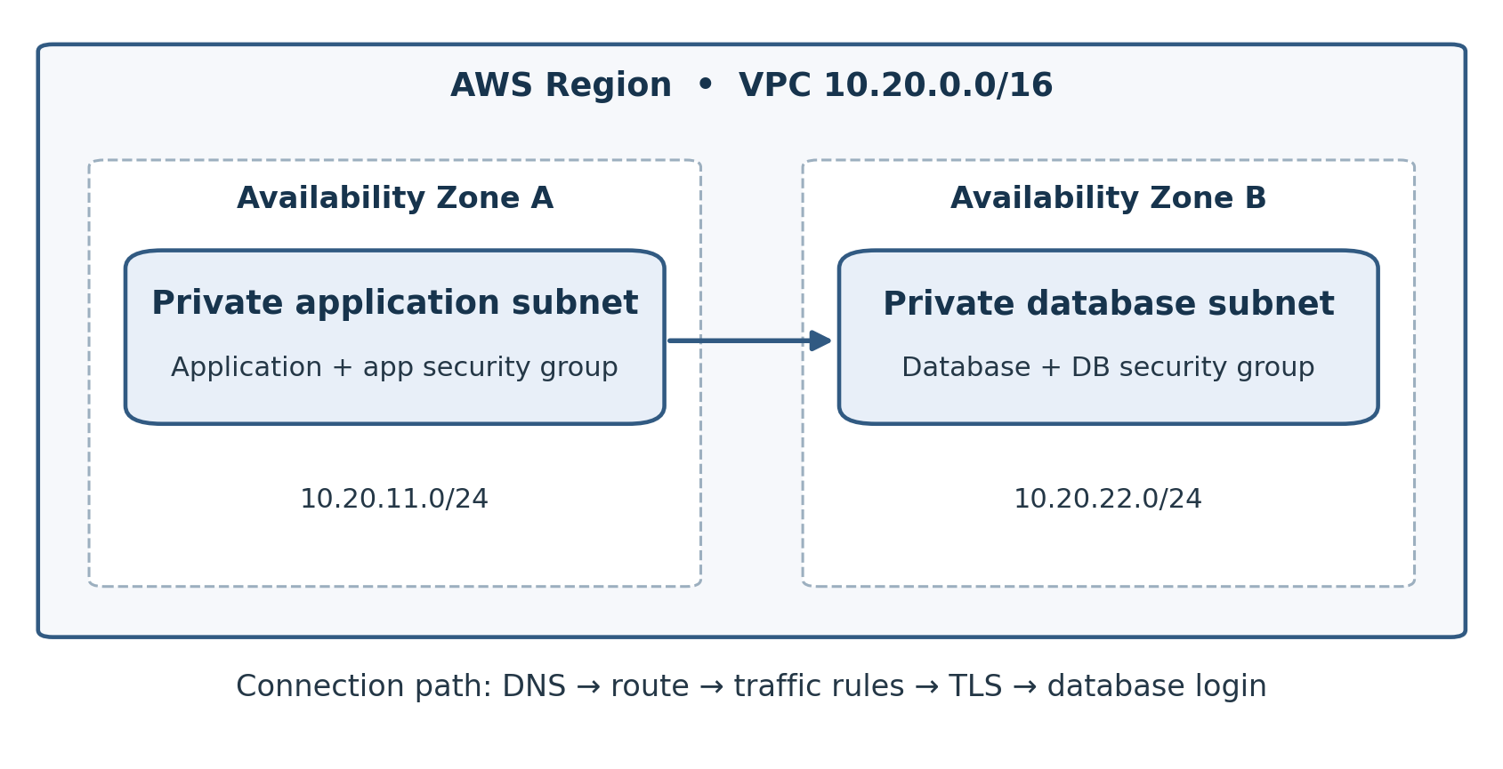
Figure 2.1. Example private application and database tiers in two Availability Zones. The database security group allows the required port from the application security group. This diagram does not show a high availability deployment.
A database can be healthy and still be unreachable. In AWS, successful connectivity depends on several layers working together: the selected Region, the network layout, routing, traffic controls, name resolution, and authentication. Understanding those layers helps a DBA distinguish a database failure from an infrastructure problem.
This chapter introduces the AWS concepts needed to plan a database environment and investigate connection failures. The examples use a small private network with application and database tiers. They are design examples, not instructions to expose a production database or create chargeable resources.

Accounts and Resource Ownership
An AWS account provides an administrative boundary for resources, permissions, and billing. Before creating a database, confirm which account owns the environment and how people obtain access. A personal learning account and an organization's production account require different operating procedures.
Keep development, testing, and production responsibilities clear. Separate accounts can help establish stronger boundaries, but account separation does not replace access policies, recovery planning, or review. Record the account identifier, environment name, resource owner, and escalation path in the database inventory.
When investigating a missing resource, first check the selected account and Region. A database that appears absent may simply be outside the console's current scope. The same check applies to command-line work: identify the active credentials and Region before running commands that change infrastructure.
Tags provide another useful organizational layer. Establish labels for environment, application, owner, and cost center. Agree on their meaning and apply them consistently. Tags are useful for inventory and cost reporting, but do not assume that a label enforces an access restriction unless the organization's policies explicitly use it.

Regions and Availability Zones
An AWS Region is a geographic area containing multiple Availability Zones. An Availability Zone consists of one or more data centers with independent supporting infrastructure. AWS resources deployed across zones can reduce exposure to the failure of a single zone. [1]
Choose a Region based on application location, organizational requirements, connectivity, service availability, and the recovery design. The geographically closest Region is a candidate, not an automatic answer. A workload may depend on a feature unavailable there or on a private connection to another location.
An Availability Zone is not another Region. Placing resources in two zones within one Region addresses a different failure scope from maintaining a recovery environment in a second Region. Write the intended failure scenario alongside the architecture so that a diagram does not imply protection the design has never tested.
For a database migration, baseline latency from the application to the database. If the application remains in a data center while the database moves to AWS, repeated network round trips can affect response time. A small individual delay may become significant when a transaction makes hundreds of sequential calls.

The Virtual Private Cloud
Amazon Virtual Private Cloud, or VPC, defines a logical network for AWS resources. Within it, you create subnets, configure routes, and establish traffic controls. A VPC is associated with a Region, while an individual subnet belongs to one Availability Zone. [2]
Treat VPC planning as part of database planning. A DBA may not own the network design, but should understand where the database resides and which application networks must reach it. Include administrative access, monitoring, replication, backup destinations, and migration tools in that review.
Use private addressing that fits the organization's network plan. In this chapter, the illustrative VPC is 10.20.0.0/16. It contains enough address space for several subnet ranges, including 10.20.1.0/24 and 10.20.2.0/24. These values are examples; check for conflicts before adopting them.
Overlapping address ranges can complicate private connectivity between environments. If both an on-premises network and a VPC use the same range, ordinary routing cannot reliably identify which location owns an address. Resolve address planning with the network team before migration rather than during cutover.

Understanding CIDR Notation
Classless Inter-Domain Routing, or CIDR, describes an address block using a network address and a prefix length. In IPv4, the prefix identifies how many of the address's 32 bits define the network. A longer prefix leaves fewer bits for addresses within the block.
A /24 IPv4 range contains 256 total addresses. A /16 contains 65,536 total addresses. These are mathematical block sizes, not counts of addresses available to applications: AWS reserves addresses in ordinary IPv4 subnets, and resources may consume more than one address. [2]
For a DBA, the practical implication is capacity. Subnets must have room for the intended deployment, replacement resources, scaling, and maintenance operations. A network that accommodates today's primary server may still be too small for tomorrow's standby or migration rehearsal.
Keep the address plan readable. Record each subnet's range, zone, purpose, and route table. Avoid assigning a range based only on what is currently free without considering future connectivity and growth.

Public Private and Isolated Subnets
A subnet is considered public when its route table provides a route to an internet gateway. That route alone does not make every resource reachable from the internet. IPv4 connectivity also depends on the resource's addressing and traffic controls. [3]
A private subnet does not have a direct internet gateway route. It may still reach external destinations through an approved outbound path, such as a NAT device. An isolated subnet has no route to destinations outside the intended private network. Terminology should be tied to actual route tables rather than subnet names.
A typical database design places database resources in private subnets. Applications reach them through approved private paths. Administrators use a controlled access method instead of making the database publicly reachable simply to connect from a laptop.
The following sample layout separates internet-facing entry points, application resources, and databases across two zones. It is an illustrative address plan, not a complete highly available deployment.
Subnet purpose | Availability Zone A | Availability Zone B
Public entry tier | 10.20.1.0/24 | 10.20.2.0/24
Private application tier | 10.20.11.0/24 | 10.20.12.0/24
Private database tier | 10.20.21.0/24 | 10.20.22.0/24
Creating two database subnets does not create database replication or failover. Those are separate deployment choices. Subnet placement provides locations in which the selected database architecture can operate.

Route Tables and Gateways
A route table maps destination address ranges to targets. Each subnet is associated with a route table, either explicitly or through the VPC's main route table. Routing determines where traffic is sent; it does not grant database access. [4]
For example, an internet-bound IPv4 route often uses 0.0.0.0/0 as the destination. A public subnet may send that destination to an internet gateway. A private subnet with outbound internet access may instead use a NAT device. More specific routes can direct traffic to other approved networks or service endpoints. [4]
When troubleshooting, inspect the route table associated with the actual subnet. A table with the right name is irrelevant if it is not associated with the resource's subnet. Also review the return path: a request reaching its destination does not prove that the response can reach the client.
Distinguish an internet gateway from a NAT gateway. The former provides the VPC's internet connection for appropriately addressed resources. A public NAT gateway is commonly used to let private IPv4 resources initiate outbound internet connections without accepting unsolicited inbound connections through that translation path. [5]
A private database does not automatically need outbound internet access. Determine which destinations are required, then choose an approved path. This can reduce unnecessary exposure and avoid adding infrastructure without a workload requirement.

Security Groups and Network ACLs
Security groups and network access control lists, or network ACLs, filter traffic at different boundaries. Security groups apply to associated resources or network interfaces and are stateful. Network ACLs apply at the subnet boundary and are stateless. [6]
Stateful filtering means that response traffic for an allowed connection is tracked. Stateless filtering requires the relevant inbound and outbound traffic to be allowed separately. A restrictive network ACL can therefore block a connection whose security group rules appear correct.
Characteristic | Security group | Network ACL
Common boundary | Associated resource or interface | Subnet
Connection tracking | Stateful | Stateless
Rule action | Allow rules | Allow and deny rules
Evaluation model | Applicable allow rules combine | Numbered rules evaluated in order
For an illustrative PostgreSQL application, the database security group might allow TCP port 5432 from the application's security group where that reference is supported. Oracle commonly uses listener port 1521 and MySQL commonly uses 3306, but confirm the configured port instead of assuming the default.
Use the narrowest approved source and port for the workload. Do not interpret a network allow rule as SQL authorization: a client still needs valid credentials and privileges. Conversely, a valid database account cannot bypass blocked network traffic.

DNS and Database Endpoints
Applications generally connect using a database endpoint name. DNS resolves that name to an address. Treat DNS as a dependency, particularly during failover, migrations, and changes to private connectivity.
Use the service's documented endpoint rather than permanently hard-coding its current resolved address. An address can change as the deployment changes. Application connection pooling, DNS caching, and retry behavior should be tested together with failover procedures.
When resolution fails, distinguish a nonexistent name from an inaccessible resolver or a private name queried from the wrong network. Record which name the client uses and which resolver it asks. A successful lookup on a DBA's laptop does not prove that the application server obtains the same answer.
Name resolution is also separate from TLS validation. Where TLS is configured, the client must trust the appropriate certificate authority and validate the intended server identity. A connection test that bypasses validation is not proof that the application's secure configuration works.

IAM Users Roles and Policies
AWS Identity and Access Management, or IAM, controls actions against AWS resources. Policies describe permissions. Roles provide a way for trusted identities or workloads to obtain temporary credentials. AWS recommends federation and temporary credentials where appropriate, least privilege, and protection of root credentials. [7]
For example, an EC2-based backup process needing S3 access can use an instance role with the required permissions. This avoids embedding a permanent access key in the backup script. Role credentials still need appropriate policy scope; using a role does not automatically make broad permissions safe.
Separate everyday DBA work from exceptional infrastructure administration. Permission to view a database resource, modify it, or delete it should follow the team's responsibilities. Review who can change access controls and who can remove recovery copies as well as who can log into the engine.
The AWS console, CLI, and SDK are different interfaces to AWS operations. Choose the interface appropriate for the task, but apply the same identity and change controls. Before using an automated command, verify its target and review how credentials are obtained.

Connecting the Data Center to AWS
Hybrid migration requires a network path between source and target. AWS Site-to-Site VPN and AWS Direct Connect are common options, but they offer different connectivity models. A VPN uses encrypted IPsec tunnels; Direct Connect provides dedicated connectivity. Direct Connect does not by itself imply that all traffic is encrypted. [8]
Discuss bandwidth, latency, encryption, routing, resiliency, and lead time with the network team. A connection suitable for ordinary application traffic may be insufficient for a large initial data transfer. A migration rehearsal should measure sustained throughput, not just confirm that a tunnel is up.
Document both ends of the connection, approved address ranges, route ownership, and monitoring. Ask what happens if the primary path fails. A second database copy is less useful when the only path to it is unavailable.
For a small practice environment, use an approved administrative connection rather than opening database ports to the entire internet. Keep production and laboratory access policies distinct, and remove temporary access when its purpose ends.

Troubleshooting a Connection in Order
Suppose an application cannot connect to a private PostgreSQL database. Start by capturing the exact error, timestamp, client location, endpoint, and port. Determine whether the problem affects every client or only one application host.
Check name resolution from the affected host. Then test the intended network path and TCP port using an approved diagnostic method. If the port is unreachable, inspect routes, security groups, network ACLs, and the configured database endpoint. Compare the current configuration with the last known working state.
If TCP connectivity succeeds, investigate TLS, authentication, privileges, connection limits, and database status. A timeout, certificate error, authentication rejection, and SQL permission error point to different stages. Keep these distinctions visible in the incident record.
Avoid broad access changes as a first diagnostic step. Prefer a precise observation or a narrowly scoped, approved test. If a temporary rule is necessary, record its owner, purpose, and removal time, then confirm that it was removed.
Once service returns, test the application's normal path rather than only a manual login. Confirm that connection pools recover and an ordinary business transaction completes.

Practical Exercise and Review
Draw an address plan for one application and database using two zones. Identify the VPC range, each subnet, route table, database port, approved client source, and administrative access path. Do this on paper before provisioning resources.
Next, explain how a connection travels from the application to the database. Identify the DNS lookup, routing decisions, traffic controls, and authentication step. Add the expected symptom if each layer fails.
Review questions: Does a public subnet guarantee internet reachability? Does a private subnet mean no outbound connectivity? Can IAM permission to modify an RDS instance grant SQL access by itself? Why must a restrictive network ACL allow response traffic? How does a second Availability Zone differ from a second Region?
Suggested answers: Internet reachability depends on more than the subnet route. Private subnets can have approved outbound paths. Infrastructure and SQL permissions are separate. Network ACLs are stateless. Zones provide failure boundaries within a Region, while another Region provides a different geographic and operational scope.
In Chapter 3, this network foundation becomes part of a larger decision: selecting the database service that fits the workload and the team's operating responsibilities.

References
[1] AWS Networking Essentials. https://aws.amazon.com/getting-started/aws-networking-essentials/
[2] VPC basics and Subnets for your VPC. https://docs.aws.amazon.com/vpc/latest/userguide/vpc-subnet-basics.html and https://docs.aws.amazon.com/vpc/latest/userguide/configure-subnets.html
[3] Internet gateways. https://docs.aws.amazon.com/vpc/latest/userguide/VPC_Internet_Gateway.html
[4] Example routing options. https://docs.aws.amazon.com/vpc/latest/userguide/route-table-options.html
[5] NAT gateways. https://docs.aws.amazon.com/vpc/latest/userguide/vpc-nat-gateway.html
[6] Infrastructure security in Amazon VPC. https://docs.aws.amazon.com/vpc/latest/userguide/infrastructure-security.html
[7] Security best practices in IAM. https://docs.aws.amazon.com/IAM/latest/UserGuide/best-practices.html
[8] AWS Site-to-Site VPN and AWS Direct Connect documentation. https://docs.aws.amazon.com/vpn/latest/s2svpn/VPC_VPN.html and https://docs.aws.amazon.com/directconnect/latest/UserGuide/Welcome.html

Chapter 3: Choosing a Database Service
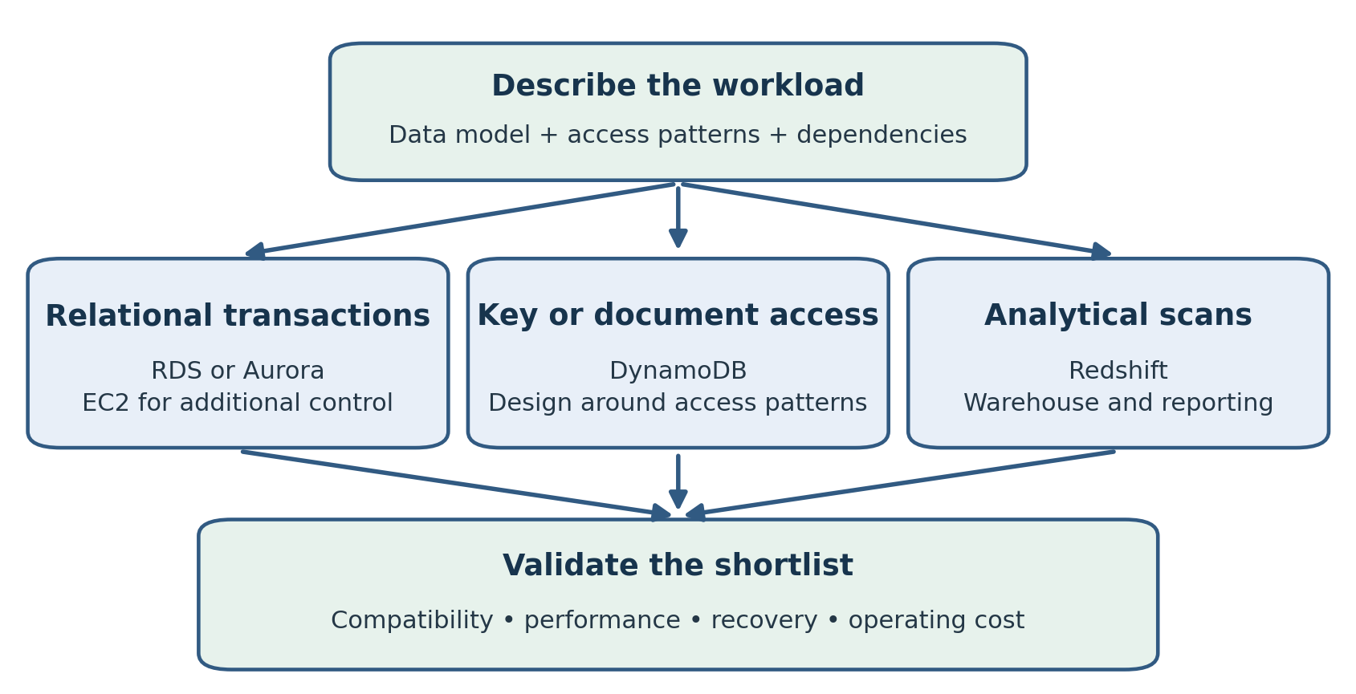
Figure 3.1. Workload needs create a service shortlist. RDS and Aurora require engine and feature compatibility; every candidate still needs a representative proof of concept.
Choosing a database service is a workload decision with operational consequences. The best candidate must support the application's data model, access patterns, recovery requirements, and dependencies. It must also fit the skills and capacity of the team that will operate it.
This chapter compares five common choices: self-managed databases on Amazon EC2, Amazon RDS, Amazon Aurora, Amazon DynamoDB, and Amazon Redshift. The goal is to create a defensible shortlist and a test plan. A product name alone cannot establish compatibility, performance, or cost.

From the Field: Chosen in the Boardroom, Fixed in the Server Room
I have seen the same project begin the same way more than once. A decision arrives from above: the old system is moving to the cloud, and the new platform has already been chosen. The choice is usually the one with the lowest price on a slide. The system being replaced is usually anything but simple.
Sometimes it was an Oracle database, built and tuned over many years, moving to PostgreSQL, SQL Server or something else because the licensing looked cheaper. Sometimes it was a whole ERP, such as Oracle E-Business Suite moving to SAP. Sometimes it was an on-premises data warehouse being replaced by a cloud data lake. The details changed. The pattern didn't.
The decision was made without the people who knew how the system actually worked. Nobody asked the DBAs which features the application depended on. Nobody asked how much custom code lived in the database, which jobs ran overnight, or what would happen when the single server everyone had priced went down.
Then the technical work began, and the problems surfaced one by one.
An Oracle-to-PostgreSQL move is not a copy. Oracle NUMBER columns have to be mapped one by one to the right target types. Oracle DATE carries a time component that a plain date column would lose. Oracle treats an empty string as NULL; PostgreSQL does not, so code that has worked for years starts behaving differently. Hundreds of PL/SQL packages, triggers and scheduled jobs need to be rewritten and tested, not just converted.
The cheapest configuration on the slide was often a single database instance with no standby. The old system had Data Guard and years of tested recovery procedures. The new one, as priced, had a single point of failure. Adding high availability, backups and a disaster recovery copy to match what the business already had changed the numbers significantly.
An ERP replacement is not a database migration at all. It is a business process change, with data conversion, custom reports and integrations that all need rebuilding. A data lake is not a warehouse with cheaper storage. Without careful modeling, governance and data quality work, it becomes a place where data goes and answers don't come out.
So the technical teams spent the following months in meetings and email threads. We explained why the timeline couldn't hold. We explained why the cost would rise once high availability, conversion effort, testing, and a period of running both systems in parallel were included. We explained it again to the next level of management, and again when the first estimate proved too optimistic. Much of that time went into defending reality rather than building the new system.
The lesson is not that cheaper platforms are bad choices. Many of these moves can be good decisions. The lesson is that a platform chosen before the workload is understood is a guess, and the technical team ends up paying for that guess in overtime, rework and lost trust.
Modern practice: assess engine compatibility before selecting a platform, compare complete operating costs, and test representative stored code, queries, and recovery. Chapter 8 covers conversion and DMS; Chapter 14 covers cost. ERP replacement and data-lake adoption also require business-process and governance planning.

Start with the Workload
Describe how the application uses data before discussing services. Does it perform many short transactions, repeatedly retrieve items by key, or scan large historical datasets? Does it require relational joins and constraints? Are query patterns predictable, or do analysts need to ask new questions every day?
Record transaction rates, concurrency, typical and largest query sizes, peak periods, growth, and latency requirements. Include background jobs and reporting activity. A system that appears lightly used during the day may perform its most demanding processing overnight.
Separate current measurements from future estimates. A capacity forecast should identify its assumptions, such as user growth, new reporting requirements, or longer data retention. This makes the forecast reviewable and helps explain why a proposed service needs headroom.
Also inventory engine-specific dependencies: stored procedures, extensions, jobs, data types, authentication methods, integration tools, and administrative requirements. An application that depends on operating system scripts or specialized engine features may require more control than a standard managed service provides.

Five Common Starting Points
AWS offers relational services, purpose-built nonrelational services, analytical databases, and the option to install database software on EC2. This chapter uses a small subset of that portfolio as a practical starting point. Other services may be appropriate when the workload requires a different model. [1]
Option | Typical candidate workload | Main question to test
Database on EC2 | Existing engine requiring extensive control | Can the team operate and recover the full stack?
Amazon RDS | Managed relational application | Are required engine features supported?
Amazon Aurora | MySQL or PostgreSQL compatible application | Does its architecture fit the workload and budget?
Amazon DynamoDB | Key-value or document access | Can the data model serve the required access patterns?
Amazon Redshift | Analytical warehouse | Can ingestion and query design meet reporting needs?
The rows are not mutually exclusive. An application may use a relational database for transactions and a warehouse for analytics. Every additional service introduces another set of data movement, security, monitoring, and recovery responsibilities.

Self Managed Databases on EC2
EC2 provides compute on which your organization can install and operate database software. This offers substantial control over the guest operating system and database configuration. It also retains substantial responsibility for installation, patching, backups, recovery, and availability engineering. [2]
Consider this option when a validated requirement needs operating system access, a specific software configuration, or a capability unavailable in the managed alternatives. Do not assume that familiarity with the current platform is enough justification; compare the operational burden and the available migration paths.
For an Oracle deployment, review licensing terms, software support, required options, and the proposed architecture with the appropriate owners. Moving an existing installation to a virtual server does not establish that its licensing or support assumptions remain valid. Obtain a current assessment for the actual configuration.
The evaluation should include storage behavior, backup destinations, patch procedures, monitoring, and recovery. Ask who responds when the engine starts successfully but the operating system, filesystem, or storage configuration is unhealthy. Self-managed control is useful only when the organization can maintain it.

Amazon RDS
Amazon RDS provides managed relational database deployments and supports multiple engines. AWS automates routine platform tasks, while customers still manage their application data, queries, access, and chosen configuration. Supported versions and features must be checked for the intended engine and Region. [3]
RDS is a useful candidate for an application that benefits from a familiar relational engine and reduced infrastructure maintenance. Evaluate the exact service restrictions rather than assuming that every on-premises administrative operation is available.
For example, an application may use standard SQL successfully while a DBA's maintenance tool depends on privileged access that the service restricts. Test both the application and the operational tooling. A migration that passes functional testing but cannot be monitored or recovered through approved procedures is incomplete.
Review availability options, backup retention, maintenance behavior, parameter settings, and integration requirements. Keep availability configuration separate from read scaling: different deployment options have different capabilities. Chapter 4 examines RDS operation in more detail.

Amazon Aurora
Aurora is a managed relational engine with MySQL-compatible and PostgreSQL-compatible editions. It uses a cluster architecture and a distributed storage design. Compatibility should be evaluated against the intended engine version and application dependencies. [4]
For selection purposes, compare Aurora with the relevant RDS engine rather than with every database in the portfolio. A PostgreSQL application may have both RDS for PostgreSQL and Aurora PostgreSQL as candidates, but each needs the same representative functional and performance tests.
Do not interpret compatibility as a guarantee that every extension, administrative feature, or operational assumption will transfer unchanged. Verify drivers, supported extensions, SQL behavior, maintenance tools, and application reconnect handling.
Aurora also offers provisioned and serverless configuration choices. [4] Assess the actual workload variation and current supported settings before choosing. The word serverless describes a service operating model; it does not establish that the workload is free, unlimited, or exempt from capacity and connection planning.
Chapter 5 examines Aurora architecture and operation. At this stage, the important result is a testable reason to include or exclude it from the shortlist.

Amazon DynamoDB
DynamoDB is a managed nonrelational database supporting key-value and document models. Its data design should begin with the application's access patterns rather than copying a relational schema table for table. [5]
Consider an application that retrieves a user's current preferences by user identifier. The request has a clear key and a predictable result. This is a different selection problem from an analyst repeatedly joining customers, products, invoices, and payments in new combinations.
Write the required requests before designing keys and indexes. Examples might include fetching an order by identifier, listing recent orders for a customer, or locating items needing action. Identify how each request will be served, how much data it returns, and how traffic is distributed.
A poor key design can concentrate activity or force inefficient access. A large item count does not automatically mean well-distributed traffic. Test the busiest customers, highly popular entities, and unusual query patterns rather than only average load.
DynamoDB supports transactions, but that does not make it a drop-in relational replacement. [6] Decide whether the application's model and access requirements justify redesign. If the existing application relies heavily on flexible joins and relational constraints, include rewrite effort and validation in the comparison.

Amazon Redshift
Redshift is an analytical data warehouse intended for large-scale reporting and analysis. Its columnar storage and parallel processing model differ from the design of a conventional transactional database. It offers provisioned and serverless deployment models. [7]
Consider Redshift when analysts aggregate substantial historical data across many records. Typical requirements include reporting across time, combining data from multiple operational sources, and serving business intelligence workloads.
Do not select it simply because it accepts SQL. SQL is an interface used by systems with different workload goals. Evaluate whether the application needs warehouse-style analysis or frequent small operational transactions.
A warehouse also requires an ingestion design. Identify the source systems, transformation rules, update cadence, deletion handling, and reconciliation process. If reports must be current within ten minutes, measure the entire ingestion path instead of only the warehouse query time.
Separate query performance from data correctness. A fast dashboard that reports duplicated transactions or omits late-arriving records has failed its business requirement.

Compare Total Operating Cost
Create a cost model for each shortlisted design using current pricing and realistic usage assumptions. Include compute or capacity, storage, backups, data movement, monitoring, supporting infrastructure, and operational effort. Review licensing separately where applicable.
Avoid comparing a single database instance price with a complete resilient architecture. Include the resources needed to meet the same requirements. Otherwise, an apparently cheaper option may simply provide less availability or recovery capability.
Use workload scenarios: ordinary operation, peak demand, growth, and recovery. Explain which costs vary with activity and which persist while the environment is idle. Serverless and managed options still require workload-specific estimates.
Operational effort matters even when it is not listed on the AWS invoice. A self-managed environment may consume more maintenance time, while a managed migration may require application or tooling changes. Include those effects without assigning invented savings.

Build a Representative Proof of Concept
A proof of concept should resolve uncertainty, not merely demonstrate that a database can be created. Select the workload's important transactions, representative data volumes, difficult SQL, integration paths, and operational procedures.
Measure response-time distributions, throughput, concurrency, and resource behavior. Test a realistic busy period. An average response time can hide a small number of slow requests that violate the application's needs.
Include restore and reconnect tests, access controls, monitoring, and maintenance rehearsal. Record failures and required changes. A candidate with excellent query performance may still be unsuitable if a critical extension is unavailable or its recovery procedure misses the RTO.
Define acceptance criteria before testing. This reduces the temptation to move the goalposts after a preferred service performs poorly. Preserve results and assumptions so that another engineer can repeat the comparison.

A Decision Example
Imagine an organization with a PostgreSQL order application and growing historical reporting. The application needs relational transactions and predictable operational latency. Analysts run broad historical queries that compete with order processing.
The team shortlists RDS for PostgreSQL and Aurora PostgreSQL for the transactional system. It evaluates compatibility, performance, recovery, and cost under the same requirements. It separately considers Redshift for historical analysis, including the effort to move and reconcile data.
DynamoDB is not automatically excluded from the organization, but it has no established advantage for this particular relational migration. EC2 remains an option if a tested requirement demands self-managed control. The decision follows the evidence rather than a preference for one service name.
The final record explains the chosen design, rejected alternatives, proof-of-concept results, outstanding risks, and review triggers. A new extension requirement or a major workload change may justify revisiting the decision later.

Practical Exercise and Review
Choose a database you know well. List its five most important access patterns, engine dependencies, RPO, RTO, growth assumptions, and operational tools. Select two candidate AWS designs and explain why each deserves testing.
Create an acceptance checklist covering compatibility, workload performance, access, backup restoration, failover or recovery, monitoring, and estimated operating cost. Identify one condition that would disqualify each candidate.
Review questions: Why is SQL support insufficient to prove workload suitability? When might EC2 be justified? What must be validated when choosing Aurora for a PostgreSQL application? Why does DynamoDB selection begin with access patterns? What must be measured besides query speed when evaluating a warehouse?
Suggested answers: Services accepting SQL can have different architecture and workload goals. EC2 may meet a requirement for control unavailable in managed alternatives. Aurora evaluation must include actual compatibility and operational behavior. DynamoDB keys and indexes must serve required requests. Warehouse evaluation must include ingestion timeliness, reconciliation, and report correctness.
With a justified shortlist, the next step is to understand the chosen service in depth. Chapter 4 begins with Amazon RDS and the decisions involved in building an operable relational database environment.

References
[1] Choosing an AWS database service. https://docs.aws.amazon.com/decision-guides/latest/decision-guides/databases-on-aws-how-to-choose.html
[2] AWS Shared Responsibility Model. https://aws.amazon.com/compliance/shared-responsibility-model/
[3] What is Amazon RDS. https://docs.aws.amazon.com/AmazonRDS/latest/UserGuide/
[4] What is Amazon Aurora and Aurora storage. https://docs.aws.amazon.com/AmazonRDS/latest/AuroraUserGuide/ and https://docs.aws.amazon.com/AmazonRDS/latest/AuroraUserGuide/Aurora.Overview.StorageReliability.html
[5] NoSQL design for DynamoDB. https://docs.aws.amazon.com/amazondynamodb/latest/developerguide/bp-general-nosql-design.html
[6] DynamoDB transactions. https://docs.aws.amazon.com/amazondynamodb/latest/developerguide/transactions.html
[7] Amazon Redshift system architecture. https://docs.aws.amazon.com/redshift/latest/dg/c_high_level_system_architecture.html

Chapter 4: Amazon RDS
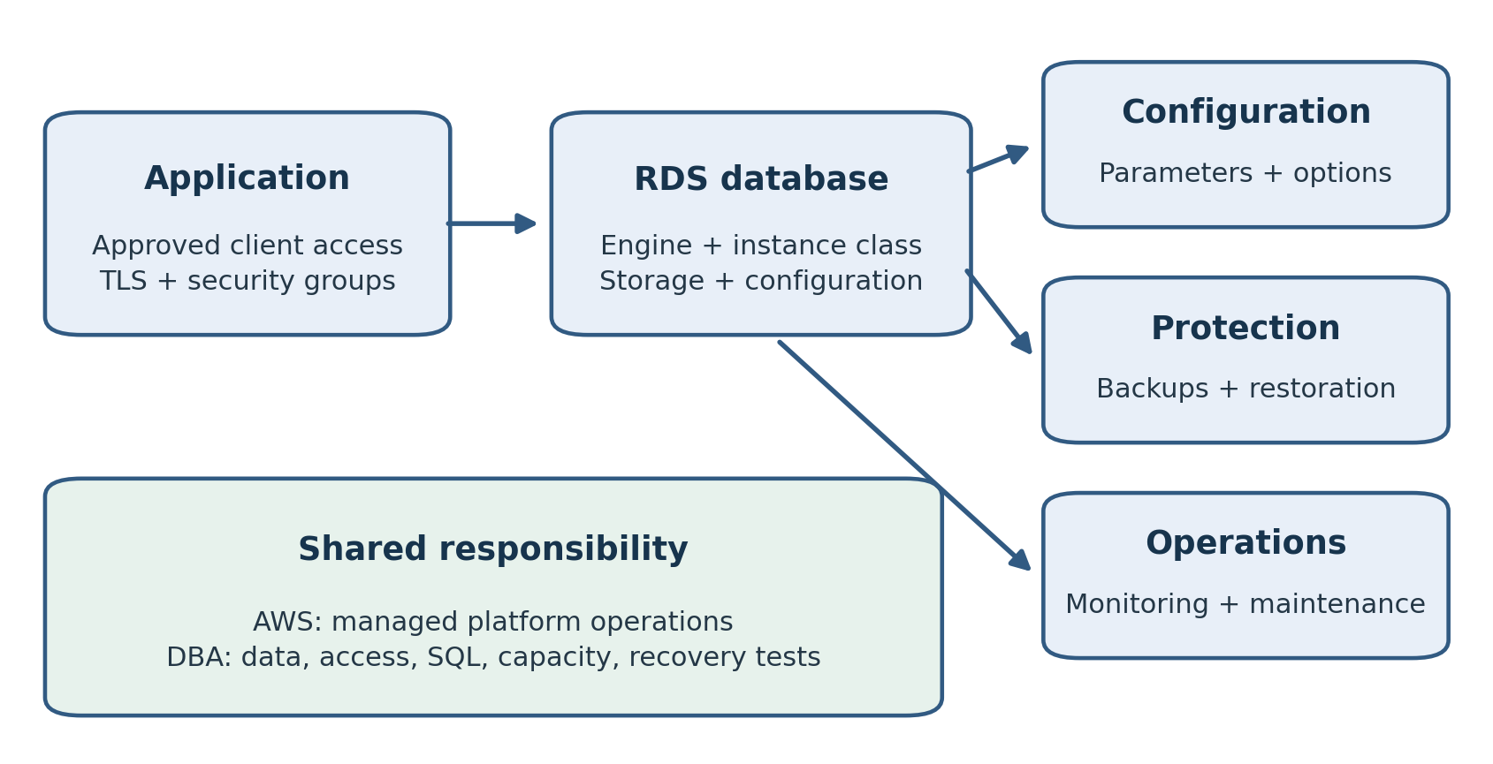
Figure 4.1. RDS deployment decisions and the shared operating responsibility between AWS and the DBA.
Amazon RDS changes how a relational database is operated, but it does not remove the need to understand the engine. A DBA still needs to size the workload, control access, tune SQL, plan changes, and prove that recovery works. The service automates parts of the platform while your organization remains accountable for the application's behavior.
This chapter explains the main decisions involved in an ordinary RDS deployment: engine selection, instance classes, storage, network placement, configuration, maintenance, backups, and operational readiness. It also identifies situations in which a self-managed database on EC2 may be a better candidate. Aurora is discussed separately in Chapter 5.
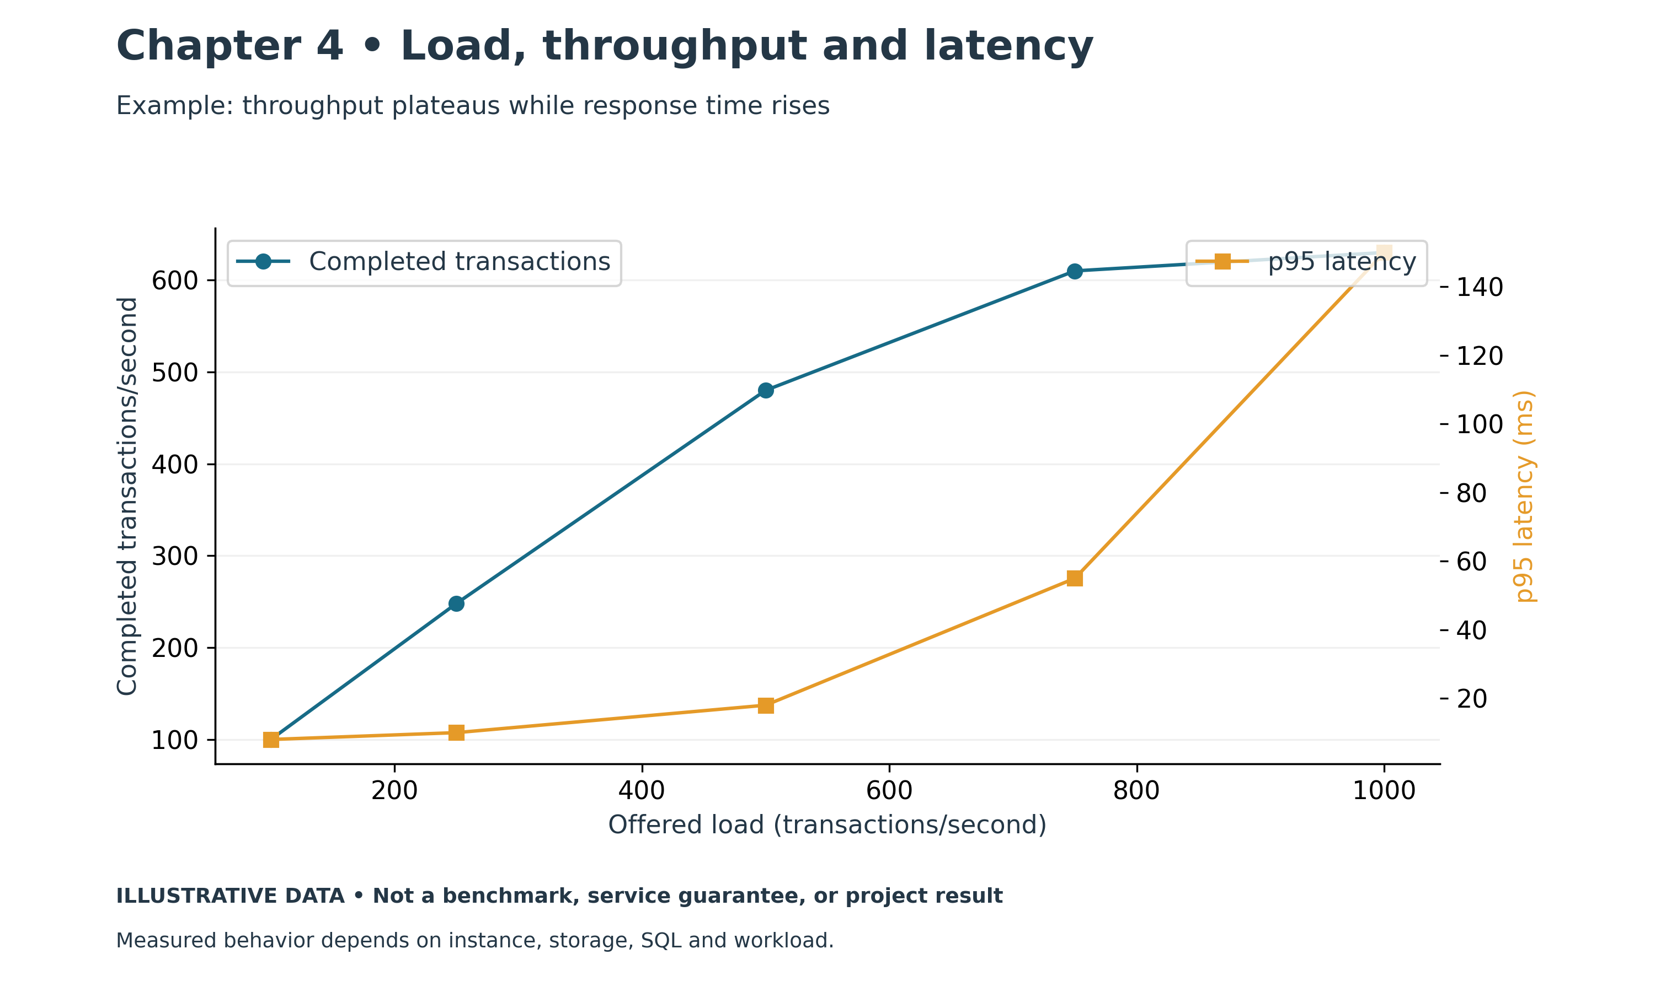
Figure 4.2. RDS load, throughput, and latency. Illustrative chart; values are examples, not measured production results.

Understand the Service Boundary
RDS is a managed relational database service supporting several database engines. It handles platform tasks such as provisioning, software maintenance, and supported backup operations. The precise capabilities depend on the engine, version, Region, and deployment type. [1]
For an experienced DBA, the most important adjustment is the administrative boundary. Standard RDS does not provide the same unrestricted operating system and engine access as a self-managed installation. Supported administrative procedures replace some familiar server-level operations.
Inventory the tools and scripts your team relies on. Check whether they require filesystem access, operating system utilities, privileged database roles, or unsupported plugins. Validate their equivalents before migration. A database that supports the application's SQL can still require substantial changes to the maintenance process.
Distinguish standard RDS from specialized service offerings such as RDS Custom. [2] Their control boundaries differ. This chapter's default discussion concerns standard RDS; never assume that a capability available in one offering exists in another.

Choose the Engine and Version
Start with the application's compatibility requirements. Record the current engine, major and minor version, character encoding, data types, procedures, extensions, scheduled jobs, and client drivers. Identify which dependencies are mandatory and which can be replaced.
Check the currently supported RDS engine versions in the intended Region. Availability and support timelines change, so treat version selection as a documented project decision rather than copying an old deployment guide. Review upgrade paths and the expected maintenance lifecycle alongside initial migration compatibility.
For an Oracle application, include edition, options, licensing arrangements, and service restrictions in the assessment. For PostgreSQL, examine supported extensions and privilege differences. For MySQL, test SQL modes, character sets, collation, and application behavior. Each engine deserves its own compatibility checklist.
Use representative tests that include operational dependencies. A batch job, integration process, or reporting client may expose a problem missed by a simple application login. Preserve the test results and the exact version used so that later changes can be evaluated against a known baseline.

Size the Instance Class from Evidence
An RDS instance class defines compute and memory characteristics, along with other resource limits. AWS offers different class families and sizes, with support varying by engine and Region. [3] Choose a class using measured workload needs rather than the number of tables or database size alone.
A large database with infrequent queries may require less compute than a smaller database with heavy concurrency. Memory needs depend on working data, connection behavior, sorts, caches, and the engine's architecture. CPU demand depends on SQL, transaction volume, background work, and peak periods.
Collect a baseline from the source environment. Include CPU use, memory pressure, database waits, connection counts, storage latency, throughput, and application response times. Capture business peaks rather than only a quiet period. Compare measurements with the capabilities of the proposed class.
Workload observation | Question to investigate before resizing
High CPU | Is the work legitimate load or inefficient SQL?
Memory pressure | Are connections and working data sized appropriately?
Slow reads or writes | Is the limit storage, instance throughput, or query behavior?
Intermittent spikes | Is demand bursty, scheduled, or tied to a specific job?
Low average use | Does a business peak still require the existing capacity?
If considering a burstable class, understand its CPU credit behavior and suitability for sustained demand. [3] A low-cost laboratory choice should not silently become a production standard. Test the expected busy period and observe whether the configuration remains stable.

Storage Capacity and Performance
Storage planning has two separate dimensions: how much data can be stored and how quickly the workload can access it. RDS storage offerings differ in capacity, performance characteristics, and pricing. Supported combinations depend on the deployment and engine. [4]
Estimate space for data, indexes, engine overhead, temporary activity, and growth. Do not assume that an exported file size equals the required target storage. Rehearse the load and measure the resulting database, including indexes and post-migration operations.
Review input/output operations per second, or IOPS, and throughput. IOPS counts operations; throughput measures data transferred over time. Latency measures how long an operation takes. These metrics describe different aspects of storage behavior and should be interpreted with the workload.
A query performing many small random reads has a different demand from a bulk process scanning large ranges. Increasing storage performance may help an I/O-constrained workload, but it will not eliminate a blocking transaction or correct a poor execution plan.
Storage autoscaling can increase allocated storage under supported conditions and within configured limits. [5] It is not a substitute for monitoring or capacity planning. Establish an appropriate maximum, understand the scaling conditions, and alert before the environment approaches its limit.
Also review the available method for reducing storage later. Do not assume that increasing allocated storage is immediately reversible. Plan changes with the service's supported modification and restore procedures in mind.

Place the Database in the Network
Use the networking concepts from Chapter 2 to define the database's location and approved access paths. Review the VPC, DB subnet group, security groups, endpoint, and port. A DB subnet group identifies subnets that the service can use for the selected deployment. [6]
For production, establish an intentional private connectivity design. Record which applications, migration tools, monitoring systems, and administrators need access. Specify the source and purpose of each permitted connection instead of granting broad access for convenience.
Test from the real application environment. Successful access from an administrator's machine does not establish that every application host has the required route, DNS behavior, and traffic permissions. Include TLS validation and credential retrieval in the test.
Use the service endpoint and test reconnect behavior. Applications need to handle interrupted sessions and re-establish connections appropriately. A resilient deployment can still produce a long outage if a connection pool continues using failed sessions.

Parameter Groups and Option Groups
Parameter groups manage database configuration settings. They are associated with an engine family, and custom groups allow supported settings to be changed. Static and dynamic parameters have different application behavior. Associating a new group can require a reboot for its changed settings to take effect. [7]
Do not describe every parameter change as immediate or every change as requiring a restart. Inspect the specific parameter, application method, and current group status. A saved value is not necessarily the active engine value.
Use separate parameter groups when environments need independent change control. A shared group can affect several associated databases. Before editing it, identify all consumers and assess the intended scope. Record the original value, proposed value, reason, application behavior, and validation.
Option groups manage supported engine-specific capabilities for applicable RDS engines. [8] They are different from parameter groups. During an Oracle or SQL Server assessment, review whether the application requires an option and how that option is enabled and licensed for the proposed deployment.
Avoid moving source configuration values blindly. Defaults and resource relationships may differ. Begin with justified requirements and tune from observations. A memory setting suitable for the original server may be inappropriate for a smaller managed instance.

Apply Changes with a Recovery Plan
A change request should explain the objective and the expected application effect. Examples include resizing compute, modifying storage, updating configuration, or upgrading an engine. Review whether the change can interrupt service, when it takes effect, and what can be reversed.
The service's apply-immediately and maintenance scheduling behavior must be checked for the specific modification. [9] Review pending changes before submitting another modification. An action intended to alter one setting can interact with work already waiting to be applied.
For an engine upgrade, test application compatibility, queries, operational scripts, and recovery procedures in a representative environment. Establish a baseline so that regressions can be detected. Define the acceptable outage and the decision point for stopping the change.
A snapshot can provide a recovery path, but restoring it creates a separate environment and requires time and application redirection. Do not present a snapshot as an instant rollback button. Identify what happens to transactions accepted after the recovery point.

Backups and Point in Time Recovery
RDS supports automated backups and manual snapshots. Automated backup retention and the available recovery window must be configured for the workload. For a DB instance, point-in-time recovery creates a new instance rather than rewinding the existing instance in place. [10]
This distinction matters operationally. A restore procedure needs the target network configuration, credentials, encryption access, validation, and application cutover steps. The source and restored instance may coexist; avoid allowing unintended writes to both.
Select the recovery time using incident evidence. Confirm time zones and the latest restorable time. If the damaging change occurred at 14:05, restoring to 14:10 may preserve the damage. A useful recovery point must precede the event while meeting the business's acceptable data loss.
Test with more than a status check. Validate key tables, business totals, user access, application transactions, scheduled jobs, and operational tooling. Measure the full recovery interval. Review the implications for legitimate changes made after the chosen recovery point.
Protect manual snapshots through a documented retention policy. Record purpose and ownership so that temporary pre-change snapshots do not accumulate indefinitely or get deleted before they are no longer needed.

Monitoring an RDS Database
Create a baseline and alerts that lead to an action. RDS provides service metrics, events, and engine-specific diagnostic capabilities; the available monitoring features should be checked for the current engine and service configuration. [11]
Monitor CPU, connections, available memory indicators, storage space, read/write latency, and workload-specific symptoms. Correlate resource metrics with application response times and database evidence. A high CPU alarm needs context: a scheduled batch and a runaway query require different responses.
Define owners and escalation thresholds. An alert is useful when someone receives it, understands its meaning, and knows what evidence to collect. Periodically test notification delivery and revise thresholds that produce noise without revealing incidents.
For slow SQL, start with the affected statements, execution plans, waits, and recent changes. Check statistics, indexes, blocking, transaction duration, and connection behavior. A managed database still needs engine-aware investigation; instance resizing should follow evidence.

When EC2 May Be the Better Candidate
Consider self-managed EC2 when a verified requirement needs capabilities outside the supported managed boundary. Examples may include operating system access, specific software installation, or specialized administrative control. Validate the actual restriction rather than assuming it exists.
Compare the full operating model. EC2 adds responsibility for system configuration, engine maintenance, backup automation, failure handling, and recovery. If the team cannot sustain that work, a requirement may need redesign rather than a move to an unmanaged environment.
Document the decision and its evidence. Include the unsupported requirement, alternatives considered, expected maintenance effort, and recovery design. This makes the tradeoff understandable to application and infrastructure owners.

Example A PostgreSQL Migration Rehearsal
A hypothetical team is moving a PostgreSQL order database to RDS. It first tests extensions and application SQL on the selected version. It chooses an initial instance and storage configuration using source measurements, then places the database in private subnets with approved application access.
During a rehearsal, nightly processing is slower than expected. The team compares query plans and observes a statement reading far more rows than anticipated. It corrects the query and statistics issue, then repeats the representative batch. The lesson is to investigate workload behavior before concluding that the service needs more capacity.
The team also restores a backup and redirects a test application to the restored endpoint. Recovery takes longer than the business target because credential and network steps were missing from the procedure. It fixes the runbook and repeats the exercise until the measured result meets the requirement.

Practical Exercise and Review
Prepare an RDS deployment worksheet for one database. Record the engine and version, compatibility findings, instance class rationale, storage assumptions, network placement, parameter group, backup retention, monitoring owners, and maintenance schedule.
Write a change procedure for one parameter. Explain whether it is static or dynamic, how to apply it, how to confirm the active value, and how to recover if the change causes a problem. Include all databases that share the group.
Review questions: Why can an application be compatible while its maintenance scripts are not? How do IOPS and throughput differ? Why is a saved parameter value not proof of application? Does point-in-time recovery rewind the source instance? What evidence justifies choosing EC2 over standard RDS?
Suggested answers: Scripts may require access outside the managed boundary. IOPS counts operations and throughput counts transferred data. Parameter application can depend on method and restart requirements. A DB instance restore creates a new instance. EC2 should follow a validated control requirement and an operable full-stack design.

References
[1] Amazon RDS overview. https://docs.aws.amazon.com/AmazonRDS/latest/UserGuide/
[2] Working with RDS Custom. https://docs.aws.amazon.com/AmazonRDS/latest/UserGuide/rds-custom.html
[3] DB instance classes. https://docs.aws.amazon.com/AmazonRDS/latest/UserGuide/Concepts.DBInstanceClass.html
[4] DB instance storage. https://docs.aws.amazon.com/AmazonRDS/latest/UserGuide/CHAP_Storage.html
[5] Managing capacity with storage autoscaling. https://docs.aws.amazon.com/AmazonRDS/latest/UserGuide/USER_PIOPS.Autoscaling.html
[6] Working with a DB instance in a VPC. https://docs.aws.amazon.com/AmazonRDS/latest/UserGuide/USER_VPC.WorkingWithRDSInstanceinaVPC.html
[7] Overview of parameter groups. https://docs.aws.amazon.com/AmazonRDS/latest/UserGuide/parameter-groups-overview.html
[8] Working with option groups. https://docs.aws.amazon.com/AmazonRDS/latest/UserGuide/USER_WorkingWithOptionGroups.html
[9] Modifying an RDS DB instance. https://docs.aws.amazon.com/AmazonRDS/latest/UserGuide/Overview.DBInstance.Modifying.html
[10] Restoring a DB instance to a specified time. https://docs.aws.amazon.com/AmazonRDS/latest/UserGuide/USER_PIT.html
[11] Monitoring metrics in an RDS instance. https://docs.aws.amazon.com/AmazonRDS/latest/UserGuide/MonitoringOverview.html

Chapter 5: Amazon Aurora
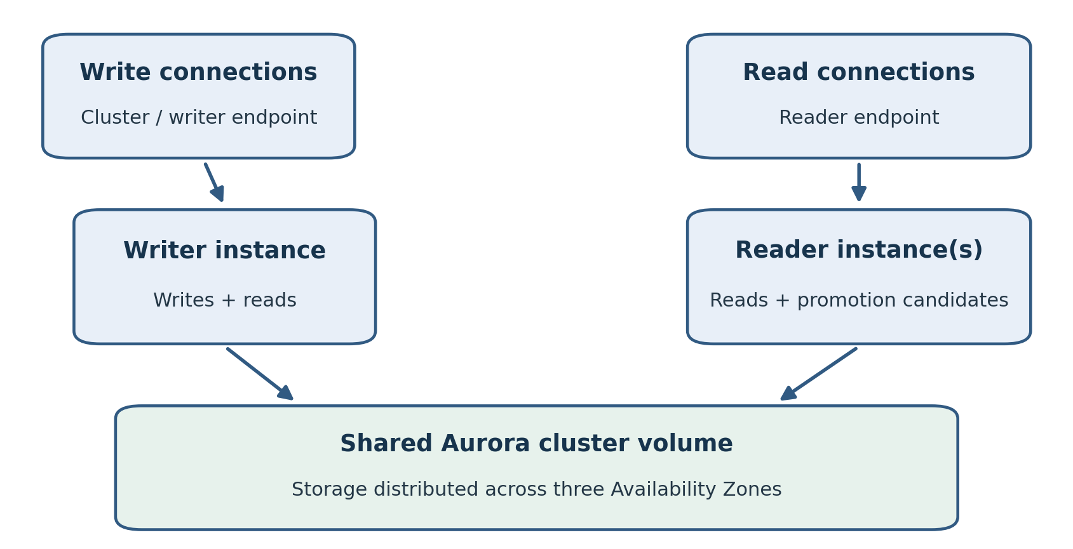
Figure 5.1. Aurora separates compute from shared storage. The reader endpoint balances connections across readers; with no readers, it can connect to the writer.
Amazon Aurora requires a DBA to think about a cluster rather than only an individual database server. Compute instances, distributed storage, endpoints, readers, and failover behavior form a single operating design. Understanding their relationships is essential before choosing capacity or directing application traffic.
This chapter explains Aurora MySQL-Compatible and Aurora PostgreSQL-Compatible clusters, provisioned and Serverless v2 compute, configuration, backups, monitoring, and Global Database. It focuses on architectural and operational decisions. The broader recovery planning process follows in Chapter 6.
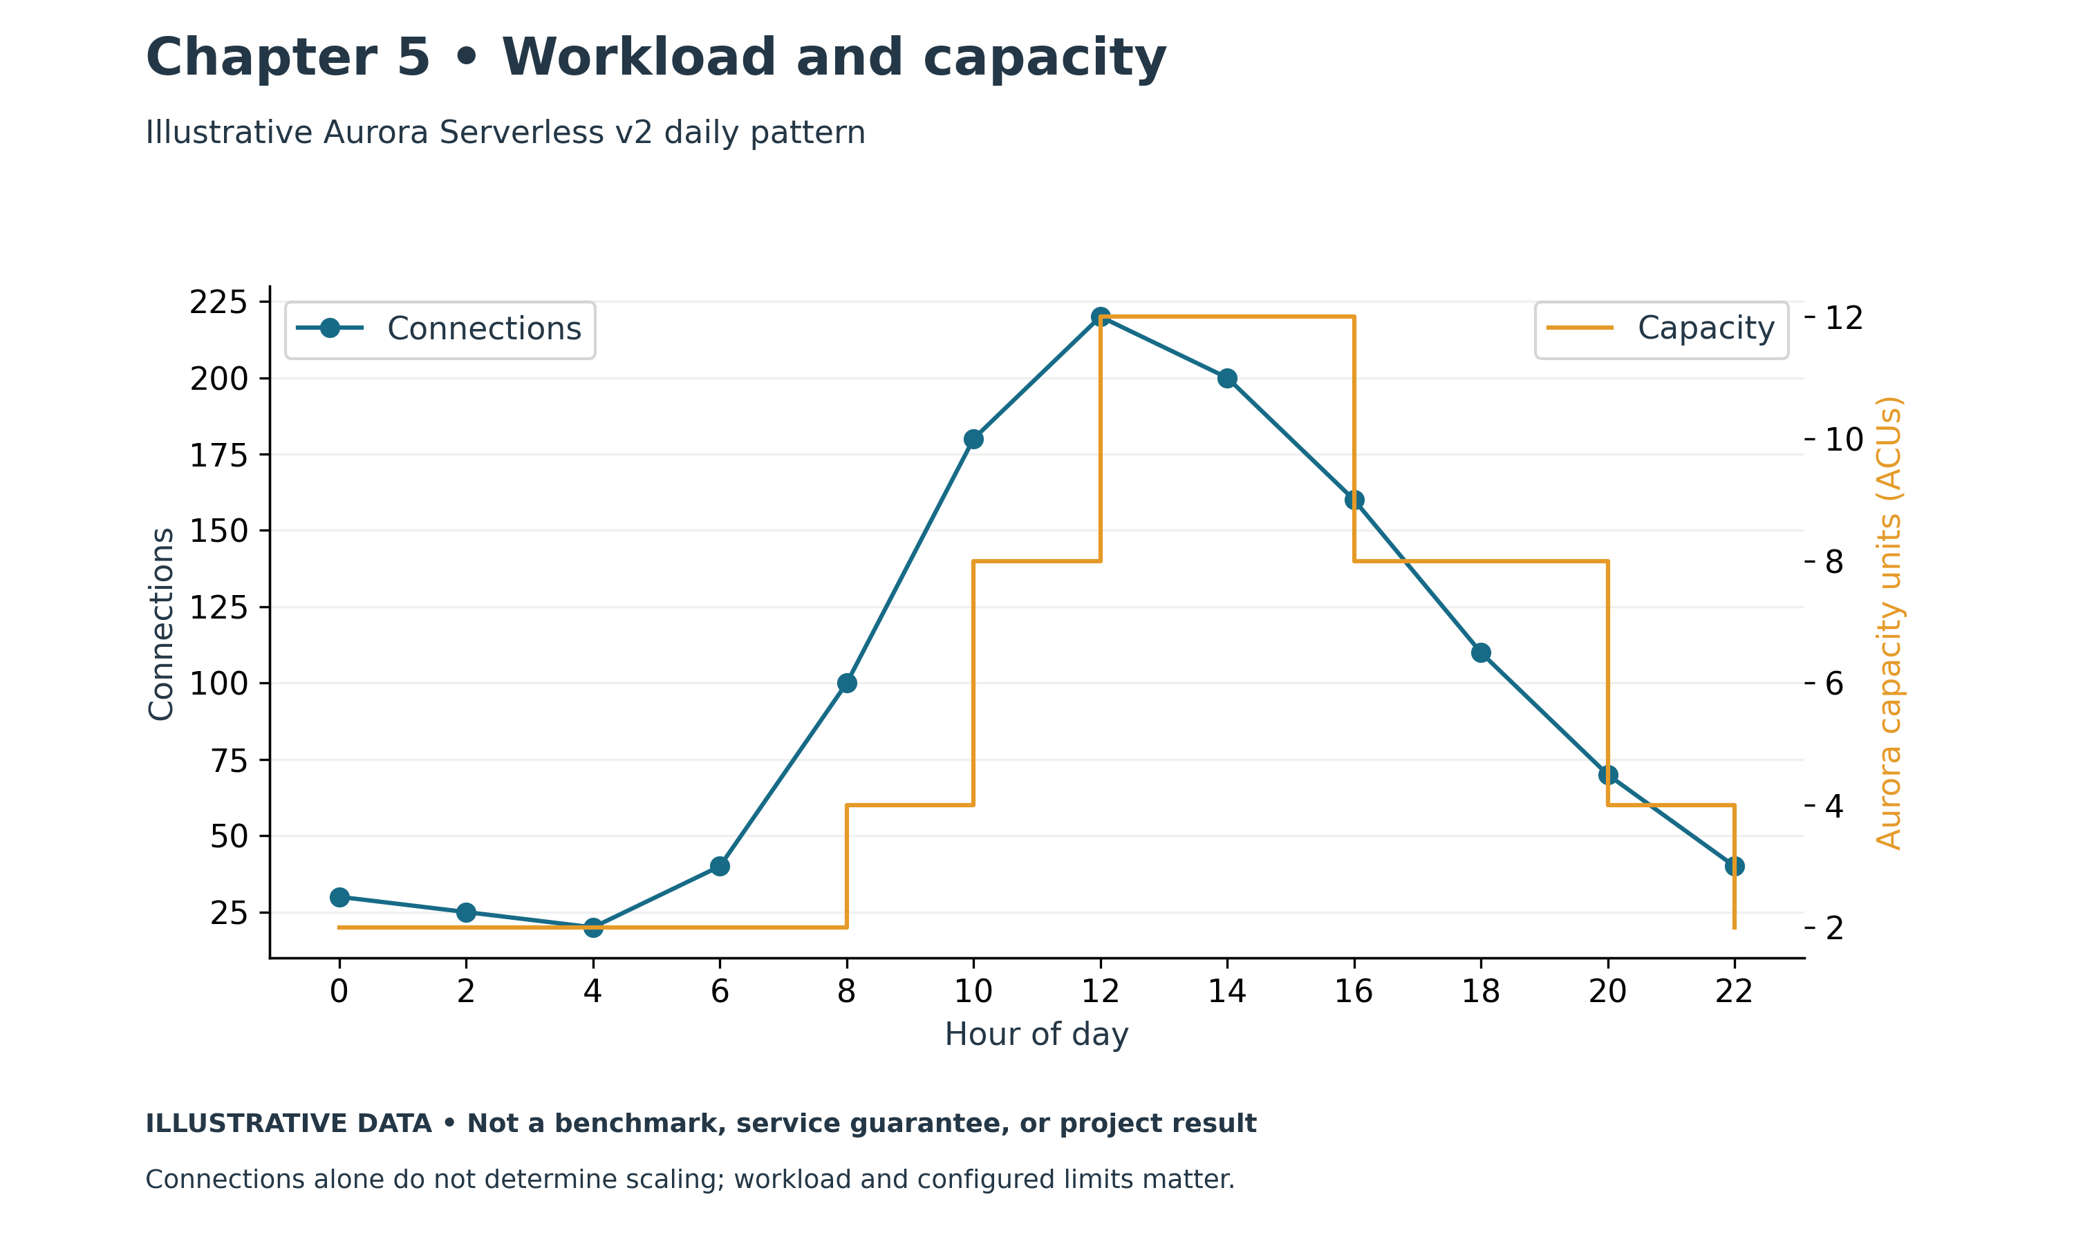
Figure 5.2. Aurora workload and capacity. Illustrative chart; values are examples, not measured production results.

Aurora Is a Distinct Engine Architecture
Aurora is a managed relational engine offering MySQL-compatible and PostgreSQL-compatible editions. It uses the RDS management interface, but its cluster and storage architecture differs from an ordinary RDS instance. [1]
Compatibility provides a starting point for migration, not a blanket promise that every source behavior will match. Check engine versions, extensions, SQL features, drivers, data types, privileged operations, and administrative tooling. Rehearse the real workload and the maintenance procedures.
This chapter concerns Aurora's MySQL-compatible and PostgreSQL-compatible cluster engines. Amazon Aurora DSQL is a separate service with a different architecture and should not be treated as another setting on these clusters. [2]
Record both the compatible engine family and the actual Aurora engine version. Support and feature availability can vary by version and Region. An example taken from one engine edition should not automatically become a procedure for the other.

Separate Compute from Cluster Storage
An Aurora cluster contains database compute instances and a shared cluster volume. Aurora distributes its storage across three Availability Zones and maintains multiple copies of the data. The storage design supports durability independently of the placement of a particular compute instance. [3]
That separation changes how readers are understood. Within an ordinary Aurora cluster, readers use the shared cluster storage; they are not conventional independent full-storage copies of the database. Their compute resources and caches still affect how quickly they can execute queries.
Distinguish durable data from service availability. Distributed storage does not prove that an application can immediately continue when its writer fails. The cluster needs an appropriate compute and failover design, and the application needs to reconnect correctly.
For a production workload, review where the writer and readers run, which instances can be promoted, and whether the promoted instance can support the writer workload. A reader serving occasional reports may be undersized for full transactional demand.

Writers Readers and Promotion
A conventional Aurora cluster has one primary writer. Aurora readers serve supported read-only work and can be candidates for promotion during failover. Promotion tiers help influence the selection of a failover target. [4]
Do not describe several readers as several independent write servers. Normal write traffic belongs on the writer path. Features such as write forwarding have specific behavior and requirements and should be assessed separately rather than assumed to provide unrestricted multi-writer operation.
Readers have two practical purposes: serving eligible reads and providing failover compute. Those purposes can compete. A heavily loaded reporting reader may be a poor failover candidate if it cannot accommodate transactional traffic after promotion.
Plan capacity for the failure case. Measure how the candidate behaves under the writer's workload, and consider what happens to its original reporting load. The application and operations teams should agree whether reports are paused during recovery.

Understand the Endpoints
Aurora provides different endpoints for different routing needs. The cluster endpoint normally directs connections to the current writer. The reader endpoint distributes new connections across available readers. Instance endpoints target individual instances, and custom endpoints can serve selected instance groups. [5]
Endpoint | Intended use | Operational consideration
Cluster writer endpoint | Normal transactional writes | Applications must reconnect after writer changes
Reader endpoint | Eligible read traffic | Balances connections rather than individual SQL statements
Instance endpoint | Targeted access to one instance | Ties the client to that instance
Custom endpoint | Selected workload grouping | Membership and failover behavior need review
Connection-level balancing means a long-lived connection remains associated with the chosen reader. A pool creating only a few connections may not distribute workload evenly. Do not expect the reader endpoint to move each expensive statement to the least busy instance.
When a cluster has no Aurora replicas, the reader endpoint can connect to the writer. [5] Endpoint names alone do not establish that a workload has a separate read tier. Confirm the deployed resources and actual destination during tests.
Use the documented endpoint rather than its current IP address. Test DNS behavior, drivers, retry logic, and connection pools. A failover procedure that ignores client caching can leave the database available while applications remain disconnected.

Choose Provisioned or Serverless v2 Compute
Provisioned instances use a selected instance class. Serverless v2 adjusts compute capacity within a configured range, expressed in Aurora Capacity Units, or ACUs. Available limits and features depend on engine, version, Region, and platform support. [6]
Provisioned capacity can be appropriate for a predictable workload whose demand is well understood. Serverless v2 is a candidate when demand varies and automatic capacity adjustment can improve the operating model. Neither option should be selected without measuring the workload and estimating cost.
Set the Serverless minimum with performance needs in mind. A minimum chosen solely to reduce idle cost may leave insufficient capacity for connection overhead, working data, or a sudden increase in demand. Test the transition from quiet activity to a realistic burst.
Set the maximum high enough for accepted demand, but review the cost implications and what happens at that limit. Monitor capacity and saturation together with application latency. Automatic adjustment cannot eliminate an inefficient query or provide capacity beyond configured bounds.
Some supported Serverless v2 versions offer automatic pause at zero capacity when configured appropriately. Resume behavior, prerequisites, and limitations must be checked for the exact deployment. [7] Do not assume that every Aurora Serverless database pauses automatically or that resume is instantaneous.

Capacity Planning Includes Failover
Size compute for ordinary operation, peaks, and failure scenarios. For a provisioned cluster, compare the writer and promotion candidates. For Serverless v2, examine capacity ranges and the behavior of readers during scaling and promotion.
Test the promoted writer with representative concurrency and business transactions. A topology may successfully elect a writer yet fail the application's response-time target. Recovery readiness includes usable performance, not only a role change.
Treat connection count as part of capacity. Each client session has engine-specific costs. Review pooling, idle connections, transaction duration, and application retry behavior. A reconnect storm after failover can create pressure precisely when the system is trying to recover.
Set application retries deliberately. Use bounded retries and appropriate delay, and address uncertain transaction outcomes. If a client loses its connection after submitting a payment, retrying blindly can produce a duplicate operation unless the application has an idempotency or reconciliation strategy.

Cluster and Instance Configuration
Aurora uses DB cluster parameter groups and DB parameter groups. Settings can apply at cluster or instance scope, and changes may be dynamic or require restart depending on the parameter. [8]
Before changing a setting, identify its scope, all affected instances, the required application method, and how to confirm its active value. A cluster-level change can have a broader effect than a change intended for one reader.
Keep parameter families aligned with the engine version. During upgrade planning, compare custom values with the target family's defaults and supported settings. Preserve the business reason for each customization so that obsolete settings can be removed intentionally.
Review maintenance and upgrade procedures for the selected version and topology. Readers can improve availability, but do not promise an interruption-free change without checking the documented behavior and rehearsing it with the application.

Storage and Cost Configuration
Aurora storage grows as data is added within supported limits, and its architecture differs from standard RDS allocated storage. Review current limits, temporary storage behavior, and the storage configuration supported by the selected engine. [3]
Aurora offers Standard and I/O-Optimized storage configurations for supported deployments. Their pricing structures differ, including how I/O charges are treated. [9] Compare them using actual workload measurements and current regional prices rather than treating one as universally cheaper.
Include all cluster instances, storage, backup retention, data movement, and monitoring in the estimate. A cluster with several readers should not be compared with the invoice for a single transactional server while ignoring their additional capability and cost.
Monitor data growth and avoid assuming that compute autoscaling controls every cost. Serverless compute can vary while stored data and retained recovery copies continue to accumulate. Assign owners for both performance and the resource inventory.

Backups and Restore Procedures
Aurora provides automated backups and point-in-time recovery, along with manual snapshots. Restoring to a point in time creates a new DB cluster; the restore workflow must also provide the compute needed to use it. [10]
Write down the complete recovery sequence. It includes selecting the recovery point, restoring the cluster, supplying or confirming compute, reviewing network and parameter configuration, validating access, and redirecting a test application.
Validate business data, not just cluster status. If an accidental update damaged order records, identify a time before the update and determine how legitimate later transactions will be reconciled. A physically available restored cluster does not settle the data recovery decision.
Protect encryption access and retention. A recovery copy is useful only when authorized responders can use the required keys and credentials. Include those dependencies in exercises rather than discovering them during an incident.

Monitor the Cluster and the Workload
Monitor both cluster-level behavior and individual instances. CPU, memory indicators, connections, reader lag, storage activity, and application latency provide different evidence. For Serverless v2, monitor capacity and utilization alongside response times. [11]
Investigate an uneven read workload at the connection and query levels. One reader may have more active work because long-lived sessions concentrate traffic or because an application uses an instance endpoint. Adding a reader may not correct that routing pattern.
For slow queries, use the engine's execution plans and workload diagnostics. Review cardinality estimates, indexes, statistics, blocking, and transaction length. Compare the workload before and after a change rather than relying on a single resource metric.
Monitor readers for failover readiness as well as reporting performance. Define alerts for conditions that would prevent them from carrying the writer workload. A healthy writer can hide a weak recovery design until the first real failure.

Aurora Global Database
Aurora Global Database connects supported Aurora clusters across Regions. A primary Region serves normal writes while secondary Regions maintain replicated data and can serve reads. Cross-Region replication is asynchronous. [12]
This design can support geographic reads and regional recovery, but it is not a substitute for a full application recovery plan. Secondary environments need appropriate connectivity, credentials, encryption access, application resources, and operational permissions.
A planned switchover and an unplanned failover have different objectives. A managed switchover coordinates a planned role change. An unplanned failover can lose transactions that have not reached the chosen secondary Region. The potential loss depends on replication state. [13]
Monitor replication lag and test the exact role-change procedure supported by the deployment. Identify how clients discover the new writer and how the former writer is prevented from receiving unintended writes. Avoid building a procedure around an assumed fixed recovery time.
After regional recovery, establish the new protection topology and plan a deliberate failback. Restoring the original Region's resources is not sufficient reason to switch traffic back immediately. Validate data direction, consistency, and application readiness first.

Example Separating Transactions and Reports
A hypothetical PostgreSQL application moves to Aurora with a writer and two readers. The writer serves order transactions, while eligible reporting queries use a designated read path. One reader is sized and configured as a strong promotion candidate.
Testing reveals that a small connection pool directs most reports to one reader. The team reviews pooling and endpoint choices, then repeats the workload. It also tests whether a user can tolerate seeing an older order status on a read path immediately after an update.
A failover rehearsal verifies reconnection and transaction handling. The team measures how the promoted instance performs, pauses nonessential reports during recovery, and updates the runbook with the observed application behavior.

Practical Exercise and Review
Design a cluster profile with the engine and version, writer, readers, zones, promotion priorities, endpoints, parameter groups, backup policy, and compute model. Explain which workloads use each endpoint and why.
Write a test for a sudden traffic increase and another for writer failover. Record latency, connection behavior, capacity, errors, and correctness of business transactions. For a Global Database candidate, add regional dependencies and an accepted data-loss decision process.
Review questions: Why are Aurora readers different from ordinary independent storage replicas? Does the reader endpoint balance each query? Why must a promotion candidate have adequate compute? What limits Serverless v2 capacity? Can an unplanned Global Database failover lose recent writes?
Suggested answers: Readers within the cluster use shared storage. The reader endpoint distributes connections. The promoted instance must carry the writer workload. Capacity is bounded by configured and supported limits. Asynchronous cross-Region replication can leave recent writes missing from the promoted Region.

References
[1] What is Amazon Aurora. https://docs.aws.amazon.com/AmazonRDS/latest/AuroraUserGuide/
[2] What is Amazon Aurora DSQL. https://docs.aws.amazon.com/aurora-dsql/latest/userguide/what-is-aurora-dsql.html
[3] Aurora storage. https://docs.aws.amazon.com/AmazonRDS/latest/AuroraUserGuide/Aurora.Overview.StorageReliability.html
[4] High availability for Aurora. https://docs.aws.amazon.com/AmazonRDS/latest/AuroraUserGuide/Concepts.AuroraHighAvailability.html
[5] Aurora connection management. https://docs.aws.amazon.com/AmazonRDS/latest/AuroraUserGuide/Aurora.Overview.Endpoints.html
[6] Using Aurora Serverless v2. https://docs.aws.amazon.com/AmazonRDS/latest/AuroraUserGuide/aurora-serverless-v2.html
[7] Automatic pause and resume. https://docs.aws.amazon.com/AmazonRDS/latest/AuroraUserGuide/aurora-serverless-v2-auto-pause.html
[8] Aurora parameter groups. https://docs.aws.amazon.com/AmazonRDS/latest/AuroraUserGuide/parameter-groups-overview.html
[9] Aurora storage configurations and pricing. https://docs.aws.amazon.com/AmazonRDS/latest/AuroraUserGuide/Concepts.Aurora_Fea_Regions_DB-eng.Feature.storage-type.html and https://aws.amazon.com/rds/aurora/pricing/
[10] Restoring an Aurora cluster to a specified time. https://docs.aws.amazon.com/AmazonRDS/latest/AuroraUserGuide/USER_PIT.html
[11] Monitoring Aurora. https://docs.aws.amazon.com/AmazonRDS/latest/AuroraUserGuide/MonitoringAurora.html
[12] Aurora Global Database. https://docs.aws.amazon.com/AmazonRDS/latest/AuroraUserGuide/aurora-global-database.html
[13] Global Database switchover and failover. https://docs.aws.amazon.com/AmazonRDS/latest/AuroraUserGuide/aurora-global-database-disaster-recovery.html

Chapter 6: High Availability and Disaster Recovery
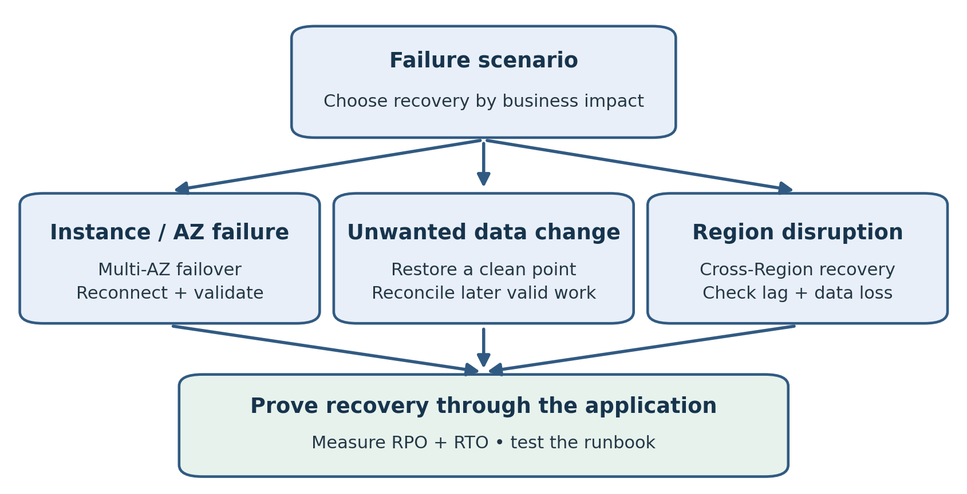
Figure 6.1. Match recovery to the failure. Replication can carry unwanted data changes, so historical recovery requires a suitable clean restore point.
A second database copy is useful only when it addresses the failure your business needs to survive. Infrastructure failure, accidental data changes, loss of a Region, and application errors require different responses. High availability and disaster recovery must be designed around those scenarios and tested through the application.
This chapter compares Multi-AZ deployments, read replicas, backups, and cross-Region recovery. It then explains how to build a runbook covering detection, decision-making, recovery, validation, and return to normal operations. The objective is a demonstrated recovery capability rather than an architecture diagram that merely looks resilient.
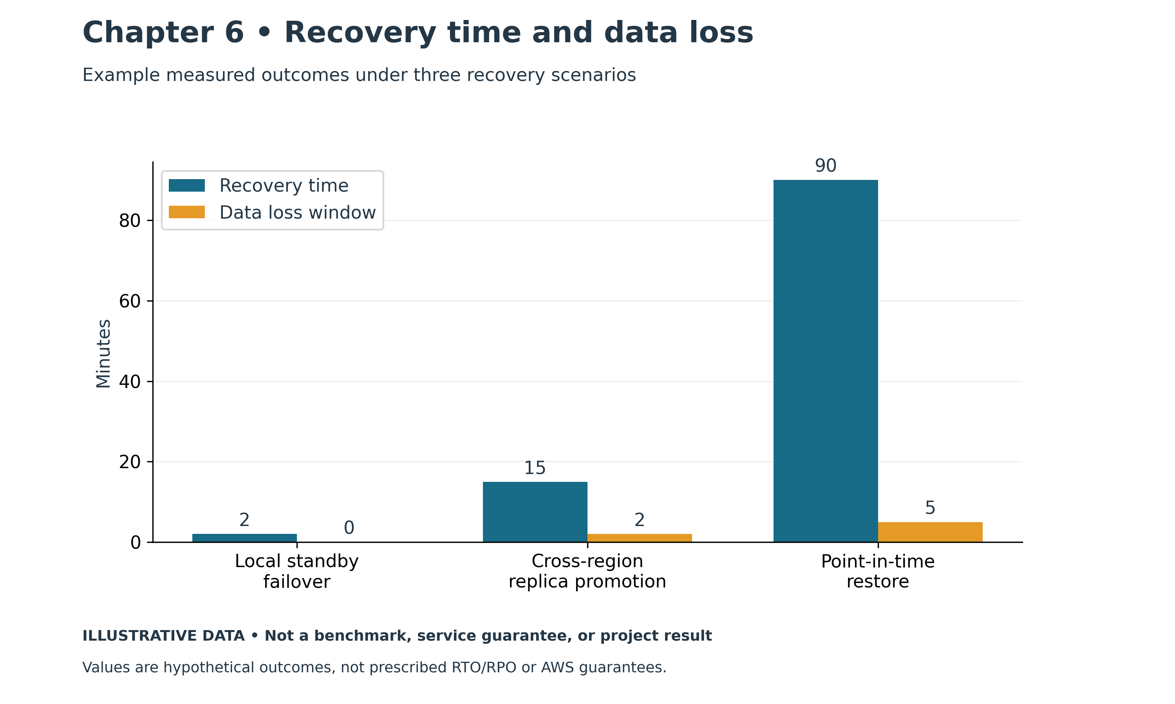
Figure 6.2. Recovery time and data loss. Illustrative chart; values are examples, not measured production results.

From the Field: Forty-Five Minutes of Work, Four Hours of Waiting
In 2006 I was a DBA at a large organization, responsible for a critical system used by thousands of customers. A denial-of-service attack made the system unavailable.
My first instinct was the one every DBA has: check the database. Sessions were piling up and CPU was climbing, but the database wasn't the cause. It was the victim. Something was flooding everything in front of it.
We pulled in the networking team. Together we worked through the numbers that mattered: bandwidth, packets per second, open connections, CPU, and HTTP request rates. We weren't collecting graphs for their own sake. We were trying to answer one question: was the attack aimed at the network pipe, the TCP connection layer, or the application itself? Each answer leads to a different fix, and guessing wrong wastes time you don't have.
Once we understood the affected path, we isolated it and moved service to our secondary environment, which included an Oracle 10g Data Guard standby. The database transition and the alternate access path together helped restore service.
From the first alert to a working failover, the technical work took less than forty-five minutes.
The outage lasted a few hours.
Much of the elapsed time was spent waiting for decisions. Actions such as isolating the network segment and moving service to the secondary needed approval through several management levels. Later, the investigation associated the traffic with sources in Eastern Europe; apparent source location alone does not establish an attacker's identity.
I learned two lessons that day. First, the technology works when you've built and tested it: Data Guard saved us. Second, an untested decision process can turn a short incident into a long one. The slowest component in an outage is often not a server.
Modern practice: combine upstream DDoS mitigation, edge protection, WAF rules, private database access, and a rehearsed incident runbook. Private subnets reduce direct exposure, but malicious application traffic can still overload a database. Database failover alone does not stop a DDoS attack; recovery requires a usable alternate network and application path. Define who may act and under what conditions before an incident. The following sections cover database recovery; Chapters 2 and 11 cover networking and security.

Define the Service to Recover
Begin by identifying the business service. A database may support orders, payroll, patient scheduling, or reporting. Its recovery requirements depend on the consequences of interruption and data loss. The database's importance cannot be inferred solely from size or transaction count.
Agree on the recovery point objective, or RPO, and recovery time objective, or RTO. RPO describes acceptable data loss measured in time. RTO describes the acceptable time to restore the agreed service after disruption. Record the scope and measurement assumptions with the targets.
For example, a fifteen-minute RPO and one-hour RTO mean the design must limit accepted loss of recent data to the agreed interval and restore the service within one hour. A backup schedule alone does not prove either objective. Recovery might depend on transfer, restore, validation, credentials, and application redirection.
Ask the business owner to approve the requirements and the recovery tradeoffs. An engineer should not silently decide that losing recent payments is acceptable because it makes a recovery procedure faster. Identify who can authorize that decision during an incident.

Identify Failure Scenarios
Build a short scenario inventory. Include loss of a compute instance, loss of a zone, a damaging application release, accidental deletion, unavailable encryption access, and a regional disruption. Also include failures in the application's dependencies.
Each scenario should have a detection method, likely impact, recovery mechanism, accountable owner, and validation requirement. This makes uncovered risks visible before production use.
Scenario | Candidate response | What still needs validation
Database compute failure | Supported automatic failover | Reconnection and usable performance
Availability Zone failure | Deployment across zones | Application and network dependencies
Accidental mass update | Restore an earlier valid state | Reconciliation of later transactions
Regional outage | Cross-Region recovery | Secondary application readiness and data loss
Credential or key problem | Restore authorized access | Availability of protected recovery copies
The table lists candidates, not guaranteed solutions. A particular service configuration may not support every mechanism. Confirm the selected engine, topology, version, and Region before writing executable procedures.

Availability and Recovery Solve Different Problems
High availability aims to reduce interruption from defined failures. Disaster recovery establishes how to restore service after a larger disruption or loss. Backups protect recoverable historical states, while replication maintains another copy of changing data.
Replication can carry an unwanted but valid change. If an application deletes every order, the replicated environment may contain the same deletion. Switching to that environment can restore infrastructure availability without recovering the lost records.
Likewise, a backup may preserve correct data while taking too long to restore for a demanding RTO. A workload may therefore need both live redundancy and historical recovery copies. Choose their roles deliberately and test them separately.
Do not describe any single feature as complete disaster recovery. Database protection, application deployment, network access, identity, operational permissions, and business validation form one service recovery process.

RDS Multi AZ DB Instance Deployments
In a conventional RDS Multi-AZ DB instance deployment, RDS maintains a synchronous standby in another Availability Zone. The standby provides availability and is not used to serve normal read traffic. Supported failures can trigger automatic failover. [1]
This option addresses a different need from adding a read replica. If the goal is to reduce reporting load on the primary, a non-readable standby does not provide that read capacity. Identify which requirement you are trying to satisfy.
During failover, applications must handle interrupted sessions and reconnect through the database endpoint. DNS behavior and client caching matter. The database's role change does not mean every client transaction continued uninterrupted.
Test the complete application path. Measure detection and failover, reconnect behavior, retry handling, and successful business transactions. Avoid using a generic published failover interval as the workload's promised RTO.

RDS Multi AZ DB Cluster Deployments
RDS also offers Multi-AZ DB cluster deployments for supported MySQL and PostgreSQL configurations. This architecture has a writer and two readable instances across three Availability Zones and uses semisynchronous replication. It is distinct from the conventional single-standby deployment. [2]
Readable instances can serve suitable read workloads and act as failover targets. Review endpoint behavior, lag, capacity, and the supported deployment settings. Do not apply the statement that a Multi-AZ standby cannot serve reads to every Multi-AZ product.
Deployment | Readable standby or reader | Primary operating goal
RDS Multi-AZ DB instance | Conventional standby is not readable | Availability with a synchronous standby
RDS Multi-AZ DB cluster | Two readable instances | Availability and supported read capacity
Aurora cluster with readers | Aurora readers are readable | Read capacity and failover compute
The architectures use different storage and replication mechanisms. Match procedures and monitoring to the deployed product instead of relying on the broad label Multi-AZ.

Read Replicas and Replication Lag
RDS read replicas use engine-specific replication and are commonly used for eligible read workloads. Ordinary DB instance read replicas are generally asynchronous, and supported configurations may also provide a recovery path through promotion. Engine, edition, licensing, and Region restrictions apply. [3]
Asynchronous replication introduces lag. A replica may not yet contain the latest committed source changes. This affects both read behavior and the amount of data available after an unplanned promotion.
For application reads, decide whether stale results are acceptable. A historical report might tolerate delay; a user checking a just-completed payment might not. Route workloads based on the consistency they require rather than sending every SELECT to a replica.
For recovery, monitor lag and establish a decision process for missing transactions. A low average lag does not guarantee no loss at the instant of a failure. Capture the relevant metrics and evidence when evaluating the recovery point.
Promotion changes the replica's operating role and replication relationship according to the service's supported procedure. [3] Plan the new writer endpoint, application access, backup policy, and future replica topology. Promotion is not the end of the recovery runbook.

Cross Region Recovery Options
Cross-Region recovery addresses a broader failure scope than redundancy within one Region. Common approaches include restoring recovery copies in another Region, maintaining a supported cross-Region read replica, or using Aurora Global Database. Their cost and readiness differ.
Backup-based recovery can reduce the cost of continuously running a second database, but restore and application deployment take time. Evaluate available snapshot copies or supported automated backup replication, the usable recovery point, and the target Region's configuration. [4]
A cross-Region replica keeps a running copy for supported RDS configurations. [5] It can reduce the database preparation work during recovery, but still requires promotion, access validation, client redirection, and acceptance of any replication gap.
Do not build a plan around a feature unsupported by the chosen engine or deployment type. Check cross-Region replica and backup support separately. They are different mechanisms with different availability matrices.
Include recovery copies in another account where organizational requirements call for a separate protection boundary. This requires deliberate permission and encryption design. Another location is not protection from every destructive action if the same credentials can remove all copies.

Aurora Global Database and Role Changes
Aurora Global Database maintains supported Aurora clusters across Regions using asynchronous replication. A planned switchover coordinates a primary Region change; an unplanned failover can lose recent changes that have not reached the selected secondary. [6]
Choose the recovery target using replication evidence and business requirements. Identify who approves potential loss, how clients reach the new writer, and how the former primary is prevented from receiving conflicting writes.
Test the actual client routing design. Endpoint capabilities depend on the supported service configuration. A runbook should describe what applications do after a role change and how responders verify their destination.
After recovery, re-establish protection. Confirm which Region is primary, which secondaries are healthy, how backups operate, and whether the topology meets the original requirements. A recovered service with no remaining redundancy is a temporary operating state requiring attention.

Build a Complete Recovery Runbook
A recovery runbook should be usable by an authorized engineer who did not design the environment. Begin with the business service, deployment details, dependencies, RPO, RTO, escalation contacts, and decision authority.
Describe the stages in order: detect and assess, contain the problem, select a recovery point or target, execute the supported recovery procedure, validate data and application behavior, redirect traffic, and monitor the result. Include the criteria for proceeding or stopping at each stage.
Use exact resource identifiers and current configuration in the environment-specific runbook. Keep secrets outside the document and describe the approved retrieval method. Record the permissions responders need before an incident occurs.
Specify evidence to preserve. Logs, timestamps, replication metrics, application transaction identifiers, and the damaging operation can be important for recovery selection and reconciliation. Avoid destroying that evidence during an urgent restart or cleanup.
Write down how to stop conflicting activity. Scheduled jobs, integration processes, and old application instances may continue sending writes to the wrong location. A recovery plan should establish a single intended writer and verify where clients connect.

Restoring from a Backup
For an RDS DB instance, point-in-time recovery creates a new instance. For Aurora and supported RDS cluster deployments, the relevant procedure creates a new cluster. [7] Plan the restored environment's compute, network, parameter configuration, access, and application cutover.
Select a recovery point using the incident timeline, and verify time zones. The latest available backup state may already contain the damaging change. The best recovery point is the latest valid state that fits the recovery objective and the incident's nature.
Do not expose a restored copy to production writers before validation. Use a controlled test application or query process to assess the result. Confirm critical records, counts, business totals, and the ability to complete normal transactions.
Plan what happens to valid later data. A full database restore to an earlier time can omit legitimate transactions. Reconciliation may require application logs, external systems, exports, or a targeted recovery approach. The business owner should understand and approve the process.

Application Behavior Determines the User Outage
An automatic database failover does not automatically make an application resilient. Clients need appropriate timeout settings, reconnect logic, and transaction handling. Long-lived pools may retain broken sessions, while aggressive retries may overwhelm the recovered writer.
Address uncertain commit outcomes. If a connection fails after a request is sent, the client may not know whether the transaction committed. Design business operations with an appropriate duplicate-prevention or status-check mechanism. Database availability cannot by itself solve this application problem.
Test noninteractive components too. ETL jobs, reporting tools, integration services, and scheduled tasks may use different drivers or endpoints from the main application. A website working again does not prove that the full business service has recovered.
Observe post-recovery performance. Cold caches, reconnect bursts, deferred jobs, and increased load can affect response times. Define when the system is considered stable and who monitors the transition back to ordinary operation.

Measure Recovery with Exercises
Begin with a tabletop exercise to review responsibilities and dependencies. Then perform a controlled technical rehearsal in an appropriate environment. Choose a scenario, define the starting condition, and use the documented runbook.
Record the recovery timeline. Capture detection, decision, database availability, application reconnection, data validation, and business acceptance. Compare the measured service recovery time with the RTO rather than measuring only the database restore command.
Milestone | Evidence to record
Incident detection | First symptom and alert timestamp
Recovery decision | Approved target and accepted data-loss scope
Database recovery | Resource availability and engine checks
Application recovery | Successful business transaction and client destination
Validation complete | Reconciliation results and business approval
Repeat a test when a material change affects the recovery design. Examples include an engine upgrade, new application dependency, changed key policy, or topology modification. Routine rehearsals should also verify that contacts and access methods remain current.
Review failures constructively. If responders needed undocumented knowledge or unavailable permissions, update the design and runbook. A failed exercise provides useful evidence while the business is not depending on emergency recovery.

Plan Failback Deliberately
Failback is another controlled migration. The original environment may be stale after the recovery target has accepted new writes. Switching traffic back without synchronizing and validating data can lose work or create conflicting histories.
Decide whether the recovery location should remain primary temporarily or permanently. If returning, establish the supported synchronization path, cutover conditions, and fallback plan. Rehearse where practical and obtain the necessary operational approval.
After the transition, confirm backups, replicas, alerts, endpoints, and documentation. Close temporary access and remove obsolete resources according to the retention policy. The incident is not complete until the service has a clear, protected operating state.

Example Two Different Incidents
A hypothetical order system uses a supported Multi-AZ RDS deployment and maintains a separate recovery strategy. During a compute failure, the service performs failover. The application reconnects, checks uncertain transaction outcomes, and completes a test order. The team measures the interruption and verifies steady performance.
Later, an application defect updates historical order amounts incorrectly. The standby has the same changes. The team contains the application, preserves evidence, restores an earlier valid copy, and uses transaction records to reconcile legitimate later activity. It validates totals before cutover.
Both incidents affect the same database, but they require different responses. The first primarily restores availability; the second requires a data recovery decision and reconciliation. This is why live redundancy and historical recovery belong in separate parts of the plan.

Practical Exercise and Review
Create three scenarios for one database: compute failure, accidental data change, and regional loss. For each, document the detection method, recovery mechanism, decision owner, required dependencies, possible data loss, and validation evidence.
Then write a timeline worksheet with the milestones above. Identify the slowest expected step and one improvement that could reduce it without compromising correctness. Use the worksheet in the next rehearsal.
Review questions: Why is a standby insufficient for accidental deletion? Which RDS Multi-AZ design has readable instances? How can replication lag affect RPO? Why might the application remain unavailable after database recovery? Why is failback a separate engineering task?
Suggested answers: Replication may preserve the deletion. Supported Multi-AZ DB clusters have readable instances, unlike conventional single-standby deployments. Lag can leave recent changes absent from a recovery target. Clients and dependencies may not have recovered. Failback must account for new writes, synchronization, and validation.

References
[1] RDS Multi-AZ DB instance deployments. https://docs.aws.amazon.com/AmazonRDS/latest/UserGuide/Concepts.MultiAZSingleStandby.html
[2] RDS Multi-AZ DB cluster deployments. https://docs.aws.amazon.com/AmazonRDS/latest/UserGuide/multi-az-db-clusters-concepts.html
[3] Working with DB instance read replicas. https://docs.aws.amazon.com/AmazonRDS/latest/UserGuide/USER_ReadRepl.html
[4] Replicating automated backups to another Region. https://docs.aws.amazon.com/AmazonRDS/latest/UserGuide/USER_ReplicateBackups.html
[5] Creating a read replica in another Region. https://docs.aws.amazon.com/AmazonRDS/latest/UserGuide/USER_ReadRepl.XRgn.html
[6] Aurora Global Database switchover and failover. https://docs.aws.amazon.com/AmazonRDS/latest/AuroraUserGuide/aurora-global-database-disaster-recovery.html
[7] Point-in-time restoration for RDS instances and Aurora clusters. https://docs.aws.amazon.com/AmazonRDS/latest/UserGuide/USER_PIT.html and https://docs.aws.amazon.com/AmazonRDS/latest/AuroraUserGuide/USER_PIT.html

Chapter 7: Assessment and Planning
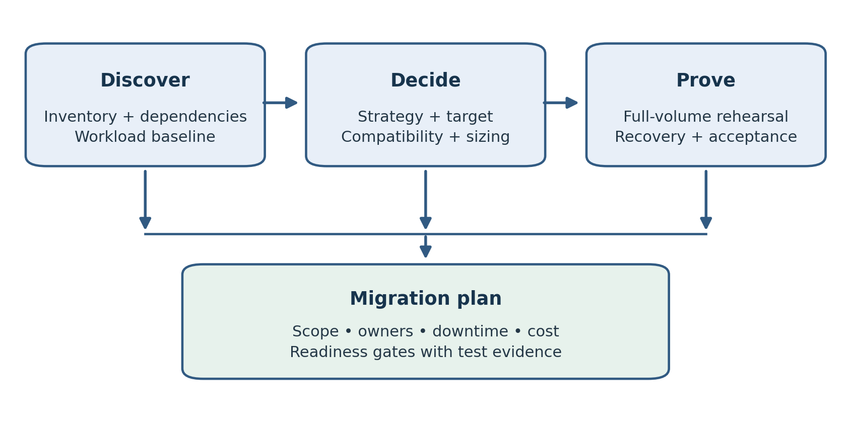
Figure 7.1. Assessment turns discovery and design choices into a tested migration plan.
A database migration begins with a business decision, not a replication task. Before moving a single row, the DBA must establish what is moving, why it is moving, which behavior must be preserved, and how success will be demonstrated. A technically successful copy can still be a failed migration if the application misses its service target, a monthly process stops working, or the new operating cost exceeds the approved budget.
The earlier chapters introduced AWS services and their operating boundaries. This chapter turns those choices into a migration plan. The emphasis is on evidence: an inventory that exposes dependencies, a workload baseline that supports sizing, and a rehearsal that proves the proposed method can meet the downtime window. Chapter 8 covers schema conversion and AWS Database Migration Service; Chapter 9 examines native and hybrid migration methods.

From the Field: The Email Nobody Ran Past IT
The new billing system had just gone live. It had passed its functional tests, the screens worked, and payments posted correctly. By every measure we had checked, it was ready.
Then the accounting department sent an email to more than 100,000 customers. The message was simple and well meant: you can now pay your bill online, starting on the 29th, ahead of the due date on the 1st of next month.
Nobody in accounting thought of that email as a load test. Nobody in IT knew it was going out. And nobody, in the whole project, had asked how many customers each part of the system could handle at once.
On the 29th, customers responded to the invitation. The sudden demand overwhelmed a system whose capacity had not been tested for that peak. The application, network, and database all needed investigation.
We had to stop the system so it could catch up. We were turning customers away on the very day we had invited them in. As an interim fix, we added throttling throughout the stack: limits on how many requests the application would accept and how many sessions could reach the database. It kept the system alive, but it was a tourniquet, not a cure. Fixing the underlying capacity problem properly took another two months.
We had tested whether the system worked, but had not established whether every component could handle the expected peak. The business teams who influenced demand needed to be part of capacity planning.
Modern practice: include billing dates and customer communications in the capacity plan. Load-test the full application path, scale supported tiers ahead of predictable peaks, and bound database connections. Queues can absorb suitable asynchronous work, but acknowledging receipt of a payment request is different from confirming a completed payment. Use durable processing, idempotency, and reconciliation. Chapters 12 and 15 cover monitoring and automation.

7.1 Start with the migration contract
Write a one-page statement of intent with the application owner. Identify the business outcome, data scope, target service, acceptable interruption, and required recovery behavior. Assign an owner to each acceptance criterion. A useful contract says that order entry must resume within 45 minutes and that all committed source orders must appear on the target. A vague contract says that the migration should have minimal downtime.
Separate the migration outage from steady-state recovery objectives. A business may accept a scheduled two-hour migration window while requiring a 15-minute recovery time after an unplanned production failure. Both requirements matter, but they drive different work. The migration window governs loading and cutover; the production objectives govern the target's availability and recovery design.
Also define what is outside scope. If only the HEALTH application schema is moving, specify whether reporting users, historical archives, scheduled jobs, and external integrations move with it. Schema ownership does not prove isolation. A package in one schema can query another schema, send a message, or read a file on the database server.
Record who can approve a delay or a rollback. The migration lead should not discover during a failed cutover that the business owner is unavailable. Agree on a decision deadline, the evidence required, and how the team communicates the decision.

7.2 Build an inventory that explains behavior
Collect engine version, edition, patch level, deployment architecture, database size, allocated storage, actual data volume, and growth history. For Oracle, identify the CDB and PDB involved rather than referring only to the host. A listener connection to the wrong service can produce an apparently valid assessment of the wrong database.
Inventory tables, indexes, partitions, views, sequences, triggers, stored code, materialized views, database links, users, grants, and scheduled jobs. Add engine-specific features such as Oracle object types or PostgreSQL extensions. Record whether each object is required, obsolete, or awaiting an owner's decision. Do not silently omit an object because a migration tool cannot handle it.
Distinguish application data from operating artifacts. Audit records, temporary staging tables, queue tables, and migration logs can have different retention and transfer requirements. An old staging table containing several terabytes may be disposable, but only its owner can authorize that decision. Data minimization should follow a documented retention decision.
Inventory area | Evidence to collect | Decision it supports
Database platform | Version, edition, options, character set | Target compatibility and licensing review
Data layout | Largest tables, partitions, LOB sizes, keys | Load strategy and replication feasibility
Stored logic | Packages, triggers, jobs, dependencies | Conversion and application testing effort
Workload | CPU, memory, I/O, sessions, top SQL | Initial capacity and performance tests
Integrations | Links, APIs, files, batch schedules | Migration grouping and network design
Protection | Backup history, restore tests, retention | Recovery readiness during the move
Keep the inventory reproducible. Store the collection queries, collection time, database identity, and privilege context. An account with limited visibility may miss objects, so document its limitations and obtain the missing evidence. Refresh the inventory before the final rehearsal to detect newly introduced objects.

7.3 Map the application dependency graph
Draw the path of a transaction from the client through the application to the database and downstream systems. Include DNS, identity providers, connection pools, message queues, reporting, payment services, file transfers, and monitoring. For each connection, record direction, authentication, port, expected latency, and ownership.
A database link can conceal a tightly coupled application. If a transaction makes repeated remote queries, moving only one database may turn local work into expensive network round trips. Similarly, an application that fetches rows one at a time may perform adequately on the same LAN and poorly across a VPN. Measure the call pattern before deciding that database capacity is the problem.
Identify every writer. Interactive users are only part of the list. Batch jobs, ETL tools, integration accounts, administration scripts, and scheduled exports can continue changing data after the front-end application is placed in maintenance mode. The eventual cutover plan must stop or redirect all of them.
Group interdependent components into migration waves. Moving an application tier and its database together may reduce latency risk. Moving them separately may simplify deployment or allow a longer validation period. Make that tradeoff explicit and test the temporary hybrid arrangement as well as the final design.

7.4 Use the Rs to make a deliberate choice
The familiar six Rs are useful for discussing migration strategy: retain, retire, rehost, replatform, repurchase, and refactor. Current AWS guidance describes seven Rs, adding relocate. Use the vocabulary to explain the decision rather than treating the categories as a mandatory sequence. [1]
Strategy | Database-oriented example | Main planning question
Retain | Keep a system on premises for now | Which constraint prevents a move?
Retire | Decommission an unused reporting database | Who approves retention and deletion?
Rehost | Move self-managed Oracle to EC2 | Can existing operations run on AWS?
Replatform | Move PostgreSQL to RDS PostgreSQL | Which managed-service restrictions matter?
Repurchase | Replace an application with SaaS | How will data and processes change?
Refactor | Redesign an Oracle application for PostgreSQL | What behavior must be rewritten and tested?
Relocate | Move an existing platform environment | Which platform-specific relocation path fits?
An engine change does not automatically describe the full application strategy. Moving tables from Oracle to PostgreSQL while rewriting packages and changing transaction handling can require substantial application work. A migration plan should name that work instead of presenting the project as a simple data transfer.
Allow different components to follow different strategies. The operational database may be replatformed while an obsolete reporting module is retired. An archive may be retained until its retention period expires. This is often more practical than forcing every component into the same approach.

7.5 Assess compatibility before estimating dates
Compatibility has several layers. Start with engine features and version support, then examine privileges, administrative access, extensions, storage behavior, and integration options. RDS does not provide the same host access as a self-managed database. A script that assumes access to a local server directory needs a replacement design.
For heterogeneous migrations, inspect both data representation and behavior. Precision, time zones, character encodings, collation, null handling, identifier case, and generated values can change application results. A conversion report is a starting point for engineering work; it does not demonstrate that the application behaves correctly.
Build a register of blockers. Each entry should contain the object or feature, business use, proposed replacement, owner, test, and due date. A single payroll package may be more important than hundreds of automatically converted tables. Count critical execution paths rather than relying only on object conversion percentages.
Review licensing and vendor certification with the responsible teams. A technically possible Oracle deployment may have license constraints, and a commercial application vendor may support only selected platforms or versions. Obtain written confirmation where it is needed before investing in a target that cannot be approved.

7.6 Size from a representative workload
Collect a baseline across ordinary activity and meaningful peaks: end-of-month processing, overnight ETL, reporting, backups, and seasonal demand. Record CPU demand, active sessions, memory pressure, storage latency, throughput, IOPS, temporary spill, transaction rate, and top SQL. A quiet afternoon is insufficient evidence for a production design.
For Oracle, familiar AWR and related diagnostics can help when licensed and authorized. For PostgreSQL and MySQL, use the engine's statistics and query instrumentation. Preserve the measurement interval and workload context so that the target can be compared under similar conditions.
Allocated storage is not the same as migrated data. Separate used table and index space from unused capacity, temporary space, logs, and retained backups. Then budget for growth, target indexes, load-time temporary space, replication backlog, and the headroom needed for maintenance. A smaller initial data footprint does not mean the target can run with almost no free space.
Choose an initial instance and storage configuration as a hypothesis. Run a representative workload and measure application latency, throughput, resource pressure, and error rate. Matching vCPU counts between platforms does not prove equivalent performance. The target can have a different processor, cache behavior, storage path, and execution plan.

7.7 Estimate transfer time and catch-up capacity
Use effective throughput rather than the network circuit's advertised speed. Suppose a rehearsal moves 1,200 GB at 60 MB per second. Using decimal units, the transfer alone takes approximately 20,000 seconds, or 5.6 hours. Export, import, indexing, validation, and retries extend the elapsed time. This estimate is useful for planning, not a promised completion time.
Online migration adds a second capacity problem: the target must apply changes faster than they arrive. If a workload generates 20 GB of relevant changes per hour and the pipeline processes only 15 GB per hour, its backlog grows. Redo volume and logical apply work are different measurements, so measure the actual pipeline rather than equating the two.
Retention must cover the initial load, outages, and recovery time with margin. If required source logs disappear before capture reaches them, the migration may need another baseline. For Oracle, review archive-log generation and retention; for PostgreSQL, examine replication slots and WAL retention. Retained logs also consume source storage and require monitoring.
Break estimates into stages and identify the critical path. Parallel export can reduce one stage while target index creation remains the longest stage. Increasing concurrency can also overload the source. Tune the migration to stay within its agreed production-impact budget.

7.8 Choose offline or online migration deliberately
An offline migration stops writes, takes a consistent export or backup, loads the target, validates it, and redirects the application. It is often easier to reason about because the dataset stops changing. It fits when the measured end-to-end duration fits the allowed outage with contingency.
An online migration copies a baseline while changes are captured and applied. It reduces the period during which writes must stop, but introduces log retention, capture positions, apply lag, and synchronization requirements. Online does not mean zero interruption. Applications still need a controlled writer transition and final checks.
Do not spend months constructing a complex replication design for a database that can be moved safely in an approved weekend window. Conversely, do not choose a simple dump because it is familiar when the restore alone exceeds the business's maximum outage. Choose the method using measured duration and operational risk.

7.9 Make security and operations part of readiness
Plan private connectivity, routing, DNS, security groups, TLS certificates, migration accounts, secrets, and encryption keys. Test connections from the actual migration compute and application environment. A successful connection from a DBA laptop does not prove that the migration service can reach both endpoints.
Separate permission to provision AWS resources from database permission to read or write data. Document each account's role and the plan for removing temporary access. Protect export files and staging buckets with the same care as the live database, because those files can contain the entire application dataset.
Before launch, verify backups, restoration, monitoring, alert delivery, maintenance windows, and support ownership on the target. A migration should not finish with an unmonitored database whose recovery procedure has never been tested. Include operating documentation in the acceptance criteria.

7.10 Build rehearsal gates and a cost model
Use explicit gates: inventory approved, critical compatibility issues resolved, connectivity demonstrated, baseline loaded, representative workload passed, recovery tested, and cutover rehearsed. Each gate needs an owner and evidence. A green project status should mean that a test passed, not that nobody has reported a problem.
Budget for the overlap period. Costs can include source operations, target compute and storage, migration compute, retained logs, backup storage, staging files, connectivity, data transfer, licensing, and engineering effort. Temporary larger target capacity may shorten a load, but include the decision to resize and the test needed afterward.
Record rehearsal durations and differences from production. A rehearsal using one tenth of the data and no concurrent writes does not establish the real cutover duration. Use a realistic volume or explain the uncertainty and obtain enough margin to cover it.

7.11 Worked example: a HEALTH application migration
Consider an illustrative Oracle application with a 600 GB HEALTH schema, including 90 GB of document LOBs. It has nightly imports, a reporting database link, and PL/SQL packages used by the application. The business permits a 45-minute planned outage. The proposed target is Aurora PostgreSQL.
The team first discovers that the nightly import writes independently of the application. It also finds that a reporting package uses Oracle-specific SQL. These become named work items: redirect the import, replace the reporting dependency, and test package behavior. The data copy cannot resolve them.
A rehearsal shows that bulk loading and indexing need several hours, so a fully offline approach does not fit. The team plans schema conversion followed by a baseline and CDC, measures catch-up at peak load, and profiles the LOBs before choosing replication settings. The target is tested with application calls, not just direct SQL queries.
The final gate requires a full-volume rehearsal, a tested writer freeze, validated data at a common endpoint, and a documented decision boundary for rollback. If these gates fail, the team revises the method or date. The outage target remains a requirement rather than being quietly replaced by an optimistic estimate.

7.12 Practical exercise and review
Choose one nonproduction database and produce a migration dossier. Include scope, an object inventory, the ten largest tables, a dependency map, a representative workload baseline, and two possible target designs. Explain the preferred strategy and identify three assumptions that require testing.
Estimate the load window from a measured sample. List the additional stages excluded from the transfer estimate, then define the rehearsal that will establish the real duration. Finish with five acceptance criteria and named owners. The exercise is complete when another DBA can understand the proposal and identify its unresolved risks.
Review question: Why can a schema-only migration still require several application teams? Answer: schema objects can depend on other schemas, jobs, integrations, and application behavior that must be moved or replaced together.
Review question: Why is average CPU utilization insufficient for sizing? Answer: it hides peaks and does not reveal memory, I/O, concurrency, or SQL efficiency. Representative workload testing is needed.
Review question: What makes an online migration feasible? Answer: a compatible capture and apply path, a consistent baseline, sufficient retained logs, apply capacity that can catch up, and a controlled final writer transition.
Assessment ends with a testable plan. The next chapter explains how to turn that plan into converted schemas and a monitored data migration pipeline.

References
[1] AWS Prescriptive Guidance, About the migration strategies. https://docs.aws.amazon.com/prescriptive-guidance/latest/large-migration-guide/migration-strategies.html
[2] AWS Prescriptive Guidance, Detailed portfolio discovery. https://docs.aws.amazon.com/prescriptive-guidance/latest/strategy-migration/detailed-portfolio-discovery.html
[3] AWS DMS User Guide, Converting database schemas using DMS Schema Conversion. https://docs.aws.amazon.com/dms/latest/userguide/CHAP_SchemaConversion.html
[4] AWS Database Blog, Plan an Oracle migration to Amazon RDS for Oracle using Oracle Data Pump and AWS DMS. https://aws.amazon.com/blogs/database/plan-an-oracle-migration-to-amazon-rds-for-oracle-using-oracle-data-pump-and-aws-dms/

Chapter 8: Schema Conversion and DMS
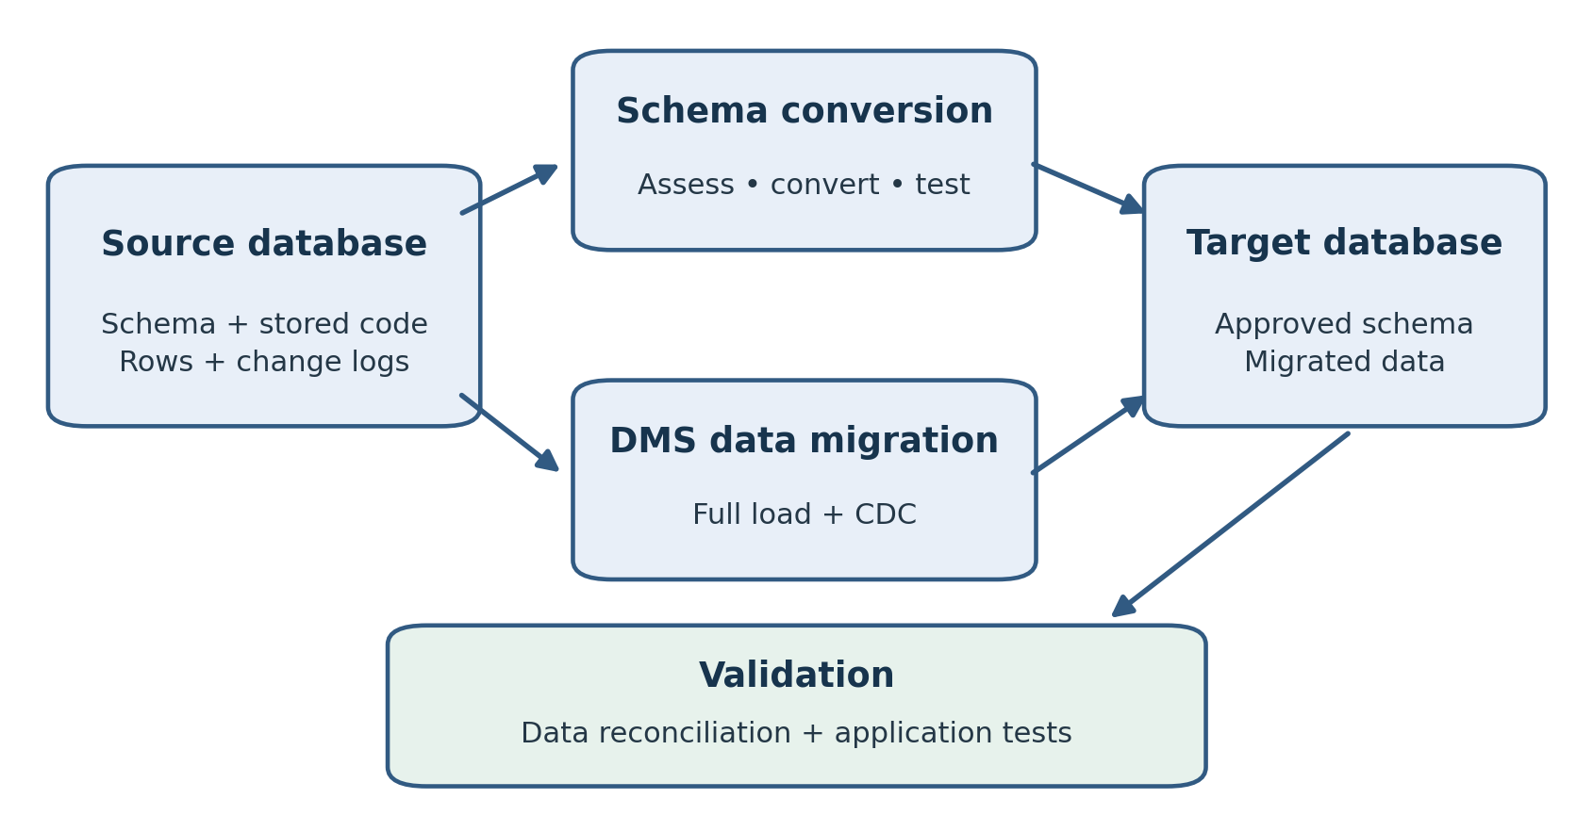
Figure 8.1. Schema conversion and data migration are separate paths, followed by data and application validation.
A heterogeneous migration has two related problems: making the target behave correctly and moving data into it. Schema conversion addresses structure and database code. AWS Database Migration Service, or AWS DMS, provides data migration capabilities, including initial loading and change data capture for supported paths. Neither part eliminates the need to test the application.
An Oracle DBA may recognize familiar replication concepts: a source position, retained logs, a capture process, a change backlog, and target apply. What changes is the service interface and the exact support matrix. This chapter explains a practical workflow from assessment to validated target data. The final production cutover and rollback decision receive their own treatment in Chapter 10.
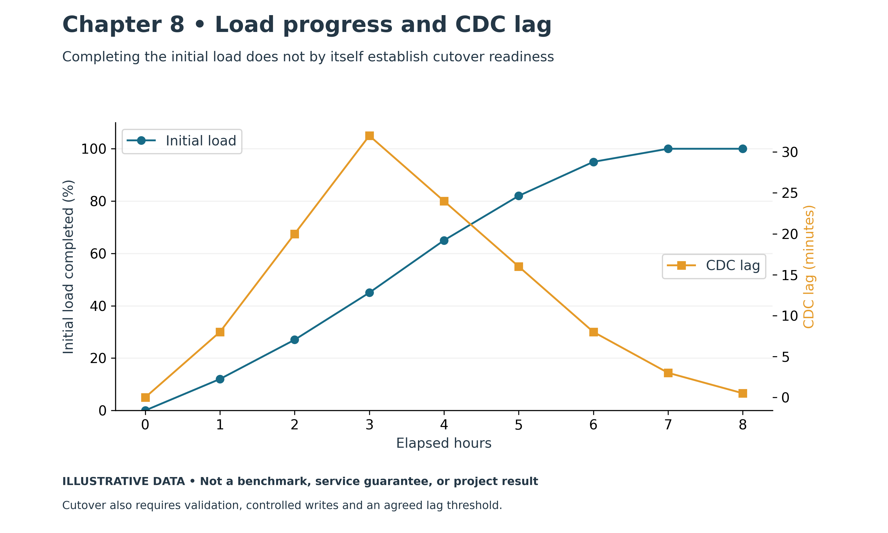
Figure 8.2. Migration progress and CDC lag. Illustrative chart; values are examples, not measured production results.

From the Field: The Migration That Was "Just Data"
I have run into every problem in this story, not once but across many heterogeneous migrations. The project below brings them together in one place, because sooner or later most migrations meet several of them.
The plan looked simple on paper. An Oracle database would move to Aurora PostgreSQL using AWS Database Migration Service: a full load to copy the existing data, followed by change data capture to keep the target in sync until cutover. The project schedule treated it as a data copy. DMS would move the rows, and we would point the application at the new database.
The first surprise came on the first test run. DMS created the tables and loaded the rows, but that was nearly all it created. The primary keys were there. The secondary indexes were not. Neither were the foreign keys, the default values, the triggers, the stored procedures or the hundreds of PL/SQL packages the application relied on. DMS is built to move data, not to rebuild a database. Every one of those objects had to be converted with the AWS Schema Conversion Tool, fixed by hand where the conversion fell short, and deployed on the target as a separate workstream. The "data copy" had just become a schema conversion project.
The second surprise was the large objects. A few tables held documents and scanned images in BLOB and CLOB columns. The ordinary tables loaded quickly. The LOB tables crawled. In full LOB mode, DMS fetched each large value separately, so the load ran far slower than the row counts suggested. We tried the usual remedy, splitting the big tables into ranges and loading them in parallel, and it barely helped. The large values were the bottleneck, not the number of rows. Limited LOB mode was faster, but it truncated anything over the configured size, and some of our documents were larger than anyone had told us. We had to profile the real LOB sizes, choose settings table by table, and give the largest tables their own task.
Then we learned how much DMS depends on configuration. Parallelism, commit batch sizes, memory for LOB buffers, logging levels and validation settings all interacted. One run failed not because of bad data, but because the replication instance ran short of memory and its storage filled with buffered changes. Another stalled because the network path to the source was saturated during the business day. Most of our failures were operational, not data corruption.
CDC brought its own lessons. During a busy batch window, the target fell behind. Capture kept up with the source, but applying changes on Aurora was slower than the source produced them, and the backlog grew. Later, a task restart replayed changes that had already been applied, and the task stopped on duplicate primary keys. A column of JSON documents stored in an Oracle CLOB was meant to land in a native PostgreSQL JSON column, and the first malformed document stopped the stream. When a task broke badly enough, finding a clean restart point meant matching an Oracle SCN to what the target already contained. Once, the archived logs we needed had already been deleted, and the only safe option was a full reload.
The last surprise came during validation. Row counts matched. The application still failed. A character set conversion had turned a few special characters into something else, and some names no longer fit their columns because Oracle had measured length in bytes and the new definitions didn't account for it. Because the foreign keys hadn't been created during the load, a handful of orphaned child rows had slipped through. Nothing in the data copy had flagged any of it. We found these problems only because we wrote our own reconciliation checks and ran the application against the target.
The migration succeeded in the end, but not on the original schedule. The data copy was never the hard part. Everything around it was.
Modern practice: plan schema conversion and data movement as separate workstreams. Profile LOBs, protect source-log retention, monitor capture and apply separately, rehearse restart, and validate business totals and application behavior. The following sections develop these controls. This story combines issues encountered across several migrations rather than describing one project.

8.1 Separate structure, data, and application behavior
Treat the migration as three workstreams. The schema workstream handles tables, types, keys, views, stored code, and supporting objects. The data workstream handles the baseline, ongoing changes, errors, and reconciliation. The application workstream handles drivers, SQL, transactions, generated values, authentication, and integration behavior.
DMS Schema Conversion is a managed conversion feature built on the AWS Schema Conversion Tool conversion engine. AWS SCT is also a tool used for schema assessment and conversion. Check which conversion paths and deployment options fit the project. Schema conversion does not move the application data; data migration is a separate operation. [1]
Do not assume that a DMS-created target table is a complete production schema. The target needs deliberate design and deployment of the objects required by the application. Keep conversion scripts under version control and define which tool owns table creation. Otherwise, a data-loading task can replace a carefully converted table with a different definition.
Maintain a manifest of all objects expected on the target. Use it to distinguish objects deployed before loading, objects enabled after loading, and objects that remain intentionally absent. Record a reason for each exception so that a missing trigger is not mistaken for a completed decision.

8.2 Read an assessment report as a work queue
Run assessment against the actual source scope and chosen target engine. Review action items by business importance, complexity, dependencies, and test effort. Assign each unresolved item to an engineer with a proposed implementation and acceptance test.
Conversion percentages can be misleading. A schema with 1,000 easily converted tables and one unconverted pricing package may still have a major blocker. Review the application's critical transaction paths and the stored code they call. A converted object that compiles can still calculate a different result.
For each important function, prepare input and expected-output cases before rewriting it. Include normal transactions, boundary values, nulls, exceptions, and concurrency. Use these cases to compare the source implementation with the target implementation. This turns conversion into a measurable engineering task.
Keep deployment repeatable. Rebuild a clean target from the approved scripts during rehearsal rather than manually fixing objects only in one database. Manual edits that never reach version control create a target the next migration run cannot reproduce.

8.3 Test semantic differences explicitly
Review Oracle NUMBER columns individually. Some represent integers, some require fixed decimal precision, and some contain values that do not fit the proposed target type. Profile real minimums, maximums, scale, and future requirements. A generic mapping applied across a schema can introduce rounding or overflow in a critical table.
Oracle DATE includes a time component. A target date-only type can lose information. Define whether a value represents a local business time, a UTC instant, or a date without time. Then test time-zone conversion, daylight-saving boundaries, and client display. Similar-looking type names do not guarantee equivalent meaning.
Oracle character semantics also need attention. Oracle generally treats a zero-length character string as null, while PostgreSQL distinguishes an empty string from null. Review checks, concatenation, filters, and application validation that depend on this behavior. Test explicit cases instead of normalizing every value without a business decision.
Inspect identifier case, collation, sort order, pagination, implicit conversions, exception handling, and transaction boundaries. Stored code can depend on package state, autonomous transactions, or engine-specific locking. A replacement should preserve the application's required behavior, even when the target implementation uses a different technique.
Sequences and identity columns deserve a separate deployment and cutover procedure. Copying rows with their identifiers does not prove that the target's generator will issue the next safe value. Test a new application insert after the final synchronization and coordinate generator state with all migrated rows.

8.4 Understand the DMS execution model
A conventional DMS replication task connects a source endpoint and a target endpoint through replication compute. Provisioned replication instances and DMS Serverless offer different capacity-management models. Verify engine, feature, networking, and Region support for the chosen model; changing the capacity model does not remove endpoint requirements.
An endpoint contains connection information and engine-specific settings. A task defines migration type, table selection, transformations, loading behavior, logging, and validation. Keep these configuration artifacts alongside the migration runbook, excluding secrets. Record their versions so the team can reproduce a rehearsal.
Three common task types are full load, full load plus CDC, and CDC only. Full load copies existing rows. Full load plus CDC also captures and applies ongoing changes. CDC only assumes that a suitable baseline already exists and requires a source position coordinated with that baseline. [2]
Do not confuse a successful endpoint test with a successful migration. A connection can authenticate while lacking a privilege needed for a particular table, log-reading method, or data type. Use a small representative task to prove reading, applying, updating, deleting, and validating data before expanding the scope.

8.5 Establish connectivity and controlled access
Place replication compute where it can reach both databases through the approved network paths. Validate routing, security groups, network ACLs, name resolution, and TLS from that execution environment. Check the path in both directions where return routing requires it. A database port opened on one firewall is only one part of connectivity.
Separate AWS resource permissions from source and target database permissions. The source account needs the documented read and capture privileges for the selected engine and method. The target account needs the permissions required to load and apply changes. Use dedicated migration identities and document when their access will be removed.
For private on-premises sources, plan the VPN or Direct Connect path and its failure behavior. Measure effective throughput and latency. During a network outage the source can keep producing changes, so log retention and replication storage need enough margin for recovery.
Configure TLS deliberately, including certificate trust and endpoint verification where supported. Store credentials using approved secret handling. Keep passwords out of task exports, shell history, screenshots, and source control. Test credential rotation in rehearsal if rotation could occur during a long migration.

8.6 Prepare the source for CDC
CDC prerequisites vary by engine. Oracle migrations require attention to archive logging, supplemental logging, privileges, and log access. DMS can use Oracle LogMiner or its Binary Reader for supported configurations; select the method based on the documented requirements and a workload test. CDB/PDB, ASM, RAC, and source version details can affect setup. [3]
Use the engine-specific documentation as the authority for exact grants and endpoint attributes. Do not copy a SYSDBA grant from an unrelated example simply to make an endpoint test pass. Request the smallest documented privilege set that supports the chosen configuration and verify it with actual migration operations.
Profile table keys before starting CDC. A primary key or suitable unique key helps identify the row being updated or deleted. A table without one needs a deliberate supported strategy and testing; duplicate business rows make reconciliation harder. Adding a key can itself require a source change, data cleanup, and an operational window.
Measure additional source work after enabling capture prerequisites. Supplemental logging and capture can increase resource consumption. Confirm that archive-log storage and retention remain sufficient during the full load, anticipated interruptions, and catch-up. Monitor the source's production response time as well as replication health.
For other engines, examine their corresponding log and replication requirements. PostgreSQL logical decoding and MySQL binary logging have their own settings and retention considerations. Oracle procedures cannot be translated into another engine by changing table names.

8.7 Define table mappings and preparation behavior
Make table selection explicit. Verify schema name case, inclusion rules, exclusion rules, partitions where relevant, and transformations against the approved manifest. Test that an excluded audit or staging table is genuinely excluded. Broad wildcard rules are convenient but can unintentionally include newly created tables.
Review target preparation settings before every task run. Depending on configuration, a task can leave existing tables, truncate them, or drop and recreate them. These choices are materially different. A truncate can remove test evidence; a drop can remove converted definitions and supporting objects. Inspect the actual task settings rather than relying on a remembered console default. [4]
Document the order for constraints, indexes, and triggers. Loading into a target with every secondary index can increase load time, while a target without required keys can complicate CDC. A target trigger can duplicate side effects already represented by source changes. Rehearse the chosen object lifecycle and include the steps needed to make the target production-ready.
Do not let applications write to the target while it is being used as a one-way migration destination. Even a test that inserts a harmless row can create conflicts or distort validation. Use a separate application-test clone or a controlled reset procedure for tests that modify data.

8.8 Choose LOB settings from measured data
Large objects require profiling before settings are selected. Measure the number of LOB columns, null rates, size distribution, largest values, and how often values change. A setting that works for a table of short comments may be unsuitable for scanned documents or binary attachments.
DMS has limited, full, and inline LOB modes for supported endpoints. Limited mode uses a configured maximum size and can truncate values beyond the limit. Full mode handles large values through additional processing; inline mode handles smaller values inline and larger values through full LOB processing. Endpoint support and key requirements vary. [5]
Create test rows below, at, and above the proposed boundary. Compare full content, not just row counts, on the target. Include updated LOBs during CDC and null-to-value transitions. Inspect warnings and validation behavior. A table that reports a completed load can still contain incomplete large values if the configuration was unsuitable.
Tune using the measured workload. Larger LOB buffers and more parallel loading can consume additional replication memory. Separate exceptionally large tables into their own tested arrangement when that improves observability or capacity control. The goal is a correct and sustainable pipeline, not the largest possible concurrency setting.

8.9 Manage the full load and catch-up period
Track progress by table, including rows loaded, errors, elapsed time, and outstanding work. A task-level running status hides individual table failures. Compare loaded tables against the manifest and investigate suspended or errored tables immediately.
Full load and CDC overlap, so the target is not automatically ready for application reads as each table finishes. Related tables can be at different stages. Avoid interpreting temporary differences during loading as proof of corruption or consistency. The readiness gate must consider the whole required scope and its synchronization state.
Start with conservative concurrency and increase it based on source impact, replication resource usage, and target capacity. More loading threads can move the bottleneck to target storage, lock contention, network throughput, or memory. Rehearse both the load and the subsequent catch-up phase under representative source activity.
Plan for long transactions. A transaction can begin before a planned boundary and commit later, complicating simplistic timestamp comparisons. Track the migration's documented position and transaction handling. At the final writer freeze, drain active transactions and prove that the pipeline has reached the agreed endpoint.

8.10 Diagnose latency as a pipeline
Observe source capture, replication compute, and target apply separately. Source-side delay suggests capture is behind current source activity. Target-side delay can reflect captured changes waiting or taking time to apply. The exact interpretation of DMS metrics should follow their definitions; a single lag value does not identify the bottleneck.
Observation | Questions to investigate | Useful evidence
Capture falls behind | Are logs accessible and capture resources sufficient? | Source load, log access, capture messages
Apply falls behind | Is target work slow or blocked? | Target waits, locks, I/O, apply messages
Backlog grows | Can sustained capacity exceed incoming work? | Change rate and backlog trend
Replication storage fills | Are buffered changes accumulating? | Free storage and disk spill trend
One table fails | Is there a key, type, permission, or data issue? | Table statistics and precise error
Correlate the event with a source batch, target index build, network interruption, or resource change. Preserve task and table logs before making changes. Fix the underlying problem and observe whether the backlog shrinks over a meaningful interval.
Restarting repeatedly can obscure the cause and extend recovery. Understand resume, reload, and restart behavior before using them. A table reload may alter target contents and require a fresh validation pass. Treat it as a documented operation rather than an automatic response to every error.

8.11 Validate data at several levels
Use DMS validation where the migration path supports it and review pending, failed, and suspended validation results. Validation reads add work to the source and target, so include that cost in capacity planning. Keys, data types, transformations, and endpoint limitations affect what can be compared. [6]
Add independent reconciliation. Compare object counts, row counts by stable ranges, key uniqueness, null distributions, numeric totals, and selected content checks. Normalize representations deliberately when comparing different engines. A raw hash of differently formatted timestamps or decimals can produce a mismatch even when the intended business value is equivalent.
Choose a common consistency boundary. Counts read independently from a changing source and a lagging target can differ for legitimate reasons. Final reconciliation should use a controlled writer freeze or another explicitly designed comparison point. Include the time and migration position with the validation evidence.
Validate business outcomes as well as rows. Check order totals, account balances, document availability, historical reports, and a complete application transaction. Confirm that a new row receives a safe generated identifier. A successful data comparison does not establish that privileges, jobs, or stored logic are ready.

8.12 Worked example: Oracle to Aurora PostgreSQL
An illustrative HEALTH application needs its relational data and document attachments moved from Oracle to Aurora PostgreSQL. The team first converts tables and code, resolves an Oracle-specific reporting function, and tests date and numeric behavior. Approved schema scripts create the target before loading.
A pilot migration selects three representative tables: a small reference table, a frequently updated transactional table, and a LOB table. The test includes inserts, updates, deletes, and a document larger than the initially proposed LOB limit. That last test exposes a configuration problem before the full load begins.
The team adjusts the supported LOB mode, retests content, and enables validation for the supported scope. It records the source logging configuration and retention budget, then runs the full-volume rehearsal. During a peak batch, target apply falls behind; target wait evidence reveals costly maintenance work competing with apply. The team reschedules that work and repeats the affected test.
Finally, the rehearsal freezes all source writers, drains transactions, observes completion to the chosen endpoint, and reconciles business totals. Sequence state and target application permissions are checked separately. The evidence supports a cutover estimate; it does not authorize skipping the production checks.

8.13 Practical exercise and review
In an isolated lab, build a small source with a parent table, child table, generated identifier, and LOB column. Prepare a supported target and deploy its schema intentionally. Record the endpoint configuration, selection rules, target preparation setting, LOB setting, and validation choice before running the task.
Run a full-load-plus-CDC migration on a supported path. Change rows on the source, including an update and delete, and verify the target. Introduce a large LOB boundary case and compare its complete content. Record table statistics, task messages, and the resource impact of validation.
Perform a controlled writer freeze and final reconciliation. Explain how you know the target has reached the chosen endpoint. Remove lab resources and temporary access when finished, including replication compute and retained staging data.
Review question: Does automatic schema conversion prove application compatibility? Answer: no. Converted structures and code still require semantic, transaction, and application tests.
Review question: Why can a completed load contain incomplete documents? Answer: unsuitable LOB settings can omit or truncate content. Full content checks and task warnings must be reviewed.
Review question: Why do equal row counts provide weak validation? Answer: different values, duplicate keys, missing relationships, or incorrect transformations can exist with the same count.
Review question: When is CDC-only appropriate? Answer: when a compatible baseline has already been loaded and its consistency point is correctly coordinated with retained source changes.
DMS provides a useful migration pipeline, but some workloads fit native tools better. The next chapter compares those tools and shows how a native baseline can be combined with a separately coordinated replication stream.

References
[1] AWS DMS User Guide, Converting database schemas using DMS Schema Conversion. https://docs.aws.amazon.com/dms/latest/userguide/CHAP_SchemaConversion.html
[2] AWS DMS User Guide, Creating a task. https://docs.aws.amazon.com/dms/latest/userguide/CHAP_Tasks.Creating.html
[3] AWS DMS User Guide, Using an Oracle database as a source for AWS DMS. https://docs.aws.amazon.com/dms/latest/userguide/CHAP_Source.Oracle.html
[4] AWS DMS User Guide, Full-load task settings. https://docs.aws.amazon.com/dms/latest/userguide/CHAP_Tasks.CustomizingTasks.TaskSettings.FullLoad.html
[5] AWS DMS User Guide, Setting LOB support for source databases in an AWS DMS task. https://docs.aws.amazon.com/dms/latest/userguide/CHAP_Tasks.LOBSupport.html
[6] AWS DMS User Guide, AWS DMS data validation. https://docs.aws.amazon.com/dms/latest/userguide/CHAP_Validating.html
[7] AWS DMS User Guide, Best practices for AWS Database Migration Service. https://docs.aws.amazon.com/dms/latest/userguide/CHAP_BestPractices.html

Chapter 9: Native Tools and Hybrid Approaches
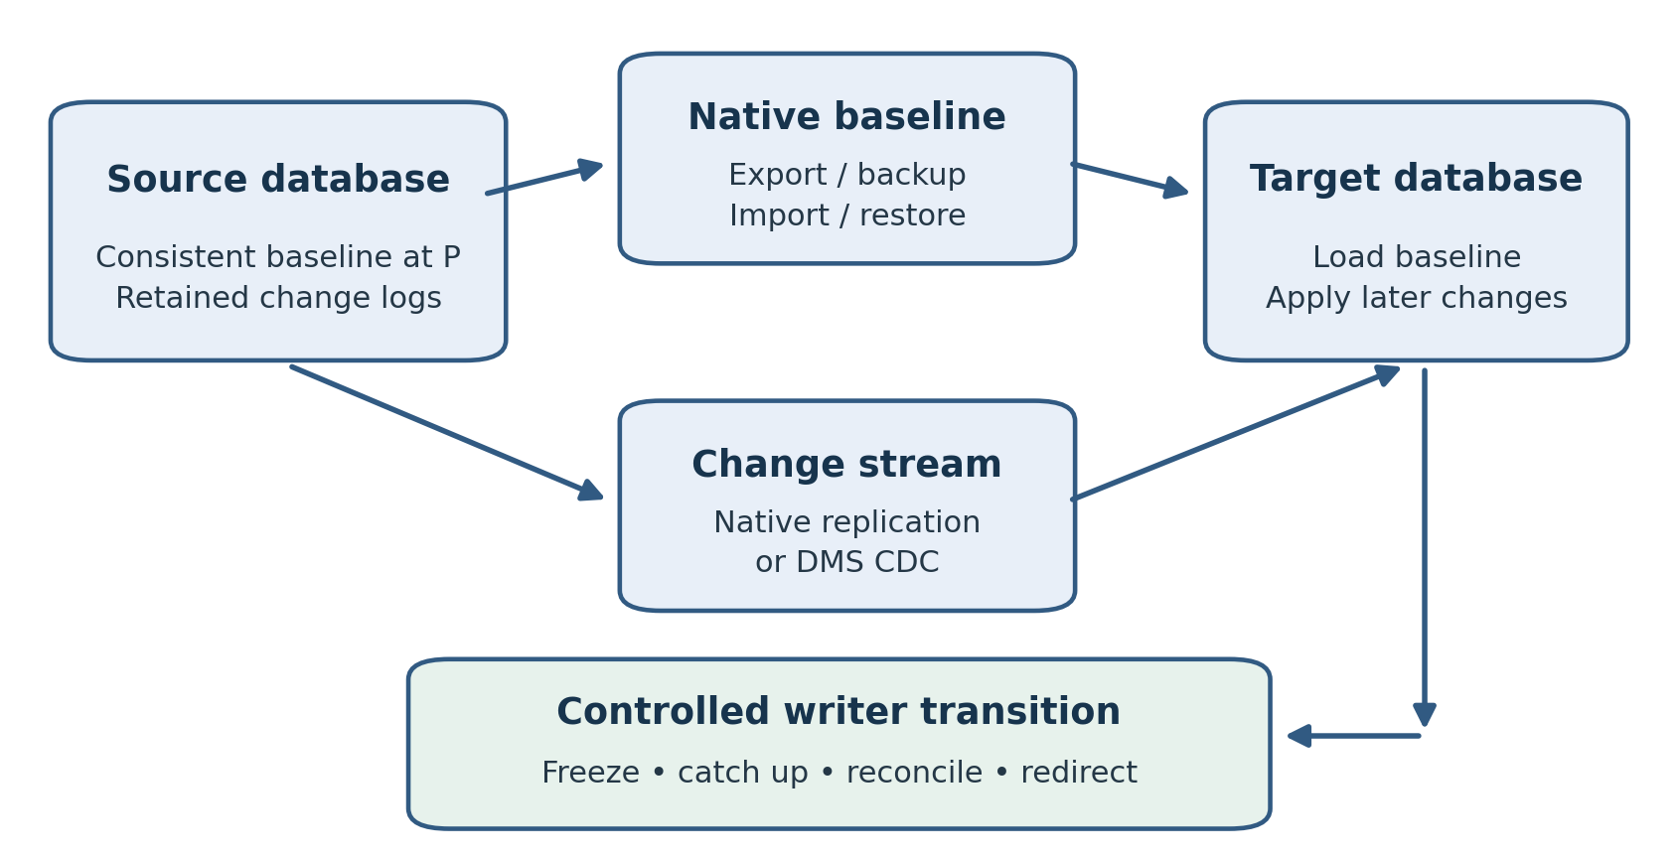
Figure 9.1. A hybrid migration coordinates a native baseline at point P with a supported change stream. Exact synchronization depends on the tools and engine.
AWS DMS is one migration option, but a DBA should also evaluate the tools native to the source engine. A homogeneous migration may preserve database structures and behavior more conveniently through a logical export, supported backup import, or native replication. The right choice depends on the destination's operating boundary, the data volume, and the measured outage window.
Native tools are not interchangeable. Oracle Data Pump exports logical objects and data, while RMAN works with physical backup and recovery. PostgreSQL pg_dump produces a logical export; its result is not a physical replica. A managed database service can accept selected import methods without exposing the operating system or allowing arbitrary backup restoration.
This chapter compares the main choices and explains hybrid approaches that use one tool for the baseline and another for ongoing changes. The central requirement is a consistent handoff: the replication stream must correspond to the exact state represented by the loaded baseline.

9.1 Begin with the destination boundary
On EC2, the team controls the host and database installation. That control can make a familiar physical restore or replication arrangement practical, provided versions, platforms, storage, privileges, and licensing are compatible. It also leaves the team responsible for operating the resulting database.
On RDS and Aurora, use the documented import or replication path for that engine and version. Host access and administrative permissions differ from self-managed deployments. A method that works on EC2 can fail on RDS because it expects filesystem access, an unsupported extension, or unrestricted administrative privileges.
Workload and destination | Candidate method | Requirement to prove
Oracle schema to RDS Oracle | Data Pump import | Supported objects, version, permissions, duration
Oracle to EC2 Oracle | RMAN restore or Data Pump | Physical compatibility or logical import readiness
Large supported Oracle scope to RDS Oracle | Transportable tablespaces | Eligibility and documented managed workflow
PostgreSQL to RDS or Aurora PostgreSQL | pg_dump/pg_restore, logical replication | Extensions, ownership, schema, synchronization
MySQL to RDS MySQL | Logical dump, supported S3 backup import, replication | Version and backup compatibility, log position
SQL Server to RDS SQL Server | Supported native backup and restore | Option, permissions, version, feature support
Treat the table as a shortlist. A production selection requires an actual test against the proposed destination. Include import, post-load object work, validation, and application checks in the timing.

9.2 Oracle Data Pump for logical migration
Data Pump fits many Oracle-to-Oracle schema migrations. It moves logical data and metadata, allowing the team to select a schema and review remapping or exclusion requirements. RDS for Oracle documents supported import methods, including Data Pump workflows with Amazon S3. [1]
Prepare an object inventory before exporting. Review tablespaces, directory objects, grants, jobs, links, and engine-specific objects. Some objects require replacement, manual deployment, or omission on a managed target. Preserve an exception register and inspect the import log object by object.
Data Pump executes work on the database server even when a client launches the command. A local pathname on the DBA laptop is not automatically a server directory. On RDS, use the documented directory and S3 integration procedures, including the required IAM and database setup. Test file accessibility before beginning a large export or import.
Plan export consistency deliberately. For a cross-table consistent Oracle export, an appropriate FLASHBACK_SCN or FLASHBACK_TIME setting can establish a common point; sufficient undo must remain available for the export. Changing data and concurrent DDL require care. Record the point used and verify that the complete selected scope was exported successfully. [2]
After import, compare expected objects, compile stored code, inspect failures, restore intended grants, and validate the data. Measure index construction and statistics collection separately. The final part of an import can take substantial time even after most rows have arrived.

9.3 RMAN and transportable tablespaces
RMAN is a natural choice when moving a compatible self-managed Oracle database to another self-managed Oracle installation. Rehearse restoration, recovery, database identity, file placement, encryption-key availability, and connectivity. A backup that validates successfully still needs a demonstrated restore and application test.
Avoid treating RDS for Oracle as an unrestricted RMAN destination. RDS offers a documented transportable-tablespace workflow that uses physical files and metadata through managed procedures. Eligibility and restrictions must be checked for the source and target. This is a specific supported path, with its own stages and recovery considerations. [3]
For transportable tablespaces, identify a self-contained set and examine dependencies outside it. Review platform compatibility, character set, source and target versions, encryption, and downtime requirements. Physical data movement can reduce work compared with recreating every row, but metadata and final synchronization still matter.
An EC2 intermediate database is another possible arrangement. It can provide a controlled place to restore a source backup and then produce a supported logical export for RDS. Account for the additional storage, compute, licensing, elapsed time, and data protection. Adding an intermediate copy creates another environment that must be reconciled and cleaned up.

9.4 PostgreSQL logical dumps
For a homogeneous PostgreSQL migration, pg_dump and pg_restore provide a familiar logical path. A custom-format archive allows selective restoration and suitable parallel restore work. Use compatible client tooling and test the exact source and target versions. AWS documents native import approaches for RDS PostgreSQL. [4]
Inventory extensions, roles, privileges, ownership, tablespaces, collations, and external dependencies. A per-database dump does not capture every cluster-wide operating object. Review the restore plan for managed-service restrictions rather than trying to recreate self-managed superuser behavior on the target.
Review restore errors individually. A failed ownership assignment may require an intentional mapping; a failed extension creation can make application objects unusable. Do not hide all errors behind a general instruction to ignore warnings. Maintain a small approved exception list and investigate anything outside it.
A consistent dump represents a point in time. Writes committed afterward do not appear unless another process carries them. Therefore, an offline plan must prevent subsequent source writes until the application moves, while an online plan needs a coordinated change stream. The dump's consistency does not by itself make the migration current.
After loading, collect appropriate statistics and test representative SQL. Compare required privileges and perform an application transaction using the application's own account. Restoring as an administrator can conceal permission problems that ordinary application users will encounter.

9.5 PostgreSQL logical replication
Logical replication can support an online migration of selected tables on a compatible, supported path. It uses a publication and subscription arrangement and needs appropriate replication identity for the operations being replicated. Verify the managed-service setup, version compatibility, and available features before using it.
PostgreSQL's documented logical replication restrictions include schema/DDL handling and sequence state. Ordinary sequence state is not copied simply because generated identifier values arrive in replicated rows. Deploy required schema changes deliberately and synchronize generators as part of the final writer transition. [5]
Replication slots can retain WAL needed by a consumer. Monitor retained WAL and storage when a subscriber is slow or disconnected, and define alerts and response steps. A stopped consumer is a source-capacity concern as well as a migration-delay concern. [6]
Use either a supported initial synchronization mechanism or a carefully coordinated external baseline. Do not import a dump and create a subscription that also copies the same rows without understanding the result. Duplicate loading, gaps, and conflicting apply can follow an unplanned combination of methods.

9.6 MySQL dumps, backup imports, and replication
Logical dumps are useful when their measured export and restore duration fits the plan. Review consistency across the storage engines used, stored routines, triggers, events, character sets, and generated values. A consistent option for transactional tables does not automatically protect nontransactional tables or concurrent DDL.
RDS for MySQL also documents importing supported Percona XtraBackup files from S3 into a new DB instance. This is a defined backup-import feature with source-version, backup-version, and other restrictions; it is not a general upload of arbitrary MySQL data files. Confirm eligibility before producing a large backup. [7]
For a low-downtime move, a baseline can be followed by external binlog replication where supported. The source binlog coordinates or GTID position must correspond to the baseline. Use the RDS procedures documented for the target engine version, because procedure names and supported arrangements can differ. [8]
Retain logs long enough for backup transfer, import, interruptions, and catch-up. Inspect replication errors and executed positions, then test updates and deletes. A reported connection to the source is insufficient proof that the target is current and correct.

9.7 SQL Server native backup and restore
RDS for SQL Server supports a native backup-and-restore workflow using S3 and documented stored procedures. Prepare the required option and IAM permissions, review engine-version and feature limitations, and protect the backup and any necessary encryption material. A backup from an unsupported source configuration will not become compatible merely because it is stored in S3. [9]
Remember that database contents are only part of a SQL Server deployment. Inventory server-level logins, SQL Agent jobs, credentials, linked servers, and application dependencies. Map them to supported target arrangements and test the application identity after restoration.
Distinguish backup restoration from a continuously synchronized migration. Any full or differential backup chain used must match a supported restore sequence. If the allowed outage is shorter than the measured native workflow, assess a supported replication or migration alternative and rehearse it. Do not assume arbitrary transaction-log shipping into RDS is available.

9.8 Combine a native baseline with CDC carefully
A hybrid method can use Data Pump for Oracle metadata and bulk data, followed by DMS CDC for later changes. AWS describes this approach for Oracle-to-RDS Oracle migrations. Its value comes from matching native bulk loading with a change pipeline; its difficulty lies at their boundary. [10]
Define a baseline point P using the chosen tool's consistency mechanism. Establish a supported capture arrangement that retains all required changes around P, including the documented treatment of transactions spanning that point. Load the baseline, then apply the corresponding later changes using the supported handoff procedure.
Starting CDC at the time the import finishes can omit changes committed during the export and import. Starting it arbitrarily earlier can reapply work already represented by the baseline. A timestamp in a spreadsheet is not a substitute for a tested source position and tool-specific synchronization procedure.
Rehearse inserts, updates, deletes, and a transaction spanning the handoff. Check key conflicts, LOB content, and changes made during the longest load stage. Confirm that task settings preserve the imported target. Keep the baseline identity, capture position, task configuration, and final reconciliation evidence together.

9.9 Where GoldenGate and other replication tools fit
Teams with Oracle GoldenGate expertise may evaluate it for a supported migration path. Existing experience with capture, trails, checkpoints, and apply can be useful. Check the product's support matrix, licensing, target integration, data-type handling, and administrative requirements for the actual configuration.
GoldenGate Microservices describes a deployment and management architecture. It does not by itself establish engine compatibility or the appropriate capture/apply mode. Likewise, a running Extract or Replicat is operational evidence, but it does not prove that every required object and change has been migrated.
Whichever replication product is chosen, document baseline synchronization, log retention, keys, DDL policy, failure recovery, and reconciliation. Decide who owns conflicts and table reloads. Do not introduce bidirectional replication merely as an assumed rollback feature; it requires a separately engineered conflict and ownership model.

9.10 Prove the whole method
Time every stage in rehearsal: export or backup, transfer, import or restore, recovery, index work, catch-up, validation, and application checks. Inspect logs and object manifests, then compare business totals at a common boundary. Include the operational configuration needed after temporary load settings are reversed.
For an illustrative 400 GB Oracle schema with a two-hour outage window, suppose Data Pump import and indexing need four hours. An offline move fails the requirement even if export is very fast. The team can evaluate a native baseline plus CDC, but must demonstrate correct synchronization and a final freeze that fits the remaining window.
If the online method cannot catch up during peak activity, increasing the outage window, changing capacity, reducing the approved scope, or selecting another method are possible decisions. Each needs evidence and business approval. Hiding an unresolved backlog behind a planned restart creates uncertainty at cutover.

9.11 Practical exercise and review
Select one nonproduction database and compare a native offline method with an online or hybrid alternative. Record prerequisites, target restrictions, consistency mechanism, retained-log requirements, expected stages, and cleanup. Run the native export and restore, and inspect every error against the object manifest.
For the online option, draw the baseline and capture handoff on a timeline. Identify a transaction that crosses the chosen boundary and explain how the documented method handles it. Test a new generated identifier on the target after synchronization. Deliver timing and reconciliation evidence, not only a statement that the tools completed.
Review question: Why is RMAN restoration to EC2 different from migration to RDS Oracle? Answer: EC2 permits a self-managed host and database, while RDS requires its supported managed workflows and restrictions.
Review question: What can go wrong when CDC begins after import? Answer: changes made after the baseline but before capture begins can be missing from the target.
Review question: Why test jobs and application accounts after a successful restore? Answer: data restoration does not necessarily recreate every operating dependency or permission needed by the application.
The chosen method is ready when it can reproduce the correct target and demonstrate a reliable synchronization boundary. Chapter 10 applies that evidence to the production cutover, rollback decision, and final acceptance.

References
[1] Amazon RDS User Guide, Importing data into Oracle on Amazon RDS. https://docs.aws.amazon.com/AmazonRDS/latest/UserGuide/Oracle.Procedural.Importing.html
[2] Oracle, Oracle Database Utilities Data Pump best practices. https://www.oracle.com/apac/a/tech/docs/oracle-database-utilities-data-pump-bp-2019.pdf
[3] Amazon RDS User Guide, Migrating using Oracle transportable tablespaces. https://docs.aws.amazon.com/AmazonRDS/latest/UserGuide/oracle-migrating-tts.html
[4] Amazon RDS User Guide, Importing data into PostgreSQL on Amazon RDS. https://docs.aws.amazon.com/AmazonRDS/latest/UserGuide/PostgreSQL.Procedural.Importing.html
[5] PostgreSQL Documentation, Logical replication restrictions. https://www.postgresql.org/docs/current/logical-replication-restrictions.html
[6] PostgreSQL Documentation, Logical decoding concepts. https://www.postgresql.org/docs/current/logicaldecoding-explanation.html
[7] Amazon RDS User Guide, Restoring a backup into an Amazon RDS for MySQL DB instance. https://docs.aws.amazon.com/AmazonRDS/latest/UserGuide/MySQL.Procedural.Importing.html
[8] Amazon RDS User Guide, Configuring binary log file position replication with an external source instance. https://docs.aws.amazon.com/AmazonRDS/latest/UserGuide/MySQL.Procedural.Importing.External.ReplMariaDB.html
[9] Amazon RDS User Guide, Importing and exporting SQL Server databases using native backup and restore. https://docs.aws.amazon.com/AmazonRDS/latest/UserGuide/SQLServer.Procedural.Importing.html
[10] AWS Database Blog, Plan an Oracle migration to Amazon RDS for Oracle using Oracle Data Pump and AWS DMS. https://aws.amazon.com/blogs/database/plan-an-oracle-migration-to-amazon-rds-for-oracle-using-oracle-data-pump-and-aws-dms/

Chapter 10: Cutover Rollback and Validation
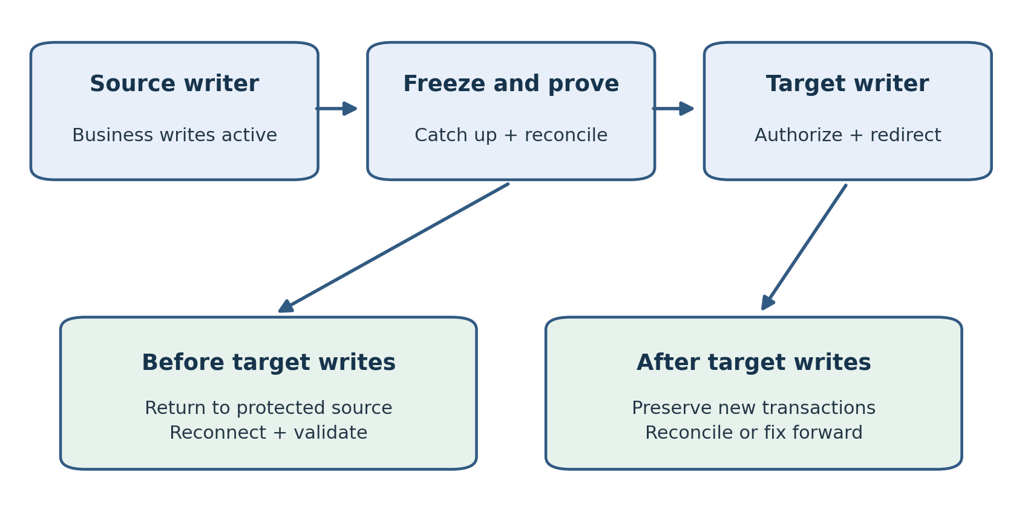
Figure 10.1. The writer transition changes the recovery decision. Before target writes, return can use the protected source; afterward, new business transactions must be preserved.
A migration becomes a business change when applications begin writing to the new database. Copying data and observing low replication lag are necessary preparations, but neither proves that the transition is ready. Cutover must coordinate database state, application connections, background jobs, and the people authorized to accept the result.
This chapter develops a cutover procedure for the migrations discussed in Chapters 7 through 9. It explains how to establish a final synchronization point, validate the target, distinguish rollback before and after target writes, and close the migration without losing the evidence needed for support. The central requirement is that every acknowledged business transaction has an understood destination.
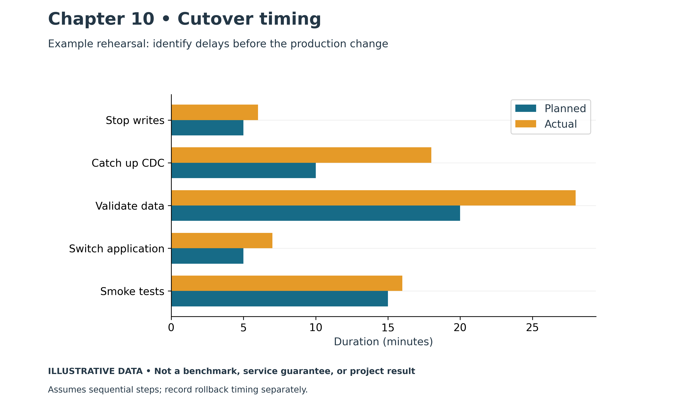
Figure 10.2. Planned versus actual cutover. Illustrative chart; values are examples, not measured production results.

From the Field: The Backup That Couldn't Come Back
The go-live was scheduled, the business was ready, and the last remaining task was a platform patch.
The system was a data lake of about 100 TB built on Cloudera Hadoop, with roughly 5,000 tables stored in Kudu and Spark jobs processing data that came from Oracle databases I supported. About 50 of those tables were between 500 GB and 1 TB each. I knew the system from both ends. I looked after the Oracle sources that fed it, and I regularly worked in Impala and Hive to fix queries and check the metrics the business relied on.
The patch and the environment changes that came with it meant the Kudu tables could not simply stay in place. They would have to be rebuilt. So before the patch, the data had to be backed up and then restored into the rebuilt tables afterward. Space was tight. With more than 100 TB in Kudu, there was nowhere to keep a second full copy in the same form, so the backup was written as Parquet files to another part of HDFS. After the patch, the plan was to recreate the tables and reload them from those files, one table at a time.
Another team ran the backup, which was a sensible division of work. It also turned out to matter. Their export used different parameters from the ones the restore would need.
Nobody knew that until we needed it.
The patch went in, the tables were rebuilt, and the restore began. It failed. I spent the whole weekend working through it: checking the Parquet files, the table definitions, the restore steps, the configuration and the logs, trying to understand why a backup that had completed successfully could not be loaded back. With thousands of tables and dozens of them approaching a terabyte, every attempt took hours. Eventually I found the cause. The Parquet files had been written with parameters that didn't match how the restore expected to read them. The backup job had reported success, but what it produced couldn't be restored the way we needed.
By then the go-live window was gone, and we postponed.
We were lucky in one way. The test and pre-production environments closely matched production, so we could restore the data from test instead. We rebuilt from that copy, validated it, and went live the following week.
The experience changed how I think about every go-live. A backup is only a plan until someone has restored it. A backup job that reports success tells you that something was written. It doesn't tell you that the right data was written, in a form your restore procedure can use, with the parameters the restore expects. When backup and restore are owned by different people, that gap is easy to miss, because each side can be confident its own half is correct.
I was also reminded how valuable a well-maintained test environment is. Because test truly resembled production, it gave us a way back that the backup couldn't. That wasn't part of the plan. It should have been.
Modern practice: treat the pre-change backup as a go-live acceptance item, not a background task. Before any patch or cutover, restore a representative set of tables, including the largest ones, into an isolated environment using the exact procedure and parameters that would be used in an emergency, then validate the data and time the restore. Keep backup and restore definitions together in version-controlled code so the two cannot drift apart, and name one owner for the end-to-end result. Set a go/no-go deadline that leaves time for a failed restore, and identify a second recovery source, such as a validated copy from another environment, before you need it. On AWS, keeping a data lake in Amazon S3, separate from the compute cluster, means patching or rebuilding an EMR cluster does not require moving the data at all, and S3 versioning and AWS Backup add further protection. Each still needs a tested restore. The following sections cover acceptance criteria, rollback deadlines and validation.

Define the Writer Transition
Begin by drawing every path that can change the source database. Include application servers, scheduled jobs, integration accounts, bulk loaders, reporting tools with update privileges, and administrators. A maintenance page may stop customer traffic while a warehouse feed or settlement job continues to write. The freeze procedure must cover those paths explicitly.
Identify which component controls each writer. The application team may stop web requests, a scheduler owner may suspend batches, and the DBA may enforce the agreed database restriction. Describe how each owner proves the change. A message that a job was stopped is weaker evidence than a recorded job state and confirmation that its active transaction has finished or been handled.
Do not assume a read-only application setting makes the database read-only. Enforcement depends on the engine and migration method. Some replication processes need to apply changes while ordinary users are blocked. The chosen control must allow that operation without leaving an overlooked application writer active.
Define the transition as a sequence of database states. Initially the source owns writes and the target receives copied data. During the freeze, the source accepts no new business writes and replication catches up. After validation and authorization, the target becomes the writer. Record the time and synchronization evidence for each state so that responders can establish where a disputed transaction belongs.

Turn Readiness into Acceptance Criteria
Write acceptance criteria before the production window. Include migration completeness, data reconciliation, application behavior, operational access, and recovery readiness. Each criterion needs an owner, a test, and a result that can be evaluated without interpreting optimistic language.
For example, an order migration might require all selected tables loaded, no unexplained validation failures, the final committed source change applied, successful creation of a test order through the application, and a verified target backup configuration. Set workload-specific tolerances for latency and error rate. A transaction count alone cannot establish that order totals, item quantities, and payment references are correct.
Resolve exceptions before cutover wherever possible. If a known historical mismatch is accepted, document its scope and business approval separately. Do not add it to a growing list of unspecified differences during the migration window. Unexplained discrepancies involving current financial or inventory data should stop acceptance until their meaning is established.
Operational readiness matters because the migration team will eventually leave. Confirm that the support team can locate the target, authenticate, inspect monitoring, receive alerts, and follow the recovery runbook. Validate service quotas, target storage headroom, and connectivity from the actual application runtime. A DBA laptop connection does not substitute for that test.

Build a Timed Runbook
Use a runbook that another engineer can follow. Every step should identify its owner, prerequisites, action, expected evidence, estimated duration, and stop condition. Record dependencies instead of assigning every team the same start time. Final reconciliation cannot start against a moving source unless its consistency model accounts for ongoing changes.
Estimates should come from rehearsal. Test the complete sequence with representative data volume, change rate, and application connection behavior. Include approvals and handoffs in elapsed time. If the database work takes twenty minutes but application restarts take thirty, the outage budget must include both.
Leave time for investigation and return to service. Suppose the maintenance window is ninety minutes and the rehearsed rollback takes twenty-five. A team that waits until minute eighty to consider rollback has already lost its safe return window. Establish an abandonment deadline earlier than the end of the outage allowance, and make its decision owner available.
Keep commands and endpoints unambiguous. Record account, Region, database resource identifier, source and target endpoint, and application environment. Use approved credential retrieval rather than embedding passwords. A peer should verify commands that redirect writers, modify replication, or remove access restrictions.

Freeze and Confirm Final Synchronization
Announce the writer freeze through the agreed operating process, then stop new work and handle transactions already in progress. Long-running transactions can delay final synchronization. Decide beforehand whether they will be allowed to finish, cancelled, or rescheduled. Cancellation can have application consequences even when the database rolls back correctly.
Capture a final position appropriate to the method: an Oracle SCN, PostgreSQL log position, MySQL binary log position, or a tool-specific checkpoint. The identifier must have an established relationship to the baseline copy and change stream. Recording an arbitrary current value does not prove that every earlier committed change is present at the target.
For DMS, inspect task health, table state, errors, and the relevant latency measures. Low latency can coexist with a suspended table or an exception. The meaning of a checkpoint depends on the task configuration and engine. Use the rehearsed method to establish completeness, and retain supporting task logs. AWS documents DMS validation as a separate facility with its own requirements and limitations. [1]
Check sequences, identity values, jobs, privileges, and other objects that the chosen migration method does not synchronize automatically. A target can contain all copied rows and still generate duplicate identifiers on its first insert. Do the final object adjustments in the documented order and repeat the relevant checks afterward.

Validate Data at a Consistent Point
Choose validation methods by business risk. Counts are useful for identifying missing batches, but equal counts can hide changed values or swapped records. Add aggregates over business fields, key-range reconciliation, and selected record comparisons. Define how nulls, numeric precision, timestamps, character encoding, and collation differences will be treated.
Run comparisons against equivalent states. If one side continues changing, a difference may be caused by timing rather than migration failure. For a frozen cutover, retain the source reference point and complete the corresponding target synchronization before final comparison. For online validation, use a method that handles changes explicitly rather than comparing unrelated query results.
Consider the cost of validation. A full-table scan can compete with replication or exhaust the remaining window. Perform most broad checks before the freeze, then validate the final changes and critical totals during cutover. This division must be justified by the migration method and rehearsal results; it cannot simply assume that previously checked rows will never change.
Record comparison queries and parameters, not only screenshots of successful results. If a later issue appears, the team needs to know which date range, tenant, and transaction status were included. Preserve discrepancy details in a controlled location because comparison output may contain sensitive data.
Acceptance area | Example evidence | Decision owner
Final data state | Source checkpoint applied and critical totals reconciled | Migration lead and DBA
Application function | Order created and retrieved through normal application path | Application owner
Operational readiness | Alerts delivered and target backup settings verified | Operations lead
Business acceptance | Agreed process checks pass and exceptions are approved | Business owner

Redirect and Test the Application
Change the approved connection configuration, then refresh processes that retain old settings. DNS changes alone may leave connection pools attached to the source. Secrets, environment variables, proxy targets, and application configuration can each contain an endpoint. Inventory those locations during planning and verify them after redirection.
Keep the old source protected from accidental writes. Mixed writers can create two diverging histories even if both databases appear healthy. Review source sessions and application telemetry during the transition. A background process that reconnects to the old endpoint needs immediate handling before its new changes become a reconciliation problem.
Test a small set of normal business transactions. Verify reads, inserts, updates, commits, and the required downstream effects. A successful login only demonstrates part of the connection path. Check that a generated order identifier is valid, its rows can be retrieved by another application session, and any required event or integration is produced once.
Increase traffic in a controlled manner if the application supports it. Observe error rate, response-time distribution, connection growth, and resource pressure. Decide how test transactions will be identified and reconciled. Avoid creating fictitious payments or inventory movements in production without the business procedure for handling them.

Rollback Before Target Writes
Rollback is simplest while the target has accepted no new business writes. The source remains the authoritative history if it was frozen correctly and retained intact. Return application connections to it, re-enable writers in the approved sequence, and verify that service has resumed.
That return still requires coordination. Processes may have cached target endpoints, and jobs may have been resumed in the wrong environment. Confirm the actual writer destination before opening customer traffic. Preserve the failed attempt's logs and target state for investigation rather than immediately deleting evidence.
Document what makes this return possible. A source backup does not replace an accessible source environment when the outage budget assumes an immediate restart. If the source is being dismantled or its credentials revoked during cutover, the plan may no longer have the rollback capability its schedule claims.

Recovery After Target Writes
Once the target accepts new business transactions, changing the endpoint back can lose those transactions from the application's active history. This is the practical point at which a simple return becomes a data recovery problem. The team must account for target changes before it can declare the old source authoritative again.
Possible approaches include a tested reverse replication path, a controlled export and reconciliation of new transactions, or fixing the target while keeping it as the writer. Each depends on compatibility, keys, conflict rules, and the business process. Reverse replication is not created by reversing an arrow on the architecture diagram.
If reverse synchronization is planned, rehearse it before the production migration. Confirm treatment of generated keys, schema differences, deletes, large objects, and application side effects. Two databases receiving writes independently can create conflicts even when their initial copies were identical.
For a payment system, external acknowledgments may matter as much as database rows. Replaying a transaction without an idempotency control can charge a customer twice. Include the application and integration owners in the recovery decision. The objective is to preserve business history, rather than merely to restore an earlier database endpoint.

Stabilization and Closure
Keep enhanced observation through a representative operating cycle. The first ten minutes may be quiet while the overnight batch, reporting workload, or peak user period exposes a problem. Set a defined stabilization period with owners and escalation coverage, then compare target behavior with the source baseline.
Investigate deviations using evidence. A larger instance can mask a poor plan, and a copied parameter value can be inappropriate for the target architecture. Record temporary changes, their reason, and their expiry. Operational handover should include current settings rather than the configuration assumed before cutover.
Close the migration only after data acceptance, application acceptance, and recovery readiness are documented. Record outstanding work, retire obsolete endpoints and secrets, and schedule source decommissioning under the agreed retention policy. Source shutdown and source deletion should be separate decisions where later reconciliation may be necessary.

Practical Exercise and Review
For a lab order database, create a timed cutover runbook with a forty-five-minute outage allowance. Include two writers: an application and a scheduled loader. Define the final synchronization evidence, three data checks, two application tests, and a rollback deadline based on measured return time. Rehearse once with a deliberately delayed transaction and record the effect.
Then introduce one successful target transaction before a simulated failure. Explain why an endpoint change back to the source is insufficient. Propose how that transaction and its external effects would be reconciled, and identify who must authorize the action.
Review questions: What can zero replication lag fail to prove? Why must connection pools be checked after redirection? When does rollback become a data reconciliation problem? How should a long-running transaction affect the freeze procedure?
Suggested answers: Lag alone does not establish complete table migration or absence of exceptions. Existing pools can retain connections to the old writer. Target writes introduce new history that must be preserved before returning to the source. Active transactions require a rehearsed decision to finish, cancel, or reschedule, with their business effects understood.
Chapter 11 examines the security controls that must continue protecting the migrated database after the project becomes ordinary operations.

References
[1] AWS DMS data validation. https://docs.aws.amazon.com/dms/latest/userguide/CHAP_Validating.html

Chapter 11: Security
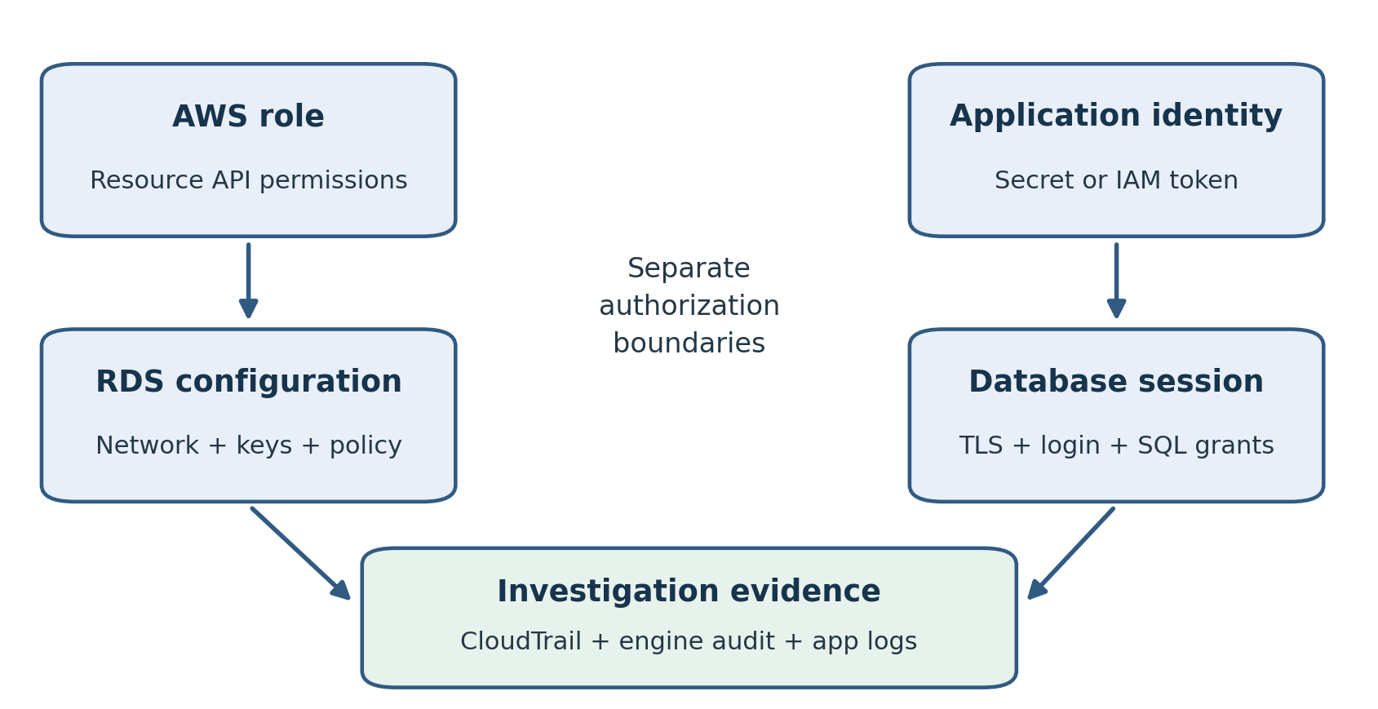
Figure 11.1. AWS resource administration and database access have separate permission boundaries. Correlated API, engine and application records support investigation.
A cloud database security design must control who can change the AWS resource, who can connect to the engine, and what each database session can do. Encryption, private networking, and credential management support those controls, but none supplies the complete design on its own. A valid database account can still have excessive privileges, while a correctly encrypted database can still expose sensitive query results.
This chapter connects IAM, AWS Key Management Service, database authentication, AWS Secrets Manager, and auditing into an operating procedure. It focuses on relational databases on RDS, Aurora, and EC2. The aim is to make access intentional, changes traceable, and recovery possible without depending on a single administrator or a forgotten credential.

From the Field: Masking Millions of Records, One at a Time
The security department at a large organization made a sound decision. Sensitive data would no longer appear in development and test environments. Those environments were refreshed from production, so they held real Social Security numbers, dates of birth, credit card numbers, passport numbers and driver's license numbers. From now on, that data would be masked: replaced with realistic but fake values.
Masking had to remain consistent across systems. The same original identifier needed the same replacement in application, warehouse, development, and test copies. Otherwise relationships could break and test results would no longer reflect the intended business behavior.
Management chose a commercial masking product. It was expensive, and it was selected without asking IT to test it against our environment.
When we ran it, we found the problem. The product masked one record at a time. It read a row, masked it, wrote it back, and committed. Then it did the same for the next row. Our environment had millions of records in many large tables. At that pace, a single refresh would have taken far longer than the window we had, and refreshes happened regularly. The tool worked in a demonstration. It could never work at our scale.
We still had a security requirement to meet, so we built our own tool.
Instead of updating rows in place, one at a time, we rebuilt the data in sets. For tables that needed custom masking logic, we used BULK COLLECT to read large batches into memory, masked them in PL/SQL, and wrote them back in bulk with FORALL, committing per batch rather than per row. For the largest tables, we avoided updates altogether. We created a new table with NOLOGGING and filled it with a direct-path insert, INSERT /*+ APPEND */ ... SELECT, applying the masking as the rows were selected. Direct-path loading writes data blocks above the table's high-water mark and bypasses most of the buffer cache, and with NOLOGGING it generates minimal redo. We then swapped the new table in for the old one, rebuilt the indexes, and restored the constraints and grants. We split the work into chunks and ran them in parallel, so the job used the CPU and memory the servers actually had.
Any use of NOLOGGING had to be limited to eligible operations with an understood recovery plan. Ordinary UPDATE still generates redo and undo. A direct-path load may reduce data redo when FORCE LOGGING is not enabled, but such changes cannot be reconstructed from ordinary redo alone. Switching back to LOGGING does not retroactively protect them; a suitable backup or refresh plan is still required.
The new approach completed the masking much faster. Security received masked environments, developers retained consistent test data, and the tool stayed in use until those environments moved to the cloud.
The experience reinforced the value of bulk processing and a proof of concept at realistic scale. A small demonstration cannot establish that a product will meet a production-sized refresh window.
Modern practice: restore into a restricted masking environment and release only verified masked copies to development and test. Protect deterministic mappings, preserve relationships, and validate constraints and business behavior. Ordinary UPDATE and FORALL still generate redo and undo. Eligible direct-path loads can minimize data redo with NOLOGGING, but FORCE LOGGING overrides that choice and recovery protection must be assessed. Chapter 15 covers the automated refresh workflow.

Classify the Data and Access Paths
Start with the data rather than the product settings. Identify sensitive fields, the people and applications permitted to use them, retention requirements, and the environments where copies may exist. Include backups, extracts, migration staging areas, diagnostic logs, and restored test databases. A protected production table can become an exposed development export.
Draw the access paths for administrators, application services, reporting jobs, and recovery automation. Specify the identity used at each step. A person may assume an AWS role to inspect RDS and use a separate database identity for SQL. A service may retrieve a secret with its workload role and then connect using a database account. These are distinct authorization decisions.
Assign ownership for each control. The DBA may own schema privileges while the platform team owns IAM roles and network paths. The security team may define key policy and log retention. Write down how changes are requested and verified across those boundaries. Otherwise an application failure can lead several teams to broaden permissions independently.
Test access removal as well as access creation. When an employee leaves or a service is retired, remove its AWS access, database grants, credential access, and approved network path as appropriate. Existing sessions and cached secrets may require separate handling. A directory account being disabled does not prove that every active database session has ended.

Separate Resource Administration from SQL Access
IAM policies govern AWS operations such as describing, modifying, or deleting an RDS resource. Database privileges govern operations such as selecting a table or creating an index. Granting an administrator permission to view RDS configuration should not automatically give that person access to customer records.
Create roles around actual work. A monitoring role may need read access to selected service metadata and metrics. A deployment role may need narrowly scoped modification rights. Recovery operations may need additional permissions for snapshots, destination resources, and encryption keys. Evaluate each against the resources and conditions it genuinely requires.
Prefer temporary workload and human credentials obtained through the organization's approved identity process. Avoid making a long-lived access key the normal foundation of database automation. Keep elevated access separate from routine observation, and define a controlled emergency access procedure that remains usable during an identity or network incident.
Least privilege needs testing. A policy that allows every action is easy to demonstrate but gives little information about the minimum required rights. Exercise the normal and failure paths with the intended role. Capture denied operations and determine whether they represent a missing requirement or a useful restriction.

Keep Database Networking Intentional
Place database resources in the approved private network design and allow only necessary sources and ports. For an application within the VPC, a supported security group reference can express that the database accepts the application's traffic. Review the application's outbound path and subnet controls as well as the database rule.
Administrative access should have its own path. A bastion, private connection, or approved session mechanism may fit the organization, but the decision must include identity, session recording where required, and emergency use. Opening a listener to all internet addresses to solve a temporary connection problem can create a lasting exposure.
Revisit Chapter 2 when troubleshooting. Name resolution, routing, security groups, network ACLs, TLS, and engine authentication each produce different failure symptoms. Narrow the failing layer before making a change. If a temporary access rule is approved, record its owner and removal time and verify that it was actually removed.

Encrypt Storage and Preserve Key Access
RDS storage encryption protects supported resources at rest, including database storage, logs, automated backups, and snapshots. AWS KMS provides the key-management integration. Check engine and deployment restrictions before selecting or changing an encryption arrangement. A customer managed key gives additional policy control and therefore adds operational responsibilities. [1]
Separate the key for database storage from keys protecting secrets or exported files when the policy requires different ownership. Record which roles need to use each key and for what purpose. A person who administers a key should not automatically receive unrestricted SQL access to the database.
Recovery depends on key availability. An encrypted snapshot is not a usable recovery artifact if the destination account or recovery role cannot use the relevant key. Include key policy, grants, destination Region, and snapshot-copy requirements in the restore rehearsal. Never assume that a familiar key alias identifies the same key in another Region.
Treat key disabling and deletion as changes to recoverability. Review dependencies before approving them, and preserve the required audit trail. Document who can restore key access during an incident. The recovery runbook should name the required keys and policies without publishing sensitive credential material.
Encryption at rest does not constrain an authorized SELECT. Apply database privileges, data masking in nonproduction copies, and application controls according to the data classification. The purpose of storage encryption is different from the purpose of access control.

Verify TLS Through the Application
Use TLS where supported and configure clients to validate the server certificate and intended endpoint. Confirm the appropriate CA bundle and driver settings for the selected engine. A connection that is encrypted but accepts any certificate does not provide the same server-identity assurance as a verified connection.
Test through the actual application runtime. A desktop client may trust a certificate authority that a container image does not. Connection pools may use different options from a command-line test. Record the configured TLS mode, certificate source, and the procedure for updating trust material.
Plan certificate changes before expiry. Rehearse deployment of the required trust chain, observe new connections, and account for long-lived sessions. Monitor connection failures during the change. Restored databases and failover destinations also need a working trust configuration.

Use IAM Database Authentication Selectively
IAM database authentication is available for supported RDS MariaDB, MySQL, and PostgreSQL configurations. It uses a signed token for connection authentication. The token lasts fifteen minutes, but expiry does not terminate a session already established. Feature support varies by engine version and Region. [2]
The mechanism still requires a correctly configured database user and SQL grants. An IAM permission to connect is not a grant to read every table. Match the AWS identity, database username, resource identifier, endpoint, and Region carefully; an otherwise valid token can fail if those details disagree.
Evaluate the application driver and connection lifecycle. Token generation belongs in the connection process, not in a fixed startup value that will be reused indefinitely. Pools should refresh authentication material for new connections. Test reconnects after failover and credential renewal rather than verifying only the first successful login.
Keep engine-specific behavior local to the design. For PostgreSQL, assigning the rds_iam role makes IAM authentication take precedence over password authentication for that user. Do not apply this change to a critical administrator account without testing the intended access and emergency procedure. [2]
SQL auditing remains necessary. IAM authentication is an access mechanism; it does not provide a complete record of subsequent database activity. Also assess memory and connection behavior before applying it to a small instance or a workload with frequent new connections. Choose it because it fits the identity model and application, rather than because it removes one visible password field.

Manage Credentials with Secrets Manager
Secrets Manager provides controlled access to stored credentials and supported rotation workflows. RDS can manage the master-user password through its integration for supported configurations. Application-user credentials require their own grants and an appropriate rotation design. Check the relevant engine and deployment limitations. [3]
Give each application a database account with the privileges it needs. Avoid using the master account as a shared application identity. Separate read-only reporting from transactional writes where that improves control and traceability. The secret should identify the intended database and user clearly, with access restricted to the workloads that require it.
Rotation must work through the application. A successful password update can still cause an outage if the application continues opening connections with an old cached value. Determine when it retrieves secrets, how long it caches them, how errors trigger refresh, and how existing connections behave.
Test rotation under traffic. Observe both established sessions and newly opened connections. Confirm that the rotation mechanism can reach the database and update the secret, and that its permissions are sufficient without exposing unrelated secrets. Monitor failures and define who responds when rotation leaves an application unable to reconnect.
Do not log secret values during diagnosis. Error messages, command history, support bundles, and pipeline output can all become unintended copies. A secret-management service cannot protect a password that an application prints into a broadly accessible log.

Design Database Roles and Grants
Organize privileges around tasks and schemas. A reporting user should receive the approved data access without ownership of the tables. A migration user may temporarily need broader privileges, with a planned removal after cutover. Track grants through roles where the engine supports an appropriate model, and review inherited access as well as direct grants.
Distinguish authentication from authorization during tests. A user may connect successfully while lacking access to the application's schema, or may read existing objects but fail on newly created ones because default privileges were omitted. Test deployment and object-creation paths alongside ordinary queries.
For PostgreSQL, understand schema usage, object ownership, and default privileges. For Oracle, map familiar system and object privileges to the restrictions of the selected RDS or EC2 deployment. Managed-service administrator accounts do not necessarily have the same powers as an on-premises unrestricted administrator.
Use synthetic or masked data in development and exercises. Validate that masking preserves the relationships needed for testing without leaving identifiers in free-text fields, logs, or historical tables. A restore request should specify who can access the restored copy and when it will be removed.

Audit the Correct Layer
CloudTrail records supported AWS API activity, such as resource configuration changes. Database auditing records engine activity according to the configured audit facility. Application logs can connect a business action to its database work. These records answer different questions and should be correlated rather than treated as interchangeable. [4]
Select audit events based on the investigation requirements. Consider privileged activity, grant changes, access to sensitive objects, and failed authentication. Engine support and configuration differ. Test that an event actually produces a usable record, then verify timestamps, identity fields, retention, and access to the log destination.
Protect logs from casual modification and unnecessary exposure. SQL text and bind values may reveal personal information or confidential business details. Grant investigators sufficient access while limiting broader readership. Include logging overhead and storage cost in the operating plan.
Run an audit exercise. Make an approved privilege change with a named identity, perform an allowed query and a denied operation, and trace the available evidence. Document any gap between the investigation question and the recorded fields. Increasing log volume without checking its meaning can make incidents harder to analyze.

Example Securing an Order Database
Consider an RDS PostgreSQL order database with an application service, a reporting service, and two administrators. The application connects through a private network using a dedicated database user. Its workload role can retrieve only its own secret. The reporting user has approved read privileges, and the administrators use separate named identities.
The team configures encrypted storage, verified TLS, credential rotation, and selected audit events. It tests that the reporting user cannot update an order and that the application user cannot administer AWS resources. It also restores a backup into an isolated environment using the designated recovery role and key access.
During a rotation rehearsal, the application initially fails on new connections because its secret cache does not refresh. The team fixes the refresh behavior and repeats the test under load. This result demonstrates why selecting a security feature is only the first part of implementing it.

Practical Exercise and Review
Build an access matrix for a synthetic order database. Include monitoring, deployment, application writes, reporting reads, and recovery. For each task identify the AWS role, database identity, network path, secret access, and audit evidence. Mark where one identity currently has more privileges than the task requires.
Test one allowed and one denied operation for each database role. Then simulate secret rotation and restore into an isolated environment. Record whether the normal application connection and the recovery role both work through their intended paths.
Review questions: Why does encrypted storage not prevent an authorized user from reading sensitive rows? What happens when an IAM authentication token expires after a session has connected? Which records would you inspect for a database grant change versus an RDS resource modification?
Suggested answers: Storage encryption and SQL authorization solve different problems. Token expiry affects authentication for new connections, not an established session. Engine audit records establish SQL grant activity; CloudTrail establishes supported AWS API changes. Correlate both with the relevant application and identity context.

References
[1] Encrypting Amazon RDS resources. https://docs.aws.amazon.com/AmazonRDS/latest/UserGuide/Overview.Encryption.html
[2] IAM database authentication. https://docs.aws.amazon.com/AmazonRDS/latest/UserGuide/UsingWithRDS.IAMDBAuth.html
[3] RDS password management with Secrets Manager. https://docs.aws.amazon.com/AmazonRDS/latest/UserGuide/rds-secrets-manager.html
[4] Logging Amazon RDS API calls using AWS CloudTrail. https://docs.aws.amazon.com/AmazonRDS/latest/UserGuide/logging-using-cloudtrail.html
[5] Using SSL and TLS with RDS. https://docs.aws.amazon.com/AmazonRDS/latest/UserGuide/UsingWithRDS.SSL.html

Chapter 12: Monitoring and Performance Tuning
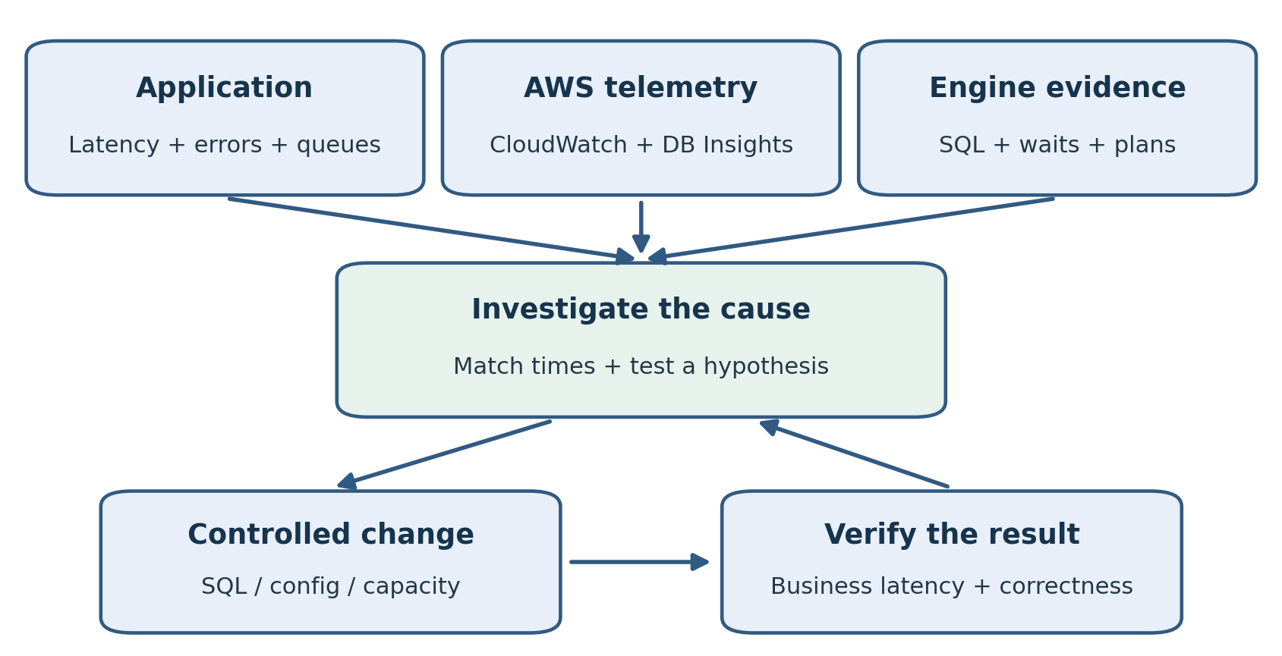
Figure 12.1. Correlate application symptoms with AWS and engine evidence. A controlled change is accepted only after its effect is verified.
A useful monitoring system tells the DBA what users are experiencing, which database work is responsible, and what changed. CPU utilization alone cannot answer those questions. A database may be slow because sessions wait on locks, storage, or application connection capacity while CPU remains available.
This chapter connects CloudWatch metrics and logs, CloudWatch Database Insights, engine diagnostics, and application measurements into a repeatable investigation. It also explains where RDS Proxy can improve connection management and where query or transaction design still requires direct work. The objective is to choose a corrective action from evidence and verify its effect through the application.
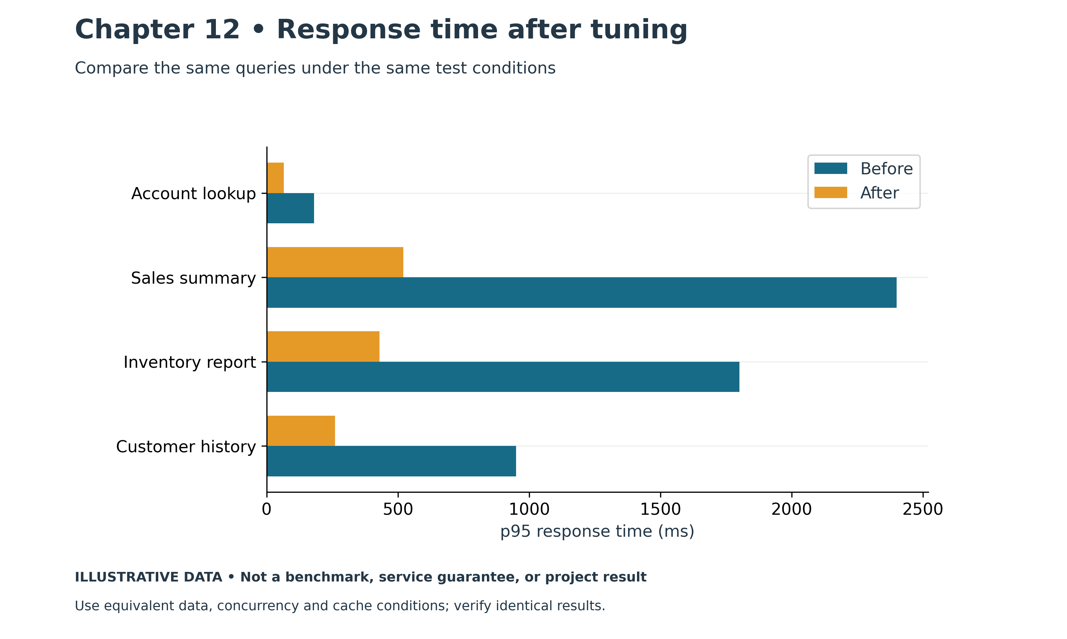
Figure 12.2. SQL tuning and response time. Illustrative chart; values are examples, not measured production results.

From the Field: Five Thousand Targets and Nobody Sleeping
In 2023, our Oracle Enterprise Manager installation monitored about 5,000 targets: hosts, operating systems, Oracle databases, Exadata systems, Data Guard configurations, MySQL databases, backups and tuning metrics. On paper, that was comprehensive monitoring. In practice, it was noise.
OEM itself had become slow. Retired databases still had targets, some checks had incorrect credentials, and monitoring settings needed correction. The resulting alert noise made it harder to identify problems that required action.
That kind of noise is dangerous, not just annoying. When most alerts are false, people stop trusting them. Sooner or later a real alert gets ignored along with the rest.
I went through the estate target by target. I removed orphaned targets, fixed or retired badly configured ones, corrected credentials and repaired monitoring parameters. When I was done, the target count had dropped by about half. OEM became noticeably faster, and the alerts that remained meant something again.
Cleaning it once was not enough, though. The mess had built up because nobody owned the lifecycle of a target. So I trained the DBA team on how to add a new target properly, how to remove a target when a system retires, and how to test that monitoring actually works before calling it done.
We also started treating OEM as a production system in its own right. Its repository database and management servers had limits too. We tracked the maximum number of targets the current hardware could handle well, and we planned new hardware before we reached it, not after OEM slowed down again.
Monitoring needs lifecycle ownership. If adding a target is a defined step but removing one is nobody's responsibility, the estate accumulates obsolete targets and unnecessary alerts.
Modern practice: create alarms with resources, retire them during decommissioning, and regularly check for orphaned monitors and missing coverage. Define ownership and a response for each alert. Infrastructure code helps enforce this lifecycle, but manual changes and external monitoring still need reconciliation. The following sections cover baselines, layered monitoring, and actionable alarms.

Establish the Workload Baseline
Capture normal behavior across representative periods. Include the busiest hour, scheduled batch processing, backups, reporting, and month-end work where relevant. Record application request rate, transaction latency, error rate, database connections, resource utilization, and the important SQL workload. A quiet afternoon is a poor capacity baseline for a nightly warehouse load.
Measure distributions rather than relying only on averages. If most orders complete quickly but a small proportion wait thirty seconds, average latency can hide the business problem. Use application percentiles and transaction categories to identify who is affected. Compare equivalent workloads when evaluating a change.
Preserve configuration alongside measurements. Instance class, storage settings, parameter groups, engine version, application release, and connection-pool configuration help explain later differences. A graph showing higher CPU is less useful if nobody recorded that the application doubled its worker count the same morning.
Assign an owner and retention policy to the baseline. Some diagnostic data is short-lived, and aggregate counters may reset after a restart or explicit maintenance. Capture the evidence needed to compare yesterday with today before it disappears.

Build Monitoring in Layers
Start with the application. Track request success, end-to-end latency, and queue depth. Database metrics can look healthy while an application exhausts its pool or repeatedly retries a failed operation. Record the point where the application begins waiting, including time spent before a database session is acquired.
Use CloudWatch for supported service metrics, alarms, dashboards, and log analysis. For RDS, inspect CPU, memory, storage headroom, connections, I/O behavior, and replication indicators appropriate to the deployment. Metric availability and meaning differ between RDS instances, Aurora clusters, and engine types. Select the correct resource dimensions. [1]
Enhanced Monitoring supplies operating-system-level information for supported RDS deployments. Treat it as another observation source, rather than a replacement for SQL evidence. On EC2, the team's monitoring responsibilities also include guest operating system processes, filesystems, and agent configuration. [2]
Finally inspect engine activity. Identify SQL, waits, blocking, transaction age, and execution plans. The investigation should connect a business symptom to actual database work. Looking at every graph without a hypothesis can consume the incident window without narrowing the cause.

Use Database Insights for Current AWS Workflows
The book's original outline named Performance Insights. AWS documentation now records its July 31, 2026 end-of-life transition and migration to CloudWatch Database Insights. Use Database Insights for the current console workflow, and check mode, retention, pricing, and engine support for the selected deployment. Older API or configuration names may still contain Performance Insights terminology. [3]
Database-load analysis helps identify whether active sessions are using CPU or waiting. Average active sessions describe database work over an interval; they are not the same as the total number of connected sessions. A large idle pool can coexist with low active load, while a small number of expensive queries can dominate it. [4]
Examine the load by the dimensions available for the engine, including SQL and waits. Compare the relevant interval with the application's incident time. If most load is waiting for a lock, adding CPU is unlikely to remove the blocker. If SQL consumes CPU under representative demand, investigate its plan and execution frequency before selecting a larger instance.
Verify diagnostic coverage before an incident. Decide who can access SQL text, whether execution-plan capture or additional analysis is available, and how long evidence is retained. Do not assume that a dashboard visible in a demonstration has the same features or retention as the production configuration.

Design Alarms Around a Response
An alarm needs a recipient and an action. For storage pressure, define the threshold, expected growth, remaining response time, and the person authorized to increase capacity or stop an uncontrolled load. A notification sent to an unmonitored mailbox does not protect the database.
Use duration and workload context to avoid excessive noise. A short CPU spike during an expected batch may be normal, while sustained connection saturation during business hours may require attention. Include missing-data behavior and verify the entire notification path. Alert on the conditions that threaten service or recoverability, rather than every metric that moves.
Keep thresholds reviewable. Explain the business or technical reason for each value and adjust it when the workload changes. A free-space threshold chosen for a small database may provide little response time after the database grows substantially.
Run a controlled alarm exercise in the lab. Trigger an approved test condition or test notification mechanism, confirm delivery, and follow the runbook. Record how long it takes to reach someone who can act. This tests the operating process as well as the metric definition.

Investigate a Slow Database in Order
First define the scope. Is every request slow, one tenant affected, one SQL statement delayed, or only new connections failing? Establish the start time and compare it with deployments, configuration changes, traffic growth, failovers, and maintenance. Preserve the error messages and relevant logs.
Next distinguish waiting outside the database from waiting inside it. A pool queue, network timeout, or TLS failure has a different remedy from a lock wait. If the application has acquired a session and submitted SQL, inspect database activity during the matching interval.
Identify the dominant wait or resource pressure and the SQL responsible. Check blockers and transaction age before cancelling anything. For storage waits, inspect latency, throughput, IOPS, queueing, and the workload driving reads or writes. For CPU pressure, compare execution count and cost per execution with the baseline.
Choose the smallest justified intervention. Correcting a runaway retry loop may be more effective than increasing max_connections. A parameter change may require a restart, and terminating a transaction may trigger application retries or a lengthy rollback. State those effects before applying the change.
After service improves, verify the business transaction and preserve the evidence. An incident is not fully explained by a graph returning to normal. Record what changed, why it addressed the observed cause, and what remains uncertain.

Read Execution Plans with Row Counts
An execution plan describes how the engine expects to obtain and combine rows. Estimated row counts affect choices such as access paths and join methods. Compare estimates with actual behavior where the engine and test conditions allow it. A severe mismatch can explain why a plan that looked inexpensive becomes slow.
Suppose a predicate is estimated to return five rows but actually returns fifty thousand. A nested loop may repeatedly probe another table far more often than expected. The problem could involve stale statistics, skewed values, correlated predicates, or parameter-sensitive behavior. The observed join is evidence to investigate, not a universal reason to force a hash join.
In PostgreSQL, EXPLAIN shows the planned operations, while EXPLAIN ANALYZE executes the statement and reports runtime observations. BUFFERS adds information about buffer activity. Use a controlled test because executing a plan can consume resources or change data. Even a SELECT can invoke functions with side effects. [5]
For a synthetic lab table, a SQL client example is:
EXPLAIN (ANALYZE, BUFFERS)
SELECT order_id, order_total
FROM lab_orders
WHERE customer_id = 42;
Compare estimated and actual rows at the nodes that determine the expensive work. Account for loops when interpreting repeated operations. Record parameter values, data volume, and whether the cache was warm. A fast second execution may reflect cached data rather than a superior plan.

Tune SQL Before Adding Capacity
Inspect predicates, joins, returned columns, and repeated execution. An application that issues hundreds of small queries for one screen can be slow even when each query looks acceptable alone. Reduce unnecessary round trips and fetch only the data required by the business operation.
Evaluate indexes against the actual access pattern. An index can reduce selective reads, but it consumes space and adds work to writes. Check column order, selectivity, filtering, sorting, and existing indexes before creating another. Test the busiest write period as well as the slow read that motivated the change.
Keep statistics appropriate to the data. Large loads or substantial distribution changes can make estimates inaccurate. For PostgreSQL, ANALYZE updates planner statistics; routine vacuuming serves additional maintenance purposes. These operations should fit the workload and engine rather than being treated as interchangeable tuning commands. [6]
On Oracle, compare plans and workload evidence using the facilities available and permitted for the deployment, including any licensing requirements. Familiar on-premises tools and privileges may differ on RDS. Preserve the same investigative discipline even when the cloud interface changes.

Investigate Blocking and Long Transactions
A blocked query may be the victim of another transaction. Identify the blocker, its owner, the statement or operation holding the lock, and how long the transaction has been open. Ask whether the application is waiting for a user or external service while holding database resources.
Cancelling the waiting query does not remove the root cause. Terminating the blocker can have business and rollback consequences. Follow the incident authority and validate whether the transaction can be safely interrupted. If intervention is necessary, record the session and transaction evidence before it disappears.
Reduce transaction duration through application design. Commit at the appropriate business boundary, avoid unnecessary network calls inside a transaction, and use consistent update order where it helps avoid contention. Do not split an atomic business operation merely to reduce lock time without preserving its correctness.
For PostgreSQL, long transactions can also interfere with maintenance of old row versions. Review transaction age and vacuum behavior together. For MySQL, investigate InnoDB transaction and lock information using the supported engine facilities. Similar symptoms do not imply identical engine internals.

Maintain PostgreSQL Vacuum and Statistics
PostgreSQL updates and deletes leave row versions that routine maintenance must handle. Autovacuum and automatic analysis are therefore operational requirements. Monitor whether busy tables receive sufficient maintenance and whether long transactions or workload growth prevent it from keeping up. [6]
Separate the questions of reclaiming reusable space, updating planner statistics, and returning space to the operating system. Ordinary VACUUM and VACUUM FULL have different behavior and disruption. Do not use VACUUM FULL as the default answer to a large table without assessing locks, storage requirements, and a maintenance window. [6]
Tune based on specific tables and observed maintenance progress. A single global change can overwork quiet tables or fail to help a rapidly changing one. Record table size, update rate, dead-row indicators, transaction age, and maintenance duration before deciding what to adjust.

Use RDS Proxy for Connection Management
RDS Proxy can pool and reuse database connections for supported RDS and Aurora configurations. It can be useful when application concurrency creates many short-lived connections or reconnect pressure. Confirm support for the exact engine, version, Region, authentication model, and workload. It does not optimize an inefficient SQL statement. [7]
Understand session pinning. When state cannot safely be shared, the proxy can keep a client session attached to a particular database connection. Pinning reduces the reuse benefit. Test the application's transaction and session behavior, then inspect proxy connection metrics and borrow latency rather than assuming all client connections will be multiplexed. [8]
Size application pools and proxy limits together. Excessive concurrency can move the queue without removing it. The database still has finite CPU, memory, and transaction capacity. Observe requests waiting for a borrowed connection and determine whether the limit is protecting the database or constraining a workload it could otherwise serve.
Rehearse failover through the proxy endpoint. Applications still need appropriate timeouts, retries, and transaction handling. A retry of a write with an uncertain commit outcome requires application correctness controls; connection routing cannot establish whether a business operation should be repeated.

Example Diagnosing Slow Order Processing
An order application becomes slow after a deployment. CPU rises only moderately, but application latency and active-session load increase. Database evidence shows many sessions waiting on a row lock held by one transaction. The new release performs an external service call before committing the order update.
The team follows its incident procedure to resolve the immediate blocker. It then changes the application flow so that the external call does not unnecessarily hold the database transaction open, while preserving the agreed business semantics. A load test confirms lower wait time and unchanged order correctness.
Increasing the instance size would not have removed the locked row. Adding a proxy might have controlled connection growth but would not have shortened the transaction. The chosen fix follows the evidence connecting the application change to the database wait.

Practical Exercise and Review
Create a baseline for a synthetic PostgreSQL order workload. Capture request latency, connection count, selected CloudWatch metrics, and an execution plan. Run a controlled selective query before and after a justified index change. Compare read benefit, write cost, and the observed row estimates.
In a separate lab exercise, hold a transaction open and observe another session waiting on it. Identify the blocker without immediately terminating either session. Document the evidence and the business questions required before an intervention.
Review questions: Why can low CPU coexist with a slow database? How do connected sessions differ from active-session load? Why does EXPLAIN ANALYZE require care? What does proxy pinning change?
Suggested answers: Locks, I/O, and connection queues can delay work independently of CPU. Many connections may be idle. EXPLAIN ANALYZE executes the statement and can consume resources or cause effects. Pinning dedicates a database connection to a client session and reduces connection reuse.

References
[1] Monitoring metrics in RDS. https://docs.aws.amazon.com/AmazonRDS/latest/UserGuide/MonitoringOverview.html
[2] Enhanced Monitoring. https://docs.aws.amazon.com/AmazonRDS/latest/UserGuide/USER_Monitoring.OS.html
[3] CloudWatch Database Insights. https://docs.aws.amazon.com/AmazonCloudWatch/latest/monitoring/Database-Insights.html
[4] Database load. https://docs.aws.amazon.com/AmazonRDS/latest/UserGuide/USER_PerfInsights.Overview.ActiveSessions.html
[5] PostgreSQL Using EXPLAIN. https://www.postgresql.org/docs/current/using-explain.html
[6] PostgreSQL Routine Vacuuming. https://www.postgresql.org/docs/current/routine-vacuuming.html
[7] Amazon RDS Proxy. https://docs.aws.amazon.com/AmazonRDS/latest/UserGuide/rds-proxy.html
[8] Avoiding proxy pinning. https://docs.aws.amazon.com/AmazonRDS/latest/UserGuide/rds-proxy-pinning.html

Chapter 13: Backup Recovery Patching and Upgrades
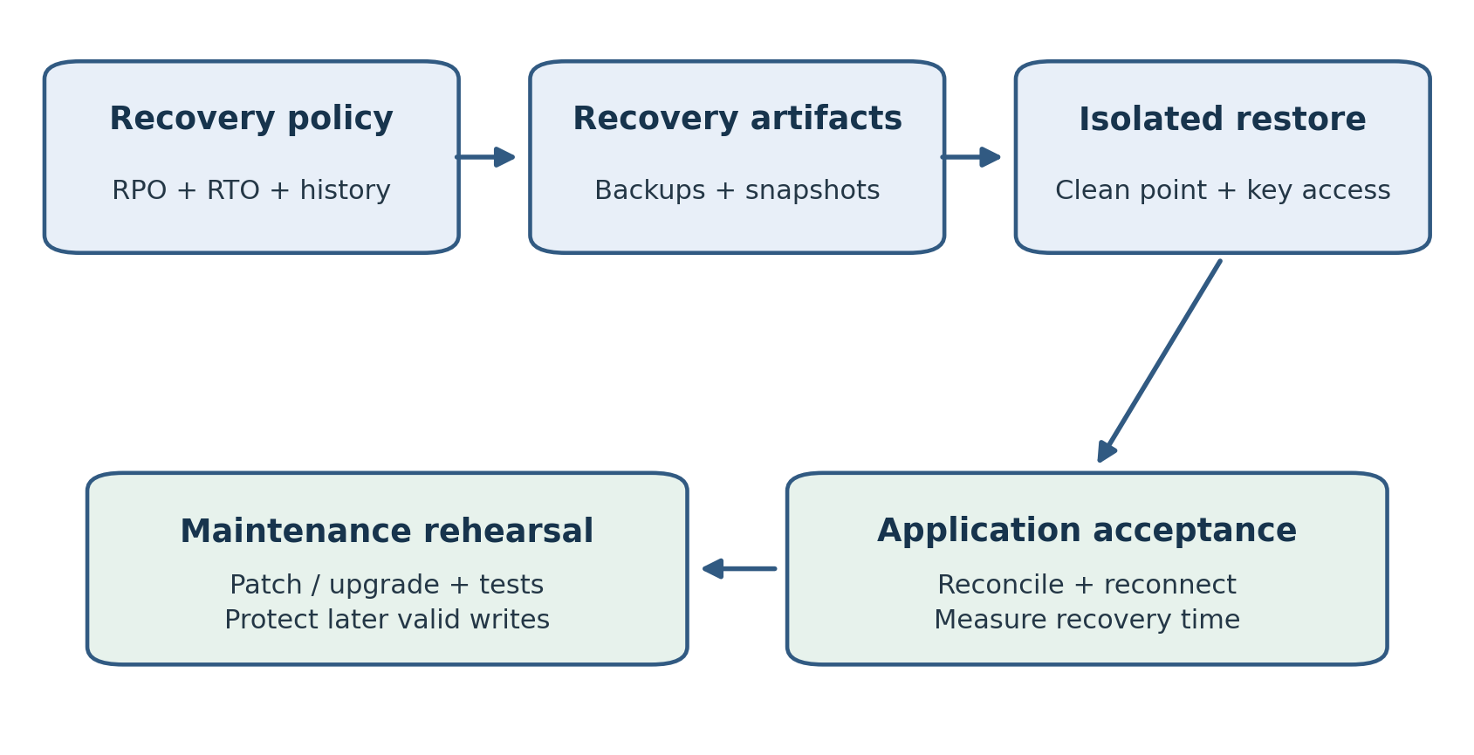
Figure 13.1. Recovery protection is proved through restore and application acceptance. Maintenance rehearsals use that protection and account for writes after a change.
A database is recoverable when the team can restore the required data, reconnect the application, and complete the agreed business checks within its objectives. A completed backup job supplies part of that capability. Recovery also depends on keys, permissions, network paths, credentials, and procedures that work under the conditions of the incident.
This chapter turns backup settings and maintenance features into a tested operating schedule. It covers automated backups, snapshots, point-in-time recovery, restore validation, patches, engine upgrades, and supported blue/green deployments. It builds on Chapter 6 by concentrating on the recurring work that keeps an availability and recovery design usable.

From the Field: The 4 AM Call That Taught Me What a Database Means to a Factory
Around 1995, before internet access became a routine part of working life, supporting a system remotely meant dialing into it through a modem. Our connections ran at 1,200 or 2,400 baud. They were painfully slow, but when they worked, they could save you a drive to the factory.
One morning at about 4 a.m., my phone rang.
The first shift had arrived, and nobody could log in.
The manufacturing facility ran two shifts: one from 4 a.m. until noon, and another from 3 p.m. until midnight. Oracle Manufacturing and Financials supported the business. With the system unavailable, the problem reached well beyond the computer room.
I tried connecting through the modem. No luck.
After failing to get remote access, I drove to the factory. At the main database server, I found a message I would remember for years:
“Operating system missing.”
This was a Sun Microsystems UNIX machine hosting an Oracle 7 database of roughly 500 MB, a substantial database in our environment at the time.
We were facing something much bigger than a login problem. Before anyone could use the applications again, we had to rebuild the system underneath them.
I asked management to switch to paper so the factory could continue operating while we worked on recovery. Transactions that normally went into Oracle would have to be recorded manually and entered later.
Then came the long job of bringing the server back.
We installed the operating system, rebuilt the Oracle environment, created the database, and restored the data from backup. Each stage depended on the one before it. There was no quick restart that could solve this, and no shortcut around the recovery work.
It took about 36 hours to get the system back.
During that time, the factory kept working on paper. Getting Oracle running again was a major relief, but it did not finish the job. We still had to enter all the accumulated paperwork into the system. The outage had created another workload, and we all had to help clear it.
Later, we learned what had caused the failure.
A senior DBA had run a UNIX script intended to clean up old logs. The script contained SQL-style comment syntax:
/* This is a comment */
In SQL, that marks a comment. A UNIX shell does not interpret it that way. In the wrong command context, /* can expand to files and directories directly under the root directory. What was intended as routine housekeeping had become a destructive operation.
The exact command mattered, but the lesson was clear: syntax that is harmless in one environment can be dangerous in another.
This happened before I became a DBA. At the time, I was helping recover a system that the factory depended on. Looking back, it was one of my earliest lessons in the responsibility that comes with managing databases.
I saw why backups matter, why recovery takes more than having a backup available, and why even an experienced administrator must review a cleanup script carefully.
I also saw the human side of an outage: workers unable to log in at the start of their shift, management arranging a temporary way to keep production moving, and everyone entering handwritten records after the system returned.
More than thirty years later, I still remember that early morning phone call and the message on the server.
A database was only about 500 MB. Yet when it disappeared, an entire factory felt the impact.
Modern practice: keep tested backups, rebuildable infrastructure, and reviewed scripts with limited privileges. RDS manages the host operating system, while an EC2 deployment still needs host-level recovery planning. A standby can reduce downtime for covered failures, but failover and restore times must be measured. Point-in-time recovery recovers recorded database changes; it does not enter transactions captured on paper during an outage. Reconciliation remains part of business recovery. Chapters 6 and 15 explain availability and automation.

Translate Requirements into Backup Policy
Record recovery point objective and recovery time objective for each application. RPO describes acceptable loss of recent data; RTO describes the target time to restore service. Also identify how long an incorrect change might remain undetected. A backup policy that retains only a short history may fail when the business discovers corruption several weeks later.
Separate operational recovery from longer retention requirements. Recent recoverable history, monthly records, audit obligations, and a migration rollback copy can have different retention and access needs. Assign a business owner to the policy and a technical owner to its implementation. Do not retain every copy indefinitely simply because deletion requires a decision.
List the scenarios the policy must cover. Accidental data changes, instance failure, credential loss, key-access failure, and Region disruption require different preparations. A backup within the affected account and Region may not provide the isolation assumed by a wider disaster recovery plan.
Specify application dependencies. Restoring an order database may require secrets, configuration, queues, and connectivity before users can work. If the recovery procedure depends on an identity system that is unavailable in the scenario, establish an approved alternative and test it.

Understand Automated Backups and Snapshots
RDS automated backups provide recoverable history according to the configured retention and supported service behavior. Manual snapshots preserve a database state until removed. They serve different operational purposes and should have explicit owners and retention rules. Inspect the actual resource configuration rather than assuming the backup setting used by the console default is sufficient. [1]
For standard RDS DB instances, the supported automated backup retention is up to thirty-five days; setting zero disables automated backups where that setting is allowed. Deployment types differ, so confirm the exact limits for instances and clusters. Review retention after infrastructure changes and restores. [1]
Create a manual snapshot before a significant change when the procedure requires a known recovery point. Record the reason, source identifier, timestamp, engine version, encryption key, and expiry. A name such as final-backup is ambiguous if several changes occur later.
Keep snapshots separate from logical exports. A database snapshot is a service-level recovery artifact. A logical dump can support selective object migration or another approved use, but may omit objects or require a long reload. Choose the method based on the recovery requirement and test its completeness.

Check Recoverable History
Verify the latest restorable time and whether it advances as expected. A retention value describes a policy, while the available restore interval describes what can actually be recovered. Alert and investigate when the interval is stale or insufficient for the business requirement.
Review backup events and the selected backup window. Include workload impact in the operating baseline. Engine and deployment behavior vary, so test how backups interact with busy periods rather than assuming they are always invisible to users.
Monitor backup-related failures through a defined response. The runbook should distinguish service events, permission failures, capacity pressure, and missing recovery artifacts. Record whether a failed backup threatens the required RPO and what temporary protection can be established while the issue is resolved.
For EC2 databases, the organization also owns the engine-aware backup process. An Oracle RMAN procedure, a PostgreSQL physical backup strategy, and an arbitrary filesystem copy have different consistency requirements. Snapshotting storage without coordinating the database does not automatically provide the recovery guarantees of a tested native method.

Restore to a Clean Point
RDS point-in-time recovery restores a new DB instance from the available history rather than rewinding the existing instance in place. The resulting resource needs its intended settings and application connection configuration checked. Cluster recovery has its own workflow. [2]
Determine the desired point from incident evidence. If a damaging update committed at a known time, select a clean state before that change and validate it. Time zones and timestamp precision matter. Record the chosen time in an unambiguous format and compare it with database, application, and audit records.
Do not equate restoring before a mistake with preserving all valid work. Legitimate transactions after that point may also be absent. Decide how those transactions will be identified and reconciled. The business owner must understand the recovered state and any remaining data loss before service is accepted.
Keep the affected database available for controlled investigation where the procedure allows it. Its later valid transactions, audit records, or external references may support reconciliation. Prevent it from remaining an accidental writer while the restored database is being prepared.

Validate the Restored Environment
Check the restored database state, engine version, parameters, option groups where applicable, security groups, subnet placement, and encryption. Confirm expected users and grants. Restored resource settings can differ from the desired production design if the operation used defaults or incomplete inputs.
Verify data with critical queries and business controls. Check representative key ranges, totals, recent known transactions, and the affected objects. A successful engine startup does not prove that the requested recovery point was correct or that the application can use it.
Connect through the intended application runtime. Validate DNS, TLS, secrets, connection pools, and required integrations. Some configurations reference resource identifiers or endpoints that change after restore. Update monitoring and backup policy for the new resource before handing it to operations.
Observe performance through a representative workload. A restore may require data access to warm caches or initialize storage behavior. Include that effect in measured recovery time. Declare service restored at the business acceptance point, rather than stopping the RTO clock when the database first becomes available.

Protect Recovery Across Accounts and Regions
Where the requirement includes a broader failure scope, evaluate supported snapshot copying, backup replication, or AWS Backup arrangements for the selected resource. Confirm destination account and Region access, retention, encryption, and restore procedures. Replication of a database and protection of historical backups address different risks. [3]
Encrypted copies require suitable key access. A snapshot listed in a destination account is not sufficient proof that its recovery role can restore it. Rehearse the destination operation with the actual role and network design. Record the time to obtain any required permissions or capacity.
Verify when copies become usable. A scheduled copy that has not completed does not protect the most recent source state. Use the timestamp and successful completion evidence of the destination artifact to assess the data exposure in the planned scenario.

Schedule Restore Exercises
Choose a restore exercise frequency based on business importance and change rate. Repeat after significant changes to engine version, encryption, identity, network, or automation. A procedure tested last year can fail after a credential policy change even when backup creation continues normally.
Use synthetic or appropriately controlled data for ordinary practice. Isolate restored copies from production integrations so that test jobs do not send messages, charge customers, or overwrite shared systems. Limit access and define cleanup before restoring sensitive data.
Record elapsed time for provisioning, data readiness, application reconnect, validation, and authorization. Identify steps that depend on another team. The exercise report should show whether RPO and RTO were met, what prevented success, and who owns the corrective work.
Maintenance activity | Evidence to retain | Follow-up decision
Restore exercise | Recovery point and application acceptance time | Whether objectives were met
Patch deployment | Version and workload checks before and after | Whether service is stable
Major upgrade rehearsal | Compatibility failures and measured transition time | Whether production can proceed
Backup copy test | Destination artifact and successful restore | Whether the wider failure scope is covered

Manage Routine Patching
Track pending maintenance and the engine support lifecycle. Review what changes, whether a restart or failover may occur, and what the application must tolerate. The maintenance window identifies when applicable work may run; it does not remove the need for a tested reconnect procedure. [4]
Distinguish operating system maintenance, minor engine changes, and major engine upgrades. The service's automation and responsibilities vary. Verify the configured automatic minor version behavior and any required maintenance notifications for the deployment. Avoid treating all maintenance as a single risk category.
Apply changes to a representative nonproduction environment first when possible. Check drivers, extensions, scheduled jobs, backup procedures, and application behavior. Compare performance with the baseline and identify any changed defaults. A simple login test is insufficient for a system with complex stored code or integrations.
Prepare the production procedure with acceptance checks and recovery options. Know which settings can be changed immediately, which require a reboot, and which actions cannot be reversed by selecting the previous value. A backup supports recovery, but restoring it may introduce downtime and loss of later transactions.

Rehearse Major Engine Upgrades
Inventory dependencies before choosing a target version. Include extensions, database drivers, authentication, stored code, data types, and monitoring tools. Engine support for an in-place upgrade follows specific paths; skipping versions or downgrading afterward may not be supported. Confirm the vendor procedure. [5]
Restore a representative copy and run the upgrade there. Test application transactions, background jobs, data reconciliation, and workload performance. Capture warnings and incompatibilities in a register with owners. Correct them before scheduling production rather than hoping the upgrade will tolerate them.
Review parameters and statistics afterward. A new engine version can change optimizer behavior, defaults, or extension compatibility. Compare plans for critical SQL and assess whether statistics or maintenance need attention. Do not copy every old setting without understanding whether its reason still applies.
Decide what recovery means after the upgraded database accepts writes. Returning to a pre-upgrade snapshot can discard those writes. A forward fix, a tested migration back, or controlled reconciliation may be required. Apply the same writer-history reasoning developed in Chapter 10.

Evaluate Blue Green Deployments
For supported RDS configurations, Blue/Green Deployments create a linked staging environment in which changes can be prepared and tested before a managed switchover. Engine support, replication behavior, and restrictions vary. Check the documented limitations for the exact source, target version, and configuration. [6]
Use green to test the planned engine or configuration changes with representative application behavior. Understand what can be changed while synchronization continues and which actions would disrupt it. Do not allow test activity to create unexamined differences that invalidate the switchover plan.
Rehearse the switch with the application's connections and jobs. Evaluate lag, long transactions, guardrails, endpoint behavior, and the measured interruption. A service feature can shorten parts of the procedure, but application acceptance and business authorization still belong to the team.
After switchover, verify resource identifiers, monitoring, backup assignments, and integration references. Keeping the old environment does not by itself guarantee a safe reversal after new writes. Determine whether it remains current and how the chosen service handles the retained environment before calling it a rollback solution.

Example Recovering an Accidental Update
An administrator discovers that a batch changed all open orders to a closed status. The team stops the faulty writer, preserves incident evidence, and identifies a clean point before the batch committed. It restores an isolated database to that point and checks the affected orders.
Several valid payments arrived after the clean point. The business and application teams reconcile those transactions using controlled records before accepting the recovered writer. They then redirect connections, verify order processing, and confirm backup and monitoring settings on the restored resource.
The exercise exposes a missing recovery-role permission for the KMS key. The team corrects the role and repeats the restore. This is the type of dependency a recurring recovery exercise should uncover before an actual outage.

Practical Exercise and Review
Create a synthetic table with a timestamped set of inserts and one deliberate unwanted update. Record the clean point, restore using the supported lab procedure, and prove which valid changes are present and absent. Measure through application acceptance and remove the restored resources when the exercise is complete.
Prepare an upgrade checklist for one engine you administer. Identify the supported upgrade path, dependencies, rehearsal data, acceptance tests, and the treatment of writes after the transition. Include backup protection and the permissions required to use it.
Review questions: How does a manual snapshot differ from automated recoverable history? Why is PITR not an automatic repair of the existing database? What can make an encrypted backup unusable? Why must an upgrade recovery plan account for later writes?
Suggested answers: A snapshot preserves a specific state, while automated history supports recovery within its available interval. RDS instance PITR creates a new resource that needs configuration and redirection. Missing key access or restore permissions can block recovery. Later writes represent business history that a pre-upgrade restore does not contain.

References
[1] Introduction to RDS backups. https://docs.aws.amazon.com/AmazonRDS/latest/UserGuide/USER_WorkingWithAutomatedBackups.html
[2] Restoring to a specified time. https://docs.aws.amazon.com/AmazonRDS/latest/UserGuide/USER_PIT.html
[3] Replicating automated backups. https://docs.aws.amazon.com/AmazonRDS/latest/UserGuide/USER_ReplicateBackups.html
[4] Maintaining a DB instance. https://docs.aws.amazon.com/AmazonRDS/latest/UserGuide/USER_UpgradeDBInstance.Maintenance.html
[5] Upgrading a DB instance engine version. https://docs.aws.amazon.com/AmazonRDS/latest/UserGuide/USER_UpgradeDBInstance.Upgrading.html
[6] RDS Blue/Green Deployments and limitations. https://docs.aws.amazon.com/AmazonRDS/latest/UserGuide/blue-green-deployments.html and https://docs.aws.amazon.com/AmazonRDS/latest/UserGuide/blue-green-deployments-considerations.html

Chapter 14: Cost Optimization
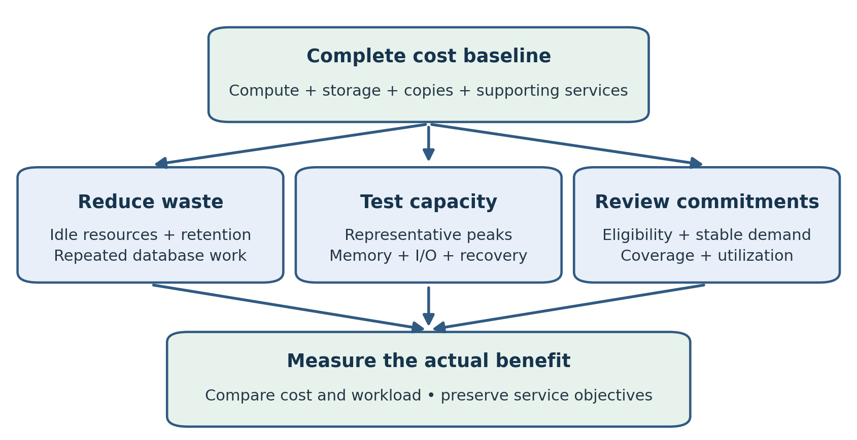
Figure 14.1. Cost optimization combines waste removal, tested capacity and suitable pricing commitments. Measure the benefit against the same workload and service requirements.
Database cost optimization means meeting the agreed service and recovery requirements with less unnecessary expenditure. Reducing the instance size is one possible action, but a cheaper database that cannot handle the peak workload or meet recovery objectives has not met the requirement. Begin with the complete operating design and its measured workload.
This chapter explains cost attribution, right-sizing, storage and backup spending, idle resources, Reserved Instances, and Savings Plans. It connects financial decisions to the operational evidence collected in Chapter 12. The aim is to produce a change with a measurable benefit, an owner, and tests that establish the database still does its job.
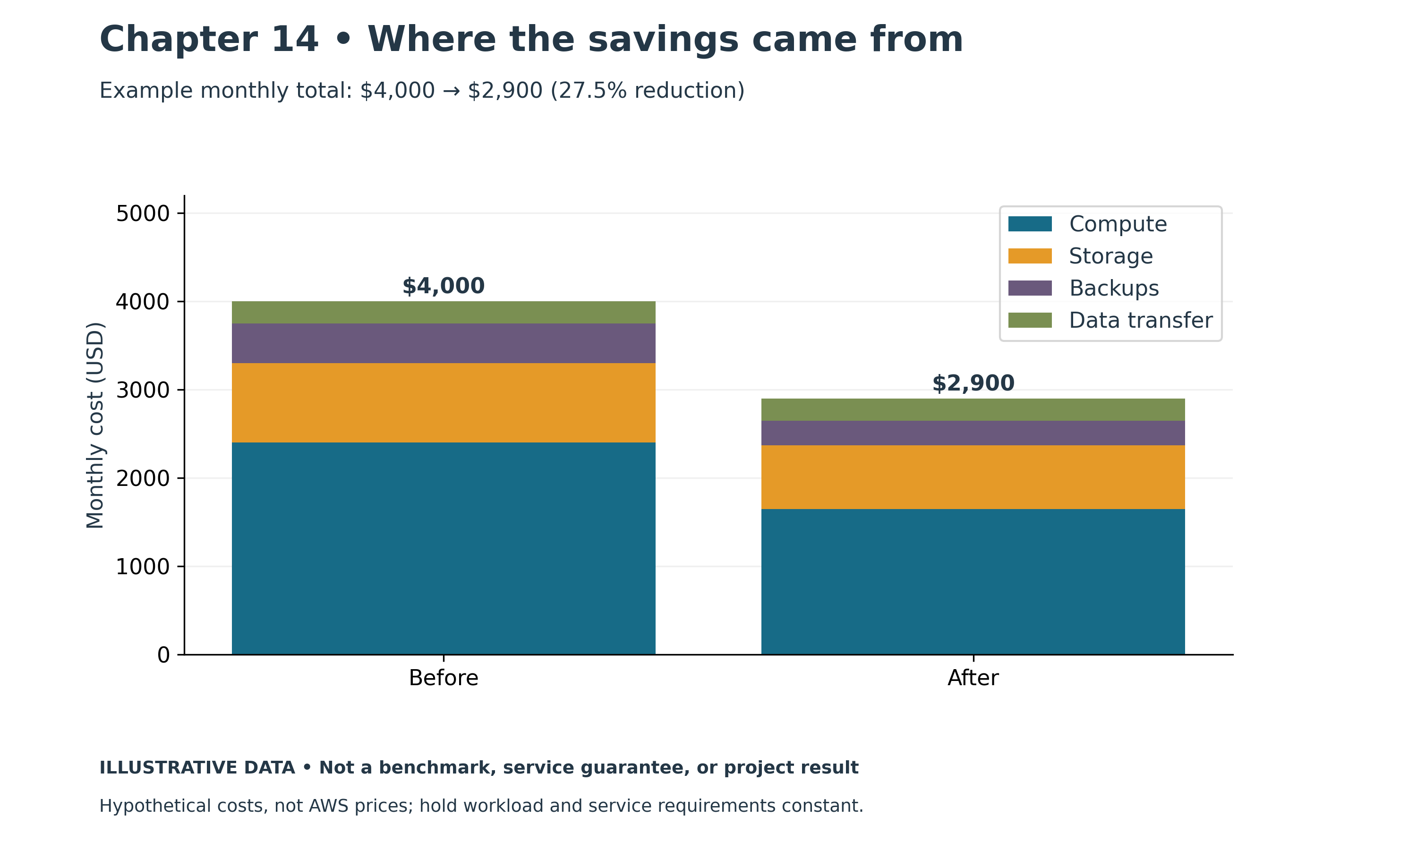
Figure 14.2. Monthly costs before and after optimization. Illustrative chart; values are examples, not measured production results.

From the Field: Five Hundred Branches, Five Hundred Supply Closets
One of the most convincing cost lessons I ever saw had nothing to do with servers. It was about paper, pens and bottled water.
A retail bank with more than 500 branches gave each branch manager a budget for local supplies: stationery, printer paper, water, cleaning supplies and the hundred small things a branch needs to open its doors every morning. Each manager ordered those supplies through software installed on a bank-provided PC.
No single order was large. A box of pens here, a case of water there. But multiply those small purchases across more than 500 branches, every week, all year, and the total ran into millions of dollars. Because every branch bought on its own, the bank had no single view of what it was spending, no leverage with suppliers, and no easy way to see that two branches a few miles apart were paying different prices for the same item.
The bank replaced that process with a business-to-business (B2B) web system. Instead of working through software on their own PCs, managers simply opened a browser and ordered what their branch needed directly from manufacturers and wholesale merchants. The catalog, the prices and the approved suppliers were the same for every branch. Orders, budgets and spending were visible in one place.
The result was more than $1 million in savings every year.
The savings didn't come from any one dramatic change. They came from consolidation and visibility. Buying through approved manufacturers and wholesalers removed middlemen and brought better pricing. Seeing the bank's total demand in one place made that pricing possible. Moving from desktop software to a web application meant there was one system to maintain instead of hundreds of installations. And because every order passed through the same system, the bank could finally see where its money was going, branch by branch and item by item.
The lesson stayed with me: large costs often hide inside thousands of small, scattered decisions. No branch manager was wasteful. Each one made reasonable choices with the information in front of them. The waste lived in the structure, not in any individual purchase, and it only became visible once the spending was brought together and measured.
Cloud costs behave the same way. No single development database or forgotten snapshot looks expensive. Hundreds of them, across many teams and accounts, can add up to a serious bill that nobody owns.
Modern practice: bring cloud spending together before trying to cut it. Use consistent tags and account structure so every database has an owner and a cost center, and review spending in Cost Explorer by team, environment and application. Standardize on approved database modules and instance families, just as the bank standardized on approved suppliers, and use Savings Plans or Reserved Instances only for stable, consolidated demand. Measure savings against a recorded baseline. The following sections cover cost baselines, right-sizing, idle resources and commitments.

Establish the Full Cost Baseline
List every resource needed to operate the application. Include database compute, storage, provisioned I/O where applicable, backup copies, replicas, proxies, monitoring, log retention, data transfer, and supporting infrastructure. For EC2 databases, include attached volumes, snapshots, guest administration, and applicable software licensing.
Separate recurring production cost from temporary project cost. A migration may require duplicate environments, replication resources, staging storage, and additional diagnostics. These are justified while the project is active but need cleanup owners and expiry dates. Otherwise temporary capacity becomes part of the bill without an explicit operating decision.
Use consistent resource tags and account structure for attribution. Cost Explorer and the organization's billing data can help identify trends and resource categories; allocation accuracy depends on the configured tags and billing dimensions. Review how shared services and discounts are assigned before comparing team totals. [1]
Explain the period represented by each number. Compare a full month with another full month, or normalize for hours and workload when using partial periods. A lower bill during a maintenance outage does not demonstrate better efficiency. Record taxes, credits, support, and licensing separately when they affect the comparison.

Relate Cost to Business Work
Track a useful workload measure such as completed orders, processed events, or an agreed batch volume. Cost per unit can reveal whether growth is efficient, but only when the numerator and denominator have compatible scope. A database serving both orders and analytics cannot be fairly judged against order count alone without accounting for the other work.
Pair cost with service measures. Include latency, error rate, throughput, and recovery capability. A change that reduces monthly spending by ten percent while doubling peak response time may be unacceptable. Write the acceptance criteria before choosing the saving so that the result can be evaluated consistently.
Keep assumptions visible. Forecasts should identify expected demand, retention growth, runtime hours, and likely migration or engine changes. Use a range when uncertainty is material. A precise-looking monthly figure derived from an untested workload is weaker than a transparent estimate with defined assumptions.

Right Size from Representative Evidence
Use CPU, memory, active load, connection behavior, storage performance, and application latency together. Low average CPU is not proof that an instance is oversized. It may need memory for a working set, capacity for a short critical peak, or headroom during maintenance and failover.
Evaluate the period that sets the capacity requirement. Include month-end jobs, backup activity, deployment bursts, and the surviving workload after a failure where relevant. A read replica sized for normal reporting may be inadequate if the design expects it to become the writer.
Test a smaller class or different family in a representative environment. Confirm engine support and assess architectural differences, drivers, extensions, and any licensing effect. Compare the same workload and data volume. Record the changes in latency, resource pressure, and recovery behavior.
Implement a production resizing change through the operating procedure. Know whether interruption or failover is expected, which settings change, and how the application reconnects. Define a return option and a period of observation that includes the workload which originally justified capacity.

Reduce Unnecessary Database Work
SQL efficiency can lower the capacity requirement. Correct repeated full scans, unnecessary row retrieval, excessive round trips, and duplicate background work using the evidence from Chapter 12. Measure the result before claiming savings. A faster query does not reduce the bill automatically if the same resources remain provisioned.
Consider the whole effect of an index. It may reduce expensive reads while adding write I/O and storage. A new index that helps one report but harms a heavily used order path can shift cost rather than reduce it. Reconcile the benefit against the application's workload mix.
Archiving can reduce active data and maintenance work, but it creates another operating responsibility. Define what moves, how it is retrieved, who can access it, and how long it is retained. Do not remove data simply to lower storage cost without the business retention decision and retrieval procedure.

Review Storage and I O Spending
Match storage characteristics to observed requirements. Provisioned capacity that is never used may be an opportunity, while inadequate throughput can cause application delay despite available CPU. RDS storage options and Aurora storage pricing follow different models; check current documentation for the selected service. [2]
Use latency, IOPS, throughput, and queueing evidence to evaluate a change. Some storage capabilities depend on allocated size or configuration. Avoid assuming that changing a single IOPS value leaves every other performance limit unchanged.
Review whether allocated storage can be reduced using the intended service operation. In many RDS instance workflows, shrinking storage requires a migration or restore strategy rather than an in-place reduction. Estimate that work, outage risk, and temporary duplicate cost before treating it as a quick saving.
For Aurora, compare available storage pricing configurations against measured I/O and the full cluster design. Include writers, readers, and any global configuration. An attractive rate for one dimension can be offset by another. Use the current calculator or rates and retain the comparison inputs instead of a general rule based on an old price ratio.

Control Backups Logs and Data Transfer
Inventory retained snapshots, automated backup copies, and cross-Region copies. Attach each to its recovery or retention purpose. Remove only copies that the owner has confirmed are no longer required. A low-cost old snapshot may be the only artifact retained for a particular recovery requirement.
Set log retention deliberately. More detailed auditing or diagnostics can increase volume, and indefinite retention can accumulate cost. Balance investigation needs, privacy, and applicable retention requirements. Consider which logs need frequent query access and which require a different approved storage arrangement.
Review data movement through the actual architecture. Cross-Region replication, application access across locations, exports, and backup copying can create charges or supporting network costs. Check current pricing rather than assuming every private path is free. Avoid relocating a database solely to reduce a transfer line without measuring latency and recovery implications.

Remove Idle Resources with an Owner
Schedule nonproduction runtime only where the service supports the intended stop or pause behavior and the workload can tolerate it. RDS stop/start restrictions vary, and stopped instances may restart automatically after the supported interval. Storage and retained backups can still incur charges. EC2 instances also retain chargeable attached storage when stopped. [3]
Use an inventory and owner confirmation before deletion. Names and tags can be stale. Check recent activity, dependencies, backups, and retention obligations. A database with no interactive users may still serve a monthly batch or recovery exercise.
Create a cleanup record for each lab or project. Include resource identifiers, associated snapshots, logs, network resources, secrets, and temporary compute. Confirm the remaining inventory after cleanup. Stopping the main instance is not equivalent to removing every project expense.

Understand RDS Reserved Instances
RDS Reserved Instances provide a pricing commitment for matching usage over a supported term, commonly one or three years. Eligibility and matching depend on factors such as engine, Region, instance family, deployment, and payment option. They are a billing discount arrangement rather than a substitute for the availability design. [4]
Purchase only after understanding stable demand. Right-size first, then evaluate how much of the remaining workload is likely to continue through the term. If an Oracle workload is scheduled to migrate to a different service in six months, an unsuitable long commitment can outlive the resource it was meant to discount.
Track coverage and utilization separately. Coverage asks how much eligible usage receives a discount. Utilization asks how much of the purchased commitment is used. High coverage does not prove good utilization if commitments are oversized. Review both with the team responsible for shared billing benefits.
Confirm size flexibility and other matching rules for the exact engine and offering. Do not assume that a reservation can move between unrelated families, engines, or Regions. Build the calculation from current terms and compare the effective rate including any upfront payment.

Compare Savings Plan Types
Compute and EC2 Instance Savings Plans address eligible compute usage; they do not automatically discount every managed database charge. For a self-managed database on EC2, evaluate eligible compute separately from storage, backup, and software costs. [5]
AWS also now offers Database Savings Plans. Current terms describe a one-year hourly monetary commitment with discounts applying to eligible usage across supported database services. This expands the choices beyond an older assumption that Savings Plans concern only compute. Check eligible services, instance generations, serverless usage, and exclusions before estimating the benefit. [6]
Unused hourly commitment is a cost even when the database is quiet. Additional eligible usage beyond the commitment is charged according to the applicable terms. Choose a commitment supported by stable baseline demand rather than a peak that occurs only occasionally. Treat service or Region flexibility as a pricing property, not a migration compatibility guarantee.
The same usage cannot receive both a Database Savings Plan discount and an RDS Reserved Instance discount. Account for existing commitments and their expiry before buying another plan. Compare the organization's actual mix and projected changes, not only the largest advertised percentage. [6]

Example Evaluating a Cost Change
Consider a hypothetical order database whose monthly total is 1,000 cost units: 600 for compute, 200 for storage and I/O, 100 for backups, and 100 for monitoring and supporting resources. These are illustrative allocations, not AWS prices. A thirty-percent reduction in compute rate would reduce the total by 180 units if all compute usage qualified and other costs stayed unchanged.
The team first removes an unused test replica and reduces excessive diagnostic retention under its approved policy. It then tests a smaller production instance. The smaller class performs well during the day but misses the overnight batch requirement, so it is not adopted without further tuning.
Finally the team evaluates a commitment against the stable remaining usage and existing discounts. The business case includes expected migrations and recovery capacity. The resulting decision states the saving, the assumptions, and the date when utilization will be reviewed.

Maintain a Cost Review Register
For each opportunity, record the current baseline, proposed action, expected benefit, implementation effort, service risk, and owner. Include the tests and dependencies. This makes a storage migration visibly different from deleting an unused lab database, even if their predicted savings are similar.
Review actual results after implementation. Compare cost and workload over a suitable interval, account for partial-month effects, and check that service objectives remain met. Record unexpected costs such as temporary duplicate resources or increased monitoring usage.
Make cost review recurring operational work. Budget notifications and anomaly detection can help identify changes, but someone must investigate them. A sudden increase could be an application retry problem, a forgotten project environment, or a legitimate growth event. The response follows that cause.

Practical Exercise and Review
Build a cost inventory for one lab design using current Region-specific rates. Separate compute, storage, backups, diagnostics, and supporting resources. Propose three opportunities, but implement only a reversible change that fits the lab. Measure both cost inputs and workload behavior afterward.
Using hypothetical hourly demand, compare a steady baseline commitment with a commitment sized to the daily peak. Explain the unused commitment during quiet hours and the treatment of demand above the baseline. Include existing reservations in the calculation.
Review questions: Why is low average CPU insufficient for right-sizing? Which costs remain after stopping a database? How do coverage and utilization differ? Why should commitment purchases follow workload and migration planning?
Suggested answers: Memory, peaks, maintenance, and failure capacity can determine size. Storage and retained artifacts can remain chargeable. Coverage measures discounted eligible use, while utilization measures use of the purchased commitment. A commitment can outlast the workload or cease to match its planned architecture.

References
[1] AWS Cost Explorer. https://docs.aws.amazon.com/cost-management/latest/userguide/ce-what-is.html
[2] Amazon RDS pricing and Aurora pricing. https://aws.amazon.com/rds/pricing/ and https://aws.amazon.com/rds/aurora/pricing/
[3] Stopping an RDS DB instance temporarily. https://docs.aws.amazon.com/AmazonRDS/latest/UserGuide/USER_StopInstance.html
[4] Reserved DB instances. https://docs.aws.amazon.com/AmazonRDS/latest/UserGuide/USER_WorkingWithReservedDBInstances.html
[5] Savings Plans types. https://docs.aws.amazon.com/savingsplans/latest/userguide/plan-types.html
[6] Database Savings Plan pricing. https://aws.amazon.com/savingsplans/database-pricing/

Chapter 15: Infrastructure as Code and Automation
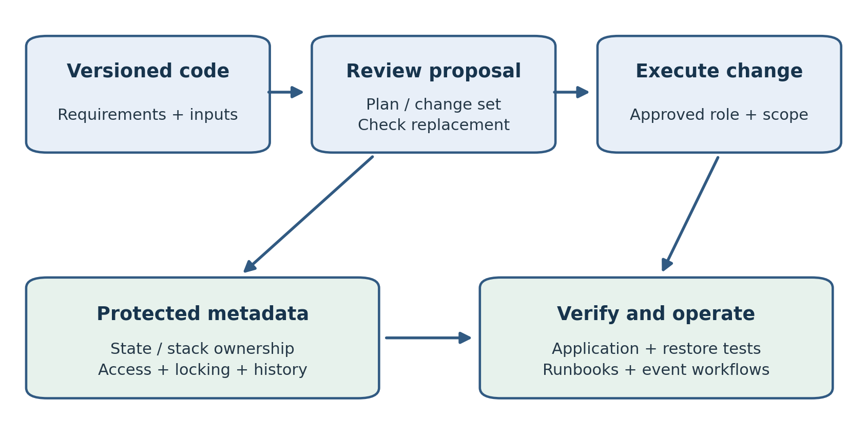
Figure 15.1. Review infrastructure changes before execution, protect ownership metadata, and verify the application afterward. Resource configuration does not replace a data recovery procedure.
Infrastructure as code makes a database environment reviewable and repeatable by recording its desired resource configuration. Automation applies procedures consistently after that environment exists. Both can reduce manual mistakes, but a repeatable action can still be wrong. A database change must preserve data, respect the operating window, and produce evidence that the application remains usable.
This chapter explains CloudFormation, Terraform, Systems Manager, and Lambda from a DBA perspective. It distinguishes resource provisioning from schema changes and recurring operations, describes the risks of state and replacement, and develops an automation procedure with explicit preconditions and validation. The objective is a process another engineer can inspect, execute, and support.
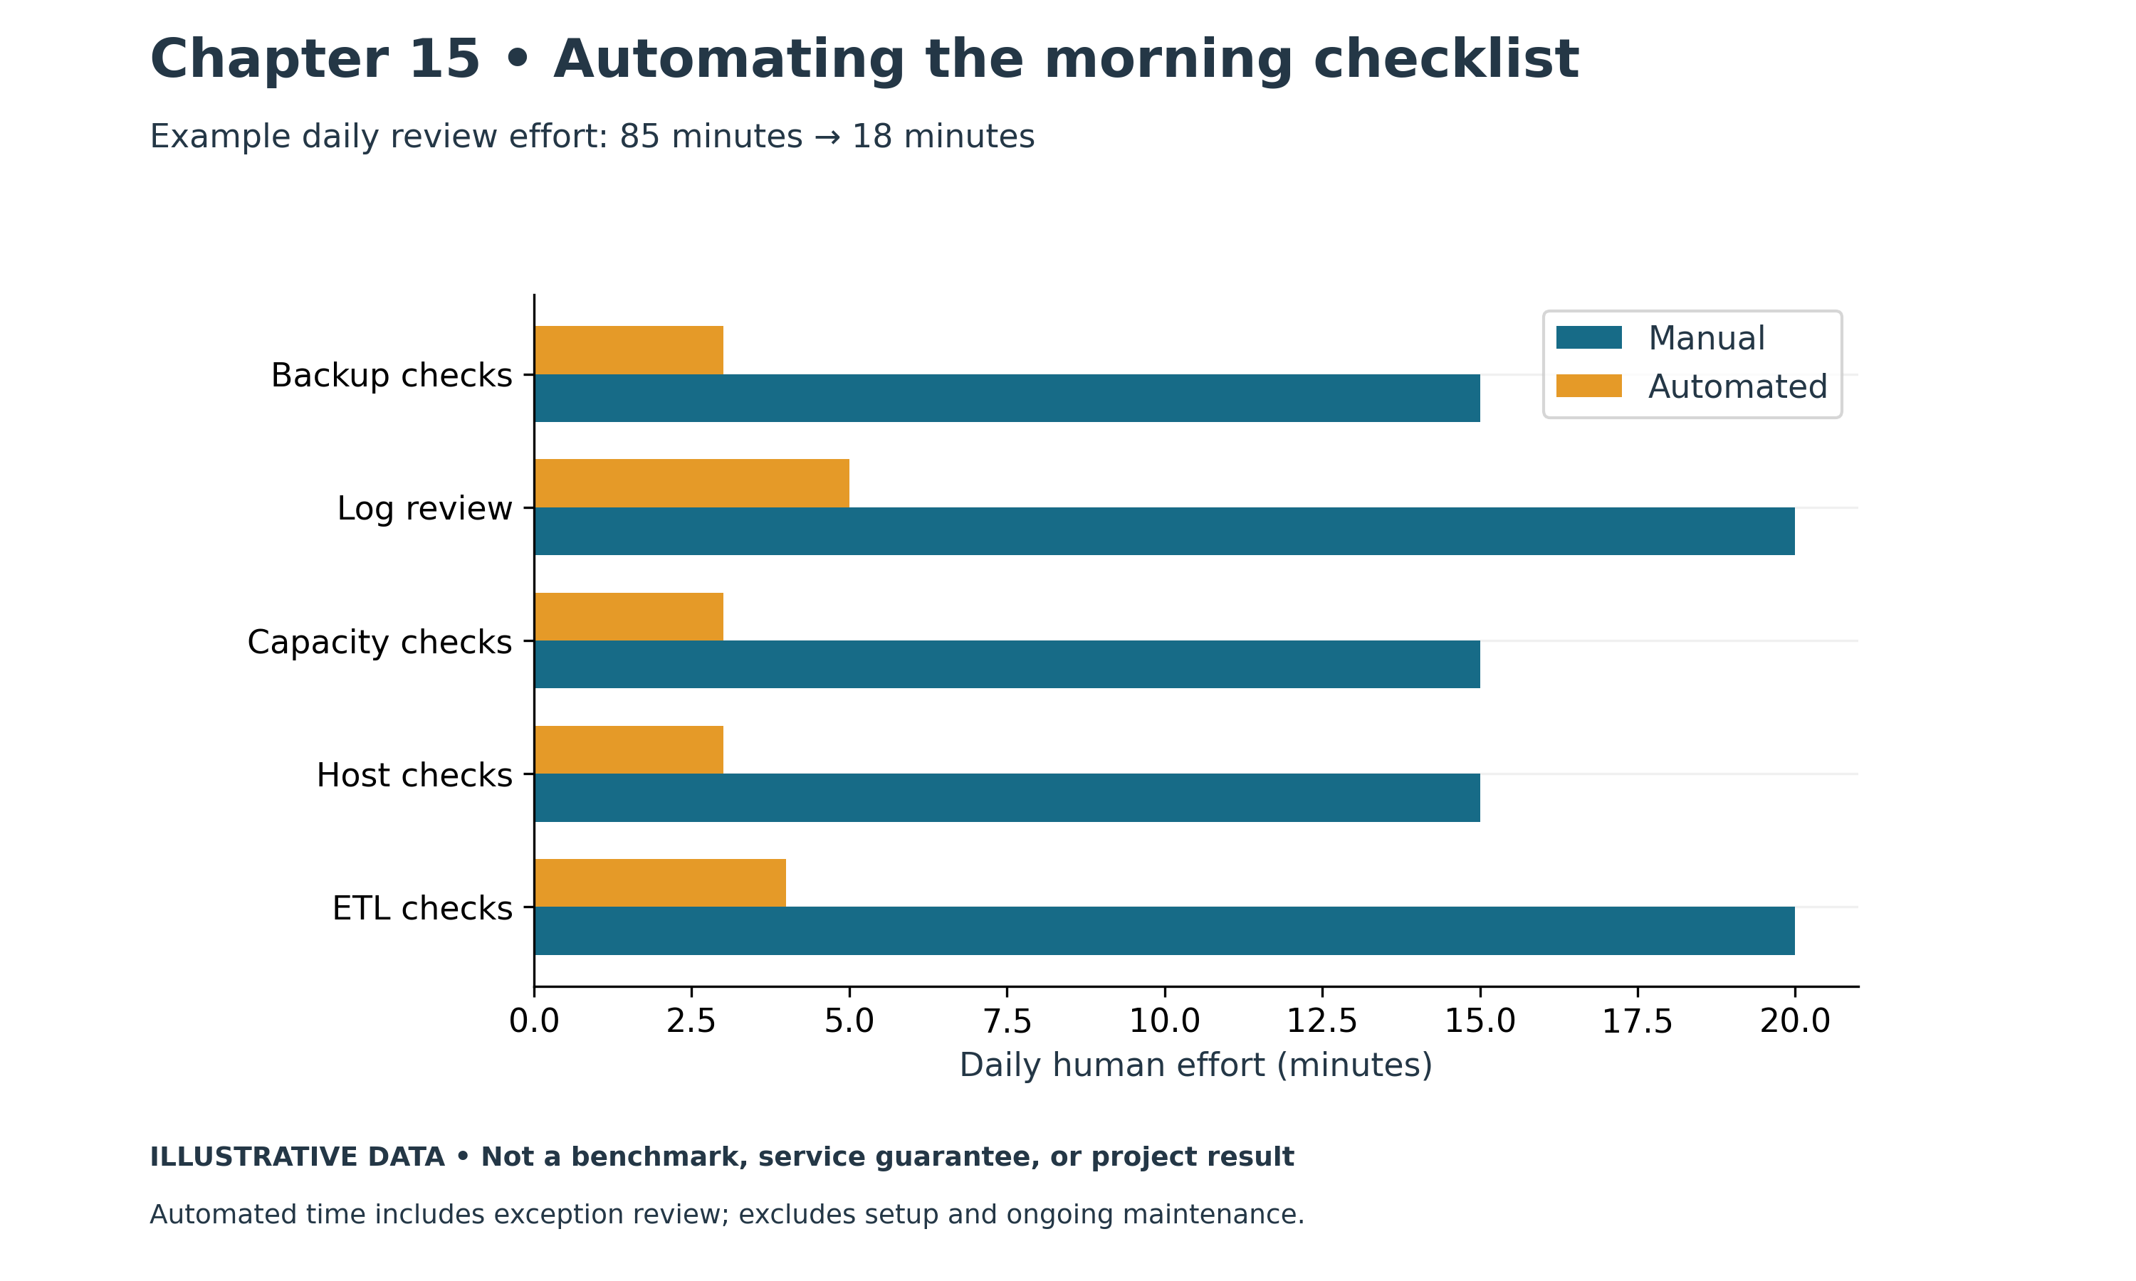
Figure 15.2. Daily effort before and after automation. Illustrative chart; values are examples, not measured production results.

From the Field: Automating Myself Out of the Morning Checklist
For years, much of my day followed the same pattern. I started by checking whether last night's backups had completed. Then I read through alert logs and listener logs looking for errors, checked which tablespaces were close to full, looked at CPU, memory and disk usage on each server, and hunted for the SQL that had misbehaved overnight. Somewhere in between, I built new environments by hand, refreshed and masked test data, and kept an eye on the nightly ETL to make sure it finished before the business arrived.
None of this work was difficult. That was the problem. It was repetitive, it depended on my memory, and it was easy to get wrong on a busy day. A missed check meant a backup failure discovered a week later, or a tablespace that filled up in the middle of the night. A slightly different setup on a new server meant a bug that appeared in production but never in test. When I was on vacation, someone else had to remember everything I did, and they usually didn't know half of it.
So I started automating, one task at a time.
The first target was building new systems. Instead of creating servers and installing software by hand, I defined the infrastructure in Terraform and CloudFormation and used Ansible to prepare the operating system, install and patch the database software, and apply our standard configuration. Everything lived in GitHub, so every change was reviewed and every environment could be rebuilt the same way. A new database environment that once took days of careful manual work became a pipeline run, and development, test and production finally looked alike.
Next came the nightly ETL. Our loads had to run in a strict order: dimension tables first, then the fact tables that referenced them. Previously that order depended on start times and hope. If a dimension load ran late, the fact load started anyway and failed, or worse, loaded rows that pointed to missing dimensions. I rebuilt the process with DBMS_SCHEDULER chains, so each step started only when the steps it depended on had succeeded. If a step failed, the chain stopped, the dependent loads waited, and the failure was reported instead of quietly spreading bad data.
Backups and data masking followed the same path. Backups ran on a schedule with their results recorded and checked automatically. The masking process from my earlier refresh work became a repeatable job that restored, masked and verified test data without anyone running steps by hand.
The biggest change was the daily health report. Instead of opening a dozen screens every morning, I wrote jobs that gathered the evidence for me: backup status from V$RMAN_BACKUP_JOB_DETAILS, errors from the alert log through V$DIAG_ALERT_EXT, problems in the listener log, tablespace usage from DBA_TABLESPACE_USAGE_METRICS, host CPU, memory and disk space, and the top resource-consuming SQL from the previous day. Every morning, one report arrived listing only what needed attention. A quiet day meant a short report. A tablespace trending toward full showed up days before it became an outage.
Automation didn't remove the DBA's judgment. Someone still had to decide what a warning meant, tune the SQL the report flagged, and approve changes before they reached production. But it removed the guesswork and the memory test. The work became consistent, it was documented in the code itself, and anyone on the team could see what ran, when, and why.
The lesson I took away is simple: if you do something twice, write it down. If you do it every day, automate it, keep it in version control, and make it tell you when something goes wrong.
Modern practice: define environments with reviewed Terraform or CloudFormation code and configure them with Ansible from a version-controlled repository. Use DBMS_SCHEDULER chains or a workflow tool for dependent jobs, so each step runs only after its prerequisites succeed. On AWS, CloudWatch alarms and dashboards, Systems Manager Automation and AWS Backup can take over much of the daily checklist, while a scheduled report still gathers the engine-level evidence that service metrics don't show. Sections on database modules, dependent jobs and failing clearly later in this chapter cover these patterns.

Decide What the Code Owns
Begin with ownership boundaries. A platform module may create the VPC, subnets, and security groups. A database module may create a subnet group, instance or cluster, parameter groups, and monitoring settings. Application deployment may own schema migrations and connection configuration. Record those responsibilities before several tools begin modifying the same property.
Infrastructure state is different from business data. A resource template can specify instance class and backup retention, but it does not contain the database's current rows. Recreating the resource from code is not a data recovery procedure unless a suitable restore source and complete workflow are included.
Keep schema changes under an appropriate migration process. Version SQL, test it against representative data, and define application compatibility during deployment. A tool that creates an RDS instance does not automatically manage every table, grant, index, and stored procedure safely.
Document inputs and outputs. Inputs should represent intentional choices such as engine, approved subnets, instance class, retention, and encryption key. Outputs should provide identifiers and endpoints needed by dependent systems without publishing passwords. Defaults deserve the same review as explicitly supplied values.

Choose CloudFormation or Terraform by Operating Needs
CloudFormation manages AWS resources from templates and stack operations. Change sets let reviewers inspect proposed changes before execution. Terraform uses provider configuration, a plan, and state to manage resources. Both can support controlled database infrastructure when the team understands their lifecycle behavior. [1][2]
Select the tool the organization can support through deployment, drift handling, and recovery. Consider provider or resource coverage, existing modules, identity integration, review workflow, and state operations. Avoid maintaining two independent sources of desired configuration for the same database properties.
A familiar language is helpful, but it is not the only criterion. Ask who can investigate a failed update, restore the required state metadata, and determine whether an operation replaced a database. The team needs operating knowledge of the chosen tool as well as database knowledge.

Review CloudFormation Changes
Treat a change set as a proposal to inspect. Look for additions, modifications, deletions, and replacements, especially on stateful resources. A change that appears to update one engine property may require a new resource. Confirm the documented update behavior for the exact property before execution. [1]
Configure deletion and replacement policies deliberately. DeletionPolicy governs applicable removal behavior, while UpdateReplacePolicy governs the old physical resource during replacement. Retaining a resource or creating a snapshot can protect an artifact, but it does not automatically reconnect the application or complete recovery. Retained resources also need ownership and cost review. [3]
Understand stack failure behavior. Infrastructure rollback concerns resource operations; it does not undo every database transaction or external application effect. Before a substantial update, confirm that backup protection and the database recovery procedure fit the potential failure.
Review stack service-role permissions. Broad deployment rights can affect resources beyond the database. Limit the role to the intended scope, and test the necessary operations. Keep execution authorization separate from the ability to read the template where the operating model requires it.

Understand Terraform State
Terraform state associates configuration addresses with managed objects and records relevant attributes. Protect it as operational data. Losing access to state can complicate resource management even when the database continues running. Copying an old state file over current state can create an incorrect view of ownership. [4]
Use an approved backend with access controls, encryption, versioning or recovery protection, and supported locking. Locking helps prevent concurrent operations from writing conflicting state. Investigate a stuck lock before using force-unlock; confirm that another run is not still active. [5]
State and saved plan files can contain sensitive values. Marking a Terraform variable sensitive controls display behavior but does not make every persisted value disappear. Prefer service-managed secrets and supported mechanisms that avoid placing secret values into ordinary state where appropriate. Restrict access to plans and build artifacts as well as the backend. [4]
Use separate environments and clear state boundaries. A development engineer should not accidentally apply a lab configuration against production state. Record the active account, Region, backend, workspace or environment, and assumed role before planning or applying.

Plan Before Applying
Use a version-controlled configuration and review changes through the team's normal process. Pin appropriate Terraform and provider version constraints, retain the dependency lock file, and upgrade deliberately. A provider upgrade can change planning behavior even when the database configuration is unchanged.
For an existing, reviewed Terraform lab directory, the shell workflow is:
aws sts get-caller-identity
terraform init
terraform fmt -check
terraform validate
terraform plan -out=reviewed.tfplan
These commands identify the AWS caller, initialize the working directory, check formatting and configuration, and save a plan. They do not prove that the design meets database requirements. Inspect the plan and protect it because it can contain sensitive information. Applying a saved plan creates or changes chargeable resources. [2]
Once execution is authorized through the established workflow, apply that reviewed plan rather than an unrelated newly generated one. If inputs, dependencies, or relevant infrastructure change, generate a new plan and review it. Keep the plan, code revision, execution identity, and outcome correlated.
Pay close attention to replacement. A destroy-and-create action on a database can affect availability and data even if the configuration looks cleaner afterward. Explicitly review resource identifiers, storage changes, engine transitions, and lifecycle settings. A protective lifecycle rule is useful, but it cannot compensate for removing the entire resource definition or choosing the wrong state.

Build a Database Module Around Requirements
A database module should expose meaningful operating choices. Include approved engine and version, private subnet placement, security groups, encryption, backup retention, maintenance windows, monitoring, and resource tags. Add validations where they can reject an obviously invalid combination before provisioning.
Avoid hiding critical behavior behind convenient defaults. The caller should understand whether the deployment has high availability, how deletion is handled, and whether a configuration change applies immediately. Document which settings may cause interruption and which require a separate migration procedure.
Use outputs for dependent identifiers and endpoints, then retrieve credentials through the approved secret mechanism. Do not return the master password as a general output for application teams. The module should facilitate separate application identities rather than normalize use of the administrator account.
Test the module with a synthetic environment. Confirm the actual resulting network exposure, encryption, retention, monitoring, and tags using service metadata. Infrastructure creation success establishes that the API accepted a configuration; it does not establish application connectivity or recoverability.

Building Development Environments for Different Roles
Infrastructure as Code has made it much easier to provision systems for specific development tasks. Instead of manually installing and configuring every environment, teams can define the infrastructure, software, and configuration in reusable files.
Different developers often need different environments. A database developer may need a database, a SQL development tool, sample data, and access to business-rule documentation. An application developer may need Java or Python, application libraries, an API service, and a database connection. Providing each person with an environment suited to their work can reduce setup time and unnecessary resource use.
These environments can use virtual machines, containers, or a combination of both. A virtual machine includes its own operating system. A Docker container packages an application and its dependencies while sharing the host's operating-system kernel. Kubernetes coordinates containerized workloads across machines. The appropriate choice depends on software compatibility, isolation requirements, and operational complexity.
For example, a customer developing an accounting query may need only the relevant database objects and a representative dataset. Another customer may need manufacturing or customer data. Automation can provision a dedicated database, schema, or container-based environment for each task, depending on the required level of isolation. Sensitive production data should be masked or replaced with suitable test data before being made available.
The business rules matter as much as the software. A technically correct query can still produce an incorrect business result if the developer misunderstands how balances, manufacturing transactions, or customer records are defined. Making the relevant documentation available alongside the development environment helps developers validate both the query and its meaning.

Bringing Individual Work into a Shared Test Environment
Developers can work in separate environments and then bring their changes into a shared integration or test environment. This is where the team checks that database changes, application code, interfaces, and configuration work together.
Each iteration follows a repeatable cycle: build, deploy, test, correct defects, and test again. Version-controlled infrastructure definitions, container images, configuration, and database migration scripts help make the results reproducible. The shared test environment should reflect the intended production architecture closely enough to reveal integration problems before release.
Separate development environments still need coordination. A database change that works for one developer may break an application used by another. Shared testing exposes these dependencies and gives the team an opportunity to resolve them.

Adopt Existing Resources Carefully
An existing database can be brought under code management using the selected tool's supported import or adoption process. First inventory its current configuration and dependencies. Write the intended configuration to match the state that should be preserved, then inspect the plan for unexpected changes.
Import does not convert every surrounding manual decision into a complete operating design. Parameter groups, subnet groups, security groups, secrets, and monitoring may have separate owners. Record which resources are managed, which are referenced, and which remain external.
Use a read-only planning review before the first apply. If the plan proposes replacement or configuration changes, investigate why. Do not apply merely because import succeeded. The value of adoption is controlled future change, rather than immediately forcing an old database to match a new generic template.

Detect and Resolve Drift
Drift occurs when actual resource configuration differs from the intended code or recorded configuration. Console changes made during incidents are a common cause. They may have been justified, but they must be reconciled so that the next deployment does not silently reverse them.
Review the drift with its owner. Decide whether to incorporate the observed setting into code or restore the intended setting through a planned change. Preserve the incident reason and any temporary expiry. Automated drift detection should surface the difference; automatic correction of every database difference can create an outage.
Include properties outside the tool's managed scope in the operational inventory. A clean Terraform plan or stack drift result does not prove that database grants, application secrets, or schema objects are unchanged. Those need their own appropriate controls.

Use Systems Manager for Procedures
Systems Manager Automation runs defined steps across supported AWS resources and managed nodes. Runbooks can express preconditions, actions, branching, approval steps where required, and verification. Choose the facility that fits the action instead of treating every administrative task as an operating-system command. [6]
For EC2 databases, managed-node operations can support guest procedures where the agent, permissions, and network requirements are met. RDS does not provide the same guest shell access. An RDS procedure should use supported service APIs or an approved database connection, depending on the task.
Build a restore exercise runbook with a specific target environment and resource scope. Verify the source backup, restore the isolated resource, wait for service state, run approved validation, collect results, and apply the agreed cleanup policy. Separate destructive cleanup from evidence collection so a failed test does not erase its own diagnostic record.
Review the automation role independently from the human role that starts it. The runbook may execute with privileges the caller does not normally hold. Restrict inputs so an authorized lab exercise cannot be redirected to an unrelated production resource.

Use Lambda for Bounded Event Actions
Lambda can perform short, event-driven actions such as inspecting a resource, recording a compliance result, or initiating an approved workflow. Keep long-running database operations in a workflow that can wait, retry, and retain state without depending on one function invocation remaining active. [7]
Design for duplicate delivery and retries. An event handler that receives the same request twice should not create two restore resources or send conflicting modifications. Use a stable request identifier and a persisted record of progress where the action requires it. Check the resource's current state before requesting a transition.
Bound concurrency and API calls. A fleet-wide event can overwhelm a database or service quota if every handler acts simultaneously. Use controlled batching, backoff, and a limit on simultaneous disruptive operations. A retry must recheck whether the previous request already succeeded.
Separate observation from remediation. A function that reports unapproved backup retention is easier to introduce than one that changes every database automatically. Automatic remediation should have clearly defined conditions, resource scope, and a failure path understood by operations.

Make Automation Fail Clearly
Every procedure needs an initial check and a final verification. Reject the wrong account, Region, environment, or resource state before action. Validate that the required backup, key access, and permissions exist. These checks make the procedure's assumptions executable.
Record progress at meaningful steps. If a restore request succeeded but validation timed out, the retry should recognize the existing restored database and continue appropriately. A script that reports only success or failure leaves responders unable to tell whether a resource was created.
Use explicit stop conditions. A failed data check, unexpected writer, or incompatible version should halt the procedure and retain evidence. Do not catch every exception and continue merely to keep the automation green. Failure should identify the action completed, the action pending, and the next decision required.

Automating Jobs with Dependencies and Conditional Recovery
Automation also makes it easier to coordinate tasks that depend on earlier tasks. A workflow may provision a machine, install database software, create the database, load test data, and then run validation queries. Each step should begin only when its prerequisites have succeeded.
Ansible can perform configuration tasks and use conditions, registered results, and error-handling blocks to control what happens next. A workflow orchestrator or CI/CD platform can coordinate larger sequences across systems.
For example, Job 1 might create a database and Job 2 might load an accounting dataset. If Job 1 succeeds, the workflow proceeds to Job 2. If Job 1 fails with a recognized, recoverable error, the workflow can perform a corrective action and retry with approved variables. An unexpected failure should stop the dependent work and report the problem.
Retries need limits and safeguards. Repeating a task must not accidentally create duplicate resources, load the same transactions twice, or overwrite useful data. Idempotent tasks—tasks that leave the system in the intended state even when repeated—are especially valuable here.
For a DBA, this turns environment setup and routine operational work into a repeatable process. A request for a particular database version, application dataset, or development configuration can become a defined workflow with validation, logging, and predictable results.

Example Automating a Recovery Exercise
Consider a monthly test for an RDS PostgreSQL application. The workflow starts from an approved request, verifies the source identifier and restore point, and creates a uniquely named isolated database. It uses the recovery role and approved key, then waits for readiness.
An approved test runner checks critical synthetic records and application connectivity. Results include the restore point, provisioning duration, validation duration, and errors. Cleanup occurs only after the evidence is retained and the environment is confirmed to be the test target.
The first execution discovers that the validation role cannot retrieve its test secret. The workflow stops after restore and records the resource identifier instead of deleting it silently. Once the permission is corrected, a controlled continuation completes validation. The resulting runbook describes the failure and recovery behavior as well as the normal path.

Practical Exercise and Review
Create a small Terraform or CloudFormation design for a synthetic database lab using an approved existing network. Include encryption, private access, retention, tags, and an explicit deletion approach. Review the planned resource changes before creating anything, then verify the actual configuration and remove the lab through its cleanup procedure.
Write pseudocode for a restore-test workflow. Include preconditions, a duplicate request, a timeout after resource creation, a failed validation, and cleanup. Explain which facts must be persisted so that another engineer can continue safely.
Review questions: Why is infrastructure state not a database backup? What does a replacement action require the DBA to assess? Why are saved plans sensitive? How should automation handle a timeout after an API request may have succeeded?
Suggested answers: State records resource management information rather than current business rows. Replacement can affect data, availability, endpoints, and recovery. Plans may contain resource attributes and secrets. Reconcile the resource state before retrying, preserving a stable request identity and progress record.
Chapter 16 extends these operating habits to additional data services and a practical path for continued learning.

References
[1] CloudFormation change sets. https://docs.aws.amazon.com/AWSCloudFormation/latest/UserGuide/using-cfn-updating-stacks-changesets.html
[2] Terraform plan. https://developer.hashicorp.com/terraform/cli/commands/plan
[3] CloudFormation deletion and replacement policies. https://docs.aws.amazon.com/AWSCloudFormation/latest/TemplateReference/aws-attribute-deletionpolicy.html and https://docs.aws.amazon.com/AWSCloudFormation/latest/TemplateReference/aws-attribute-updatereplacepolicy.html
[4] Terraform sensitive data and state. https://developer.hashicorp.com/terraform/language/manage-sensitive-data
[5] Terraform state locking. https://developer.hashicorp.com/terraform/language/state/locking
[6] Systems Manager Automation. https://docs.aws.amazon.com/systems-manager/latest/userguide/systems-manager-automation.html
[7] Lambda best practices. https://docs.aws.amazon.com/lambda/latest/dg/best-practices.html

Chapter 16: Beyond Relational and Your Career Path
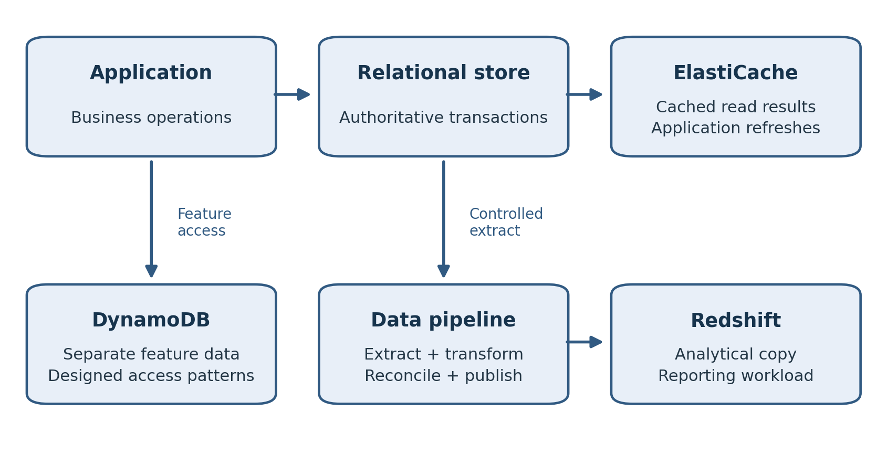
Figure 16.1. Each service has a defined data role. Cached results and analytical copies depend on the relational source in this example; DynamoDB serves a separate feature with its own data model.
An application can use a relational database for transactions, an in-memory cache for repeated reads, and a warehouse for analysis. Each component solves a different problem and introduces its own operating responsibilities. A cloud DBA needs enough knowledge of those responsibilities to choose a suitable service, investigate a failure, and identify which team owns the remedy.
This chapter introduces DynamoDB, ElastiCache, and Redshift through the questions an experienced DBA already asks about data, access, performance, and recovery. It then develops a practical learning path. The aim is to extend your judgment beyond a familiar engine while keeping your established strengths in database operations.

Begin with the Workload and Its Data Contract
Before comparing services, describe how the application uses its data. Which requests retrieve one object? Which require joins or transactions across several entities? Which aggregate millions of historical records? Identify the acceptable age of a result, the consequence of a lost update, and whether a derived copy can be rebuilt.
A product catalog illustrates the distinction. Product definitions and prices might remain in a relational system with existing business rules. Frequently requested descriptions can be cached. A separate store might serve a predictable lookup pattern for a new feature. Sales history can feed a warehouse for reporting. Splitting the workload only helps when the interfaces between these components are explicit.
Record the system of record for each entity. A customer balance should not become authoritative in both a cache and a relational table without a designed synchronization protocol. Also record how a derived copy is refreshed, how stale data is detected, and how it is rebuilt. These decisions determine what recovery means for each component.
Use the smallest architecture that meets the requirement. Every additional service introduces credentials, monitoring, data movement, cost, and an incident boundary. A well-tuned relational query may be sufficient for a modest workload. Add another store when measured demand or a concrete feature justifies the operating effort.

DynamoDB Starts with Access Patterns
Amazon DynamoDB is a managed NoSQL service for key-value and document workloads. Its data model uses tables, items, and attributes. A table primary key is either a partition key or a combination of partition key and sort key. In the composite form, the combination identifies an item. The partition key participates in data distribution; the sort key organizes items sharing the same partition key. [1]
For a simple order-history design, consider partition key CUSTOMER#1042 and sort keys ORDER#2026-10-09#0001 and ORDER#2026-10-10#0002. The intended request is to retrieve orders for that customer in a range of sort-key values. This example demonstrates an access pattern; it is not a complete production model. An application needing lookup by order identifier or reporting across all customers requires additional design.
Write the important requests before choosing keys. For each request, identify the required attributes, result size, expected rate, and consistency requirement. A design that supports the most common request efficiently can still fail on a less frequent but essential operational request, such as finding all unprocessed orders.
Secondary indexes support alternative access paths. They also introduce storage, write work, and consistency considerations. Do not translate every relational index into a DynamoDB index automatically. Evaluate whether the access pattern needs that index and whether the projected attributes provide the required result. [1]
Skew matters. A partition key such as a single current status can concentrate activity when most writes share that value. A customer-based key may distribute ordinary traffic but still need attention when one customer generates exceptional demand. Test realistic key popularity, including a dominant customer or event. Aggregate throughput alone can hide concentration on a small part of the key space.
Capacity decisions should follow the workload and current service limits. Compare supported capacity modes using actual request behavior, item sizes, and the operational need to handle bursts. Monitor throttling, latency, errors, and consumed capacity where applicable. A retry policy should bound attempts and preserve the identity of a business operation; repeating a write must not accidentally create a second order.

Consistency and Global Tables Require Specific Choices
DynamoDB supports eventually consistent reads and, for supported operations, strongly consistent reads. A strongly consistent read returns a result reflecting successful prior writes. Global secondary indexes support eventually consistent reads, so an index lookup must not be assumed to have the same freshness as a strongly consistent table read. [2]
Choose consistency from the business operation. A product description may tolerate a brief delay after an edit. A workflow deciding whether a payment has already been processed needs a stronger correctness design. Conditional updates, transaction support where appropriate, and stable operation identifiers deserve examination alongside read consistency. Simply increasing read freshness does not define the whole transaction protocol.
DynamoDB global tables replicate data across Regions. Current documentation distinguishes multi-Region eventual consistency and multi-Region strong consistency. Their availability, topology, and operational behavior differ. Check the supported consistency mode and Regions for the intended design instead of assuming every global table uses the same conflict and replication model. [3]
For an eventual-consistency design, investigate concurrent updates and the documented conflict resolution behavior. For a strong-consistency design, investigate the permitted topology, write behavior during a disruption, and application latency. In either case, test application routing and dependencies. Replicating table data does not make every application component available in another Region.
Keep historical recovery separate from replication. A valid service replication mechanism can distribute an unwanted business update. Define backup and recovery requirements, test a supported restore, and prove how the application will use the recovered data. The writer-history reasoning from Chapter 10 still applies when valid transactions occur after the selected recovery point.

ElastiCache Changes the Read Path
Amazon ElastiCache provides managed in-memory data stores using supported Valkey, Redis OSS, and Memcached engines. Select the engine and deployment model from the commands, availability, scaling, and durability requirements of the application. Do not assume all engine features or deployment choices are interchangeable. [4]
In a cache-aside design, the application first checks the cache. On a miss it reads the authoritative database and may populate the cache. A later request can use the cached result. The database therefore remains responsible for the original data, while the application controls the lifecycle of the derived copy. [5]
Define expiration and invalidation together. A time to live limits how long a cached entry remains eligible, but it does not guarantee immediate freshness after a database change. For a mutable price or permission, determine whether the application must invalidate an entry, update it, or bypass the cache for a correctness-sensitive operation. Include failed invalidation in the design.
Cache keys need clear scope. A key used by several tenants must not return one tenant's data to another. Include the relevant tenant, object, and version dimensions, and apply suitable access controls. Avoid logging sensitive values merely because the cache is considered temporary.
Prepare for a cold cache. After a restart, scaling event, or broad expiration, many requests may reach the database together. Test whether the source database can handle that load. Controlled refresh, limits on concurrent loads, and variation in expiration times can help where the application design permits them. Measure the effect instead of relying on a high steady-state hit ratio.
Observe hit and miss behavior alongside application latency, memory pressure, evictions, and database request volume. A cache can have a good overall hit rate while a critical request remains slow. A stale result can be returned quickly and still be wrong. Include correctness checks and the fallback path in the acceptance criteria.
If the application stores sessions, locks, or other operational state in the in-memory service, identify the consequence of losing that state. A disposable query cache and a store holding essential workflow information have different recovery requirements. Document supported durability and backup behavior for the actual engine and configuration, then rehearse the relevant failure.

Redshift Serves Analytical Workloads
Amazon Redshift is a managed data warehouse. Its columnar storage supports analytical queries that read selected columns across many records. This differs from the usual transaction workload that retrieves or updates a small set of individual rows. SQL familiarity helps a DBA learn Redshift, but familiar syntax does not establish identical storage, constraint, or performance behavior. [6]
Start with an analytical question, such as daily revenue by product and Region. Identify the grain of the source data, the relevant event timestamp, late-arriving updates, and the required freshness. If an order can be canceled after its first load, the pipeline must account for that change rather than treating the initial insert as final history.
Separate extraction, transformation, and warehouse acceptance. Land a controlled source extract, record its scope, transform it according to documented rules, and reconcile the loaded result. Counts are useful, but also compare business totals and rejected records. A pipeline that silently drops invalid rows can report success while producing incorrect revenue.
Redshift COPY can load data from supported sources, including files in Amazon S3. Use the documented authorization method and file-format options for the exercise. Give the load role access to the intended objects and keys, and verify that every expected file belongs to the load. Loading data and proving its business meaning are separate tasks. [7]
For ongoing pipelines, define a checkpoint and retry behavior. If a job fails after some work has completed, the next run should establish what is already present before loading again. Staging tables, batch identifiers, and a controlled publication step can make that behavior reviewable. The suitable implementation depends on the source and pipeline tools.
Investigate warehouse performance through query plans, data volume, physical design, and workload concurrency. A scan that is expensive on an operational database may be appropriate for a large analytical aggregate. Evaluate supported distribution, sorting, and automatic optimization features in the selected deployment. Preserve the query's correctness while testing changes.
Keep reporting off the production writer when the business requirement and architecture permit it. Also account for the cost and latency of maintaining the analytical copy. A separate warehouse can protect transaction processing, but it creates another recovery procedure, authorization boundary, and data-quality obligation.

From the Field: The Report That Joined Everything to Everything
Point-and-click reporting tools were supposed to free customers from waiting on IT. With tools like Cognos and Tableau, anyone could drag a few fields onto a canvas and get a report. Behind each click, the tool wrote the SQL.
Some generated SQL was inefficient. Missing join conditions could produce Cartesian products. Filters could prevent useful index access, and queries against partitioned history could read far more data than needed. A report that looked simple to its author could consume substantial database resources.
At first I dealt with these queries one at a time. I'd find the expensive SQL, trace it back to a report, and contact the customer who built it. They were rarely careless. The tool had hidden the SQL from them, and they had no way to know their three clicks had asked the database to do something enormous.
I asked customers to involve the database team when building reports from generated SQL. We reviewed their requirements and the data model, then tuned the queries before they became recurring reports.
Then I went a step further. Instead of tuning each report, I built tuned views that did the hard work correctly: the right joins, the right filters, and access paths that used partitions and indexes. Customers selected from the view and didn't need to know how it worked. Many needs overlapped, so I designed generic views that served many customers at once. One well-built view replaced dozens of badly generated queries.
Curated access gave customers a better starting point and reduced the number of generated queries that needed individual repair.
Modern practice: publish curated views or a governed semantic model, test generated SQL, and apply query limits suitable for each engine. Use materialized views or a separate analytical platform where justified. A view is not automatically fast: verify its execution plan, joins, partition pruning, and predicates. The Redshift discussion above explains analytical platforms; Chapter 12 covers execution plans and SQL tuning.

Carry Your Existing DBA Skills Forward
An Oracle DBA already knows how to establish a baseline, investigate blocking, test recovery, and distinguish a successful command from a usable service. Apply those habits to the new platform. Replace an unavailable tool with evidence that answers the same operational question.
For DynamoDB, ask which access pattern is slow and whether key popularity is uneven. For a cache, ask whether misses, invalidation, or memory pressure explain the symptom. For Redshift, ask whether query work, load behavior, or concurrency changed. In every case, connect service evidence to what the application experienced.
Develop Linux, networking, IAM, SQL, and automation skills together. Many database incidents cross those boundaries. A correct database password cannot repair a denied network path, and a healthy service metric cannot prove that a client trusts its TLS certificate. Record which observation eliminated each possible cause.

Build a Portfolio That Shows Operational Judgment
Choose one manageable lab and deepen it. A relational migration with synthetic data can demonstrate assessment, schema conversion, baseline loading, change capture, validation, and cutover. A second exercise can compare a cache read path or a DynamoDB access pattern. A warehouse load can demonstrate reconciliation and restart behavior.
Keep an architecture diagram, a short explanation of the decisions, reproducible configuration, and the acceptance evidence. Include a recovery exercise and cleanup record. Remove credentials, account identifiers, customer information, and confidential employer material before sharing anything publicly.
A useful portfolio describes a failure as well as a successful run. For example, a validation job might stop because its role cannot read a secret. Show how the job preserved its progress and how you corrected the permission. Explain why the correction was limited to the required scope.
In interviews, describe the requirement, the design, the evidence, and any remaining limitation. State whether work was a lab or production experience. A precise explanation of a lab restore is stronger than an unsupported claim that you have managed every AWS database service.

Choose Certifications to Support Your Work
AWS Certified Cloud Practitioner can support foundational AWS vocabulary, particularly when an employer requires it. AWS Certified Solutions Architect Associate addresses architectural choices across AWS. AWS Certified Data Engineer Associate is relevant when your role increasingly includes pipelines, data modeling, and data quality. Review current exam guides before scheduling an exam. [8]
Do not plan around the retired AWS Certified Database Specialty exam. AWS announced its retirement in 2024. Use current certification options and practical database exercises to demonstrate continuing development. Certification is a useful checkpoint; it does not replace the ability to restore data or explain an incident. [9]
Create a twelve-week learning plan with observable outcomes. In the first four weeks, build a private relational environment and explain its IAM and network paths. In the next four, migrate synthetic data and complete restore and failover exercises. In the final four, automate the configuration and add one focused nonrelational or analytical exercise. Adjust the pace to your available time.
At the end of each phase, have another engineer follow the runbook or challenge the design. A procedure that depends on knowledge left in your memory is incomplete. Use the feedback to improve the explanation, prerequisites, and failure handling.

Practical Exercise and Review
Design a small order application using synthetic data. Identify its authoritative transactional store, one read that could benefit from a cache, and one analytical question for a warehouse. Separately propose a DynamoDB key design for retrieving a customer's recent orders. Explain why each service is justified or why the relational database alone is sufficient.
Write acceptance tests for a stale cache entry, a dominant DynamoDB partition-key value, a repeated warehouse load, and an application dependency failing during a regional exercise. You do not need to deploy every service at once. Begin with one approved lab and collect evidence before adding another component.
Review questions: Why should DynamoDB key design begin with requests? Why is a cache TTL insufficient for immediate freshness? Why must a warehouse load be reconciled? What makes a cloud DBA portfolio credible?
Suggested answers: Requests define the access paths that keys and indexes must support. TTL limits entry lifetime but does not immediately reflect every source update. Reconciliation checks completeness and business meaning, including rejects and duplicates. A credible portfolio shows reproducible decisions, validation, recovery, limitations, and honest identification of lab work.

References
[1] DynamoDB core components and partitions. https://docs.aws.amazon.com/amazondynamodb/latest/developerguide/HowItWorks.CoreComponents.html and https://docs.aws.amazon.com/amazondynamodb/latest/developerguide/HowItWorks.Partitions.html
[2] DynamoDB read consistency. https://docs.aws.amazon.com/amazondynamodb/latest/developerguide/HowItWorks.ReadConsistency.html
[3] DynamoDB global table consistency and behavior. https://docs.aws.amazon.com/amazondynamodb/latest/developerguide/V2globaltables_HowItWorks.html
[4] What is Amazon ElastiCache. https://docs.aws.amazon.com/AmazonElastiCache/latest/dg/WhatIs.html
[5] ElastiCache caching strategies. https://docs.aws.amazon.com/AmazonElastiCache/latest/dg/Strategies.html
[6] Redshift columnar storage. https://docs.aws.amazon.com/redshift/latest/dg/c_columnar_storage_disk_mem_mgmnt.html
[7] Redshift COPY. https://docs.aws.amazon.com/redshift/latest/dg/r_COPY.html
[8] AWS Certification and current exam guides. https://aws.amazon.com/certification/ and https://aws.amazon.com/certification/certified-solutions-architect-associate/ and https://aws.amazon.com/certification/certified-data-engineer-associate/
[9] AWS Certification retirements and launches. https://aws.amazon.com/blogs/training-and-certification/aws-certification-retirements-and-launches/

Closing Section

Putting the Book into Practice
A cloud database design is ready for use when the team can explain its responsibilities, verify its data, recover its service, and support the application under representative demand. The exercises in this book build toward that standard. Carry the evidence from them into your next design or migration.
Start with one database that you understand well. Record its users, dependencies, workload, recovery requirements, and operational constraints. Compare a managed service with a self-managed deployment using those requirements. Treat access, migration, recovery, performance, and cost as parts of the same decision.
Keep a small operating record for every environment. It should identify the authoritative writer, resource owners, access paths, backup policy, latest restore exercise, important alarms, and approved change procedure. The record should help another engineer respond when you are unavailable. Update it after a migration, engine change, or recovery exercise.
Your experience remains valuable because the difficult questions still concern data and service. Was the transaction committed? Is the copy complete? Can the application reconnect? Which observation explains the delay? What would be lost by restoring an earlier point? AWS changes how you obtain some of the answers; it does not remove the need to ask them.
Choose the next exercise from an actual gap. If you have never restored the target service, start there. If a migration is approaching, rehearse validation and the writer transition. If your role is expanding into pipelines, demonstrate a repeatable load with reconciliation. Continue learning by producing evidence that another person can inspect.

Appendix A

On Premises to AWS Terminology Map
This map connects familiar DBA concepts with AWS vocabulary. The entries identify related responsibilities rather than exact feature equivalence. Confirm the behavior of the specific service, engine, and deployment before replacing an established procedure.
Familiar concept | Related AWS term or service | Practical distinction
Data center location | AWS Region | Select for latency, residency, dependencies, and recovery design.
Separate local failure location | Availability Zone | A Region contains multiple AZs; application placement still needs design.
Private network segment | VPC and subnet | Routing, DNS, security groups, and subnet placement jointly affect connectivity.
Firewall rule for a host | Security group | Controls allowed resource traffic; it does not grant a database login.
Site connectivity | Site-to-Site VPN or Direct Connect | Network connection and database authorization remain separate.
Server or virtual machine | Amazon EC2 instance | Your team manages the guest operating system and installed database.
Managed database environment | Amazon RDS | Supported administration is through service features and engine access.
Database platform identity | DB instance or DB cluster | Instance and cluster resources have different settings and recovery workflows.
Database initialization settings | Parameter group | Change behavior depends on the parameter and deployment.
Engine extensions or optional features | Option group where applicable | Availability depends on the engine and supported configuration.
Storage volume | Amazon EBS or managed database storage | Control, resizing, and performance options depend on the service.
Administrative identity | IAM principal and role | Controls AWS actions; SQL privileges are another authorization boundary.
Database account | Engine user or role | Grants database access according to engine rules.
Password vault | AWS Secrets Manager | Applications must retrieve and use credentials correctly, including rotation.
Encryption key management | AWS KMS | Key access is also a recovery dependency.
Host and service monitoring | CloudWatch and Enhanced Monitoring | Available telemetry differs between EC2 and managed databases.
Database workload analysis | CloudWatch Database Insights and engine tools | Use SQL and wait evidence appropriate to the engine and available features.
Administrative action audit | AWS CloudTrail | AWS API records do not replace database statement auditing.
Standby for service continuity | Supported RDS Multi-AZ design | Failover behavior and readable capacity differ by deployment type.
Reporting copy | Read replica | Lag and application routing matter; a replica is not historical backup protection.
Database backup copy | Automated backup or manual snapshot | Retention, restore selection, and resulting resources differ.
Recovery to an earlier point | Point-in-time recovery | Test configuration and application reconnection after the supported restore.
Replication checkpoint | CDC position or native replication checkpoint | Position formats and restart guarantees depend on the migration tool.
Schema portability assessment | AWS SCT or DMS Schema Conversion | Conversion output needs code and application testing.
Data transfer with change capture | AWS DMS | Full load and CDC need prerequisites, monitoring, and reconciliation.
Configuration scripts | CloudFormation or Terraform | Resource configuration does not contain the database's current business rows.
Operating procedure automation | Systems Manager Automation | Define scope, preconditions, failure handling, and verification.
Event handler | AWS Lambda | Handle retries and duplicates; retain workflow progress when required.
Analytical database | Amazon Redshift | Warehouse design and data quality differ from transaction processing.
Application key-value store | Amazon DynamoDB | Key and index design begins with access patterns.
In-memory cache | Amazon ElastiCache | Freshness, fallback load, and the loss of cached state require decisions.

Appendix B

Migration Checklist and Acceptance Record
Use this checklist to create a migration-specific runbook. Each item needs an owner, evidence, and a clear completion condition. Record not-applicable decisions with a reason. An unchecked item is a planning gap; a checked item without evidence is not proof of readiness.

Stage 1 Scope and Assessment
1. Identify the business owner, technical owner, migration lead, application owner, and recovery decision maker.
2. List databases, schemas, tables, stored code, scheduled jobs, users, interfaces, and external dependencies in scope.
3. Record engine and version, data volume, growth, workload peaks, licensing constraints, and required features.
4. Establish downtime tolerance, RPO, RTO, data residency, security requirements, and acceptance criteria.
5. Identify an authoritative source writer and all processes that can change the data, including jobs and integration services.
6. Select the target service and migration method from the assessment. Document unsupported features and the plan for each.

Stage 2 Target and Access Preparation
1. Prepare the target network, subnet placement, security groups, DNS, and approved administrative path.
2. Configure engine version, storage, parameters, optional features, monitoring, and backup policy.
3. Establish least-privilege migration roles, database grants, secrets, TLS configuration, and encryption key access.
4. Test source and target connectivity from the actual migration and application runtimes.
5. Confirm change-capture prerequisites and log retention where CDC is required. Estimate retention against load time and disruption risk.
6. Test target restore and application reconnection before relying on the target recovery design.

Stage 3 Conversion and Data Rehearsal
1. Review conversion assessment findings. Resolve or explicitly accept every required schema and code change.
2. Test datatypes, precision, character encoding, time zones, generated values, large objects, constraints, and important SQL behavior.
3. Load representative data and then rehearse at the intended production scale where feasible.
4. Coordinate the baseline with the change-capture position. Prove that the combination neither omits nor duplicates required changes.
5. Monitor task failures, rejected records, throughput, resource pressure, and capture or apply lag.
6. Reconcile counts, key ranges, business totals, and critical transactions. Test changed and deleted rows as well as inserts.
7. Run application, batch, reporting, and integration tests through the target environment.
8. Record load duration, catch-up duration, validation time, interruption, and unresolved limitations.

Stage 4 Cutover Readiness
1. Produce a timed runbook with named operators, decision points, commands, expected outcomes, and stop conditions.
2. Identify every writer to freeze, the method of freezing it, and the evidence that writes have stopped.
3. Specify the final checkpoint and method of proving required changes reached the target.
4. Define final data checks and application acceptance before new target writes are authorized.
5. Document endpoint, secret, pool, job, and integration changes. Test reconnection and routing behavior.
6. Define return to the source before target writes, and a separate recovery method after target writes begin.
7. Agree how new target transactions will be protected and reconciled if recovery becomes necessary.
8. Confirm source retention, backups, staffing, communications, outage authority, and stabilization coverage.

Stage 5 Execution and Acceptance
1. Record start time, source state, current backups, and readiness authorization.
2. Freeze all source writers and verify the freeze. Capture the agreed final position.
3. Allow supported change application to reach that position. Investigate errors instead of treating a low lag value as sufficient proof.
4. Complete final reconciliation and required target checks while writer authority remains controlled.
5. Apply the approved application routing changes. Verify login, reads, critical transactions, and integrations.
6. Authorize the target writer at the defined point. Record the time and successful business transaction evidence.
7. Observe application latency, errors, jobs, database workload, and backups during the agreed stabilization period.
8. Obtain acceptance from the named business and technical owners, including any known data exposure or exceptions.

Stage 6 Stabilization and Source Retirement
1. Resolve migration exceptions and verify recurring jobs, monitoring routes, credential rotation, and operating ownership.
2. Complete a target restore exercise using the production operating roles and approved recovery procedure.
3. Review target capacity and cost using representative demand rather than the migration load alone.
4. Preserve source artifacts for the approved retention period and prevent unintended source writes.
5. Retire the source only after authorization and confirmed retention requirements. Remove unnecessary replication and temporary access.
6. Check retained storage, snapshots, logs, network resources, secrets, and temporary compute for cleanup ownership.
7. Archive the migration evidence and record what should change in the next migration.

Acceptance Record
Complete this record alongside the detailed runbook. Attach the underlying query output, logs, timestamps, and application results to the migration evidence.
Record item | Value or evidence location
Application and migration identifier
Source and target identifiers
Runbook revision and execution date
Freeze verification and final source position
Target application of final position
Final reconciliation result and exceptions
Target writer authorization time
First accepted target business transaction
Measured interruption and data exposure
Recovery decision after target writes
Business and technical acceptance
Stabilization owner and end criteria
Source retirement authorization

Appendix C

Further Resources and Continued Study
Use primary documentation to check the behavior of a specific resource, engine version, Region, and deployment. Read prerequisites and limitations before copying a command. Keep the documentation links used for a runbook with its revision so later reviewers can understand the assumptions.

AWS Foundations and Database Operations
AWS documentation provides the service guides and API references. Start at https://docs.aws.amazon.com/ and follow the documentation for the selected service. The architecture guidance at https://aws.amazon.com/architecture/ supports broader design review.
For relational database administration, use the Amazon RDS User Guide at https://docs.aws.amazon.com/AmazonRDS/latest/UserGuide/Welcome.html and the Amazon Aurora User Guide at https://docs.aws.amazon.com/AmazonRDS/latest/AuroraUserGuide/Welcome.html. Review the engine-specific chapters rather than assuming that an Oracle, PostgreSQL, or MySQL workflow applies to all deployments.
For migration, use the AWS DMS User Guide at https://docs.aws.amazon.com/dms/latest/userguide/Welcome.html and AWS Schema Conversion Tool User Guide at https://docs.aws.amazon.com/SchemaConversionTool/latest/userguide/CHAP_Welcome.html. Match endpoint prerequisites, datatype limitations, validation support, and restart behavior to the exact migration method.
For current monitoring workflows, consult CloudWatch Database Insights at https://docs.aws.amazon.com/AmazonCloudWatch/latest/monitoring/Database-Insights.html. For access and encryption, begin with IAM at https://docs.aws.amazon.com/IAM/latest/UserGuide/introduction.html and AWS KMS at https://docs.aws.amazon.com/kms/latest/developerguide/overview.html.

Database Engines and Automation
The PostgreSQL manual at https://www.postgresql.org/docs/ explains execution plans, transactions, vacuuming, backup methods, and engine behavior. Use the manual matching the deployed major version. The MySQL documentation at https://dev.mysql.com/doc/ and Oracle documentation at https://docs.oracle.com/en/database/ provide corresponding engine references. Check service restrictions as well as native engine capabilities when running in RDS.
For infrastructure code, consult CloudFormation at https://docs.aws.amazon.com/AWSCloudFormation/latest/UserGuide/Welcome.html and Terraform at https://developer.hashicorp.com/terraform/docs. Pay particular attention to state, backend access, changes that replace resources, and the lifecycle of retained objects.
For operating procedures, consult Systems Manager Automation at https://docs.aws.amazon.com/systems-manager/latest/userguide/systems-manager-automation.html and Lambda guidance at https://docs.aws.amazon.com/lambda/latest/dg/best-practices.html. Separate the authorization to start a procedure from the permissions used by its execution role.

Additional Data Services and Training
DynamoDB documentation starts at https://docs.aws.amazon.com/amazondynamodb/latest/developerguide/Introduction.html. ElastiCache documentation starts at https://docs.aws.amazon.com/AmazonElastiCache/latest/dg/WhatIs.html. Redshift documentation starts at https://docs.aws.amazon.com/redshift/latest/dg/welcome.html. Work through one focused use case and test its failure behavior before extending an application architecture.
Current AWS certification options are listed at https://aws.amazon.com/certification/. Review the current exam guide, then map each learning objective to an exercise. Keep exam preparation separate from claims of production experience. Use Chapter 16's portfolio guidance to demonstrate what you can explain and reproduce.

A Reusable Lab Evidence Sheet
For each exercise, record the question, configuration, synthetic dataset, expected result, actual result, failure tested, recovery result, and cleanup. Add one paragraph explaining what the evidence supports and what it does not establish. A successful small lab does not establish production capacity, but it can establish that a procedure works under its documented conditions.

Glossary

Terms Used in This Book
The definitions describe how terms are used in this book. Service-specific behavior belongs in the current vendor documentation. The index that follows points to chapters for fuller explanations.
Access pattern — A specific way an application reads or writes data, including keys, filters, frequency, and result size.
ACID — Atomicity, consistency, isolation, and durability; properties used to describe transaction behavior.
Amazon Aurora — An AWS relational database service with compatible MySQL and PostgreSQL engine offerings and a cluster-based architecture.
Amazon DynamoDB — An AWS managed NoSQL service for key-value and document workloads.
Amazon EBS — Elastic Block Store; persistent block storage commonly attached to EC2 instances.
Amazon EC2 — Elastic Compute Cloud; virtual compute used for applications and self-managed databases.
Amazon ElastiCache — A managed in-memory data store service supporting selected Valkey, Redis OSS, and Memcached configurations.
Amazon RDS — Relational Database Service; managed deployment and operation of supported relational database engines.
Amazon Redshift — An AWS managed data warehouse for analytical workloads.
Amazon S3 — Simple Storage Service; object storage used for files, data landing, and other artifacts.
Application acceptance — Evidence that required business operations work correctly after a deployment, migration, or recovery.
Authentication — Verification of the identity attempting to connect or perform an action.
Authorization — Determination of the operations an authenticated identity is allowed to perform.
Autovacuum — PostgreSQL's background facility for routine vacuum and analysis work according to configuration and activity.
Availability Zone — An isolated location within an AWS Region, used in designing placement and failure tolerance.
AWS CLI — The AWS Command Line Interface for calling supported service operations.
AWS DMS — Database Migration Service; supports data migration and change capture for supported sources and targets.
AWS KMS — Key Management Service; manages cryptographic keys and their authorized use.
AWS SCT — Schema Conversion Tool; assesses and converts supported database schema and code between platforms.
Baseline — A recorded starting state or representative measurement used to assess later differences.
Blue Green Deployment — A linked source and staging arrangement for supported changes followed by a managed switchover.
Cache aside — An application pattern that reads the source on a cache miss and can populate the cache with the result.
Cache hit — A request satisfied by an eligible cached entry.
Cache miss — A request for which the cache has no eligible entry, requiring another source or fallback behavior.
CDC — Change data capture; identification and transfer of data changes after a coordinated baseline.
Change set — A CloudFormation proposal describing resource changes for review before execution.
Checkpoint — A recorded progress position used to coordinate or restart processing; its guarantees depend on the tool.
CloudFormation — AWS infrastructure as code service that manages resources through templates and stacks.
CloudTrail — AWS service that records supported account and API activity for investigation and auditing.
CloudWatch — AWS monitoring service for supported metrics, logs, alarms, and related analysis.
Columnar storage — Storage organized by column, useful for analytical queries reading selected attributes over many rows.
Connection pool — A set of reusable database connections managed by a client or intermediary.
Consistency model — The rules governing what a read may observe relative to writes and replication.
Credential rotation — Replacement of a password or other authentication secret, coordinated with applications that use it.
Cutover — The controlled transition of application traffic and writer authority to a target environment.
Database Insights — CloudWatch capabilities for database performance analysis, with features depending on mode and deployment.
DeletionPolicy — A CloudFormation attribute controlling applicable resource handling when a resource is removed.
Direct Connect — An AWS service for dedicated network connectivity; database privileges remain separate.
Disaster recovery — Arrangements for restoring service after a failure outside the ordinary availability design.
DNS — Domain Name System; resolves names to information such as network addresses.
Drift — A difference between deployed configuration and the configuration managed or expected by a tool.
Endpoint — A connection address or service interface; in DMS, also a configured source or target connection definition.
Enhanced Monitoring — RDS operating-system telemetry for supported deployments.
Eventually consistent read — A read that may temporarily return an older value after a successful write.
Execution plan — The operations the database engine selects to execute a statement.
EXPLAIN ANALYZE — PostgreSQL facility that executes a statement and reports runtime plan observations.
Failover — Transition to another resource or role after a failure or initiated availability event.
FRA — Oracle Fast Recovery Area; a managed location for configured recovery-related files.
Full load — Initial transfer of existing data in a migration workflow.
Global Database — An Aurora cross-Region database arrangement; supported behavior depends on configuration and engine.
Global secondary index — A DynamoDB index supporting an alternative key-based access path with its own consistency considerations.
Global table — A DynamoDB table replicated across Regions under a supported consistency mode and topology.
GoldenGate — Oracle replication software used for supported change capture and delivery workflows.
High availability — Design intended to maintain or resume service through defined component failures.
Hot key — A key or small key set receiving disproportionate activity and potentially concentrating resource demand.
IAM — Identity and Access Management; AWS identities, roles, policies, and authorization for supported actions.
IAM database authentication — Supported database login using an AWS-generated authentication token and required engine configuration.
Idempotency — Behavior that prevents repeated execution of the same logical operation from producing unintended duplicate effects.
Infrastructure as code — Resource configuration expressed in reviewable, versioned code or templates.
IOPS — Input/output operations per second; one measure of storage demand or capacity.
Key rotation — Replacement of cryptographic key material according to the key management mechanism; it is distinct from password rotation.
Lambda — AWS service for running functions in response to supported invocations and events.
Least privilege — Granting only the permissions needed for the defined responsibilities and scope.
Logical dump — An export of database objects and data in a logical representation rather than a physical database copy.
Multi AZ — An AWS deployment across Availability Zones; database behavior depends on the selected deployment type.
Network ACL — Subnet-level network filtering in a VPC, distinct from security groups.
OLAP — Online analytical processing; queries that analyze substantial data, often using aggregates.
OLTP — Online transaction processing; operational requests that read or change business records.
Option group — RDS configuration for supported optional engine capabilities where applicable.
Parameter group — A collection of database engine settings applied according to service and parameter rules.
Partition key — A DynamoDB key attribute used in item identification and data distribution.
PITR — Point-in-time recovery; recovery to an available point in retained database history.
Query latency — Elapsed time for a request; specify whether it includes application and connection waiting.
RDS Proxy — A managed intermediary that can pool database connections for supported RDS and Aurora configurations.
Read replica — A replicated database copy used for supported read or recovery purposes, with relevant lag and promotion behavior.
Reconciliation — Comparison of source, target, or business records to establish completeness and correctness.
Region — An AWS geographic service area containing multiple Availability Zones.
Reserved Instance — A billing commitment for matching eligible usage under the selected service's rules.
RMAN — Oracle Recovery Manager; tool for supported backup, restore, and recovery operations.
Rollback — Returning to an earlier state; infrastructure rollback and preservation of business transactions require different procedures.
RPO — Recovery point objective; acceptable data loss commonly expressed as a period of time.
RTO — Recovery time objective; target elapsed time for restoring usable service.
Runbook — A documented procedure with prerequisites, actions, expected results, stop conditions, and recovery handling.
Savings Plan — A monetary usage commitment that discounts eligible usage according to the selected plan's terms.
Schema conversion — Assessment and adaptation of database structures and code to a target platform.
Secrets Manager — AWS service for storing and managing secrets, including supported rotation workflows.
Security group — Stateful network rules controlling allowed traffic for associated AWS resources.
Serverless — A service model that abstracts selected capacity management; cost and operating responsibilities still exist.
Session pinning — RDS Proxy behavior that keeps a client session attached to a particular database connection when needed.
Shared responsibility — Division of platform and workload responsibilities between AWS and the customer for a selected service.
Snapshot — A service or storage artifact representing a captured state, restored according to that artifact's rules.
Sort key — The second key attribute in a composite DynamoDB table primary key, ordering items under a partition key.
SQL privilege — Permission to perform an engine-specific operation on a database or its objects.
State file — Terraform metadata associating configuration with managed resources; it may contain sensitive values.
Strongly consistent read — A supported read that reflects successful prior writes according to the service's consistency rules.
Switchover — A planned change in serving resource or role under a defined procedure.
System of record — The authoritative source for a defined business entity or fact.
Systems Manager Automation — AWS facility for executing supported operating procedures through runbooks.
Terraform — An infrastructure as code tool using providers, configuration, plans, and state to manage resources.
Throttling — Limiting or rejecting requests when a relevant service or resource limit is reached.
TLS — Transport Layer Security; protects communication and supports peer identity checks when configured correctly.
TTL — Time to live; an expiration setting whose exact effect depends on the system using it.
UpdateReplacePolicy — CloudFormation attribute controlling handling of the old physical resource during replacement.
Validation — Checks establishing whether data, configuration, or application behavior meets stated criteria.
VPC — Virtual Private Cloud; a logically isolated AWS network with configured subnets and routes.
VPN — Virtual private network; encrypted network connectivity between defined endpoints.
Wait event — Engine evidence describing why a database session is waiting.
Writer authority — The controlled right of an environment or process to accept authoritative business changes.

Index

Alphabetical Chapter References
Numbers refer to chapters rather than pages. Entries point to the main discussions, so they remain useful in the separate chapter documents and in a reflowable ebook. Appendix A provides the terminology map, Appendix B the migration checklist, and Appendix C further resources. Definitions appear in the Glossary.

A
Access patterns — Chapter 16
Application acceptance — Chapters 10, 13
Assessment and inventory — Chapter 7
Aurora — Chapter 5
Aurora Global Database — Chapters 5, 6
Autovacuum and statistics — Chapter 12
Availability Zones — Chapters 2, 6
AWS CLI — Chapter 15

B
Backups and restore — Chapters 4, 6, 13
Baseline measurements — Chapters 7, 12
Blue Green Deployments — Chapter 13

C
Cache freshness and invalidation — Chapter 16
Cache misses and cold starts — Chapter 16
Career development and portfolio — Chapter 16
CDC — Chapters 8, 9
Certifications — Chapter 16
Checkpoints — Chapters 9, 10
CIDR notation — Chapter 2
CloudFormation — Chapter 15
CloudTrail and auditing — Chapter 11
CloudWatch — Chapter 12
Columnar storage — Chapter 16
Connection pooling — Chapter 12
Cost baseline and right sizing — Chapter 14
Cutover — Chapter 10

D
Data Pump — Chapter 9
Database Insights — Chapter 12
Database Savings Plans — Chapter 14
DeletionPolicy and UpdateReplacePolicy — Chapter 15
Direct Connect and VPN — Chapter 2
Disaster recovery — Chapter 6
DMS endpoints and tasks — Chapter 8
DMS lag and latency — Chapter 8
DNS and endpoints — Chapters 2, 5
Drift — Chapter 15
DynamoDB keys and indexes — Chapter 16

E
EC2 and self managed databases — Chapters 3, 4
ElastiCache — Chapter 16
Encryption and key access — Chapter 11
Enhanced Monitoring — Chapter 12
Execution plans and row estimates — Chapter 12
EXPLAIN ANALYZE — Chapter 12

F
Failback — Chapter 6
Failover and application behavior — Chapter 6
Full load and catch up — Chapter 8

G
GoldenGate — Chapter 9

I
IAM database authentication — Chapter 11
IAM roles and policies — Chapters 2, 11
Idempotency and retries — Chapters 15, 16
Infrastructure as code — Chapter 15

K
KMS — Chapter 11

L
Lambda — Chapter 15
Large objects and LOB settings — Chapter 8
Least privilege — Chapter 11
Linux and host responsibility — Chapters 1, 3
Locks and long transactions — Chapter 12
Logical dumps and replication — Chapter 9

M
Migration rehearsal — Chapters 7, 10
Multi AZ deployment choices — Chapter 6
MySQL migration methods — Chapter 9

N
Native backup and restore — Chapter 9
Network ACLs — Chapter 2

O
Option groups — Chapter 4
Oracle migration — Chapters 8, 9

P
Parameter groups — Chapters 4, 5
Partition key skew — Chapter 16
Patching and upgrades — Chapter 13
Point in time recovery — Chapters 4, 13
PostgreSQL migration methods — Chapter 9

R
RDS — Chapter 4
RDS Proxy and session pinning — Chapter 12
Read replicas and lag — Chapter 6
Reconciliation — Chapters 8, 10, 13
Redshift and warehouse loading — Chapter 16
Regions and placement — Chapter 2
Reserved Instances — Chapter 14
RMAN — Chapter 9
Rollback and later writes — Chapters 10, 13
RPO and RTO — Chapters 6, 13
Runbooks — Chapters 10, 15

S
Savings Plans — Chapter 14
Schema conversion — Chapter 8
Secrets Manager and rotation — Chapter 11
Security groups — Chapters 2, 11
Serverless v2 — Chapter 5
Service selection — Chapter 3
Shared responsibility — Chapter 1
Snapshots and retention — Chapter 13
SQL Server backup import — Chapter 9
Strong and eventual consistency — Chapter 16
Systems Manager Automation — Chapter 15

T
Terraform plans and state — Chapter 15
TLS — Chapter 11
TTL and cache expiration — Chapter 16

V
Validation of migrated data — Chapters 8, 10
VPC routing and subnets — Chapter 2

W
Waits and database load — Chapter 12
Writer authority — Chapter 10

