CONTREXX INSTALLATION

Step 1: Extract the contrexx file to /var/www and then set permission.

“chmod -R 777 /var/www/contrexx”

Step 2: Open the browser then type http://localhost/contrexx, now you see the welcome page then select english language.

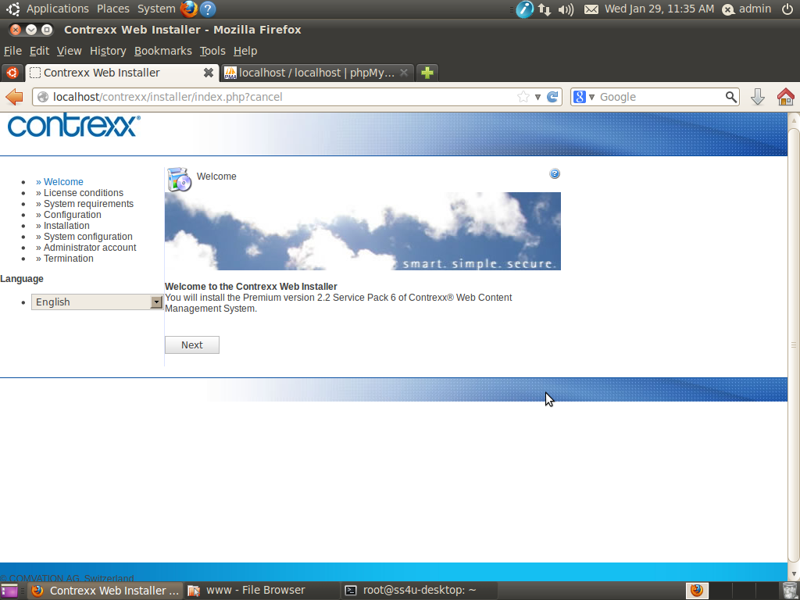

Step 3: You read the license conditions and accept the conditions then click Next.
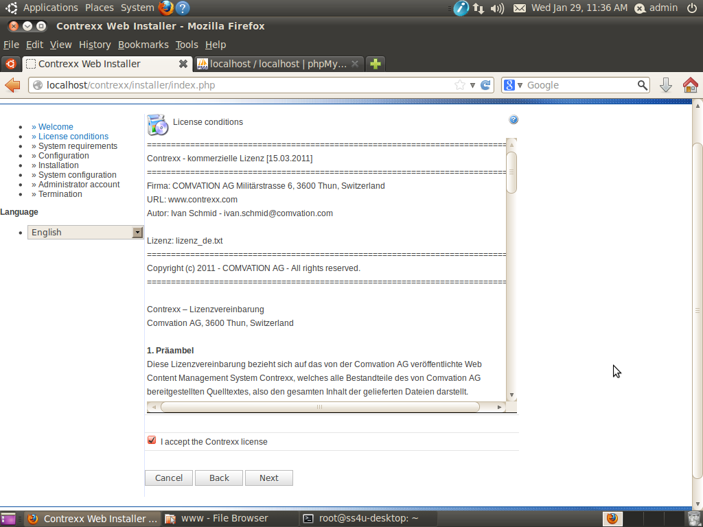

Step 4: You read the system requirements page then click Next.
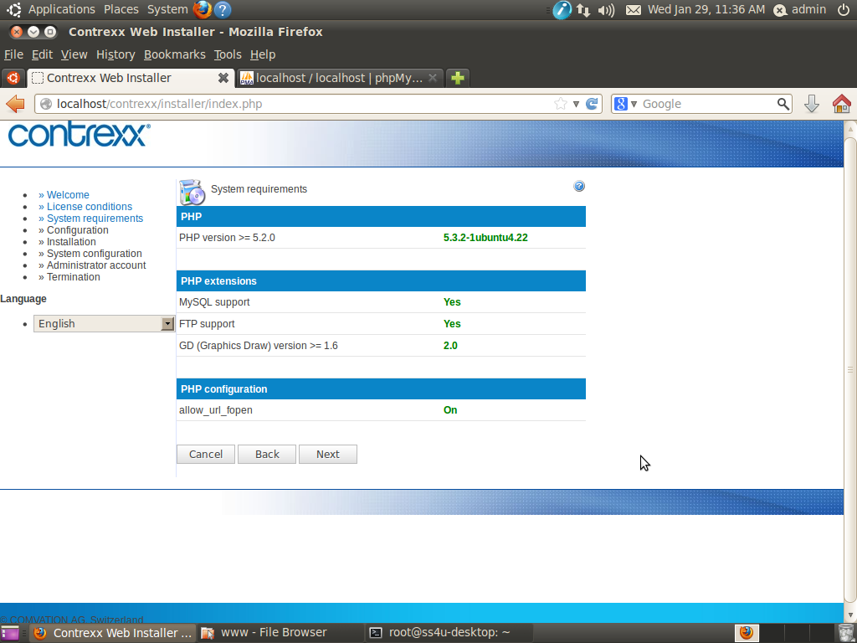

Step 5: You see configuration page then create a database name and give username with password, now click Next.

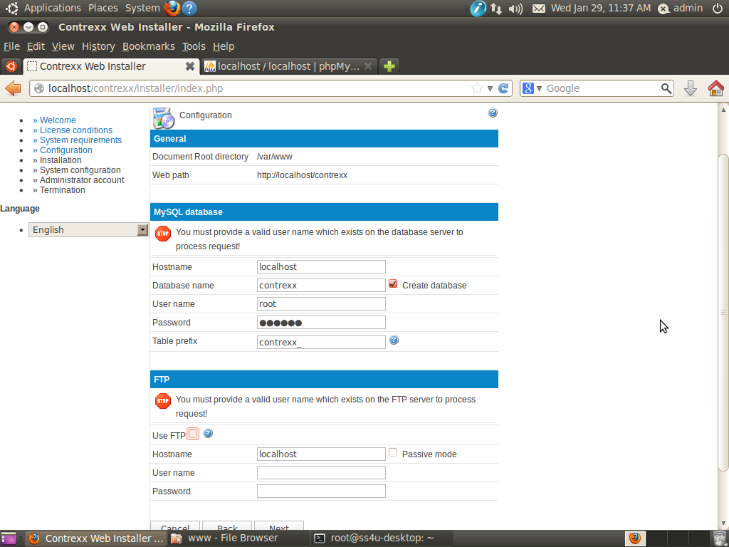

Step 6: You see Installation page then click Next.

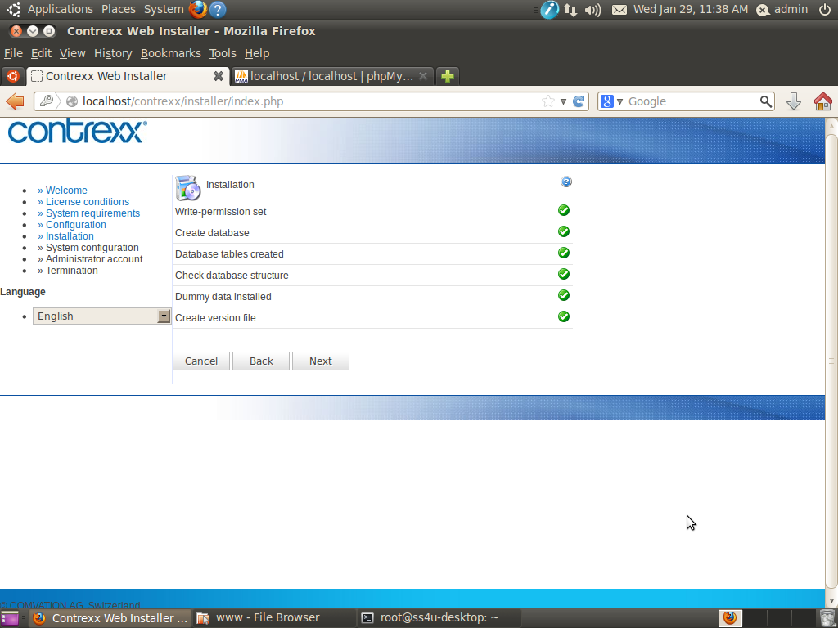

Step 7: Enter administrator email id and username, then click Next.

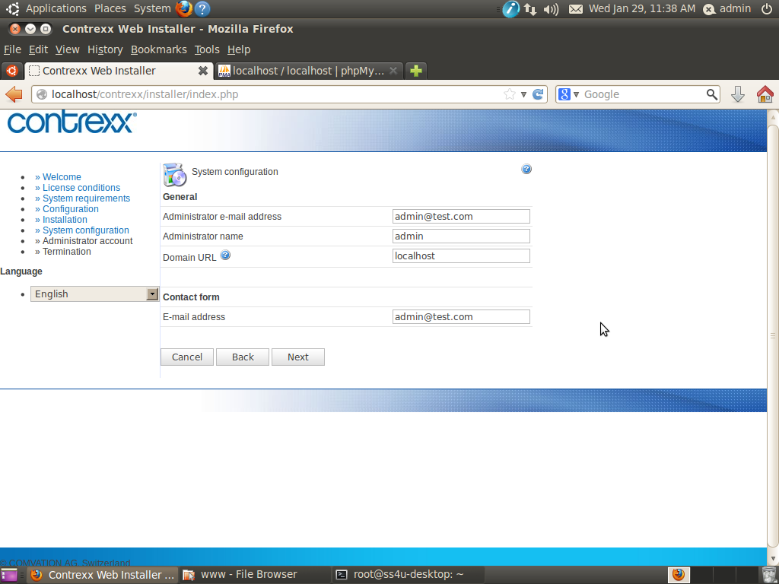

Step 8: Give administrator username with password and email id, then click Next.

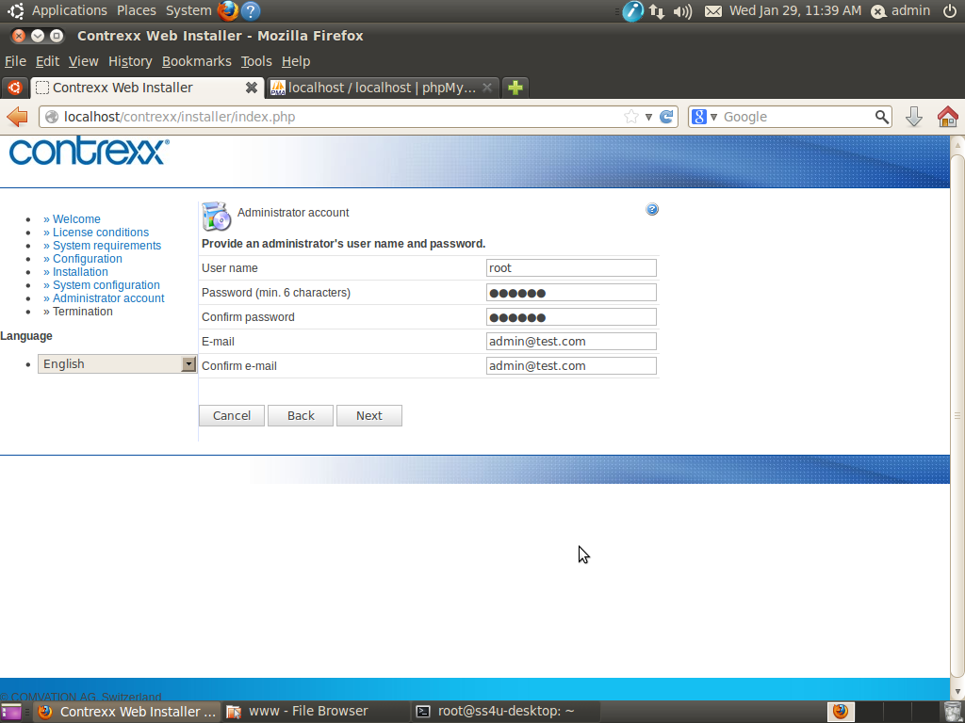

Step 9: You see the last page of the installation.

