CONFIGURE IP ADDRESS IN CENTOS

- Go to terminal and type “setup” to see the configuration.
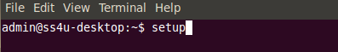

- Go to Network configuration -> Edit Devices

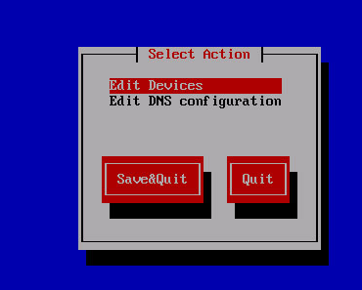

- Select eth0 and save it.

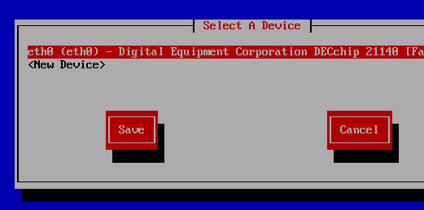
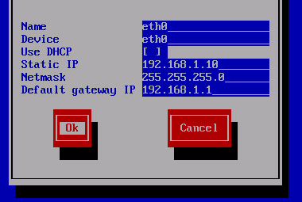
- Enter ip address, netmask and default gateway.

- Select DNS configuration
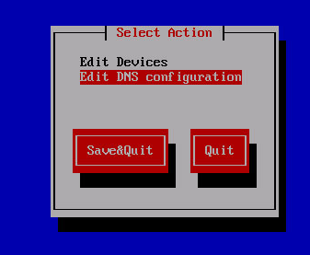

- Enter the primary, secondary and tertiary DNS. Save your settings and quit.
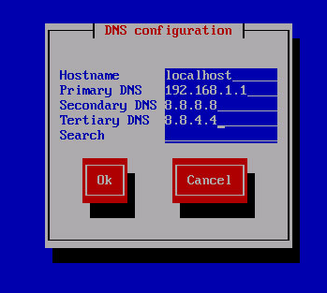

- To restart the network : service network restart
- Now you check the ip address using ifconfig command.

