
Soft_Solutions4U
Quality System Procedure

Training Manual Template Volume 1 Version No. 1 Effective from Nov 19 2010
Nov 12 2010.



MYSQL Password Reset in Ubuntu OS

Prepared By (SS4U) | Signature | R.MARIKKANNAN
Prepared By (SS4U) | Name | R.MARIKKANNAN
Reviewers | Signature
Reviewers | Name
Approvers | Signature
Approvers | Names

Soft_Solutions4U
Quality System Procedure

Training Manual Template Volume 12 Version No. 1.2 Effective from 12 may
may 12 2010.

HOW TO RESET THE MYSQL PASSWORD IN UBUNTU OS

STEP:1

Change as “root” user by using the following command .

#sudo -i /* it will ask password of that system */

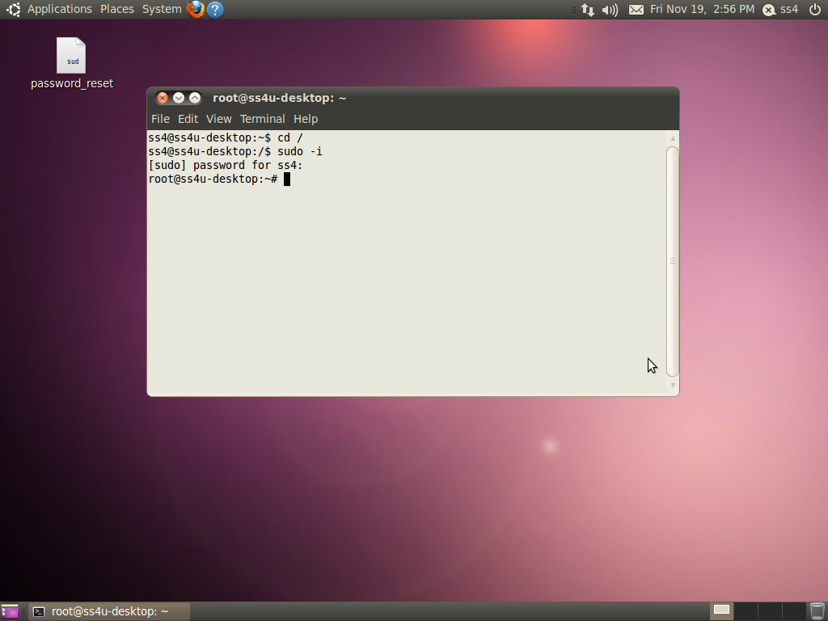

Soft_Solutions4U
Quality System Procedure

Training Manual Template Volume 1 Version No. 1 Effective from Nov 19 2010
Nov 12 2010.

STEP 2:

Stop the mysql server by using the following command

#/etc/init.d/mysql stop

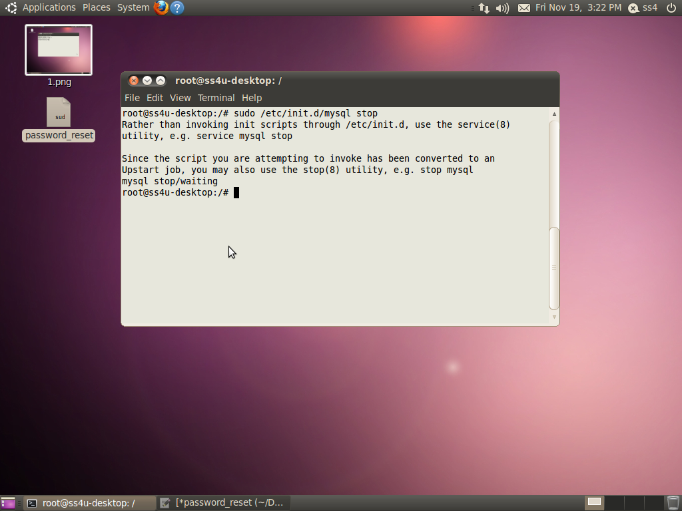

Soft_Solutions4U
Quality System Procedure

Training Manual Template Volume 1 Version No. 1 Effective from Nov 19 2010
Nov 12 2010.

STEP :3

Start the mysqld configuration by using the following command

#sudo mysqld --skip-grant-tables &

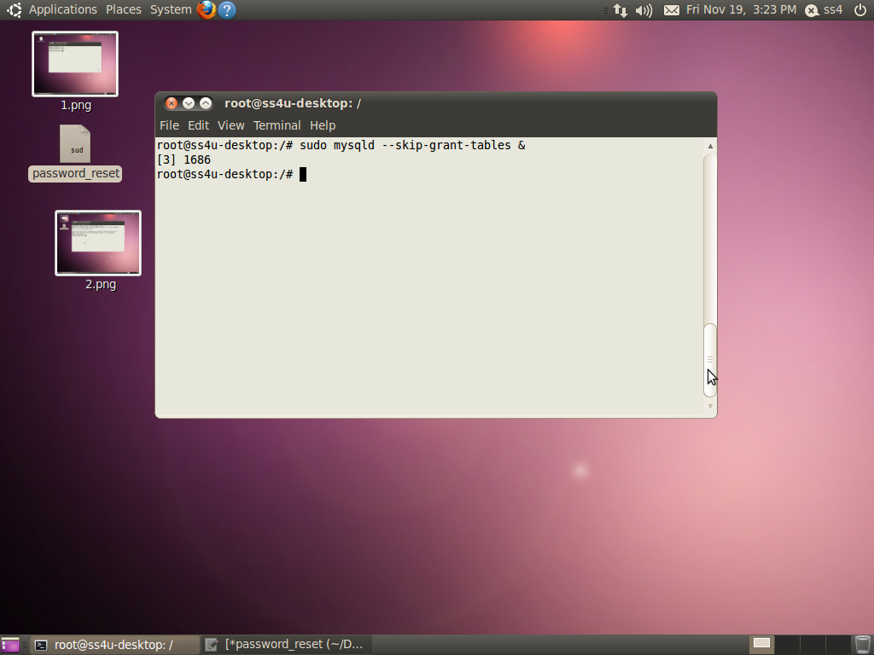

Soft_Solutions4U
Quality System Procedure

Training Manual Template Volume 1 Version No. 1 Effective from Nov 19 2010
Nov 12 2010.

STEP :4

Login to “MYSQL” as root by using the following command

#mysql -u root mysql

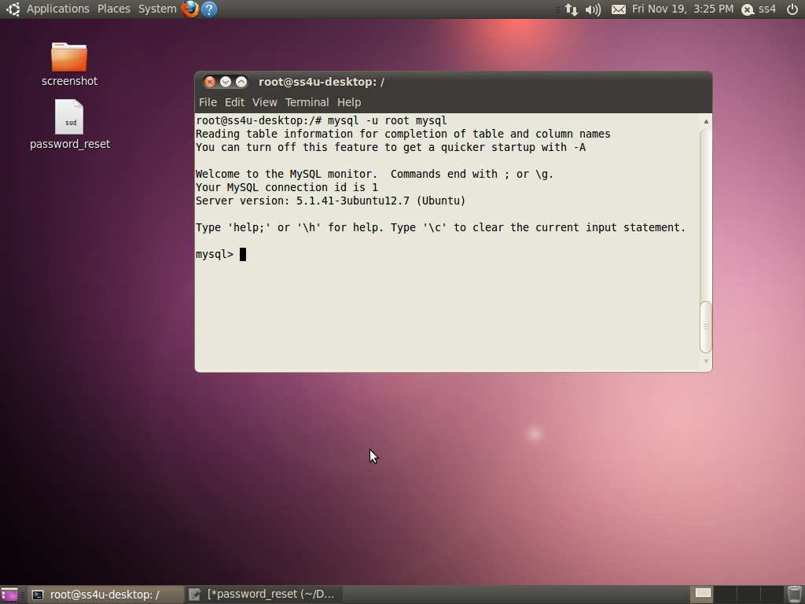

Soft_Solutions4U
Quality System Procedure

Training Manual Template Volume 1 Version No. 1 Effective from Nov 19 2010
Nov 12 2010.

STEP :5

Reset the MYSQL password by using the following command .

After you login to mysql, you execute the following command. Your mysql login identified by

“mysql>”.

UPDATE user SET Password=PASSWORD('YOURNEWPASSWORD') WHERE User='root';
FLUSH PRIVILEGES; exit;

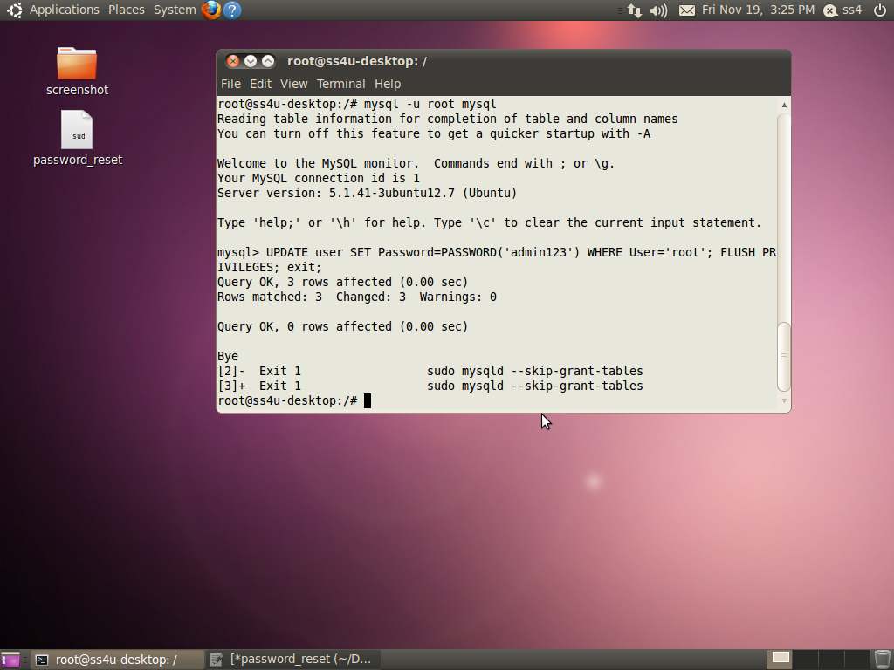

Soft_Solutions4U
Quality System Procedure

Training Manual Template Volume 1 Version No. 1 Effective from Nov 19 2010
Nov 12 2010.

In the above mentioned command “YOURNEWPASSWORD” Field is optional one. Here you can
replace that field by yourself(your password).

In the screen short we set password as “admin123” for mysql.

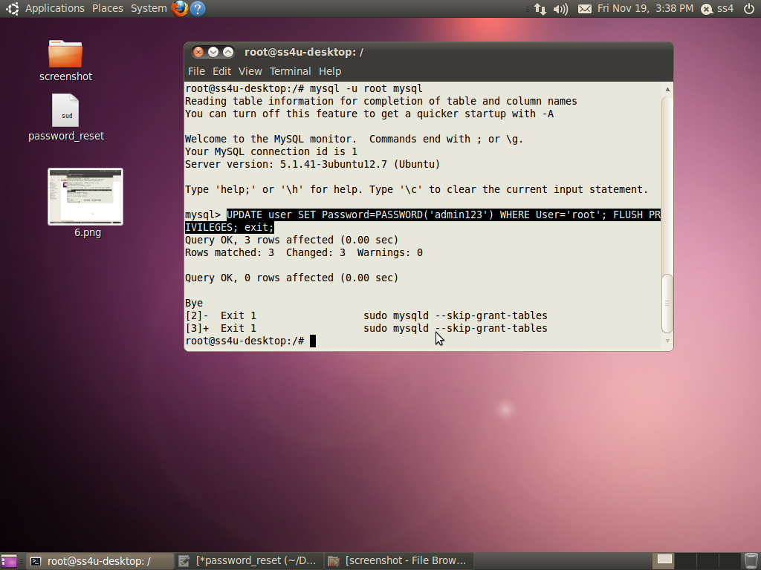

Soft_Solutions4U
Quality System Procedure

Training Manual Template Volume 1 Version No. 1 Effective from Nov 19 2010
Nov 12 2010.

STEP :6

After the successful execution of above commands you must restart the “Apache and
Mysql Servers” by using the following command.

1.Restart the Apache Server:

#/etc/init.d/apache2 restart

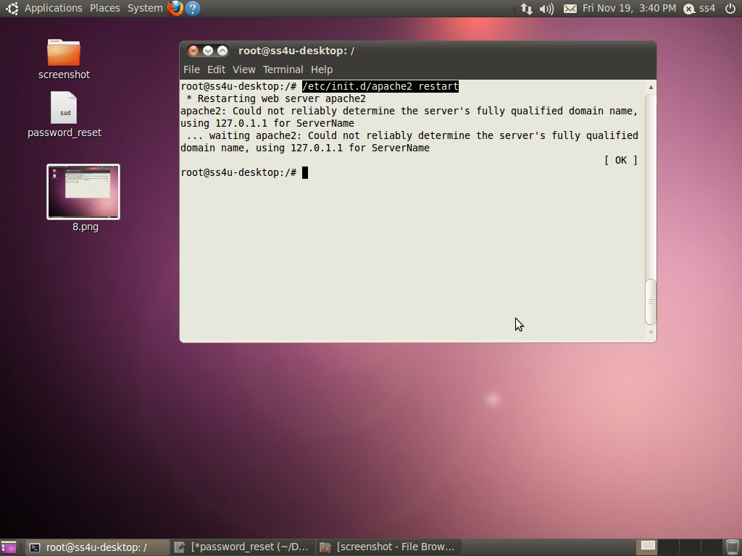

Soft_Solutions4U
Quality System Procedure

Training Manual Template Volume 1 Version No. 1 Effective from Nov 19 2010
Nov 12 2010.

- Start the mysql server:

#/etc/init.d/mysql start

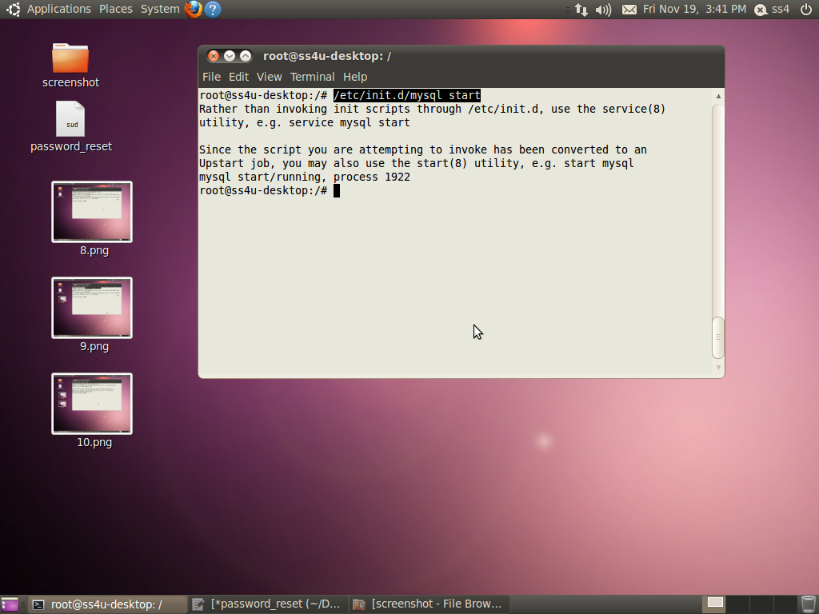

Soft_Solutions4U
Quality System Procedure

Training Manual Template Volume 1 Version No. 1 Effective from Nov 19 2010
Nov 12 2010.

After changing your password, you login through your new password.

Successful Login Screen Short:

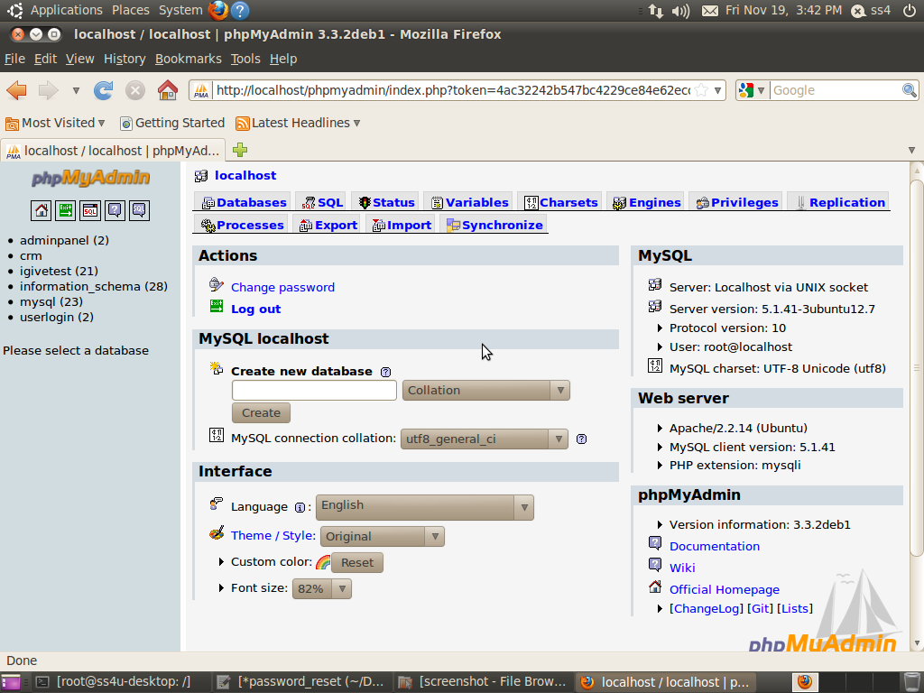

Soft_Solutions4U
Quality System Procedure

Training Manual Template Volume 1 Version No. 1 Effective from Nov 19 2010
Nov 12 2010.

Your password is incorrect means the following screen will appear.

Password Incorrect Screen Short:

