Remove log file

Steps :

- Login as a root user.

- After that cd /var/log, give ls command to view the log files.
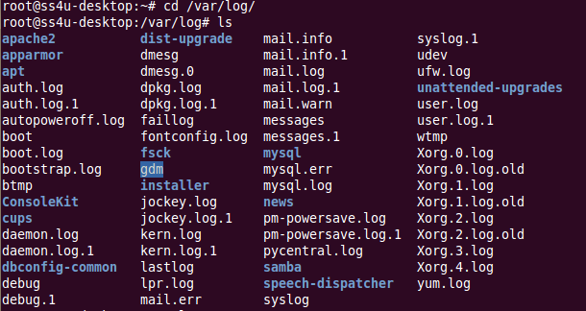
- du -sh command show the usage of hard disks.


- rm -rf command used for delete the log files.

- For deleting Apache error,
- After create new file using touch command and change owner for files
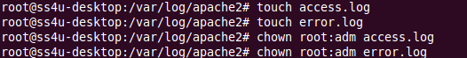
- After remove the files now you will be check the usage of hard disks.
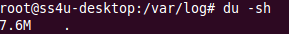

- We want to restart the apache.

