SSH(SECURE SHELL)

- securely remote accessing one computer from another

- to run command line & graphical programs and transfer files.

- Service commands :

i) sudo service ssh start

ii) sudo service ssh stop

iii) sudo service ssh restart

iv) sudo service ssh status

- Configuration files:

i) /etc/ssh/sshd_config - OpenSSH server configuration file.

ii) /etc/ssh/ssh_config - OpenSSH client configuration file.

iii) ~/.ssh/ - Users ssh configuration directory.

iv) ~/.ssh/authorized_keys - Lists the public keys (RSA or DSA) that can be used to log into the user’s account

v) /etc/nologin - If this file exists, sshd refuses to let anyone except root log in.

vi) /etc/hosts.allow and /etc/hosts.deny : Access controls lists that should be enforced by tcp-wrappers are defined here.

- ssh default port : TCP 22

- Set users access ssh: First create “try1” and “try2” users, then give ssh access permission to “try1” user only.

i)To allow ”try1” user : open sshd file

Then write : “AllowUsers root try1” and exit, then restart sshd.

“try1” user access ssh
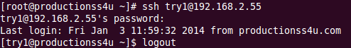

ii) To deny ”try2” user : open sshd file

Then write : “DenyUsers try2” and exit, then restart sshd.

“try2” user not able to access ssh

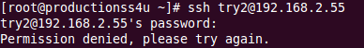

- disable root login via sshd_config to write the following line:
“PermitRootLogin no”

- disable empty passwords via sshd_config to write the following line:
“PermitEmptyPasswords no”

- to install both ssh client and server to write the following line:
“apt-get install openssh-server openssh-client”

- remote access from other computer “ssh ip-address”

