
Soft_Solutions4U
Quality System Procedure

Training Manual Template Effective from August 09.08.10
August 09.08.10



Integrated Quality Management System

<<Documentation on Team Viewer Software >>

Prepared By (SS4U) | Signature | R.MARIKKANNAN
Prepared By (SS4U) | Name | R.MARIKKANNAN
Reviewers | Signature
Reviewers | Name
Approves | Signature
Approves | Names

Soft_Solutions4U
Quality System Procedure

Training Manual Template Effective from August 09.08.10
August 09.08.10

DOCUMENTATION ON TEAM VIEWER SOFTWARE
Step:1

Download the Team viewer software from the internet.

Based on the OS we download the different Packages.
1.For windows we need .exe package.
2.For Ubuntu we need .deb package.
3.For Cent Os we need .rpm package.

Step:2

After download the package, double click on it. It will automatically installed.

After the installation, the team viewer will generate the unique ID to that machine.
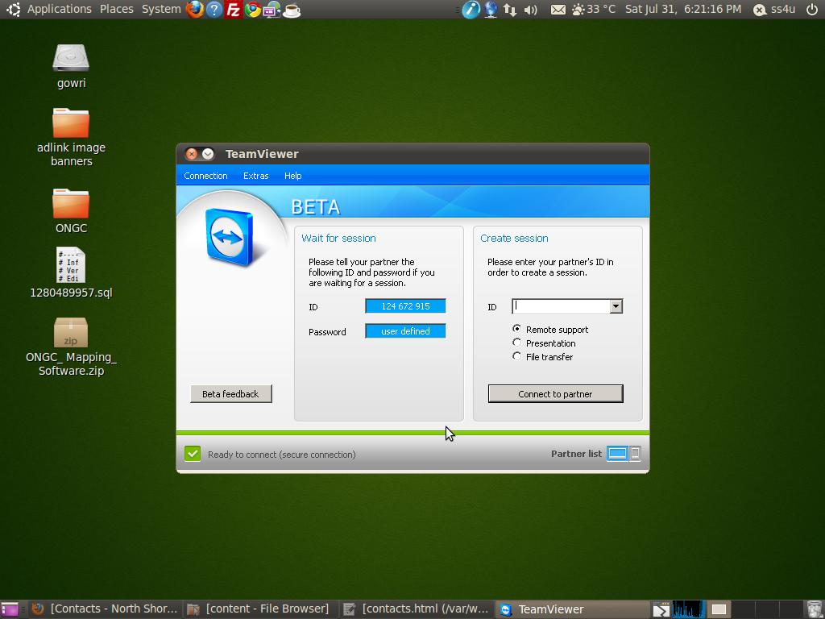
Soft_Solutions4U
Quality System Procedure

Training Manual Template Effective from August 09.08.10
August 09.08.10

Step:3

Go to “extra” menu and select the “General” option the following screen will appear.

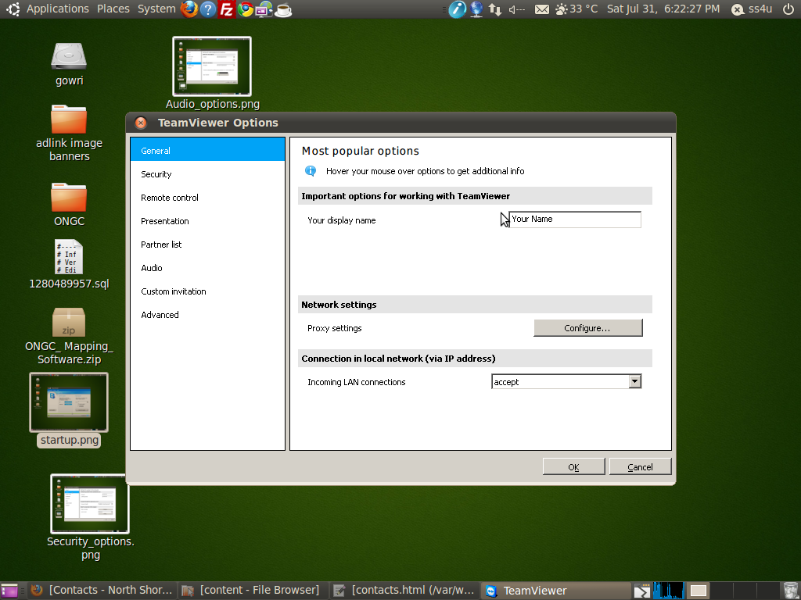

Here you set the display name to that system by using “your display name”option.

Soft_Solutions4U
Quality System Procedure

Training Manual Template Effective from August 09.08.10
August 09.08.10

Step:4

Set “Proxy settings” by using “configure button”. After you click the “configure button” the “Proxy Settings” window will appear. In that appearing window you select “Use manual proxy” and set Ipaddress and port number of your proxy server.

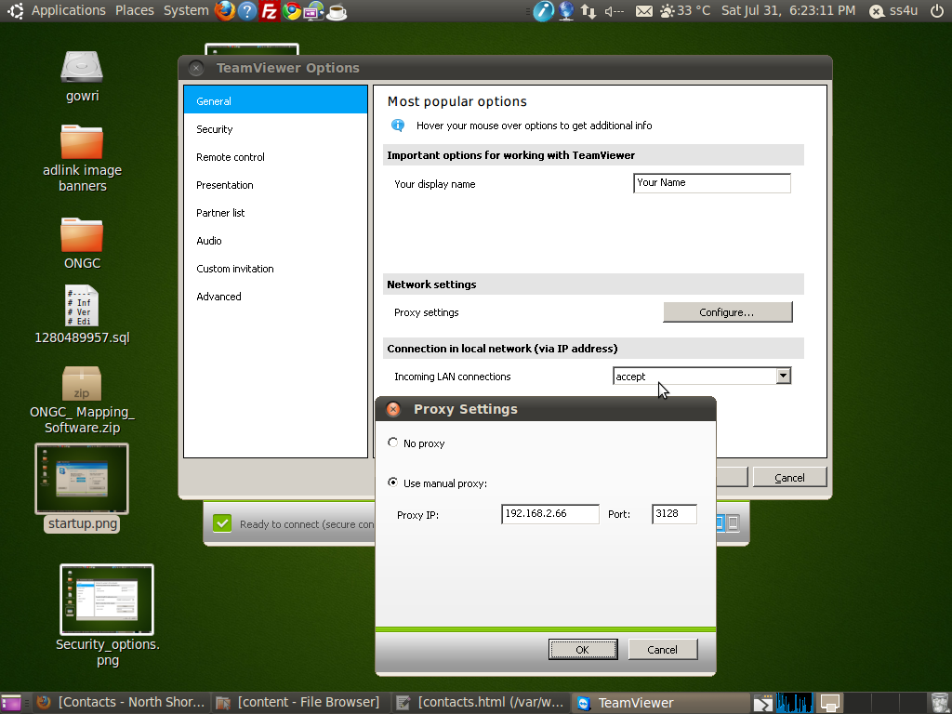

And also set “Incoming LAN connections” as “accept” for allowing the server to access with in the
LAN network.

Soft_Solutions4U
Quality System Procedure

Training Manual Template Effective from August 09.08.10
August 09.08.10

Step 5:

Set the Password to the Team viewer by using the following steps

Go to the Extra menu and select the “security option” then the following window will appear.
In that window you set the password to the team viewer. And also choose the password strength as
“Disabled (no session password)” otherwise it will generate random password for every session.

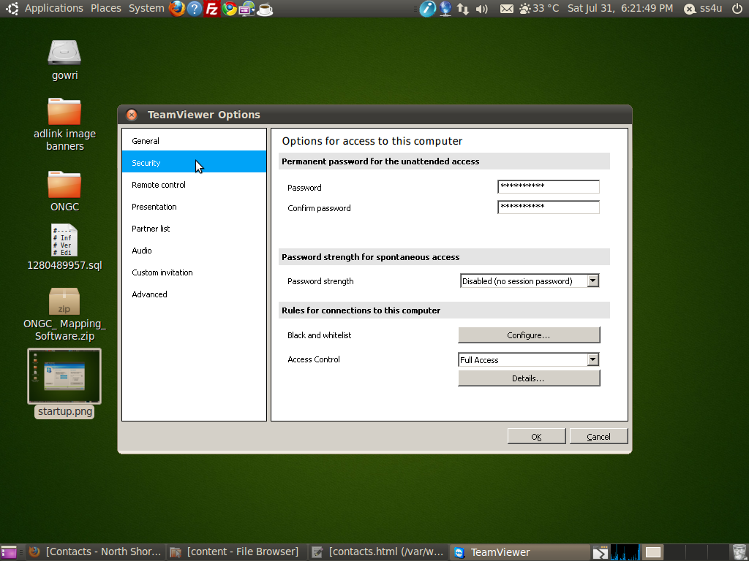
Here you select “access control” as “Full access”,then only you have full access with the
remote desktop .

Soft_Solutions4U
Quality System Procedure

Training Manual Template Effective from August 09.08.10
August 09.08.10

Step 6:

Connect to the remote host by using the remote systems “Team viewer ID” and “Password”.

First you start the team viewer by using team viewer icon. After it started the following screen
will appear.

Here we have an ID test box, in that text box you give the remote systems team viewer id and
then click the “connect to partner” button.

Soft_Solutions4U
Quality System Procedure

Training Manual Template Effective from August 09.08.10
August 09.08.10

It will ask the remote system team viewer password. Here you give remote system password
then you click “log on” button.

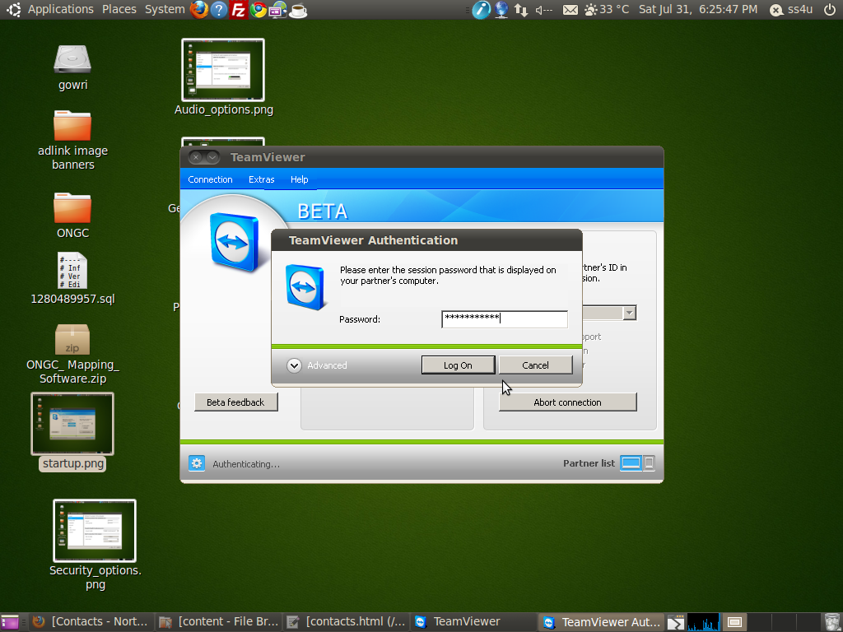

Now the remote system Desktop screen will appear.

Soft_Solutions4U
Quality System Procedure

Training Manual Template Effective from August 09.08.10
August 09.08.10

In the remote screen, at the top edge you have some options to communicate with remote host.

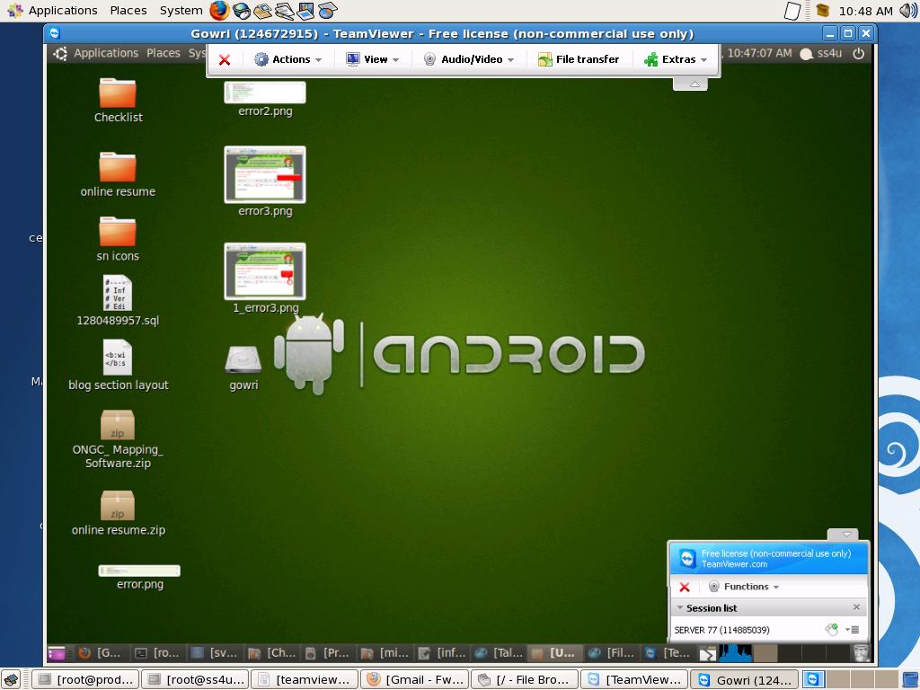

Soft_Solutions4U
Quality System Procedure

Training Manual Template Effective from August 09.08.10
August 09.08.10

Chat:

To chat with the remote host by click “Audio/Video” option and then select “chat”. The chat
window will appear,

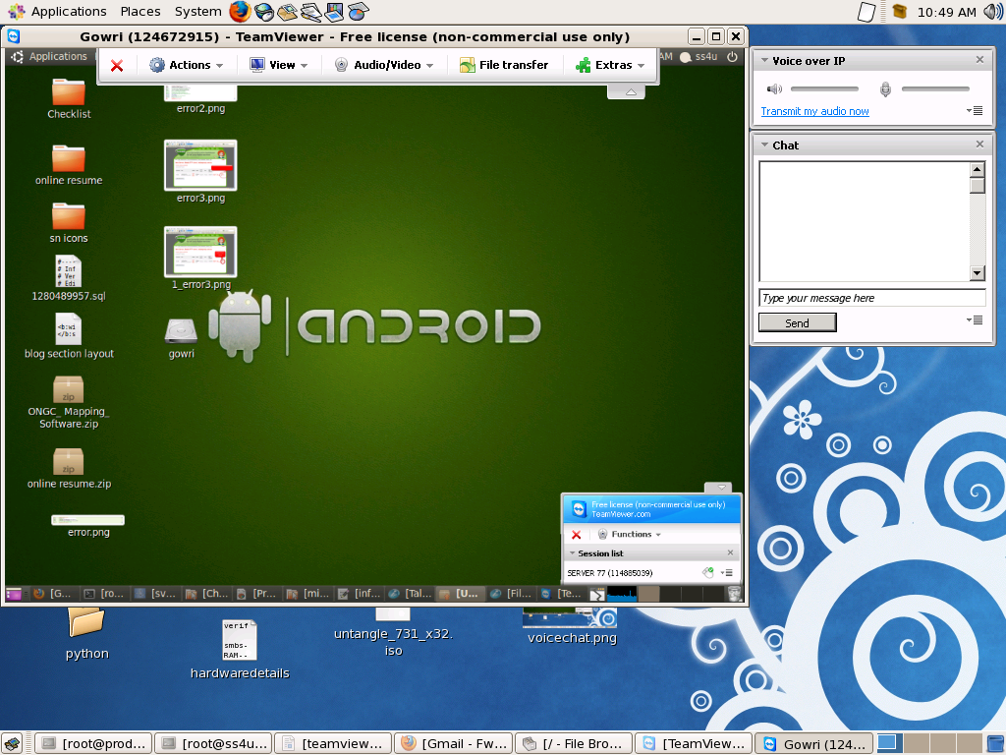
Voice Chat:

To perform the “Voice Chat” by select “Audio/Video”option and then click “Voice Over IP”.
The voice chat screen will appear, in that screen you must select “Transmit my audio now”. Then
you communicate with remote host through voice.

Soft_Solutions4U
Quality System Procedure

Training Manual Template Effective from August 09.08.10
August 09.08.10

To adjust the screen resolution of remote host by using “View” Option,

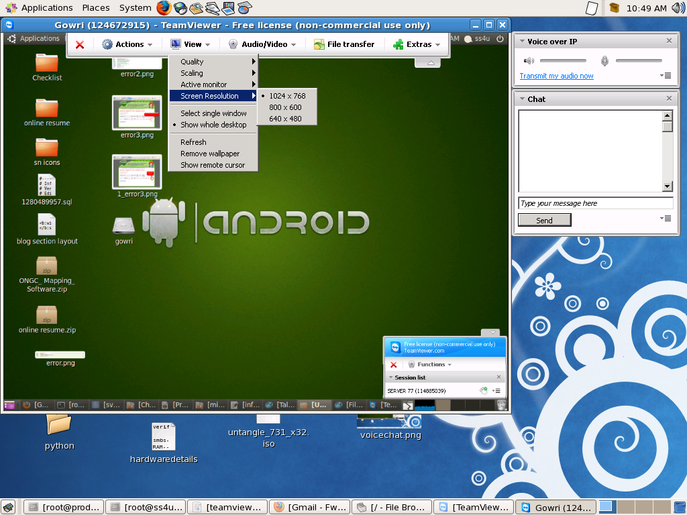

Soft_Solutions4U
Quality System Procedure

Training Manual Template Effective from August 09.08.10
August 09.08.10

There is no team viewer connection in the remote host the following error will appear.



