VNC

- VNC is to be remotely viewed and controlled over a network connection.
- VNC viewer package is installed to the remote computer.
- VNC server package is installed to the server.

VNC server:

Step 1: Installing required packages

yum install vnc vnc-server
Step 2: Password creation
Following command for password creation for vncserver:
vncpasswd
Step 3: Configure VNC
To edit the /etc/sysconfig/vncservers file. At the end of that file, enter the following:
VNCSERVERS="1"
VNCSERVERARGS[1]="-geometry 1024x768 -depth 16"
Save that file.

Step 4: Create xstartup scripts
Editing their ~/.vnc/xstartup script.
Within that script, uncomment the following two lines
- unset SESSION_MANAGER
- exec /etc/X11/xinit/xinitrc
Save that file.

Step 5: Check VNC server startup
- service vncserver start (or) vncserver:2
- service vncserver stop (or) vncserver -killall:2

Set VNC to be start at boot with the command:
- chkconfig vncserver on

VNC Clients:
Installation: yum install vncviewer
- To access the remote desktop by using the following command
Start VNC : vncviewer 192.168.2.55:2
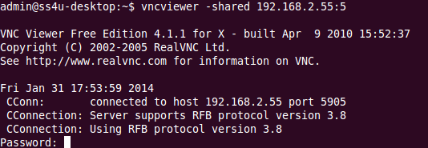
- Give password to view remotely.
