
Soft_Solutions4U
Quality System Procedure

Training Manual Template Effective from january 25.01.2011
January 25.01.2011



<< Automatic shutdown in ubuntu OS >>

Prepared By (SS4U) | Signature | R.MARIKKANNAN
Prepared By (SS4U) | Name | R.MARIKKANNAN
Reviewers | Signature
Reviewers | Name
Approves | Signature
Approves | Names

Soft_Solutions4U
Quality System Procedure

Training Manual Template Effective from January 25.01.2011
January 25.01.2011

Automatic shutdown in ubuntu OS When the system is idle for more than 20 Min

Step:1

Download the autopoweroff .deb package from the internet by using the following url.

Link: http://sourceforge.net/projects/autopoweroff/files/autopoweroff/2.9.1/autopoweroff-2.9.1-1.noarch.deb/download

After downloading the “.deb” package you must install that package

Change the autopoweroff configuration file permission as “777” by using the following command

# chmod 777 /etc/autopoweroff.conf

Configuration through command line:

After changing the permission you make the following changes in configuration file for automatic

shutdown.

Go to “Automatic poweroff configuration file” by using the following path

#vim /etc/autopoweroff.conf

Soft_Solutions4U
Quality System Procedure

Training Manual Template Effective from January 25.01.2011
January 25.01.2011

In “NO_SHUTDOWN_TIME_RANGE” section you set the following factors to be null.

Default:

Start hour = 05

End hour = 22

Set As:

Start hour = 00

End hour = 00

Then only the system will do the automatic poweroff at any time when the system is idle for
more than what we specified in the configuration file.

Set the idle time for system perform the automatic shutdown.

In “Timeouts” section part you make the following change

[TIMEOUTS]:

StartupDelay = 0

IdleTime = 20

Here you configure the system to perform the automatic shutdown in 20min.

Restart the Service by using the following command:

#sudo /etc/init.d/autopoweroff restart

Soft_Solutions4U
Quality System Procedure

Training Manual Template Effective from January 25.01.2011
January 25.01.2011

Configuration through GUI Mode:

Changing the permission of autopoweroff configuration file by using following steps.

Go to “/etc” directory by using the command “ cd /etc”, and refer the following screen shot to
change the permission of autopoweroff.conf file.

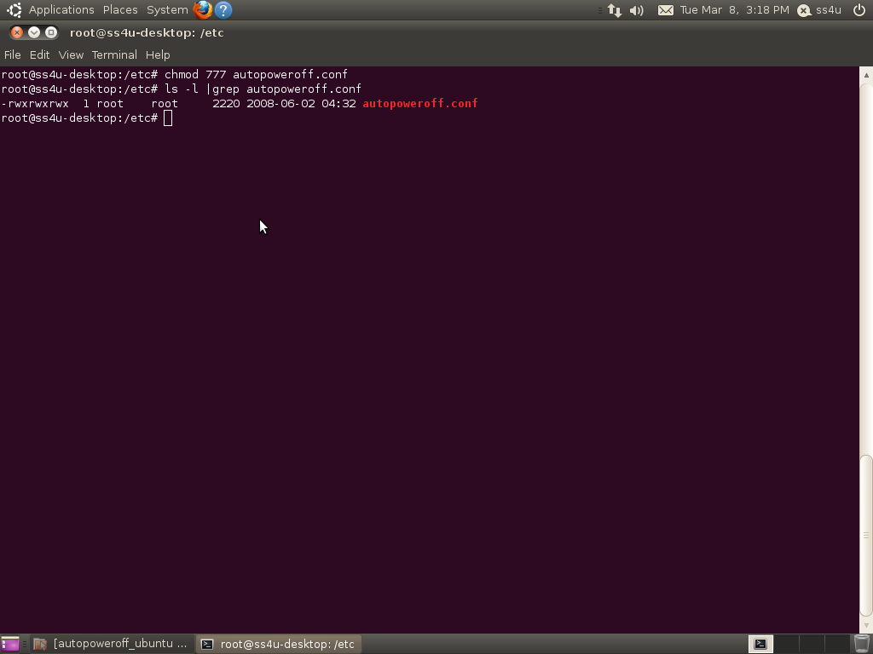

Soft_Solutions4U
Quality System Procedure

Training Manual Template Effective from January 25.01.2011
January 25.01.2011

Press “Alt+F2” key, it will display the following windows. It is used to run the application.

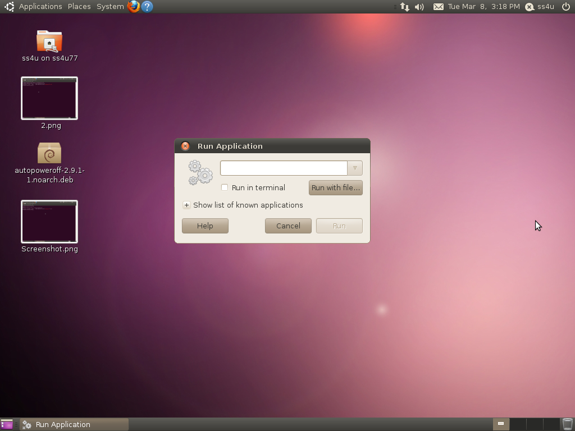

Soft_Solutions4U
Quality System Procedure

Training Manual Template Effective from January 25.01.2011
January 25.01.2011

In that “Run Application window” you type “autopoweroff” and press “Run” button

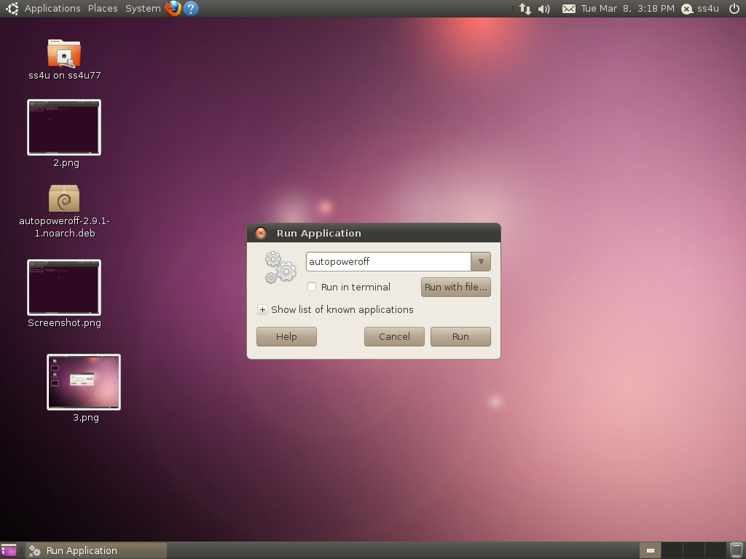

Soft_Solutions4U
Quality System Procedure

Training Manual Template Effective from January 25.01.2011
January 25.01.2011

The following “Autopoweroff” configuration window will appear

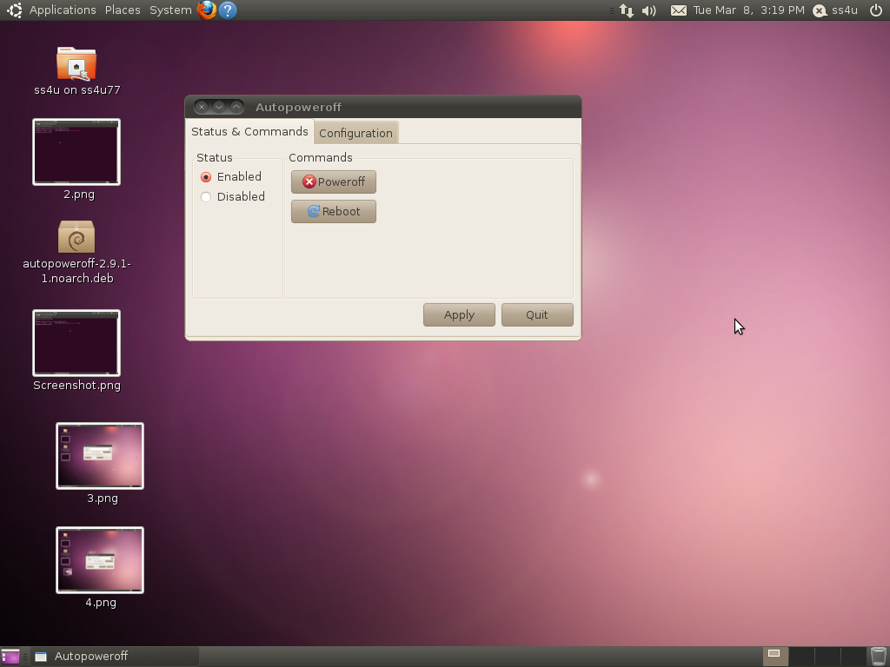

Here status must be in “Enabled” state.

Soft_Solutions4U
Quality System Procedure

Training Manual Template Effective from January 25.01.2011
January 25.01.2011

In the Configuration tab,you must set the following parameter to configure the autopoweroff server.

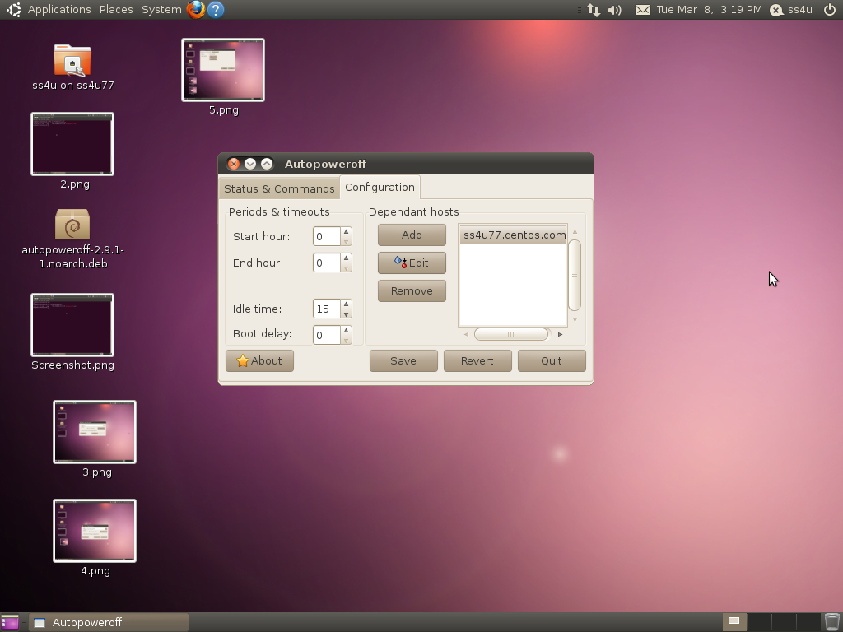

After changing the parameters, you must save the configuration by using the button “SAVE”

Soft_Solutions4U
Quality System Procedure

Training Manual Template Effective from January 25.01.2011
January 25.01.2011

The following screen must indimate the modified configuration.

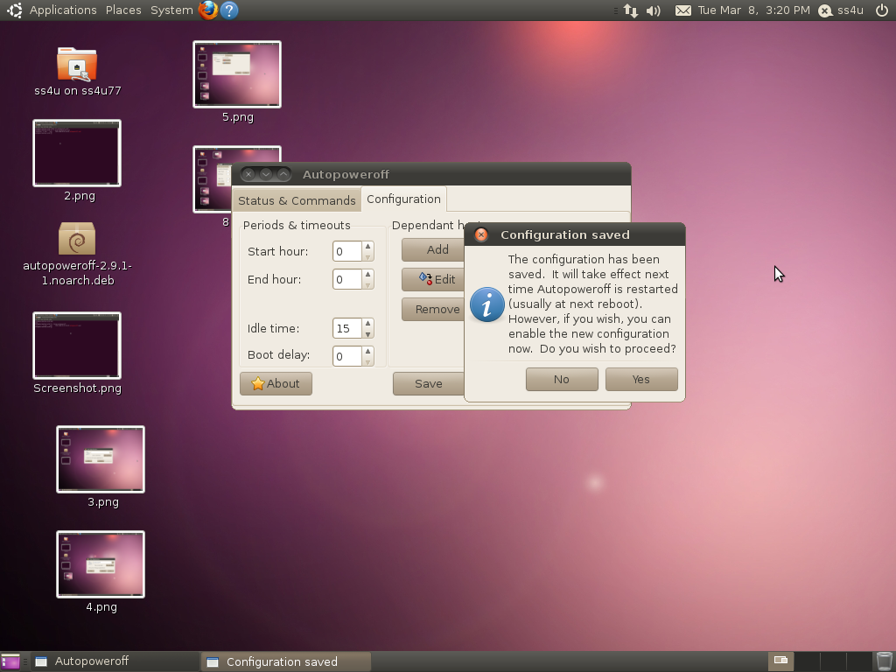

Here you press “yes” button is used for proceed with new configuration.

Soft_Solutions4U
Quality System Procedure

Training Manual Template Effective from January 25.01.2011
January 25.01.2011

The new configuration must indimate by following screen.

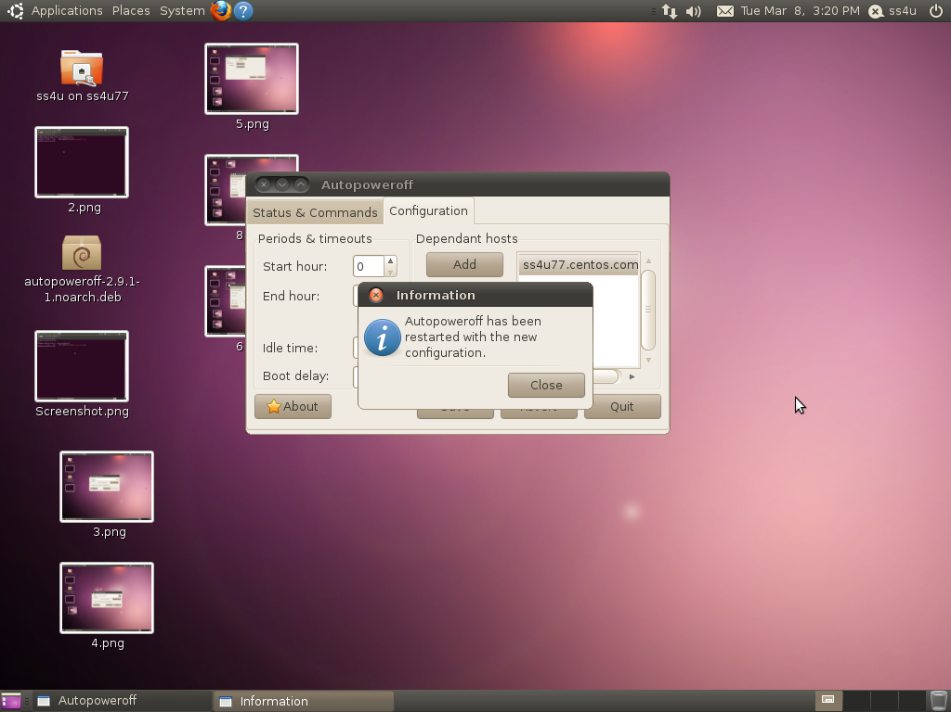

Now the system is idle for more than 15 minutes,the system automatically shutdown.

