
Soft_Solutions4U
Quality System Procedure

Training Manual Template Effective from December 29.12.10
December 29.12.10



Integrated Quality Management System

<<Configuration of Scanner in Ubuntu Os >>

Prepared By (SS4U) | Signature | R.MARIKKANNAN
Prepared By (SS4U) | Name | R.MARIKKANNAN
Reviewers | Signature
Reviewers | Name
Approves | Signature
Approves | Names

Soft_Solutions4U
Quality System Procedure

Training Manual Template Effective from December 29.12.10
December 29.12.10

Configuration of Scanner in ubuntu OS

Step:1

First you install the scanning software for ubuntu through “synaptic package manager”.

“System----->Administration------>synaptic package manager”

In the synaptic package manager you select the following packages for scanning

1.Simple Scan /* scan the images as “black & white */

2.Xsane /* These two for colour scan */

3.Skanlite

Step :2

Download the latest version of driver for scanner from the internet as “HPLIP 3.10.9”.
The downloaded package is in “.tar.gz” format.

Link: http://sourceforge.net/projects/hplip/files/hplip/3.10.9/hplip-3.10.9.tar.gz/download

You extract the downloaded package of “hplip-3.10.9.tar.gz”. After that you must follow the
following steps for installation.

Step :3 Installation

Change as root user by using the following command then only you have the permission to
install software

#sudo -i
it will ask the root password that means your system password.

Soft_Solutions4U
Quality System Procedure

Training Manual Template Effective from December 29.12.10
December 29.12.10

Then go to the extracted download package folder path by

#cd /hplip-3.10.9

To configure the package by using

#./hplip-install

Here it will ask the option like “a or c or q”

a---->automatic installation of package.

c----->custom installation of package.

q----->quit the installation.

Here you choose the option like “ C ” , it will ask which platform here you choose “linux”.
After that you will choose “ubuntu_10 and above” in linux platform”.

During the installation it will check the network connection and check the scanner device
connection also. If the device is switched off means please switch on the device then only it
will be detected.

After the successful installation, you find out the installed driver in the following path

Applications----->Accessories---->HPDevice manager

Soft_Solutions4U
Quality System Procedure

Training Manual Template Effective from December 29.12.10
December 29.12.10

Step :4 Configuration

The installed “HP Driver” will support all models available in “HP Product”

The configuration file itself having all models specification, in that configuration file you
must select the needed model and make the following changes in that file.

Configuration file path: /usr/share/hplip/data/models/models.dat

Go to the configuration file path by using the following command

#cd /usr/share/hplip/data/models/

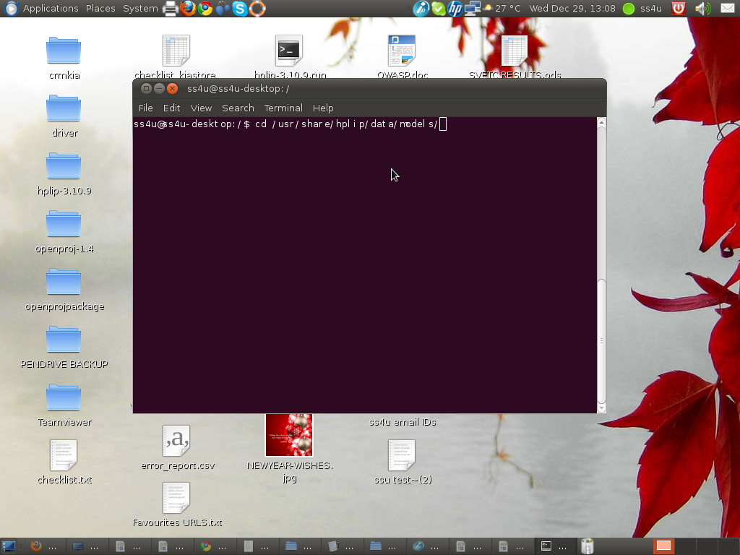
Soft_Solutions4U
Quality System Procedure

Training Manual Template Effective from December 29.12.10
December 29.12.10

First you take the backup of that file for restore purpose by using the following command

# cp models.dat models.dat_backup

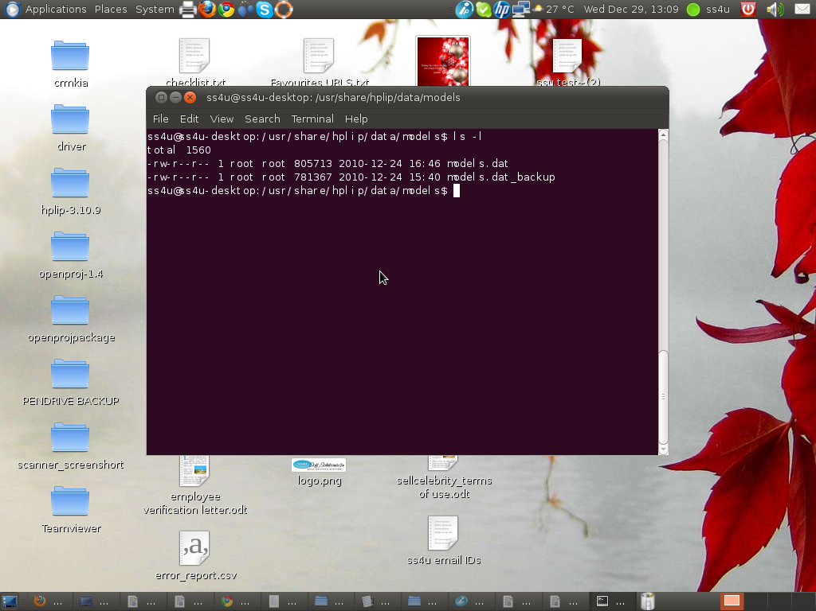

Soft_Solutions4U
Quality System Procedure

Training Manual Template Effective from December 29.12.10
December 29.12.10

Then you edit the “models.dat” file by using the “vi” editor by

#vi models.dat

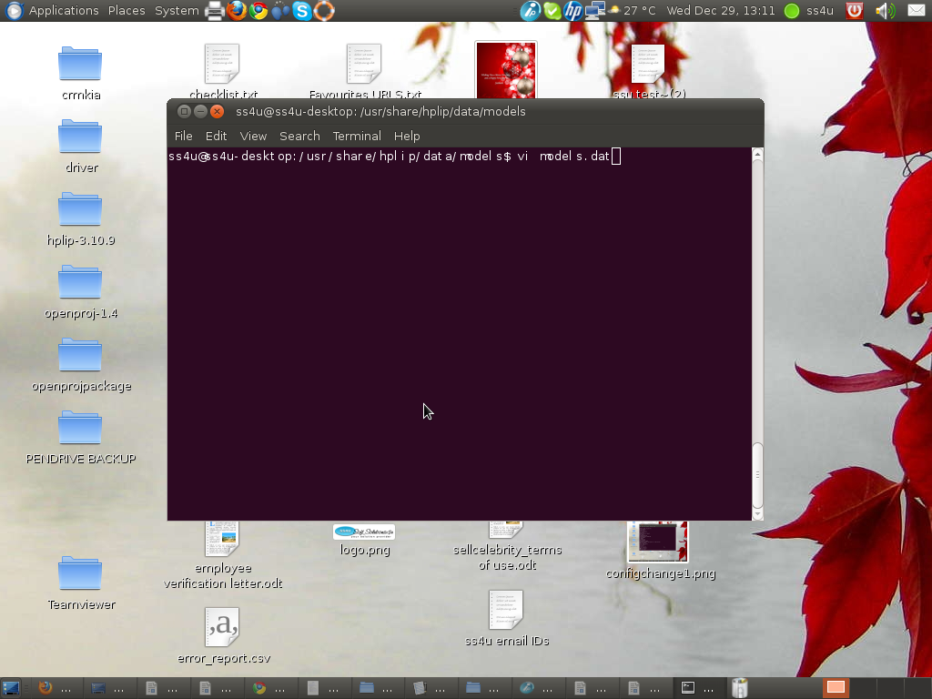

In that file you select your models name and make the following changes. Our scanner model
name is “HP_Deskjet_1050_j410”. In that file,model selection part you make the following
changes

Soft_Solutions4U
Quality System Procedure

Training Manual Template Effective from December 29.12.10
December 29.12.10

[Deskjet_1050_j410]
Default:
io_mfp_mode = 3 (or) some other value
scantype = -1

Change as :
io_mfp_mode = 1
scantype = 7

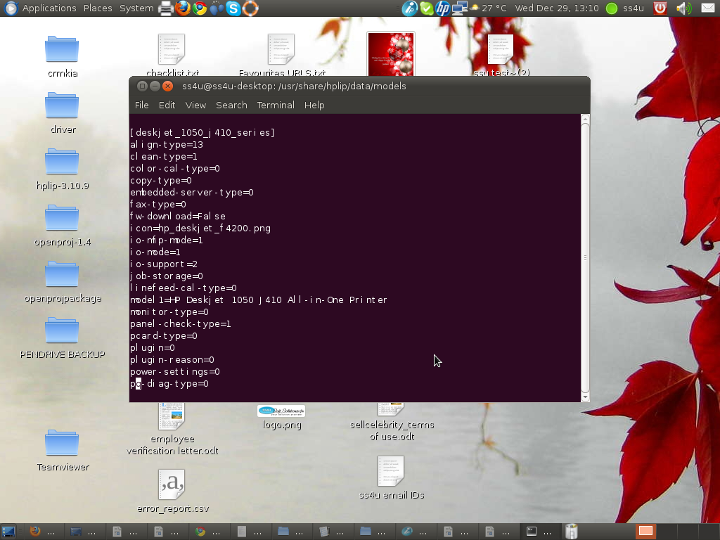

Soft_Solutions4U
Quality System Procedure

Training Manual Template Effective from December 29.12.10
December 29.12.10

save the file and restart the xsaned service by using the following command

#sudo /etc/init.d/saned restart

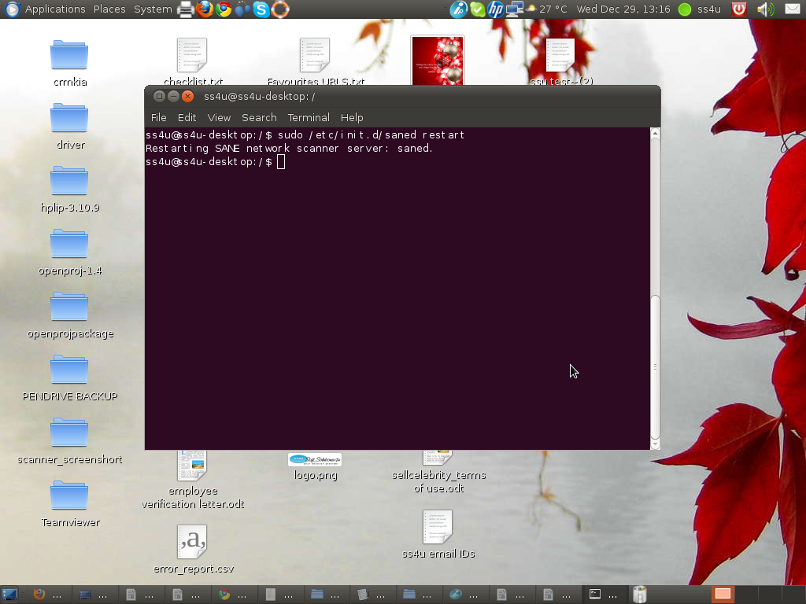

Soft_Solutions4U
Quality System Procedure

Training Manual Template Effective from December 29.12.10
December 29.12.10

Check the “xsaned service” by using the following command

#sudo /etc/init.d/saned status

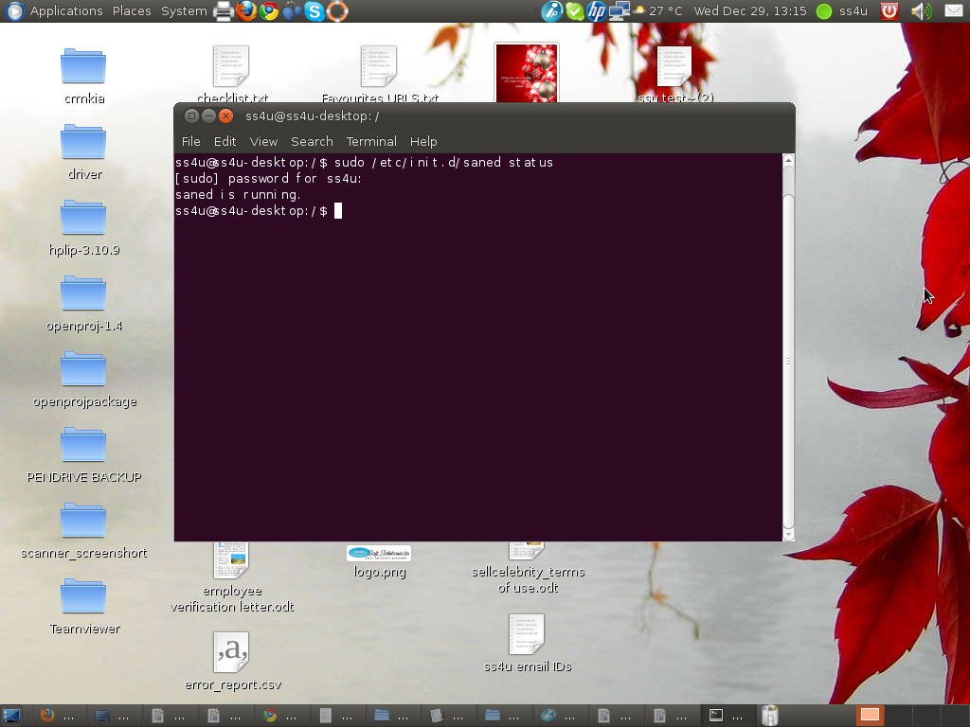

Soft_Solutions4U
Quality System Procedure

Training Manual Template Effective from December 29.12.10
December 29.12.10

Step :5 ACCESSING THE SCANNER

For block and white scanning use simple scan

Applications---->Graphics---->simple scan

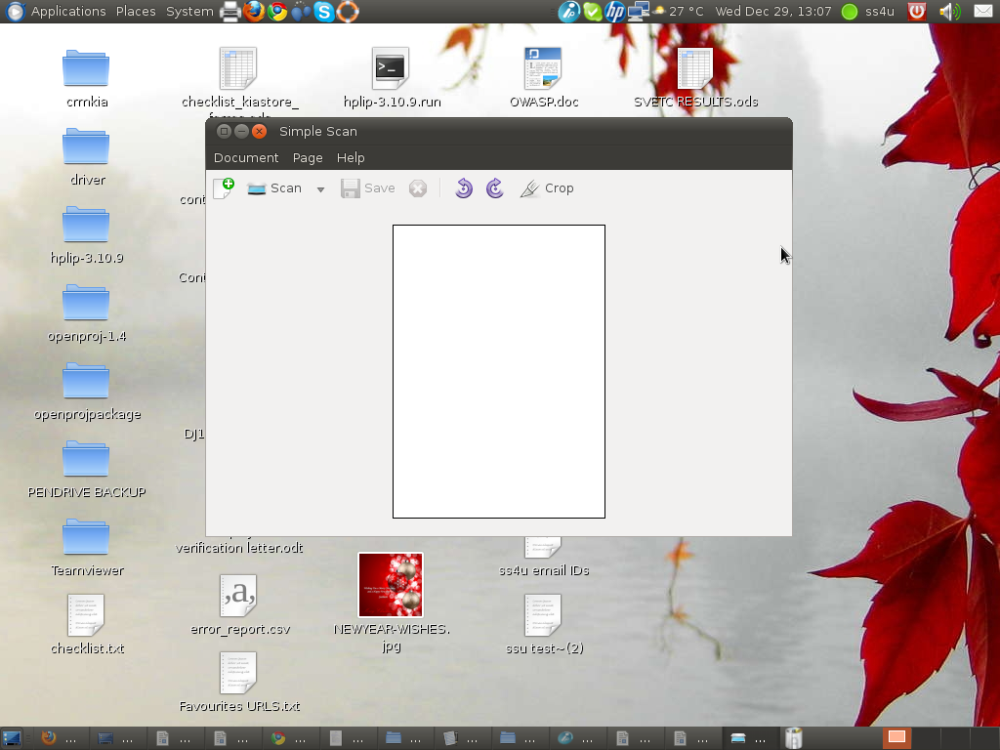
By using scan button you scan the image.

Soft_Solutions4U
Quality System Procedure

Training Manual Template Effective from December 29.12.10
December 29.12.10

If the scanner is “switched off” or “not working” means the following error will be displayed in the “simple scan” software.

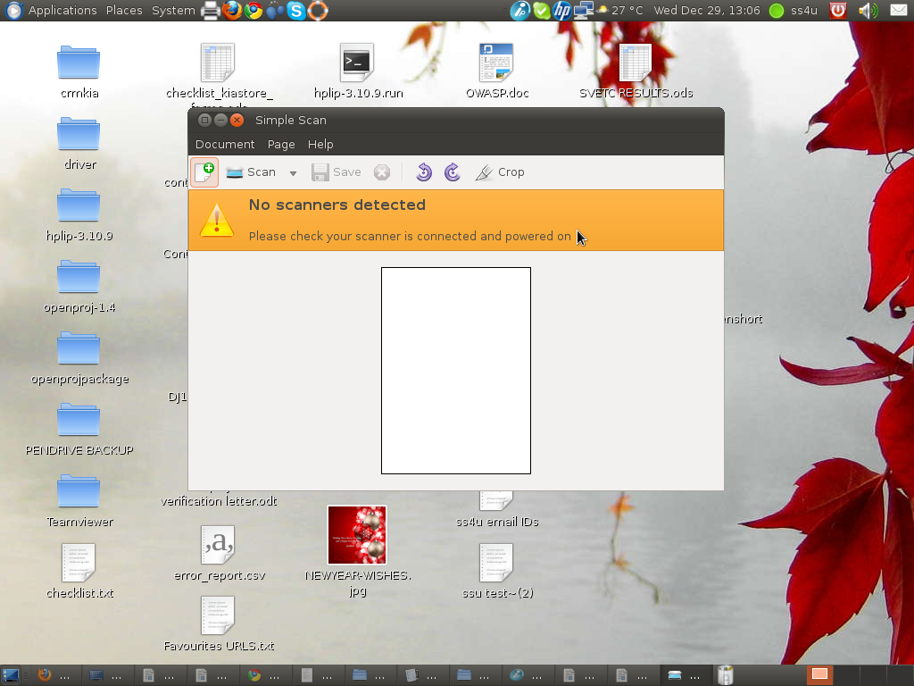

Soft_Solutions4U
Quality System Procedure

Training Manual Template Effective from December 29.12.10
December 29.12.10

For colour scan please use the “ Xsane” or “Skanlite”.

Applications------>Graphics-------->Xsane (or) Skanlite

If the device is “switched off” or “not working” means the following error will be displayed.

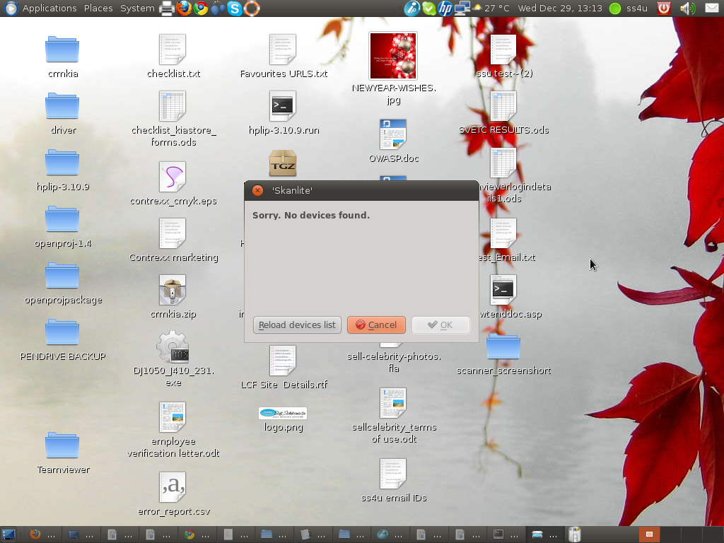

Soft_Solutions4U
Quality System Procedure

Training Manual Template Effective from December 29.12.10
December 29.12.10

Accessing the “HP Device manager”

Applications--------->Accessories---------->HP Device manager

By using HP Device manager, you configure your scanner and printer and make the settings as per your wish.

