
Soft_Solutions4U
Quality System Procedure

Training Manual Template Effective from May 04.06.2011
May 0 4.06. 2011



<<Errorlog Deletion in MediaTemple Server>>

Prepared By (SS4U) | Signature | s.mohan
Reviewers | Signature
Reviewers | Name
Approves | Signature
Approves | Names

Soft_Solutions4U
Quality System Procedure

Training Manual Template Effective from May 04.06.2011
May 04.06.2011

ERROR LOG DELETION IN MEDIA TEMPLE SERVER

Step:1

First login to MediaTemple Server through “ssh login” by using our local server. The ssh
login can be done through the following command.

# ssh 216.70.102.80

Here 216.70.102.80 is the ipaddress of the Media Temple Server.

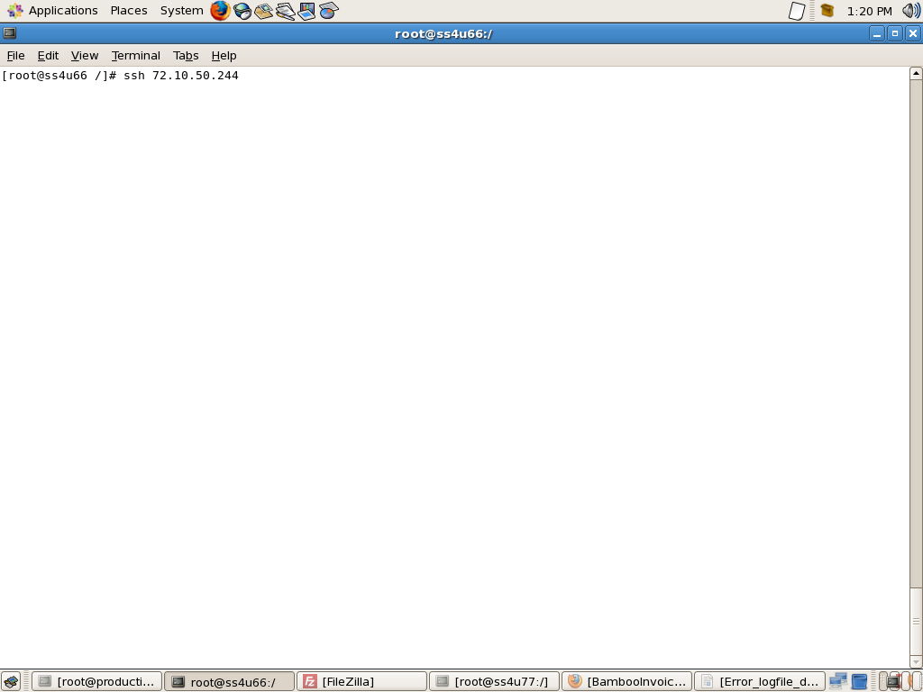
Soft_Solutions4U
Quality System Procedure

Training Manual Template Effective from May 04.06.2011
May 04.06.2011

It will ask the password (root password) for successful login.

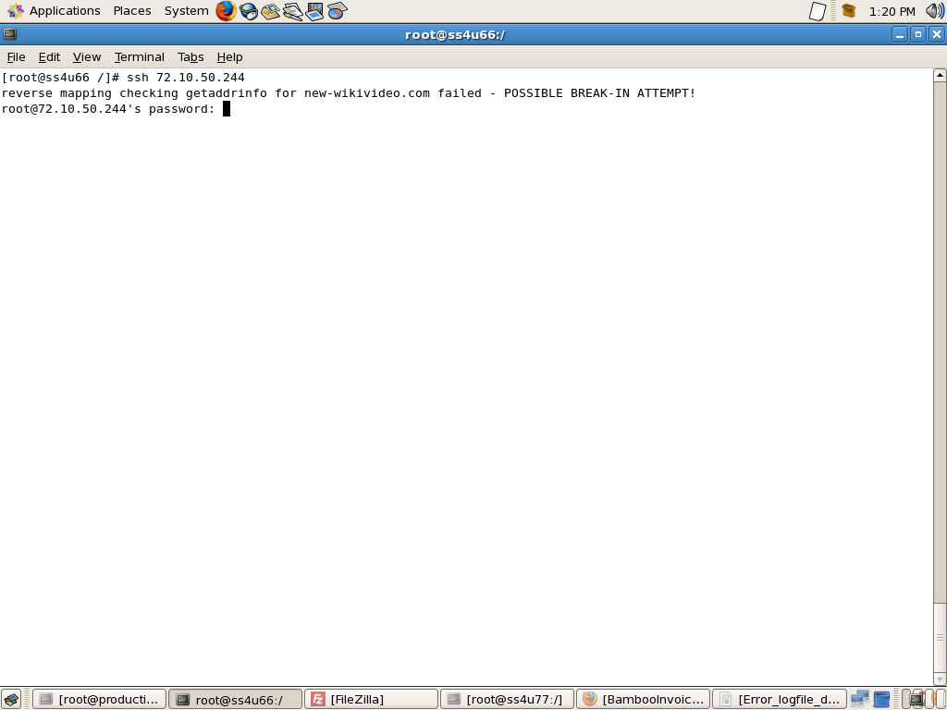

Here you give the correct root password then only you get successful login.

Soft_Solutions4U
Quality System Procedure

Training Manual Template Effective from May 04.06.2011
May 04.06.2011

Successful login :

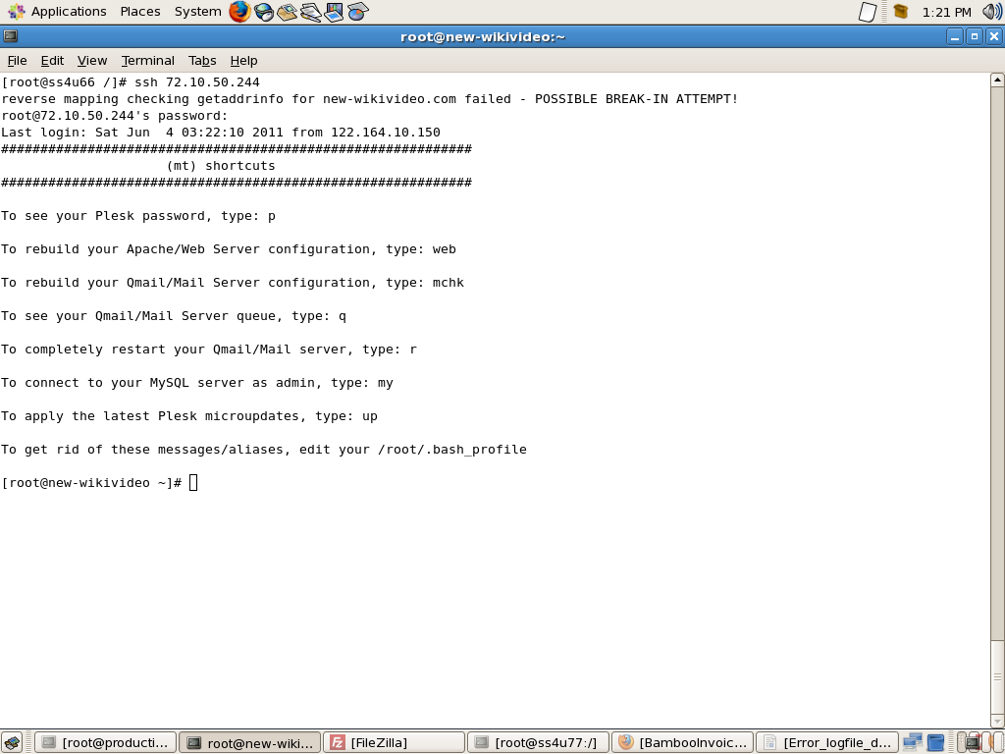

It will intimate the successful ssh remote login.

Soft_Solutions4U
Quality System Procedure

Training Manual Template Effective from May 04.06.2011
May 04.06.2011

Wrong Password Attempt:

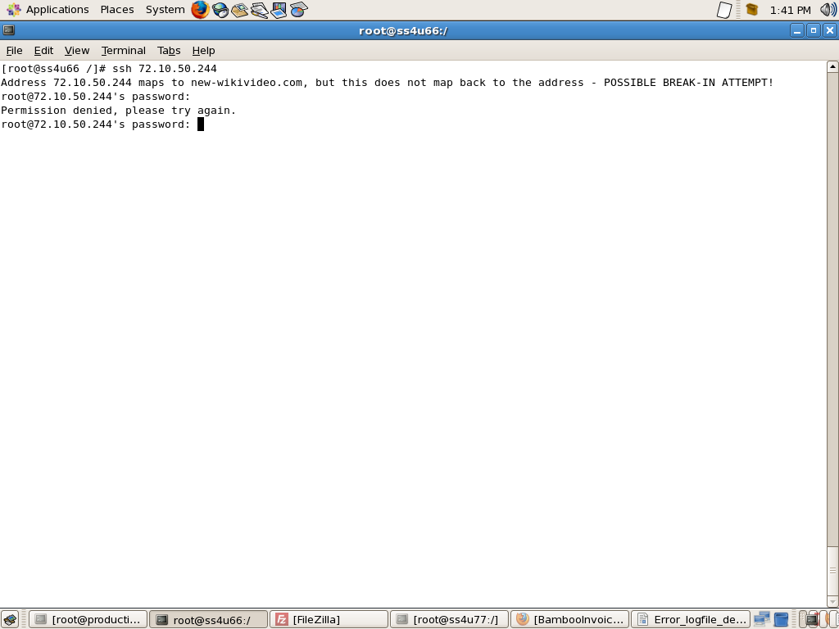

You type the wrong password means it will ask “please try again”.

It will allow only three wrong password attempts.

Soft_Solutions4U
Quality System Procedure

Training Manual Template Effective from May 04.06.2011
May 04.06.2011

After getting successful login. You go to “/var/www/vhosts” directory by using the following

command.

Cd /var/www/vhosts

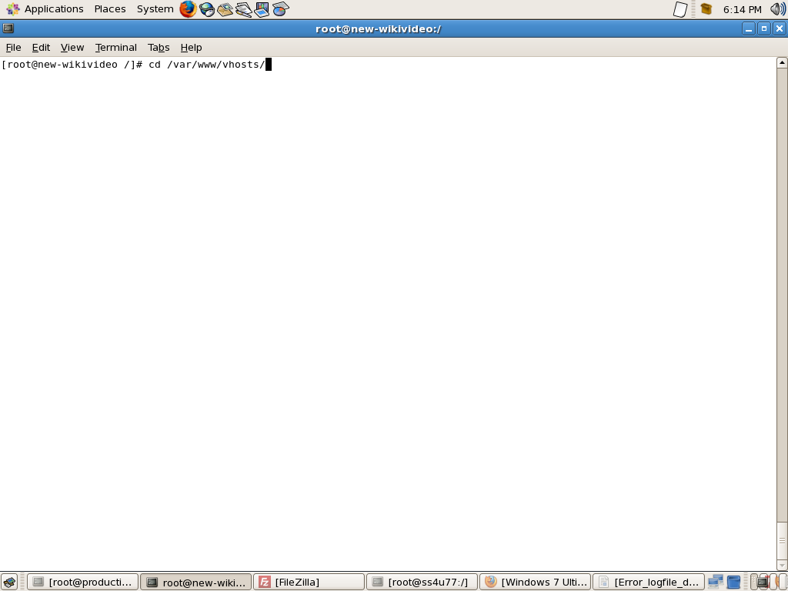

Soft_Solutions4U
Quality System Procedure

Training Manual Template Effective from May 04.06.2011
May 04.06.2011

After go to that directory, you type the following command to check the disk usage.

# du -sh */

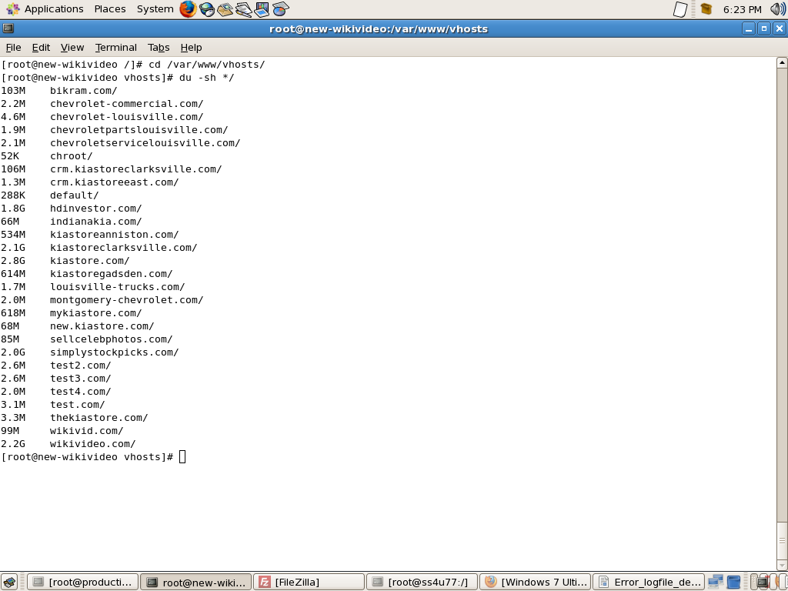

Here you can findout the disk usage of the server domains like “wikivideo.com”.

Soft_Solutions4U
Quality System Procedure

Training Manual Template Effective from May 04.06.2011
May 04.06.2011

Go to more disk usage domains “logfile location directory” .And also all domains having the logfiles
at “statistics/logs” under their own domain.

For example,the “wikivideo.com” domain having more log files means,you go to that log file domain
by using the following command.

“Cd wikivideo.com/statistics/logs”

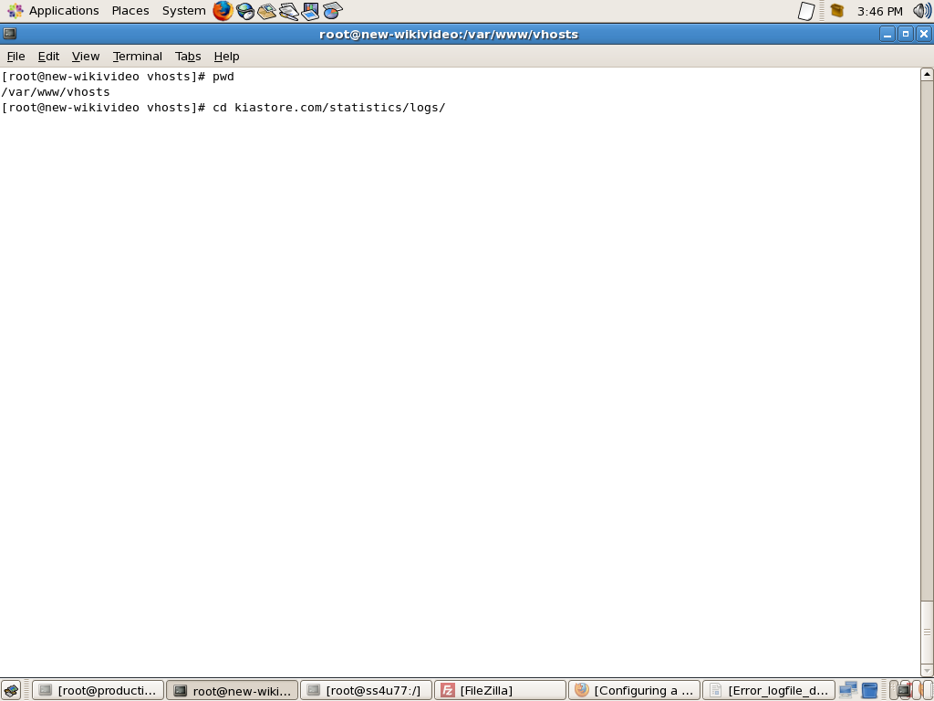

The above command is used to go that particular directory.

Soft_Solutions4U
Quality System Procedure

Training Manual Template Effective from May 04.06.2011
May 04.06.2011

After reaching that particular directory, you see the log file and their size by using the following
commands.

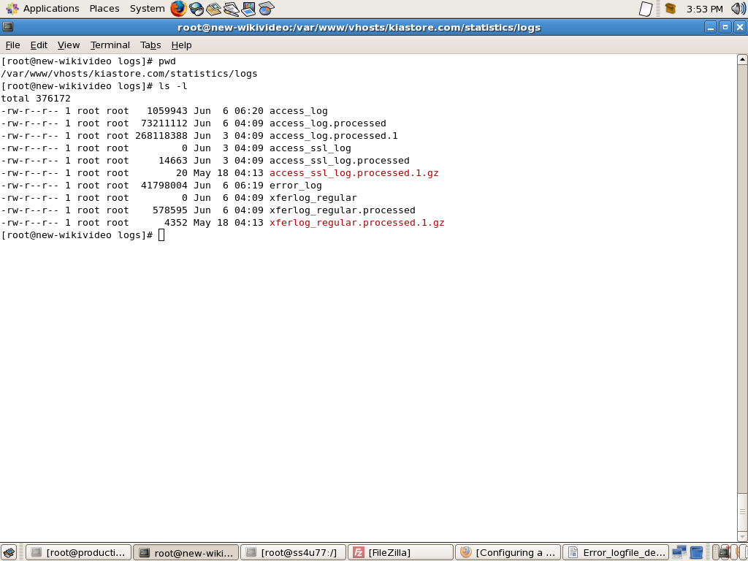
The command “pwd” is used to check the “Present Working Directory”.

The command “ls -l” is used to dispaly all the files in that directory with its details.

Soft_Solutions4U
Quality System Procedure

Training Manual Template Effective from May 04.06.2011
May 04.06.2011

Remove the “error_log” file by using the following command.

# rm -f error_log

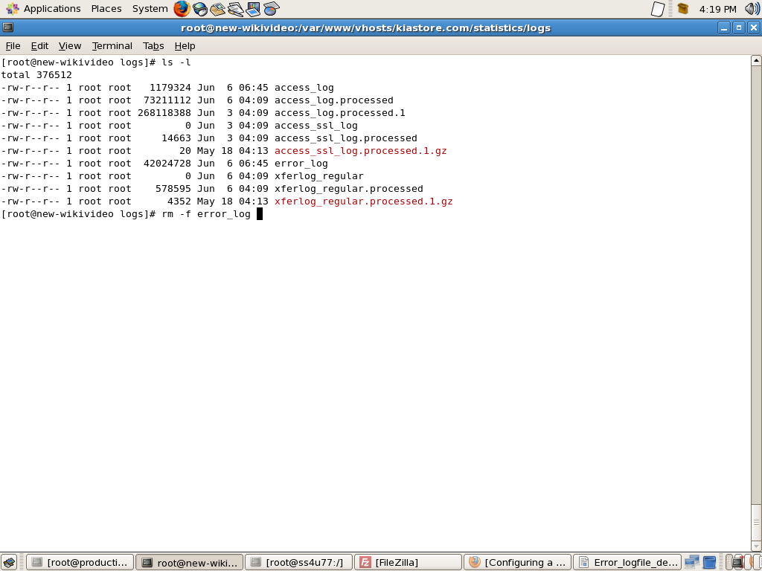

For ubuntu system
==============

- Login as a root user.
- After that cd /var/log.
- Give ls -l command to view the Log files.
- du -sh command show the usage of hard disks.
- rm -rf command used for delete the log files.
- For deleting Apache error.
- Cd apache2
- rm -rf access.log
- rm -rf error.log
- After create new file using Touch command.
- Touch access.log
- chown for change user and group for files
- chown root:adm access.log
- After we want to restart the apache2
- /etc/ini.d/apache2 restart.

