
Soft_Solutions4U
Quality System Procedure

Training Manual Template Effective from january 04.01.2011
january 4 2011



Integrated Quality Management System

<<Installation of Tomcat6 in ubuntu 10.04 >>

Prepared By (SS4U) | Signature | R.MARIKKANNAN
Prepared By (SS4U) | Name | R.MARIKKANNAN
Reviewers | Signature
Reviewers | Name
Approves | Signature
Approves | Names

Soft_Solutions4U
Quality System Procedure

Training Manual Template Effective from january 04.01.2011
january 4 2011

Installation of Tomcat 6 Server in Ubuntu 10.04

Step:1

Before installation of tomcat server,first you must install java on your system.

Installation of java in ubuntu done through “synaptic package manager”

Go to “synaptic package manager” by using the following path

“ system--->administration--->synaptic package manager”.

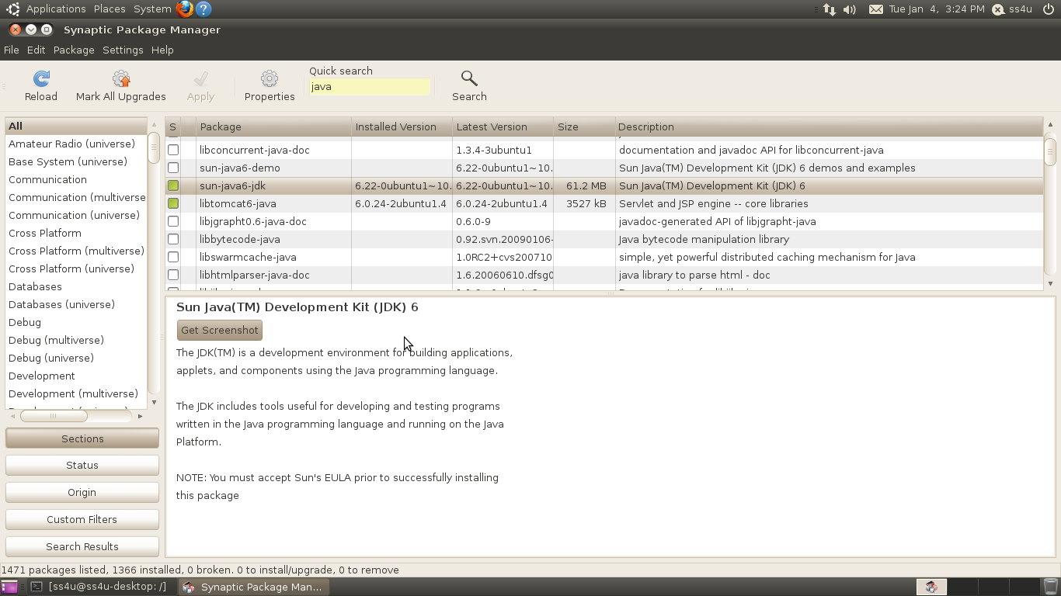
In the synaptic package manager,you search the package name by “java”. In the searched items
you choose the package name as “java 6”.

Then you select “mark for installation”,after that you must click “apply” button for installation.
It will automatically download the packages and make installation also.

Soft_Solutions4U
Quality System Procedure

Training Manual Template Effective from january 04.01.2011
january 4 2011

Step:2

After installation of java through “synaptic package manager”,you verify through command
line java is installed or not by using the following command.

#java -version

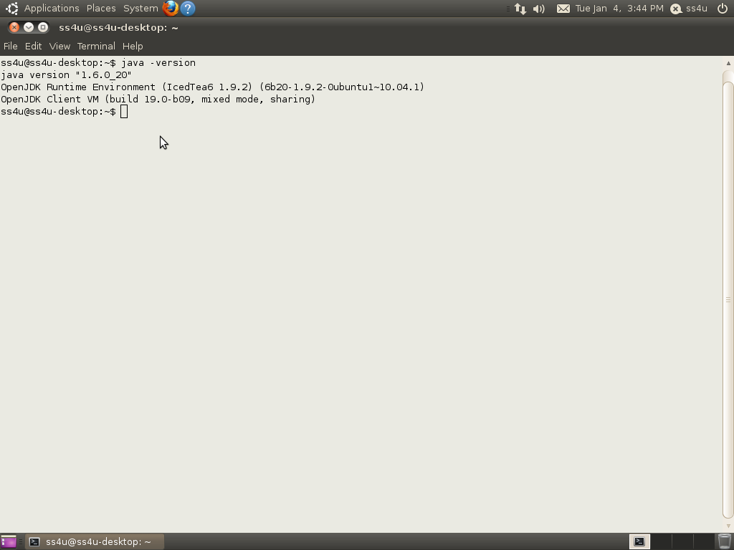

After the verification of java installation,you start the tomcat server installation.

Soft_Solutions4U
Quality System Procedure

Training Manual Template Effective from january 04.01.2011
january 4 2011

Step:3

Installation of tomcat6 server

In the synaptic package manager, “Edit---->Mark by Task---->tomcat6 java server”.It will
automatically download the packages and make installation also.

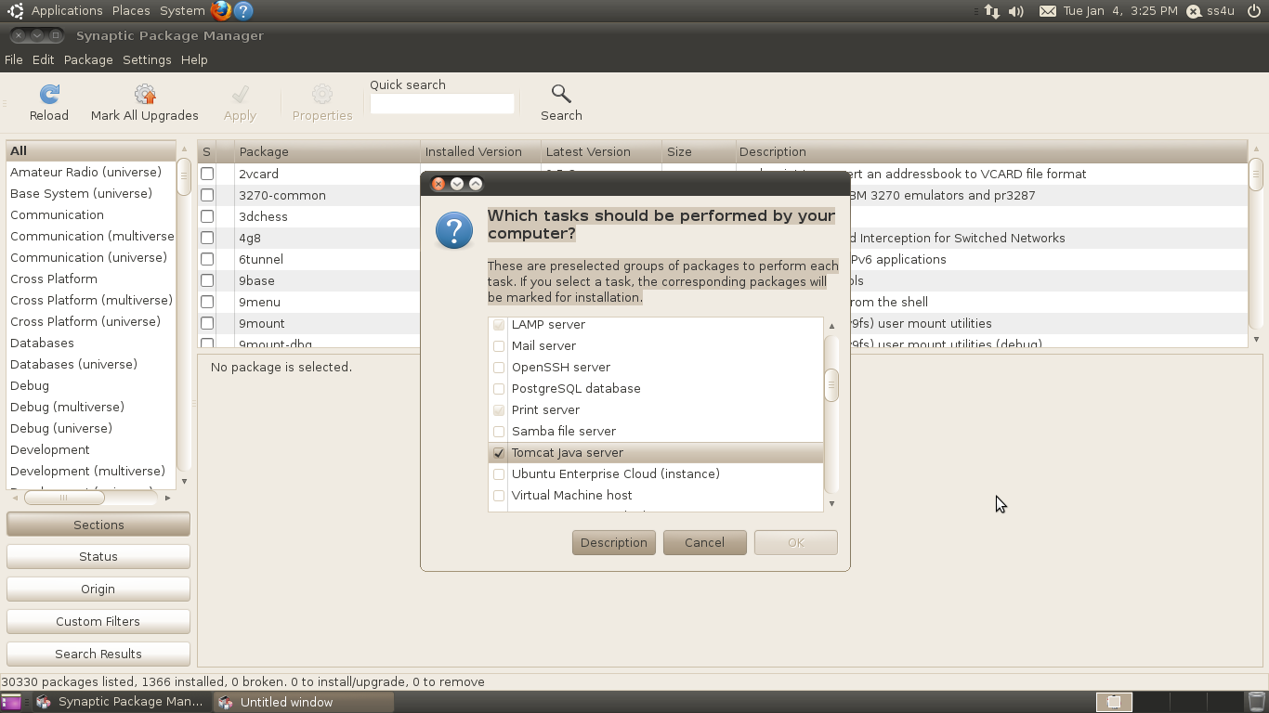

After select the “tomcat java Server” ,you press the “apply” button for installation of packages.

The default port number for tomcat-java server is 8080.

Soft_Solutions4U
Quality System Procedure

Training Manual Template Effective from january 04.01.2011
january 4 2011

Step :4

Both “Apache and Apache Tomcat 6 java server” are using the same port number “8080”.

We run both in single machine means we must change the port number of tomcat server.

Here we change the tomcat 6 java server port number as “8081”. The port number “8081” is
optional one.

Configuration file path tomcat6-java server:

#vim /etc/tomcat6/server.xml

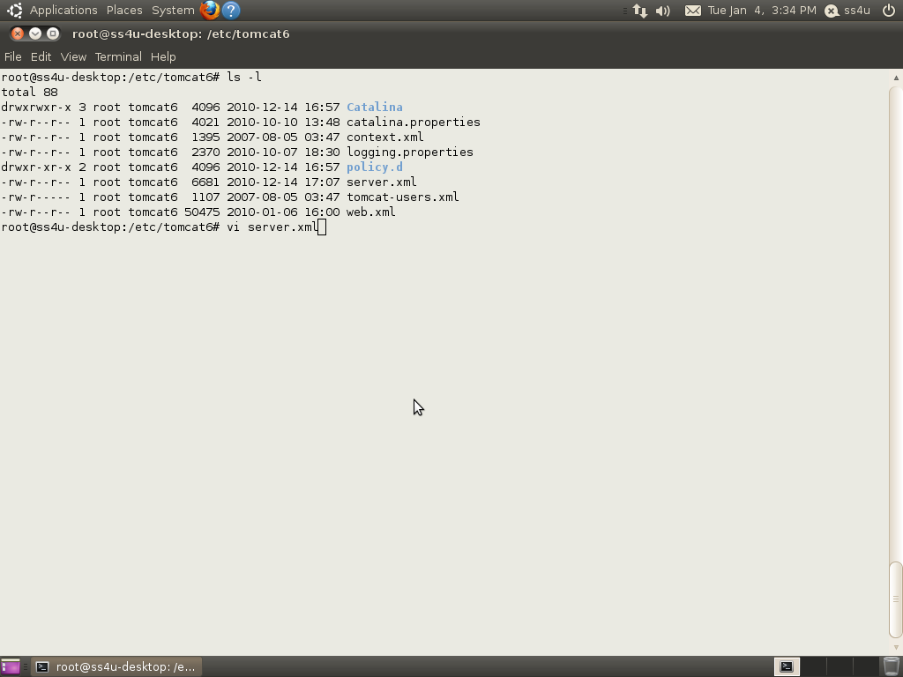

Soft_Solutions4U
Quality System Procedure

Training Manual Template Effective from january 04.01.2011
january 4 2011

Coding part for changing the port number of tomcat6-java server in the tomcat server
configuration file of “server.xml”.

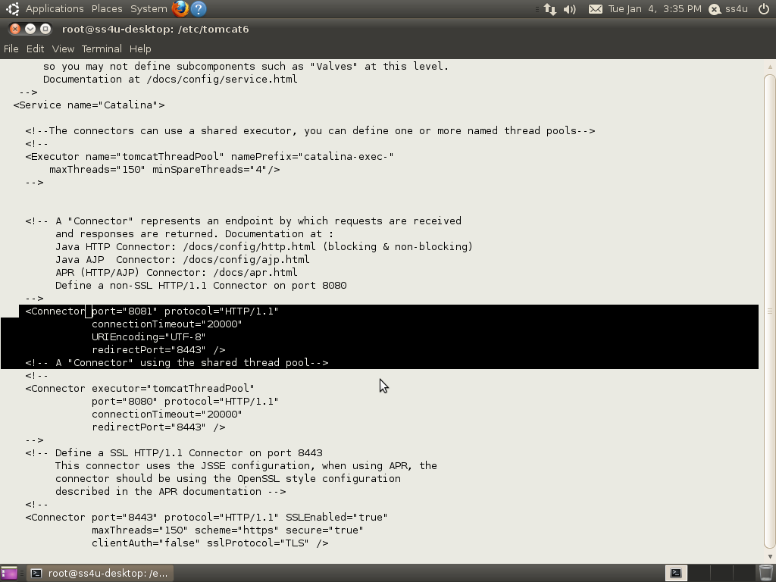

Soft_Solutions4U
Quality System Procedure

Training Manual Template Effective from january 04.01.2011
january 4 2011

Screen short for Change the port of tomcat6-java server as 8081:

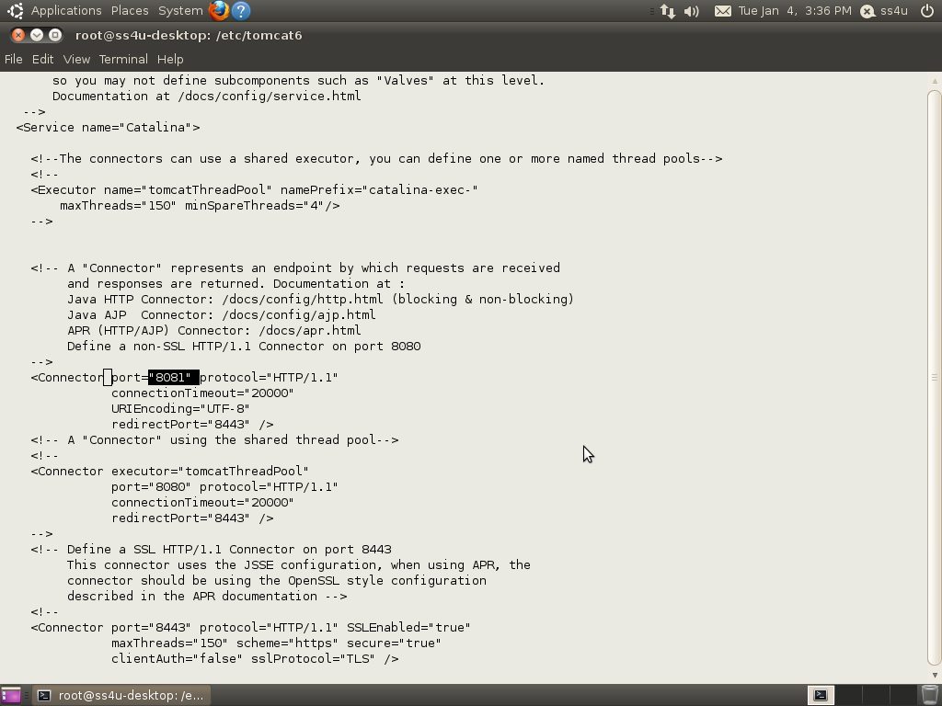

After changing the port number, you save file and restart the tomcat server.

Soft_Solutions4U
Quality System Procedure

Training Manual Template Effective from january 04.01.2011
january 4 2011

Step:5

Tomcat6 java server “START/STOP/RESTART/STATUS”of the service.

Start the “tomcat6-java server” by using the following command,

#sudo /etc/init.d/tomcat6 start

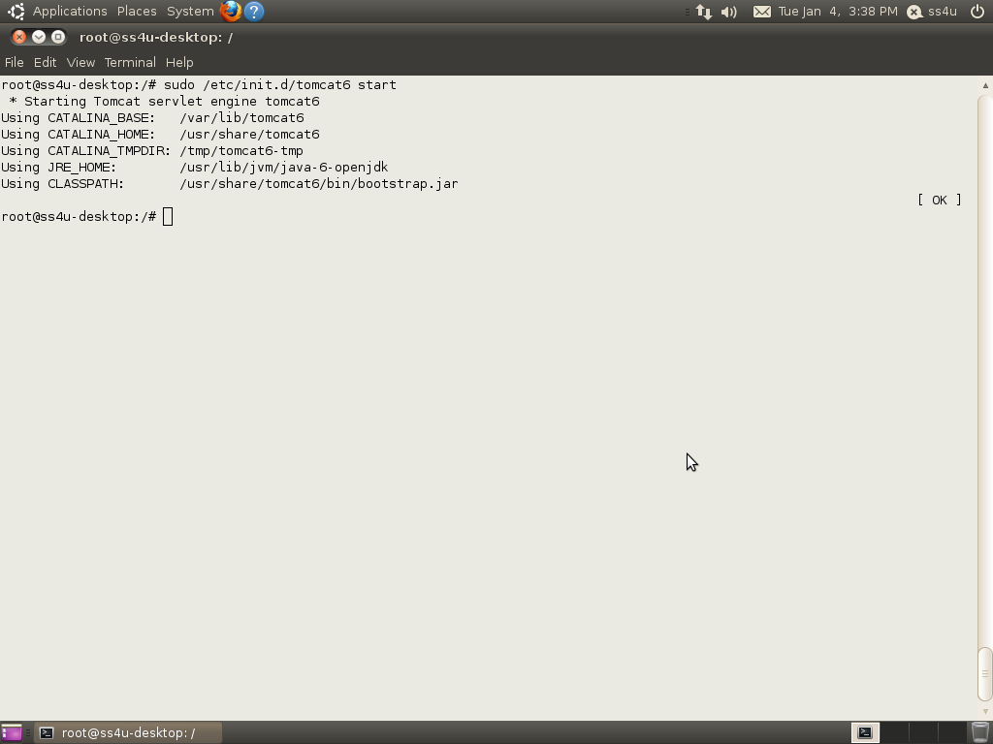

Soft_Solutions4U
Quality System Procedure

Training Manual Template Effective from january 04.01.2011
january 4 2011

Stop the “tomcat6-java server” by using the following command,

#sudo /etc/init.d/tomcat6 stop

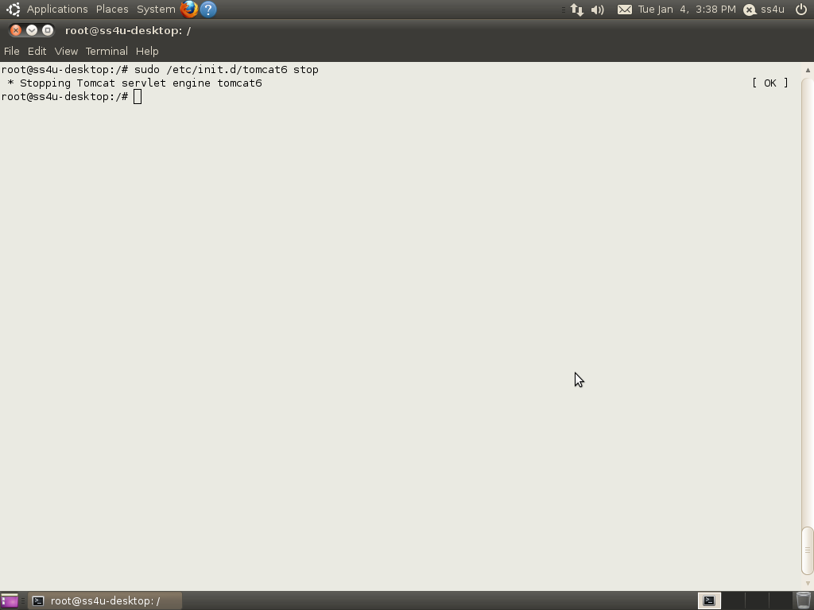

Soft_Solutions4U
Quality System Procedure

Training Manual Template Effective from january 04.01.2011
january 4 2011

Restart the “tomcat6-java server” by using the following command,

# sudo /etc/init.d/tomcat6 restart

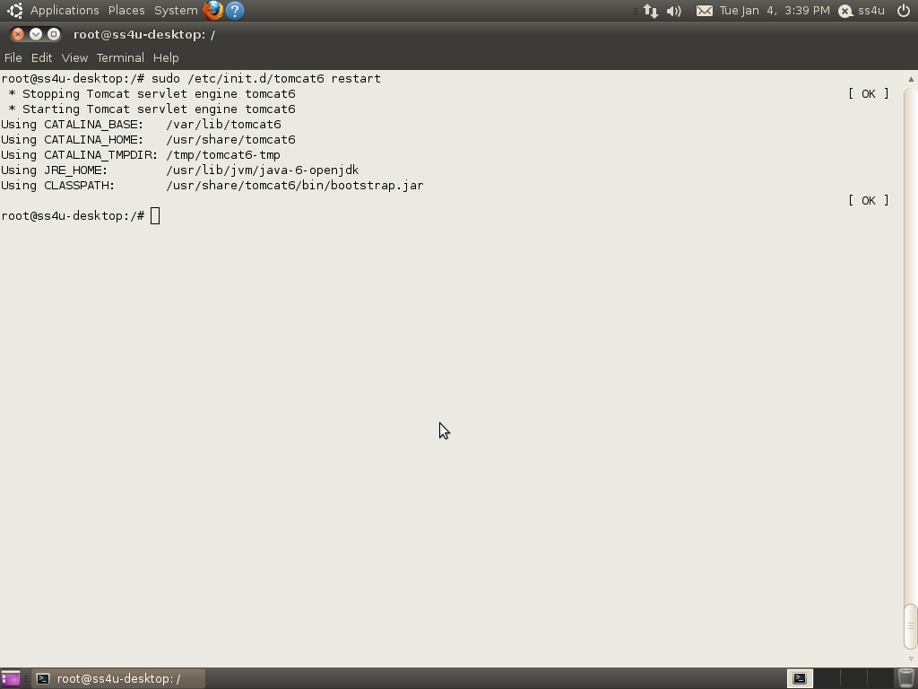

Soft_Solutions4U
Quality System Procedure

Training Manual Template Effective from january 04.01.2011
january 4 2011

To know the status of the “tomcat6-java server” by using the following command,

# sudo /etc/init.d/tomcat6 status

It will give the result like tomcat server is on/off.

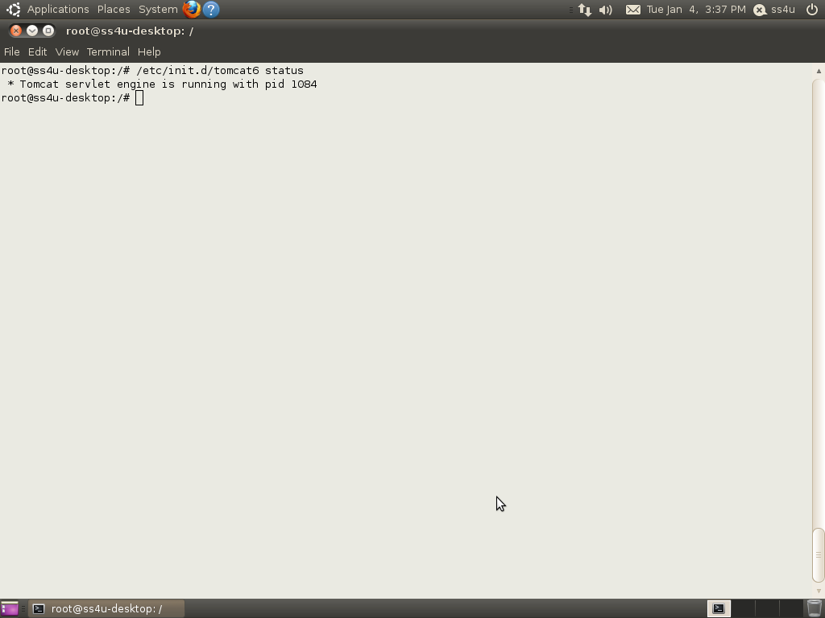

Soft_Solutions4U
Quality System Procedure

Training Manual Template Effective from january 04.01.2011
january 4 2011

Step:6
Accessing the tomcat server

Accessing the tomcat6-java server through browser

http://localhost:8081/

here we change the default port number of tomcat-java server by 8081.

