
Soft_Solutions4U
Quality System Procedure

Training Manual Template Effective from April 30.04.2011
April 30.04.2011



<< Soap Installation in CentOS >>

Prepared By (SS4U) | Signature | R.MARIKKANNAN
Prepared By (SS4U) | Name | R.MARIKKANNAN
Reviewers | Signature
Reviewers | Name
Approves | Signature
Approves | Names

Soft_Solutions4U
Quality System Procedure

Training Manual Template Effective from April 30.04.2011
April 30.04.2011

Installation of SOAP in CentOS

Step :1

Install the php-soap package in centos by using the following command

# yum install php-soap;

It will automatically download the package from internet and slove the
dependency itself and install it.

Step :2

After installation of php-soap package,you verify the installed package by using
the following command.

# rpm -qa php-soap*;

It will show the package is installed or not.

Step 3:

After installation of php-soap package,you restart the apache server by using the
following command.

# service httpd restart

After restarting the apache server, you verify the soap package is enabled or not.

Soft_Solutions4U
Quality System Procedure

Training Manual Template Effective from April 30.04.2011
April 30.04.2011

To verify the soap package is enabled or not through command line by using the
following command.

# php -v

It will show the installed php version.

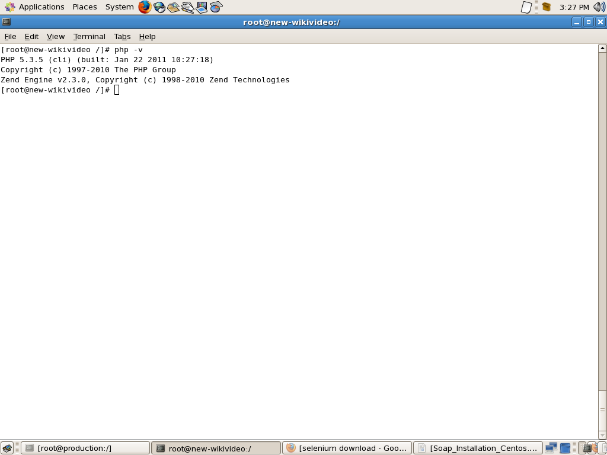

Soft_Solutions4U
Quality System Procedure

Training Manual Template Effective from April 30.04.2011
April 30.04.2011

To verify through browser by passing “phpinfo.php” in the url of the site.

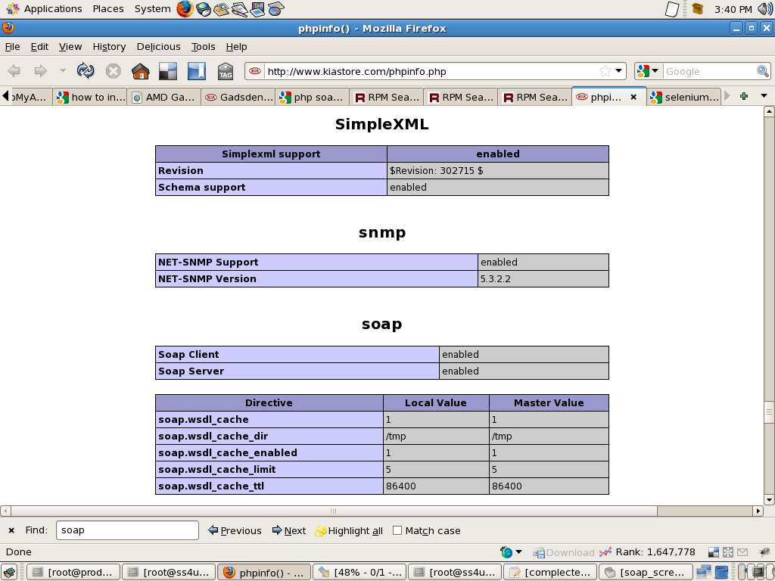

Now the screen shot shows the soap enabled in php.

Soft_Solutions4U
Quality System Procedure

Training Manual Template Effective from April 30.04.2011
April 30.04.2011

Trouble Shooting:

Trouble shooting in soap enable in php

After installation of soap service in centos,you execute “ php -v ” command it

will display the error like “/usr/lib/php/modules/soap.so cannot loaded ”.

It will indicate the soap.so file not supported for that version . Now you cann't install
that particular version alone.you install that specified version means that will generate
dependency mismatch error.

Note: “DO NOT GO FOR FORCE INSTALLATION”

Trouble shoot that problem by downloading that specified version rpm file.

64 bit processor:

Extract the rpm file and copy the "soap.so" file from extracted folder itself in the
following path"/usr/lib64/php/modules"

Paste the source file in the same path in the system folder like "/usr/lib64/php/modules"

php -v command used to check (It doesn't generate any error).

Restart the web server (apache only)

Enabling soap service identified by passing "phpinfo.php" after the "site URL"

Soft_Solutions4U
Quality System Procedure

Training Manual Template Effective from April 30.04.2011
April 30.04.2011

32 bit processor:

Extract the rpm file and copy the "soap.so" file from extracted folder itself in the
following path"/usr/lib/php/modules"

Paste the source file in the same path in the system folder like "/usr/lib/php/modules"

php -v command used to check (It doesn't generate any error).

Restart the web server (apache only)

Enabling soap service identified by passing "phpinfo.php" after the "site URL" .

